Supporting information (SI)

Pre-regulatory actions as a driver for reduced PFAS emissions? Long-term trends and change points for human and environmental samples from Germany
Alexander Badry^{1a}, René Lämmer^{2a}, Bernd Göckener^{2*} and Jan Koschorreck¹
¹German Environment Agency (Umweltbundesamt), Wörlitzer Platz 1, 06813 Dessau-Roßlau, Germany
²Fraunhofer Institute for Molecular Biology and Applied Ecology IME, Auf dem Aberg 1, 57392 Schmallenberg, Germany
ª shared first authorship
*Corresponding author: bernd.goeckener@ime.fraunhofer.de
List of Figures
Figure SI-1: Overview of the sampling sites for all surveyed matrices (human, coastal, terrestrial and freshwater samples) in the German environment. 3
Figure SI-2: Segmented linear regression of geometric mean for PFAS (≥ 75% detection rate) in human plasma from Münster (1982 to 2019) based on the dataset of Figure 1 (A) and based on data from Yeung et al. 2013^{1/2} (1982-2009) for a single CP estimate (B) and two CP estimates (C). Starting values for two CPs estimates were 1990 and 2000 for PFSAs, whereas PFOA did not result in multiple CP estimates (starting values: 1990 and 2005). Regression lines are displayed along with 95% confidence intervals (per segment). The CPs are indicated horizontally above the x-axis along with 95% confidence intervals as well. 4
Figure SI-3: Segmented linear regression of geometric means for PFAS (≥ 75% detection rate) in livers of one-year old deer from different sampling sites. A regression line is displayed along with 95% confidence intervals (per segment). The CP is indicated horizontally above the x-axis along with 95% confidence intervals as well. 6
Figure SI-4: Segmented linear regression of geometric means for PFAS (≥ 75% detection rate) in eggs of herring gulls from the Trischen and Mellum (North Sea) separated by PFSAs (left side) and PFCAs (right side). A regression line is displayed along with 95% confidence intervals (per segment). The CP is indicated horizontally above the x-axis along with 95% confidence intervals as well. 8
Figure SI-5: Segmented regression for geometric means of PFSAs (left) and PFCAs (right) (≥75% detection rate) in muscle of bream given for each river. A regression line is displayed along with 95% confidence intervals (per segment). The change point is indicated horizontally above the x-axis along with 95% confidence intervals as well. 12
Figure SI-6: Segmented linear regression of geometric means for PFAS (≥75% detection rate) in muscle of bream from Bimmen, Rhine using target analysis. A regression line is displayed along with 95% confidence intervals (per segment). The CP is indicated horizontally above the x-axis along with 95% confidence intervals as well. 13
Figure SI-7: Segmented linear regression of geometric means for PFAS (≥ 75% detection rate) in livers of bream from Bimmen, Rhine for dTOP (top) and target (bottom). A regression line is displayed along with 95% confidence intervals (per segment). The CP is indicated horizontally above the x-axis along with 95% confidence intervals as well. 14
Figure SI-8: Linear regression of geometric means for PFOS (left) and segmented linear regression of PFCAs (right) (≥ 75% detection rate) in soft tissue of Dreissena mussels from Blankenese, Elbe River. A regression line is displayed along with 95% confidence intervals (per segment). The CP is indicated horizontally above the x-axis along with 95% confidence intervals as well. 16
Figure SI-9: Segmented linear regression of geometric means for PFOS (in µg kg⁻¹) in soft tissue of Dreissena mussels from Blankenese, Elbe River by the lmcp-package. 17

List of Tables
Table SI-1: Regression estimates, rounded CP statistics (SE: standard error) and 50% reduction times (t₅₀) for PFAS in human plasma from Münster (matching results from Figure 1). An asterisk (*) indicates a significant difference in-slope at p-value < 0.05 (*), < 0.01 (**), < 0.001 (***) (test for a non-constant regression parameter in the linear predictor). 4
Table SI-2 Regression estimates, rounded CP statistics (SE: standard error) and 50% reduction times (t₅₀) for PFAS in human plasma (matching results from Figure SI-2). An asterisk (*) indicates a significant difference in-slope at p-value < 0.05 (*), < 0.01 (**), < 0.001 (***) (test for a non-constant regression parameter in the linear predictor). Starting values for two CPs: 1990, 2000 (PFSAs). 50% reduction times are based on the most recent CP and associated decline. 5
Table SI-3: Regression estimates, rounded CP statistics (SE: standard error) and 50% reduction times (t₅₀) for PFAS in livers of one-year old deer from different sampling sites. An asterisk (*) indicates a significant difference in-slope at p-value < 0.05 (*), < 0.01 (**), < 0.001 (***) (test for a non-constant regression parameter in the linear predictor). 7
Table SI-4: Regression estimates, rounded CP statistics (SE: standard error) and 50% reduction times (t₅₀) for PFAS in eggs of herring gulls from Trischen and Mellum (North Sea, individual and cumulated), and Heuwiese (Baltic Sea). An asterisk (*) indicates a significant difference in-slope at p-value < 0.05 (*), < 0.01 (**), < 0.001 (***) (test for a non-constant regression parameter in the linear predictor). 8
Table SI-5: Regression estimates, rounded CP statistics (SE: standard error) and 50% reduction times (t₅₀) for PFAS in muscles of bream over all rivers (matching results of Figure 4). An asterisk (*) indicates a significant difference in-slope at p-value <0.05 (*), <0.01 (**), < 0.001 (***) (test for a non-constant regression parameter in the linear predictor). 10
Table SI-6: Regression estimates, rounded CP statistics (SE: standard error) and 50% reduction times (t₅₀) for PFAS in muscles of bream among rivers. An asterisk (*) indicates a significant difference in-slope at p-value <0.05 (*), <0.01 (**), < 0.001 (***) (test for a non-constant regression parameter in the linear predictor). 12
Table SI-7 Regression estimates, rounded CP statistics (SE: standard error) and 50% reduction times (t₅₀) for PFAS in muscle of bream from Bimmen, Rhine. An asterisk (*) indicates a significant difference in-slope at p-value <0.05 (*), <0.01 (**), < 0.001 (***) (test for a non-constant regression parameter in the linear predictor). 13
Table SI-8: Regression estimates, rounded CP statistics (SE: standard error) and 50% reduction times (t₅₀) for PFAS in liver of bream from Bimmen, Rhine. An asterisk (*) indicates a significant difference in-slope at p-value < 0.05 (*), < 0.01 (**), < 0.001 (***) (test for a non-constant regression parameter in the linear predictor). 15
Table SI-9: Regression estimates, rounded CP statistics (SE: standard error) and 50% reduction times (t₅₀) for PFAS in Dreissena from Blankenese Elbe River. An asterisk (*) indicates a significant difference in-slope at p-value < 0.05 (*), < 0.01 (**), < 0.001 (***) (test for a non-constant regression parameter in the linear predictor). 16
Table SI-10: Overview of the PFAS analysed in the different matrices. It is important to note that the number of analytes, the methods for their analysis and the limits of quantification differed both over time and between laboratories. 17

- Overview of the sampling sites
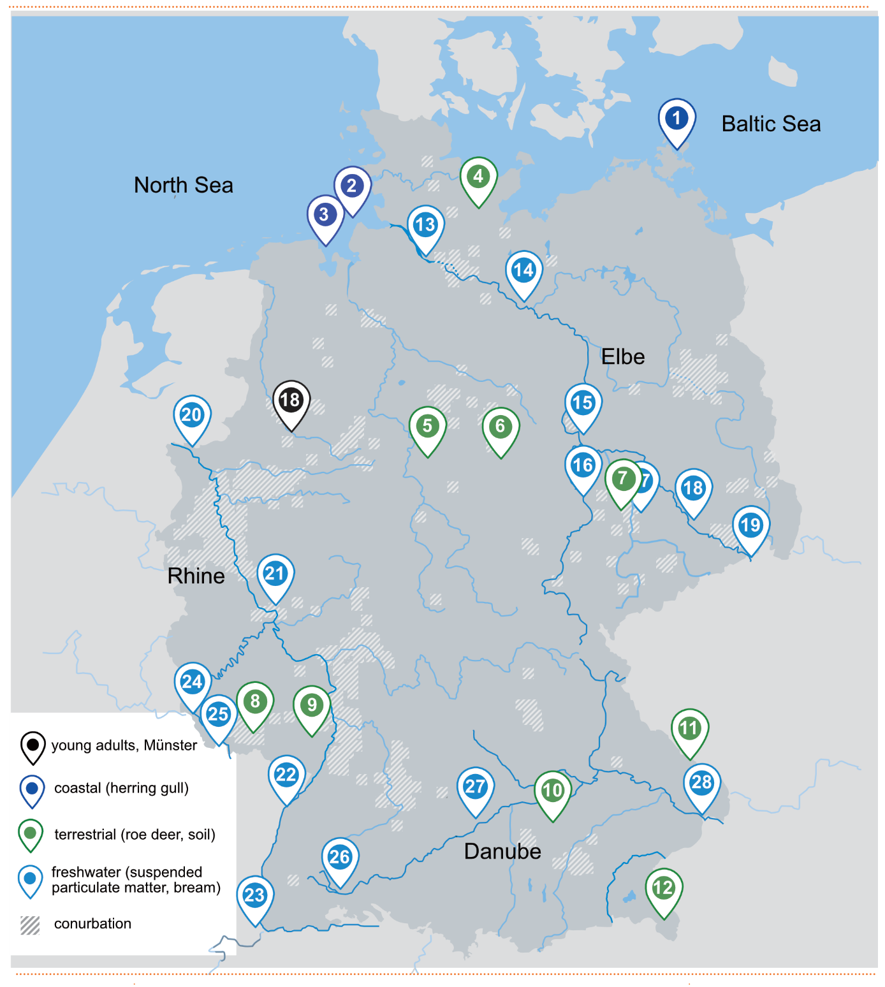
Figure SI-1: Overview of the sampling sites for all surveyed matrices (human, coastal, terrestrial and freshwater samples) in the German environment.

- Change point analysis in human plasma from Münster
Table SI-1: Regression estimates, rounded CP statistics (SE: standard error) and 50% reduction times (t₅₀) for PFAS in human plasma from Münster (matching results from Figure 1). An asterisk (*) indicates a significant difference in-slope at p-value < 0.05 (*), < 0.01 (**), < 0.001 (***) (test for a non-constant regression parameter in the linear predictor).
 | Change in % per year before CP (95% CI) | CP (year) ± SE | Change in % per year after CP (95% CI) | t₅₀ in years (95% CI)
PFHxS | +2.6 (-0.3 – 5.6) | 2000 ± 1.9*** | -7.1 (-9.0 – -5.2) | 9.3 (7.3 – 12.9)
PFOS | +2.4 (-2.0 –7.0) | 1997 ± 1.5*** | -12.1 (-13.9 – -10.2) | 5.4 (4.6 – 6.4)
PFOA | +0.2 (-1.5 – 1.9) | 2005 ± 1.5*** | -8.1 (-10.2 – -6.0) | 8.2 (6.5 – 11.1)

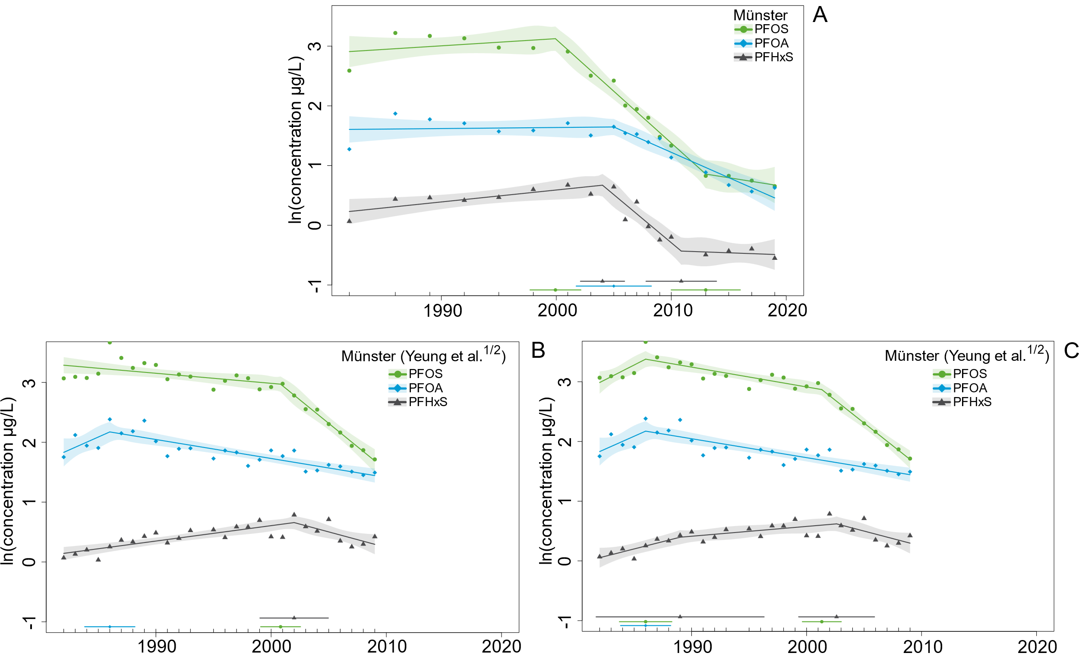
Figure SI-2: Segmented linear regression of geometric mean for PFAS (≥ 75% detection rate) in human plasma from Münster (1982 to 2019) based on the dataset of Figure 1 (A) and based on data from Yeung et al. 2013^{1/2} (1982-2009) for a single CP estimate (B) and two CP estimates (C). Starting values for two CPs estimates were 1990 and 2000 for PFSAs, whereas PFOA did not result in multiple CP estimates (starting values: 1990 and 2005). Regression lines are displayed along with 95% confidence intervals (per segment). The CPs are indicated horizontally above the x-axis along with 95% confidence intervals as well.

Table SI-2 Regression estimates, rounded CP statistics (SE: standard error) and 50% reduction times (t₅₀) for PFAS in human plasma (matching results from Figure SI-2). An asterisk (*) indicates a significant difference in-slope at p-value < 0.05 (*), < 0.01 (**), < 0.001 (***) (test for a non-constant regression parameter in the linear predictor). Starting values for two CPs: 1990, 2000 (PFSAs). 50% reduction times are based on the most recent CP and associated decline.
 | Change in % per year before CP (95% CI) | CP (year) ± SE | Change in % per year after CP (95% CI) | CP (year) ± SE | Change in % per year after CP (95% CI) | t₅₀ in years after latest CP (95% CI)
A: Figure 1: Two CPs
PFHxS | +2.0  (0.4 – 3.6) | 2004  ± 0.9 | -14.9  (-20.9 – -8.4) | 2011  ± 1.4 | -0.7  (-7.3 – 6.3) | 99.0  (9.2 – /)
PFOS | +1.2  (-1.4 – 3.9) | 2000  ± 1.0 | -15.9  (-19.4 – -12.2) | 2013  ± 1.4 | -3.0  (-10.2 – 4.8) | 22.7  (6.4 – /)
PFOA | +0.2  (-1.5 – 1.9) | 2005  ± 1.5 | -8.1  (-10.2 – -6.0) | / | / | 8.2  (6.5 – 11.1)
B: Yeung et al 2013^{1/2}: Single CP
PFHxS | +2.6  (1.7 – 3.5) | 2002 ± 1.4*** | -5.1  (-9.3 – -0.6) | / | / | 13.3  (7.1 – 117.2)
PFOS | -1.7  (-2.9 – -0.4) | 2001 ± 0.8*** | -14.5  (-17.8 – -11.1) | / | / | 4.4  (3.5 – 5.9)
PFOA | + 8.9  (-0.5 – 19.3) | 1986  ± 1.1* | -3.1  (-4.0 – -2.2) | / | / | 21.9  (17.0 – 30.7)
C: Yeung et al 2013^{1/2}: Two CPs
PFHxS | +5.0  (0.4 – 9.9) | 1989  ± 3.5 | +1.7  (0.0 – 3.3) | 2002  ± 1.6 | -4.9  (-9.1 – -0.5) | 13.7  (7.2 – 135.0)
PFOS | +10.3  (-0.4 – 22.1) | 1986  ± 1.1 | -3.3  (-4.5 – -2.1) | 2001  ± 0.8 | -14.1  (-17.1 – -11.1) | 4.5  (3.7 – 5.9)
PFOA | + 8.9  (-0.5 – 19.3) | 1986  ± 1.1 | -3.1  (-4.0 – -2.2) | / | / | 21.9  (17.0 – 30.7)

- Change point analysis in livers of one-year old deer
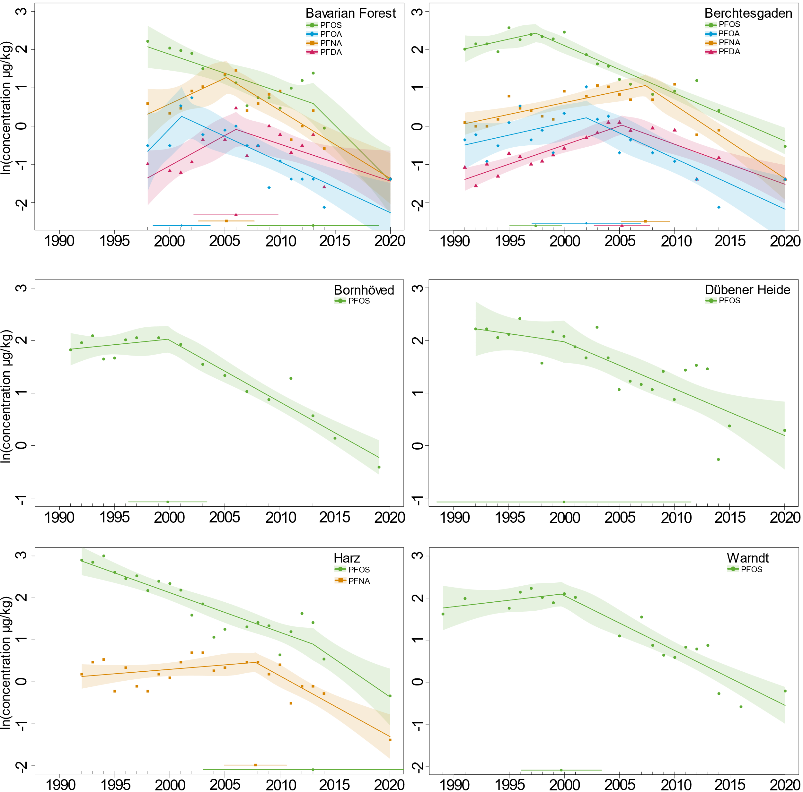
Figure SI-3: Segmented linear regression of geometric means for PFAS (≥ 75% detection rate) in livers of one-year old deer from different sampling sites. A regression line is displayed along with 95% confidence intervals (per segment). The CP is indicated horizontally above the x-axis along with 95% confidence intervals as well.

Table SI-3: Regression estimates, rounded CP statistics (SE: standard error) and 50% reduction times (t₅₀) for PFAS in livers of one-year old deer from different sampling sites. An asterisk (*) indicates a significant difference in-slope at p-value < 0.05 (*), < 0.01 (**), < 0.001 (***) (test for a non-constant regression parameter in the linear predictor).
 | Change in % per year before CP (95% CI) | CP (year) ± SE | Change in % per year after CP (95% CI) | t₅₀ in years (95% CI)
Overall
PFOS | +7.0 (-1.7 – 16.4) | 1997 ± 1.2*** | -11.4 (-13.2 – -9.5) | 5.7 (4.9 – 6.9)
PFNA | +11.0 (6.9 – 15.2) | 2004 ± 0.9*** | -13.3 (-16.5 – -9.9) | 4.9 (3.8 – 6.6)
Bavarian Forest
PFOS | -9.4 (-14.0 – -4.6) | 2013 ± 2.7 | -25.1 (-39.3 – -7.7) | 2.4 (1.4 – 8.7)
PFOA | +34.6 (-18.3 – 121.8) | 2001 ± 1.2 | -12.5 (-17.8 – -6.7) | 5.2 (3.5 – 9.9)
PFNA | +14.4 (-1.5 – 32.9) | 2005 ± 1.2** | -16.3 (-21.7 – -10.5) | 3.9 (2.8 – 6.2)
PFDA | +17.2 (-1.2 – 38.9) | 2006 ± 1.8* | -9.2 (-15.8 – -2.1) | 7.2 (4.0 – 32.7)
Berchtesgaden
PFOS | +6.6 (-3.0 – 17.1) | 1997 ± 1.1*** | -11.7 (-13.7 – -9.7) | 5.5 (4.7 – 6.8)
PFOA | +6.7 (-5.0 – 19.8) | 2002 ± 2.3* | -12.4 (-17.7 – -6.8) | 5.2 (3.6 – 9.8)
PFNA | +6.3 (2.8 – 9.9) | 2007 ± 1.0*** | -17.5 (-22.7 – -11.9) | 3.6 (2.7 – 5.5)
PFDA | +10.5 (6.6 – 14.5) | 2005 ± 1.2*** | -9.9 (-14.6 – -5.1) | 6.6 (4.4 – 13.3)
Bornhöved
PFOS | +2.2 (-4.4 – 9.2) | 2000 ± 1.6** | -11.1 (-13.6 – -8.5) | 5.9 (4.7 – 7.8)
Dübener Heide
PFOS | -3.0 (-13.0 – 8.1) | 2000 ± 5.5 | -8.5 (-12.2 – -4.7) | 7.8 (5.3 – 14.3)
Harz
PFOS | -9.0 (-11.1 – -6.9) | 2013 ± 4.8 | -16.5 (-28.9 – -1.9) | 3.8 (2.0 – 35.9)
PFNA | +2.2 (-1.3 – 5.7) | 2008 ± 1.4*** | -13.5 (-18.5 – -8.2) | 4.8 (3.4 – 8.1)
Warndt
PFOS | +3.1 (-4.3 – 11.1) | 2000 ± 1.7** | -12.2 (-15.2 – -9.1) | 5.3 (4.2 – 7.2)

- Change point analysis in herring gull eggs
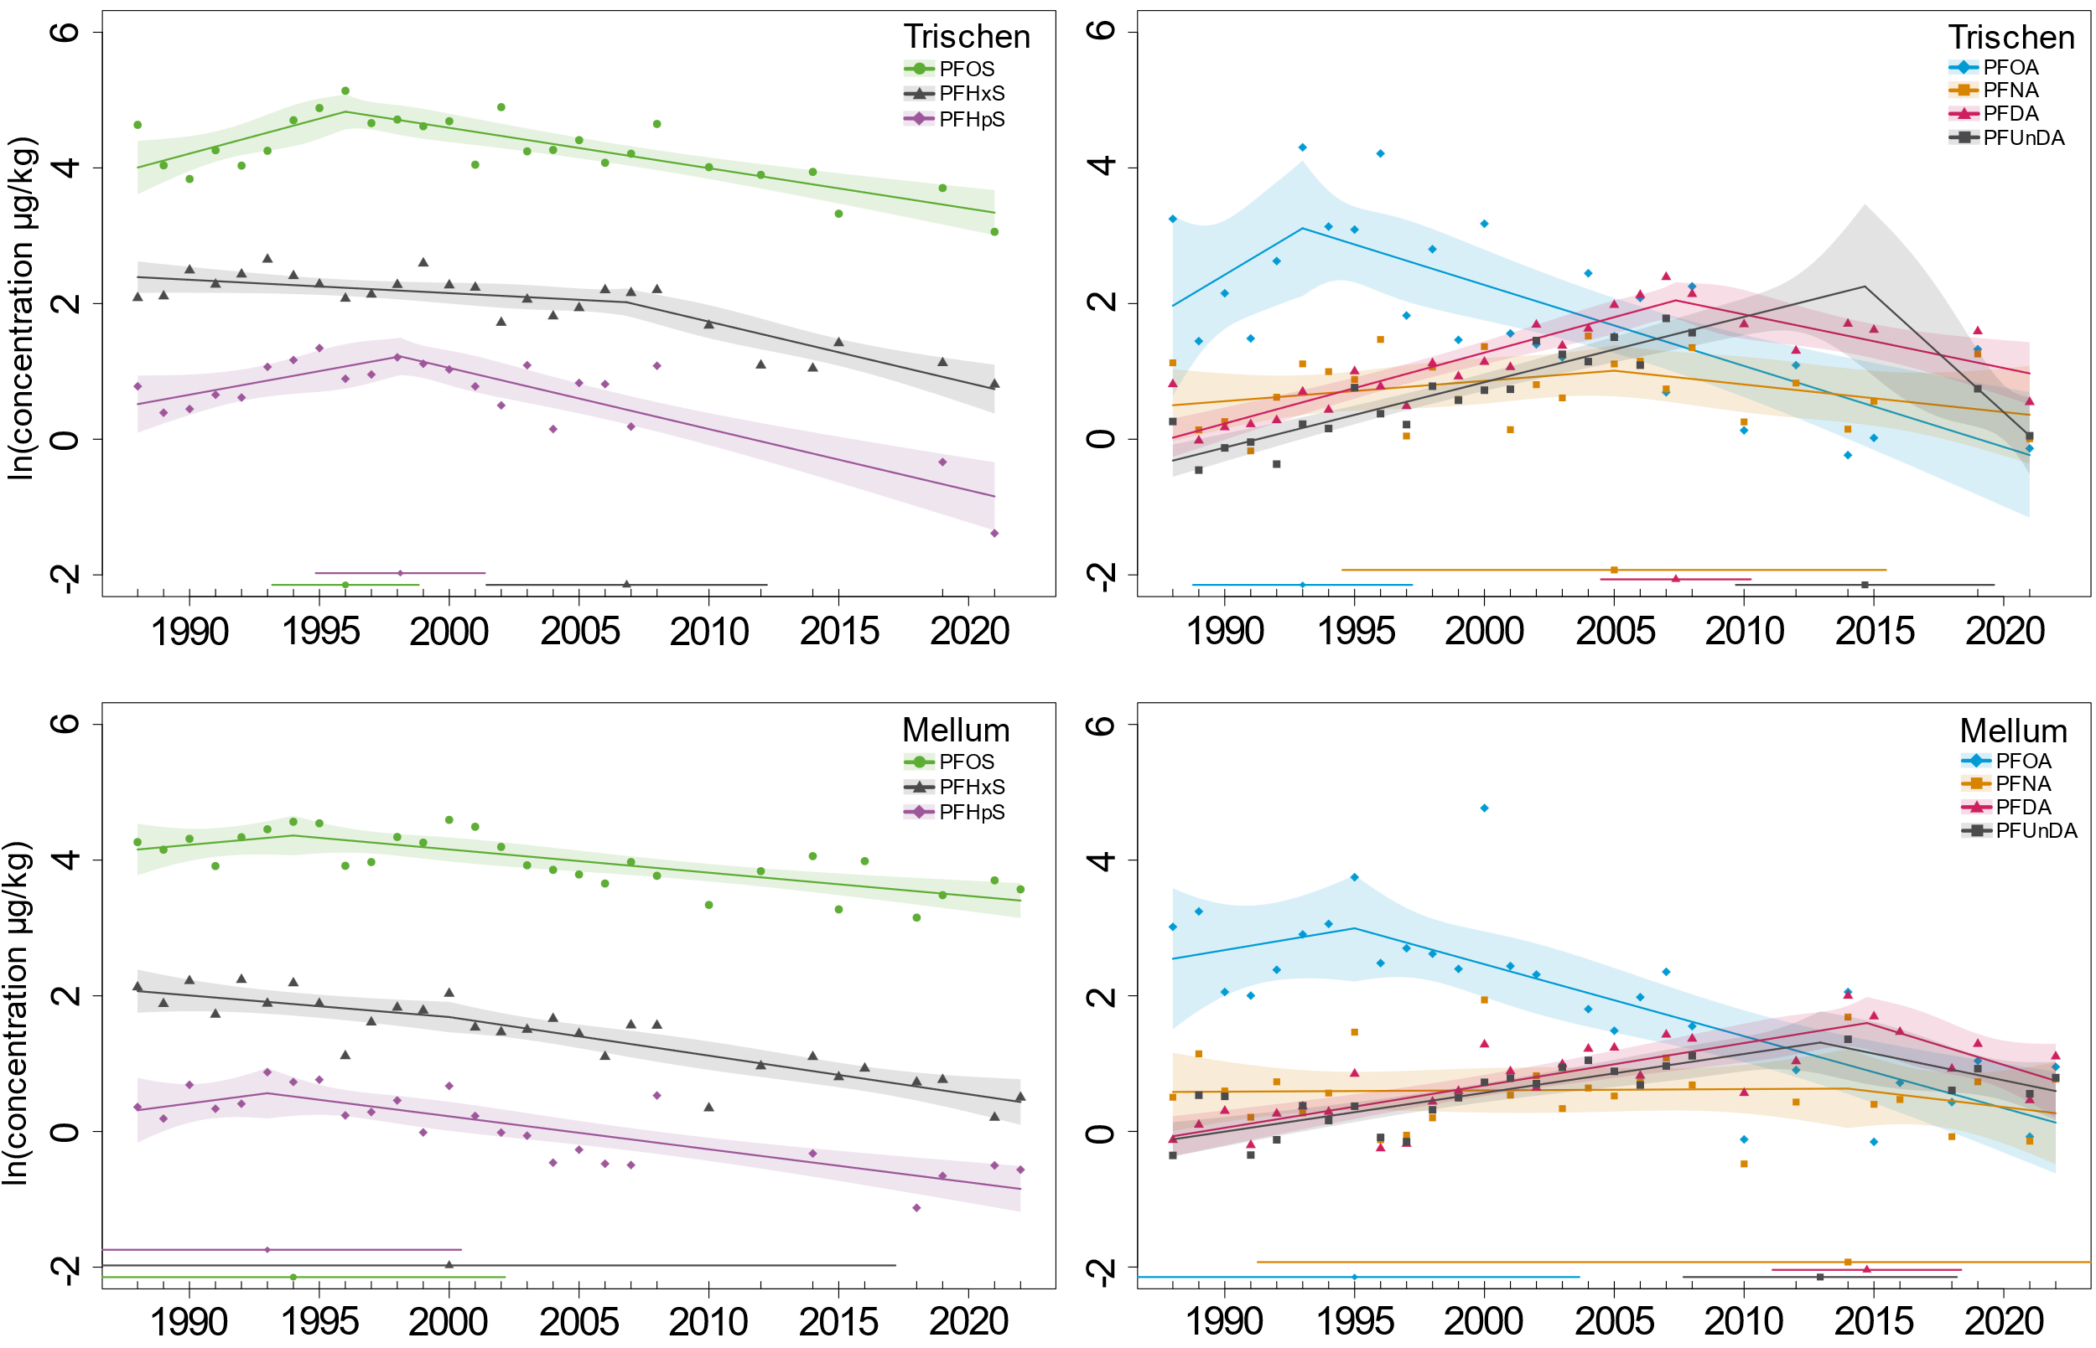
Figure SI-4: Segmented linear regression of geometric means for PFAS (≥ 75% detection rate) in eggs of herring gulls from the Trischen and Mellum (North Sea) separated by PFSAs (left side) and PFCAs (right side). A regression line is displayed along with 95% confidence intervals (per segment). The CP is indicated horizontally above the x-axis along with 95% confidence intervals as well.

Table SI-4: Regression estimates, rounded CP statistics (SE: standard error) and 50% reduction times (t₅₀) for PFAS in eggs of herring gulls from Trischen and Mellum (North Sea, individual and cumulated), and Heuwiese (Baltic Sea). An asterisk (*) indicates a significant difference in-slope at p-value < 0.05 (*), < 0.01 (**), < 0.001 (***) (test for a non-constant regression parameter in the linear predictor).
 | Change in % per year before CP (95% CI) | CP (year) ± SE |  | Change in % per year after CP (95% CI) |  | t₅₀ in years (95% CI)
Trischen
PFHxS | -2.0 (-4.0 – 0.1) | 2007 ± 2.6* |  | -8.6 (-12.0 – -5.1) |  | 7.7 (5.4 – 13.2)
PFHpS | +7.2 (0.2 – 14.7) | 1998 ± 1.6*** |  | -8.6 (-11.4– -5.8) |  | 7.7 (5.7 – 11.6)
PFOS | +10.8 (2.5 – 19.2) | 1996 ± 1.4*** |  | -5.8 (-7.7 – -3.8) |  | 11.6 (8.6 – 17.8)
PFOA | +25.7 (-17.7 – 91.8) | 1993 ± 2.0 |  | -11.3 (-15.6 – -6.7) |  | 5.8 (4.1 – 10.1)
PFNA | +3.0 (-2.1 – 8.4) | 2005 ± 5.1 |  | -4.0 (-9.8 – 2.2) |  | 17.0 (6.7 – /)
PFDA | +11.0 (8.3 – 13.8) | 2007 ± 1.4*** |  | -7.6 (-12.6 – -2.3) |  | 8.8 (5.1 – 29.8)
PFUnDA | +10.1 (7.9 – 12.4) | 2015 ± 2.4*** |  | -29.3 (-52.6 – 5.4) |  | 2.0 (0.9 – /)
Mellum
PFHxS | -3.1 (-7.7 – 1.7) |  | 2000 ± 8.4 |  | -5.5 (-7.4 – -3.7) |  | 12.2 (9.1 – 18.6)
PFHpS | +5.1 (-14.8 – 29.7) |  | 1993 ± 3.6 |  | -4.7 (-6.3 – -3.2) |  | 14.2 (10.7 – 21.4)
PFOS | +3.5 (-9.4 – 18.3) |  | 1994 ± 4.0 |  | -3.4 (-4.7 – -2.1) |  | 20.2 (14.5 – 33.3)
PFOA | +6.6 (-21.1 – 44.1) |  | 1995 ± 4.2 |  | -10.1 (-13.6 – -6.4) |  | 6.5 (4.7 – 10.5)
PFNA | +0.2 (-2.9 – 3.4) |  | 2014 ± 11.1 |  | -4.4 (-20.5 – 14.9) |  | 15.3 (3.0 – /)
PFDA | +6.5 (4.3 – 8.7) |  | 2015 ± 1.8** |  | -11.1 (-21.3 – 0.5) |  | 5.9 (2.9 – /)
PFUnDA | +5.9 (3.6 – 8.2) |  | 2013 ± 2.5** |  | -7.6 (-16.1 – 1.8) |  | 8.8 (4.0 – /)
North Sea (Trischen + Mellum)
PFHxS | -1.1 (-4.7 – 2.6) |  | 2000 ± 2.8* |  | -6.5 (-7.9 – -5.1) |  | 10.4 (8.5 – 13.3)
PFHpS | +8.6 (-3.1 – 21.8) |  | 1994 ± 1.7* |  | -5.8 (-7.4 – -4.3) |  | 11.5 (9.1 – 15.9)
PFOS | +5.6 (-1.7 – 13.4) |  | 1996 ± 1.9** |  | -4.5 (-5.6 – -3.3) |  | 15.2 (12.0 – 20.9)
PFOA | +9.1 (-17.5 – 44.2) |  | 1994 ± 3.0 |  | -10.0 (-13.3 – -6.5) |  | 6.6 (4.9 – 10.3)
PFNA | +1.0 (-3.1 – 5.3) |  | 2006 ± 8.5 |  | -2.7 (-7.5 – 2.3) |  | 25.1 (8.8 – /)
PFDA | +8.7 (6.1 – 11.5) |  | 2008 ± 1.9*** |  | -4.6 (-9.0 – -0.1) |  | 14.6 (7.4 – 661.8)
PFUnDA | +7.5 (5.6 – 9.4) |  | 2011 ± 2.1*** |  | -8.9 (-16.0 – -1.3) |  | 7.4 (4.0 – 52.6)
PFDoDA | -28.2 (-78.2 – 136.7) |  | 1990 ± 2.5 |  | +3.6 (1.9 – 5.4) |  | /
Baltic Sea (Heuwiese)
PFOS | +7.3 (0.8 – 14.2) |  | 2007 ± 2.6* |  | -6.6 (-12.1 – -0.8) |  | 10.2 (5.4 – 89.9)
PFDA | +21.6 (11.0 – 33.2) |  | 2006 ± 1.9** |  | -5.0 (-11.5 – 2.0) |  | 13.5 (5.7 – /)
PFDoDA° | +16.8 (9.3 – 24.8) |  | 2008 ± 3.1* |  | -2.0 (-12.0 – 9.1) |  | - (5.4 – /)

- Change point analysis in bream muscle (cumulated and individual rivers)
Table SI-5: Regression estimates, rounded CP statistics (SE: standard error) and 50% reduction times (t₅₀) for PFAS in muscles of bream over all rivers (matching results of Figure 4). An asterisk (*) indicates a significant difference in-slope at p-value <0.05 (*), <0.01 (**), < 0.001 (***) (test for a non-constant regression parameter in the linear predictor).
 | Change in % per year before CP (95% CI) | CP (year) ± SE | Change in % per year after CP (95% CI) | t₅₀ in years (95% CI)
All sampling sites
PFHxS | +18.5 (-7.4 – 51.6) | 1998 ± 1.2 | -4.7 (-7.1 – -2.2) | 14.5 (9.4 – 31.0)
PFOS | +4.1 (-3.8 – 12.6) | 2002 ± 1.7* | -7.3 (-9.6 – -4.9) | 9.1 (6.9 – 13.7)
FOSA | -0.5 (-15.0 – 16.5) | 2000 ± 1.5* | -17.2 (-19.3 – -15.1) | 3.7 (3.2 – 4.2)
PFDS | +15.9 (4.4 – 28.5) | 2002 ± 0.7*** | -18.0 (-20.7 – -15.2) | 3.5 (3.0 – 4.2)
PFDA | +16.4 (14.0 – 18.8) | 2007 ± 0.5*** | -4.8 (-7.3 – -2.2) | 14.1 (9.1 – 31.5)
PFDoDA | +14.3 (12.4 – 16.2) | 2008 ± 0.5*** | -6.2 (-8.9 – -3.4) | 10.9 (7.5 – 20.0)

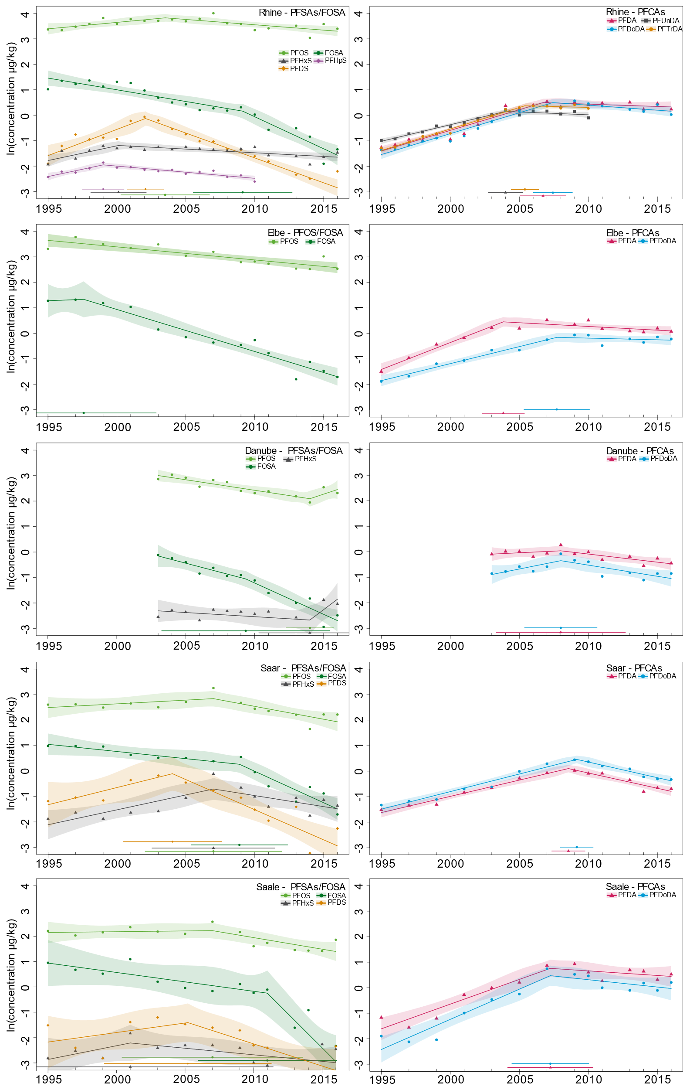
Figure SI-5: Segmented regression for geometric means of PFSAs (left) and PFCAs (right) (≥75% detection rate) in muscle of bream given for each river. A regression line is displayed along with 95% confidence intervals (per segment). The change point is indicated horizontally above the x-axis along with 95% confidence intervals as well.
Table SI-6: Regression estimates, rounded CP statistics (SE: standard error) and 50% reduction times (t₅₀) for PFAS in muscles of bream among rivers. An asterisk (*) indicates a significant difference in-slope at p-value <0.05 (*), <0.01 (**), < 0.001 (***) (test for a non-constant regression parameter in the linear predictor).
 | Change in % per year before CP (95% CI) | CP (year) ± SE | Change in % per year after CP (95% CI) | t₅₀ in years (95% CI)
Rhine
PFHxS | +12.3 (4.0 – 21.2) | 2000± 1.0** | -2.9 (-4.6– -1.1) | 23.9 (14.8 – 61.7)
PFHpS | +12.2 (3.3 – 21.7) | 1999 ± 0.7*** | -4.7 (-6.1– -3.2) | 14.4 (10.9 – 21.2)
PFOS | +5.2 (0.7 – 10.0) | 2004 ± 1.5** | -4.1 (-6.5 – -1.6) | 16.5 (10.3 – 42.8)
FOSA | -8.8 (-11.8 – 5.6) | 2009 ± 1.7* | -22.2 (-30.3 – -13.3) | 2.8 (1.9 – 4.9)
PFDS | +22.9 (11.7 – 35.2) | 2002 ± 0.6*** | -17.7 (-21.1 – -14.2) | 3.5 (2.9 – 4.5)
PFDA | +17.6 (14.2 – 21.1) | 2007 ± 0.8*** | -1.8 (-5.5 – 2.1) | 37.8 (12.2 – /)
PFUnDA | +13.9 (11.8 – 16.1) | 2004 ± 0.6*** | -2.2 (-6.1 – 2.0) | 31.8 (11.0 – /)
PFDoDA | +17.8 (15.0 – 20.7) | 2007 ± 0.7*** | -3.9 (-7.8 – 0.3) | 17.6 (8.5 – /)
PFTrDA | +18.4 (16.5 – 20.2) | 2005 ± 0.5*** | -1.4 (-6.4 – 3.8) | 49.1 (10.6 – /)
Elbe
PFOS | -5.0 (-6.7 – -3.2) | / (no CP) | / (no CP) | 13.5 (10.0 – 21.1)
FOSA | +2.2 (-36.2 – 63.7) | 1998 ± 2.4 | -15.2 (-18.2 – -12.1) | 4.2 (3.5 – 5.4)
PFDA | +23.5 (17.5 – 29.8) | 2004 ± 0.7*** | -2.9 (-5.7 – 0.1) | 23.8 (11.8 – /)
PFDoDA | +14.3 (11.0 – 17.7) | 2008 ± 1.1** | -1.3 (-6.0 – 3.6) | 53.3 (11.4 – /)
Danube
PFHxS | -3.2 (-9.0 - 3.0) | 2014 ± 1.6 | +50.4 (-44.5 – 308) | /
PFOS | -8.0 (-11.6 - -4.2) | 2014 ± 0.8 | +19.7 (-8.9 – 57.3) | /
FOSA | -13.2 (-22.0 - -3.5) | 2009 ± 2.7 | -21.8 (-29.9 – -12.8) | 2.8 (2.0 – 5.1)
PFDA | +2.6 (-7.9 – 14.4) | 2008 ± 2.1 | -6.2 (-10.2 – -1.9) | 10.9 (6.4 – 36.0)
PFDoDA | +11.5 (-0.5 – 24.9) | 2008 ± 1.2 | -8.4 (-14.9 – -1.4) | 7.9 (4.3 – 50.4)
Saar
PFHxS | +12.4 (4.4 – 21.0) | 2007 ± 2.0* | -8.3 (-18.7 – 3.5) | 8.0 (3.3 – /)
PFOS | +3.0 (-3.7 – 10.1) | 2007 ± 2.2 | -9.6 (-15.5 – -3.3) | 6.9 (4.1 – 20.5)
FOSA | -5.5 (-10.8 – 0.2) | 2009 ± 1.6* | -21.9 (-29.0 – -14.1) | 2.8 (2.0 – 4.6)
PFDS | +14.4 (-4.1 – 36.6) | 2004 ± 1.6* | -21.1 (-29.1 – -12.2) | 2.9 (2.0 – 5.3)
PFDA | +13.6 (10.7 – 16.6) | 2009 ± 0.5*** | -11.3 (-15.0 – -7.5) | 5.8 (4.3 – 8.9)
PFDoDA | +14.8 (12.3 – 17.3) | 2009 ± 0.5*** | -11.6 (-16.3 – -6.6) | 5.6 (3.9 – 10.2)
Saale
PFHxS | +11.4 (-22.1 – 59.5) | 2001 ± 4.7 | -5.0 (-11.0 – 1.3) | 13.4 (6.0 – /)
PFOS | +0.6 (-5.9 – 7.5) | 2007 ± 3.0 | -8.7 (-14.7 – -2.4) | 7.6 (4.4 –28.4)
FOSA | +7.2 (-14.4 – 0.6) | 2011 ± 2.3* | -41.7 (-68.3 – 7.1) | 1.3 (0.6 – /)
PFDS | +7.8 (-8.0 – 26.3) | 2005 ± 2.7 | -16.1 (-28.4 – -1.5) | 4.0 (2.1 – 44.5)
PFDA | +21.4 (14.5 – 28.7) | 2007 ± 1.4** | -3.5 (-12.3 – 6.2) | 19.2 (5.3 – /)
PFDoDA | +26.7 (18.4 – 35.5) | 2007 ± 1.3** | -5.6 (-15.5 – 5.4) | 12.0 (4.1 – /)
- Change point analysis in bream muscle from Bimmen (Rhine: 1995-2022)
In general, fewer PFAS were frequently detected in muscle compared to liver as PFHpS, FOSA and PFDoDA had detection frequencies below 75% (Figure SI-6). The significant CP for PFOS (1999) and PFHxS (1997) was one year and for PFDS (2001) four years later in muscle compared to liver (Figure SI-6). All tested PFSAs were increasing before the CP and decreasing afterwards, with PFDS showing the strongest decline (-12.8% per year) followed by PFOS (-7.7% per year) and PFHxS (-5.6% per year), which is the same order compared to the liver (Figure SI-7). Among the PFCAs, only PFDA and PFDoDA were frequently detected, with PFDA showing a seven year earlier CP (2007) and PFDoDA a six year earlier CP (2009) compared to liver. The slopes of PFDA are comparable between both matrices by showing an increase before (+15.6% per year) and a decrease after the CP (-7.8% per year).

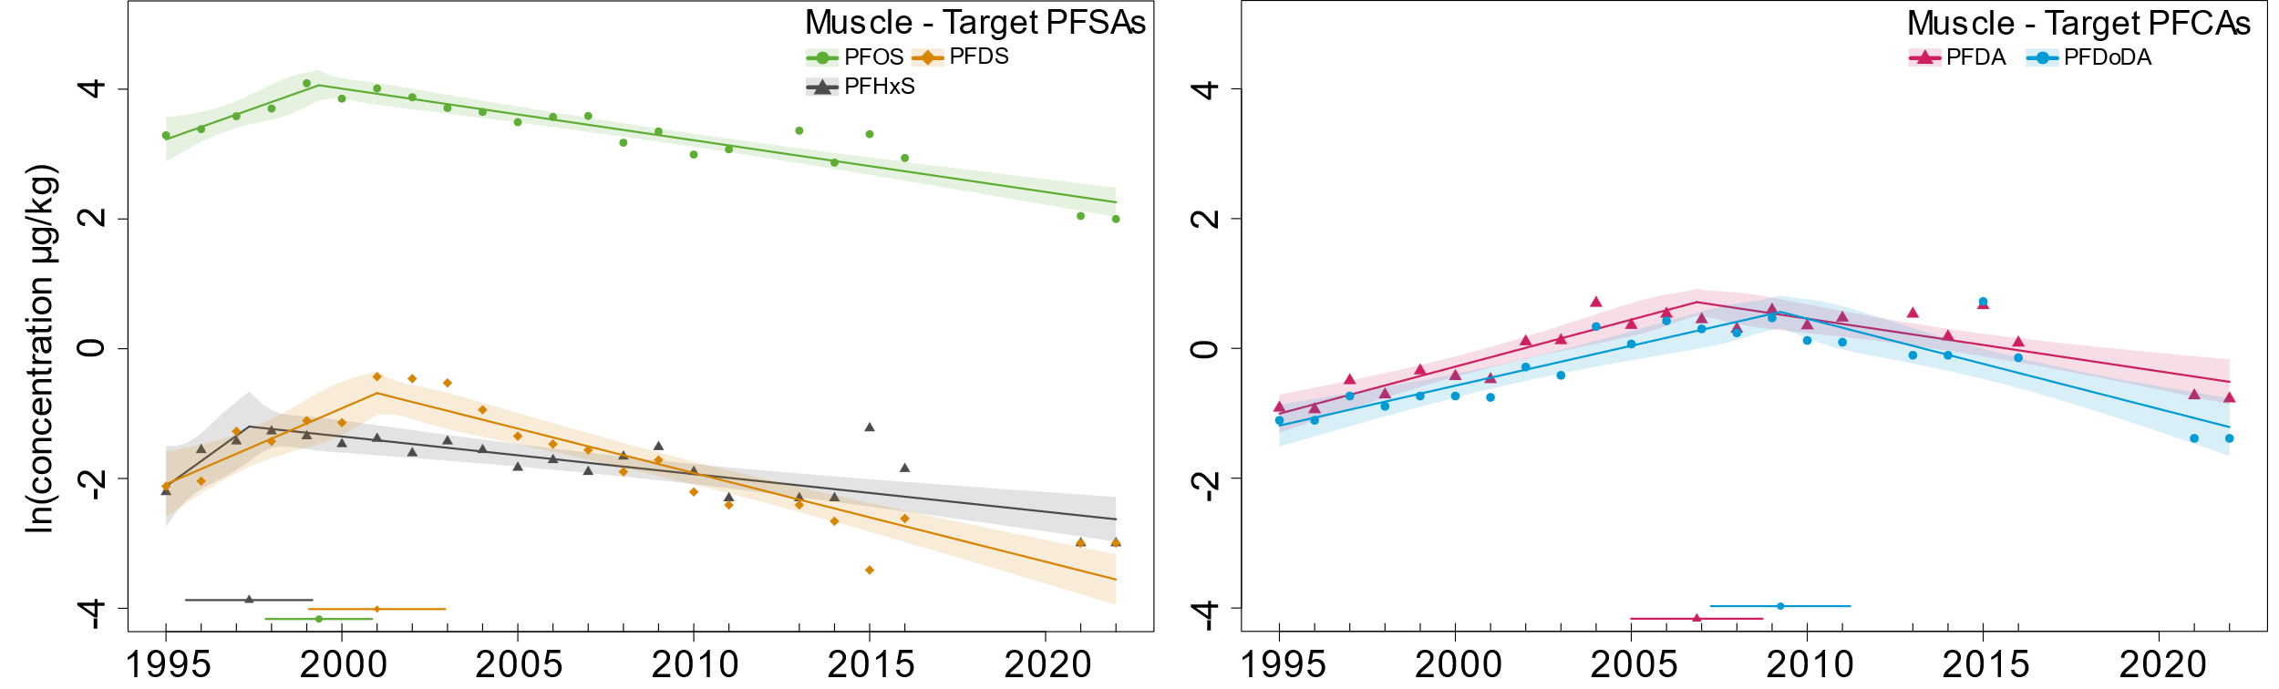
Figure SI-6: Segmented linear regression of geometric means for PFAS (≥75% detection rate) in muscle of bream from Bimmen, Rhine using target analysis. A regression line is displayed along with 95% confidence intervals (per segment). The CP is indicated horizontally above the x-axis along with 95% confidence intervals as well.

Table SI-7 Regression estimates, rounded CP statistics (SE: standard error) and 50% reduction times (t₅₀) for PFAS in muscle of bream from Bimmen, Rhine. An asterisk (*) indicates a significant difference in-slope at p-value <0.05 (*), <0.01 (**), < 0.001 (***) (test for a non-constant regression parameter in the linear predictor).
 | Change in % per year before CP (95% CI) | CP (year) ± SE | Change in % per year after CP (95% CI) | t₅₀ in years (95% CI)
Target - PFSAs
PFHxS | +47.7 (-8.1 – 138) | 1997 ± 0.9* | -5.6 (-7.7 – -3.5) | 12.0 (8.7 – 19.2)
PFOS | +21.2 (6.0– 38.5) | 1999 ± 0.7*** | -7.7 (-9.1 – -6.2) | 8.7 (7.3 – 10.8)
PFDS | +26.4 (6.9 – 49.4) | 2001 ± 0.9*** | -12.8 (-15.2 – -10.3) | 5.1 (4.2 – 6.4)
Target - PFCAs
PFDA | +15.6 (10.5 – 20.9) | 2007 ± 0.9*** | -7.8 (-10.9 – -4.6) | 8.5 (6.0 – 14.7)
PFDoDA | +13.1 (8.8 – 17.5) | 2009 ± 0.9*** | -13.0 (-17.7 – -8.0) | 5.0 (3.6 – 8.3)

- Change point analysis in bream liver from Bimmen (Rhine: 1995-2022)
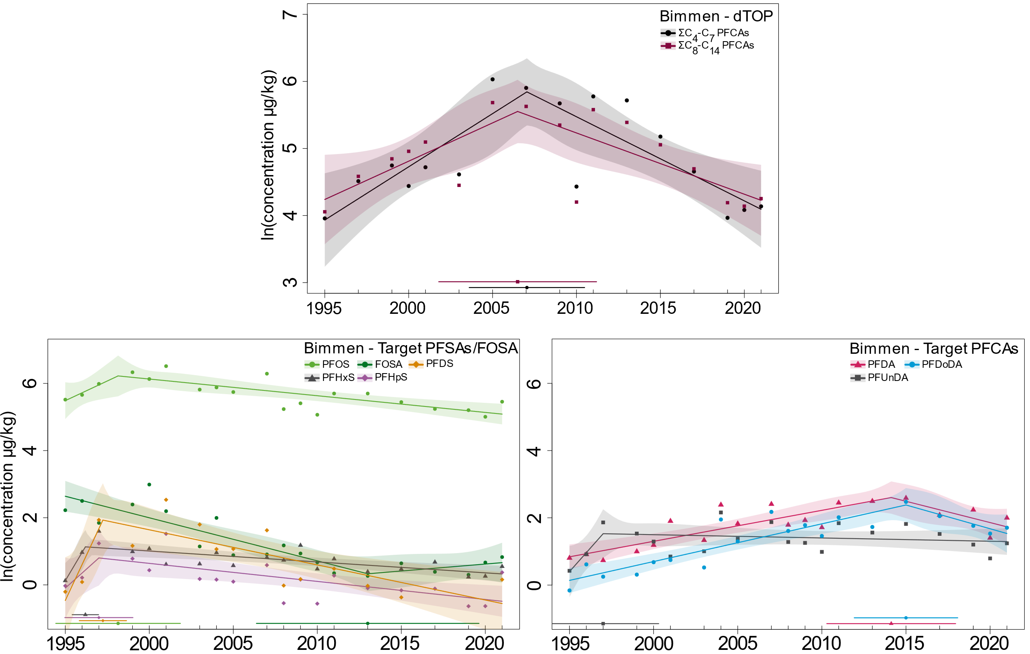
Figure SI-7: Segmented linear regression of geometric means for PFAS (≥ 75% detection rate) in livers of bream from Bimmen, Rhine for dTOP (top) and target (bottom). A regression line is displayed along with 95% confidence intervals (per segment). The CP is indicated horizontally above the x-axis along with 95% confidence intervals as well.

Table SI-8: Regression estimates, rounded CP statistics (SE: standard error) and 50% reduction times (t₅₀) for PFAS in liver of bream from Bimmen, Rhine. An asterisk (*) indicates a significant difference in-slope at p-value < 0.05 (*), < 0.01 (**), < 0.001 (***) (test for a non-constant regression parameter in the linear predictor).
 | Change in % per year before CP (95% CI) | CP (year) ± SE | Change in % per year after CP (95% CI) | t₅₀ in years (95% CI)
dTOP - PFCAs
∑C₄-C₇ PFCAs | +17.2 (6.7 – 28.7) | 2007 ± 1.6** | -11.8 (-18.4 – -4.6) | 5.5 (3.4 – 14.7)
∑C₈-C₁₄ PFCAs | +12.1 (0.5 – 25.1) | 2006 ± 2.2* | -8.7 (-14.2 – -2.9) | 7.6 (4.5 – 23.4)
Target - PFSAs
PFHxS | +132.2 (10.0 – 390.3) | 1996 ± 0.4* | -3.2 (-4.8 – -1.5) | 21.3 (14.0 – 44.9)
PFHpS | +56.7 (-21.6 – 231.1) | 1997 ± 1.0 | -5.2 (-8.4 – -1.9) | 12.9 (7.9 – 35.9)
PFOS | +26.4 (-18.7 – 96.5) | 1998 ± 1.7 | -4.9 (-6.9 – -2.7) | 13.9 (9.7 – 24.9)
FOSA | -12.0 (-15.5 – -8.4) | 2013 ± 3.1* | +4.2 (-12.8 – 24.6) | /
PFDS | + 191.3 (10.6 – 667.6) | 1997 ± 0.6* | -9.9 (-15.7 – -3.8) | 6.6 (4.1 – 17.9)
Target - PFCAs
PFDA | +9.7 (6.0 – 13.5) | 2014 ± 1.8** | -11.9 (-24.4 – 2.7) | 5.5 (2.5 – /)
PFUnDA | +75.8 (-45.7 – 468.8) | 1997 ± 1.6 | -1.0 (-3.6 – 1.7) | 71.3 (19.0 – /)
PFDoDA | +11.9 (7.9 – 15.9) | 2015 ± 1.5** | -13.2 (-26.0 – 1.8) | 4.9 (2.3 – /)

- Change point analysis in mussel (Dreissena) soft tissue (Elbe: 1995-2018)
PFAS were only investigated in mussels throughout a whole sampling period in Blankenese, Elbe River. The only PFSA that met the detection criterion, PFOS, did similar to the bream muscle from the Elbe (Figure SI-5) not result in a CP estimate (Figure SI-8). Therefore, a regular linear regression was fitted. Throughout the sampling period, PFOS showed a significant linear decline of -5.9% per year (Table SI-7), which was again similar to bream muscle from the Elbe (-5.0%, Table SI-4). The CP analysis by the lmcp-package revealed a non-significant CP in 1999 that generally follows the PFOS-pattern of other matrices with an increase before (+22.3% per year) and a decrease after the CP (-8.0% per year) (Figure SI-9). Among the PFCAs, all compounds were frequently detected between C₁₀ and C₁₄ with the exception of C₁₂ (PFDoDA, 66.7% detection frequency). Both C₁₀ (PFDA) and C₁₁ (PFUnDA) show a significant CP at a similar time (2001 and 2000), whereas C₁₃ (perfluorotridecanoic acid, PFTrDA) and C₁₄ (perfluorotetradecanoic acid, PFTeDA) showed later CPs in 2007 and 2008 (Table SI-7). Besides similarities in their CPs, the slope of PFDA and PFUnDA were also similar by showing a comparably strong increase before the CP (+55.0% and +61.7% per year) followed by weaker decline afterwards (-2.5% and -5.3% per year). Both PFTrDA and PFTeDA showed a similar increase before the CP (14.2% and 17.2% per year) that is followed by a decline afterwards (-11% and -9.3% per year).

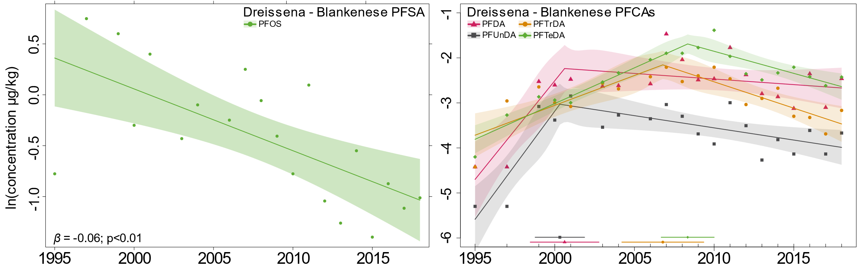
Figure SI-8: Linear regression of geometric means for PFOS (left) and segmented linear regression of PFCAs (right) (≥ 75% detection rate) in soft tissue of Dreissena mussels from Blankenese, Elbe River. A regression line is displayed along with 95% confidence intervals (per segment). The CP is indicated horizontally above the x-axis along with 95% confidence intervals as well.

Table SI-9: Regression estimates, rounded CP statistics (SE: standard error) and 50% reduction times (t₅₀) for PFAS in Dreissena from Blankenese Elbe River. An asterisk (*) indicates a significant difference in-slope at p-value < 0.05 (*), < 0.01 (**), < 0.001 (***) (test for a non-constant regression parameter in the linear predictor).
 | Change in % per year before CP (95% CI) | CP (year) ± SE | Change in % per year after CP (95% CI) | t₅₀ in years (95% CI)
PFSAs
PFOS | Linear trend without CP: -5.9** (-8.9 – -2.7) |  |  | 11.4 (7.4 – 25.0)
PFCAs
PFDA | +55.0 (21.0 – 98.5) | 2001 ± 1.0** | -2.5 (-7.0 – 2.3) | 27.9 (9.6 – /)
PFUnDA | +61.7 (30.4 – 100.5) | 2000 ± 0.7*** | -5.3 (-9.1 – -1.3) | 12.8 (7.3 – 53.9)
PFTrDA | +14.2 (6.2 – 22.7) | 2007 ± 1.2*** | -11.0 (-16.1 – -5.7) | 5.9 (3.9 – 11.9)
PFTeDA | +17.2 (12.9 – 21.7) | 2008 ± 0.8*** | -9.3 (-14.1 – -4.3) | 7.1 (4.6 – 15.7)

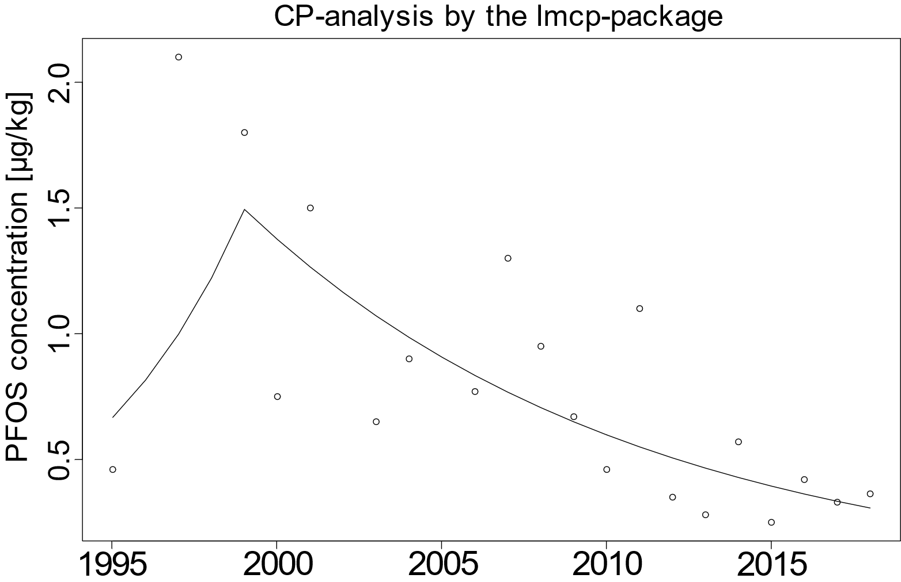
Figure SI-9: Segmented linear regression of geometric means for PFOS (in µg kg⁻¹) in soft tissue of Dreissena mussels from Blankenese, Elbe River by the lmcp-package.

Table SI-10: Overview of the PFAS analysed in the different matrices. It is important to note that the number of analytes, the methods for their analysis and the limits of quantification differed both over time and between laboratories.
PFCAs | PFSAs | FTSs
PFBA | PFBS | 4:2 FTS
PFPeA | PFPeS | 6:2 FTS
PFHxA | PFHxS | 8:2 FTS
PFHpA | PFHpS
PFOA | PFOS linear
PFNA | PFOS branched
PFDA | PFOS total
PFUnDA | PFNS
PFDoDA | PFDS
PFTrDA
PFTeDA
PFHxDA
PFODA
FOSAs | diPAPs | others
FOSA | 6:2 diPAP | ADONA
MeFOSA | 6:2/8:2 diPAP | 9Cl-PF3ONS
EtFOSA | 8:2 diPAP | 11Cl-PF3OUdS
FOSAA |  | HFPO-DA
MeFOSAA |  | 7H-PFHpA
EtFOSAA |  | PFECHS
 |  | PFMOPrA
 |  | 8:2 FTCA

- References
¹Yeung, L. W. Y., Robinson, S. J., Koschorreck, J. and Mabury, S. A. (2013a). "Part I. A Temporal Study of PFCAs and Their Precursors in Human Plasma from Two German Cities 1982–2009." Environmental Science & Technology 47(8): 3865-3874, DOI: 10.1021/es303716k.
²Yeung, L. W. Y., Robinson, S. J., Koschorreck, J. and Mabury, S. A. (2013b). "Part II. A Temporal Study of PFOS and Its Precursors in Human Plasma from Two German Cities in 1982–2009." Environmental Science & Technology 47(8): 3875-3882, DOI: 10.1021/es4004153.

