Supplementary Text
Supplementary Note: SNP Annotation and Functional Enrichment of PFAS Genetic Instruments
1. Gene Mapping from Instrumental SNPs
To clarify the biological relevance of genetic variants used as instruments for PFAS exposure, we conducted comprehensive annotation of all independent SNPs (P < 1×10⁻⁵) employed in the MR analysis. Each SNP was mapped to its nearest gene or known expression quantitative trait loci (eQTL) target using Ensembl (v109, https://www.ensembl.org) and GTEx databases (v8, https://gtexportal.org) (if available). This mapping yielded 55 unique protein-coding genes, listed below:
id | chr | start | end | strand | gene_ids | gene_names | 3_prime_utr_variant | nmd_transcript_variant | intron_variant | missense_variant | stop_gained
rs141471965 | 4 | 88125050 | 88125050 | + | ENSG00000118777 | ABCG2 | 0 | 0 | 4 | 0 | 0
rs45499402 | 4 | 88122482 | 88122482 | + | ENSG00000118777 | ABCG2 | 0 | 0 | 6 | 0 | 0
rs9809948 | 3 | 38459156 | 38459156 | + | ENSG00000114739 | ACVR2B | 0 | 0 | 3 | 0 | 0
rs2306053 | 5 | 7784583 | 7784583 | + | ENSG00000078295 | ADCY2 | 0 | 0 | 3 | 0 | 0
rs143551944 | 6 | 109687045 | 109687045 | + | ENSG00000155085 | AK9 | 0 | 0 | 2 | 0 | 0
rs147707132 | 4 | 113116571 | 113116571 | + | ENSG00000145362 | ANK2 | 0 | 0 | 13 | 0 | 0
rs78352525 | 2 | 240514986 | 240514986 | + | ENSG00000144504 | ANKMY1 | 0 | 0 | 6 | 0 | 0
rs186404391 | 11 | 129042506 | 129042506 | + | ENSG00000134909 | ARHGAP32 | 0 | 0 | 3 | 0 | 0
rs9614577 | 22 | 44840735 | 44840735 | + | ENSG00000241484 | ARHGAP8 | 0 | 0 | 4 | 0 | 0
rs6935886 | 6 | 156928844 | 156928844 | + | ENSG00000049618 | ARID1B | 0 | 0 | 4 | 0 | 0
rs142317920 | 15 | 80543842 | 80543842 | + | ENSG00000172379 | ARNT2 | 0 | 0 | 2 | 0 | 0
rs396050 | 6 | 25479571 | 25479571 | + | ENSG00000079691 | CARMIL1 | 0 | 0 | 6 | 0 | 0
rs117568662 | 16 | 65100809 | 65100809 | + | ENSG00000140937 | CDH11 | 0 | 0 | 1 | 0 | 0
rs72767818 | 9 | 132533247 | 132533247 | + | ENSG00000188523 | CFAP77 | 0 | 0 | 1 | 0 | 0
rs62208501 | 20 | 41500916 | 41500916 | + | ENSG00000124177 | CHD6 | 0 | 0 | 4 | 0 | 0
rs145825225 | 8 | 113055569 | 113055569 | + | ENSG00000164796 | CSMD3 | 0 | 0 | 4 | 0 | 0
rs10099460 | 8 | 1045786 | 1045786 | + | ENSG00000198010 | DLGAP2 | 0 | 0 | 2 | 0 | 0
rs187310156 | 2 | 84766861 | 84766861 | + | ENSG00000115423 | DNAH6 | 0 | 0 | 1 | 0 | 0
rs2369463 | 12 | 77038743 | 77038743 | + | ENSG00000165891 | E2F7 | 0 | 0 | 4 | 0 | 0
rs114686372 | 2 | 212506784 | 212506784 | + | ENSG00000178568 | ERBB4 | 0 | 0 | 3 | 0 | 0
rs74464512 | 16 | 74723227 | 74723227 | + | ENSG00000103089 | FA2H | 0 | 0 | 1 | 0 | 0
rs114844958 | 10 | 14150063 | 14150063 | + | ENSG00000151474 | FRMD4A | 0 | 0 | 2 | 0 | 0
rs3795737 | 1 | 156727264 | 156727264 | + | ENSG00000143319 | ISG20L2 | 0 | 0 | 0 | 4 | 0
rs138620492 | 10 | 77316362 | 77316362 | + | ENSG00000156113 | KCNMA1 | 0 | 0 | 15 | 0 | 0
rs71439202 | 2 | 25942865 | 25942865 | + | ENSG00000084731 | KIF3C | 0 | 0 | 2 | 0 | 0
rs73164873 | 22 | 21051257 | 21051257 | + | ENSG00000187905 | LRRC74B | 0 | 0 | 1 | 0 | 0
rs59494605 | 6 | 43638011 | 43638011 | + | ENSG00000124688 | MAD2L1BP | 0 | 0 | 2 | 0 | 0
rs7788282 | 7 | 78051952 | 78051952 | + | ENSG00000187391 | MAGI2 | 0 | 0 | 4 | 0 | 0
rs57965817 | 12 | 49563320 | 49563320 | + | ENSG00000187778 | MCRS1 | 0 | 0 | 2 | 0 | 0
rs140776996 | 14 | 64428834 | 64428834 | + | ENSG00000100714 | MTHFD1 | 0 | 0 | 1 | 0 | 0
rs143450669 | 19 | 50277121 | 50277121 | + | ENSG00000105357 | MYH14 | 0 | 0 | 5 | 0 | 0
rs3822433 | 5 | 6600751 | 6600751 | + | ENSG00000037474 | NSUN2 | 0 | 0 | 4 | 0 | 0
rs184629627 | 7 | 8467436 | 8467436 | + | ENSG00000122584 | NXPH1 | 0 | 0 | 1 | 0 | 0
rs188743649 | 2 | 205306028 | 205306028 | + | ENSG00000116117 | PARD3B | 0 | 0 | 2 | 0 | 0
rs117814140 | 18 | 80242969 | 80242969 | + | ENSG00000178184 | PARD6G | 0 | 0 | 2 | 0 | 0
rs117098421 | 8 | 17602473 | 17602473 | + | ENSG00000104213 | PDGFRL | 0 | 0 | 2 | 0 | 0
rs191399201 | 18 | 11077630 | 11077630 | + | ENSG00000154864 | PIEZO2 | 0 | 0 | 9 | 0 | 0
rs374054065 | 22 | 46165066 | 46165066 | + | ENSG00000186951 | PPARA | 0 | 0 | 2 | 0 | 0
rs182382599 | 8 | 18806195 | 18806195 | + | ENSG00000156011 | PSD3 | 0 | 0 | 2 | 0 | 0
rs11571396 | 12 | 932937 | 932937 | + | ENSG00000002016 | RAD52 | 0 | 0 | 5 | 0 | 0
rs3025772 | 14 | 73121705 | 73121705 | + | ENSG00000119707 | RBM25 | 1 | 0 | 0 | 0 | 0
rs535404541 | 10 | 16750282 | 16750282 | + | ENSG00000148484 | RSU1 | 0 | 0 | 3 | 0 | 0
rs147218384 | 2 | 166418920 | 166418920 | + | ENSG00000136546 | SCN7A | 0 | 0 | 2 | 0 | 0
rs35008345 | 11 | 64556141 | 64556141 | + | ENSG00000168065 | SLC22A11 | 0 | 0 | 0 | 0 | 1
rs9420708 | 10 | 97158385 | 97158385 | + | ENSG00000187122 | SLIT1 | 0 | 2 | 6 | 0 | 0
rs72826541 | 5 | 168949668 | 168949668 | + | ENSG00000184347 | SLIT3 | 0 | 0 | 2 | 0 | 0
rs74811952 | 8 | 50555771 | 50555771 | + | ENSG00000147481 | SNTG1 | 0 | 0 | 3 | 0 | 0
rs141922951 | 4 | 7645052 | 7645052 | + | ENSG00000184985 | SORCS2 | 0 | 0 | 3 | 0 | 0
rs34427182 | 1 | 76569409 | 76569409 | + | ENSG00000184005 | ST6GALNAC3 | 0 | 0 | 1 | 0 | 0
rs7811269 | 7 | 11377733 | 11377733 | + | ENSG00000005108 | THSD7A | 0 | 0 | 2 | 0 | 0
rs147987488 | 12 | 129619679 | 129619679 | + | ENSG00000151952 | TMEM132D | 0 | 0 | 1 | 0 | 0
rs182132379 | 3 | 171256489 | 171256489 | + | ENSG00000154310 | TNIK | 0 | 0 | 3 | 0 | 0
rs563296440 | 10 | 17144165 | 17144165 | + | ENSG00000107614 | TRDMT1 | 1 | 0 | 0 | 0 | 0
rs569187847 | 11 | 78213337 | 78213337 | + | ENSG00000118369 | USP35 | 0 | 0 | 3 | 0 | 0
rs192152691 | 5 | 83495982 | 83495982 | + | ENSG00000038427 | VCAN | 0 | 0 | 4 | 0 | 0
rs189068579 | 8 | 55329325 | 55329325 | + | ENSG00000206579 | XKR4 | 0 | 0 | 1 | 0 | 0
Among these genes, several are strongly associated with kidney function and disease. For instance:
● SLC22A11 encodes an organic anion transporter (OAT4) highly expressed in renal proximal tubules, implicated in urate and xenobiotic clearance. Genetic variation in SLC22A11 is associated with eGFR and uric acid levels in multiple GWAS studies [1-3].
● PPARA encodes peroxisome proliferator-activated receptor alpha, a transcription factor that modulates lipid metabolism, inflammation, and renal tubular energy homeostasis. PPARA activation has been shown to mitigate PFOA-induced renal injury in experimental models [4-7].
● THSD7A, an autoantigen in membranous nephropathy, is involved in podocyte function and slit diaphragm integrity [8].
● ERBB4 encodes a receptor tyrosine kinase involved in renal development and injury repair. It regulates tubular polarity and lumen formation, and its dysregulation is linked to kidney developmental defects, fibrosis, podocyte injury, and diabetic nephropathy [9-12].
● ARNT2 encodes the HIF-2β subunit, which heterodimerizes with HIF-α to regulate cellular responses to hypoxia. It is highly expressed during kidney development, particularly in distal nephron segments, playing a critical role in nephrogenesis and tubular adaptation to low oxygen [13].
● MAGI2 encodes a scaffold protein that regulates podocyte cytoskeletal architecture and is mutated in congenital nephrotic syndrome [14, 15].

Other genes such as TRDMT1, USP35, PDGFRL, ISG20L2, and FA2H are involved in stress response regulation, RNA modification, or lipid metabolism, processes that may influence renal pathophysiology under toxicant exposure. Although their direct roles in kidney disease are less established, their functional relevance to cellular homeostasis suggests potential involvement in PFAS-induced renal effects. These observations suggest that the SNPs selected as PFAS instruments capture biologically meaningful signals related to renal processes.

2. Protein–Protein Interaction and Functional Enrichment Analysis
To investigate the potential biological relevance of PFAS-associated genetic instruments, we first constructed a protein–protein interaction (PPI) network using the 55 annotated genes identified through SNP-to-gene mapping. The interaction network was generated using the STRING database (v11.5, https://string-db.org) with a medium confidence threshold (score ≥ 0.4), showed below:
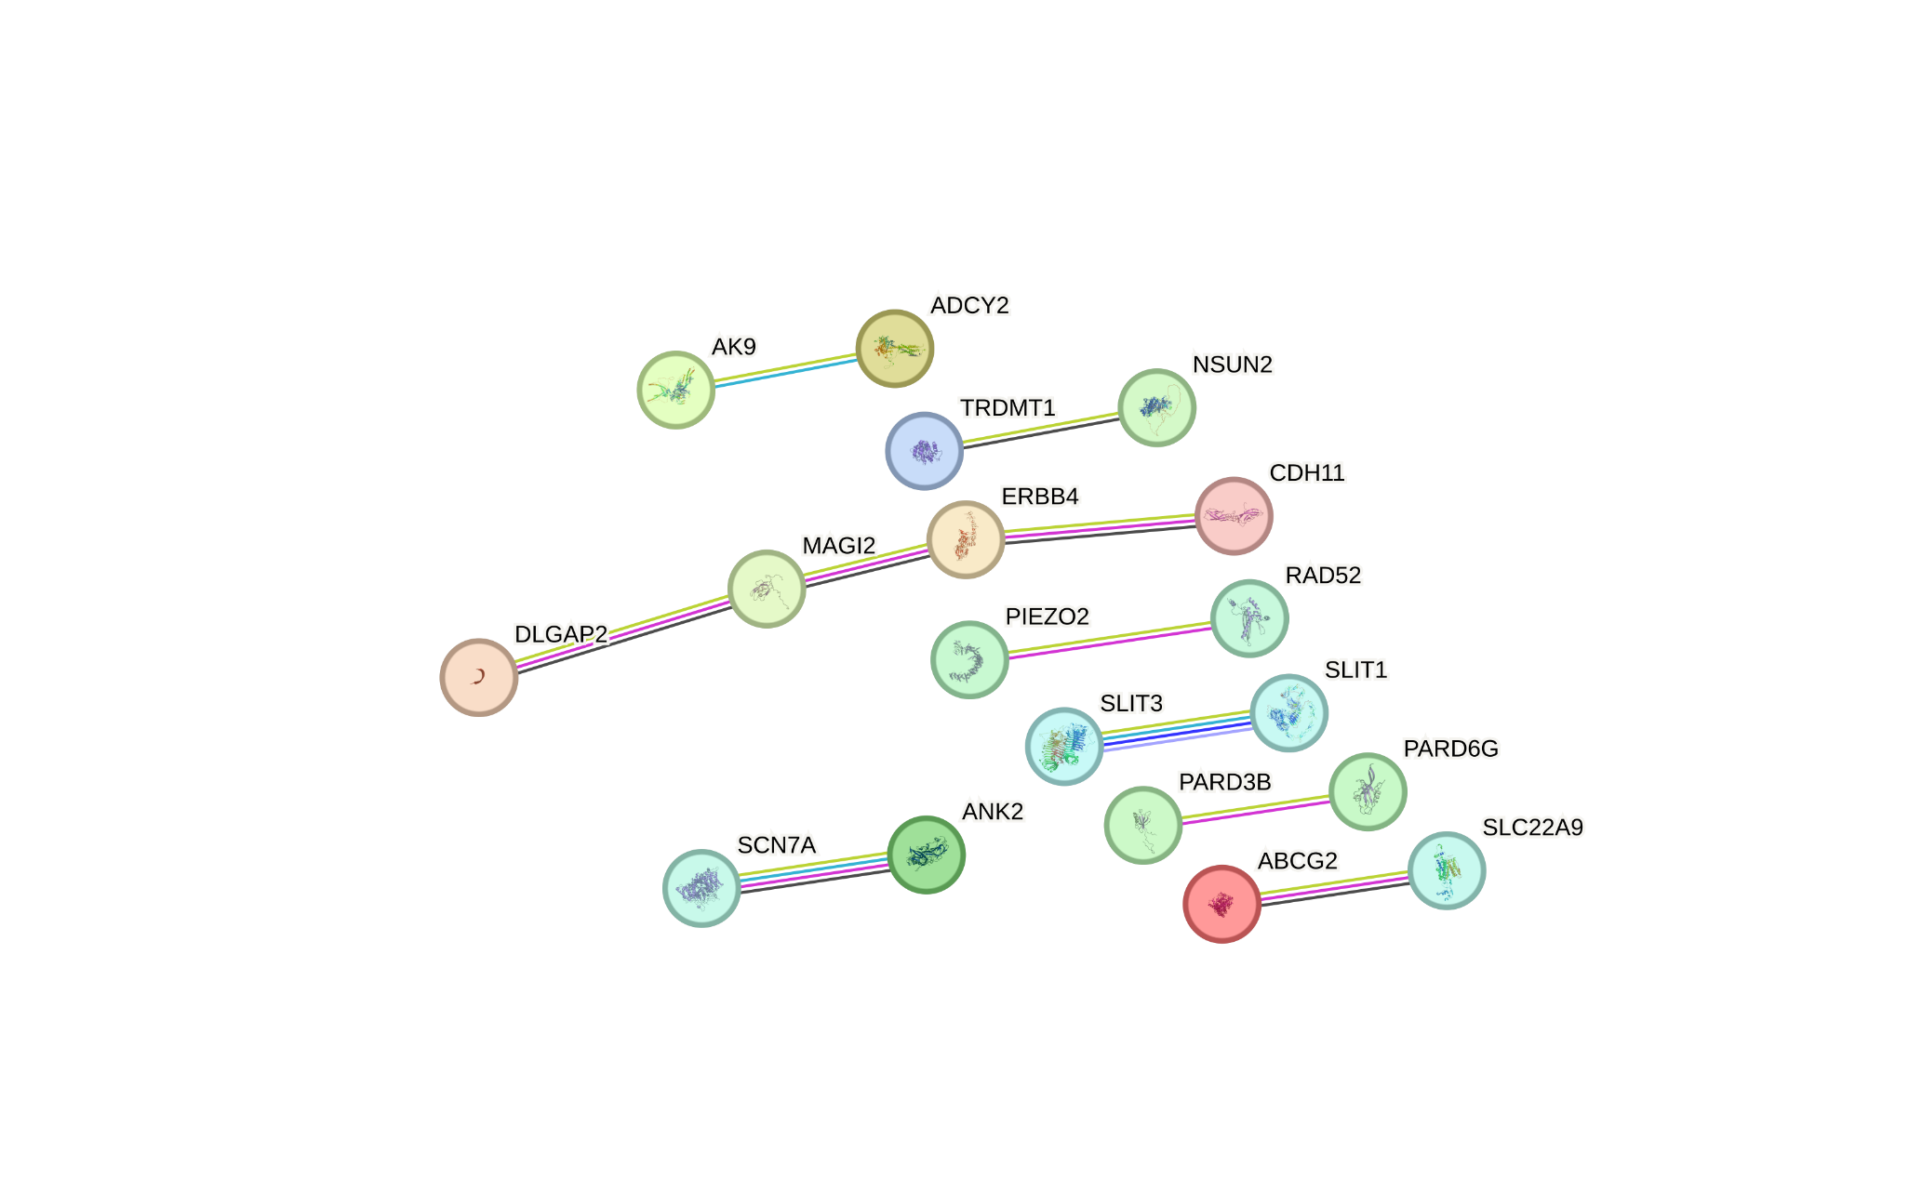
Subsequently, we performed Gene Ontology (GO) and Kyoto Encyclopedia of Genes and Genomes (KEGG) pathway enrichment analysis for 55 genes using the clusterProfiler package in R.

GO analysis covered all three major domains:
● Biological Process (BP): Enriched terms included urate metabolic process, regulation of tRNA stability, and tRNA catabolic process, suggesting involvement in nucleotide metabolism and renal excretory function.
● Cellular Component (CC): The gene products were predominantly localized to structures such as the postsynaptic density, tight junction, and apical plasma membrane, indicating potential roles in maintaining epithelial polarity and barrier integrity.
● Molecular Function (MF): Enriched terms included tRNA methyltransferase activity and Roundabout binding, implying possible epigenetic regulation and signaling interactions.

In parallel, KEGG pathway analysis did not yield any significantly enriched pathways under the adjusted p-value threshold, indicating that the functional insights were primarily captured through GO terms. These results suggest that the selected SNP-associated genes may be involved in renal epithelial function, cellular stress responses, and other biologically meaningful processes relevant to PFAS exposure.
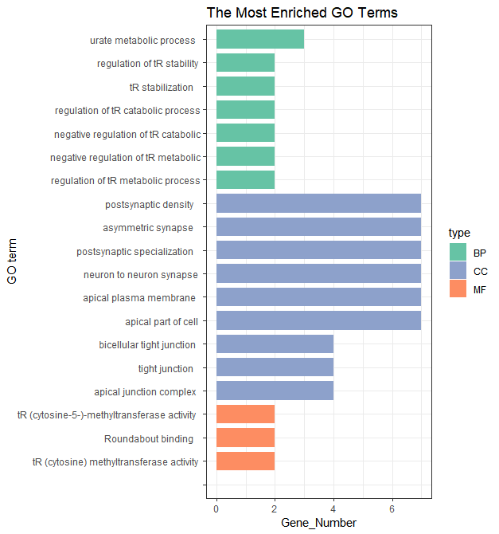
Reference
1. Zhou F, You G. Molecular insights into the structure-function relationship of organic anion transporters OATs. Pharm Res. 2007;24(1):28-36.
2. Sakiyama M, Matsuo H, Shimizu S, Nakashima H, Nakayama A, Chiba T, et al. A common variant of organic anion transporter 4 (OAT4/SLC22A11) gene is associated with renal underexcretion type gout. Drug Metab Pharmacokinet. 2014;29(2):208-10.
3. Yang Q, Köttgen A, Dehghan A, Smith AV, Glazer NL, Chen MH, et al. Multiple genetic loci influence serum urate levels and their relationship with gout and cardiovascular disease risk factors. Circ Cardiovasc Genet. 2010;3(6):523-30.
4. Chung KW, Lee EK, Lee MK, Oh GT, Yu BP, Chung HY. Impairment of PPARα and the Fatty Acid Oxidation Pathway Aggravates Renal Fibrosis during Aging. J Am Soc Nephrol. 2018;29(4):1223-37.
5. Liu ZQ, Lee JN, Son M, Lim JY, Dutta RK, Maharjan Y, et al. Ciliogenesis is reciprocally regulated by PPARA and NR1H4/FXR through controlling autophagy in vitro and in vivo. Autophagy. 2018;14(6):1011-27.
6. Zhang Y, Li Y, Gao N, Gong Y, Shi W, Wang X. Transcriptome and Metabolome Analyses Reveal Perfluorooctanoic Acid-Induced Kidney Injury by Interfering with PPAR Signaling Pathway. International Journal of Molecular Sciences [Internet]. 2023; 24(14).
7. Sahara Y, Fukui C, Kuniyoshi Y, Takasato M. Proximal tubule cell maturation rate and function are controlled by PPARα signaling in kidney organoids. Commun Biol. 2024;7(1):1532.
8. Sethi S. New 'Antigens' in Membranous Nephropathy. J Am Soc Nephrol. 2021;32(2):268-78.
9. Veikkolainen V, Naillat F, Railo A, Chi L, Manninen A, Hohenstein P, et al. ErbB4 modulates tubular cell polarity and lumen diameter during kidney development. J Am Soc Nephrol. 2012;23(1):112-22.
10. Zeng F, Miyazawa T, Kloepfer LA, Harris RC. Deletion of ErbB4 accelerates polycystic kidney disease progression in cpk mice. Kidney Int. 2014;86(3):538-47.
11. Li X, Venkatesh I, Villanueva V, Wei H, Geraghty T, Rajagopalan A, et al. Podocyte-specific deletion of miR-146a increases podocyte injury and diabetic kidney disease. Front Med (Lausanne). 2022;9:897188.
12. Zeng F, Miyazawa T, Kloepfer LA, Harris RC. ErbB4 deletion accelerates renal fibrosis following renal injury. Am J Physiol Renal Physiol. 2018;314(5):F773-f87.
13. Freeburg PB, Abrahamson DR. Divergent expression patterns for hypoxia-inducible factor-1beta and aryl hydrocarbon receptor nuclear transporter-2 in developing kidney. J Am Soc Nephrol. 2004;15(10):2569-78.
14. Wang G, Wu H, Zhai X, Zhang L, Zhang C, Cheng C, et al. Kidney Organoid Modeling of WT1 Mutations Reveals Key Regulatory Paths Underlying Podocyte Development. Adv Sci (Weinh). 2024;11(29):e2308556.
15. Siegerist F, Hay E, Hammer E, Iervolino A, Weber C, Dikou JS, et al. The differential expression of MAGI2 in glomerulopathies and its application as a molecular discriminator of podocytopathies. J Transl Med. 2025;23(1):701.

