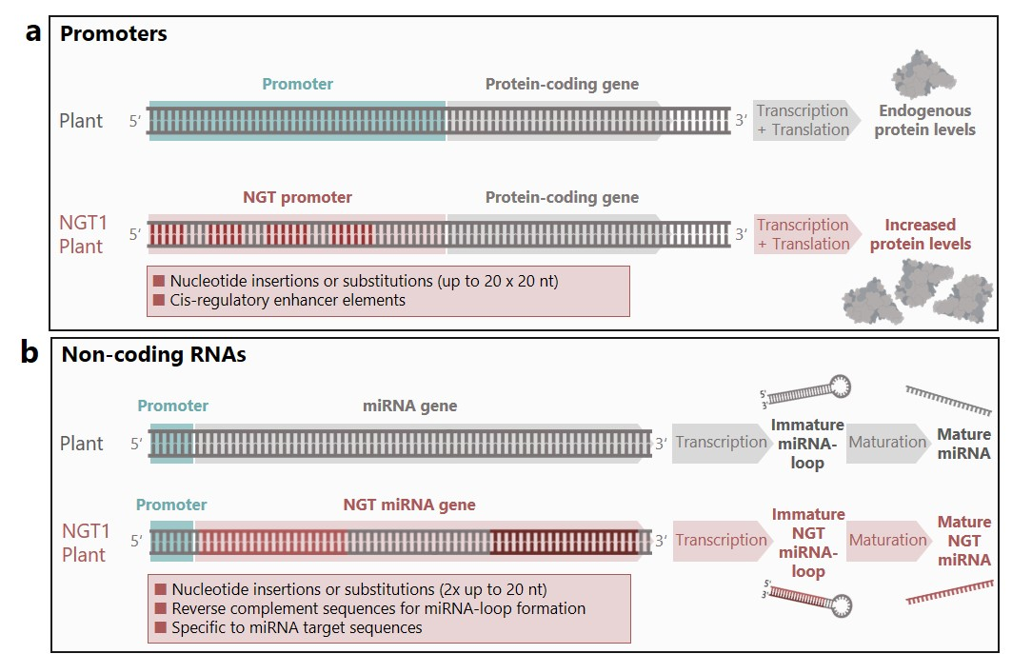

Supplementary Figure 1. Genetic engineering examples of promoters and non-coding RNAs modified with NGTs that outperform conventional breeding.
Schematic representation of genetic modifications covered by the two threshold criteria of Annex I that define NGT1 plants: up to 20 genetic modifications per NGT1 plant and insertions or substitutions of up to 20 nucleotides. (a) NGTs can modify gene expression by changing enhancing and suppressing cis-regulatory elements in promoter regions. For example, synthetic promoters can be generated by the insertion/substitution of up to 20 transcription factor binding sites (each 6-10 nt long). (b) NGTs can modify non-coding genes, such as genes encoding endogenous microRNA (miRNA), to trigger RNA interference (RNAi) and silencing of genes of interest. With this, pesticidal NGT-RNAi plants could be designed with possible lethal effects for target and non-target organisms. Redirection of NGT-miRNAs can be achieved by changing the recognition sequence of the miRNA (20-24 nt long) at the two complementary sites found close to each other in the miRNA encoding gene. Abbreviations: miRNA, micro RNA; NGT, new genomic technique; nt, nucleotide; RNAi, RNA interference. Colour code: Dark grey = DNA, RNA, and proteins; blue box = promoter; light grey arrow = (non-coding) gene; red = NGT modified nucleotides and amino acids; dark red = reverse complement nucleotides for miRNA-loop.

