Supplementary Information

Advancing Sustainability of Textiles: A Life Cycle and Microfiber Emission Assessment of Locally-Manufactured Circular Sportswear
Pellengahr, F., Ghannadzadeh, A. & van der Meer, Y.

Content
Supplementary note 1: Literature review of polyester textile case studies 2
Supplementary note 2: General approach for data acquisition and template used for textile value chain inventory data collection 4
Supplementary note 3: Life cycle inventory 7
Supplementary note 4: Life Cycle Assessment results 12
References 15

Supplementary note 1: Literature review of polyester textile case studies

Table S1: LCA case studies of polyester textiles.
Study | Object of study | Geogra-phical scope | Functional unit | Processing steps and characteristics | Additional notes
Moazzem, Crossin, et al., 2018 | Polyester knitted T-shirt | Australia | 50 days use of a polyester knitted T-shirt over one year life time | PET resin manufacturing, polyester filament spinning (22.23 kWh/kg, 15 % loss, fiber preparation: 5 % loss), knitting (8.08 kWh/kg, 1.5 % loss), wet processing (dyeing and pretreatment: 3 % loss, dyeing and finishing: 7.11 kWh/kg), apparel making (inspection, laying, cutting, sewing: 11 % material loss, 2.38 kWh/kg), importing agent, retailer, consumer, disposal
Walser et al., 2011 | Polyester T-shirt (conventional, nanoparticles triclosan) (1.56 m² textile, 130 g) | Switzer-land | Being dressed with a biocidal polyester T-shirt for outdoor activities during one year in Switzerland (wearing it once a week) | PET spinning (3 kWh/kg, 5 % loss; incinerated), knitting (1.5 kWh/kg), finishing (24.8 kg water use, 0.82 kWh/kg), making up (0.3 kWh/kg), transport, polyester fabric manufacturing, use phase, disposal | 100 washes
Braun et al., 2021 | Polyester jacket (size L; PES 1.55 m², 233+20+47 g; yarn 400 m PVA, 3.5 g) | Germany | Use of a three-layer-laminate jacket, repellent to water and permeable to heat and moisture, for a period of four years | PES fiber production (partly from PET bottles) (5 % loss), fabric production (10 % loss), garment production (37 % loss), use phase (3x washing), dismantling (5 % loss), shredding (5 % loss), regranulation (1 % loss) | Including auxiliary products, circular jacket; no data for individual production steps
Krishna Manda et al. 2015 | Antibacterial T-shirt |  | One T-shirt being worn for 100 days |  | Modal fibers
Moazzem, Daver, et al., 2018 | Polyester knit shirt | Australia | Use of one kilogram selected apparel over the life time | PES fiber production, yarn production (spinning and yarning 1.76 kWh/kg, 4 % loss), fabric production (knitting), wet processing (pre-treatment, dyeing, finishing; 3-10 % loss), textile make-up (cutting 13.57 % loss, inspection 6.91 %, sewing 4.31 % --> 13 % loss during make-up), distribution and transportation, use phase (washing, drying, ironing), consumer transport, end-of-life (landfill, reuse in Australia, reuse in overseas)

Table S1 (continued): LCA case studies of polyester textiles.
Study | Object of study | Geogra-phical scope | Functional unit | Processing steps and characteristics | Additional notes
Temizel-Sekeryan & Hicks, 2021 | Antibacterial T-shirt | USA | 145 g silver enabled PES textile (indicates men’s t-shirt with a large size) during its lifetime of 100 laundering cycles | PES textile manufacturing (adapted to 1 kg of PES: 24,83 kg/kg deionized water, 19.77 kWh/kg, 9.26 MJ/kg) | 100 laundry cycles, landfilling and incineration, using data from Walser et al. 2011
Wu, 2020 | 100 % polyester sports shirt | China | Lifetime of 1 100 % polyester sports shirt | PET production (26.67 MJ/kg, 1.36 %), PES manufacturing (120 MJ/kg, 1.36 %), PES transportation (8 MJ/kg, 0.67 %), yarn manufacturing (40 MJ/kg, 2.67 %), weaving (7.33 MJ/kg, 8.67 %). pre-treatment (6 MJ/kg, 2 %), dyeing (12 MJ/kg, 6 %), finishing (6 MJ/kg, 2 %), transportation (0.14 MJ/kg, 1.33 %), washing and drying (480 MJ/kg, 142 %), disposal (landfill, 26.67 MJ/kg, 1.36 %) | Life span: 2 years, 52 times laundry (values scaled on 1 kg, assuming 150 g of T-shirt)

Supplementary note 2: General approach for data acquisition and template used for textile value chain inventory data collection
To collect inventory data for the case study, the following steps were conducted.
- Step 1: First meeting with the jersey brand to identify the supply chain partner and to map out the value chin and life cycle of the jersey.
- Step 2: Creation of LCI information sheets (as shown in Figure S1 and Figure S2 for the case of the supply chain partner that is responsible for texturizing and knitting), tailored to each supply chain partner.
- Step 3: Verification meeting with the brand to discuss the value chain map and LCI sheets.
- Step 4: LCI sheets are sent to supply chain partners through the brand.
- Step 5: Returned LCI sheets are screened. If information is missing or unclear, a meeting for an interview is scheduled.
- Step 6: Interviews are conducted together with a brand representative to complete the LCI data.
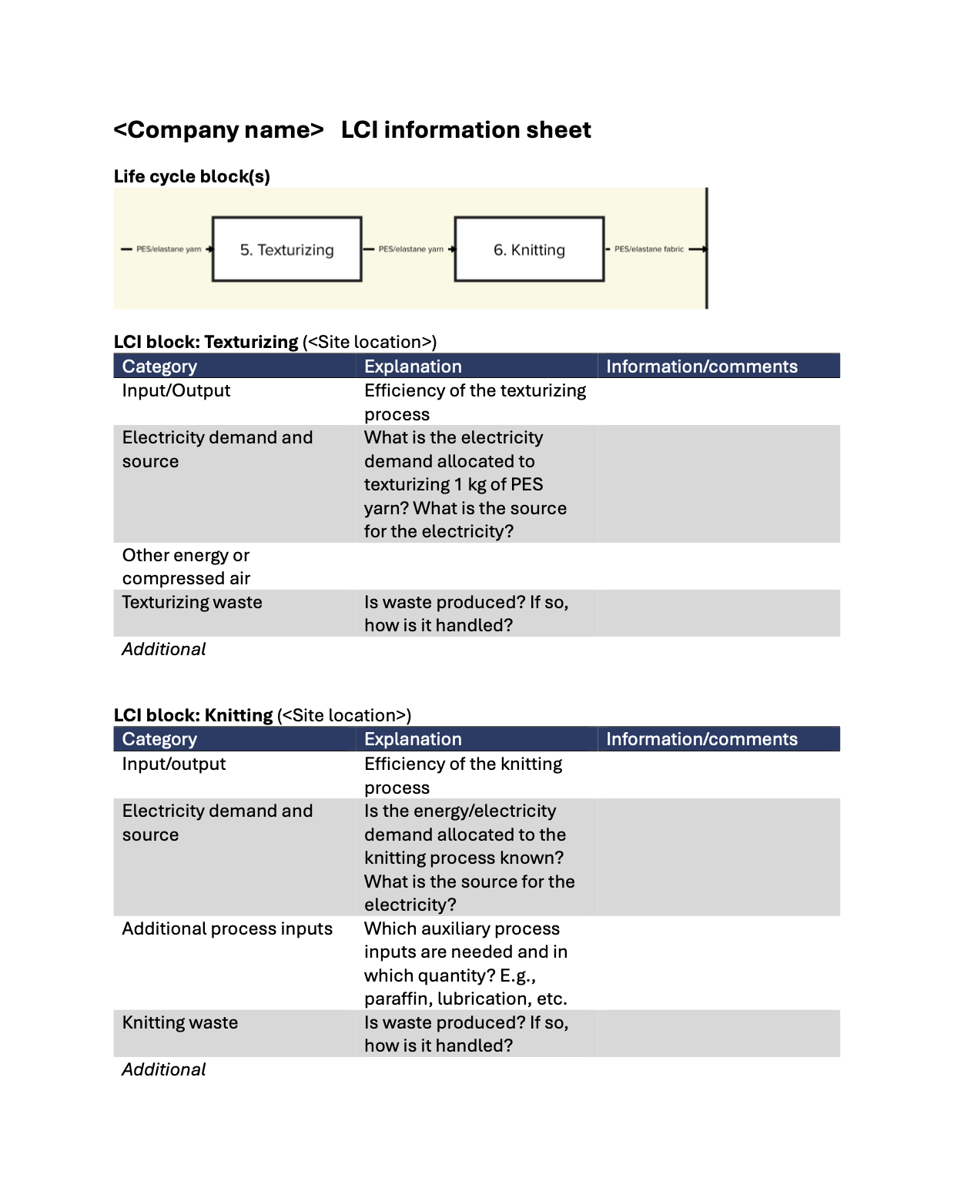
Figure S1: Life cycle inventory information sheet as sent to the supply chain partner responsible for texturizing and knitting (page 1).
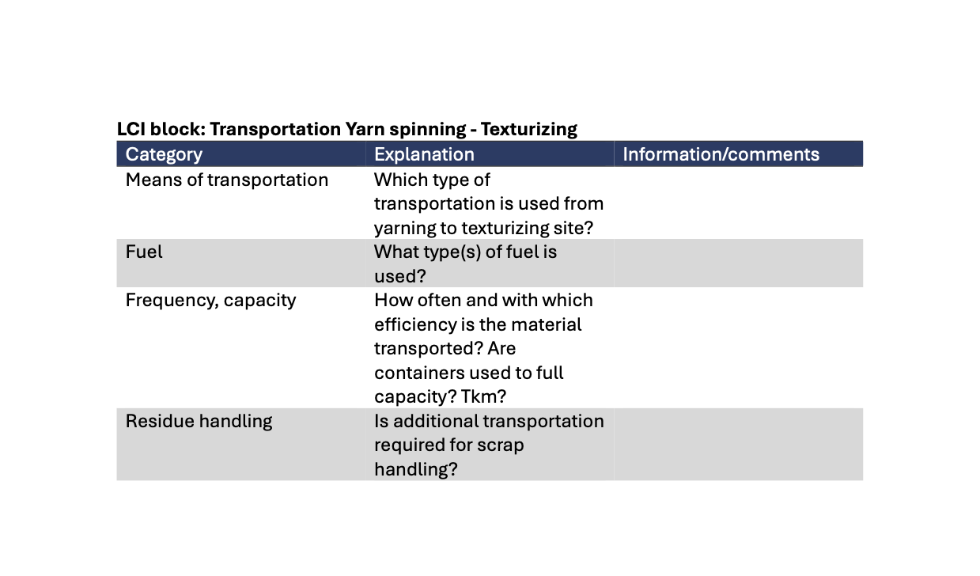
Figure S2: Life cycle inventory information sheet as sent to the supply chain partner responsible for texturizing and knitting (page 2).

Supplementary note 3: Life cycle inventory
The following LCI information are based on supplier information and, where applicable, literature data.

Table S2: LCI of the production phase.
Activity/process | Quantity | Unit | Comment
Yarn production
Polyester yarn | 1.30E-01 | kg | Based on confidential supplier information
Elastane | 9.77E-03 | kg | Based on Sandin et al. (2019)
Knitting |  |  | See Table S3
Garment preparation and assembly |  |  | See Table S4

Table S3: LCI of the knitting process for fabric for one jersey based on supplier information.
Activity/process | Quantity | Unit | Comment
Electricity | 4.88E-02 | kWh
Oil | 2.09E-03 | L
Waste | 6.61E-03 | kg | See Table S4

Table S4: LCI of knitting waste treatment per 1 kg of waste based on supplier information.
Activity/process | Quantity | Unit | Comment
Transportation | 2.50E-01 | tkm
Shredding electricity demand | 9.00E-02 | kWh | Based on Witik et al. (2011)
Filling material avoided | -4.00E-01 | kg | Assuming a 50:50 mix of cotton and polyester fiber

Table S5: LCI of the garment preparation and assembly processes, based on supplier information, Moazzem, Crossin, et al. (2018b) and Horn et al. (2023).
Activity/process | Quantity | Unit | Comment
Zipper | 1.2 | - | See Table S6, one large zipper in front, one small in the back (20% of front)
Sublimation printing |  |  | See Table S7
Electricity | 3.16E-01
Polyester thread | 4.07E-04
Heat | 8.14E-03
Water | 2.09E-02
Wicking chemical | 1.57E-03
Waste water | -2.09E-05
Waste fabric to incineration | -1.99E-02
Packaging | 1.20E-02 |  | Paper packaging, brand information

Table S6: LCI of the zipper production per one zipper, based on supplier information.
Activity/process | Quantity | Unit | Comment
Recycled polyester yarn |  | kg
  7-71E-03
Recycled polyester chips | 6.43E-03 | kg
Recycled polyamide chips | 2.68E-03 | kg
Transport of raw materials | 7.57E-03 | tkm
Tape weaving | 7.71E-03 | kg | Modelled by adapting the ecoinvent process “weaving of synthetic fiber, for industrial use (GLO)” to polyester and CN electricity supply
Zipper teeth extrusion | 6.43E-03 | kg
Zipper slider injection | 2.68E-03 | kg
Treatment of waste | -4,02E-04 | kg
Transport by air to Nice | 1,67E-01 | tkm | Based on searates.com and airportdistancecalculator.com
Assembling packaging | 5,44E-03 | kg | Kraft paper
Transport by truck to CZ | 1,80E-02 | tkm

Table S7: LCI of the sublimation printing per garment, adapted from Peters et al. (2018).
Activity/process | Quantity | Unit | Comment
Electricity | 1.30E-03 | kWh
Paper | 8.10E-02 | kg
Electricity for heat press | 3.91E-01 | kWh
Compressed air | 2.04E-01 | L
Dyestuff | 4.25E-03 | L
Paper waste | -8.10E-02 | kg

Table S8: LCI of the transportation phase.
Activity/process | Quantity | Unit | Comment
Transport from Spain to the Czech Republic | 2.66E-01 | tkm | Based on Google Maps, 2000 km
Transport from the Czech Republic to the Netherlands | 1.07E-01 | tkm | Based on Google Maps, 800 km

Table S9: LCI of the use phase.
Activity/process | Quantity | Unit | Comment
Online purchase |  |  | See Table S10
Washing | 5.88E+00 | kg | See Table S11
Tumble drying | 2.06E+00 | kg | See Table S12

Table S10: LCI of the online purchase (Hischier, 2018).
Activity/process | Quantity | Unit | Comment
“Delivery to me transport” – lorry | 2.33E-02 | tkm | 80% of 200 km
“Delivery to me transport” – van | 5.84E-03 | tkm | 20% of 200 km
Packaging waste management | -1.20E-02 | kg

Table S11: LCI of the washing process for 1 kg of laundry (Sandin et al., 2019).
Activity/process | Quantity | Unit | Comment
Water | 6.20E+00 | kg
Detergent | 1.58E-02 | kg | LCI see Sandin et al. 2019
Electricity | 2.25E-01 | kWh
Waste water treatment | -5.20E-03 | m³

Table S12: LCI of the tumble drying process for 1 kg of laundry (Sandin et al., 2019).
Activity/process | Quantity | Unit | Comment
Electricity | 6.70E-01 | kWh
Waste water treatment | -1.00E-03 | m³

Table S13: LCI of the end-of-life phase of one jersey.
Activity/process | Quantity | Unit | Comment
Incineration with energy recovery in NL | 55.00 | % | See Table S14
Incineration in open burning in PAK | 4.50 | % | See Table S15
Open dump in PAK | 3.15 | % | See Table S16
Reuse in PAK | 23.40 | % | See Table S17
Mechanical recycling in PAK | 13.95 | % | See Table S18

Table S14: LCI of the incineration in the Netherlands of one jersey.
Activity/process | Quantity | Unit | Comment
Transport for collection | 1.34E-02 | tkm
Jersey incineration in municipal incineration plant | -1.34E-01 | kg
Electricity from polyester incineration, avoided impact | -2.27E-01 | kWh
Heat from polyester incineration, avoided impact | -7.77E-01 | MJ

Table S15: LCI of the open burning in Pakistan of one jersey.
Activity/process | Quantity | Unit | Comment
Transportation from NL to PAK | 1.34E-01 | kg | See Table S19
Open burning of jersey | -1.34E-01 | kg

Table S16: LCI of the open dumping in Pakistan of one jersey.
Activity/process | Quantity | Unit | Comment
Transportation from NL to PAK | 1.34E-01 | kg | See Table S19
Open dumping of jersey | -1.34E-01 | kg

Table S17: LCI of the reuse in Pakistan of one jersey.
Activity/process | Quantity | Unit | Comment
Transportation from NL to PAK | 1.34E-01 | kg | See Table S19
Jersey reuse |  |  | Cut off

Table S18: LCI of the mechanical recycling in Pakistan of one jersey.
Activity/process | Quantity | Unit | Comment
Transport to PAK | 1.34E-01 | kg | See Table S19
Mechanical recycling of polyester textile | 1.34E-01 | kg | See Table S20

Table S19: LCI of the transport to Pakistan of one kilogram of textile.
Activity/process | Quantity | Unit | Comment
Truck transport within the Netherlands | 1.00E-01 | tkm
Sea freight transport to Pakistan | 1.39E+01 | tkm

Table S20: LCI of the mechanical recycling of polyester textile per 1 kg of textile waste (Duhoux et al., 2021).
Activity/process | Quantity | Unit | Comment
Electricity | 5.00E-01 | kWh
Water | 2.00E-02 | kg
Spinnable fibers | -2.50E-01 | kg
Fluff | -7.50E-02 | kg | PET assumed
Filling material, avoided | -3.00E-01 | kg | Polyurethane foam assumed

Table S21: LCI for ethylene glycol based glycolysis of 1 kg of waste PET based on Selvam et al. (2023), using conventional heating and homogeneous catalysis.
Material | Quantity | Unit | Comment
Input
PET | 1.000 | kg
Ethylene glycol | 0.328 | kg
Water | 0.247 | kg
Steam | 0.300 | MJ
Electricity | 0.074 | kWh
Zinc acetate | 0.100 | kg | See Table S22
Output
BHET | 1.323 | kg
Waste treatment | 0.005 | kg

Table S22: LCI for zinc acetate based on a stoichiometric approach and Huber et al. (2022).
Material | Quantity | Unit | Comment
Input
Zinc oxide | 0.444 | kg
Acetic acid | 0.654 | kg
Heat | 4.000 | MJ | Conservative estimation, based on Huber et al. (2022)
Output
Zinc acetate | 1.000 | kg
Waste water | 0.098 | kg

To model the polycondensation of BHET to PET, the ecoinvent activity to produce PET, amorphous, bottle-grade, was used. This approach serves as a conservative estimate.

Supplementary note 4: Life Cycle Assessment results

Table S23: LCA results for the functional unit (see manuscript) in terrestrial acidification, global warming (GWP), ecotoxicity, freshwater (FETP), marine (METP), and terrestrial (TETP), fossil depletion (FDP), and freshwater eutrophication potential (FEP).
 | TAP | GWP | FETP | METP | TETP | FDP | FEP
Life cycle phase | kg SO₂-eq. | kg CO₂-eq. | kg 1,4-DCB-eq. | kg 1,4-DCB-eq. | kg 1,4-DCB-eq. | kg oil-eq. | kg P-eq.
Yarn production | 2.23E-03 | 5.69E-01 | 3.16E-03 | 5.17E-03 | 1.93E+00 | 1.72E-01 | 4.12E-05
PES fiber production | 1.99E-03 | 4.98E-01 | 4.06E-04 | 1.54E-03 | 1.69E+00 | 1.47E-01 | 2.62E-05
Elastane fiber production | 2.47E-04 | 7.06E-02 | 2.76E-03 | 3.62E-03 | 2.44E-01 | 2.51E-02 | 1.50E-05
Knitting | -3.38E-05 | 5.19E-03 | -1.99E-04 | 4.11E-05 | 5.33E-03 | 3.58E-03 | -3.58E-06
Garment preparation and assembly | 2.46E-03 | 1.01E+00 | 3.93E-02 | 5.34E-02 | 1.80E+00 | 2.03E-01 | 9.60E-04
Zippers | 7.72E-04 | 2.83E-01 | 5.71E-03 | 8.03E-03 | 9.48E-01 | 8.12E-02 | 5.61E-05
Sublimation printing | 1.06E-03 | 4.63E-01 | 1.97E-02 | 2.64E-02 | 5.56E-01 | 7.43E-02 | 5.70E-04
Electricity | 5.97E-04 | 2.10E-01 | 1.03E-02 | 1.38E-02 | 1.69E-01 | 4.44E-02 | 3.32E-04
Others | 3.41E-05 | 4.95E-02 | 3.63E-03 | 5.11E-03 | 1.24E-01 | 2.95E-03 | 2.58E-06
Transport | 2.62E-04 | 8.85E-02 | 2.02E-03 | 3.53E-03 | 1.43E+00 | 2.83E-02 | 6.28E-06
Transport for production | 1.87E-04 | 6.31E-02 | 1.44E-03 | 2.51E-03 | 1.02E+00 | 2.02E-02 | 4.47E-06
Transport to NL | 7.52E-05 | 2.54E-02 | 5.81E-04 | 1.01E-03 | 4.12E-01 | 8.13E-03 | 1.80E-06
Use phase | 2.73E-03 | 1.41E+00 | 1.28E-01 | 1.60E-01 | 6.87E+00 | 4.42E-01 | 6.25E-04
Purchase delivery | 2.81E-05 | 1.03E-02 | 3.55E-04 | 5.48E-04 | 1.35E-01 | 2.92E-03 | 7.35E-07
Washing | 1.62E-03 | 7.48E-01 | 6.62E-02 | 8.29E-02 | 3.59E+00 | 2.34E-01 | 3.48E-04
Drying | 1.09E-03 | 6.54E-01 | 6.10E-02 | 7.70E-02 | 3.14E+00 | 2.05E-01 | 2.76E-04
End-of-life | -5.58E-05 | 4.48E-02 | 8.74E-03 | 1.28E-02 | 3.23E-01 | -4.17E-02 | -3.45E-05
Incineration NL | -8.90E-05 | 6.84E-02 | 1.07E-02 | 1.53E-02 | 3.20E-01 | -2.52E-02 | -2.28E-05
Incineration PAK | 3.56E-05 | 1.40E-02 | 1.93E-04 | 2.75E-04 | 1.17E-01 | 2.86E-04 | 3.93E-08
Landfill PAK | 1.47E-05 | 1.10E-03 | 2.78E-05 | 6.58E-05 | 5.49E-02 | 2.00E-04 | 2.75E-08
Reuse PAK | 8.54E-05 | 5.18E-03 | 5.65E-05 | 8.87E-05 | 2.31E-02 | 1.49E-03 | 2.04E-07
Recycling PAK | -1.03E-04 | -4.39E-02 | -2.25E-03 | -2.97E-03 | -1.93E-01 | -1.85E-02 | -1.20E-05

Table S24: LCA results for the functional unit (see manuscript) in marine eutrophication (MEP), human toxicity, carcinogenic (HTPc) and non-carcinogenic (HTPnc), ionizing radiation (IRP), Land use (LOP), material resources, metals/minerals (SOP), and ozone depletion potential (ODP).
 | MEP | HTPc | HTPnc | IRP | LOP | SOP | ODP
Life cycle phase | kg N-eq. | kg 1,4-DCB-eq. | kg 1,4-DCB-eq. | kg Co-60-eq. | m2*a crop-eq. | kg Cu-eq. | kg CFC-11-eq.
Yarn production | 2.43E-05 | 6.93E-03 | 1.68E-01 | 1.55E-02 | 1.42E-01 | 1.67E-03 | 4.02E-07
PES fiber production | 1.35E-05 | 3.30E-03 | 1.14E-01 | 1.36E-02 | 1.41E-01 | 1.04E-03 | 2.75E-07
Elastane fiber production | 1.08E-05 | 3.64E-03 | 5.40E-02 | 1.83E-03 | 8.28E-04 | 6.21E-04 | 1.27E-07
Knitting | -5.72E-05 | 2.56E-04 | -3.35E-03 | 1.02E-02 | -7.58E-03 | 5.98E-05 | -8.72E-08
Garment preparation and assembly | 1.69E-04 | 5.63E-02 | 1.20E+00 | 2.17E-01 | 1.88E-01 | 1.01E-02 | 5.83E-07
Zippers | 1.97E-05 | 7.69E-03 | 1.68E-01 | 5.59E-03 | 3.88E-02 | 2.69E-03 | 3.45E-07
Sublimation printing | 1.26E-04 | 3.03E-02 | 6.41E-01 | 1.25E-01 | 1.45E-01 | 6.82E-03 | 1.54E-07
Electricity | 2.25E-05 | 1.78E-02 | 3.64E-01 | 8.65E-02 | 3.23E-03 | 4.55E-04 | 4.98E-08
Others | 1.08E-06 | 5.22E-04 | 2.38E-02 | 3.50E-04 | 3.91E-04 | 1.73E-04 | 3.43E-08
Transport | 2.58E-06 | 4.45E-03 | 6.56E-02 | 1.76E-03 | 2.90E-03 | 9.22E-04 | 1.33E-08
Transport for production | 1.84E-06 | 3.17E-03 | 4.67E-02 | 1.26E-03 | 2.07E-03 | 6.57E-04 | 9.51E-09
Transport to NL | 7.41E-07 | 1.28E-03 | 1.88E-02 | 5.06E-04 | 8.33E-04 | 2.65E-04 | 3.83E-09
Use phase | 3.15E-04 | 7.16E-02 | 1.83E+00 | 1.65E-01 | 9.17E-02 | 1.08E-02 | 9.52E-07
Purchase delivery | 6.34E-07 | 6.30E-04 | 1.07E-02 | 1.98E-04 | 2.82E-04 | 1.13E-04 | 6.37E-09
Washing | 2.81E-04 | 4.29E-02 | 1.02E+00 | 8.87E-02 | 7.22E-02 | 6.50E-03 | 6.02E-07
Drying | 3.34E-05 | 2.81E-02 | 8.05E-01 | 7.57E-02 | 1.92E-02 | 4.18E-03 | 3.44E-07
End-of-life | -9.17E-06 | -3.87E-03 | -1.60E-02 | -8.32E-03 | -2.19E-03 | -6.21E-04 | -1.19E-07
Incineration NL | -1.56E-06 | -1.76E-03 | 2.40E-02 | -7.16E-03 | -1.68E-03 | -2.32E-04 | 3.42E-08
Incineration PAK | 2.21E-08 | 2.92E-04 | 2.13E-03 | 6.82E-06 | 7.96E-06 | 7.80E-06 | 8.14E-09
Landfill PAK | 1.55E-08 | 3.35E-05 | 1.21E-03 | 4.77E-06 | 1.66E-05 | 5.46E-06 | 3.06E-10
Reuse PAK | 1.15E-07 | 2.36E-04 | 1.22E-03 | 3.54E-05 | 4.14E-05 | 4.06E-05 | 2.27E-09
Recycling PAK | -7.76E-06 | -2.67E-03 | -4.45E-02 | -1.20E-03 | -5.77E-04 | -4.42E-04 | -1.64E-07

Table S25: LCA results for the functional unit (see manuscript) in particulate matter formation potential (PMFP), photochemical oxidant formation: humans (HOFP) and ecosystem (EOFP), water consumption (WCP), and water deprivation potential (WDP), and endpoint damage on ecosystem quality (DEQ).
 | PMFP | HOFP | EOFP | WCP | WDP | DEQ
Life cycle phase | kg PM2.5-eq. | kg NOx-eq. | kg NOx-eq. | cubic meter | cubic meter | species*year
Yarn production | 8.97E-04 | 1.32E-03 | 1.36E-03 | 1.40E-02 | 6.28E-02 | 2.20E-08
PES fiber production | 7.89E-04 | 1.16E-03 | 1.19E-03 | 8.07E-03 | 8.07E-03 | 1.89E-08
Elastane fiber production | 1.08E-04 | 1.65E-04 | 1.74E-04 | 5.90E-03 | 5.48E-02 | 3.05E-09
Knitting | 2.12E-07 | 1.47E-05 | 2.05E-05 | 1.08E-02 | -2.50E-01 | 1.07E-10
Garment preparation and assembly | 8.66E-04 | 2.30E-03 | 2.38E-03 | 1.33E-01 | 2.45E-01 | 6.64E-08
Zippers | 2.96E-04 | 1.21E-03 | 1.26E-03 | 9.39E-03 | 3.88E-02 | 1.33E-08
Sublimation printing | 3.57E-04 | 7.15E-04 | 7.38E-04 | 7.65E-02 | 1.37E-01 | 3.45E-08
Electricity | 1.98E-04 | 3.44E-04 | 3.49E-04 | 4.58E-02 | 5.87E-02 | 1.56E-08
Others | 1.49E-05 | 3.09E-05 | 3.21E-05 | 1.18E-03 | 1.03E-02 | 2.98E-09
Transport | 1.11E-04 | 5.37E-04 | 5.57E-04 | 1.93E-03 | 6.11E-03 | 4.41E-09
Transport for production | 7.88E-05 | 3.83E-04 | 3.97E-04 | 1.37E-03 | 4.36E-03 | 3.15E-09
Transport to NL | 3.18E-05 | 1.54E-04 | 1.60E-04 | 5.53E-04 | 1.76E-03 | 1.27E-09
Use phase | 1.02E-03 | 2.16E-03 | 2.27E-03 | 2.08E-01 | 5.25E-01 | 8.38E-08
Purchase delivery | 1.17E-05 | 5.64E-05 | 5.85E-05 | 2.56E-04 | 1.47E-03 | 1.02E-09
Washing | 5.97E-04 | 1.19E-03 | 1.27E-03 | 1.37E-01 | 3.86E-01 | 4.46E-08
Drying | 4.08E-04 | 9.13E-04 | 9.48E-04 | 7.13E-02 | 1.37E-01 | 3.82E-08
End-of-life | 4.34E-05 | 3.02E-05 | 1.85E-05 | -1.29E-02 | -4.53E-02 | 5.77E-09
Incineration NL | -3.33E-05 | -9.74E-05 | -1.04E-04 | -8.37E-03 | -6.54E-03 | 6.42E-09
Incineration PAK | 1.45E-05 | 7.15E-05 | 7.29E-05 | 9.84E-06 | 1.71E-04 | 1.21E-09
Landfill PAK | 8.99E-05 | 2.11E-05 | 2.12E-05 | 6.89E-06 | 2.75E-05 | 2.22E-10
Reuse PAK | 2.77E-05 | 9.03E-05 | 9.15E-05 | 5.12E-05 | 2.04E-04 | 1.91E-10
Recycling PAK | -5.54E-05 | -5.52E-05 | -6.34E-05 | -4.65E-03 | -3.92E-02 | -2.27E-09

References
Braun, G., Som, C., Schmutz, M., & Hischier, R. (2021). Environmental Consequences of Closing the Textile Loop—Life Cycle Assessment of a Circular Polyester Jacket. Applied Sciences, 11(7), 2964. https://doi.org/10.3390/app11072964
Duhoux, T., Maes, E., Hirschnitz-Garbers, M., Peeters, K., Asscherickx, L., Christis, M., Stubbe, B., Colignon, P., Hinzmann, M., & Sachdeva, A. (2021). Study on the technical, regulatory, economic and environmental effectiveness of textile fibres recycling. European Commission.
Hischier, R. (2018). Car vs. Packaging—A First, Simple (Environmental) Sustainability Assessment of Our Changing Shopping Behaviour. Sustainability, 10(9), 3061. https://doi.org/10.3390/su10093061
Horn, S., Mölsä, K. M., Sorvari, J., Tuovila, H., & Heikkilä, P. (2023). Environmental sustainability assessment of a polyester T-shirt - Comparison of circularity strategies. The Science of the Total Environment, 884, 163821. https://doi.org/10.1016/j.scitotenv.2023.163821
Huber, E., Bach, V., Holzapfel, P., Blizniukova, D., & Finkbeiner, M. (2022). An Approach to Determine Missing Life Cycle Inventory Data for Chemicals (RREM). Sustainability, 14(6), 3161. https://doi.org/10.3390/su14063161
Moazzem, S., Crossin, E., Daver, F., & Wang, L. (2018). Baseline Scenario of Carbon Footprint of Polyester T-Shirt. Journal of Fiber Bioengineering and Informatics, 11(1), 1–14. https://doi.org/10.3993/jfbim00262
Moazzem, S., Daver, F., Crossin, E., & Wang, L. (2018). Assessing environmental impact of textile supply chain using life cycle assessment methodology. The Journal of the Textile Institute, 109(12), 1574–1585. https://doi.org/10.1080/00405000.2018.1434113
Peters, G., Sandin, Spak, B., & Roos, S. (2018). LCA on fast and slow garment prototypes. Mistra Future Fashion Report.
Sandin, G., Roos, S., Spak, B., Zamani, B., & Peters, G. M. (2019). Environmental assessment of Swedish clothing consumption. https://doi.org/10.13140/RG.2.2.30502.27205
Selvam, E., Luo, Y., Ierapetritou, M., Lobo, R. F., & Vlachos, D. G. (2023). Microwave-assisted depolymerization of PET over heterogeneous catalysts. Catalysis Today, 418, 114124. https://doi.org/10.1016/j.cattod.2023.114124
Temizel-Sekeryan, S., & Hicks, A. L. (2021). Cradle-to-grave environmental impact assessment of silver enabled t-shirts: Do nano-specific impacts exceed non nano-specific emissions? NanoImpact, 22, 100319. https://doi.org/10.1016/j.impact.2021.100319
Walser, T., Demou, E., Lang, D. J., & Hellweg, S. (2011). Prospective environmental life cycle assessment of nanosilver T-shirts. Environmental Science & Technology, 45(10), 4570–4578. https://doi.org/10.1021/es2001248
Witik, R. A., Payet, J., Michaud, V., Ludwig, C., & Månson, J.‑A. E. (2011). Assessing the life cycle costs and environmental performance of lightweight materials in automobile applications. Composites Part a: Applied Science and Manufacturing, 42(11), 1694–1709. https://doi.org/10.1016/j.compositesa.2011.07.024
Wu, Z. (2020). Haode Evaluating the Life-cycle Environmental Impacts of Polyester Sports T-shirts. IOP Conference Series: Earth and Environmental Science, 474(2), 22017. https://doi.org/10.1088/1755-1315/474/2/022017

