Supplementary information
Trifluoroacetate leaching potential from fluorinated pesticides – an emission estimation and FOCUS modelling approach

Table S1 Modelling input data
Active substance (abbreviation) | Active substance / metabolite with C-CF₃ group | Molar mass M [g/mol] | Vapour pressure at 20 °C [Pa] | Solubility in water at 20 °C [mg/L] | Degradation half-life DT₅₀ in soil, aerobic degradation [d] | Partition coefficient K_{om} (geom. mean) [mL/g] | Freundlich exponent 1/n | Formation fraction ff | Plant uptake factor
Cyflufenamid (Cyf) | Cyf | 412.4 | 3.54E-05 | 0.52 | 33.8 | 883.4 | 0.93 | - | 0
Cyflufenamid (Cyf) | Cyf01 | 380.3 | 1.00E-10 | 1000 | 2.3 | 7.0 | 0.88 | 1 from parent | 0
Cyflufenamid (Cyf) | Cyf02 | 294.2 | 1.00E-10 | 1000 | 8.9 | 16.2 | 0.84 | 1 from Cyf01 | 0
Cyflufenamid (Cyf) | Cyf03 | 224.1 | 1.00E-10 | 1000 | 168.5 | 41.2 | 0.94 | 1 from Cyf02 | 0
Cyflufenamid (Cyf) | Cyf04 | 225.1 | 1.00E-10 | 1000 | 1247 | 4.8 | 0.99 | 1 from Cyf03 | 0
Diflufenican (Dif) | Dif | 394.3 | 4.25E-06 (25°C) | 0.05 | 95.7 (fast phase)  112 (slow phase)¹⁾ | 750.0²⁾ | 0.87 | - | 0
Diflufenican (Dif) | Dif01 | 283.2 | 1.00E-10 | 140 | 20.1 | 3.4²⁾ | 0.86 | 0.48 from parent  0.89 from Dif02 | 0
Diflufenican (Dif) | Dif02 | 282.2 | 1.00E-10 | 88 | 40.3 (fast phase)  53.5 (slow phase)¹⁾ | 70.1 | 0.84 | 0.23 from parent | 0
Flazasulfuron (Fla) | Fla | 407.4 | 1.33E-05 (25°C) | 2100 (25°C) | pH < 6: 20.9  pH > 6: 43.6³⁾ | pH < 6: 99.8  pH > 6: 34.2³⁾ | pH < 6: 0.86  pH > 6: 0.84³⁾ | - | 0
Flazasulfuron (Fla) | Fla01 | 343.3 | 1.00E-10 | 1000 | 208.2 | 60.3 | 0.88 | 0.37 from parent | 0
Flazasulfuron (Fla) | Fla02 | 300.2 | 1.00E-10 | 1000 | 365.9 | 230.6 | 0.71 | 1 from Fla01 | 0
Flazasulfuron (Fla) | Fla03 | 286.2 | 1.00E-10 | 1000 | 25.1 | 106.7 | 0.8 | 1 from Fla02 | 0
Flazasulfuron (Fla) | Fla04 | 226.2 | 1.00E-10 | 1000 | 780.8 | 17.1 | 0.89 | 0.17 from parent | 0
Flazasulfuron (Fla) | Fla05 | 393.3 | 1.00E-10 | 1000 | 7.44 | 0 | 0.9 (default) | 0.46 from parent | 0
Flazasulfuron (Fla) | Fla06 | 311.2 | 1.00E-10 | 1000 | 39.46 | 8.2 | 0.879 | 0.5 from Fla05 | 0
Flazasulfuron (Fla) | Fla07 | 329.2 | 1.00E-10 | 1000 | 2 | 0 | 0.9 (default) | 0.5 from Fla05 | 0
Flonicamid (Flo) | Flo | 229.2 | 9.43E-07 | 5200 | 1.1 | 3.4⁴⁾ | 0.9 (default) | - | 0
Flonicamid (Flo) | Flo01 | 191.1 | 1.00E-10 | 1000 | 0.4 | 1.2⁴⁾ | 0.9 (default) | 0.42 from parent, 0.68 from Flo04 | 0
Flonicamid (Flo) | Flo02 | 207.1 | 1.00E-10 | 1000 | 1.6 | 1.7⁴⁾ | 0.9 (default) | 1 from Flo01 | 0
Flonicamid (Flo) | Flo03 | 247.2 | 1.00E-10 | 1000 | 0.5 | 5.3⁴⁾ | 0.9 (default) | 0.59 from parent | 0
Flonicamid (Flo) | Flo04 | 248.2 | 1.00E-10 | 1000 | 0.5 | 0.9⁴⁾ | 0.9 (default) | 1 from Flo03 | 0
Flonicamid (Flo) | Flo05 | 190.1 | 1.00E-10 | 1000 | 1.6 | 3.6⁴⁾ | 0.9 (default) | 0.32 from Flo04 | 0
Fluazifop-P (Flu) | Flu (Fluazifop-P-buthyl) | 383.4 | 1.20E-04 | 0.93 | 0.3⁵⁾ | 1968.7 | 1 | - | 0
Fluazifop-P (Flu) | Flu01 (Fluazifop-P) | 327.3 | 1.00E-10 | 780 | 9.1 | 27.1 | 0.9 (default) | 1 from parent (hydrolysis to acid) | 0
Fluazifop-P (Flu) | Flu02 | 255.2 | 1.00E-10 | 1000 | 0.5 | 13.4 | 0.84 | 0.29 from Flu01 | 0
Fluazifop-P (Flu) | Flu03 | 163.0 | 1.00E-10 | 6000 | 75.3 | 145.6 | 0.86 | 0.71 from Flu01 | 0
Fluazinam (Flz) | Flz | 465.1 | 1.72E-05 | 0.135 | 25.5 (field) | 1128.2 | 0.65 | - | 0
Fluazinam (Flz) | Flz01 | 446.65 | 1.00E-10 | 10.45 | 131 (field) | pH < 7: 734.9  pH > 7: 302.2⁶⁾ | pH < 7: 0.85  pH > 7: 0.88⁶⁾ | 0.19 from parent | 0
Flufenacet (Flf) | Flf | 363.3 | 9.00E-05 | 51 | 12.1 | 128.3 | 0.92 |  | 0.233
Flufenacet (Flf) | Flf01 | 170.1 | 2.05 | 100000 | 2.0 | 24.4 | 0.76 | 0.57 from parent | 0.452
Flufenacet (Flf) | Flf02 | 164.1 | 1.80E-08 | 160000 | 6.4 | 0.0001 | 1 | 0.47 from Flf01 | 0.00008
Fluopicolide (Flp) | Flp | 383.6 | 3.03E-07 | 2.8 | 138.8 (field) | 168.4 | 0.90 | - | 0
Fluopicolide (Flp) | Flp01 | 399.6 | 6.96E-10 | 7.2 (25°C) | pH < 6: 55.5 (field)  pH < 6: 0.1⁷⁾ | 62.0 | 0.97 | pH < 6: 0.29 from parent  pH < 6: 1 from parent⁷⁾ | 0
Fluopicolide (Flp) | Flp02 | 225.6 | 0.1016 (25°C) | 693.7 (25°C) | 2.8 | 2.4 | 0.77 | pH < 6: 0.71 from parent, 1 from Flp01  pH < 6: 1 from Flp01⁷⁾ | 0
Fluopicolide (Flp) | Flp03 | 271.2 | 1.00E-10 | 1000 | 26.4 | 1.0 | 0.9 (default) | 0.10 from Flp02 | 0
Fluopicolide (Flp) | Flp04 | 287.2 | 1.00E-10 | 1000 | 36.0 | 0.0 | 0.9 (default) | 0.05 from Flp02 | 0
Fluopicolide (Flp) | Flp05 | 241.6 | 1.00E-10 | 1000 | 11.8 | 0.0 | 0.9 (default) | 0.06 from Flp02 | 0
Fluopicolide (Flp) | Flp06 | 253.2 | 1.00E-10 | 1000 | 42.6 | 12.1 | 0.92 | 0.20 from Flp02 | 0
Fluopicolide (Flp) | Flp07 | 241.2 | 1.00E-10 | 1000 | 5.2 | 11.1 | 0.9 (default) | 0.38 from Flp06 | 0
Fluopyram (Fly) | Fly | 396.7 | 1.20E-06 | 16 | 158.4 (field) | 158.4 | 0.83 |  | 0
Fluopyram (Fly) | Fly01 | 412.7 | 1.00E-10 | 1000 | 8.1 | 58.1 | 0.93 | 0.83 from parent | 0
Flutolanil (Flt) | Flt | 323.2 | 4.10E-07 | 8.01 | 105 (field) | 324.1 | 0.83 | - | 0
Isoxaflutole (Iso) | Iso | 359.32 | 3.22E-07 | 6.2 | 0.9 | 44.3 | 0.94 |  | 0
Isoxaflutole (Iso) | Iso01 | 359.32 | 2.60E-07 | 5500 | 15.8 (field) | 7.1⁸⁾ | 0.89 | 1 from parent | 0
Isoxaflutole (Iso) | Iso02 | 268.22 | 5.70E-06 | 110000 | 12 (field) | 0 | 1 | 1 from Iso01 | 0
lambda-Cyhalothrin (Lam) | Lam | 449.9 | 2.00E-07 | 0.005 | 174.6 | 22041.8⁹⁾ | 1 | - | 0
lambda-Cyhalothrin (Lam) | Lam01 | 242.5 | 1.00E-10 | 56 | 8.9 | 7.5⁹⁾ | 0.95⁹⁾ | 0.65 from parent  1.0 from Lam02 | 0
lambda-Cyhalothrin (Lam) | Lam02 | 465.9 | 1.00E-10 | 0.15 | 14.5 | 34802.8⁹⁾ | 1 | 0.15 from parent | 0
Oxathiapiprolin (Oxa) | Oxa | 539.5 | 1.14E-06 | 0.1749 | 121.2 | 3554.5 | 0.97 | - | 0
Oxathiapiprolin (Oxa) | Oxa01 | 555.5 | 1.00E-10 | 1000 | 160 | 587.0 | 0.87 | 0.5 from parent | 0
Oxathiapiprolin (Oxa) | Oxa02 | 180.1 | 1.00E-10 | 1000 | 310.2 | 4.0 | 1.01 | 0.21 from parent  0.4 from Oxa01 | 0
Oxathiapiprolin (Oxa) | Oxa03 | 569.5 | 1.00E-10 | 1000 | 60.5 | 282.5 | 0.89 | 0.29 from parent | 0
Penthiopyrad (Pen) | Pen | 359.4 | 6.43E-06 (25°C) | 1.375 | 121.5 | 434.6 | 0.96 | - | 0
Penthiopyrad (Pen) | Pen01 | 375.41 | 1.00E-10 | 1000 | 23.1 | 43.8 | 0.82 | 0.36 from parent | 0
Penthiopyrad (Pen) | Pen02 | 180.09 | 1.00E-10 | 1000 | 90.4 | 3.2¹⁰⁾ | 0.87 | 1 from Pen01  1 from Pen03 | 0
Penthiopyrad (Pen) | Pen03 | 391.41 | 1.00E-10 | 1000 | 25.9 | 280.2 | 0.8 | 0.24 from parent | 0
Picolinafen (Pic) | Pic | 376.3 | 1.70E-07 | 0.047 | 6.1 | 12448 | 0.99 | - | 0
Picolinafen (Pic) | Pic01 | 283.3 | 1.00E-10 | 1000 | 29 | 220.5 | 0.96 | 0.73 from parent | 0
Prosulfuron (Pro) | Pro | 419.4 | 3.50E-06 (25°C) | 4000 | 62.1 | 7.4 | 0.87 | - | 0
Prosulfuron (Pro) | Pro01 | 405.4 | 1.00E-10 | 1000 | alkaline: 30.2  acidic: 2.6¹¹⁾ | 27.1 | 0.9 | 0.47 from parent | 0
Prosulfuron (Pro) | Pro02 | 404.4 | 1.00E-10 | 1000 | 62.4 | 15.2 | 0.97 | 0.12 from Pro01 | 0
Prosulfuron (Pro) | Pro03 | 381.3 | 1.00E-10 | 1000 | 84.6 | 64.4 | 0.85 | 0.88 from Pro01 | 0
Prosulfuron (Pro) | Pro04 | 338.3 | 1.00E-10 | 1000 | 153.0 | 25.5 | 0.96 | 0.86 from Pro03 | 0
Prosulfuron (Pro) | Pro05 | 253.2 | 1.00E-10 | 1000 | 188.0 | 39.4 | 0.88 | 0.43 from parent | 0
Pyroxsulam (Pyr) | Pyr | 434.4 | 1.00E-07 | 3200 | 3.3 | pH < 7: 23.5  pH > 7: 7.1¹²⁾ | pH < 7: 0.96  pH > 7: 1.01¹²⁾ | - | 0
Pyroxsulam (Pyr) | Pyr01 | 420.3 | 1.00E-10 | 1000 | 3.1 | pH < 7: 10.9  pH > 7: 1.4¹²⁾ | pH < 7: 1.0  pH > 7: 1.0¹²⁾ | 0.37 from parent | 0
Pyroxsulam (Pyr) | Pyr02 | 256.2 | 1.00E-10 | 1000 | 82.0 | 30.3 | 0.85 | 1 from Pyr01  1 from Pyr05¹³⁾ | 0
Pyroxsulam (Pyr) | Pyr03 | 257.2 | 1.00E-10 | 1000 | 300.0 | 0.6 | 1 | 1 from Pyr02¹³⁾ | 0
Pyroxsulam (Pyr) | Pyr04 | 420.3 | 1.00E-10 | 1000 | 30.0 | pH < 7: 56.6  pH > 7: 14.9¹²⁾ | pH < 7: 0.9  pH > 7: 1.0¹²⁾ | 0.63 from parent¹³⁾ | 0
Pyroxsulam (Pyr) | Pyr05 | 454.8 | 1.00E-10 | 1000 | 30.0 | pH < 7: 35.8  pH > 7: 8.7¹²⁾ | pH < 7: 1.0  pH > 7: 1.0¹²⁾ | 1 from Pyr04¹³⁾ | 0
Sulfoxaflor (Sul) | Sul | 277.3 | 1.40E-06 | 568 | 0.1 | 18.0 | 0.96 |  | 0
Sulfoxaflor (Sul) | Sul01 | 295.3 | 1.00E-10 | 1000 | 76.6 (field) | 14.1 | 0.99 | 1 from parent | 0
Sulfoxaflor (Sul) | Sul02 | 253.2 | 1.00E-10 | 1000 | 40.5 (field) | 5.0 | 1.01 | 0.5 from Sul01 | 0
Sulfoxaflor (Sul) | Sul03 | 252.3 | 1.00E-10 | 1000 | 186.7 | 8.9 | 0.82 | 0.5 from Sul01 | 0
tau-Fluvalinat (Tau) | Tau | 502.9 | 9.00E-11 | 0.00103 | 31 | 313746.9 | 1 | - | 0
tau-Fluvalinat (Tau) | Tau01 | 295.8 | 2.54E-03 | 17.96 | 0.5 | 38.7¹⁴⁾ | 0.84 | 1 from parent | 0
tau-Fluvalinat (Tau) | Tau02 | 195.7 | 2.11E+01 | 112.3 | 79 | 281.2 | 0.85 | 1 from Tau01 | 0
Tefluthrin (Tef) | Tef | 418.7 | 8.40E-03 | 0.016 | 15¹⁵⁾ | 102221.6 | 1.13 | - | 0
Tefluthrin (Tef) | Tef01 | 242.6 | 1.00E-10 | 32.6 | 16¹⁵⁾ | 14.9 | 0.92 | 1 from parent¹⁶⁾ | 0
Tembotrione (Tem) | Tem | 440.8 | 1.10E-08 | 28300 | 0.1 (field)¹⁷⁾ | 76.0¹⁷⁾ | 0.91 | - | 0
Tembotrione (Tem) | Tem01 | 346.7 | 1.00E-10 | 386 | 17.9 (field) | 1.1¹⁸⁾ | 0.98 | 0.13 from parent¹⁷⁾ | 0
Tembotrione (Tem) | Tem02 | 318.7 | 1.00E-10 | 2241 | 11.2 | 71.3¹⁷⁾ | 0.77 | 0.28 from Tem01 | 0.5
Tembotrione (Tem) | Tem03 | 332.7 | 1.00E-10 | 161.3 | 12.4 | 157.8 | 0.86 | 0.46 from Tem02 | 0.5
Trifloxystrobin (Tri) | Tri | 408.7 | 3.40E-06 (25°C) | 0.61 | 0.52 (combined) | 1326.6 | 0.96 | - | 0
Trifloxystrobin (Tri) | Tri01 | 394.4 | 1.00E-10 | 21000 (25°C) | 48.1 (field) | 67.3 | 1.00 | 0.71 from parent | 0
Trifloxystrobin (Tri) | Tri02 | 424.3 | 1.00E-10 | 290000 (25°C) | 36.1 (field) | 1.9 | 0.91 | 0.16 from Tri01 | 0
Trifloxystrobin (Tri) | Tri03 | 318.3 | 1.00E-10 | 0.6 | 51.5 (combined) | 4683.3 | 0.88 | 0.05 from Tri01 | 0
Triflusulfuron-methyl (Trf) | Trf | 492.4 | 1.01E-05 | 260 (25°C) | 4.5 (field) | 44.2 | 0.95 |  | 0
Triflusulfuron-methyl (Trf) | Trf01 | 237.2 | 1.00E-10 | 1000 | 53.5 (combined) | 77.1 | 0.90 | 0.84 from parent | 0
Triflusulfuron-methyl (Trf) | Trf02 | 223.2 | 1.00E-10 | 1000 | 89.7 (combined) | 36.5 | 0.86 | 0.88 from Trf01 | 0
Triflusulfuron-methyl (Trf) | Trf03 | 209.1 | 1.00E-10 | 1000 | 110.6 (combined) | 18.0 | 0.92 | 0.99 from Trf02 | 0
Tritosulfuron (Trt) | Trt | 445.3 | 9.30E-08 | 9900 | 8.2 (field) | 5.2 | 0.94 |  | 0.5
Tritosulfuron (Trt) | Trt01 | 353.3 | 1.00E-10 | 1000 | 155.1 | 43.2 | 0.92 | 0.55 from parent | 0
Tritosulfuron (Trt) | Trt02 | 310.3 | 1.00E-10 | 1000 | 193.2 | 16.2 | 0.90 | 1 from Trt01 | 0
Tritosulfuron (Trt) | Trt03 | 225.2 | 1.00E-10 | 1000 | 76.1 | 21.2 | 0.96 | 0.17 from parent  1 from Trt02 | 0
Tritosulfuron (Trt) | Trt04 | 194.1 | 1.00E-10 | 1000 | 29.7 | 9.7 | 0.97 | 0.11 from parent | 0
All active substances | TFA | 114.0 | 1.00E-06 | 500000 | 1000 | 0.0001 | 1 | varying, depending on active substance | 0.00008
¹⁾ Since diflufenican and its metabolite Dif02 show biphasic degradation behaviour, modelling was performed for each combination of fast and slow phase degradation and worst-case TFA concentrations results were used for further data evaluation.
²⁾ Diflufenican and its metabolite Dif01 show pH-dependent adsorption behaviour. Thus worst-case, geometric mean of alkaline soils and the worst-case value was used for diflufenican and Dif01, respectively.
³⁾ Degradation and adsorption of flazasulfuron is pH-dependent. Consequently, modelling was performed separately for pH conditions < and > pH 6 and worst-case TFA concentrations results were used for further data evaluation.
⁴⁾ Geometric mean of K_{om} values was not determinable since individual values were missing. Arithmetic mean was used for modelling instead.
⁵⁾ 0.3 d was used as worst-case assumption for modelling metabolites.
⁶⁾ Degradation of fluazinam is pH-dependent. Consequently, modelling was performed separately for acidic and alkaline conditions and worst-case TFA concentrations results were used for further data evaluation.
⁷⁾ Degradation and/or formation fractions of metabolites Flp01 and Flp02 are pH-dependent. Consequently, modelling was performed separately for pH conditions < and > pH 6 and worst-case TFA concentrations results were used for further data evaluation.
⁸⁾ Worst-case value (at pH values > 6.5) used for modelling, since Iso01 shows pH-dependent adsorption.
⁹⁾ Worst-case values were used for modelling.
¹⁰⁾ pH-dependent adsorption was concluded for metabolite Pen02. However, this was not considered in the groundwater modelling approach.
¹¹⁾ Degradation of metabolite Pro01 is pH-dependent. Consequently, modelling was performed separately for acidic and alkaline conditions and worst-case TFA concentrations results were used for further data evaluation.
¹²⁾ Adsorption of pyroxsulam and its metabolites Pyr01, Pyr04 and Pyr05 is pH-dependent. Consequently, modelling was performed separately for acidic and alkaline conditions and worst-case TFA concentrations results were used for further data evaluation.
¹³⁾ No degradation scheme was postulated for pyroxsulam in the peer-review process of this active substance and for groundwater modelling all metabolites except for Pyr01 were applied as pseudo-parents. Here, a degradation scheme based on expert judgement and chemical logic using worst-case formation fractions was postulated and used for groundwater modelling.
¹⁴⁾ For metabolite Tau01, the worst-case K_{om} value was used for modelling since this metabolite shows pH-dependent adsorption behaviour.
¹⁵⁾ Worst-case DT₅₀ values were used for modelling.
¹⁶⁾ It remained unclear whether metabolite Tef01 was modelled separately from the parent for groundwater assessment during the EU peer-review process of tefluthrin. Here, a formation fraction of 1 was assumed.
¹⁷⁾ For Tembotrine, very elaborate groundwater modelling considering biphasic degradation and scenario-specific values for pH-dependent input values was performed in the corresponding EFSA conclusion. Here, values assuming to be the worst-case regarding TFA formation were chosen for the DT₅₀ of tembotrione, the K_{om} of tembotrione and Tem02 and the formation fraction of Tem01 instead.
¹⁸⁾ For the metabolite Tem01, the arithmetic mean instead of the geometric mean was used for K_{om} since individual K_{om} values included 0 which cannot be used for geometric mean calculations.

Table S2 Application data
Active Substance | Application code | Crop (surrogate crop for modelling) | Application rate AR [g a.s./ha] | Number of applications n | Interval [d] | Application time | Crop interception CI [%] | Remarks
Cyflufenamid | Cyflu_cereals_winter | winter cereals | 25 | 2 | 28 | BBCH 30-59 | 80/90
Diflufenican | Diflu_cereals_winter | winter cereals | 187.5 | 1 | - | pre-emergence to BBCH 32 | 0
Diflufenican | Diflu_cereals_spring | spring cereals | 187.5 | 1 | - | Pre-emergence to BBCH 32 | 0
Flazasulfuron | Flaza_vine | vines | 50 (1/3 = 17) | 1 | - | spring, early post-emergence | 0 | Application under the row, 1/3 of the surface treated resulting in an equivalent dose for environmental risk assessment of 0.017 kg a.s./ha
Flazasulfuron | Flaza_citrus | citrus | 50 (1/3 = 17) | 1 | - | summer, early post-emergence | 0
Flazasulfuron | Flaza_olive | olives (citrus) | 50 (1/3 = 17) | 1 | - | autumn – spring, early post-emergence | 0
Flonicamid | Floni_potato | potatoes | 80 | 2 | 21 | BBCH 81-95 | 85/50
Flonicamid | Floni_cereals_winter | winter cereals | 70 | 2 | 21 | BBCH 51-89 | 90
Flonicamid | Floni_cereals_spring | spring cereals | 70 | 2 | 21 | BBCH 51-89 | 90
Flonicamid | Floni_pome | apples, pears | 70 | 3 | 21 | BBCH 81-89 | 65
Flonicamid | Floni_peach | peaches (apples) | 70 | 2 | 21 | BBCH 81-89 | 65
Fluazifop-P | Fluaz_pome | pome fruit | 250 (1/3 = 75) | 1 | - | Not specified | 0 | since Fluazifop-P is a post-emergence herbicide, application at BBCH 10 was assumed  assumption that only one third of the surface is treated resulting in an application rate of 75 g a.s./ha
Fluazifop-P | Fluaz_pea | peas (green without pod) | 375 | 1 | - | pre-flowering, before BBCH 59 | 35 | one application every two years, assumption that application starts at BBCH 10 at the earliest
Fluazifop-P | Fluaz_bean | beans (green with pod) | 375 | 1 | - | pre-flowering, before BBCH 59 | 25
Fluazifop-P | Fluaz_potato | potatoes | 250 | 1 | - | pre-flowering, pre-tuber formation and before any row closure, before BBCH 40 | 15
Fluazifop-P | Fluaz_oilseed_winter | oil seed rape winter | 375 | 1 | - | pre BBCH 50 | 40
Fluazifop-P | Fluaz_oilseed_summer | oil seed rape summer | 375 | 1 | - | pre BBCH 50 | 40
Fluazinam | Fluna_potato | potatoes | 200 | 6 | 7 | BBCH 11-97 | 15 (application 1-3), 60 (application 4-6)
Flufenacet | Flufe_cereals_winter | winter cereals | 240 | 1 | - | post-emergence, BBCH 10-13
Fluopicolide | Fluop_vine | vine | 133 | 3 | 10 | BBCH 53-77 | 60
Fluopicolide | Fluop_potato | potatoes | 100 | 4 | 5 | BBCH 20-89 | 60
Fluopyram | Flupy_vine | vine | 250 | 2 | 12 | BBCH 61-87 | 60
Fluopyram | Flupy_strawberry | strawberries | 250 | 2 | 7 | BBCH 61-89 | 60
Fluopyram | Flupy_tomato | tomatoes | 250 | 2 | 7 | BBCH 55-89 | 80
Flutolanil | Fluto_flower | tulip, iris (onions) | 2760 | 1 | - | BBCH 00, Oct-Dec | 0 | Incorporation into the soil, 10 – 15 cm
Flutolanil | Fluto_potato | potatoes | 2100 | 1 | - | BBCH 00-03 at planting | 0 | in furrow application directed at soil
Isoxaflutole | Isoxa_maize | maize, sweet corn | 100 | 1 |  | BBCH 00-13 | 0
lambda-Cyhalothrin | Lambd_cereals_spring | spring cereals | 7.5 | 2 | 18 | BBCH 10-85 | 0/20
lambda-Cyhalothrin | Lambd_cereals_winter | winter cereals | 7.5 | 2 | 18 | BBCH 10-85 | 0/20
lambda-Cyhalothrin | Lambd_tomato | tomatoes | 25 | 2 | 12 | BBCH 10-89 | 50
lambda-Cyhalothrin | Lambd_plum | plums (apples) | 25 | 3 | 10 | BBCH 10-79 | 60
lambda-Cyhalothrin | Lambd_potato | seed potatoes | 20 | 1 |  | BBCH 15-39 (Mar.) | 15
lambda-Cyhalothrin | Lambd_peach | peaches (apples) | 22.5 | 2 | 30 | BBCH 53-69 | 60
Oxathiapiprolin | Oxath_vine | grapes | 60 | 2 | 10 | BBCH 13-89, spring | 50/60
Oxathiapiprolin | Oxath_potato | potatoes | 15 | 4 | 7 | BBCH 10 to PHI | 15/15/15/60
Oxathiapiprolin | Oxath_tomato | tomatoes, aubergine | 30 | 3 | 7 | BBCH 15-89 | 50/50/70
Penthiopyrad | Penth_pome | apple, pear | 75/225/225 | 3 | 7 | latest growth stage set by PHI | 50/60/60 | BBCH 09 was chosen as application time
Penthiopyrad | Penth_tomato | tomatoes, aubergine | 480 | 1 | - | latest growth stage set by PHI | 80 | BBCH 61 was chosen as application time
Penthiopyrad | Penth_cucurbits | cucurbits, cucumbers, courgettes (sugar beet) | 480 | 1 | - | latest growth stage set by PHI | 80 | BBCH 61 was chosen as application time
Picolinafen | Picol_cereals_winter | winter cereals | 100 | 1 | - | BBCH 11-29 | 0
Prosulfuron | Prosu_maize | maize, sweet corn | 20 | 1 | - | BBCH 12-18 | 25
Pyroxsulam | Pyrox_cereals_winter | winter cereals | 18.75 | 1 | - | BBCH 11-39 | 0
Sulfoxaflor | Sulfo_tomato | tomatoes, pepper, aubergines | 24 | 1 | - | BBCH 20-39, BBCH 40-89 | 70
Sulfoxaflor | Sulfo_cucurbits | curcubit, cucumber, melon, water melon, courgette (sugar beet) | 24 | 1 | - | BBCH 20-39, BBCH 40-89 | 70
Sulfoxaflor | Sulfo_cereals_spring | spring cereals | 24 | 1 | - | BBCH 40-89 | 90
Sulfoxaflor | Sulfo_cereals_winter | winter cereals | 24 | 1 | - | BBCH 40-89 | 90
Sulfoxaflor | Sulfo_cotton | cotton | 24 | 1 | - | BBCH 20-39, BBCH 40-89 | 60
tau-fluvalinate | Taufl_potato | potatoes | 72 | 2 | 12 | growth stage 70, late season (summer) | 85
tau-fluvalinate | Taufl_cereals_winter | winter cereals | 48 | 2 | 12 | 1 application in autumn from growth stage 10 and 1 application in spring/summer between growth stages 40 and 69 | 0/90
tau-fluvalinate | Taufl_cereals_spring | spring cereals | 48 | 2 | 12 | 2 applications in spring/summer from growth stages 40 to 69 | 90
tefluthrin | Teflu_sugarbeet | sugar beet -seed treatment | 15.6 | 1 | - | seed treatment | - | using max. 1.3 seed units/ha, 12 g a.s. per seed unit
tembotrione | Tembo_maize | maize, sweet corn | 100 | 1 | - | BBCH 12-18 | 25
trifloxystrobin | Trifl_pome | apples, pears | 112.5 | 3 | 10 | BBCH 55-87 | 60
trifloxystrobin | Trifl_vine | grapes | 125 | 3 | 10 | BBCH 12-89 | 50/60/60
trifloxystrobin | Trifl_strawberry | strawberries | 125 | 2 | 7 | BBCH 10 | 30
Triflusulfuron-methyl | Trisu_sugarbeet | sugar beet, fodder beet, red beet | 15 | 4 | 7 | BBCH 10-39 | 20
Triflusulfuron-methyl | Trisu_chicory | chicory, witloof (cabbage) | 15 | 4 | 7 | BBCH 10-39 | 25
Tritosulfuron | Trito_cereals_winter | winter cereals | 50 | 1 |  | BBCH 13-39 | 0
Tritosulfuron | Trito_cereals_spring | spring cereals | 50 | 1 |  | BBCH 13-39 | 0
Tritosulfuron | Trito_maize | maize | 50 | 1 |  | BBCH 12-18 | 25

Table S3 Application timing
Application code | BBCH used for determination of application date | Application date for first application (determined with AppDate v. 3)  n.a. = crop not parameterised in FOCUS PEARL
 |  | Château-dun | Hamburg | Jokioinen | Kremsmün-ster | Okehamp-ton | Piacenza | Porto | Sevilla | Thiva
Cyflu_cereals_winter | 30 | 15.04. | 04.05. | 14.05. | 24.04. | 21.04. | 19.03. | 30.01. | 06.01. | 18.01.
Diflu_cereals_winter | 00 | 20.10. | 12.10. | 10.09. | 25.10. | 07.10. | 25.11. | 15.11. | 15.11. | 15.11.
Diflu_cereals_spring | 00 | 20.02. | 10.03. | 07.05. | 10.03. | 25.03. | n.a. | 20.02. | n.a. | n.a.
Flaza_vine | 11 | 06.04. | 04.05. | n.a. | 04.05. | n.a. | 06.04. | 21.03. | 04.04. | 20.03.
Flaza_citrus | - | n.a. | n.a. | n.a. | n.a. | n.a. | 01.06.  crop not available in AppDate v. 3 – application date was chosen based on application timing specified in the representative use
Flaza_olive | - | n.a. | n.a. | n.a. | n.a. | n.a. | 01.10.  crop not available in AppDate v. 3– application date was chosen based on application timing specified in the representative use
Floni_potato | 81 | 09.08. | 29.08. | 17.09. | 29.08. | 18.08. | 11.08. | 10.06. | 13.05. | 03.07.
Floni_cereals_winter | 51 | 17.05. | 24.05. | 12.06. | 23.05. | 08.05. | 24.04. | 03.04. | 12.02. | 09.03.
Floni_cereals_spring | 51 | 25.05. | 24.05. | 23.06. | 24.05. | 13.05. | n.a. | 25.05. | n.a. | n.a.
Floni_pome | 81 | 07.08. | 06.09. | 12.08. | 06.09. | 05.08. | 24.08. | 06.09. | 14.08. | 31.08.
Floni_peach | 81 | 07.08. | 06.09. | 12.08. | 06.09. | 05.08. | 24.08. | 06.09. | 14.08. | 31.08.
Fluaz_pome | 10 | 02.04. | 16.04. | 11.05. | 16.04. | 26.03. | 02.04. | 16.03. | 16.03. | 16.03.
Fluaz_pea | 10 | 06.04. | 11.04. | 26.05. | n.a. | 06.04. | n.a. | n.a. | n.a. | n.a.
Fluaz_bean | 10 | n.a. | 11.04. | n.a. | n.a. | 16.03. | n.a. | 11.03. | n.a. | 02.04.
Fluaz_potato | 10 | 01.05. | 11.05. | 06.06. | 11.05. | 01.05. | 21.04. | 16.03. | 01.02. | 02.03.
Fluaz_oilseed_winter | 10 | 08.09. | 03.09. | n.a. | 03.09. | 15.08. | 06.10. | 08.09. | n.a. | n.a.
Fluaz_oilseed_summer | 10 | n.a. | n.a. | 21.05. | n.a. | 31.03. | n.a. | 31.03. | n.a. | n.a.
Fluna_potato | 11 | 02.05. | 13.05. | 08.06. | 13.05. | 03.05. | 22.04. | 18.03. | 02.02. | 03.03.
Flufe_cereals_winter | 10 | 27.10. | 02.11. | 21.09. | 06.11. | 18.10. | 02.12. | 01.12. | 01.12. | 01.12.
Fluop_vine | 53 | 24.05. | 03.06. | n.a. | 03.06. | n.a. | 24.05. | 14.05. | 04.05. | 01.05.
Fluop_potato | 21 | 13.05. | 30.05. | 29.06. | 30.05. | 22.05. | 02.05. | 06.04. | 17.02. | 18.03.
Flupy_vine | 61 | 29.05. | 29.05. | 29.05. | 29.05. | 29.05. | 29.05. | 29.05. | 29.05. | 29.05.
Flupy_strawberry | 61 | n.a. | 04.05. | 28.06. | 04.05. | n.a. | n.a. | n.a. | 04.05. | n.a.
Flupy_tomato | 55 | 22.06. | n.a. | n.a. | n.a. | n.a. | 22.06. | 31.05. | 23.05. | 22.05.
Fluto_flower | - | 01.10.  application date was chosen based on application timing specified in the representative use, since application date for surrogate crop did not fit |  |  |  | n.a. | n.a. | 01.10.  (see explanation on the left) | n.a. | 01.10.  (see explanation on the left)
Fluto_potato | 00 | 15.04. | 01.05. | 15.05. | 01.05. | 15.04. | 01.04. | 28.02. | 15.01. | 15.02.
Isoxa_maize | 00 | 20.04. | 20.04. | n.a. | 20.04. | 07.05. | 30.04. | 20.04. | 28.02. | 01.04.
Lambd_cereals_spring | 10 | 11.03. | 02.04. | 19.05. | 02.04. | 02.04. | n.a. | 11.03. | n.a. | n.a.
Lambd_cereals_winter | 10 | 27.10. | 02.11. | 21.09. | 06.11. | 18.10. | 02.12. | 01.12. | 01.12. | 01.12.
Lambd_tomato | 10 | 11.05. | n.a. | n.a. | n.a. | n.a. | 11.05. | 16.03. | 16.04. | 11.04.
Lambd_plum | 10 | 02.04. | 16.04. | 11.05. | 16.04. | 26.03. | 02.04. | 16.03. | 16.03. | 16.03.
Lambd_potato | 15 | 07.05. | 20.05. | 17.06. | 20.05. | 10.05. | 26.04. | 25.03. | 08.02. | 09.03.
Lambd_peach | 53 | 06.05. | 30.05. | 19.05. | 30.05. | 12.05. | 06.05. | 16.05. | 29.04. | 16.05.
Oxath_vine | 13 | 14.04. | 09.05. | n.a. | 09.05. | n.a. | 14.04. | 30.03. | 09.04. | 27.03.
Oxath_potato | 10 | 01.05. | 11.05. | 06.06. | 11.05. | 01.05. | 21.04. | 16.03. | 01.02. | 02.03.
Oxath_tomato | 15 | 19.05. | n.a. | n.a. | n.a. | n.a. | 19.05. | 31.03. | 23.04. | 19.04.
Penth_pome | 09 | 01.04. | 15.04. | 10.05. | 15.04. | 25.03. | 01.04. | 15.03. | 15.03. | 15.03.
Penth_tomato | 61 | 01.07. | n.a. | n.a. | n.a. | n.a. | 01.07. | 17.06. | 30.05. | 01.06.
Penth_cucurbits | 61 | 01.07. | 23.06. | n.a. | 23.06. | n.a. | 01.07. | 17.06. | 30.05. | 01.06.
Picol_cereals_winter | 11 | 28.10. | 03.11. | 22.09. | 07.11. | 19.10. | 03.12. | 04.12. | 03.12. | 03.12.
Prosu_maize | 12 | 09.05. | 12.05. | n.a. | 12.05. | 29.05. | 21.05. | 09.05. | 15.03. | 25.04.
Pyrox_cereals_winter | 11 | 28.10. | 03.11. | 22.09. | 07.11. | 19.10. | 03.12. | 04.12. | 03.12. | 03.12.
Sulfo_tomato | 21 | 29.05. | n.a. | n.a. | n.a. | n.a. | 29.05. | 18.04. | 02.05. | 29.04.
Sulfo_cucurbits | 31 | 05.06. | 30.06. | 07.07. | 30.06. | 04.07. | 25.05. | 10.04. | 04.02. | 03.06.
Sulfo_cereals_spring | 41 | 06.05. | 12.05. | 14.06. | 11.05. | 03.05. | n.a. | 06.05. | n.a. | n.a.
Sulfo_cereals_winter | 41 | 02.05. | 14.05. | 29.05. | 09.05. | 30.04. | 07.04. | 04.03. | 25.01. | 13.02.
Sulfo_cotton | 21 | n.a. | n.a. | n.a. | n.a. | n.a. | n.a. | n.a. | 13.04. | 02.06.
Taufl_potato | 70 | 01.07. | 29.07. | 01.09. | 29.07. | 21.07. | 25.06. | 02.06. | 10.04. | 20.05.
Taufl_cereals_winter | 10 (1st applic.) / 41 (2nd applic.) | 27.10./02.05. | 02.11./14.05. | 21.09./29.05. | 06.11./09.05. | 18.10./30.04. | 02.12./07.04. | 01.12./04.03. | 01.12./25.01. | 01.12./13.02.
Taufl_cereals_spring | 41 | 06.05. | 12.05. | 14.06. | 11.05. | 03.05. | n.a. | 06.05. | n.a. | n.a.
Teflu_sugarbeet | 00 | 25.03. | 01.04. | 10.05. | 01.04. | 10.04. | 01.03. | 28.02. | 31.10. | 15.04.
Tembo_maize | 12 | 09.05. | 12.05. | n.a. | 12.05. | 29.05. | 21.05. | 09.05. | 15.03. | 25.04.
Trifl_pome | 55 | 09.05. | 03.06. | 20.05. | 03.06. | 16.05. | 09.05. | 21.05. | 03.05. | 21.05.
Trifl_vine | 12 | 10.04. | 07.05. | n.a. | 07.05. | n.a. | 10.04. | 25.03. | 06.04. | 23.03.
Trifl_strawberry | 10 | n.a. | 16.03. | 16.05. | 16.03. | n.a. | n.a. | n.a. | 01.12. | n.a.
Trisu_sugarbeet | 10 | 17.04. | 16.04. | 26.05. | 16.04. | 26.04. | 21.03. | 16.03. | 11.11. | 02.05.
Trisu_chicory | 10 | 21.04. | 21.04. | 21.05. | 21.04. | n.a. | n.a. | 01.03. | 02.03. | 16.08.
Trito_cereals_winter | 13 | 31.10. | 06.11. | 25.09. | 10.11. | 22.10. | 06.12. | 10.12. | 06.12. | 08.12.
Trito_cereals_spring | 13 | 16.03. | 06.04. | 22.05. | 06.04. | 05.04. | n.a. | 16.03. | n.a. | n.a.
Trito_maize | 12 | 09.05. | 12.05. | n.a. | 12.05. | 29.05. | 21.05. | 09.05. | 15.03. | 25.04.

Table S4 Crop production areas
Crop | Crop production areas A [1000 ha]  n.a. = no data available
Crop | 2015 | 2016 | 2017 | 2018 | 2019 | Mean
cereals (excluding rice) for the production of grain (including seed) | 57200 | 56755 | 55180 | 55020 | 56454 | 56122
field peas | 744 | 912 | 1026 | 867 | 827 | 875
broad and field beans | 624 | 655 | 689 | 624 | 548 | 628
potatoes (including seed potatoes) | 1656 | 1690 | 1746 | 1703 | 1751 | 1709
sugar beet (excluding seed) | 1420 | 1498 | 1756 | 1736 | 1641 | 1610
cotton fibre | 349 | 301 | 326 | 346 | 362 | 337
brassicas | 274 | 273 | 280 | 278 | 290 | 279
tomatoes | 254 | 247 | 241 | 240 | 235 | 244
cucumbers | 34 | 32 | 32 | 33 | 34 | 33
gherkins | 12 | 12 | 12 | 13 | 12 | 12
courgettes and marrows | 40 | 42 | 42 | 43 | 42 | 42
peppers (capsicum) | 59 | 58 | 58 | 56 | 60 | 58
strawberries | 108 | 109 | 108 | 112 | 106 | 108
apples | 539 | 523 | 522 | 523 | 507 | 523
pears | 118 | 117 | 116 | 116 | 113 | 116
pome fruits | n.a. | n.a. | 646 | 647 | 628 | 640
peaches | 158 | 156 | 154 | 151 | 145 | 153
plums | 155 | 153 | 154 | 154 | 155 | 154
citrus fruits | 528 | 519 | 503 | 509 | 513 | 514
grapes | 3162 | 3138 | 3137 | 3139 | 3163 | 3148
olives | 5033 | 503 | 5052 | 5094 | 5053 | 4147
winter rape and turnip rape seeds | 6217 | 6241 | 6520 | 6609 | 5848 | 6287
spring rape and turnip rape seeds | n.a. | 294 | 228 | 292 | 164 | 244
grain maize and corn-cob-mix | 9256 | 8546 | 8272 | 8259 | 8924 | 8651
green maize | 6268 | 6247 | 6183 | 6356 | 6440 | 6299
eggplants | 22 | 22 | 21 | 21 | 21 | 21
muskmelons | 74 | 73 | 73 | 70 | 70 | 72
watermelons | 76 | 75 | 76 | 74 | 75 | 75
beetroot | n.a. | 23 | 24 | 24 | 25 | 24
chicory | 41 | 41 | 43 | 43 | n.a. | 42

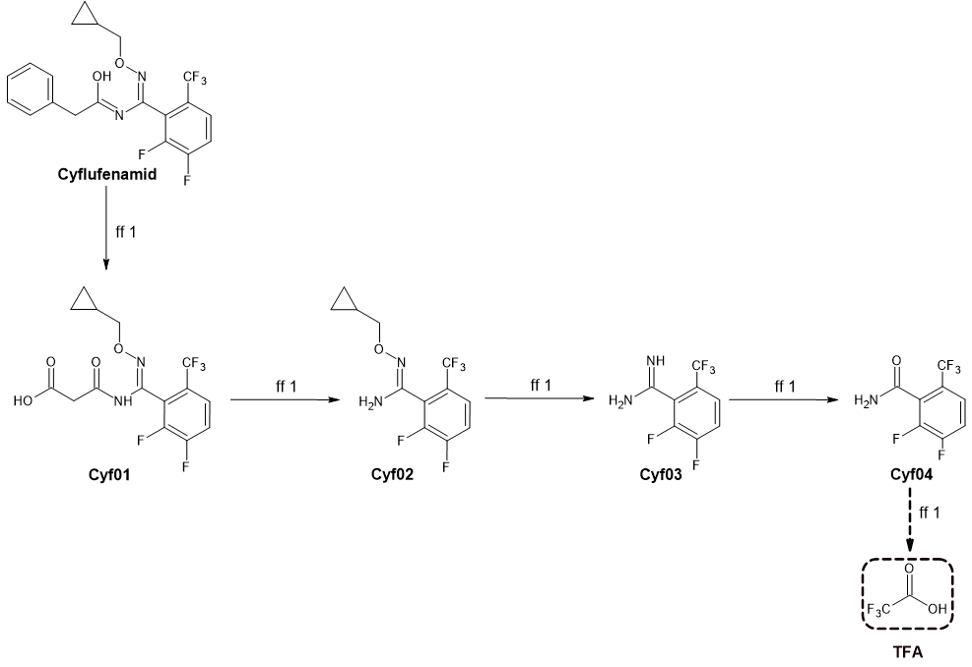
Figure S1 Degradation scheme for cyflufenamid with formation fraction (ff) used.

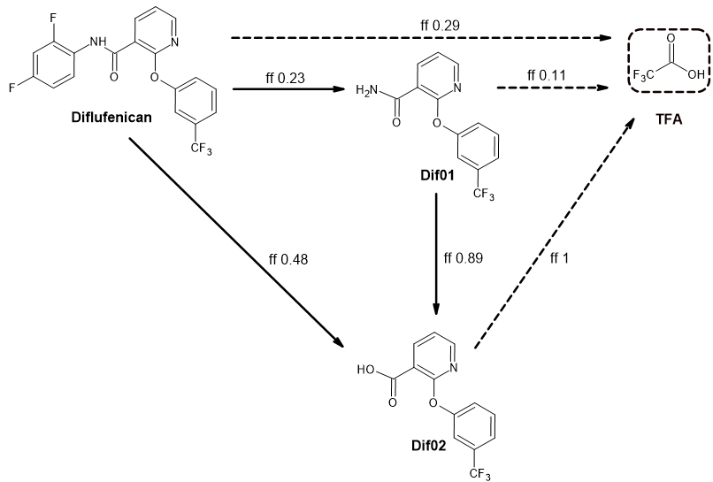
Figure S2 Degradation scheme for diflufenican with formation fraction (ff) used.
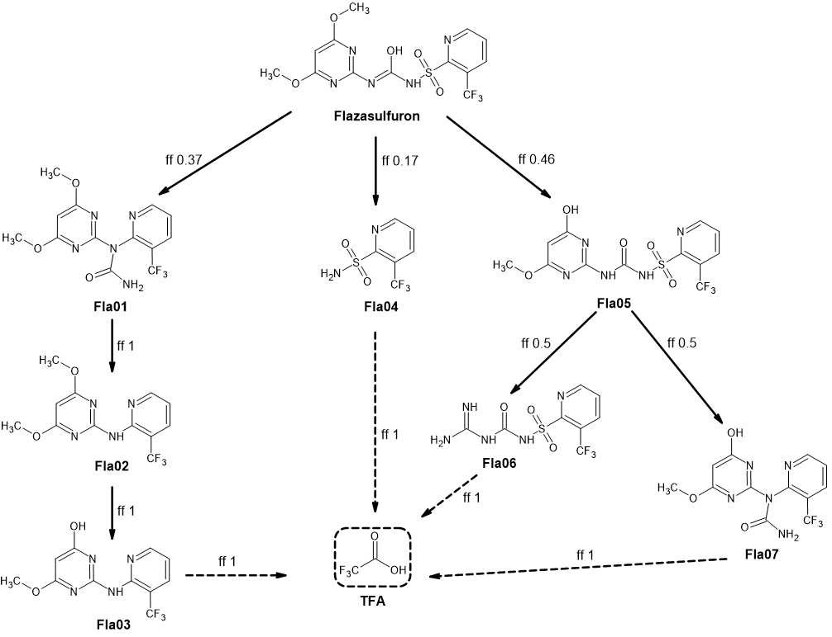
Figure S3 Degradation scheme for flazasulfuron with formation fraction (ff) used.

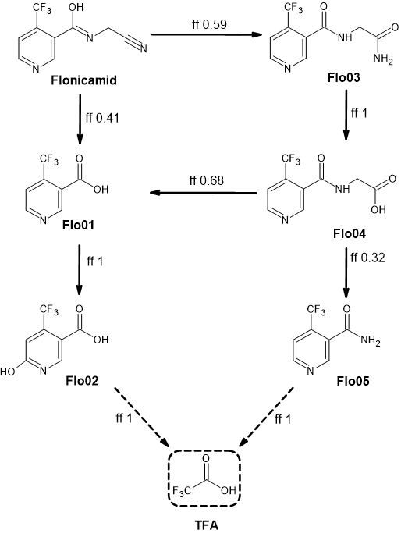
Figure S4 Degradation scheme for flonicamid with formation fraction (ff) used.

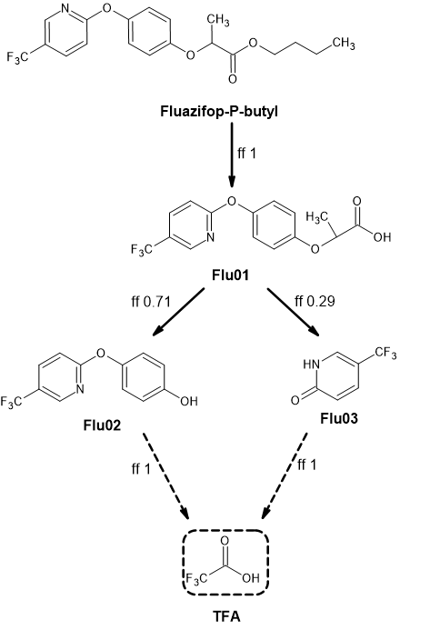
Figure S5 Degradation scheme for fluazifop-P with formation fraction (ff) used.
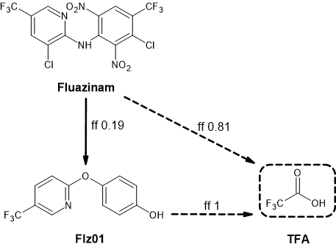
Figure S6 Degradation scheme for fluazinam with formation fraction (ff) used.

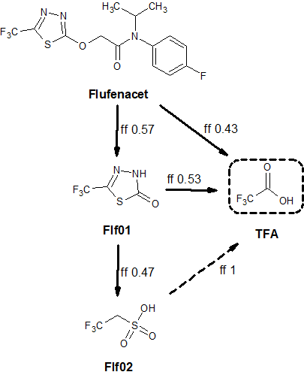
Figure S7 Degradation scheme for flufenacet with formation fraction (ff) used.

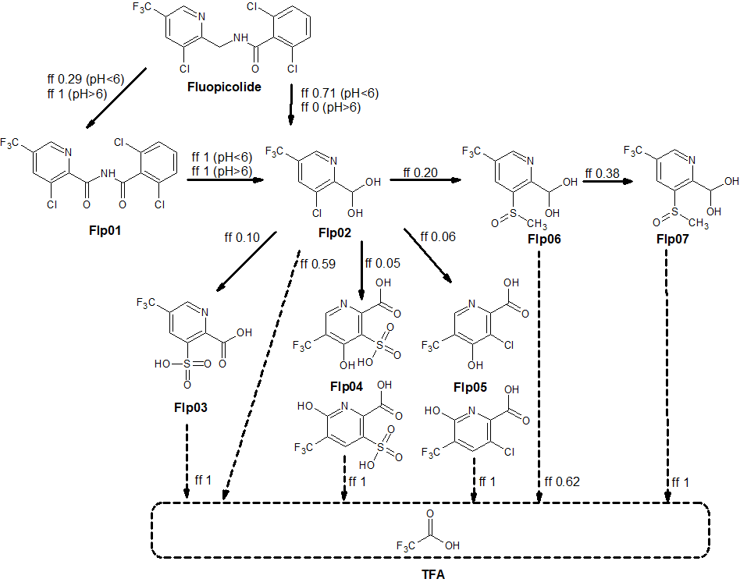
Figure S8 Degradation scheme for fluopicolide with formation fraction (ff) used.

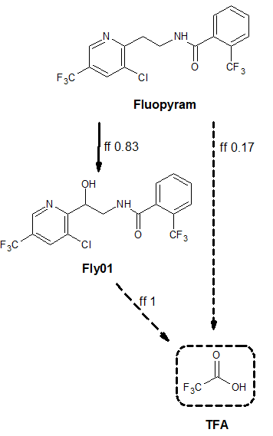
Figure S9 Degradation scheme for fluopyram with formation fraction (ff) used.

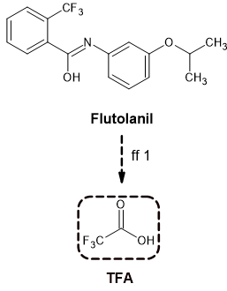
Figure S10 Degradation scheme for flutolanil with formation fraction (ff) used.

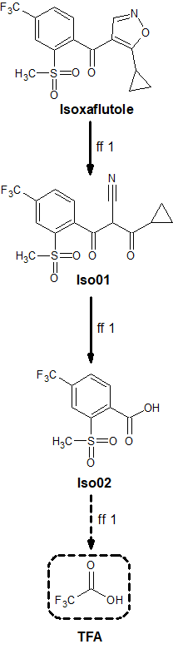
Figure S11 Degradation scheme for isoxaflutole with formation fraction (ff) used.

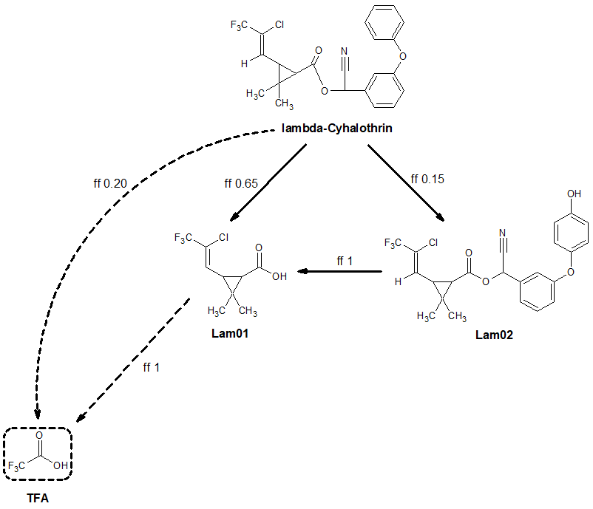
Figure S12 Degradation scheme for lambda-cyhalothrin with formation fraction (ff) used.

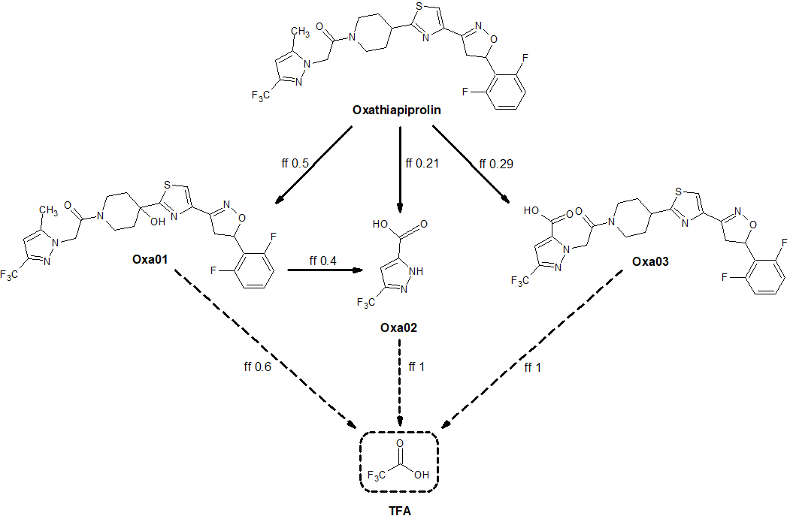
Figure S13 Degradation scheme for oxathiapiprolin with formation fraction (ff) used.
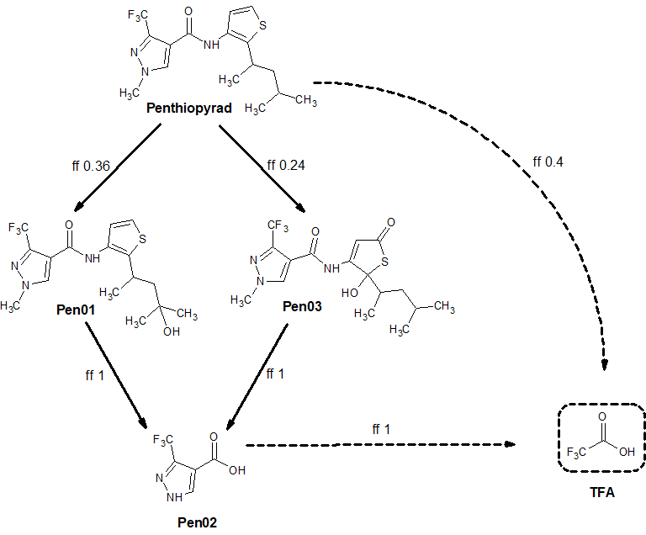
Figure S14 Degradation scheme for penthiopyrad with formation fraction (ff) used.

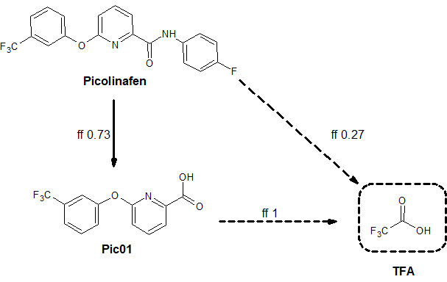
Figure S15 Degradation scheme for picolinafen with formation fraction (ff) used.

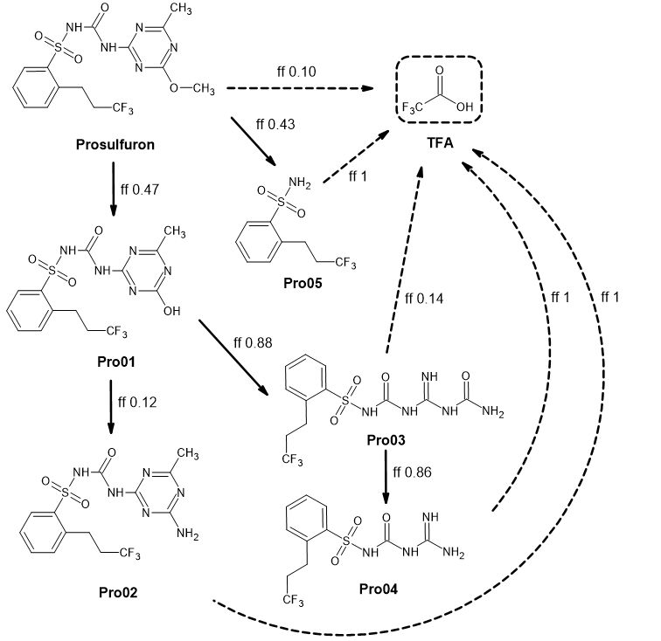
Figure S16 Degradation scheme for prosulfuron with formation fraction (ff) used.

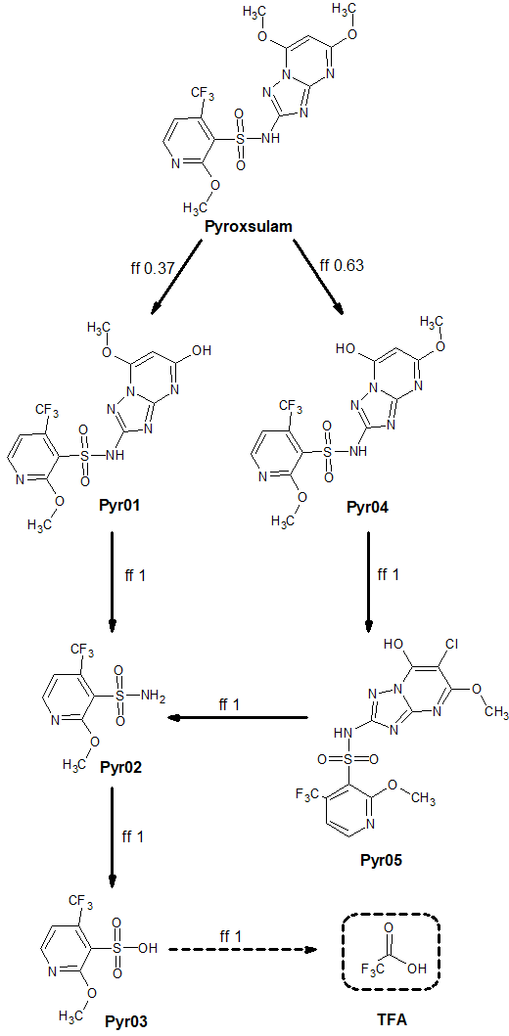
Figure S17 Degradation scheme for pyroxsulam with formation fraction (ff) used.

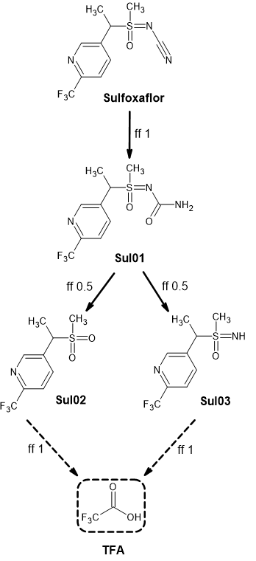
Figure S18 Degradation scheme for sulfoxaflor with formation fraction (ff) used.

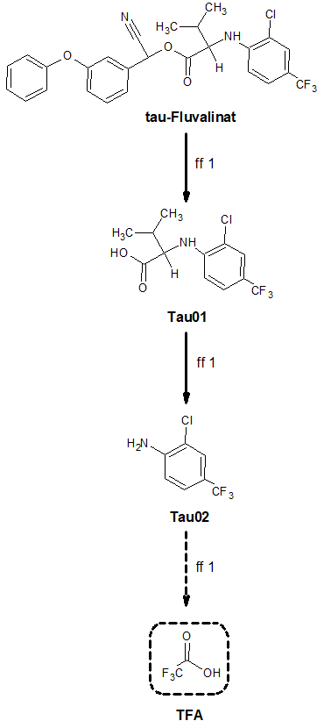
Figure S19 Degradation scheme for tau-fluvalinat with formation fraction (ff) used.

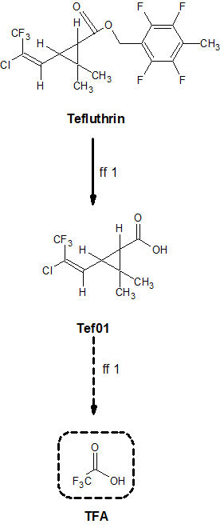
Figure S20 Degradation scheme for tefluthrin with formation fraction (ff) used.

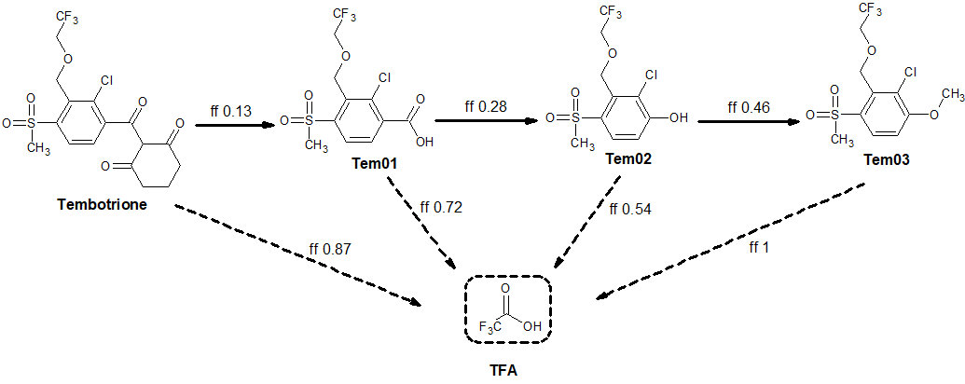
Figure S21 Degradation scheme for tembotrione with formation fraction (ff) used.

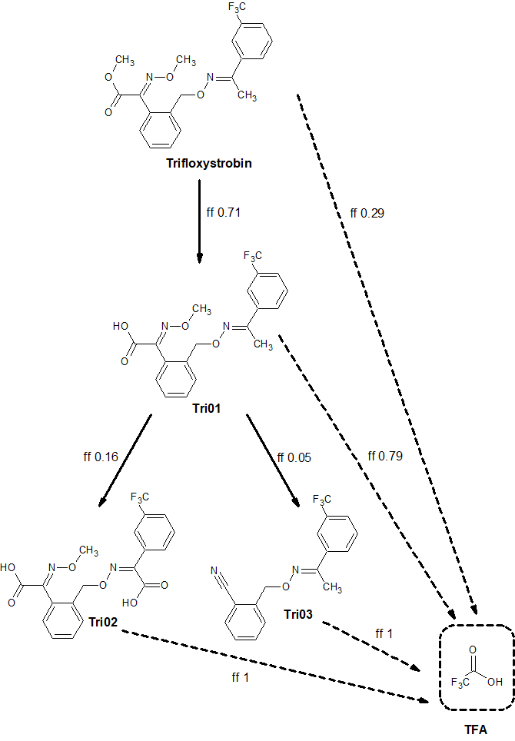
Figure S22 Degradation scheme for trifloxystrobin with formation fraction (ff) used.

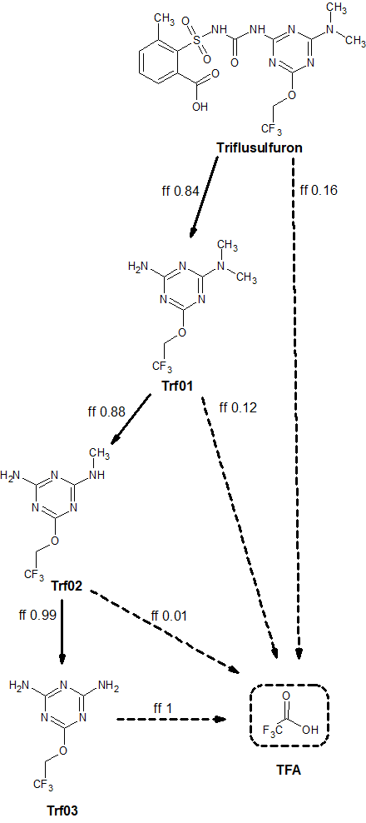
Figure S23 Degradation scheme for triflusulfuron with formation fraction (ff) used.

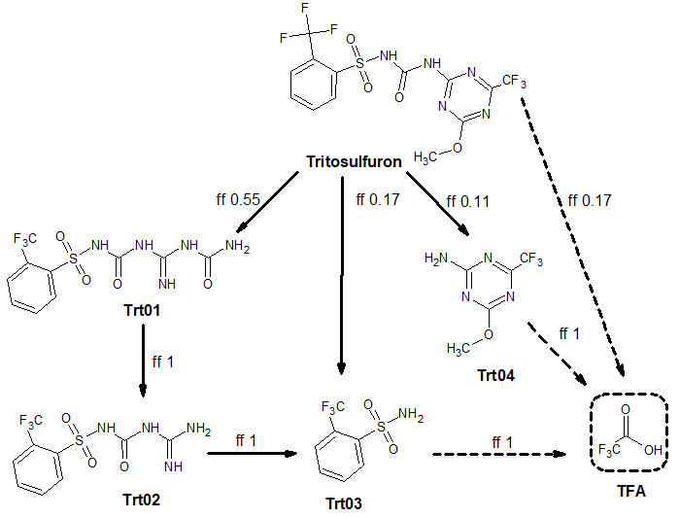
Figure S24 Degradation scheme for tritosulfuron with formation fraction (ff) used.
Table S5 Overview on the results for the first prioritisation criterion “c_{TFA}”
Application code | Total number of groundwater scenarios | Number of groundwater scenarios with a modelled TFA concentration c_{TFA} ≥ 10 µg/L | First criterion for prioritisation fulfilled? (Yes/No)
Herbicides
Diflu_cereals_winter | 9 | 9 | yes
Diflu_cereals_spring | 6 | 6 | yes
Flaza_vine | 7 | 0 | no
Flaza_citrus | 4 | 0 | no
Flaza_olive | 4 | 0 | no
Fluaz_pome | 9 | 6 | yes
Fluaz_pea | 4 | 3 | yes
Fluaz_bean | 5 | 4 | yes
Fluaz_potato | 9 | 6 | yes
Fluaz_oilseed_winter | 6 | 3 | yes
Fluaz_oilseed_summer | 3 | 1 | no
Flufe_cereals_winter | 9 | 9 | yes
Isoxa_maize | 8 | 5 | yes
Picol_cereals_winter | 9 | 6 | yes
Prosu_maize | 8 | 0 | no
Pyrox_cereals_winter | 9 | 0 | no
Tembo_maize | 8 | 3 | no
Trifl_pome | 9 | 8 | yes
Trifl_vine | 7 | 6 | yes
Trifl_strawberry | 4 | 4 | yes
Trisu_sugarbeet | 9 | 2 | no
Trisu_chicory | 7 | 0 | no
Trito_cereals_winter | 9 | 4 | no
Trito_cereals_spring | 6 | 1 | no
Trito_maize | 8 | 2 | no
Fungicides
Cyflu_cereals_winter | 9 | 0 | no
Fluna_potato | 9 | 9 | yes
Fluop_vine | 7 | 6 | yes
Fluop_potato | 9 | 8 | yes
Flupy_vine | 7 | 7 | yes
Flupy_strawberry | 4 | 4 | yes
Flupy_tomato | 5 | 5 | yes
Fluto_flower | 6 | 6 | yes
Fluto_potato | 9 | 9 | yes
Oxath_vine | 7 | 0 | no
Oxath_potato | 9 | 0 | no
Oxath_tomato | 5 | 0 | no
Penth_pome | 9 | 9 | yes
Penth_tomato | 5 | 4 | yes
Penth_cucurbits | 7 | 3 | no
Insecticides
Floni_potato | 9 | 6 | yes
Floni_cereals_winter | 9 | 1 | no
Floni_cereals_spring | 6 | 0 | no
Floni_pome | 9 | 8 | yes
Floni_peach | 9 | 6 | yes
Lambd_cereals_spring | 6 | 0 | no
Lambd_cereals_winter | 9 | 0 | no
Lambd_tomato | 5 | 0 | no
Lambd_plum | 9 | 0 | no
Lambd_potato | 9 | 0 | no
Lambd_peach | 9 | 0 | no
Sulfo_tomato | 5 | 0 | no
Sulfo_cucurbits | 9 | 0 | no
Sulfo_cereals_spring | 6 | 0 | no
Sulfo_cereals_winter | 9 | 0 | no
Sulfo_cotton | 2 | 0 | no
Taufl_potato | 9 | 0 | no
Taufl_cereals_winter | 9 | 0 | no
Taufl_cereals_spring | 6 | 0 | no
Teflu_sugarbeet | 9 | 0 | no

Table S6 Overview on the results for the second prioritisation criterion “ratio between c_{TFA} and F_{TFA}”
Application code | Total number of scenarios | Number of scenarios with a ratio above 75th percentile* | Second criterion for prioritisation fulfilled? (Yes/No)
Herbicides
Diflu_cereals_winter | 9 | 6 | yes
Diflu_cereals_spring | 6 | 5 | yes
Flaza_vine | 7 | 0 | no
Flaza_citrus | 4 | 0 | no
Flaza_olive | 4 | 0 | no
Fluaz_pome | 9 | 0 | no
Fluaz_pea | 4 | 0 | no
Fluaz_bean | 5 | 0 | no
Fluaz_potato | 9 | 0 | no
Fluaz_oilseed_winter | 6 | 0 | no
Fluaz_oilseed_summer | 3 | 0 | no
Flufe_cereals_winter | 9 | 6 | yes
Isoxa_maize | 8 | 0 | no
Picol_cereals_winter | 9 | 6 | yes
Prosu_maize | 8 | 0 | no
Pyrox_cereals_winter | 9 | 1 | no
Tembo_maize | 8 | 0 | no
Trifl_pome | 9 | 6 | yes
Trifl_vine | 7 | 0 | no
Trifl_strawberry | 4 | 1 | no
Trisu_sugarbeet | 9 | 4 | no
Trisu_chicory | 7 | 0 | no
Trito_cereals_winter | 9 | 2 | no
Trito_cereals_spring | 6 | 0 | no
Trito_maize | 8 | 0 | no
Fungicides
Cyflu_cereals_winter | 9 | 0 | no
Fluna_potato | 9 | 9 | yes
Fluop_vine | 7 | 0 | no
Fluop_potato | 9 | 0 | no
Flupy_vine | 7 | 0 | no
Flupy_strawberry | 4 | 2 | yes
Flupy_tomato | 5 | 0 | no
Fluto_flower | 6 | 0 | no
Fluto_potato | 9 | 1 | no
Oxath_vine | 7 | 0 | no
Oxath_potato | 9 | 0 | no
Oxath_tomato | 5 | 0 | no
Penth_pome | 9 | 0 | no
Penth_tomato | 5 | 0 | no
Penth_cucurbits | 7 | 2 | no
Insecticides
Floni_potato | 9 | 0 | no
Floni_cereals_winter | 9 | 8 | yes
Floni_cereals_spring | 6 | 5 | yes
Floni_pome | 9 | 7 | yes
Floni_peach | 9 | 7 | yes
Lambd_cereals_spring | 6 | 5 | yes
Lambd_cereals_winter | 9 | 5 | yes
Lambd_tomato | 5 | 3 | no
Lambd_plum | 9 | 6 | yes
Lambd_potato | 9 | 1 | no
Lambd_peach | 9 | 6 | yes
Sulfo_tomato | 5 | 0 | no
Sulfo_cucurbits | 9 | 1 | no
Sulfo_cereals_spring | 6 | 0 | no
Sulfo_cereals_winter | 9 | 3 | no
Sulfo_cotton | 2 | 1 | yes
Taufl_potato | 9 | 0 | no
Taufl_cereals_winter | 9 | 0 | no
Taufl_cereals_spring | 6 | 0 | no
Teflu_sugarbeet | 9 | 0 | no
* 75th percentile values were 0.594 for the Châteaudun scenario, 0.565 for the Hamburg scenario, 0.808 for the Jokioinen scenario, 0.332 for the Kremsmünster scenario, 0.290 for the Okehampton scenario, 0.510 for the Piacenza scenario, 0.215 for the Porto scenario, 1.040 for the Sevilla scenario and 1.151 for the Thiva scenario.

Table S7 Overview on the results for the third prioritisation criterion “EU-wide TFA formation potential” F_{TFA,EU}
Application code | EU-wide TFA formation potential F_{TFA,EU} [t] (balancing approach) | Number of scenarios with a ratio above 75th percentile (288.5 t)
Herbicides
Diflu_cereals_winter | 3042.4 | yes
Diflu_cereals_spring | 3042.4 | yes
Flaza_vine | 44.0 | no
Flaza_citrus | 7.2 | no
Flaza_olive | 58.0 | no
Fluaz_pome | 95.2 | no
Fluaz_pea | 126.9 | no
Fluaz_bean | 105.0 | no
Fluaz_potato | 216.0 | no
Fluaz_oilseed_winter | 841.2 | yes
Fluaz_oilseed_summer | 32.7 | no
Flufe_cereals_winter | 4226.5 | yes
Isoxa_maize | 1780.6 | yes
Picol_cereals_winter | 1700.2 | yes
Prosu_maize | 61.0 | no
Pyrox_cereals_winter | 276.2 | no
Tembo_maize | 290.0 | yes
Trifl_pome | 24.1 | no
Trifl_vine | 142.7 | no
Trifl_strawberry | 5.3 | no
Trisu_sugarbeet | 18.2 | no
Trisu_chicory | 0.4 | no
Trito_cereals_winter | 1436.8 | yes
Trito_cereals_spring | 1436.8 | yes
Trito_maize | 287.1 | no
Fungicides
Cyflu_cereals_winter | 116.4 | no
Fluna_potato | 314.2 | yes
Fluop_vine | 149.3 | no
Fluop_potato | 81.3 | no
Flupy_vine | 361.8 | yes
Flupy_strawberry | 12.5 | no
Flupy_tomato | 28.0 | no
Fluto_flower | No data available | not available  (n.a. and thus: no)
Fluto_potato | 1266.0 | yes
Oxath_vine | 35.9 | no
Oxath_potato | 16.0 | no
Oxath_tomato | 2.2 | no
Penth_pome | 139.0 | no
Penth_tomato | 8.1 | no
Penth_cucurbits | 2.3 | no
Insecticides
Floni_potato | 44.2 | no
Floni_cereals_winter | 390.8 | yes
Floni_cereals_spring | 390.8 | yes
Floni_pome | 23.4 | no
Floni_peach | 3.7 | no
Lambd_cereals_spring | 192.0 | no
Lambd_cereals_winter | 192.0 | no
Lambd_tomato | 1.5 | no
Lambd_plum | 1.2 | no
Lambd_potato | 7.4 | no
Lambd_peach | 0.7 | no
Sulfo_tomato | 1.0 | no
Sulfo_cucurbits | 0.7 | no
Sulfo_cereals_spring | 55.4 | no
Sulfo_cereals_winter | 55.4 | no
Sulfo_cotton | 1.3 | no
Taufl_potato | 8.4 | no
Taufl_cereals_winter | 671.7 | yes
Taufl_cereals_spring | 122.1 | no
Teflu_sugarbeet | 287.1 | no

Abbreviation:
1/n: Freundlich exponent (without unit)
A: Crop production areas A (in 1000 ha)
AR: Application rate (g active substance/ha)
a.s.: active substance
BBCH: identifier of the development stages of plants
CI: crop interception (%)
c_{TFA}: modelled groundwater concentration of TFA (µg/L)
Cyf: Cyflufenamid
Dif: Diflufenican)
DT₅₀: Degradation half-life in soil for aerobic degradation (days)
ff: formation fraction
Fla: Flazasulfuron
Flf: Flufenacet
Flo: Flonicamid
Flp: Fluopicolide
Flt: Flutolanil
Flu: Fluazifop-P
Fly: Fluopyram
Flz: Fluazinam
F_{TFA}: TFA formation potential (in tonnes)
F_{TFA,EU}: EU-wide TFA formation potential (in tonnes)
Iso: Isoxaflutole
K_{om}: partition coefficient normalised to organic matter (in L/kg)
Lam: lambda-Cyhalothrin
M: Molar mass (g/mol)
n: number of applications
Oxa: Oxathiapiprolin
Pen: Penthiopyrad
PHI: preharvest interval or the wait time between a pesticide application and when a crop can be harvested
Pic: Picolinafen
Pro: Prosulfuron
Pyr: Pyroxsulam
Sul: Sulfoxaflor
Tau: tau-Fluvalinat
Tef: Tefluthrin
Tem: Tembotrione
TFA: Trifluoroacetate
Tri: Trifloxystrobin
Trf: Triflusulfuron-methyl
Trt: Tritosulfuron

