Supporting information
Dynamics of rainfall, discharge, suspended sediment and micropollutant transport in the Moselle River, Central Europe
Magdalena Uber^{a*}, Liza-Marie Beckers^{b}, Simon Terwehª, Peer Helmkeª, Thomas Hoffmannª
ª Department of Fluvial Morphology, Sediment Dynamics and Management, Federal Institute of Hydrology, 56068 Koblenz, Germany
^{b} Department of Aquatic Chemistry, Federal Institute of Hydrology, 56068 Koblenz, Germany
* Corresponding author. E-mail address: Magdalena.Uber@baw.de. Present address: Federal Waterways Engineering and Research Institute, 22559 Hamburg, Germany

Additional figures
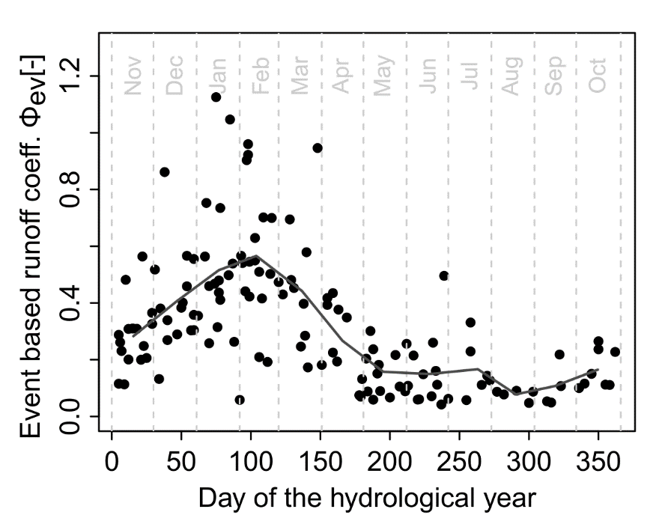
Figure S1 Temporal dynamic of the event-based runoff coefficient. Each point represents one event. The line connects the monthly means.
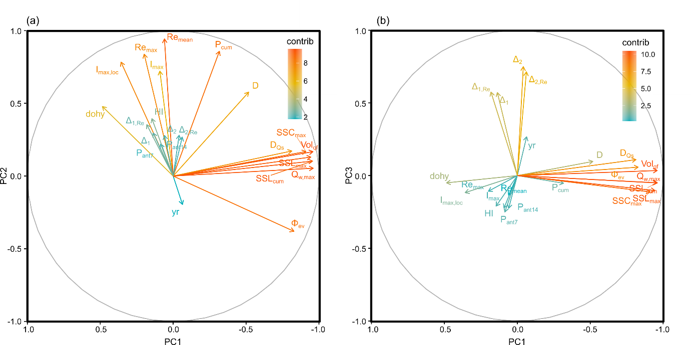
Figure S2 Contribution of the metrics to the PC1 and PC2 (a) and to PC1 and PC3 (b) in the event-based principal component analysis.
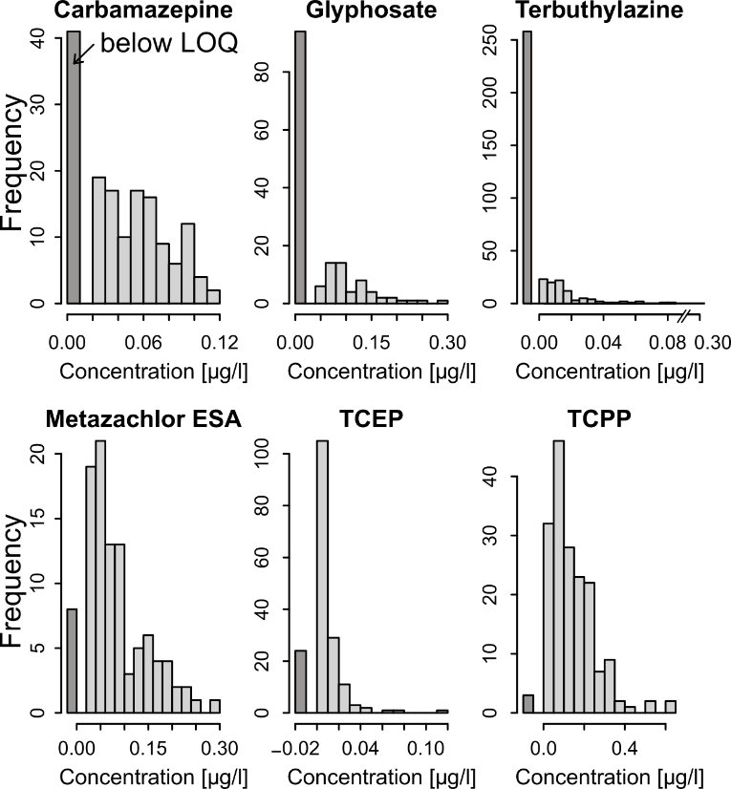
Figure S3 Distributions of the six selected OMPs in 14-day composite samples taken in the Moselle River at Koblenz between 2009 and 2022. The left bar always gives the number of samples below the limit of quantification (LOQ).
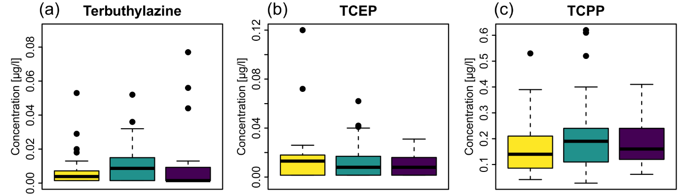
Figure S4 Concentrations of the OMPs therbuthylazine, TCEP and TCPP in sampling periods classified by the cluster analysis.

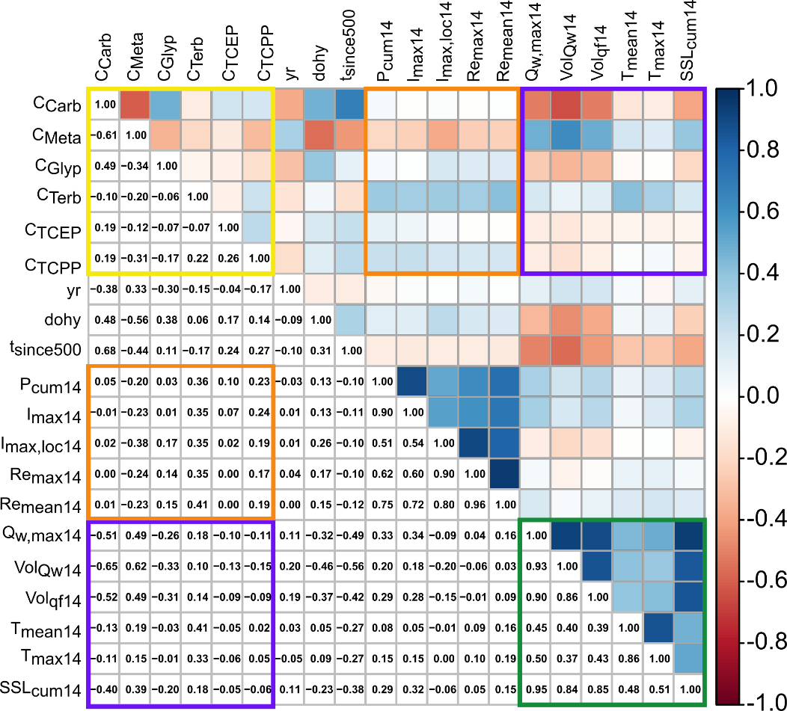
Figure S5 Correlation matrix of the selected sample-based metrics. The values given in the lower left panel and visualized in the upper right panel give Pearsons correlation coefficient.

