SUPPORTING INFORMATION
Comparative Assessment of Screening Workflows for characterizing occupational exposure to chemicals in humans: An EU-PARC interlaboratory study
Baninia Habchi^{1*}, Aurélie Martin Remy¹, Lidia Belova², Adrian Covaci², Annelaure Damont³, Tina Kosjek^{4,5}, Carolin Huber⁶, Nathalie Grova¹, Guillaume Antoine¹, Tarek Moufawad⁷, Eirini Baira⁸, Christian Baudry⁹, Clément Chalet³, Riccardo De Santo¹⁰, Gaud Dervilly⁷, Radu Corneliu Duca^{11,12,13}, François Fenaille³, Mariana F. Fernández^{14,15}, Catherine Gabriel^{16,17}, Corentin Huet⁷, Gaëlle Jadé⁹, Anna Laura Iamiceli¹⁸, Ardiana Kajtazi², Olli Kärkkäinen¹⁹, Konstantinos M. Kasiotis⁸, Alkistis Kevrekidou^{16,17}, Štěpán Koudelka^{20,21}, Lucyna Kozlowska²², Marja Lamoree²³, Michel Laurentie²⁴, Bruno Le Bizec⁷, Rosalie Nijssen²⁵, Herbert Oberacher²⁶, Elliott J. Price^{20,21}, Helena Plešnik^{4,5}, Žan Rekar^{4,5}, Andrea Rodriguez-Carrillo^{14,15}, Dimosthenis Sarigiannis^{16,17}, Jean-Marie Savignac²⁷, Marta Stelmasiak²², Katriina Sunnarborg^{19,28}, Aikaterini Termentzi⁸, An Van Nieuwenhuyse^{11,12}, Romain Vuillaume²⁷, Emma L. Schymanski²⁹, Douglas N. Rutledge^{30,31,32}, Jean-Philippe Antignac⁷, Sophie Ndaw¹
¹INRS (French National Research and Safety Institute for the Prevention of Occupational Accidents and Diseases), Department of Toxicology and Biomonitoring, France
²Toxicological Centre, University of Antwerp, Antwerp, Belgium
³Université Paris-Saclay, CEA, INRAE, Département Médicaments et Technologies pour la Santé (DMTS), MetaboHUB, F-91191 Gif sur Yvette, France
⁴Jožef Stefan Institute, Ljubljana, Slovenia
⁵Jožef Stefan International Postgraduate School, Ljubljana, Slovenia
⁶Department of Exposure Science, Helmholtz Centre for Environmental Research – UFZ, Permoserstr. 15, Leipzig, German
⁷Oniris, INRAE, LABERCA, Nantes, France
⁸Laboratory of Pesticides' Toxicology, Scientific Directorate of Pesticides Control and Phytopharmacy, Benaki Phytopathological Institute, 145 61 Kifissia, Greece
⁹Ploufragan‑Plouzané‑Niort Laboratory, Ruminant Diseases and Welfare Unit, French Agency for Food, Environmental and Occupational Health & Safety, 60 Rue Pied de Fond, 28440, 79024 Niort, CS, France
¹⁰Department of Chemistry, Sapienza University, Piazzale Aldo Moro 5, 00185 Rome, Italy
¹¹Laboratoire national de santé, Department Health Protection, Dudelange, Luxembourg
¹²Environment and Health, Department of Public Health and Primary Care, KU Leuven, Leuven, Belgium
¹³Department of Health Protection, Health Directorate, Ministry of Health and Social Security, Strassen, Luxembourg
¹⁴Instituto de Investigación Biosanitaria de Granada (ibs.GRANADA), 18016 Granada, Spain. & Spanish Consortium for Research on Epidemiology and Public Health (CIBERESP), Madrid, Spain
¹⁵Biomedical Research Center (CIBM), Department Radiology and Physical Medicine, School of Medicine, University of Granada, 18016 Granada, Spain
¹⁶Aristotle University of Thessaloniki, Department of Chemical Engineering, Environmental Engineering Laboratory, University Campus, Thessaloniki 54124, Greece
¹⁷HERACLES Research Center on the Exposome and Health, Center for Interdisciplinary Research and Innovation, Balkan Center, Bldg. B, 10th km Thessaloniki – Thermi Road, 57001, Greece
¹⁸Department of Environment and Health, Italian National Institute for Health (ISS), Rome, Italy
¹⁹School of Pharmacy, University of Eastern Finland, Kuopio, Finland
²⁰RECETOX, Faculty of Science, Masaryk University, Kotlarska 2, Brno, Czech Republic
²¹Czech node of the European Infrastructure for Human Exposome Research (EIRENE-CZ)
²²Warsaw University of Life Sciences, Institute of Human Nutrition Science, Nowoursynowska 166, 02-787 Warsaw, Poland
²³Vrije Universiteit Amsterdam, Amsterdam Institute for Life and Environment (A-LIFE), Section Chemistry for Environment and Health, De Boelelaan 1085, 1081 HV Amsterdam, the Netherlands
²⁴Statistical Analysis Platform, French Agency for Food, Environmental and Occupational Health & Safety, 10 Bis Rue Claude Bourgelat, 35306 Fougères Laboratory, Fougères, France
²⁵Wageningen Food Safety Research, part of Wageningen University and Research, Wageningen, The Netherlands
²⁶Medical University of Innsbruck, Institute of Legal Medicine and Core Facility Metabolomics, Austria
²⁷Univ Toulouse, EI-Purpan, ENVT, INRAE, Toxalim, Toulouse, France
²⁸Finnish Institute of Occupational Health, Oulu, Finland
²⁹Luxembourg Centre for Systems Biomedicine (LCSB), University of Luxembourg, 6 avenue du Swing, 4367, Belvaux, Luxembourg
³⁰Muséum national d’Histoire naturelle, France
³¹Charles Sturt University, Australia
³²Université Paris-Saclay, Faculté de Pharmacie, France
*Corresponding author: Dr. Baninia Habchi, INRS, Department of Toxicology and Biomonitoring, Vandoeuvre-Lès-Nancy, France. E-mail address: baninia.habchi@inrs.fr
Table of contents

1. Background level and blank contamination assessment 3
2. Detectability of QA/QC mix compounds 4
3. Impact of urine specific gravity on matrix-effects and detection 6
4. Comparative evaluation of analytical methods using an S-score system 7
5. PARC-H02 – SOP for real sample analysis 8

Background level and blank contamination assessment
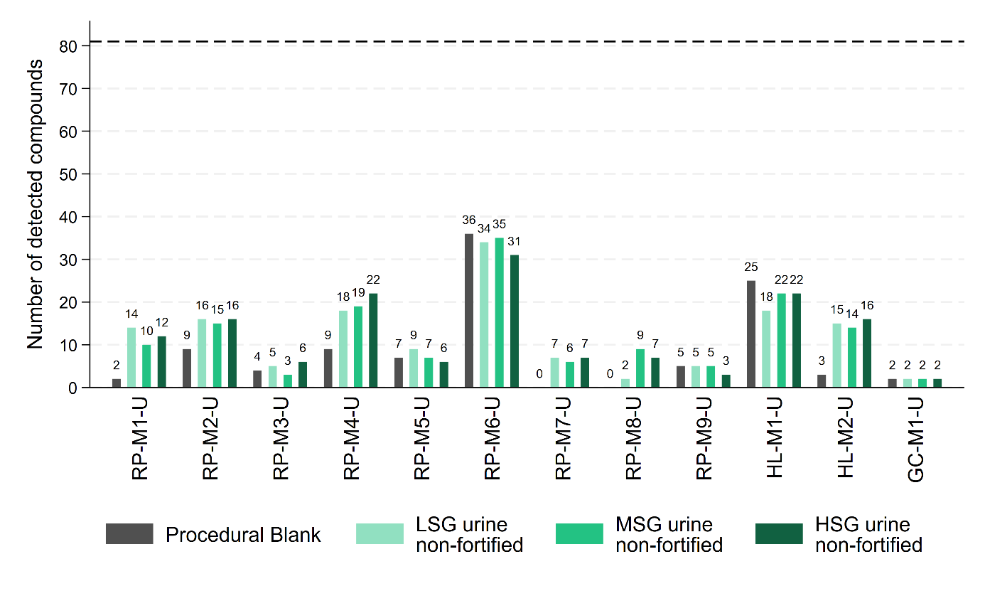
Figure S1: Number of compounds detected by each method in procedural blank (gray color) and in non-fortified urine samples (green color). The color bars reflect the number of detected compounds. While a relatively high number of compounds were reported in procedural blanks for HL-M1-U and RP-M6-U, comparison of signal intensities indicates that these compounds are predominantly present at trace levels, reflecting differences in analytical sensitivity. The lower signal intensities in blanks indicate a limited contribution of analytical contamination. The dashed line represents the maximum number of compounds analyzed, corresponding to the 81 compounds in the QA/QC mix. This definition applies to all subsequent figures.
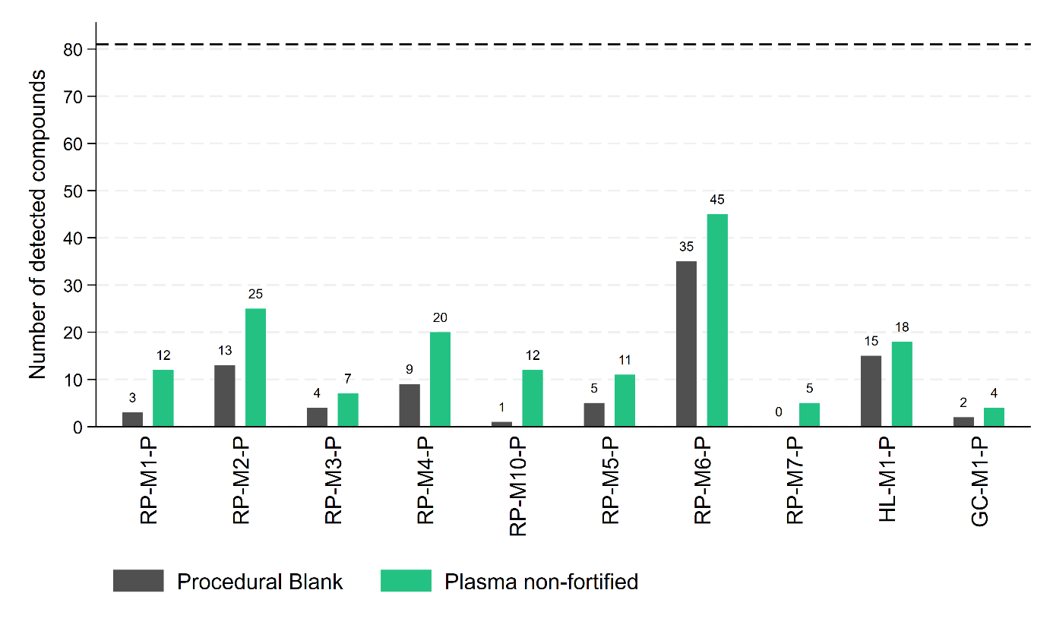
Figure S2: Number of compounds detected by each method in procedural blank (gray color) and in non-fortified plasma sample (green color). The color bars reflect the number of detected compounds. While a relatively high number of compounds were reported in procedural blanks for RP-M6-U, comparison of signal intensities indicates that these compounds are predominantly present at trace levels, reflecting differences in analytical sensitivity. The lower signal intensities in blanks indicate a limited contribution of analytical contamination.

Detectability of QA/QC mix compounds

(a)  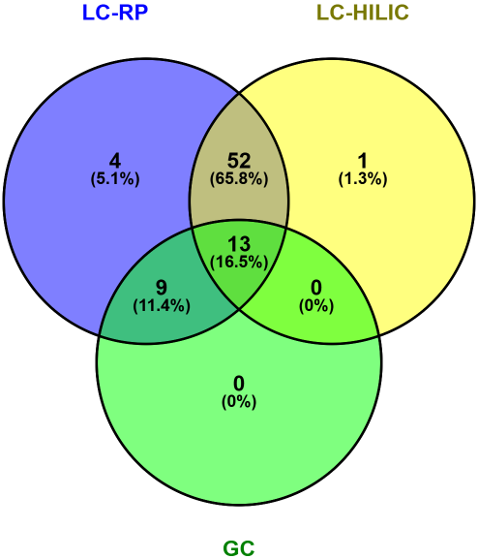
  LC-RP | LC-HILIC
  Tris(2,3-dibromopropyl) phosphate (TDBPP) | 2,3,4,5-Tetrabromophenol
  AMPA - Aminomethyl)phosphonic acid
  Glyphosate
  Sevoflurane
(b)  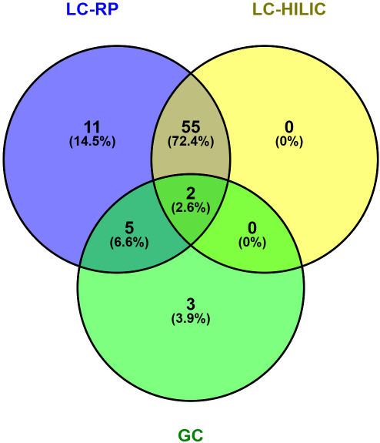
  LC-RP | GC
  Paclitaxel | Benz[a]anthracene
  Tris(1,3-dichloro-2-propyl) phosphate (TDCPP) | Benzo[a]pyrene
  Triclosan | Indeno[1,2,3-cd]pyrene
  2,6-Diethylaniline
  Tris(2,3-dibromopropyl) phosphate (TDBPP)
  alpha-hexabromocyclododecane
  Deoxynivalenol (DON)
  alpha-Fluoro-beta-alanine
  Cytarabine
  5-azacytidine
  Sevoflurane
(c)  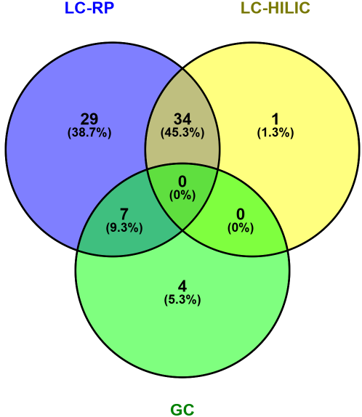
  LC-RP | LC-HILIC | GC
  2,4-Dihydroxybenzophenone  3,5,6-Trichloro-2-pyridinol  Chlorfenvinphos  2,3,4,5-Tetrachlorophenol  Mono-2-ethylhexyl phthalate (MEHP)  Fipronil  Triclosan  Cyclophosphamide  Bentazone  3-Phenoxybenzoic acid  Tris(1,3-dichloro-2-propyl) phosphate (TDCPP)  Paclitaxel  2,6-Diethylaniline  2,4-Dibromophenol  Tris(2,3-dibromopropyl) phosphate (TDBPP)  Etoposide  4-Nitrophenol  Butylparaben  Deoxynivalenol (DON)  Fumonisin b1 (FB1)  Methotrexate  Aminopterin  Ciprofloxacin  Bisphenol S monoglucuronide / Bisphenol S Bis-b-d-Glucuronide  Bisphenol A  alpha-hexabromocyclododecane  AMPA - Aminomethyl)phosphonic acid  Dihydrocaffeic acid 3-sulfate  Ibuprofen | Paraquat | Benz[a]anthracene  Benzo[a]pyrene  Indeno[1,2,3-cd]pyrene  2,2',4,4',5,5'-Hexachlorobiphenyl  (PCB-153)
Figure S3: Comparison of compound detection between RP, HILIC and GC methods in (a) the QA/QC mixture, (b) urine samples and (c) plasma samples.

Impact of urine specific gravity on matrix-effects and detection

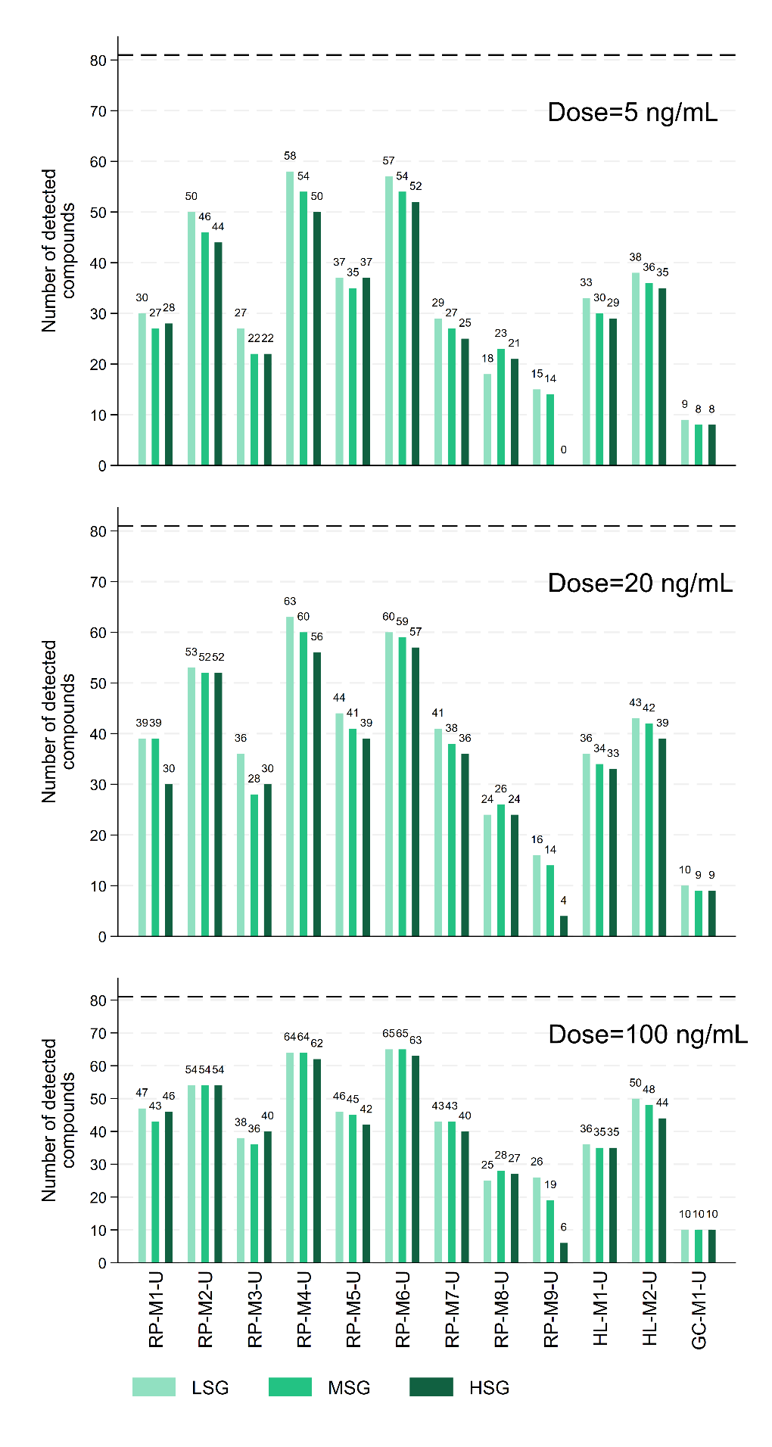
Figure S4: Number of compounds detected by each method in urine samples, shown for each specific gravity (LSG, MSG and HSG) level and for each spiking level (5, 20, and 100 ng/mL in urine).

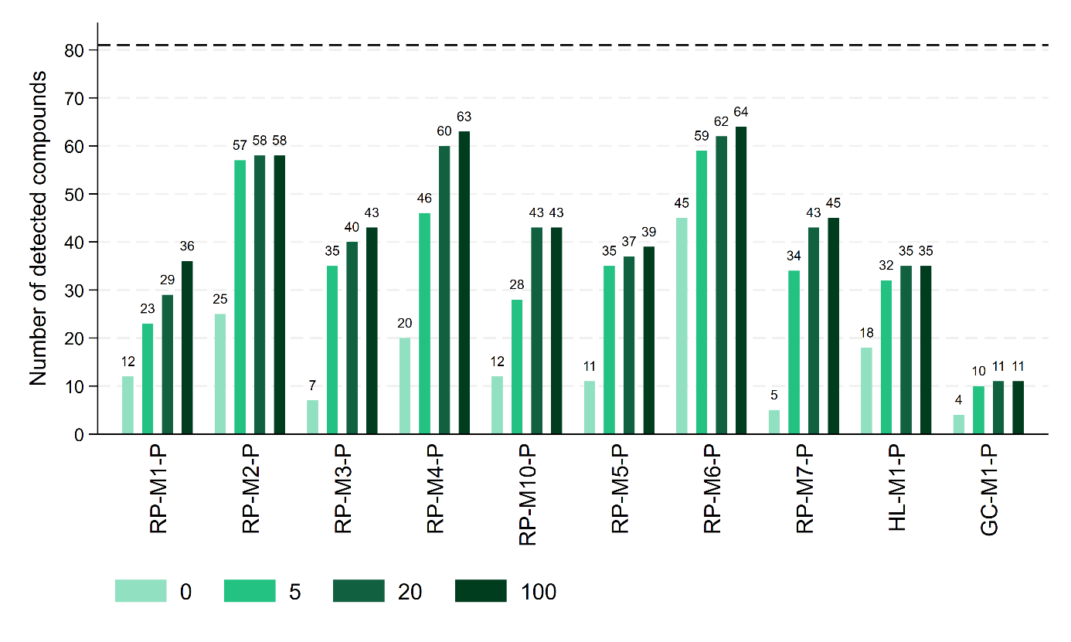
Figure S5: Number of compounds detected by each method in plasma samples, shown for each spiking level (5, 20, and 100 ng/mL in plasma).

Comparative evaluation of analytical methods using an S-score system
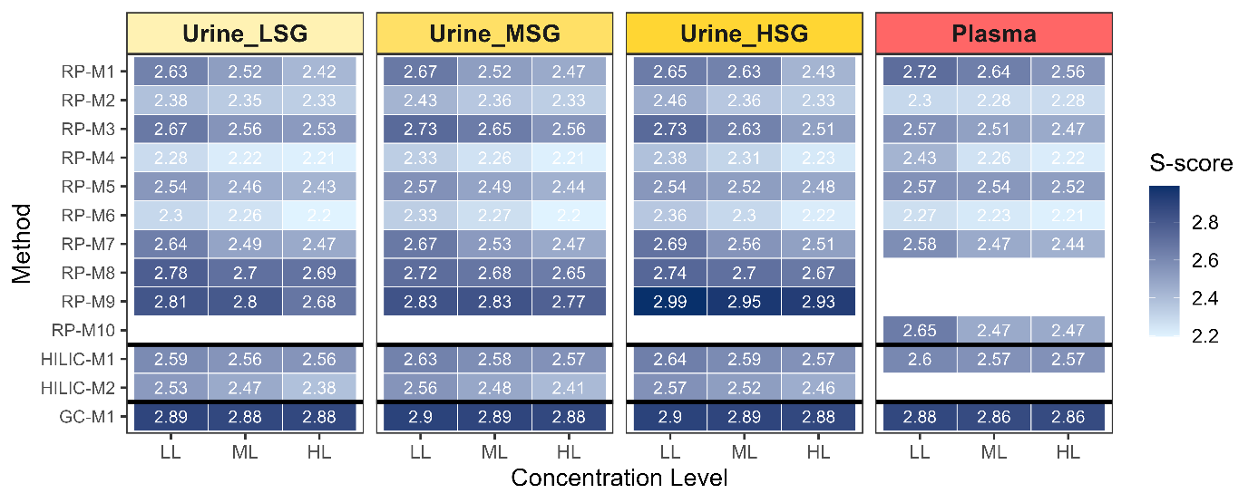
Figure S6: S-scores designed to evaluate binary qualitative results using four scoring methods, which may or may not be combined to produce a summary score. Evaluation method n° 3 was selected: an integer value of 1 indicates that 100% of the compounds were detected, while an integer value of 2 indicates that at least one compound was not detected. The decimal part corresponds to the percentage of incorrect results among the 81 compounds analyzed. S-scores calculated for the different analytical methods at the three fortification levels (LL, ML and HL corresponding to 5, 20, and 100 ng/mL). In urine samples, S-scores are shown for each specific gravity matrix (LSG, MSG and HSG).

PARC-H02 – SOP for real sample analysis

This SOP, considered as a project-specific operational guidance summarizes:
The sequence and file-naming rules (as described in the Supporting Information table file - Table S20)
The samples that partners will receive
The samples each partner must prepare
The minimum requirements for sample preparation and analysis across laboratories
1. Samples provided to partners
Partners will receive the following materials. All steps must be performed, but the exact details are left up to the individual laboratories, though they must be captured in laboratory records/notebooks.
NORMAN standard (1 µg/mL); partners have already received this mix during the H02 interlaboratory study → dilute to 200 ng/mL before injection with the appropriate solvent according to each partner’s method.
H02-QC solvent standard (25 standards, 10 µg/mL) → prepared by INRS (The French National Research and Safety Institute for the Prevention of Occupational accidents and Diseases) at 10 µg/mL→ dilute to 100 ng/mL before injection with the appropriate solvent according to each partner’s method.
T02-QC solvent standard (10 µg/mL) → dilute 1:100 with the appropriate solvent according to each partner’s method to prepare the T02-QC solvent standard at 100 ng/mL and the T02-QC solvent sample (check sequence). Use to spike QC-2 (50 ng/mL in biological matrix) and QC-1 (5 ng/mL in biological matrix).
Ref-Matrix QC-HL prepared at INRS, spiked at 50 ng/mL in biological matrix with the H02 QC mix → Process and analyze exactly as real samples.
Internal labelled markers (10 µg/mL) => add to all samples (real study samples, QC-2, QC-1, matrix blanks, field blanks, procedural blanks) at the beginning of the extraction process → The final concentration in sample must be 100 ng/mL.
External labelled markers (10 µg/mL) → add to all extracts after completion of the extraction procedure directly in the reconstitution solvent before analysis → The final concentration in the extract must be 50 ng/mL.
Real study samples from 4.1 partners => to be analyzed according to the capacity of each partner.
2. Samples partners must prepare
Each partner laboratory is responsible for preparing the following materials:
Pooled non-spiked matrix: lab-specific pooled QC urine or plasma prepared from the 4.1 biological samples analyzed by each lab. Before starting the extractions, partners should prepare the Pooled Non-Spiked Matrix using all samples. They should calculate the required volume for all sequences and prepare this pool once. Once the pooled matrix is prepared, they should aliquot it into the required number of aliquots to prepare the non-spiked pool, QC-2 HL, and QC-1 LL for all sequences. These aliquots are then used to prepare each batch of biological samples. For a sequence of 100 biological samples, partners should prepare three pooled non-spiked matrices and six QC-2 HL and six QC-1 LL samples (15 pooled matrices in total).
If 1 mL of urine is required per sample, 15 mL of pooled urine matrix is needed. With 100 urine samples, this corresponds to pooling 150 µL from each sample.
QC-2 HL (50 ng/mL in urine or plasma): Prepared by spiking the pooled matrix with the T02 QC mix (check sequence).
QC-1 LL (5 ng/mL in urine or plasma): Prepared by spiking the pooled matrix with the T02 QC mix (check sequence).
Procedural blank: A procedural blank is prepared using the full in-house sample-preparation workflow, with the addition of internal and external labelled markers but without biological matrix (for example, replacing urine or plasma by an equivalent volume of ultrapure water). If a 100-sample sequence is prepared in multiple batches (e.g., three batches of ~40 samples), one procedural blank must be prepared per batch or at least 3 procedural blanks per analytical sequence. All resulting procedural blanks are then pooled to create a single homogeneous procedural blank representing the entire sequence. This pooled procedural blank (1 vial) is injected twice, once at the beginning and once at the end of the analytical sequence. A new pooled procedural blank must be prepared for each separate sequence of 100 biological samples.
Field blanks: Prepared only if applicable, depending on the sampling procedures used by 4.1 partners (the French National Research and Safety Institute for the Prevention of Occupational Accidents and Diseases (INRS) should check with 4.1 partners).
Samples: Real study samples to be processed according to each partner’s capacity and workflow capacity.

3. Minimum requirements (mandatory for all partners)
Solvent selection (extraction and LC mobile phases): use solvents with broad polarity coverage (e.g., mixtures of methanol or acetonitrile with water) to maximize analyte recovery and minimize methodological bias.
Deconjugation: should be strictly avoided during sample preparation by all participating partners, to ensure optimal comparability of analytical results across laboratories.
SPE: should not be performed systematically unless clearly required.
Add internal and external labelled markers to all samples, including all QC and blank samples.
Follow the injection sequence exactly as described in the Excel sequence table (Table S20).
File naming rules: use the following format YYYYMMDD_XXX_SAMPLE_IonMode_Instrument_Lab where XXX = injection order.
Each partner must perform all steps, including: sample preparation, data acquisition, data processing, feature extraction and identification (based on their in-house SOP/databases and a common suspect list from project 4.1 that will be shared during 2026 + addition of conjugated forms). In addition, each laboratory will perform an initial statistical analysis using basic multivariate approaches, including at least Principal Component Analysis (PCA) and Partial Least Squares Discriminant Analysis (PLS-DA), to ensure that each partner can generate an internally interpretable dataset. Subsequently, all datasets will be centrally collected and subjected to harmonized multivariate and statistical analyses by a designated central partner, using the same approaches, enabling comprehensive cross-study comparison, group discrimination assessment, consistency and complementarity across all datasets.

A unified reporting template will be developed jointly with project H01. Partners will report all data following this template (planned for September 2026).

