Supplementary Materials

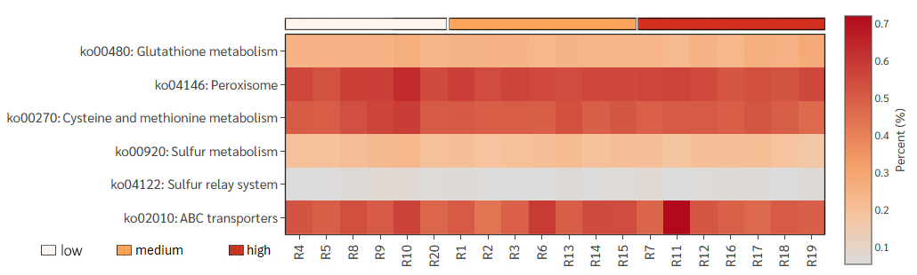
Figure S1. Heatmap of the predicted relative abundance of fungal functional pathways related to cadmium and heavy-metal resistance, inferred from ITS amplicon data using FunFun. Rows show KEGG functional categories grouped by biological role; columns show individual samples. Colour intensity indicates the predicted relative abundance (%).

Table S1. Summary of sequencing output and read-processing statistics for the bacterial (16S rRNA) and fungal (ITS1) amplicon datasets.
sample-id | #Input read | #filtered read | # denoised read | #non-chimeric read | # ASVs
16S rRNA
R11 | 168,534 | 115,771 | 110,646 | 108,412 | 2,249
R12 | 149,579 | 103,276 | 96,243 | 95,472 | 2,862
R16 | 165,000 | 117,827 | 112,196 | 111,045 | 2,638
R17 | 162,471 | 113,638 | 108,875 | 107,773 | 2,504
R18 | 151,608 | 111,354 | 106,072 | 104,602 | 2,435
R19 | 156,391 | 107,019 | 101,322 | 99,419 | 2,460
R7 | 157,667 | 106,672 | 98,954 | 98,125 | 2,753
R10 | 170,411 | 81,258 | 74,701 | 74,006 | 2,321
R20 | 153,862 | 108,459 | 100,507 | 98,354 | 2,328
R4 | 171,570 | 120,387 | 113,725 | 110,326 | 2,153
R5 | 154,773 | 97,126 | 90,953 | 89,772 | 2,729
R8 | 163,961 | 112,776 | 105,374 | 104,296 | 2,870
R9 | 156,998 | 98,214 | 92,303 | 91,044 | 2,110
R1 | 149,997 | 100,687 | 96,099 | 94,735 | 2,431
R13 | 148,448 | 94,173 | 88,133 | 86,358 | 2,234
R14 | 159,920 | 105,447 | 97,167 | 96,401 | 2,382
R15 | 169,327 | 118,156 | 109,625 | 108,266 | 3,141
R2 | 179,261 | 123,846 | 118,661 | 117,397 | 2,631
R3 | 165,779 | 108,862 | 103,533 | 101,909 | 2,382
R6 | 159,759 | 102,950 | 97,450 | 95,756 | 2,411
ITS
R11 | 96,067 | 49,755 | 49,055 | 48,511 | 171
R12 | 180,610 | 74,502 | 72,745 | 72,311 | 424
R16 | 181,938 | 106,217 | 104,923 | 103,830 | 217
R17 | 176,478 | 87,003 | 86,059 | 85,489 | 111
R18 | 196,845 | 102,439 | 101,292 | 96,083 | 223
R19 | 173,245 | 86,316 | 85,553 | 84,469 | 139
R7 | 184,336 | 111,986 | 110,575 | 110,265 | 360
R10 | 186,430 | 105,265 | 103,784 | 99,893 | 331
R20 | 187,588 | 93,779 | 92,167 | 91,234 | 424
R4 | 112,644 | 46,037 | 44,958 | 44,891 | 386
R5 | 184,315 | 78,517 | 76,777 | 75,908 | 247
R8 | 176,037 | 96,703 | 94,737 | 93,918 | 438
R9 | 186,587 | 69,655 | 68,200 | 67,597 | 252
R1 | 190,685 | 50,691 | 49,517 | 49,259 | 238
R13 | 190,770 | 136,743 | 135,093 | 133,330 | 324
R14 | 177,268 | 82,186 | 80,266 | 79,665 | 333
R15 | 185,178 | 70,611 | 68,686 | 68,496 | 445
R2 | 193,021 | 30,064 | 29,158 | 28,482 | 214
R3 | 193,606 | 103,796 | 102,390 | 100,790 | 342
R6 | 199,438 | 117,570 | 115,846 | 113,331 | 398

Table S2. Spearman correlation coefficients (ρ) and P-values between each of the top 10 most abundant bacterial and fungal genera and soil cadmium concentration.
Genus | Spearman ρ vs Cd | P-value
Top 10 bacterial genera
Streptomyces | -0.1248 | 0.5935
Agromyces | -0.3459 | 0.1178
Micromonospora | 0.2887 | 0.2007
Nocardioides | -0.1398 | 0.5490
Gaiella | -0.3579 | 0.1039
Solirubrobacter | -0.2271 | 0.3226
Neobacillus | -0.2120 | 0.3573
Anaeromyxobacter | 0.7504 | 0.0000
Nitrospira | -0.0165 | 0.9440
MND1 | 0.2241 | 0.3294
Top 10 fungal genera
Helicoma | -0.4045 | 0.0606
Cyphellophora | -0.0436 | 0.8531
Aspergillus | -0.4090 | 0.0572
Penicillium | -0.1444 | 0.5359
Talaromyces | -0.3008 | 0.1809
Trichoderma | -0.4782 | 0.0209
Myrmecridium | -0.3639 | 0.0974
Ganoderma | -0.2692 | 0.2357
Moesziomyces | -0.2451 | 0.2834
Mortierella | 0.2962 | 0.1882

Table S3. Relative abundance of predicted functional pathway related to cadmium and heavy-metal resistance (percent of total predicted gene content; mean ± standard deviation).
KO ID/  pathway | Predicted function (KEGG) | Low Cd  (≤ 1.50 mg/kg) | Medium Cd  (1.51-9.80 mg/kg) | High Cd  (≥ 9.81 mg/kg)
Bacterial functional profile by PICRUSt2
K00383 | Glutathione reductase, NADPH (gor) [EC:1.8.1.7] | 0.0099 ± 0.0036 | 0.0106 ± 0.0030 | 0.0101 ± 0.0032
K00799 | Glutathione S-transferase (gst) [EC:2.5.1.18] | 0.1060 ± 0.0273 | 0.1107 ± 0.0217 | 0.1146 ± 0.0303
K01919 | Glutamate–cysteine ligase (gshA) [EC:6.3.2.2] | 0.0191 ± 0.0025 | 0.0189 ± 0.0025 | 0.0209 ± 0.0043
K01920 | Glutathione synthase (gshB) [EC:6.3.2.3] | 0.0155 ± 0.0035 | 0.0155 ± 0.0035 | 0.0162 ± 0.0053
K01738 | Cysteine synthase (cysK) [EC:2.5.1.47] | 0.0758 ± 0.0086 | 0.0788 ± 0.0036 | 0.0781 ± 0.0031
K01534 | Zn²⁺/Cd²⁺-exporting ATPase (zntA) [EC:7.2.2.12 / 7.2.2.21] | 0.0306 ± 0.0083 | 0.0320 ± 0.0035 | 0.0311 ± 0.0033
K16264 | Cobalt–zinc–cadmium efflux system protein | 0.0426 ± 0.0033 | 0.0434 ± 0.0022 | 0.0417 ± 0.0043
K15725 | Outer-membrane protein, heavy-metal RND efflux system | 0.0340 ± 0.0095 | 0.0296 ± 0.0066 | 0.0376 ± 0.0078
K15726 | Inner-membrane protein, heavy-metal RND efflux system | 0.0429 ± 0.0127 | 0.0374 ± 0.0089 | 0.0467 ± 0.0106
K15727 | Membrane-fusion protein, heavy-metal RND efflux system | 0.0484 ± 0.0144 | 0.0430 ± 0.0090 | 0.0541 ± 0.0135
Fungal functional profile by FUNFUN
ko00480 | Glutathione metabolism | 0.250 ± 0.013 | 0.242 ± 0.004 | 0.249 ± 0.019
ko04146 | Peroxisome | 0.570 ± 0.040 | 0.555 ± 0.012 | 0.544 ± 0.022
ko00270 | Cysteine and methionine metabolism | 0.531 ± 0.041 | 0.506 ± 0.021 | 0.497 ± 0.024
ko00920 | Sulfur metabolism | 0.208 ± 0.020 | 0.200 ± 0.011 | 0.192 ± 0.019
ko04122 | Sulfur relay system | 0.067 ± 0.008 | 0.063 ± 0.006 | 0.065 ± 0.010
ko02010 | ABC transporters | 0.518 ± 0.031 | 0.517 ± 0.052 | 0.525 ± 0.087

