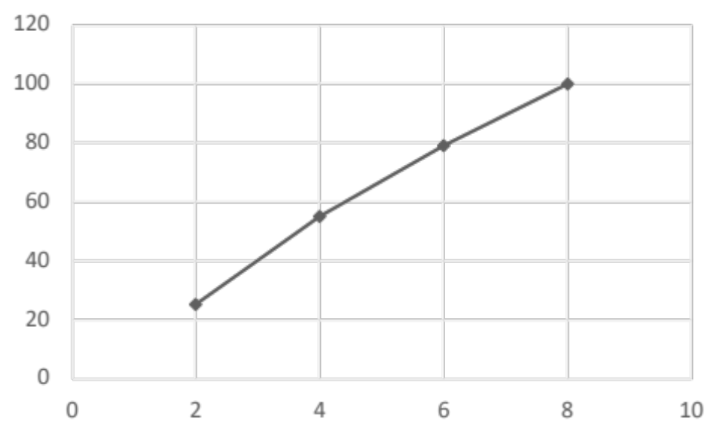

Graph 1. Percentage of population affected (in weeks) following a dose of COVID-19 vaccination.

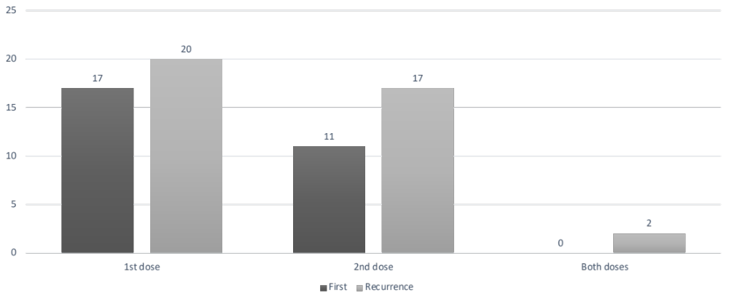

Graph 2. Type of occurrence of inflammatory manifestations following dose of vaccine.

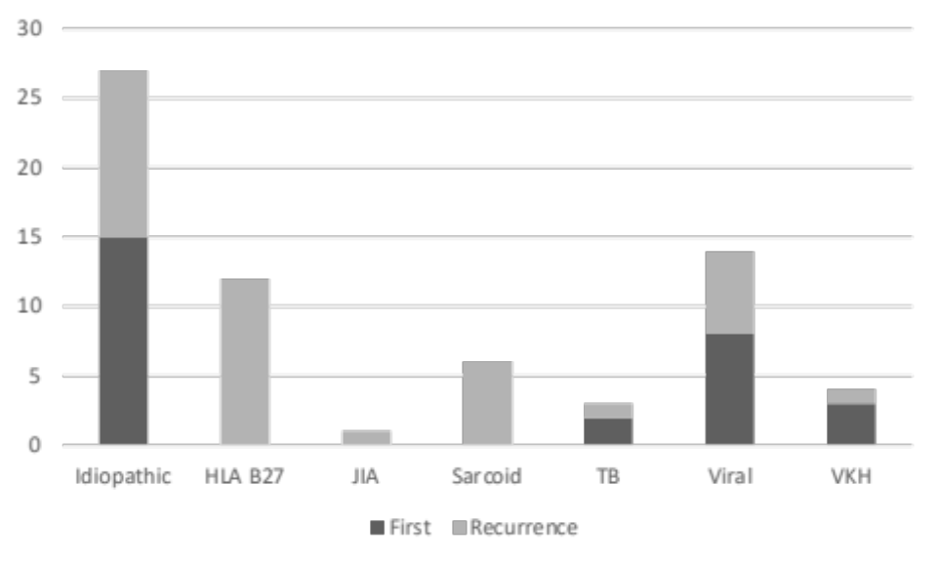

Graph 3. Etiological diagnosis and type of occurrence showing that cases with autoimmune uveitis primarily showed recurrence of inflammation and rarely presented with a first episode of disease.

