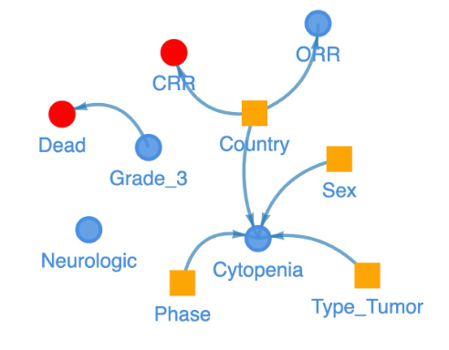
Supplementary Figure 1. Causal reasoning graphs based on multiple elements from this meta-analysis. Yellow square refers to phenotype of patients including cancer stages, gender, population. The circle represents the outcomes. The red shows key outcomes, including dead event and CRR. Arrow shows the causal direction.
Methods: Causal reasoning graphs
At first, assuming that the constraints ['Phase ',' Sex ',' Type_Tumor ',' Country '] are not result variables, and ['ORR', 'CRR', 'Dead'] are not dependent variables. The adverse reactions ["Cytopenia", "Grade_3", "Neurological"] are common and have no internal cause and effect.
In determining the threshold for edge removal, we conducted a systematic exploration across a range of values from 0 to 1, with increments of 0.1. This meticulous investigation aimed to strike a balance between preserving meaningful edges and minimizing undesirable effects on the network structure.
Upon analysis, setting the threshold to 0 resulted in a chaotic arrangement of edges, compromising the overall clarity of the network. Conversely, at a threshold of 0.2, a significant loss of edges was observed, leaving only four crucial connections related to 'sex,' 'country,' 'phase,' and tumor 'type' directing the association with Cytopenia. After careful consideration, a threshold of 0.1 was identified as the optimal choice. So, in order to reduce the influence of too many edges on the graph, we remove edges whose absolute weights are less than a defined threshold (0.1).

The strategy of literature search:
PubMed: CAR-T, Clinical Trial; Lentiviral Vector;
https://pubmed.ncbi.nlm.nih.gov/
WANFANG DATA: Lentiviral Vector, Immunotherapy, Clinical Trial;
https://www.wanfangdata.com.cn/
CNKI: CAR-T, Myeloma, Clinical Trial; CAR-T, Lymphoma, Clinical Trial;
https://www.cnki.net/

