The animal experiments were approved by the Animal Ethics Committee of Shanghai Municipal Hospital of Traditional Chinese Medicine (Approval No. 2025022). All procedures followed the relevant guidelines and regulations.

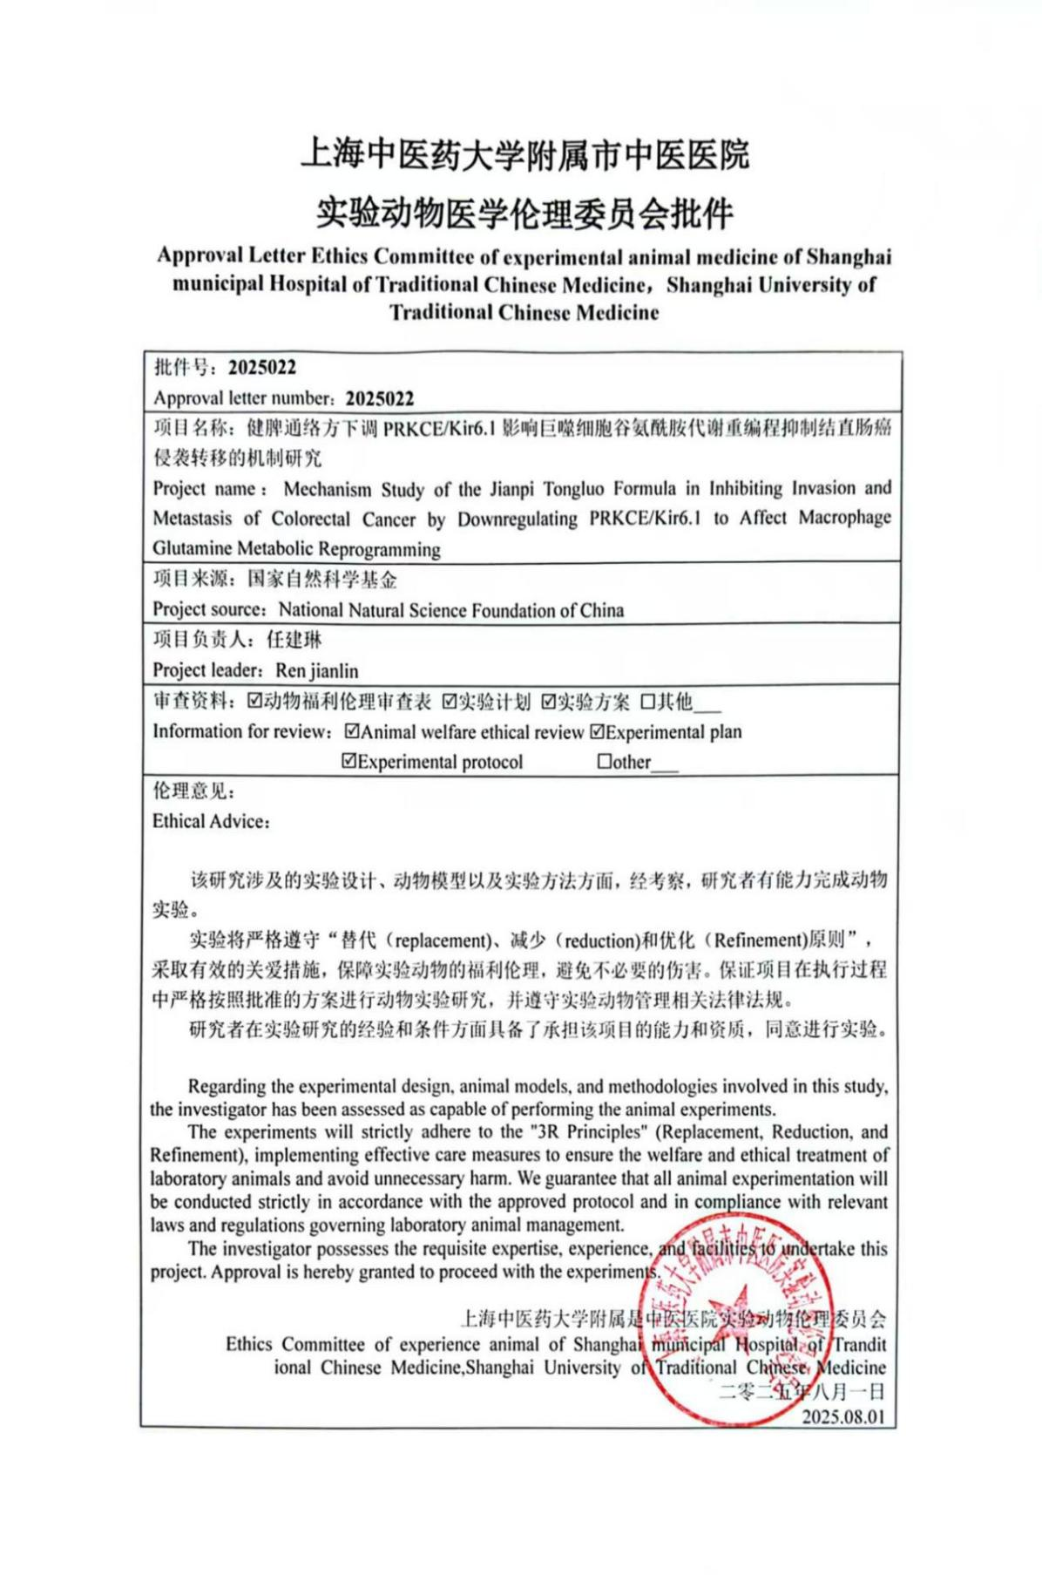
The organoid experiments and single-cell experiments involving clinical sample sources in this study were all completed before 2024. The human tissue collection and patient-derived organoid study were approved by the Ethics Committee of Shanghai Municipal Hospital of Traditional Chinese Medicine (Approval No. 2023SHL-KY-33-02).
