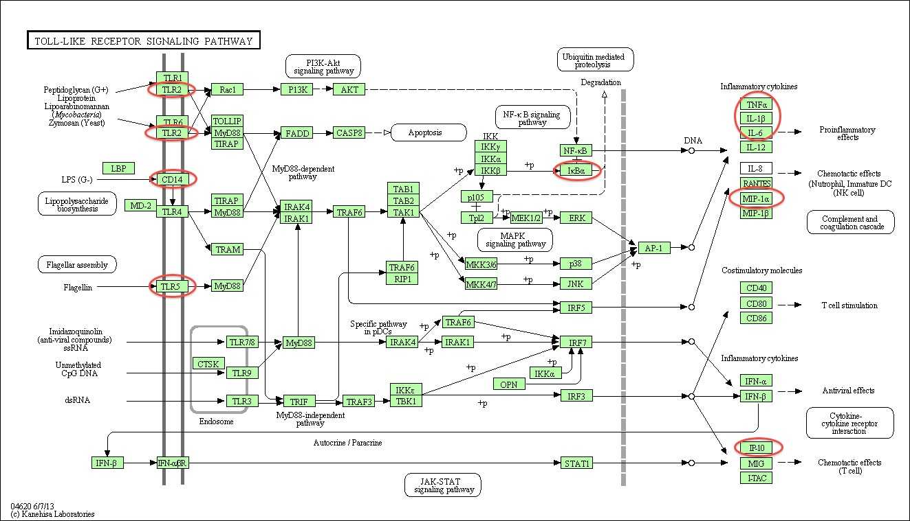
Additional file 1: Figure S1: Toll-like receptor signaling pathway including innate and adaptive immune response genes up-regulated or down-regulated by LPS-induced inflammation. The web-based DAVID Bioinformatics Resources 6.7 available through the National Institute of Allergy and Infectious Diseases (NIAID) was utilized for functional annotation and pathway map analysis. A functional clustering analysis was created based on the results of the RT-qPCR arrays. Overall, 9 genes from the innate and adaptive immune response pathway were clustered and are part of the toll-like receptor signaling pathway. With the exception of Tlr5, genes circled in red were up-regulated at 3 and/or 6 hours following LPS-induced inflammation.

