Additional information
Additional section S1: Characterization of smaller NPs used for encapsulation lipid nanoparticle system
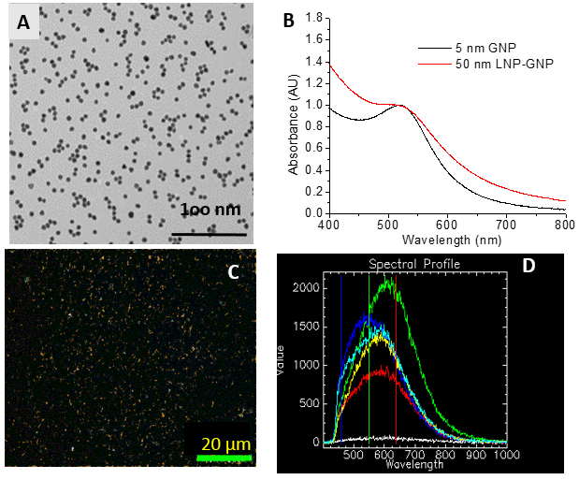
Figure S1: A) Transmission electron microscopy image, B) UV-visible spectrum of 5 nm GNPs along with LNP-GNPs, C-D) dark-field image and few spectra collected from the corresponding hyper spectral image of 5 nm nanoparticles.

Additional section S2: Biocompatibility of nanoparticles used in the study
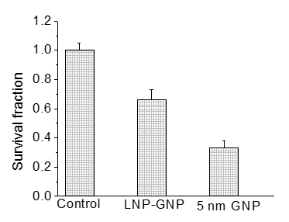
Figure S2. Biocompatibility of nanoparticles were measured using the clonogenic assay.
Additional section S3: Dark-field images of cells

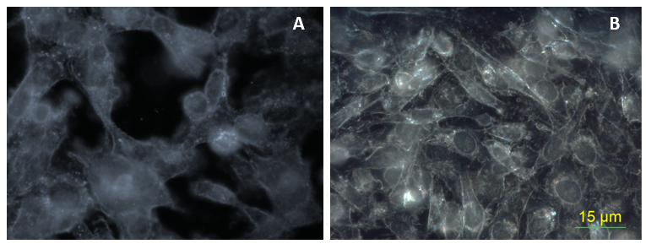
Figure S3. Dark-field images of control cells with no nanoparticles (A) and 5 nm gold nanoparticles (B).

Additional section S4: Linear accelerator set up used for the radiation experiments

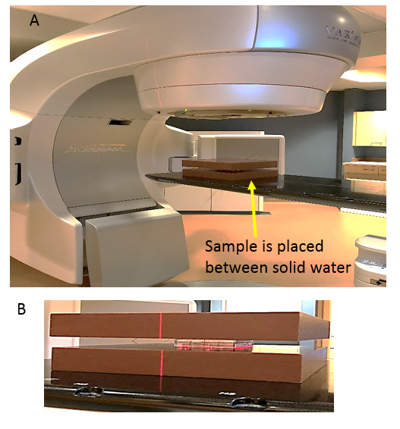
Figure S4. Linear accelerator set up used for the radiation experiments (A) and a closer look at the sample sandwiched in between solid water (B).

Additional section S5: Comparison of thymidine blocking and serum starvation methods used for tumor cell synchronization

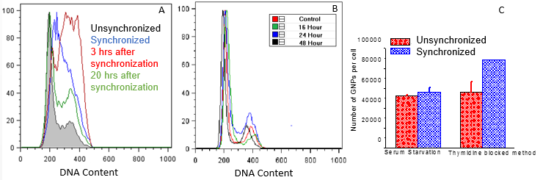
Figure S5. Comparison of thymidine blocking and serum starvation methods used for tumor cell synchronization. Progression of the phase of tumor cell population after synchronization for thymidine block method (A) and serum starvation method (B). Variation of nanoparticle uptake after 20 hrs of synchronization.

Additional section S6: Variation of DNA damage after treatment with LNP-GNPs and radiation for unsynchronized and synchronized tumor cells
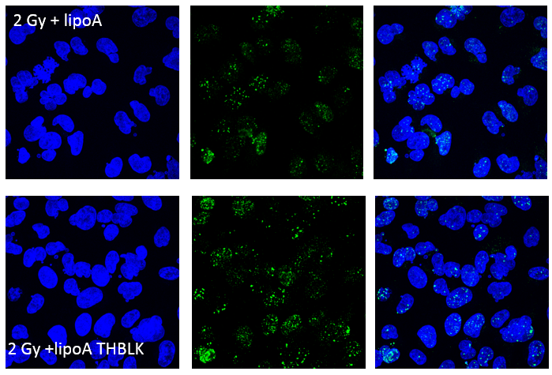
Figure S6. Variation of DNA damage after treatment with LNP-GNPs and radiation for unsynchronized and synchronized tumor cells.

