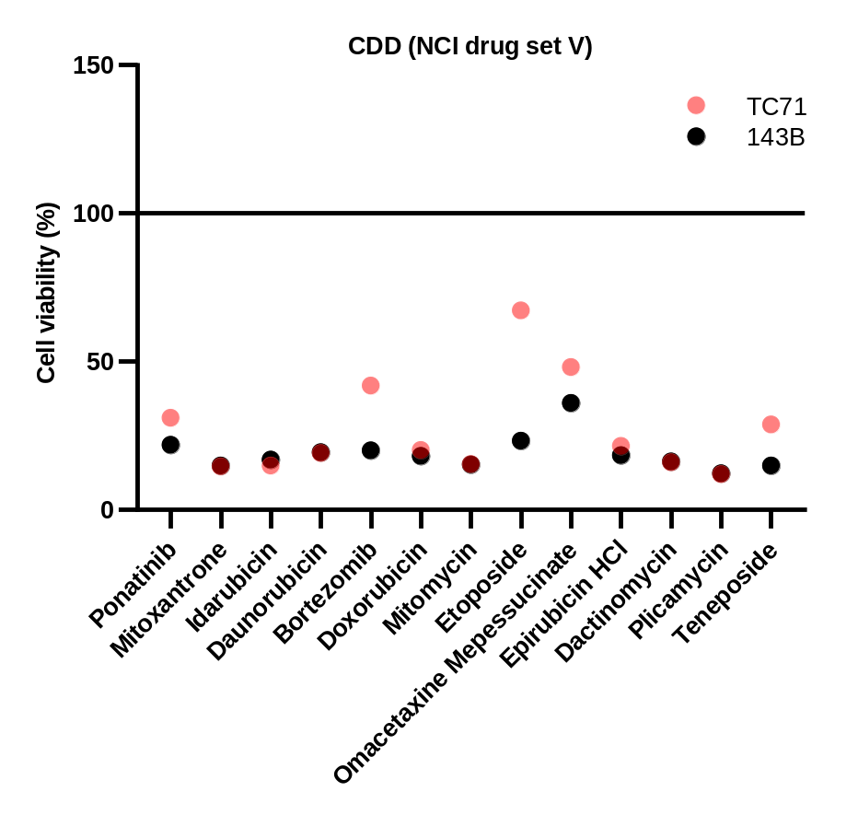

Figure S1. High throughput screen analyses in human OS cell lines.
High-throughput screen and validation of small molecule compound on human Osteosarcoma and Ewing sarcoma cell lines. Cell cytotoxicity analysis (Cell Titer Glo assay) of human OS (143B) and Ewing sarcoma (TC71) spheroids treated with NCI Approved Oncology Drugs Set V (114 cmpds), a library of FDA-approved compounds.
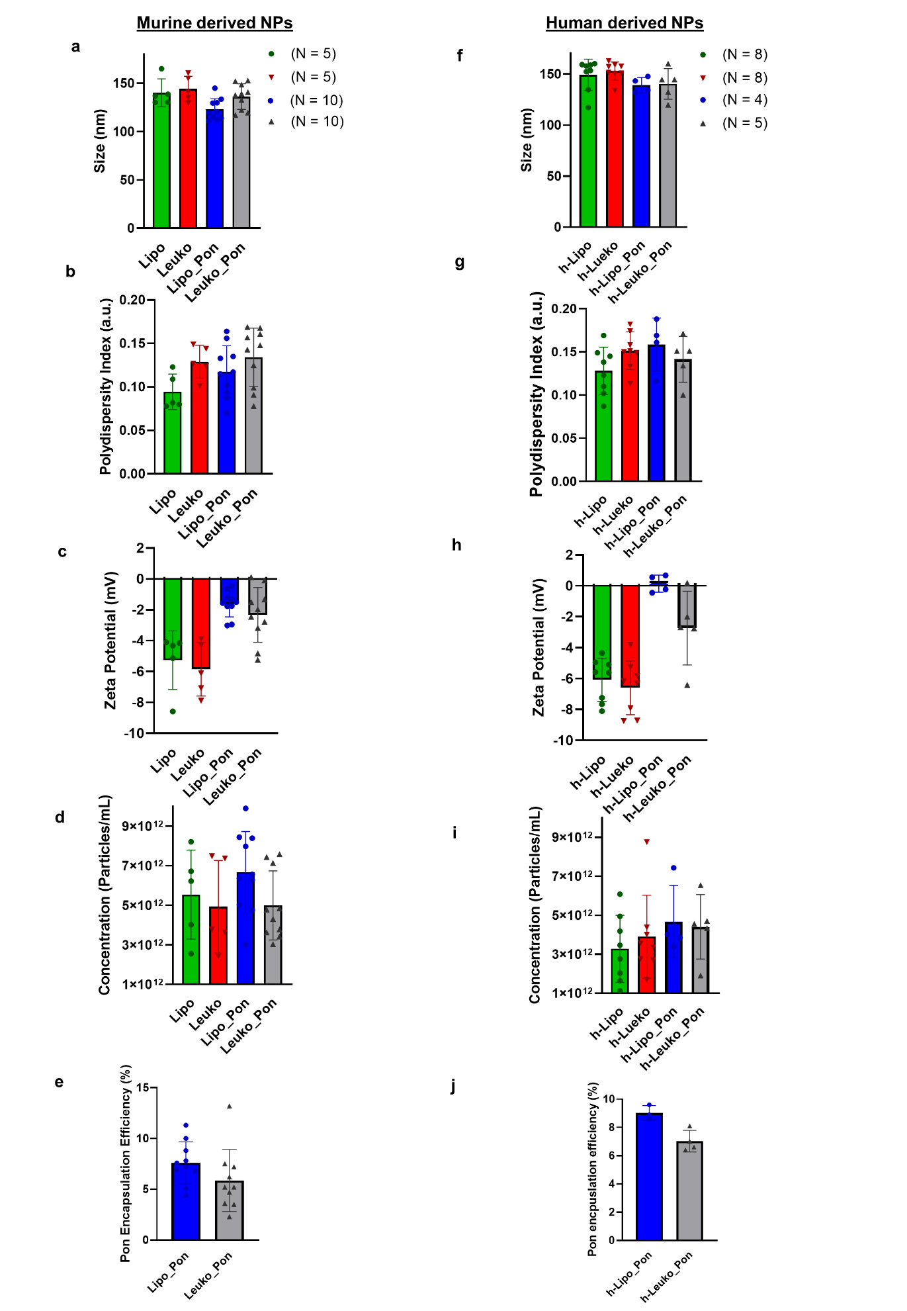
Figure S2. NP physiochemical characterization
Murine and human-derived NP (Lipo, Leuko and h-Lipo and h-Leuko respectively) size (a, e), polydispersity index (b, f), concentration (c, g), and zeta potential (d, h), Ponatinib encapsulation efficiency (e, j). Results are shown as mean ± SEM. Murine and human-derived NPs At least 9 and 3 replicates of murine and human-derived NPs respectively.
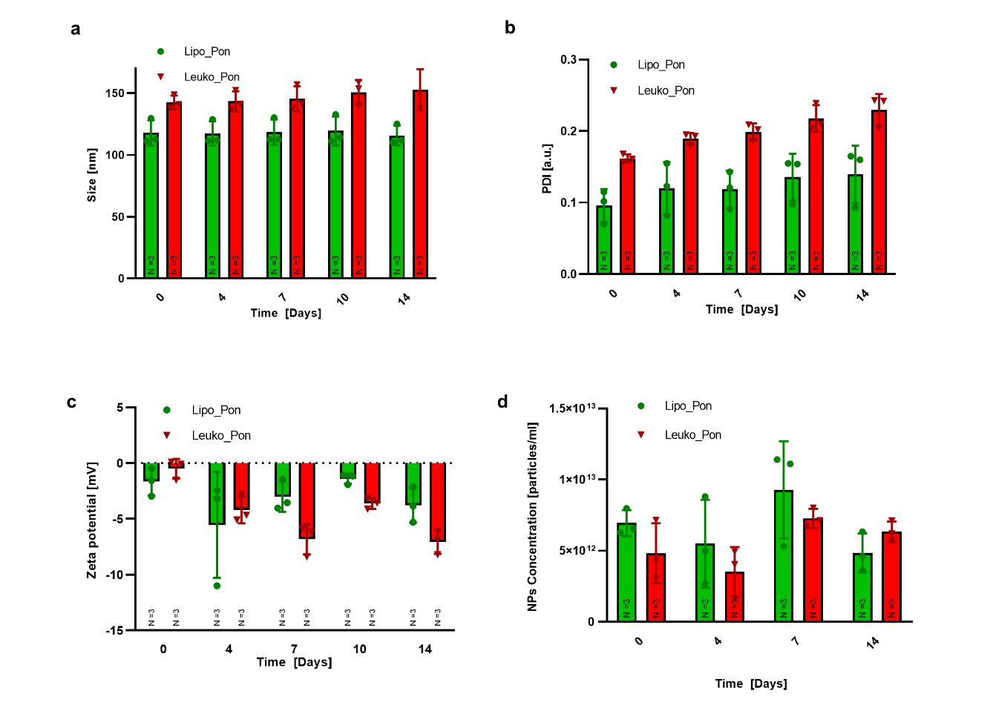
Figure S3. 14-day NP storage stability study.
Physicochemical characterization of NPs over 14 days by dynamic light scattering (DLS) and HPLC analysis of all NP formulations for (a) size, (b) PDI, (c) zeta potential and (d) concentration. Results are shown as mean ± SEM.
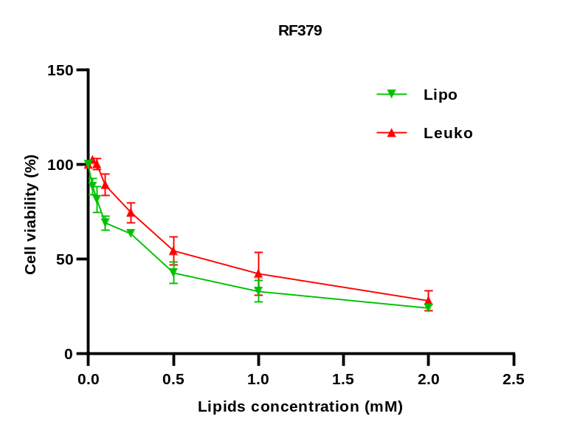
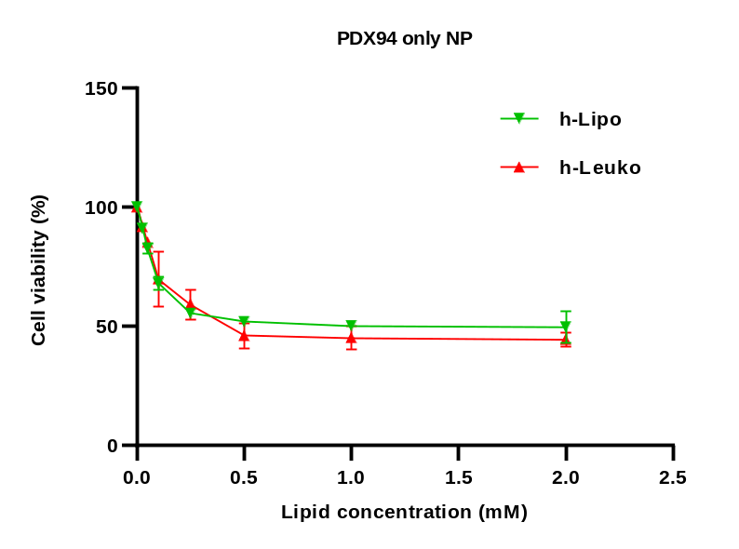
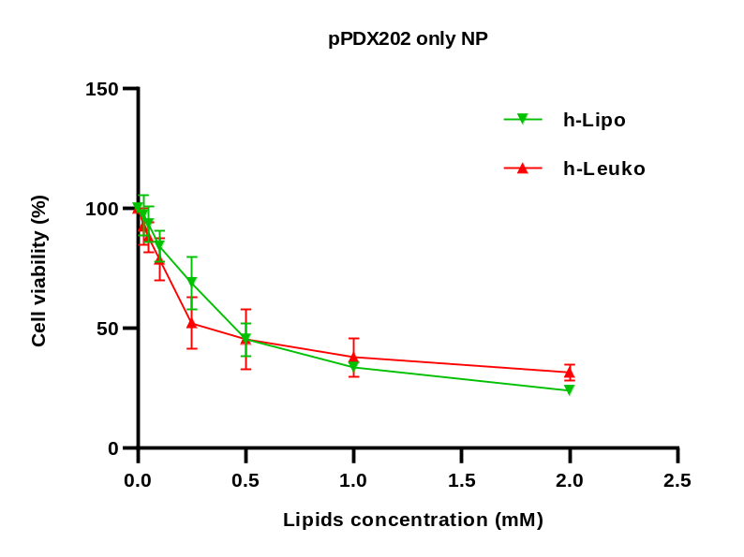
c
d
e
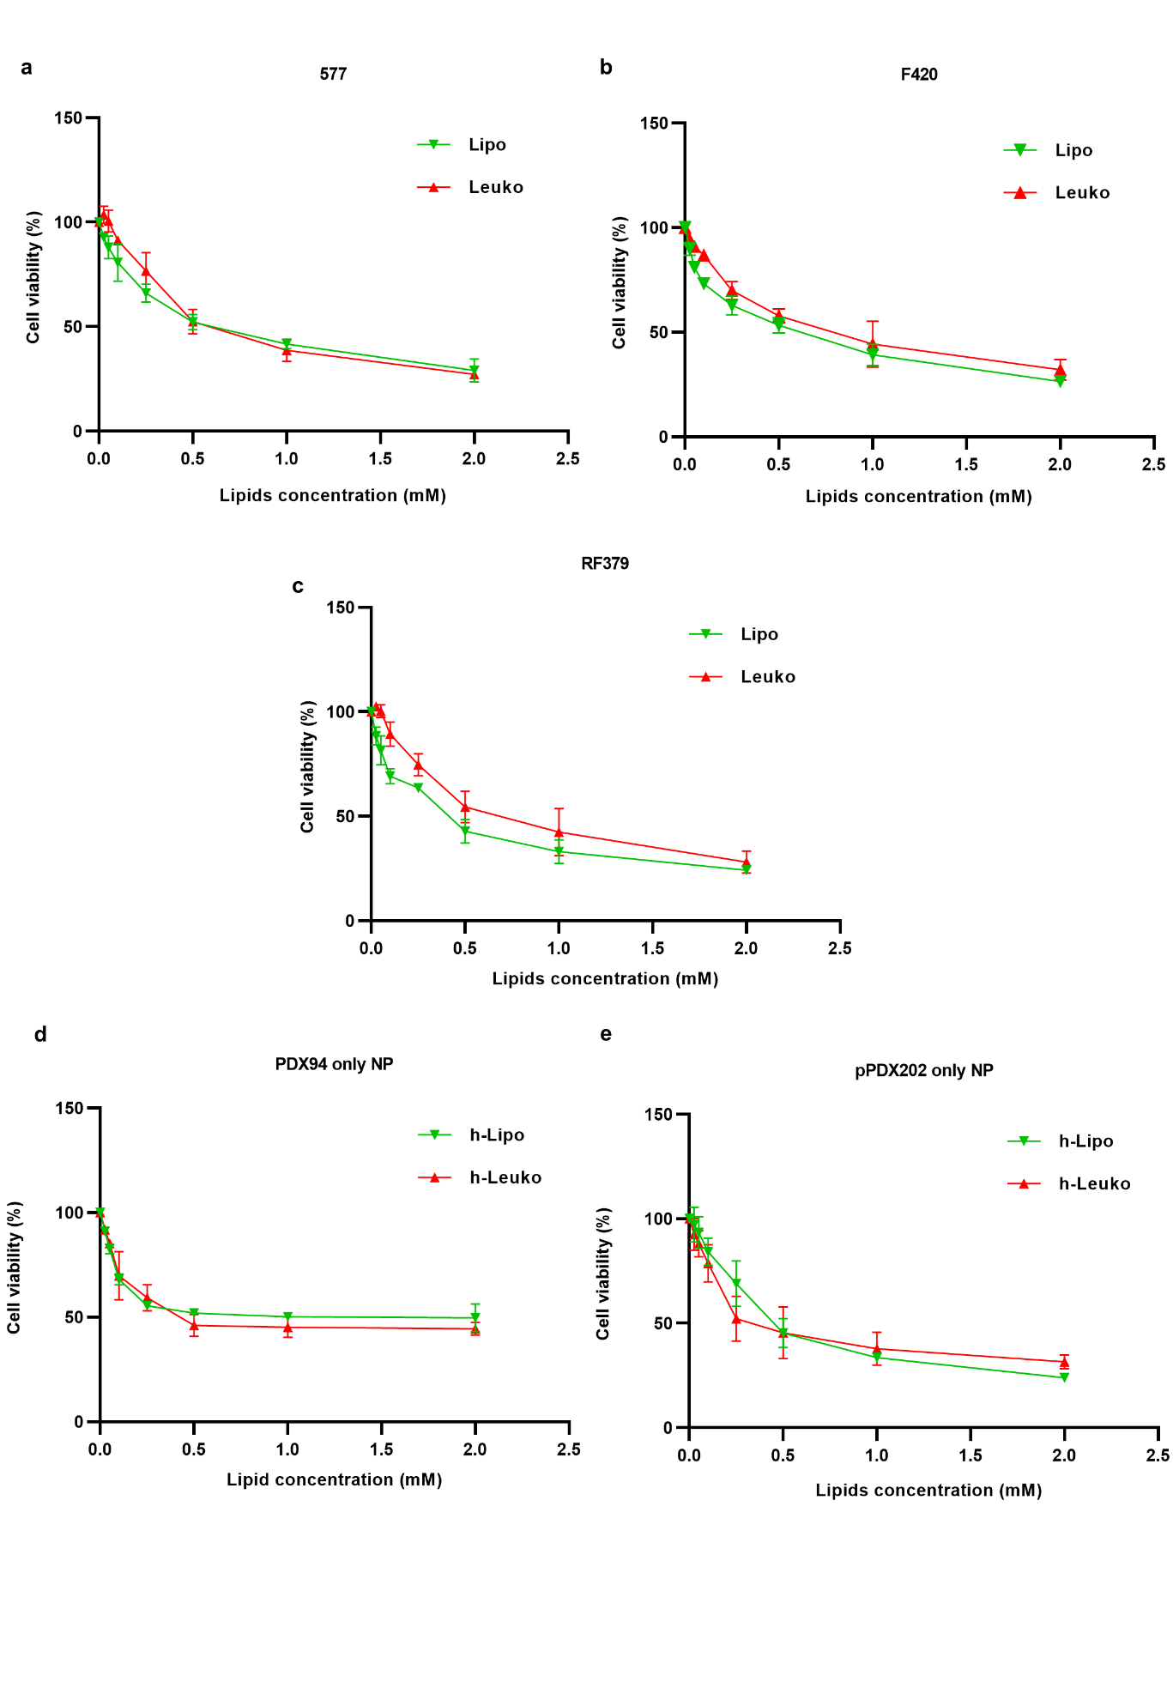

Figure S4. Empty biomimetic NP cytotoxicity on murine and human PDX-derived OS cell lines.
Cell cytotoxicity analysis (MTT assay) of mouse OS (577, F420, RF379) (a, b, c) and human PXD-derived OS (TCCC-OS94 and TCCC-OS202) (d, e) cell lines exposed for 72h to increasing concentrations of empty Lipo and Leuko NPs. All data are expressed as mean ± SD (n=3). Lipo and Leuko NPs for mouse OS, h-Lipo and h-Leuko NPs for human PDX-derived OS cells.
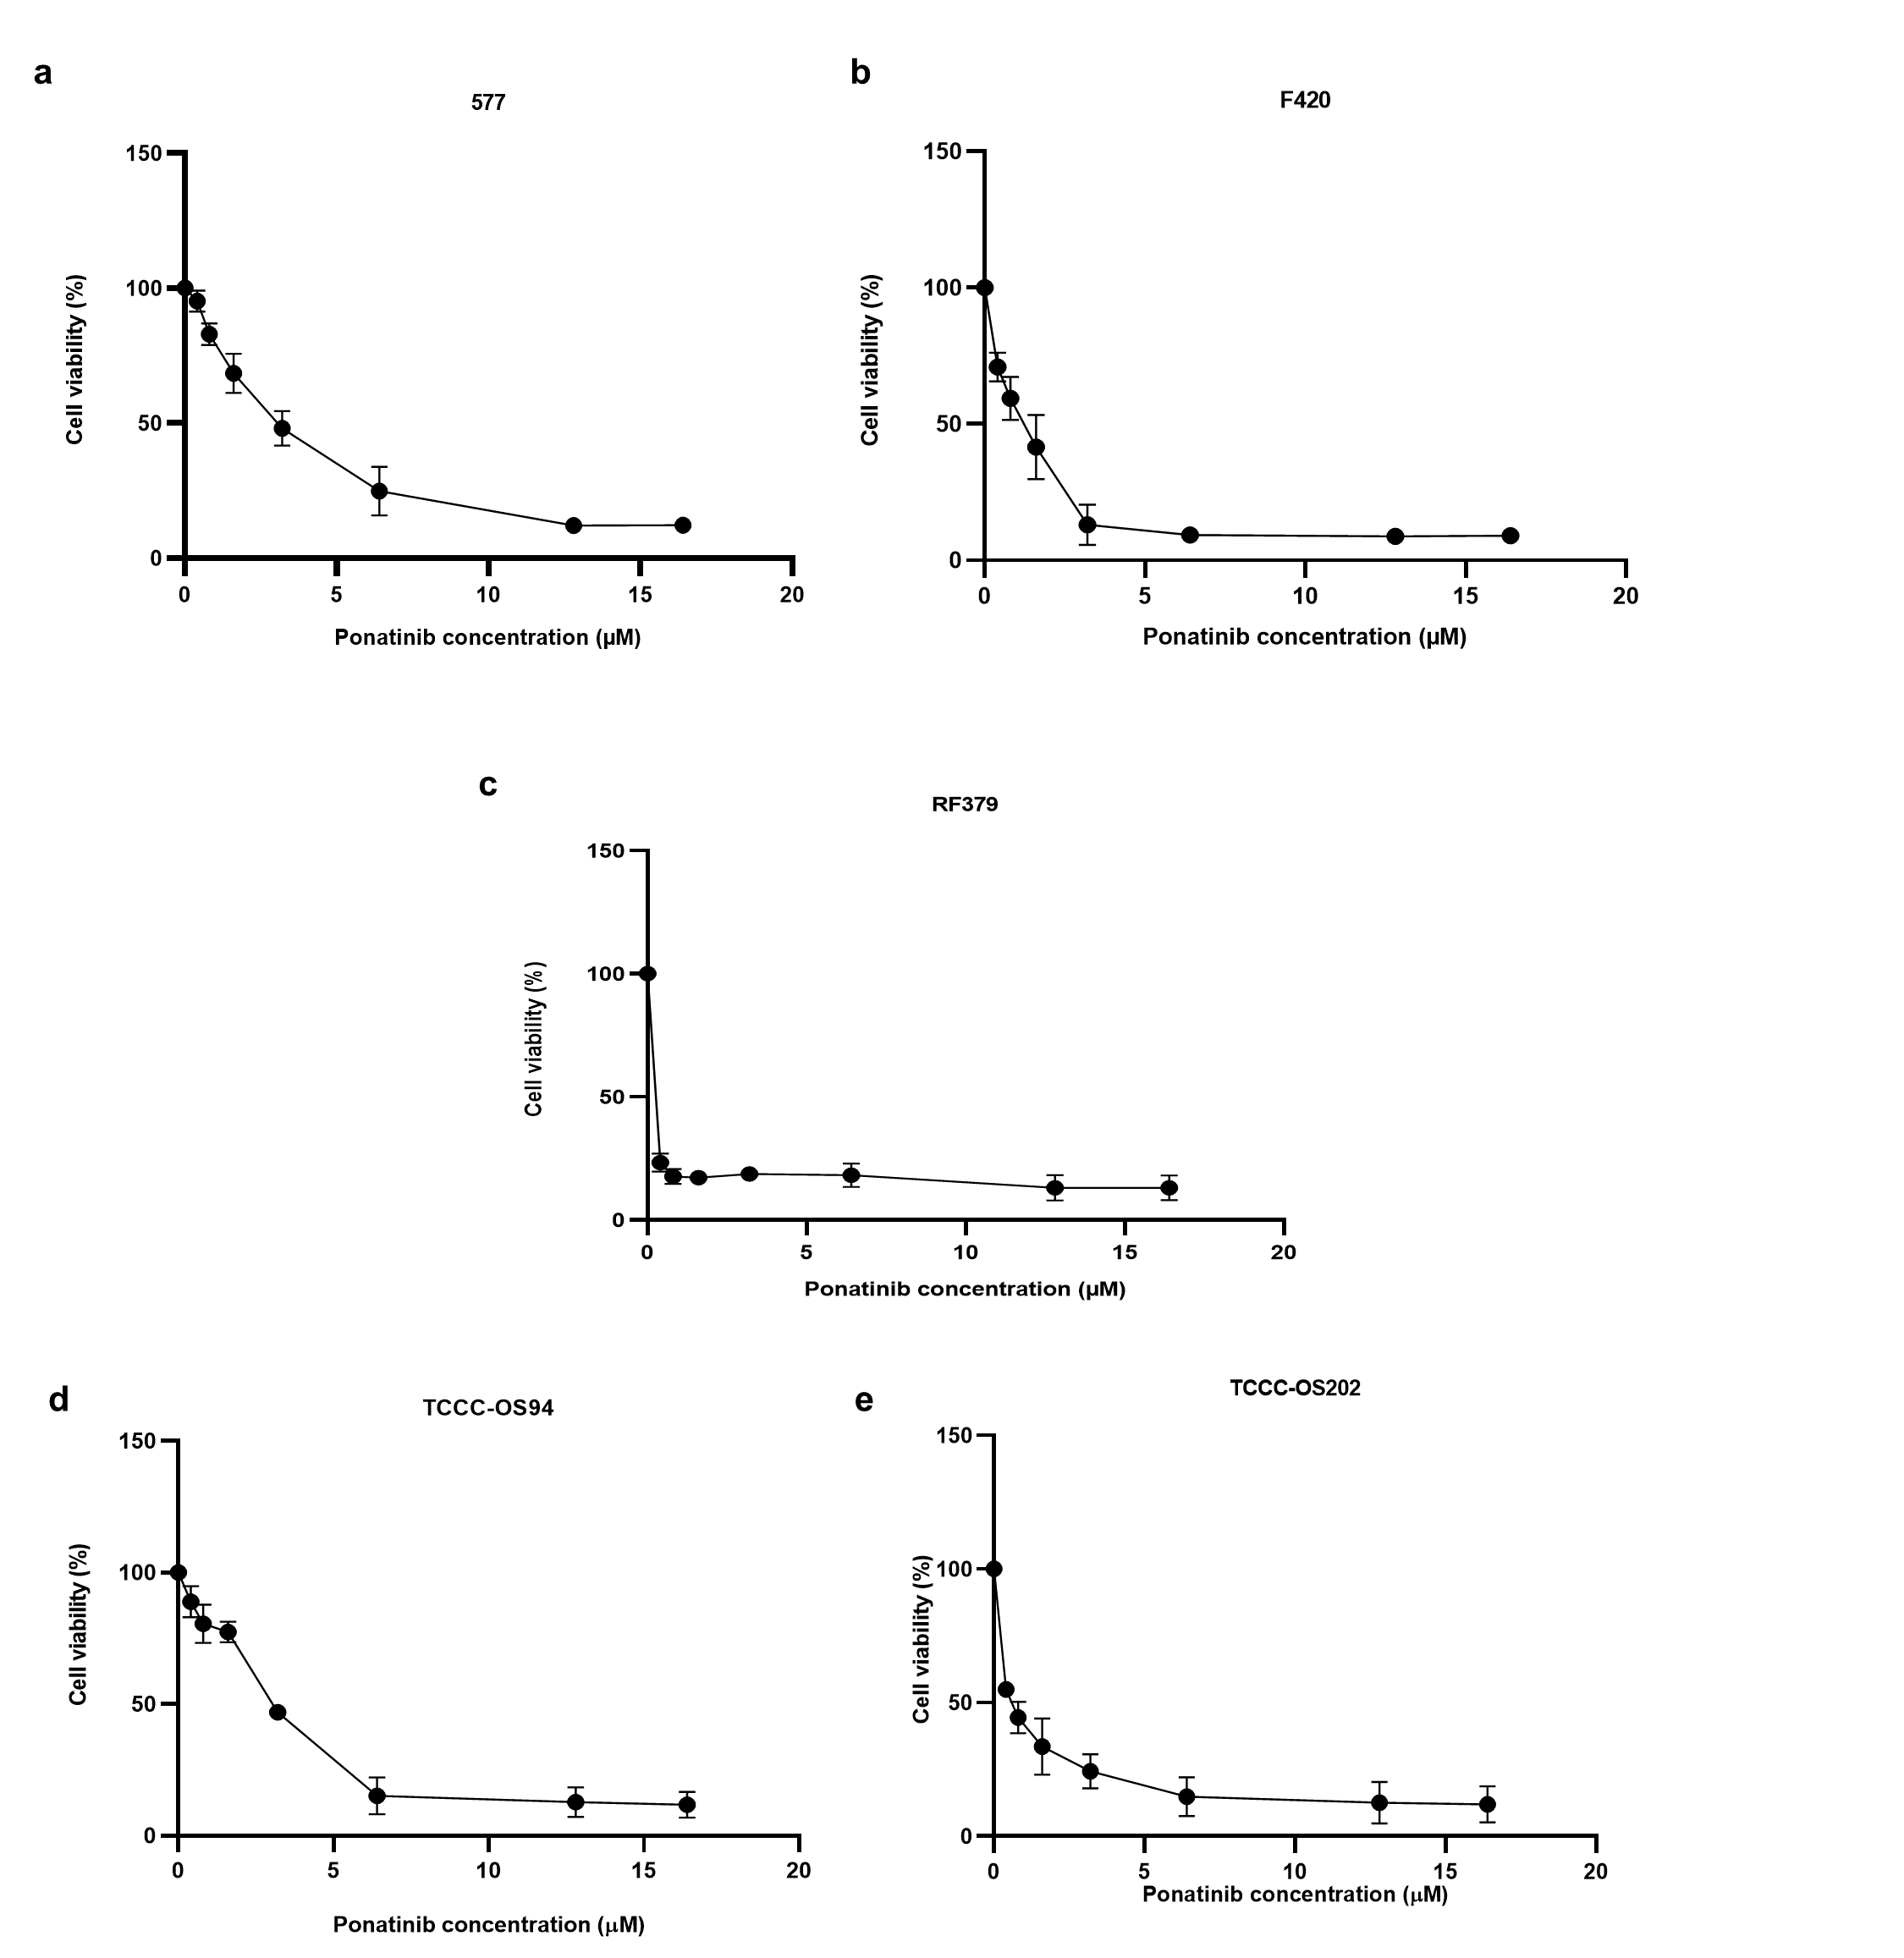
Figure S5. Ponatinib cytotoxicity in murine and human PDX-derived OS cell lines.
Cell cytotoxicity analysis (MTT assay) of mouse OS (577, F420, RF379) (a, b, c) and human PXD- derived OS (TCCC-OS94 and TCCC-OS202) (d, e) cell lines exposed for 72 h to increasing concentrations of Pon. All data are expressed as mean ± SD (n=3).

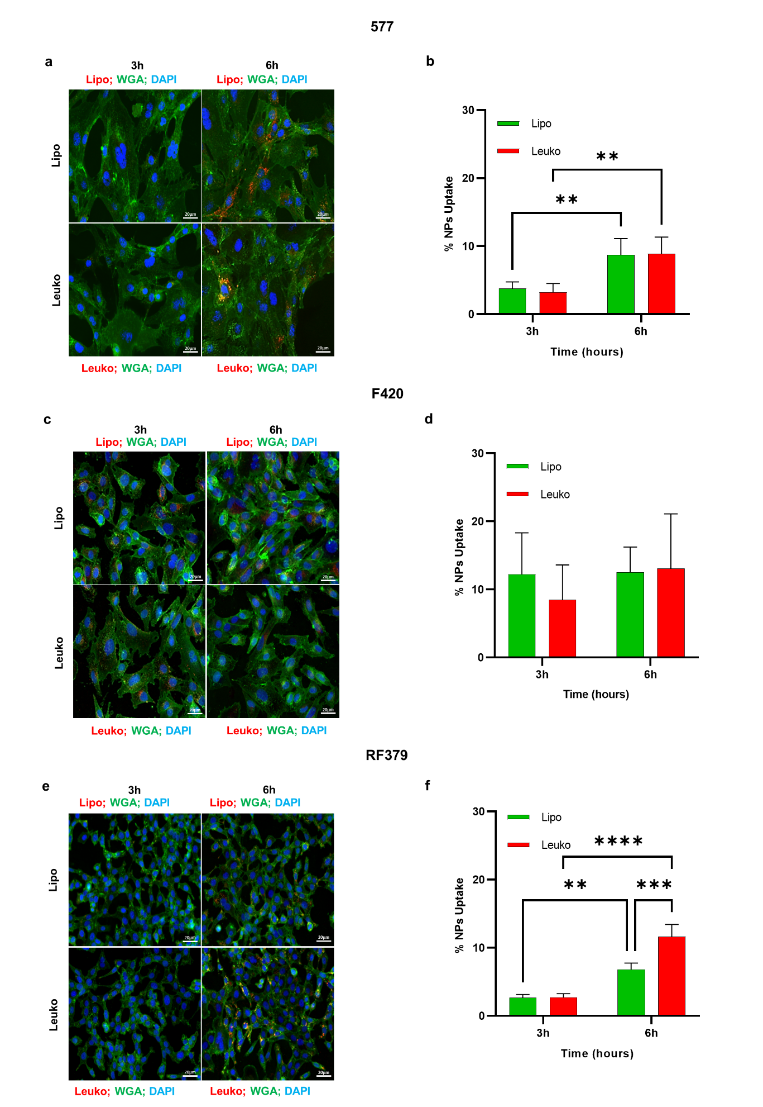

Figure S6. 2D biomimetic NP uptake on murine OS cell lines.
Representative images (a, c, e) and quantification (b, d, f) of NP internalization in mouse OS cells (577, F420, RF379) after 3 and 6 h treatment by confocal microscope (merge images of red (Rhodamine of NP), green (WGA) and blue (Dapi, nuclei) channels are shown). Scale bar = 20μm. **p<0.005, ***p<0.0005, ****p<0.0001
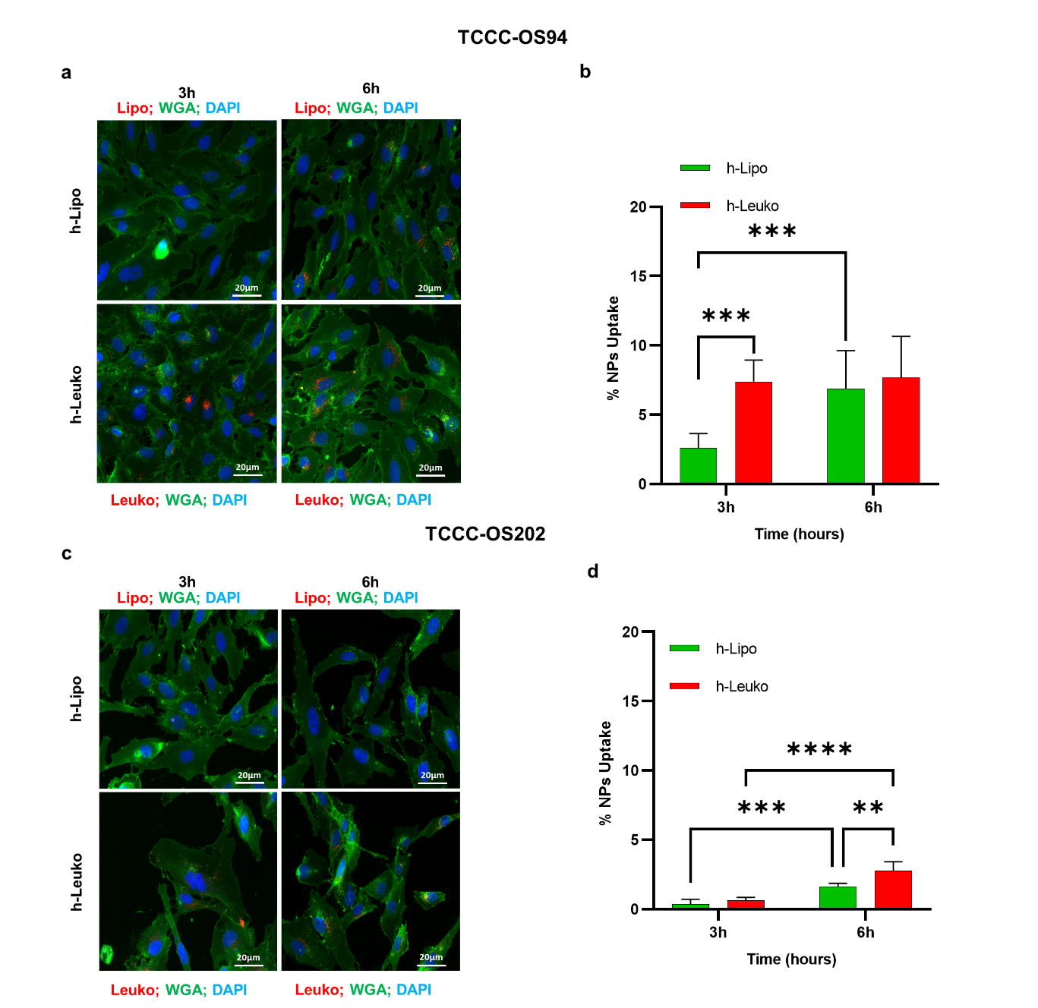

Figure S7. 2D biomimetic NP uptake on human PDX-derived OS cell lines.
Representative images (a, c) and quantification (b, d) of NP internalization in human PDX-derived OS cells (TCCC-OS94 and TCCC-OS202) after 3 and 6 h treatment by confocal microscope (merge images of red (Rhodamine of NP), green (WGA), and blue (Dapi, nuclei) channels are shown). Scale bar = 20μm, **p<0.005, ***p<0.0005, ****p<0.0001.
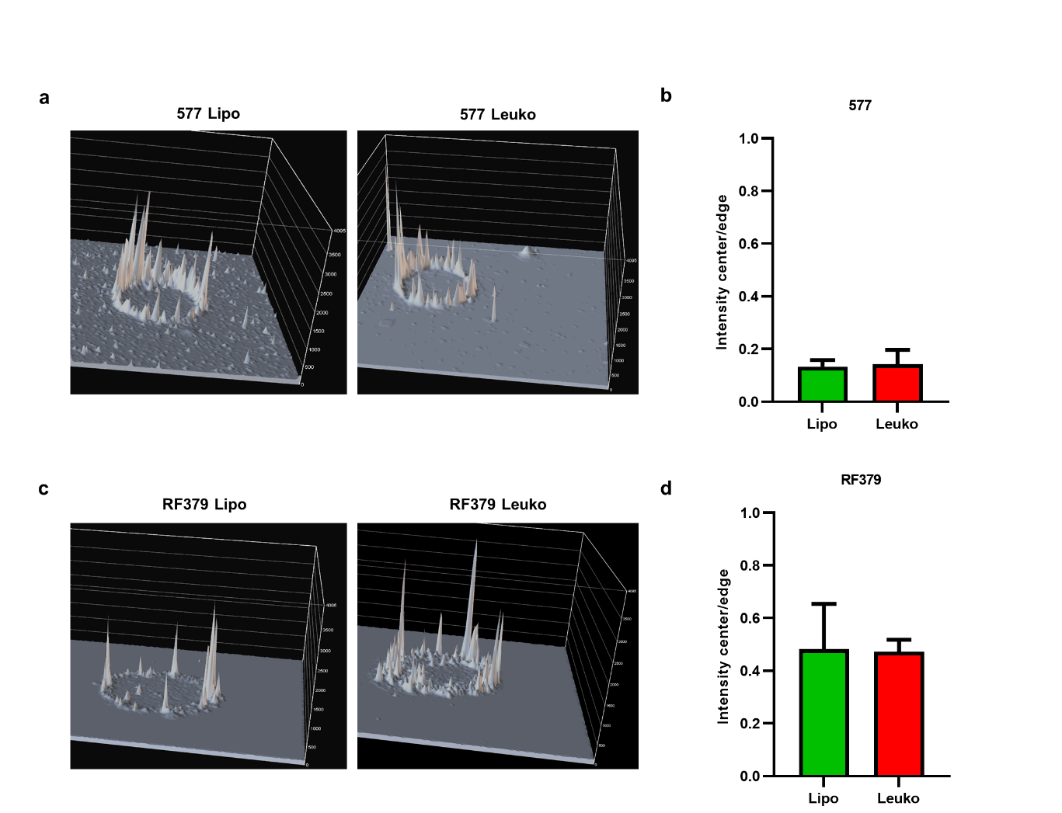
Figure S8. Biomimetic NP penetration in murine OS spheroids.
Representative reconstructed 3D surface plot images (a, c) and relative quantification (b, d) of NP penetration in the mouse OS (577 and RF379) spheroids after 24h treatment by confocal microscope. Picks in the images represent NP intensity accumulation.
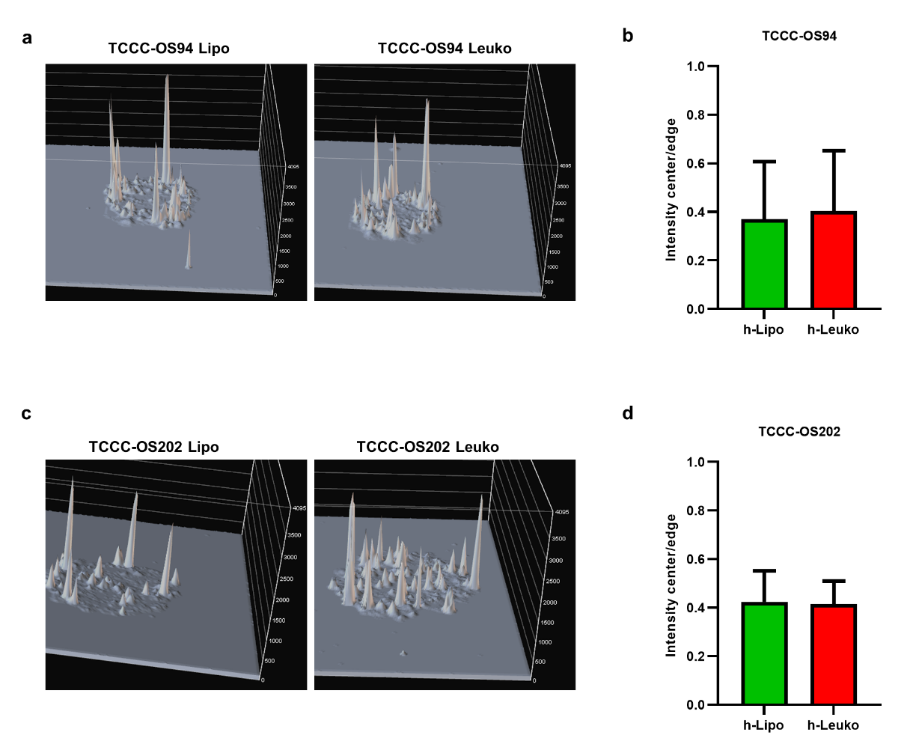
Figure S9. Biomimetic NP penetration in human PDX-derived OS spheroids.
Representative reconstructed 3D surface plot images (a, c) and relative quantification (b, d) of NP penetration in human PDX-derived OS (TCCC-OS94 and TCCC-OS202) spheroids after 24h treatment by confocal microscope. Picks in images represent NP intensity accumulation.
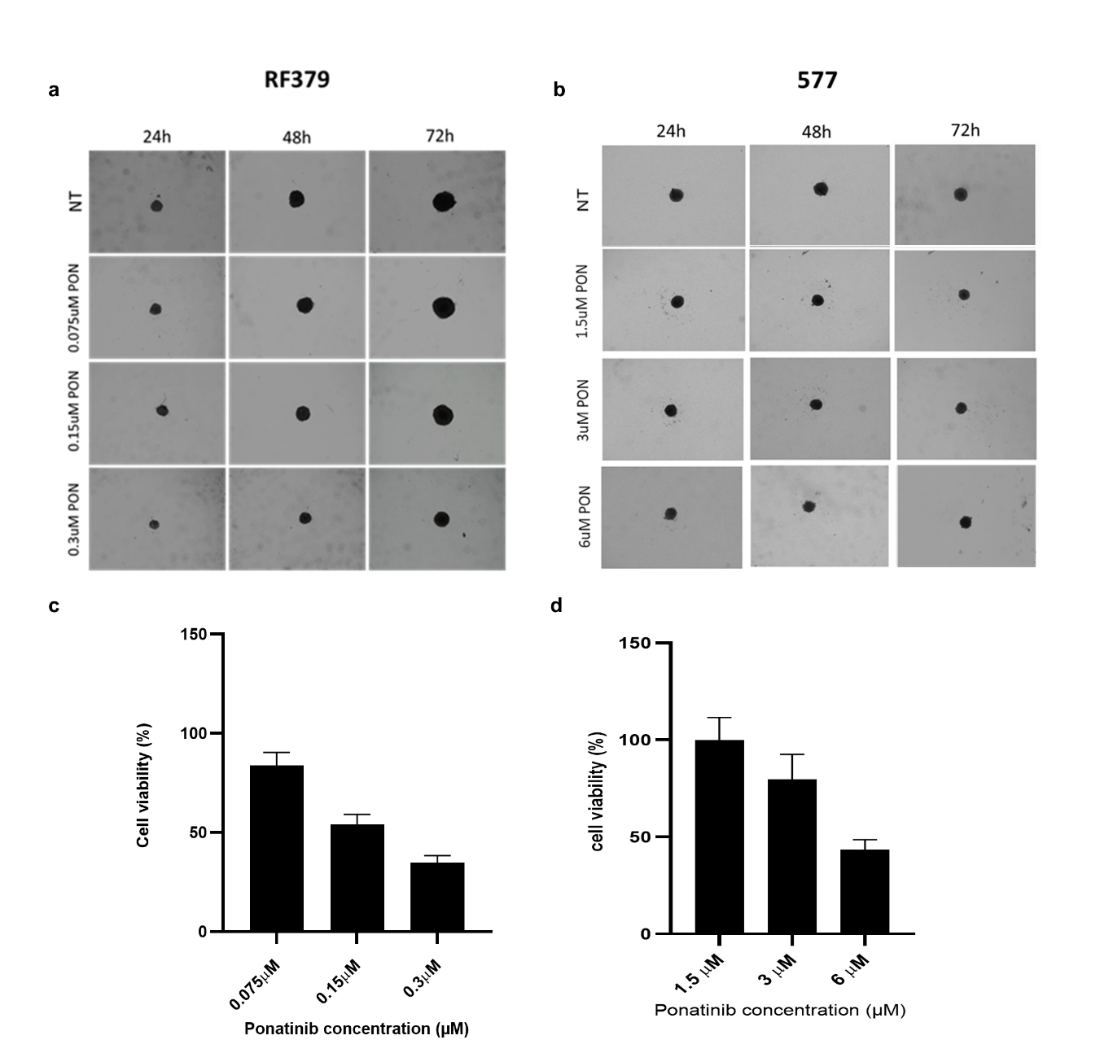
Figure S10. Ponatinib toxicity in murine OS spheroids.
Representative images (a, b) and cell viability assessment (c, d) of mouse OS spheroids (RF379 and 577) growth after treatment with increasing concentration of Pon by Keyence BZ-X800 microscope (at 24, 48, 72h) and 3D Cell titer Glo analyses (72h), respectively. Pon doses used: 1/2IC50 0.075uM, IC50 0.15uM, 2IC50 0.3uM for RF379 and 1/2IC50 1.5uM, IC50 3uM, 2IC50 6uM. All data are expressed as mean ± SD (n=3). Scale bar = 10μm.

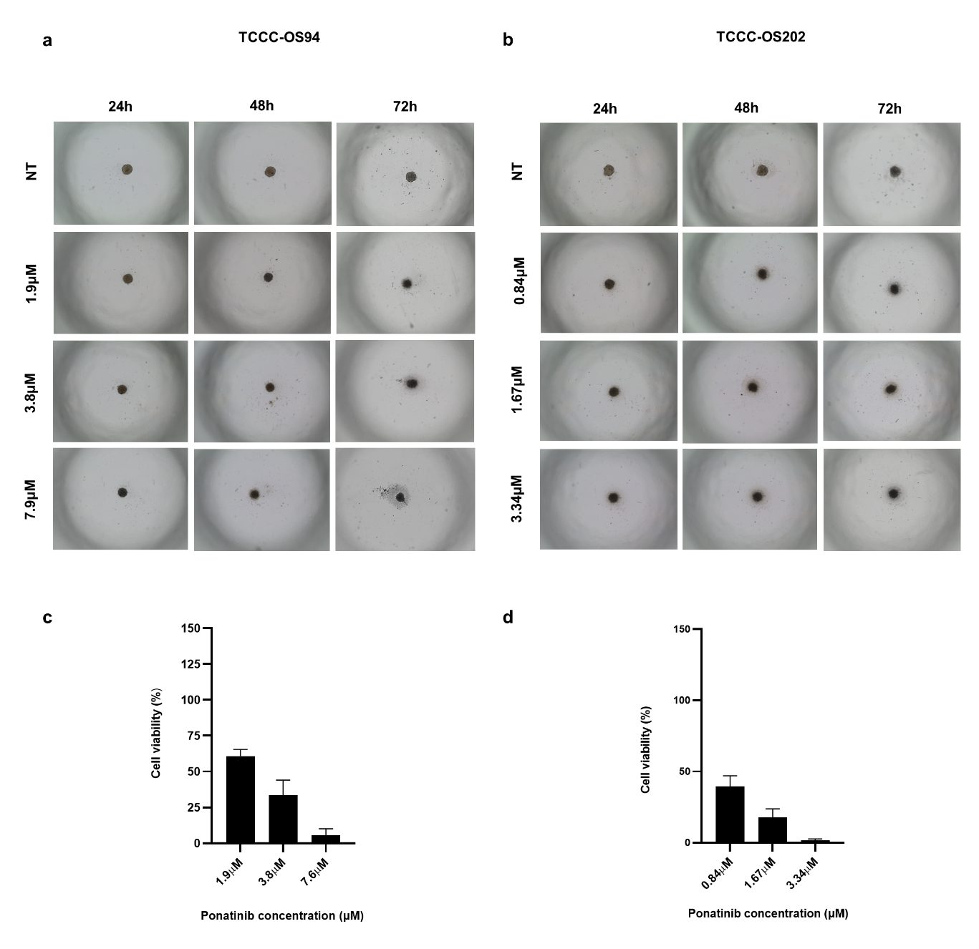Figure S11. Ponatinib toxicity in human PDX-derived OS spheroids.
Representative images (a, b) and cell viability assessment (c, d) of PDX-derived OS spheroids (TCCC-OS94 and TCCC-OS202) growth after treatment with increasing concentration of PON by Keyence BZ-X800 microscope (at 24, 48, 72h) and 3D Cell titer Glo analyses(72h), respectively. Pon doses used: 1/2IC50 1.9uM, IC50 3.8uM, 2IC50 7.9uM for TCCC-OS94 and 1/2IC50 0.84uM, IC50 1.67uM, 2IC50 3.34uM for TCCC-OS202. All data are expressed as mean ± SD (n=3) Scale bar = 10μm.
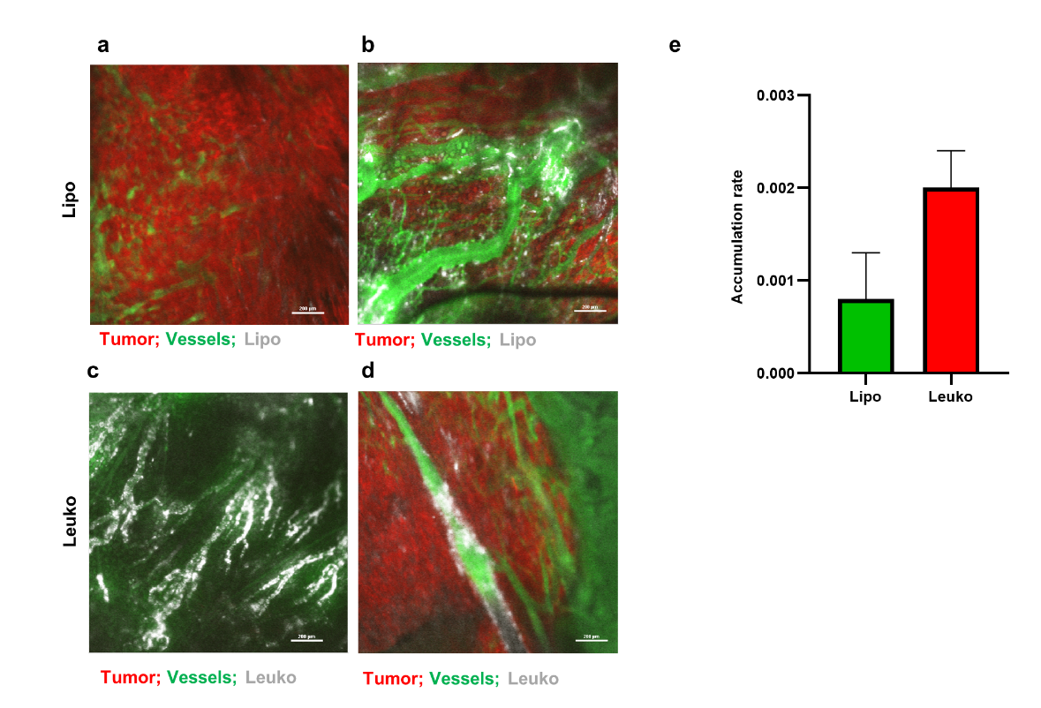
Figure S12. Biomimetic NPs in vivo tumor targeting. Representative images of Lipo and Leuko NPs accumulation in the first 60 minutes after injection within mouse orthotopic osteosarcoma tumor area on top or around the tumor (a-d) by IVM analyses showing vessels (green), tumor cells (red) and NP (white). Lipo NPs (a, b) and Leuko NPs (c, d) respectively, and accumulation quantification (e) (Leuko in red, Lipo in green) Scale bar = 200μm.
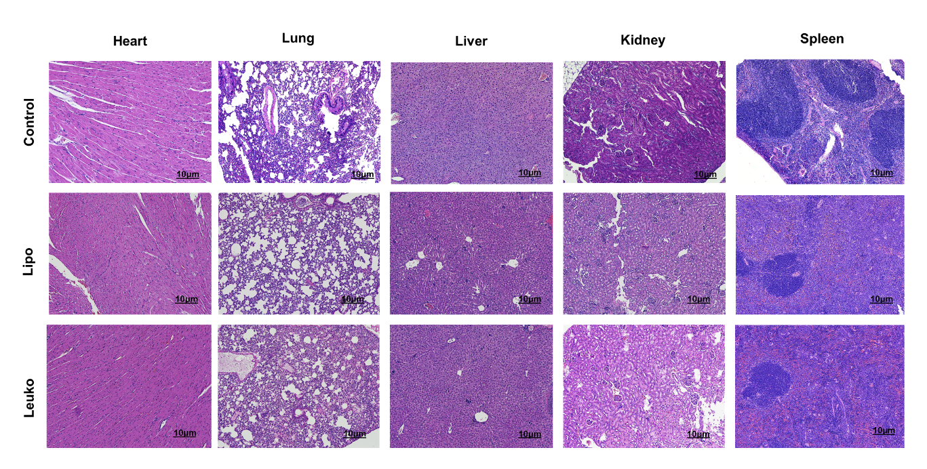
Figure S13. Empty NPs toxicity.
Representative H&E staining of mouse organs after treatment with empty Lipo and Leuko NPs compared to control. Scale bar: 10 µm.

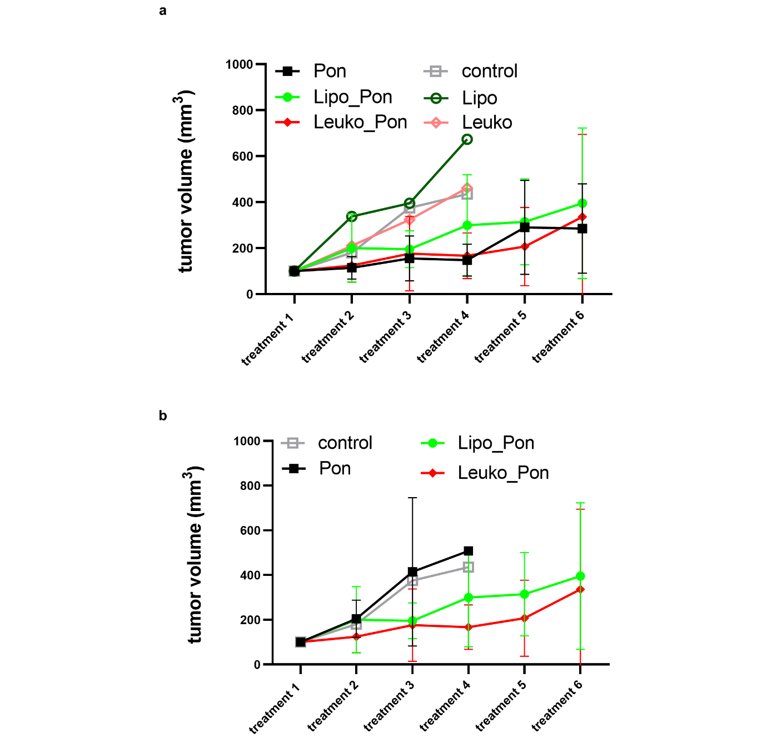

Figure S14. In vivo efficacy study. Quantification of tumor growth in mice treated with Pon (30 mg/ml, IP injections), Pon Biomimetic NPs (Lipo Pon and Leuko Pon 1.5 mg/ml IV injections) and empty NPs (Lipo and Leuko), 2 times per week, for 3 weeks (a). *p<0.5 Pon vs control, Leuko_Pon vs control, Lipo_Pon vs control. n=10 mice for each group. Quantification of tumor growth in mice treated with Pon (1.5 mg/ml, IV injections), Pon Biomimetic NPs (Lipo Pon and Leuko Pon 1.5 mg/ml IV injections), 2 times per week, for 3 weeks (b). (Leuko_Pon in red and Leuko empty NPs in pink, Lipo_Pon light green and Lipo empty NPs dark green, Pon in black, control in grey).

