Additional file 1
Figure S1 SEM image of TAFP.

Figure S2 Elements mapping of TAFP including C, N, O, Pt elements.

Figure S3 XPS spectrum of Pt 4f in TAFP indicating the existence of Pt element.

Fig.S4 The standard curve of DDP determined by HPLC at 254 nm.

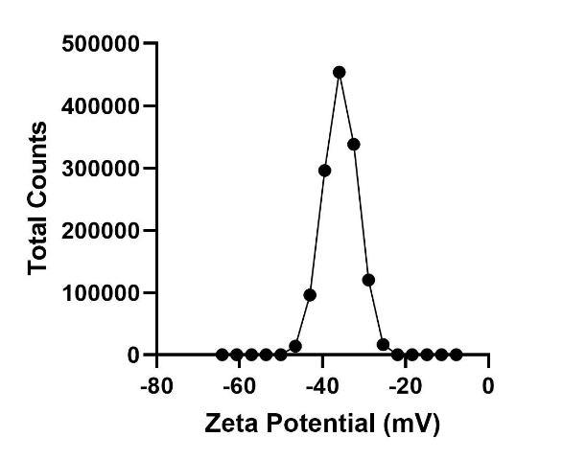
Fig.S5 Zeta potential of TAFP dispersed in DI water.

Figure S6 Fluorescence images of the uptake of TAFP by SKOV3 cells after co-incubation with TAFP for 2 h and 4 h with or without NIR laser irradiation (10 min, 1 W/cm²). Scale bar = 100 μm

Figure S7 TUNEL staining of tumors from each groups after a 14-day treatment. Scale bar = 100 μm.

