Supplementary information

Engineering M1-derived Nanovesicles Loading with Docosahexaenoic Acid Synergize Ferroptosis and Immune Activation for Treating Hepatocellular Carcinoma

Ming Meng, ‡ª Xia Zhang, ‡^{b}, Qian Li,^{c} Jingjing Han,^{c} Yu Chen,^{c} Haishi Qiao,^{d} Yonglin Yang^{*b} and Xin Huang^{*d}

ª Department of Neurology, Taizhou Third People’s Hospital, Taizhou, Jiangsu Province, China
^{b} Department of Infectious Diseases, The Affiliated Taizhou People's Hospital of Nanjing Medical University, Taizhou, Jiangsu Province, China
^{c} Department of Anesthesiology, The First Affiliated Hospital of Nanjing Medical University, Nanjing 210029, Jiangsu Province, China
^{d} Department of Pharmaceutical Engineering, School of Engineering, China Pharmaceutical University, China

* Corresponding author.
E-mail address:
easing@163.com (Y.L. Yang)
cpuhuangxin@cpu.edu.cn (X. Huang);

‡These authors contributed equally to this work

Figure S1
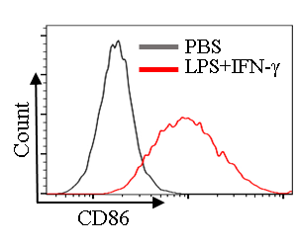
The RAW 264.7 cells were incubated with 100 ng/mL of LPS and 50 ng/nL of IFN-γ for 24 h and then stained with anti-CD86-BV421 antibodies followed by flow cytometric analysis.

Figure S2
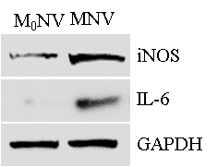
Western blot assay for M₀NV (engineering M0-derived Nanovesicles) and MNV.

Table S1
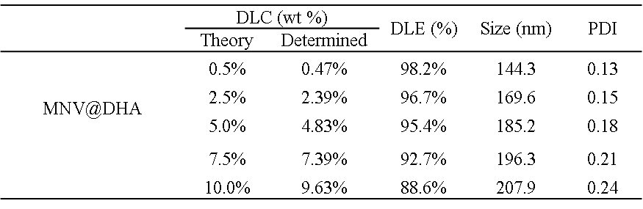
Drug loading efficacy (DLE) determined by HPLC with different drug loading contents (DLC).

Figure S3
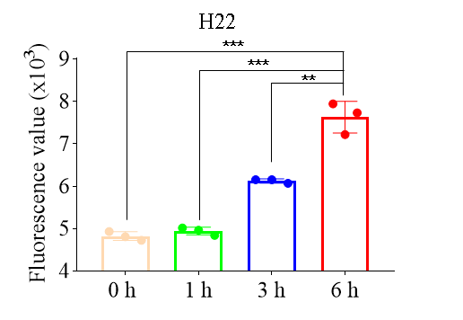
Mean fluorescence intensity of H22 cells incubated with DiR-stained MNV@DHA for indicated time and determined by flow cytometry.

Figure S4
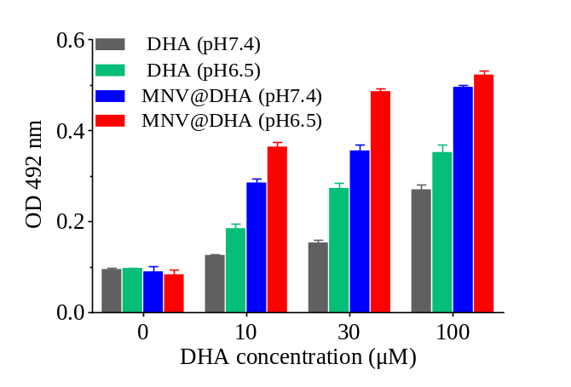
Semi-quantitative measurement of Oil Red O staining by extracting the dye with isopropanol and reading the absorbance at 492 nm.

Figure S5
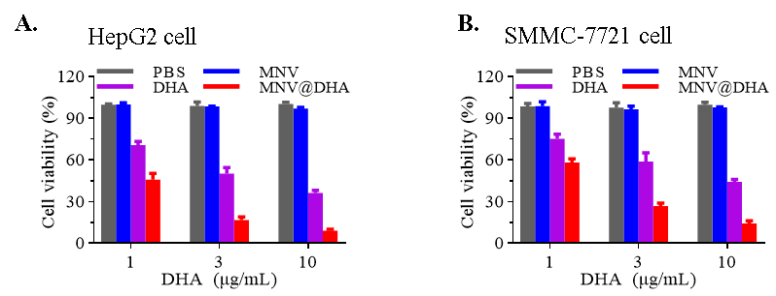
CCK8 assay for HepG2 cells (A) and SMMC-7721 cells. The cells were incubated with different concentrations of the indicated formulations for 48 h and then the cells were performed with CCK8 assay.

Figure S6
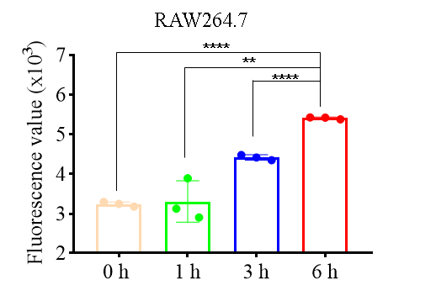
Mean fluorescence intensity of RAW 264.7 cells incubated with DiR-stained MNV@DHA for indicated time and determined by flow cytometry.

Figure S7
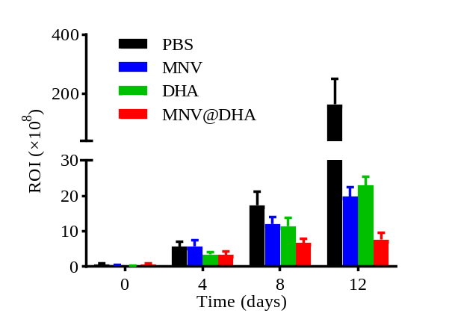
The average ROI value for tumor growth.

Figure S8
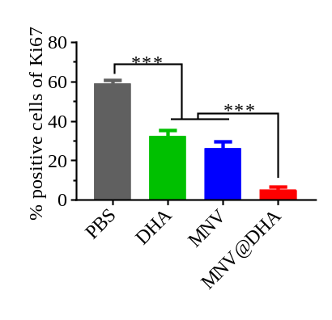
Semi-quantification of the Ki67 expression.

Figure S9
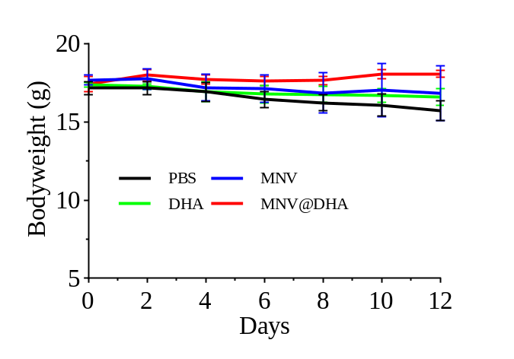
Bodyweight variation of the mice with different treatments.

Figure S10
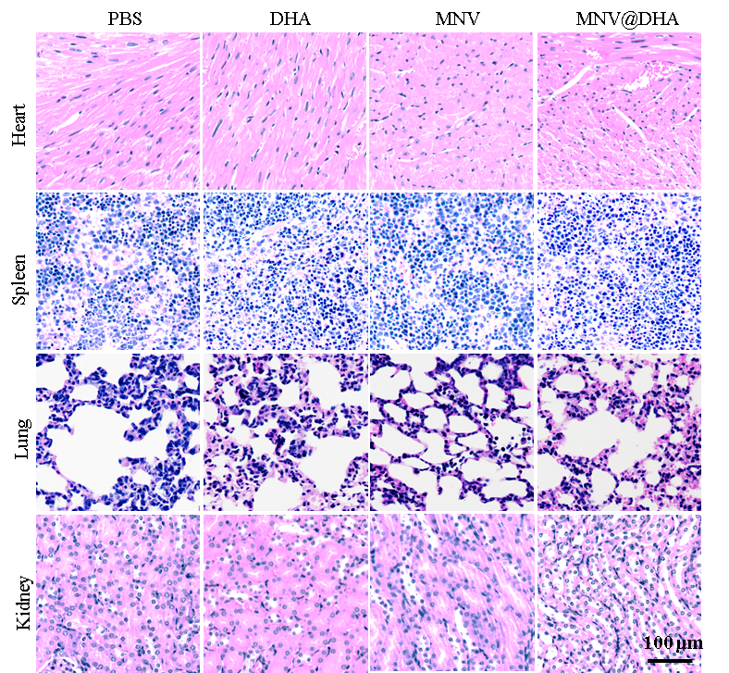
H&E staining of the major organs excised from euthanized mice.

Figure S11
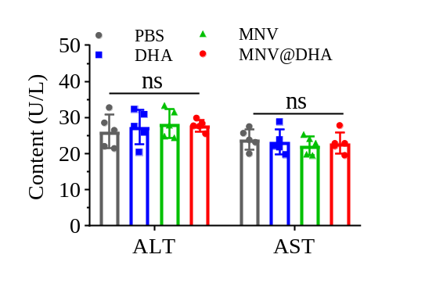
The serum level of alanine aminotransferase (ALT) and aspartate aminotransferase (AST) from different groups.

Figure S12
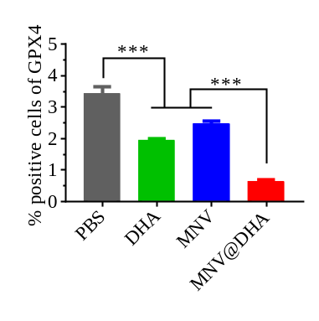
Semi-quantification of the GPX4 expression.

