Supporting Information

Aptamer modified Ti₃C₂ nanosheets application in smart targeted photothermal therapy for cancer

Zhiqiang Bai¹², Lu Zhao², Haidi Feng², Zhihui Xin¹², Chaoyu Wang², Zhixiong Liu², Maozhong Tian², Haifei Zhang⁴, Yunfeng Bai^{2,**}, Feng Feng^{123,*}

¹ School of Chemistry and Material Science, Shanxi Normal University, Linfen 041004, P. R. China.
² School of Chemistry and Chemical Engineering, Shanxi Provincial Key Laboratory of Chemical Biosensing, Shanxi Datong University, Datong 037009, P. R. China.
³ Department of Energy Chemistry and Material Engineering, Shanxi Institute of Energy, Taiyuan 030600, P. R. China.
⁴ Department of Chemistry, University of Liverpool, Crown Street, Liverpool, L69 7ZD, United Kingdom.

* Corresponding author.
** Corresponding author.

E-mail: feng-feng64@263.net (Feng Feng), baiyunfeng1130@126.com (Yunfeng Bai)
Mail address: School of Chemistry and Chemical Engineering, Shanxi Datong University, Datong 037009, P. R. China

Supplementary figures and tables

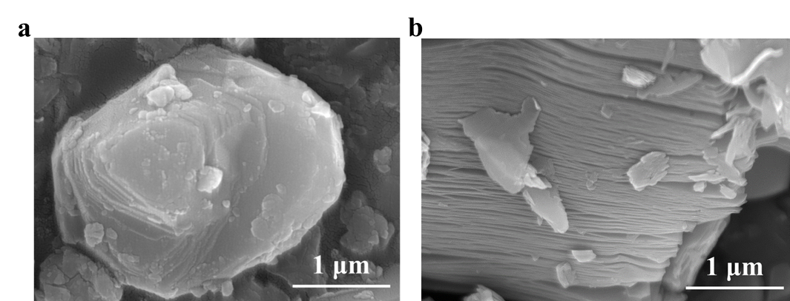
Figure S1. SEM images of (a) Ti₃AlC₂ ceramic bulks and (b) Ti₃C₂ bulks.

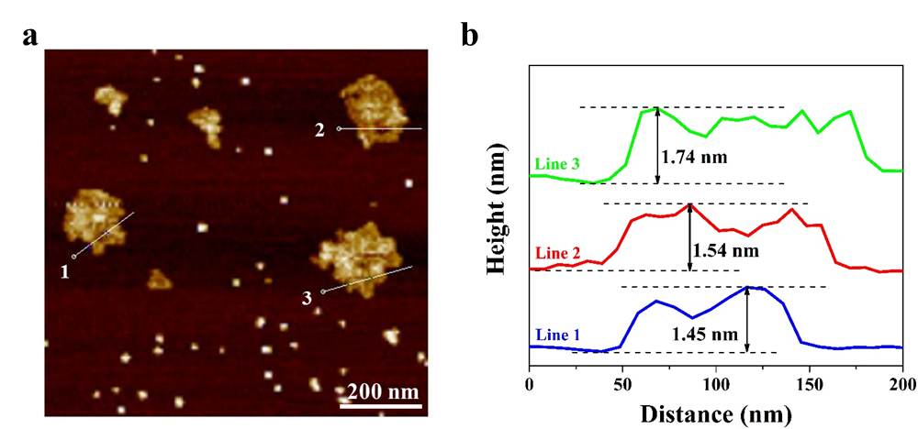
Figure S2. (a) AFM image and (b) the corresponding thickness of Ti₃C₂ nanosheets.

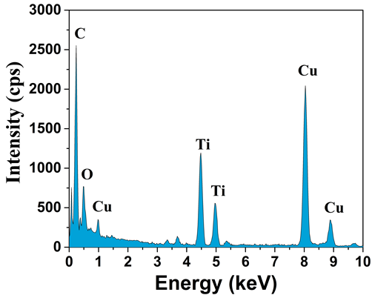
Figure S3. EDS spectra of Ti₃C₂ nanosheets.

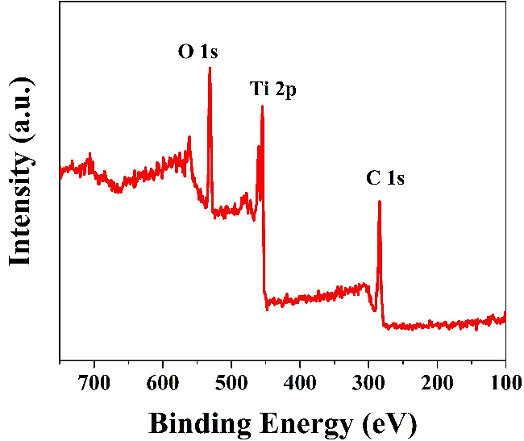
Figure S4. XPS spectra of Ti₃C₂ nanosheets.

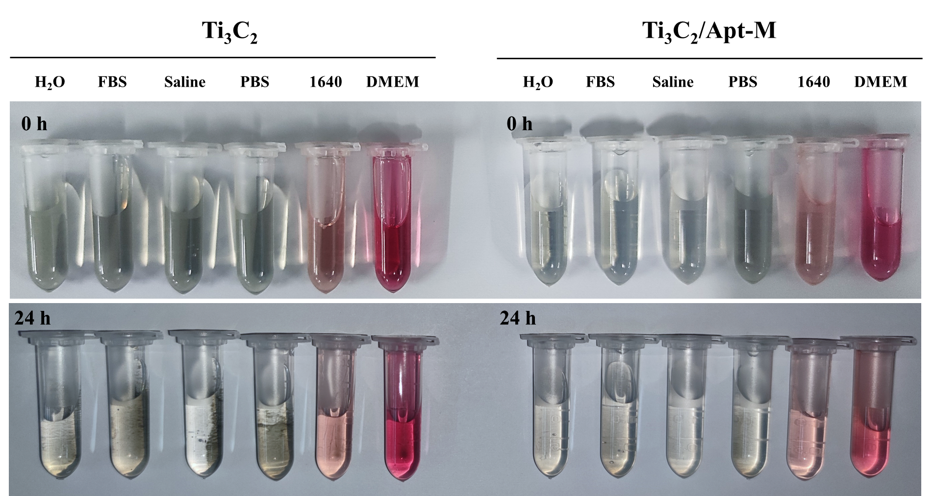
Figure S5. Digital images of Ti₃C₂ nanosheets and Ti₃C₂/Apt-M nanosheets dispersed in various solvents.

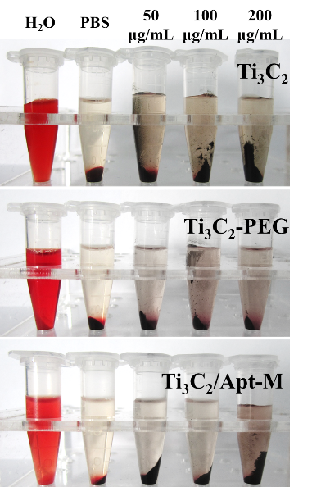
Figure S6. Digital images of hemolysis assay of Ti₃C₂, Ti₃C₂-PEG and Ti₃C₂/Apt-M nanosheets at different concentrations.

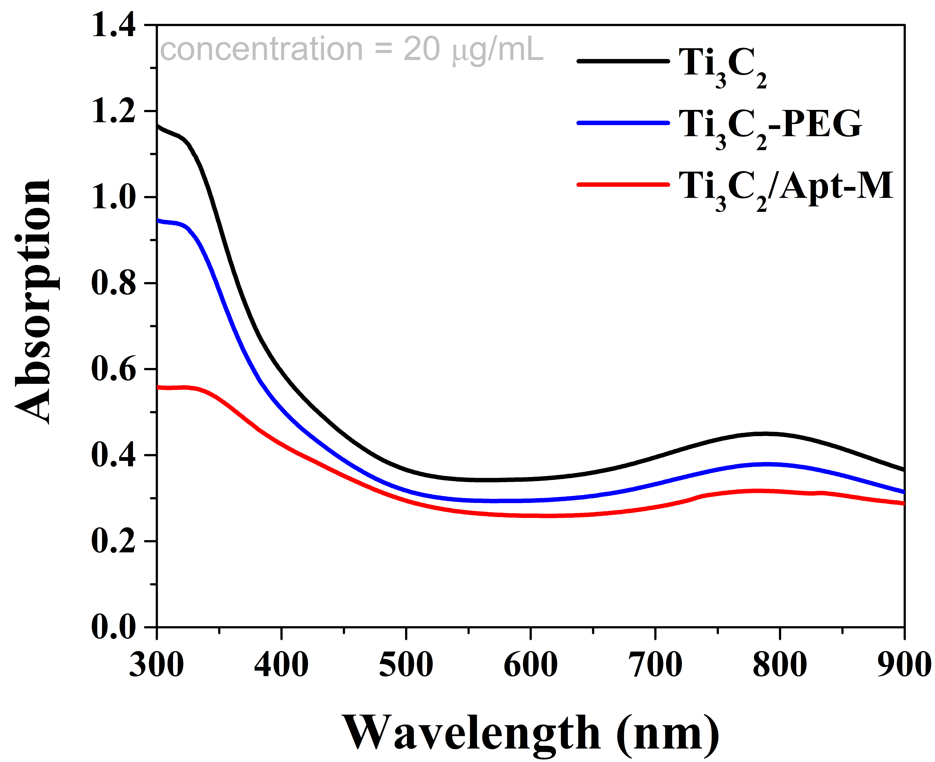
Figure S7. UV-vis spectra of Ti₃C₂, Ti₃C₂-PEG and Ti₃C₂/Apt-M nanosheets.

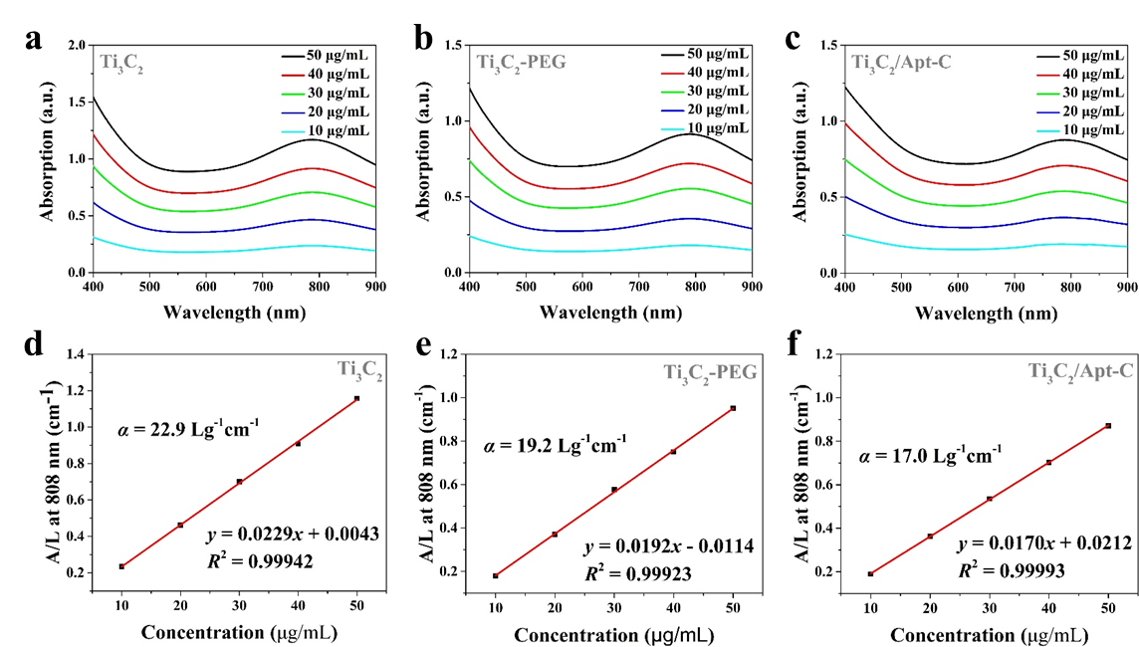
Figure S8. UV-vis spectra of (a) Ti₃C₂, (b) Ti₃C₂-PEG and (c) Ti₃C₂/Apt-C nanosheets at different concentrations. Mass extinction coefficient of (d) Ti₃C₂, (e) Ti₃C₂-PEG and (f) Ti₃C₂/Apt-C nanosheets at 808 nm. Normalized absorbance intensity at λ = 808 nm divided by the characteristic length of the cell (A/L) at varied concentrations (10, 20, 30, 40 and 50 µg mL⁻¹).

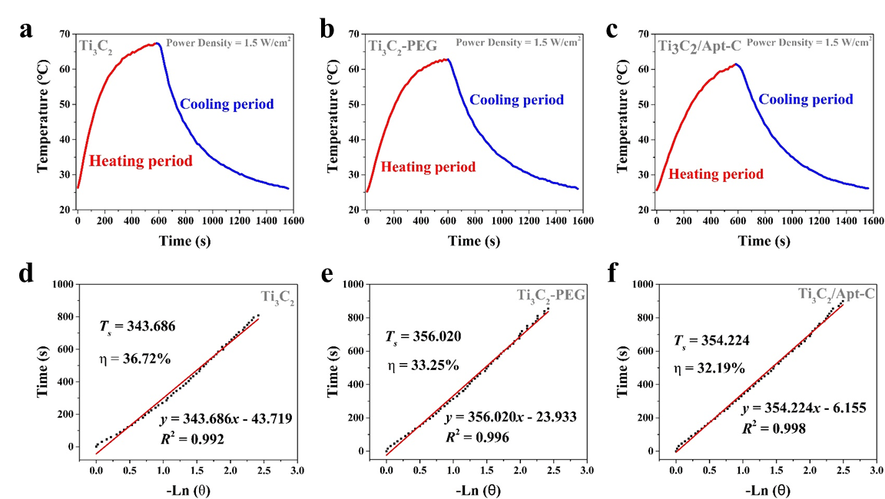
Figure S9. Photothermal performance of (a) Ti₃C₂, (b) Ti₃C₂-PEG and (c) Ti₃C₂/Apt-C nanosheets dispersed in aqueous solution under 808 nm laser irradiation. Calculation of time constant and photothermal-conversion efficiency of (d) Ti₃C₂, (e) Ti₃C₂-PEG and (f) Ti₃C₂/Apt-C nanosheets at 808 nm laser irradiation.

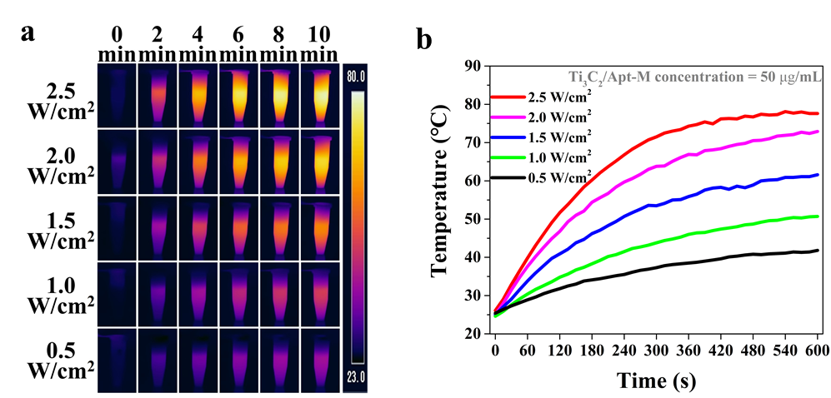
Figure S10. (a) Infrared thermal images and (b) temperature changes of Ti₃C₂/Apt-M nanosheet aqueous solutions under different laser power irradiation at 808 nm.
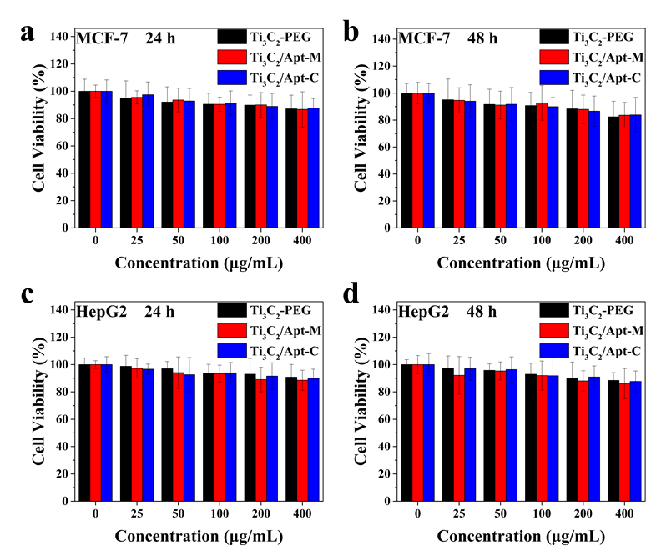
Figure S11. Cell viabilities of (a-b) MCF-7 and (c-d) HepG2 cells after incubation with Ti₃C₂-PEG, Ti₃C₂/Apt-M and Ti₃C₂/Apt-C nanosheets of varied concentrations for 24 h and 48 h.

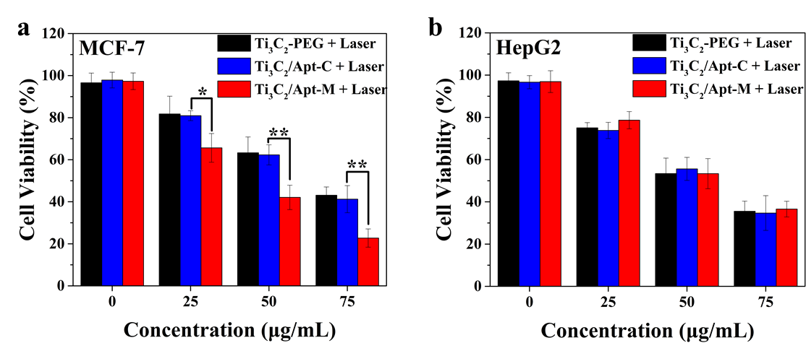
Figure S12. Cell viability of (a) MCF-7 and (b) HepG2 cells treated with different concentrations of Ti₃C₂-PEG, Ti₃C₂/Apt-C and Ti₃C₂/Apt-M nanosheets.
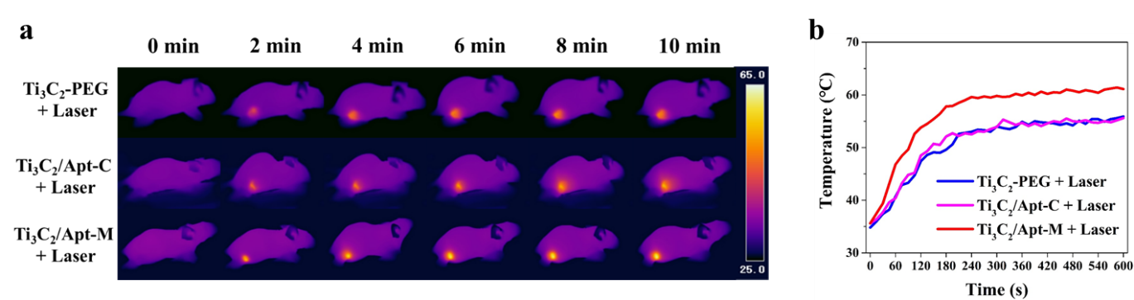
Figure S13. (a) The representative infrared thermal images and (b) temperature curves of tumor-bearing mice with different treatments at different time points.

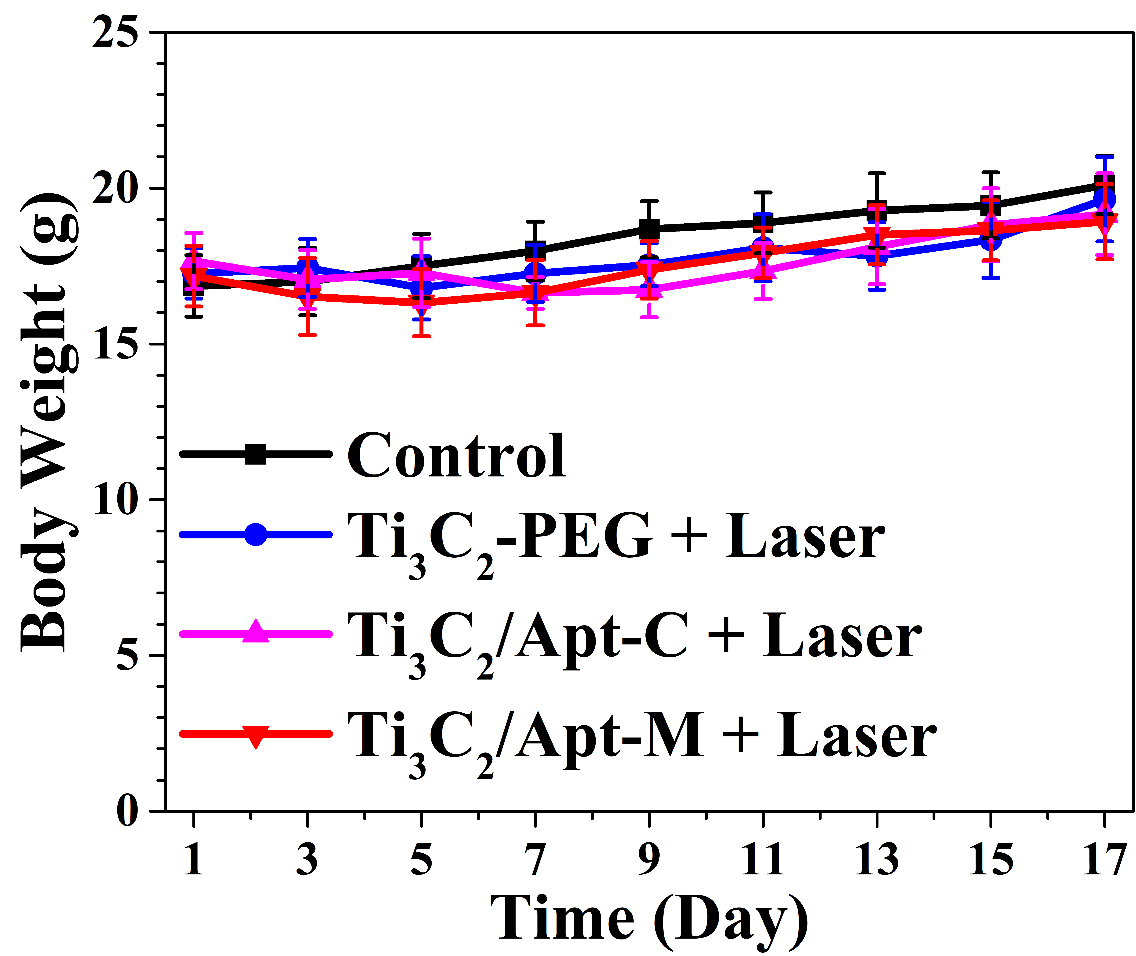
Figure S14. Body weight curves of tumor-bearing mice after different treatments in 17 d.

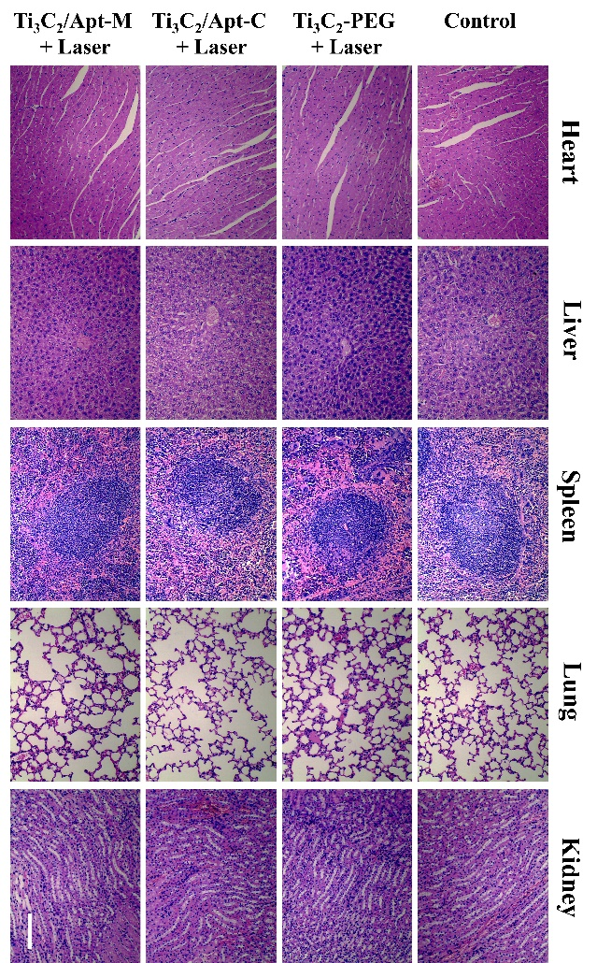
Figure S15. H&E stained tissue sections of major organs (heart, liver, spleen, lung and kidney) from mice with different treatments. Scale bar: 100 μm.
Table S1. Aptamer sequences.
Name | Sequences (5’-3’)
Apt-M | NH₂-(CH₂)₆-GCA GTT GAT CCT TTG GAT ACC CTG GTT TTT TTT TT
Apt-C | NH₂-(CH₂)₆-ATT GCA CTT ACT ATA TTG CAC TTA CTA TAT TGC AC
Apt-Mf | NH₂-(CH₂)₆-GCA GTT GAT CCT TTG GAT ACC CTG GTT TTT TTT TT-FAM
Apt-Cf | NH₂-(CH₂)₆-ATT GCA CTT ACT ATA TTG CAC TTA CTA TAT TGC AC-FAM

Table S2. The photothermal performance parameters (mass extinction coefficient and photothermal conversion efficiency) of various nanoagents in the literatures.
Nanomaterials | Mass Extinction Coefficient  (ε, Lg⁻¹cm⁻¹) | Photothermal Conversion Efficiency  (η, %) | Wavelength  (λ, nm)
Ti₃C₂ nanosheets¹ | 25.2 | 30.6 | 808
Nb₂C nanosheets² | 37.6 or 35.4 | 36.5 or 46.65 | 808 or 1064
Ta₄C₃ nanosheets³ | 8.67 | 34.9 | 808
Mo₂C nanosheets⁴ | 18.0 or 12.3 | 24.5 or 43.3 | 808 or 1064
V₂C nanosheets⁵ | 38.3 | 48.5 | 808
Ti₂N quantum dots⁶ | 41.25 or 34.92 | 48.62 or 45.51 | 808 or 1064
W_{1.33}C nanosheets⁷ | 8.54 or 4.94 | 32.5 or 49.3 | 808 or 1064
Ti₃CN nanosheets⁸ | 36.6 or 43.5 | 36.5 or 32.1 | 808 or 1064
Au nanorods⁹ | 13.9 | 21.0 | 808
BP quantum dots¹⁰ | 14.8 | 28.4 | 808
SnS bulk¹¹ | 8.2 | 24.0 | 808
WS₂ nanosheets¹² | 23.8 | 44.3 | 808

References
1. Lin, H.; Wang, X.; Yu, L.; Chen, Y.; Shi, J. Nano Lett. 2017, 17, (1), 384-391.
2. Lin, H.; Gao, S.; Dai, C.; Chen, Y.; Shi, J. J. Am. Chem. Soc. 2017, 139, (45), 16235-16247.
3. Dai, C.; Chen, Y.; Jing, X.; Xiang, L.; Yang, D.; Lin, H.; Liu, Z.; Han, X.; Wu, R. ACS Nano 2017, 11, (12), 12696-12712.
4. Feng, W.; Wang, R.; Zhou, Y.; Ding, L.; Gao, X.; Zhou, B.; Hu, P.; Chen, Y. Adv. Funct. Mater. 2019, 29, (22), 1901942.
5. Zada, S.; Dai, W.; Kai, Z.; Lu, H.; Meng, X.; Zhang, Y.; Cheng, Y.; Yan, F.; Fu, P.; Zhang, X.; Dong, H. Angew. Chem. Int. Ed. 2020, 59, (16), 6601-6606.
6. Shao, J.; Zhang, J.; Jiang, C.; Lin, J.; Huang, P. Chem. Eng. J. 2020, 400, 126009.
7. Zhou, B. G.; Yin, H. H.; Dong, C. H.; Sun, L. P.; Feng, W.; Pu, Y. Y.; Han, X. X.; Li, X. L.; Du, D.; Xu, H. X.; Chen, Y. Adv. Sci. 2021, 8, (24), 2101043.
8. Zhu, Y. H.; Tang, X. F.; Liu, Q.; Xia, Y. J.; Zhai, X. W.; Zhang, H.; Duan, D. L.; Wang, H.; Zhan, W. Q.; Wu, L.; Zheng, N.; Lv, W. F.; Wang, Y. C.; Zhou, M. Small 2022, 18, (22), 2200646.
9. Zeng, J.; Goldfeld, D.; Xia, Y. Angew. Chem. Int. Ed. 2013, 52, (15), 4169-4173.
10. Sun, Z.; Xie, H.; Tang, S.; Yu, X. F.; Guo, Z.; Shao, J.; Zhang, H.; Huang, H.; Wang, H.; Chu, P. K. Angew. Chem. Int. Ed. 2015, 54, (39), 11526-11530.
11. Ren, Q.; Li, B.; Peng, Z.; He, G.; Zhang, W.; Guan, G.; Huang, X.; Xiao, Z.; Liao, L.; Pan, Y.; Yang, X.; Zou, R.; Hu, J. New J. Chem. 2016, 40, (5), 4464-4467.
12. Yong, Y.; Cheng, X.; Bao, T.; Zu, M.; Yan, L.; Yin, W.; Ge, C.; Wang, D.; Gu, Z.; Zhao, Y. ACS Nano 2015, 9, (12), 12451-12463.

