Additional file 1
Carbon nanoparticles-Fe(II) complex for efficient theranostics of xenografted colonic tumor
Ping Xie,¹ Yuanfang Huang,² Kexin Tang,² Xian Wu,³ Cheng Zeng,² Sheng-Tao Yang,^{3*} Xiaohai Tang,^{2,*}
¹ State Key Laboratory of Oral Diseases, West China College of Stomatology, Sichuan University, Chengdu, P. R. China;
² Sichuan Enray Pharmaceutical Sciences Company, Chengdu, P. R. China;
³ Key Laboratory of Pollution Control Chemistry and Environmental Functional Materials for Qinghai-Tibet Plateau of the National Ethnic Affairs Commission, School of Chemistry and Environment, Southwest Minzu University, Chengdu 610041, P. R. China.

*Correspondence:
Sheng-Tao Yang
yangst@swun.edu.cn
Xiaohai Tang
pharmmateceo@enraypharm.com

Supplementary figure
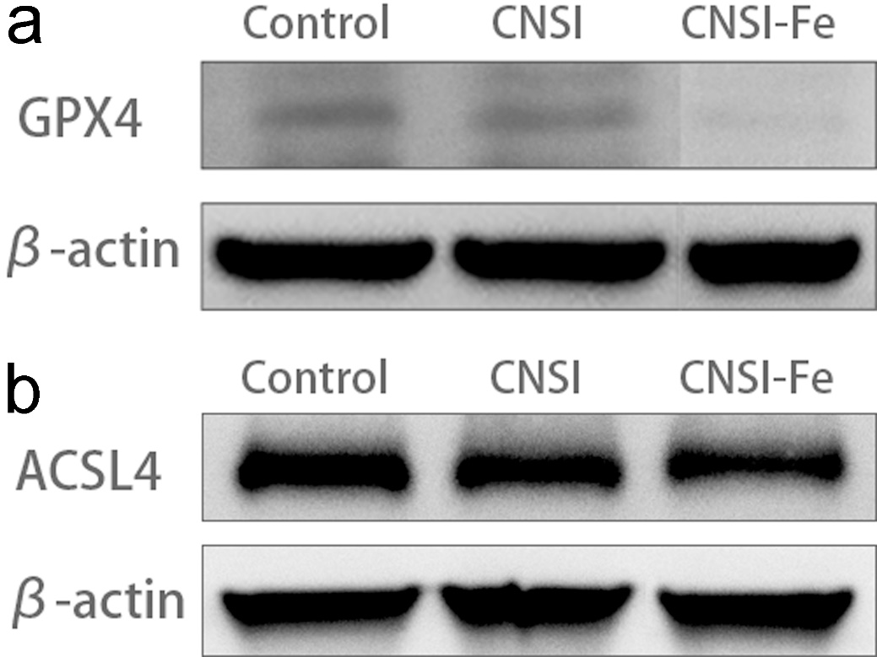
Fig. S1. Representative western blot images for GPX4 and ACSL4 in Fig. 2. a GPX4. b ACSL4.

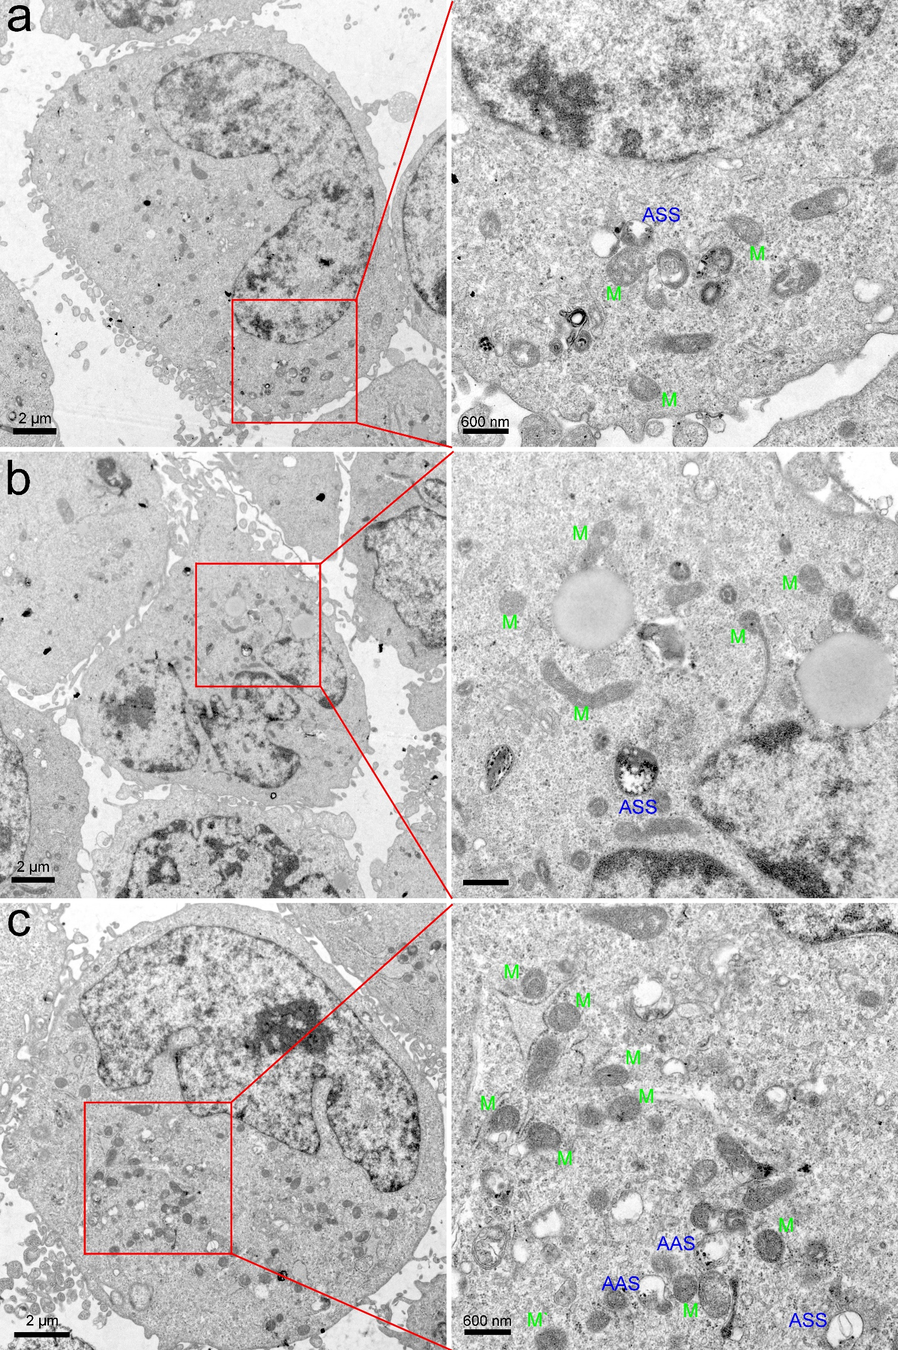
Fig. S2. Additional TEM images of the control group and the cells exposed to CNSI-Fe. a, b control group. c CNSI-Fe group. ASS means autolysosome and M means mitochondria.
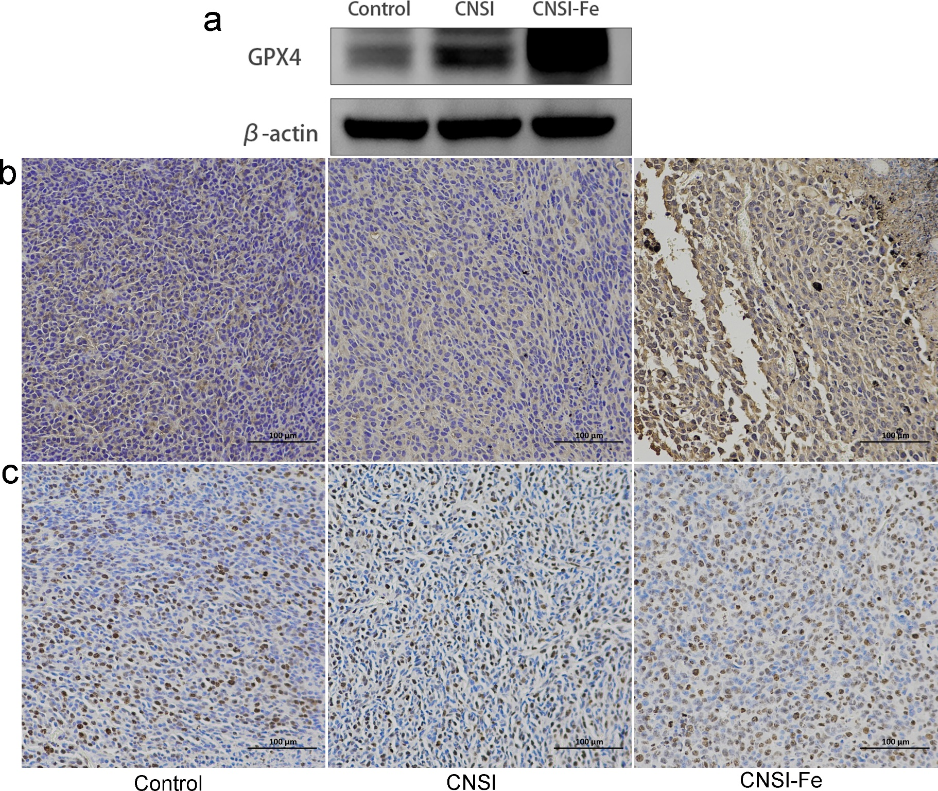
Fig. S3. Representative western blot images for GPX4 and immunohistochemical staining images for caspase-3 and Ki67 in Fig. 6. a GPX4. b caspase-3. c Ki67.

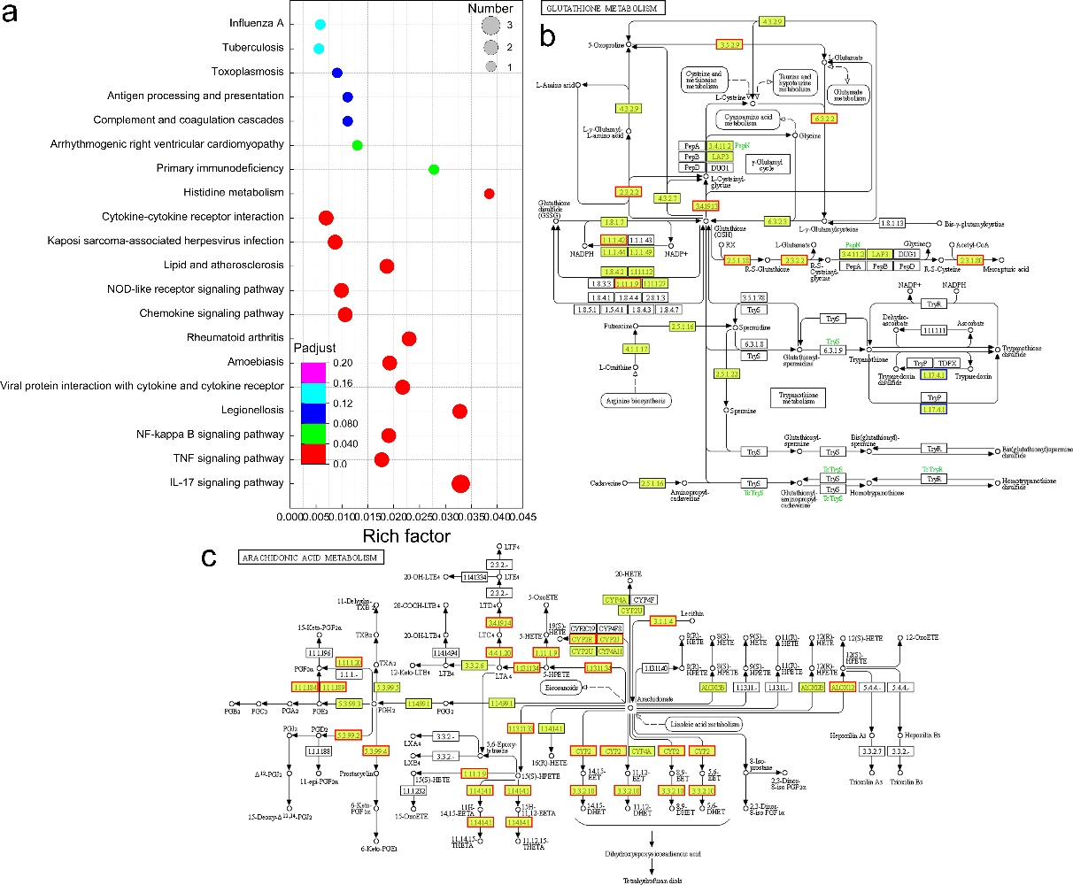
Fig. S4. Transcriptomes analysis of tumor tissue after the treatment of CNSI or CNSI-Fe. a KEGG functional enrichment of CNSI group comparing with the control. b Glutathione metabolism signaling pathway diagram. c Arachidonic metabolism signaling pathway diagram.

