Boosting Nuclear-targeted Photothermal-chemotherapy by NIR-responsive Biomimetic Hybrid Membrane Camouflaged Nanotherapeutics
Xinyue Xing¹, Yuying Zeng², Wanqing Zhong¹, Wendai Cheng¹, Chengxin Zhou¹, Xiaoxu Lu^{1*}, Liyun Zhong^{3*}

¹ Guangdong Provincial Key Laboratory of Nanophotonic Functional Materials and Devices, South China Normal University, Guangzhou, China
² Graduate School of Biomedical Sciences, Baylor College of Medicine, Houston, TX, USA
³ China Guangdong Provincial Key Laboratory of Photonics Information Technology, Guangdong University of Technology, Guangzhou, China
*Corresponding author zhongly@gdut.edu.cn, hsgdzlxx@scnu.edu.cn

Figure S1. Western blot analysis of different membrane protein for characterizing the presence of CD36 and CD81 in HepG2 membrane, Raw 264.7 membrane and the hybrid membrane vesicles.

Figure S2. Fluorescent images of PB@D@M NPs incubated with VE cells, HeLa cells and HepG2 cells for 6 h. Scale bar: 50 μm.

Figure S3. Fluorescent images of Raw 264.7 cells incubated with PB@D, PB@D@HM and PB@D@M NPs for 6 h. Scale bar: 50 μm.

Figure S4. PB content was measured by ICP in HepG2 cells incubated with PB@HM, PB@RM, PB@M and PB@N@M NPs with/without NIR irradiation. ****P<0.0001.

Table S1. Tentative assignments of Raman fingerprints in the SERS spectra collected from the HepG2 cells[1–8].
Band/cm⁻¹ | Assignment | Components
450-525 | S-S stretching | Protein
580-594 | Trp | Protein
620-660 | Phe, C-S stretching, COO-bending | Protein
670 | T ring breathing | DNA
720 | A ring breathing | DNA
750 | pyrrole breathing mode ν₁₅ of cytochrome c | Protein
780 | O-P-O stretching | DNA
950 | random coil | DNA
1001 | Phe ring breathing | Protein
1012-1030 | Phe C−H in-plane bending and  Trp ring breathing | Protein
1096 | B-DNA: O-P-O symmetric stretching | DNA
1120-1150 | C-N stretching | Protein
1170-1180 | Tyr, C-H bending, C-C stretching | Protein
1200-1210 | C₆H₅−C stretching of Phe and Tyr | Protein
1245-1250 | Amide III | Protein
1310-1340 | A ring breathing | DNA
1445 | −CH₂ bending along with methylene deformation | Lipid, protein
1550-1660 | C=C stretching, Trp, Phe | Protein
1650 | α-helix of Amide I | Protein
Abbreviations: Phe, phenylalanine; Tyr, tyrosine; Trp, tryptophan.

Figure S5. Photographic and SERS images based on the peak of 2152 cm⁻¹ of tumor isolated from the mice injected with PB@DN@M NPs for 24 h. Scale bar: 100 μm.

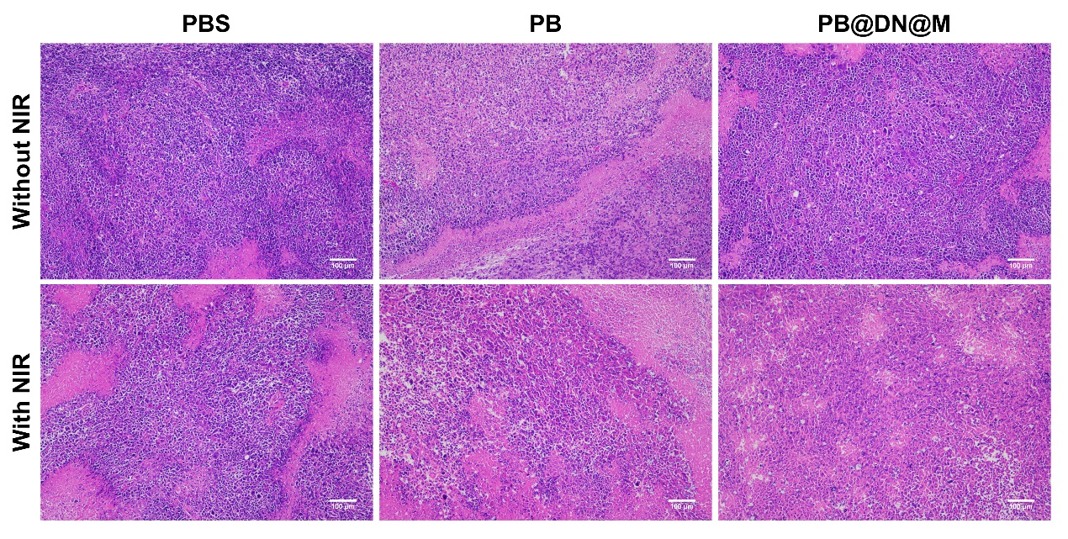
Figure S6. Representative images of H&E-stained tumors from the different treatment groups. Scale bar: 100 μm.

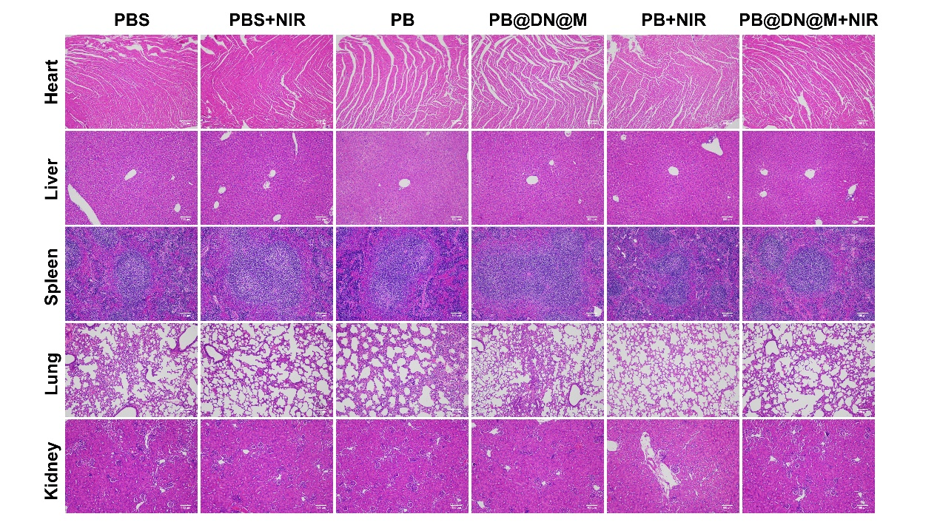
Figure S7. H&E staining of major organs from different groups. Scale bar: 100 μm.

References
1. Ali MRK, Wu Y, Han T, Zang X, Xiao H, Tang Y, et al. Simultaneous Time-Dependent Surface-Enhanced Raman Spectroscopy, Metabolomics, and Proteomics Reveal Cancer Cell Death Mechanisms Associated with Gold Nanorod Photothermal Therapy. J Am Chem Soc. 2016;138:15434–42.
2. Xie Y, Tang P, Xing X, Zhao Y, Cao S, Liu S, et al. In situ exploring Chidamide, a histone deacetylase inhibitor, induces molecular changes of leukemic T-lymphocyte apoptosis using Raman spectroscopy. Spectrochim Acta A Mol Biomol Spectrosc. 2020;241:118669.
3. Zhao Y, Tang P, He X, Xie Y, Cheng W, Xing X, et al. Study on the precise mechanism of Mitoxantrone-induced Jurkat cell apoptosis using surface enhanced Raman scattering. Spectrochim Acta A Mol Biomol Spectrosc. 2020;228:117718.
4. Panikkanvalappil SR, James M, Hira SM, Mobley J, Jilling T, Ambalavanan N, et al. Hyperoxia Induces Intracellular Acidification in Neonatal Mouse Lung Fibroblasts: Real-Time Investigation Using Plasmonically Enhanced Raman Spectroscopy. J Am Chem Soc. 2016;138:3779–88.
5. Nair JB, Joseph MM, Arya JS, Sreedevi P, Sujai PT, Maiti KK. Elucidating a Thermoresponsive Multimodal Photo-Chemotherapeutic Nanodelivery Vehicle to Overcome the Barriers of Doxorubicin Therapy. ACS Appl Mater Interfaces. 2020;12:43365–79.
6. Huang Z, McWilliams A, Lui H, McLean DI, Lam S, Zeng H. Near-infrared Raman spectroscopy for optical diagnosis of lung cancer. Int J Cancer. 2003;107:1047–52.
7. Qi G, Zhang Y, Xu S, Li C, Wang D, Li H, et al. Nucleus and Mitochondria Targeting Theranostic Plasmonic Surface-Enhanced Raman Spectroscopy Nanoprobes as a Means for Revealing Molecular Stress Response Differences in Hyperthermia Cell Death between Cancerous and Normal Cells. Anal Chem. 2018;90:13356–64.
8. Panikkanvalappil SR, Hira SM, El-Sayed MA. Elucidation of ultraviolet radiation-induced cell responses and intracellular biomolecular dynamics in mammalian cells using surface-enhanced Raman spectroscopy. Chem Sci. 2016;7:1133–41.

