Dual-targeting nanomedicine achieves synergistic multimodal therapy for tumor
Weidong Zhang^{1,2}, Liang Dai¹, Na Wang¹, Yunhe Liu³, Zining Hao², Yaqian He², Song Ni³*, Yimin Wang¹*, Dawei Gao²*

- The First Hospital of Qinhuangdao, Qinhuangdao, 066004, China.
- State Key Laboratory of Metastable Materials Science and Technology, Nano-Biotechnology Key Lab of Hebei Province, Applying Chemistry Key Lab of Hebei Province, Heavy Metal Deep-Remediation in Water and Resource Reuse Key Lab of Hebei, Yanshan University, Qinhuangdao, 066004, China.
- National Cancer Center/National Clinical Research Center for Cancer/Cancer Hospital, Chinese Academy of Medical Sciences and Peking Union Medical College, Beijing, 100021, China.

*Corresponding author:
Prof. Dawei Gao, E-mail: dwgao@ysu.edu.cn
Prof. Yimin Wang, E-mail: drwangyimin@126.com
Prof. Song Ni, E-mail: nisong168@sina.com

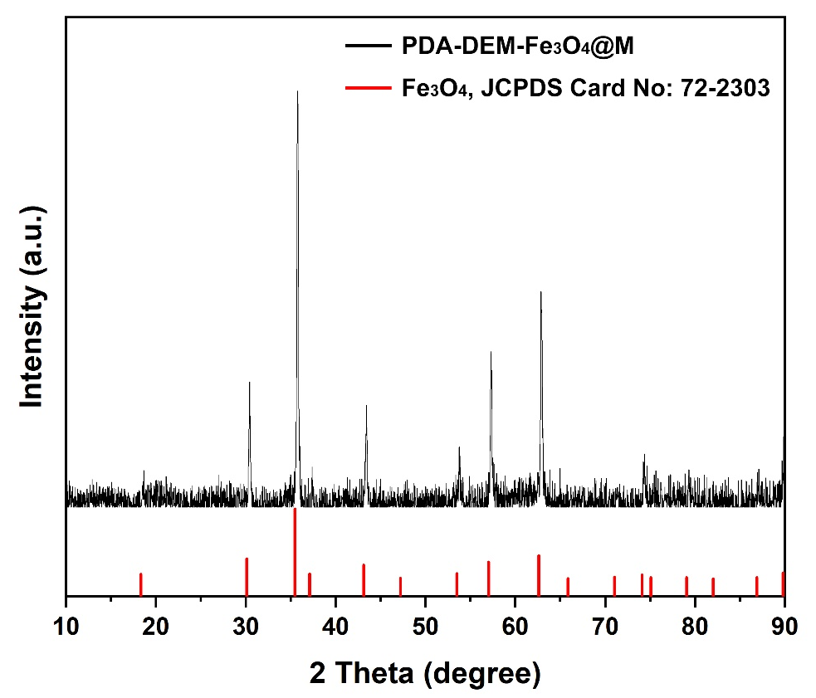
Figure S1. XRD of PDA-DOX- Fe₃O₄@M

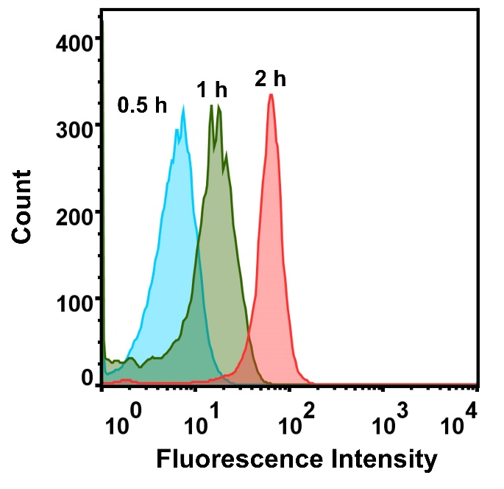
Figure S2. Uptake of PDA-DOX-Fe3O4@M by HeLa cells at different treatment times.
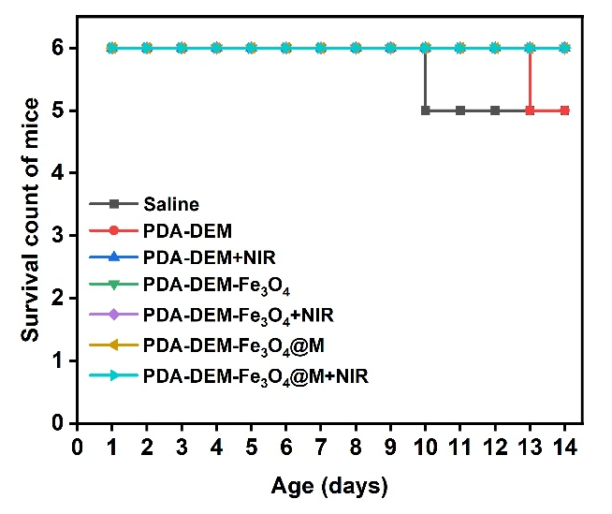
Figure S3. Survival curve of mice with different treatments.

