Supplementary Material
A novel PH1/pE27HGFK1 nanoparticles for orthotopic glioblastoma therapy
Jian zhang^{2,3#}, Tao Li^{1#}, Ling Liu³, Zhenpu Chen¹, Li Li¹, Xiaoxuan Yao¹, Jiaxing Chen¹, Xiaoyuan Hu¹, Jiyin Guo¹, Ruilei Li¹, Chunlei Ge¹, Eng-Ang, Ling⁴, Hong Yao^{1, 3*}.
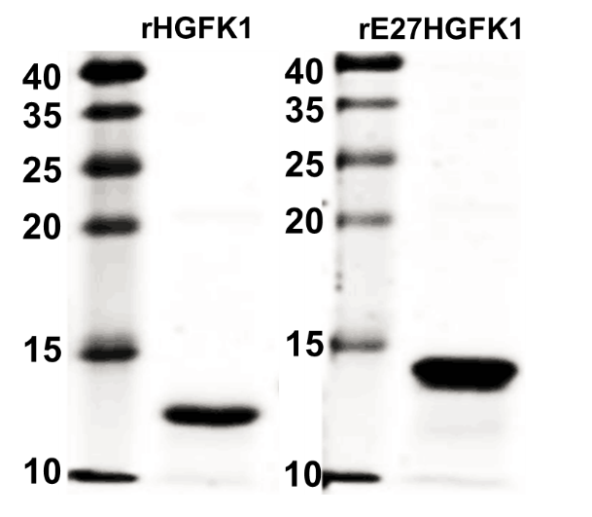
Supplementary Figure 1. The SDS-PAGE results of recombinant proteins rHGFK1 and rE27HGFK1 induced by IPTG and purified by chitin affinity chromatography.
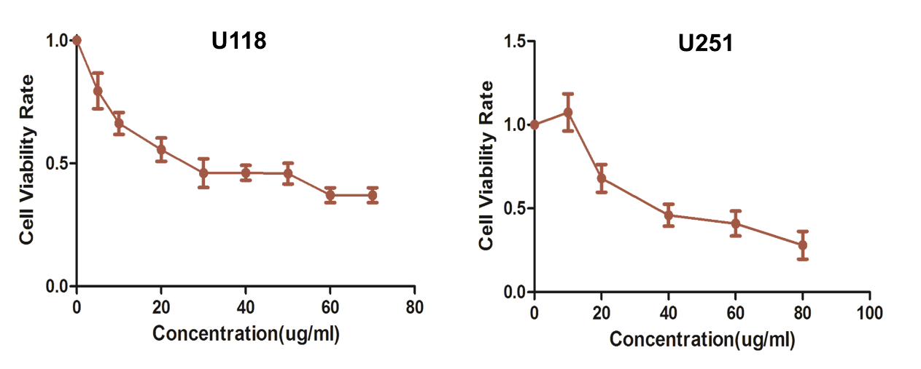
Supplementary Figure 2. CCK8 was used to determine the inhibitory effect of different concentrations of rE27HGFK1 on the proliferation of GBM lines U118 and U251.

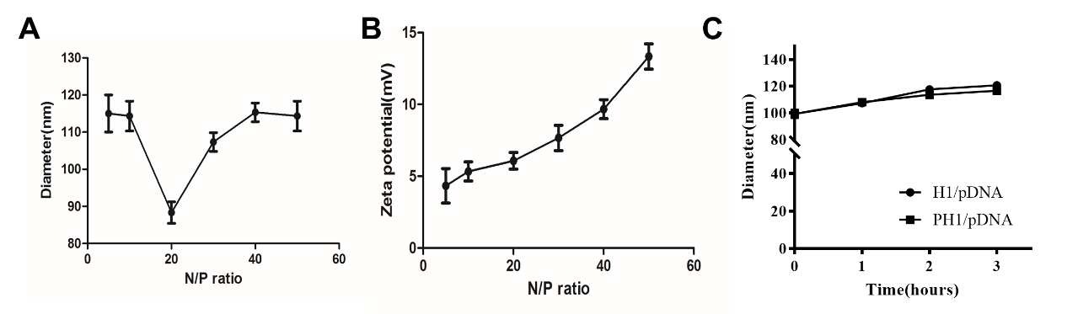
Supplementary Figure 3. Characterization of PH1/pDNA particle physical properties. A. The size distribution of PH1/pDNA polyplexes was measured by Malvern Zeta Nano sizer instrument in DDH₂O. B. The zeta potential distribution of PH1/pDNA polyplexes at different N/P ratio in DDH₂O. C. H1/pDNA and PH1/pDNA nanoparticles' stability and size vary over time in a 5% glucose solution (An isotonic solution that simulates the in vivo environment).

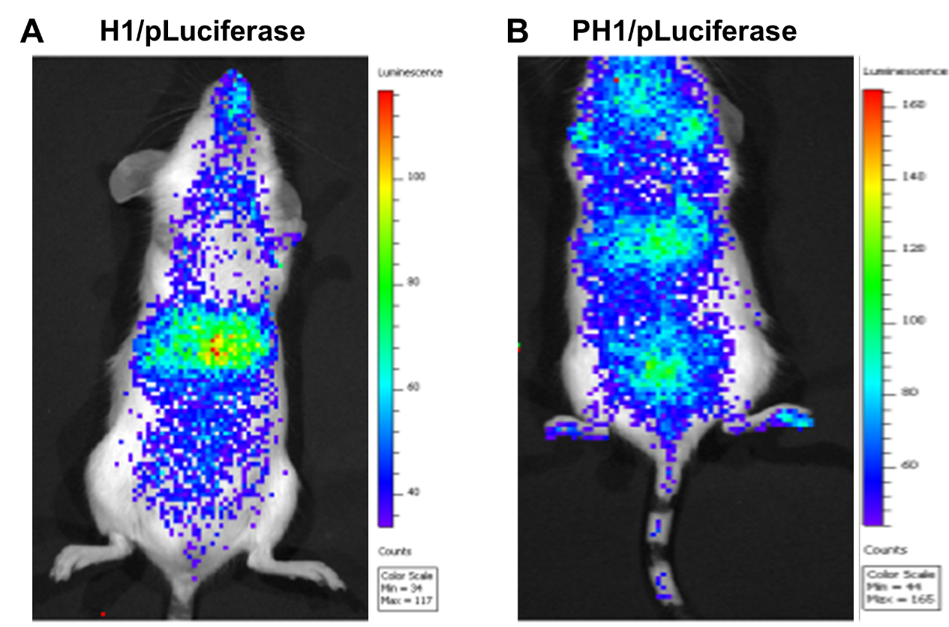
Supplementary Figure 4. Representative pLuciferase-distribution images of Balb/c mice injected with H1/pLuciferase, PH1/pLuciferase.

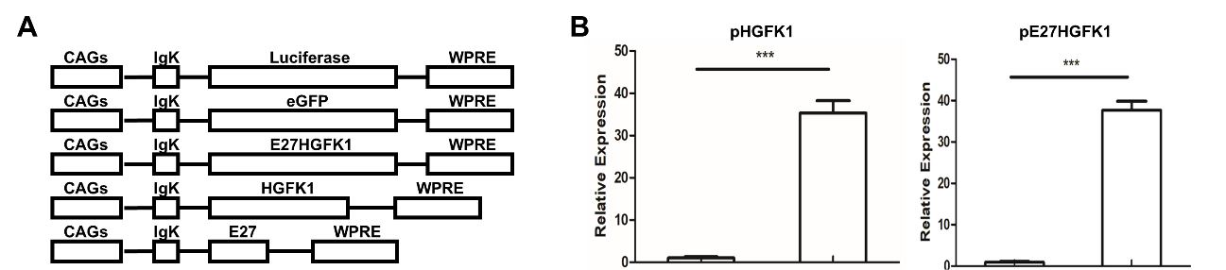
Supplementary Figure 5. A. the schematic diagram of secretory target plasmid pHGFK1 and pE27HGFK1. B. The mRNA level of the E27HGFK1 and HGFK1 were detected at 48h after the transfection of pHGFK1 and pE27HGFK1 to U118 cells by qPCR, respectively.

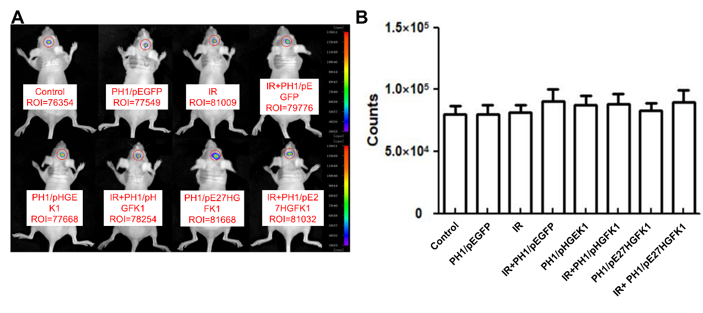
Supplementary Figure 6. The anti-tumoral and radio-sensitization functions of pH1/pE27HGFK1 nanoparticles in the orthotopic Luc-U118 xenografted nude mouse model. A&B. After treated with PH1/pE27HGFK1, PH1/pHGFK1, PH1/pE27HGFK1+IR, PH1/pHGFK1+IR, PH1/pEGFP, PH1/pEGFP+IR, IR and 5% glucose for 7 days, the tumor fluorescence density and counting values were calculated by in vivo optical imaging system.
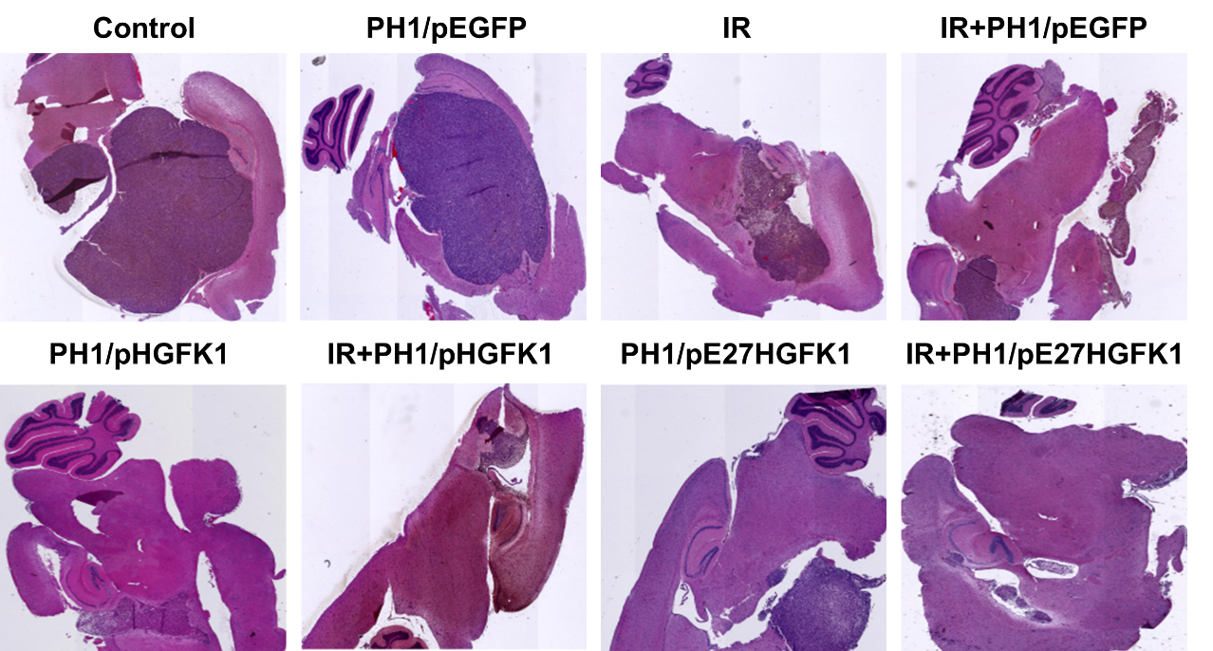
Supplementary Figure 7. HE staining to detect the morphological features in the brain tissue with different treatments of U118-luc-bearing mice.

