First, Apoptosis Markers Analysis
using Western Blot
L3
(17.2 µg/ml)
T2
(0.93 µg/ml)
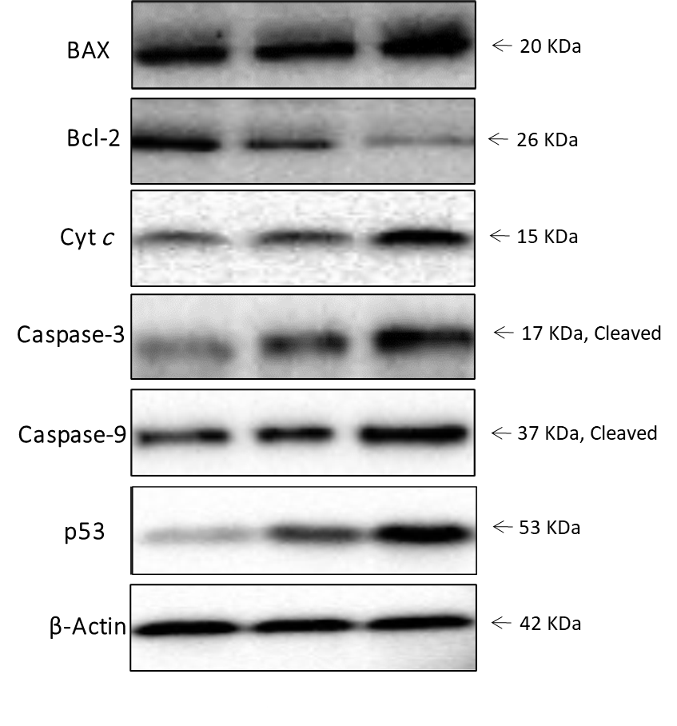
Control

Second, β-Catenin pathway proteins using Western Blot.
T3
(19.5 µg/ml)
L3
(17.2 µg/ml)
T2
(0.93 µg/ml)
Control
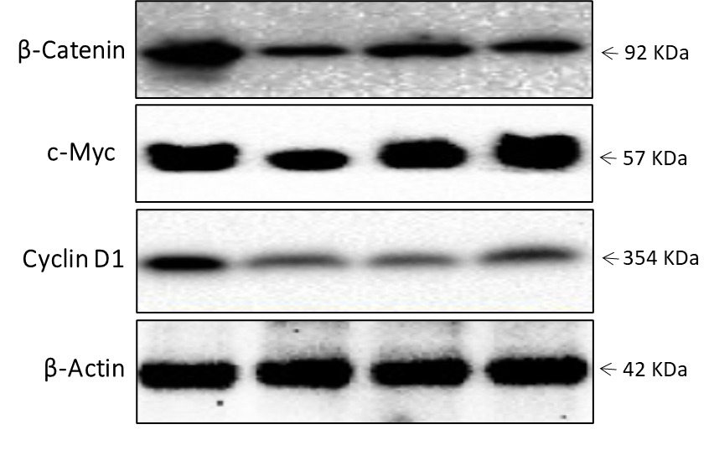

Third, DNA fragmentation data by gel electrophoresis;

Sample: T2

1-Fixed concentration of DNA with different concentrations of complex

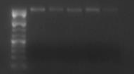

L 1 2 3 4 5

2--Fixed concentration of complex with different concentrations of DNA

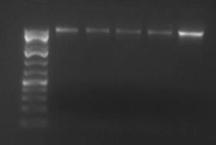

L 1 2 3 4 5

Sample: L3

sa

1-Fixed concentration of DNA with different concentrations of complex

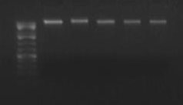
L 1 2 3 4 5

2--Fixed concentration of complex with different concentrations of DNA
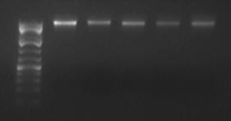
L 1 2 3 4 5

