Supporting Information

Table S1. Survival fraction analysis using the linear quadratic regression model.
 | Control | + BPA (40 ppm) | + M-Carb (40 ppm)
α | 0.109 ± 0.103 | 0.251 ± 0.113 | 0.302 ± 0.122
β | 0.007 ± 0.018 | -0.007 ± 0.019 | -0.013 ± 0.020
α/β | 15.015 | -35.572 | -22.821
R² | 0.787 | 0.864 | 0.842
D_{50%}(Gy) | 4.849 | 3.015 | 2.582

Table S2. Ex vivo biodistribution and excretion data of ¹¹¹In-M-Carb in CD1 mice at 1 and 24 h post-injection*

Organ | 1 h | 24 h
Blood | 35.8 ± 4.0 | 14.8 ± 4.3
Liver | 9.5 ± 0.9 | 10.3 ± 1.7
Intestine | 3.2 ± 0.5 | 4.8 ± 0.7
Spleen | 0.6 ± 0.2 | 0.8 ± 0.2
Heart | 0.49 ± 0.04 | 0.6 ± 0.2
Lung | 3.5 ± 0.8 | 5.7 ± 1.2
Kidney | 6.9 ± 0.9 | 11.2 ± 3.1
Muscle | 16.8 ± 2.7 | 11.2 ± 3.2
Bone | 8.1 ± 0.5 | 8.7 ± 0.7
Stomach | 0.51 ± 0.02 | 0.37 ± 0.06
Pancreas | 0.31 ± 0.06 | 0.29 ± 0.05
Excretion | 1.0 | 18.8 ± 4.4
*Results are expressed as a percentage of the injected activity per organ or tissue (% I.A.) assuming that total mass of blood, bone and muscle, correspond to 6, 10 and 40% of body weight, respectively. Excretion result is expressed as a percentage of the total injected activity (% I.A.) and was calculated by the difference between the radioactivity in the injected and sacrificed animal.

Table S3. ICP-MS analysis of boron content*.
Organ | 1 h (n=3) | 24 h (n=3)
Blood | 409.9 ± 83.8 | n.d.
Liver | 459.0 ± 43.9 | 148.0 ± 35.3
Intestine | n.d. | n.d.
Spleen | n.d. | n.d.
Lung | < 68 | n.d.
Kidney | 484.3 ± 145.3 | 222.5 ± 97.3
*Data are expressed in ng/organ. Tissues were collected at 1 h and 24 h after i.v. injection of¹¹¹In-M-Carb for analysis. n.d., non detectable.

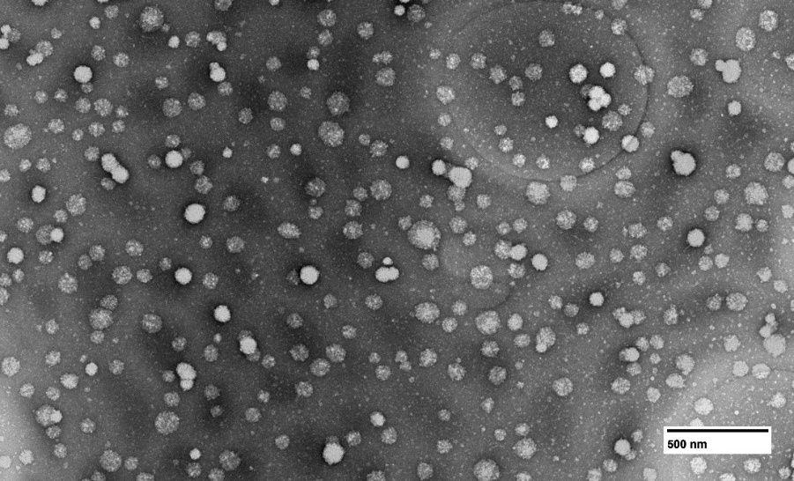
Figure S1. TEM image of M-Carb.

Figure S2. CMC of blank micelles determine by DLS measurements. The estimated CMC for blank micelles was ~20 µg/mL.

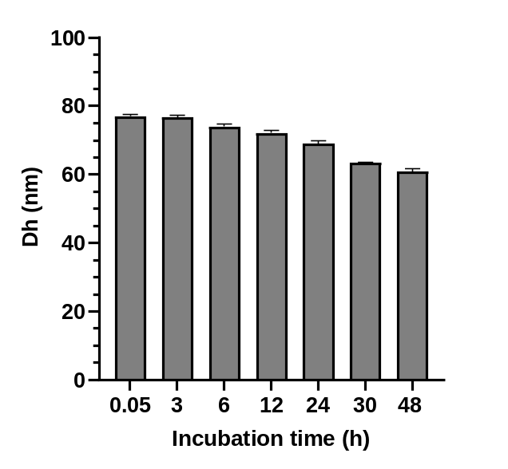
Figure S3. Stability of M-Carb. M-Carb (1.0 mg/mL) was incubated in PBS containing 10% FBS at 37°C. Nanoparticle size was measured by DLS. Data are expressed as means ± SD (n = 3).

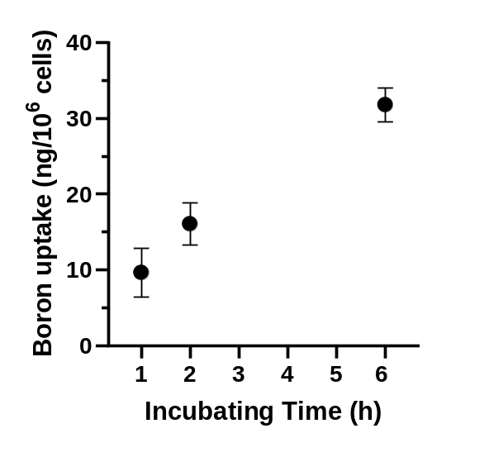
Figure S4. Uptake of boron in MiaPaca-2 cells incubated M-Carb. Cells were incubated with 0.2 mM M-Carb at 37 °C for 1, 2, and 6 h. Boron concentration was measured by ICP-MS. Data are expressed as means ± SD (n = 3).

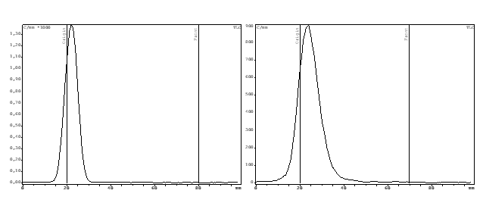
Figure S5. Radio-chromatograms of labeled micelles ¹¹¹In-M-Carb after purification (A) and after incubation in 0.1 M PBS solution pH 7.4 at 37 °C for 24 h (B). Chromatographic system: ITLC-SG using sodium acetate buffer pH 5.0 as eluent.
A
B

