Supplementary Information

Journal: Cancer Nanotechnology

Gold Nanostructure-based Cancer Photothermal Therapy: A Comprehensive Systematic Review, Meta-Analysis, and Dose–Response Evaluation

Emad khoshdel^{1,2}, Mobina Shadroy Jadid³, Mohamad Amin Younessi Heravi⁴, Behzad Fazlkhah⁵, Shima Gholami⁶, Mahboobeh Mehrabifard⁷, Naser Shifteh⁸, Reza Malekzadeh^{9*}, Farzaneh Ghorbani ^{10,11*}
¹Department of Medical Physics, Faculty of Medicine, Mashhad University of Medical Sciences, Mashhad, Iran
²Student Research Committee, Mashhad University of Medical Sciences, Mashhad, Iran
³Department of Radiology Technology, School of Paramedical Sciences, Mashhad University of Medical Sciences, Mashhad, Iran
⁴Department of Medical Physics and Radiology, North Khorasan University of Medical Sciences, Bojnurd, Iran.
⁵Department of Radiology, Faculty of Alliance Medical Sciences, Tabriz University of Medical Sciences, Tabriz, Iran.
⁶Radiation Oncology Department, Isfahan University of Medical Sciences, Isfahan, Iran
⁷Department of Medical Physics, School of Medicine, Shiraz University of Medical Sciences, Shiraz, Iran
⁸Department of Mathematics and Computer sciences, Ardabil University of Medical Sciences, Ardabil, Iran
⁹Department of Medical Physics, School of Medicine, Tabriz University of Medical Sciences, Tabriz, Iran
¹⁰Nanotechnology Research Center, Pharmaceutical Technology Institute, Mashhad University of Medical Sciences, Mashhad, Iran
¹¹Comprehensive Research Laboratory, Mashhad University of Medical Sciences, Mashhad, Iran

Corresponding authors:
- Reza Malekzadeh, Medical Physicist,
Department of Medical Physics, School of Medicine, Tabriz University of Medical Sciences, Golgasht Street, Tabriz, Iran.
Email: rmalekzadeh92@gmail.com ORCID: 0000-0001-5613-9173

- Farzaneh Ghorbani, Ph.D.,
Assistant professor of Medical physics, Nanotechnology Research Center, Pharmaceutical Technology Institute, Mashhad University of Medical Sciences, Mashhad, Iran.
Email: ghorbanifme@gmail.com ORCID: 0000-0003-4191-9868

Running Title: Gold nanostructures in cancer photothermal therapy: dose-response meta-analysis.
Study Design: Registered systematic review and meta-analysis following PRISMA guidelines.
Protocol Registration: PROSPERO 2025 CRD420251250129.

Table S1. The PRISMA 2020 checklist, outlining essential reporting items for systematic reviews and meta-analyses, as applied in this study.
Section and Topic | Item # | Checklist item | Location where item is reported
TITLE
Title | 1 | Identify the report as a systematic review. | Page 1
ABSTRACT
Abstract | 2 | See the PRISMA 2020 for Abstracts checklist. | Page 2
INTRODUCTION
Rationale | 3 | Describe the rationale for the review in the context of existing knowledge. | Page 5
Objectives | 4 | Provide an explicit statement of the objective(s) or question(s) the review addresses. | Page 5
METHODS
Eligibility criteria | 5 | Specify the inclusion and exclusion criteria for the review and how studies were grouped for the syntheses. | Page 6
Information sources | 6 | Specify all databases, registers, websites, organisations, reference lists and other sources searched or consulted to identify studies. Specify the date when each source was last searched or consulted. | Page 6
Search strategy | 7 | Present the full search strategies for all databases, registers and websites, including any filters and limits used. | Page 6
Selection process | 8 | Specify the methods used to decide whether a study met the inclusion criteria of the review, including how many reviewers screened each record and each report retrieved, whether they worked independently, and if applicable, details of automation tools used in the process. | Page 7
Data collection process | 9 | Specify the methods used to collect data from reports, including how many reviewers collected data from each report, whether they worked independently, any processes for obtaining or confirming data from study investigators, and if applicable, details of automation tools used in the process. | Page 7
Data items | 10a | List and define all outcomes for which data were sought. Specify whether all results that were compatible with each outcome domain in each study were sought (e.g. for all measures, time points, analyses), and if not, the methods used to decide which results to collect. | Page 7
Data items | 10b | List and define all other variables for which data were sought (e.g. participant and intervention characteristics, funding sources). Describe any assumptions made about any missing or unclear information. | Page 7
Study risk of bias assessment | 11 | Specify the methods used to assess risk of bias in the included studies, including details of the tool(s) used, how many reviewers assessed each study and whether they worked independently, and if applicable, details of automation tools used in the process. | Page 8
Effect measures | 12 | Specify for each outcome the effect measure(s) (e.g. risk ratio, mean difference) used in the synthesis or presentation of results. | Page 8
Synthesis methods | 13a | Describe the processes used to decide which studies were eligible for each synthesis (e.g. tabulating the study intervention characteristics and comparing against the planned groups for each synthesis (item #5)). | Page 7
Synthesis methods | 13b | Describe any methods required to prepare the data for presentation or synthesis, such as handling of missing summary statistics, or data conversions. | Page 8
Synthesis methods | 13c | Describe any methods used to tabulate or visually display results of individual studies and syntheses. | NA
Synthesis methods | 13d | Describe any methods used to synthesize results and provide a rationale for the choice(s). If meta-analysis was performed, describe the model(s), method(s) to identify the presence and extent of statistical heterogeneity, and software package(s) used. | NA
Synthesis methods | 13e | Describe any methods used to explore possible causes of heterogeneity among study results (e.g. subgroup analysis, meta-regression). | NA
Synthesis methods | 13f | Describe any sensitivity analyses conducted to assess robustness of the synthesized results. | NA
Reporting bias assessment | 14 | Describe any methods used to assess risk of bias due to missing results in a synthesis (arising from reporting biases). | NA
Certainty assessment | 15 | Describe any methods used to assess certainty (or confidence) in the body of evidence for an outcome. | NA
RESULTS
Study selection | 16a | Describe the results of the search and selection process, from the number of records identified in the search to the number of studies included in the review, ideally using a flow diagram. | Page 8
Study selection | 16b | Cite studies that might appear to meet the inclusion criteria, but which were excluded, and explain why they were excluded. | Page 9
Study characteristics | 17 | Cite each included study and present its characteristics. | Table S2
Risk of bias in studies | 18 | Present assessments of risk of bias for each included study. | Table S3
Results of individual studies | 19 | For all outcomes, present, for each study: (a) summary statistics for each group (where appropriate) and (b) an effect estimate and its precision (e.g. confidence/credible interval), ideally using structured tables or plots. | Table S2
Results of syntheses | 20a | For each synthesis, briefly summarise the characteristics and risk of bias among contributing studies. | Page 10
Results of syntheses | 20b | Present results of all statistical syntheses conducted. If meta-analysis was done, present for each the summary estimate and its precision (e.g. confidence/credible interval) and measures of statistical heterogeneity. If comparing groups, describe the direction of the effect. | Page 11
Results of syntheses | 20c | Present results of all investigations of possible causes of heterogeneity among study results. | NA
Results of syntheses | 20d | Present results of all sensitivity analyses conducted to assess the robustness of the synthesized results. | Page 11
Reporting biases | 21 | Present assessments of risk of bias due to missing results (arising from reporting biases) for each synthesis assessed. | NA
Certainty of evidence | 22 | Present assessments of certainty (or confidence) in the body of evidence for each outcome assessed. | NA
DISCUSSION
Discussion | 23a | Provide a general interpretation of the results in the context of other evidence. | Page 12-40
Discussion | 23b | Discuss any limitations of the evidence included in the review. | Page 41
Discussion | 23c | Discuss any limitations of the review processes used. | Page 42
Discussion | 23d | Discuss implications of the results for practice, policy, and future research. | Page 44
OTHER INFORMATION
Registration and protocol | 24a | Provide registration information for the review, including register name and registration number, or state that the review was not registered. | Page 6
Registration and protocol | 24b | Indicate where the review protocol can be accessed, or state that a protocol was not prepared. | Page 6
Registration and protocol | 24c | Describe and explain any amendments to information provided at registration or in the protocol. | Page 6
Support | 25 | Describe sources of financial or non-financial support for the review, and the role of the funders or sponsors in the review. | Page 46
Competing interests | 26 | Declare any competing interests of review authors. | Page 46
Availability of data, code and other materials | 27 | Report which of the following are publicly available and where they can be found: template data collection forms; data extracted from included studies; data used for all analyses; analytic code; any other materials used in the review. | Page 46
From: Page MJ, McKenzie JE, Bossuyt PM, Boutron I, Hoffmann TC, Mulrow CD, et al. The PRISMA 2020 statement: an updated guideline for reporting systematic reviews. BMJ 2021;372:n71. doi: 10.1136/bmj.n71. This work is licensed under CC BY 4.0. To view a copy of this license, visit https://creativecommons.org/licenses/by/4.0/

Table S2. PICOs framework used to define eligibility criteria and guide study selection for the systematic review and meta-analysis of gold nanostructure-based photothermal therapy in preclinical cancer models.
PICOs Elements |  | Details
P  (Population) | - Cancer models treated with gold nanoparticle-based PTT  - In vitro: Cancer cell lines (breast, prostate, liver, lung, melanoma, colorectal, glioblastoma, etc.)  - In-vivo: Animal models (mice, rats, rabbits, guinea pigs) with subcutaneous xenografts, orthotopic tumors, or syngeneic allografts  - No restrictions on cancer type or animal species
I  (Intervention) | - Gold nanoparticle-based photothermal therapy (PTT)  - Gold nanostructures: spherical nanoparticles, nanorods, nanoshells, nanostars, nanocages.  - Laser irradiation (NIR: 750-1700 nm)  - Surface modifications: PEG, chitosan, PVP, PDA, targeting ligands (RGD, antibodies, folic acid)  - Nanoparticle concentrations: 1-200+ μg/mL
C  (Comparison) | - Untreated controls or standard care  - Negative controls: untreated cells/tumors  - Vehicle controls: saline, PBS, or non-irradiated nanoparticle groups
O  (Outcome) | - Primary Outcomes:  - Temperature increase (ΔT, °C)  - Cell viability reduction (%)  - Tumor volume/weight reduction (mm³/mg)  - Tumor inhibition rate (%)  - Secondary Outcomes:  - Apoptosis/necrosis rates  - Survival extension (days)  - Photothermal conversion efficiency (η, %)  - 4. Cell death mechanisms (ROS, mitochondrial dysfunction, ICD)
S  (Study design) | - Experimental preclinical studies  - Original research articles (full-text, English)  - In-vitro cellular studies  - In-vivo animal studies  - Hybrid in-vitro/in-vivo designs  - Exclusion: Reviews, protocols, case reports, computational models without experimental validation

Table S3. Detailed study retrieval and search strategies in four main databases performed in current study.
Database | Search Terms | Hits
PubMed  /Medline | (("gold nanoparticles"[All Fields] OR "Au nanoparticles"[All Fields] OR "AuNPs"[All Fields] OR "gold nanospheres"[All Fields] OR "gold nanorods"[All Fields] OR "gold nanoshells"[All Fields] OR "gold nanocages"[All Fields] OR "gold nanostars"[All Fields]) AND ("photothermal therapy"[All Fields] OR "photothermal treatment"[All Fields] OR "PTT"[All Fields] OR "plasmonic photothermal"[All Fields] OR "hyperthermia"[All Fields] OR "photo-induced hyperthermia"[All Fields] OR "NIR laser"[All Fields] OR "near-infrared laser"[All Fields])) AND (y_10[Filter]) | 1895
Web of Science | TS=(("gold nanoparticles" OR "Au nanoparticles" OR "AuNPs" OR "gold nanospheres" OR "gold nanorods" OR "gold nanoshells" OR "gold nanocages" OR "gold nanostars") AND ("photothermal therapy" OR "photothermal treatment" OR "PTT" OR "plasmonic photothermal" OR "hyperthermia" OR "photo-induced hyperthermia" OR "NIR laser" OR "near-infrared laser")) AND PY=(2015-2025) | 1102
Scopus | TITLE-ABS-KEY(("gold nanoparticles" OR "Au nanoparticles" OR "AuNPs" OR "gold nanospheres" OR "gold nanorods" OR "gold nanoshells" OR "gold nanocages" OR "gold nanostars") AND ("photothermal therapy" OR "photothermal treatment" OR "PTT" OR "plasmonic photothermal" OR "hyperthermia" OR "photo-induced hyperthermia" OR "NIR laser" OR "near-infrared laser")) AND ( LIMIT-TO ( DOCTYPE,"ar" ) ) AND ( LIMIT-TO ( LANGUAGE,"English" ) ) | 3798
Cochrane  library | #1: "gold nanoparticles" OR "gold nanoparticles" OR "Au nanoparticles" OR "gold nanorods" OR "gold nanoshells" OR "gold nanostars"  #2: "photothermal therapy" OR "PTT" OR "hyperthermia" OR "NIR laser"  #3: #1 AND #2 | 5

Table S4. Data extraction table for studies included in the systematic review contains: first author, year of publication, country of origin, study design (SD), cancer type, nanoparticles (NPs) characteristics, size (nm) and shape, surface functionalization, polymer/ligand & targeting, NPs concentration (Con), leaser exposure parameters (wavelength, intensity and time), photothermal efficiency (PTT eff), photothermal parameters (photothermal conversion efficiency (PCE)), cell death percentage, tumor volume/weight change, cell death mechanism and main findings.
Author/  Year | Country | SD | Cancer Type  (cell line/animal type) | NPs Characteristics | Size (nm), Shape | Surface Functionalization | Polymer/Ligand & Targeting | Dose/Con  (${µg}/{mL}$) | leaser exposure parameters (wavelength, intensity and time), | photothermal efficiency  (%) | Photothermal Parameters (PCE, max temp) | Cell death mechanism | Biological Outcomes (Tumor inhibition, Cell viability) | Tumor Volume/Weight Change | Main findings
Zhu et al., 2017  [1] | USA | In vitro | Human cervical cancer (HeLa cells) | Ligand-stabilized heterogeneous Au-Cu2-xSe nanocrystals | ~15 nm diameter (core), heterodimer shape | PEGylation (polyethylene glycol) | - | 25 - 200 | 980 nm, 1.34 W/cm², 10 min | 32 | PCE 32%, max temperature not explicitly stated | Apoptosis, necrosis, reactive oxygen species (ROS) | 50% decrease in cell viability at 25 µg/mL; increased cell death up to 100 µg/mL, plateau beyond 100 µg/mL | Not specified | Broad LSPR absorbance (750-1150 nm), stable aqueous dispersion, low toxicity at treatment dose. Effective PTT comparable to Au nanorods and nanoparticles with smaller size for better biodistribution.
Hu et al., 2025  [2] | China | In vitro & In-vivo | Adipocytes (differentiated human stem cells) and obese mice | Gold nanorods (AuNRs) conjugated with PPAR monoclonal antibody (PPARmAb) for targeting adipocytes | Diameter 32 nm, Length 115.5 nm, Rod shape | PEGylated via carbodiimide chemistry (EDC) conjugating PPARmAb | PPARmAb antibody targeting adipocytes | 0.1 mg/mL | 808 nm, 0.7 W/cm², 5 min | Not explicitly % but efficient heating raising temp to ~40°C | Optimized for 0.7 W/cm² power to avoid necrosis (>43°C), temperature reaches ~40°C | Apoptosis via upregulation of Bax protein, increased caspase-3 and TUNEL positive cells | Significant induction of adipocyte apoptosis in vitro and in vivo; marked fat pad weight, size and thickness reduction in obese mice | Reduced fat pad weight and thickness | Targeted photothermal nanoplatform (AuNRs-PPARmAb) effectively induces adipocyte apoptosis and reduces fat tissue with minimal side effects; high biocompatibility; photothermal effect achieved under 808 nm NIR laser; promising for non-surgical fat reduction clinical applications
Zhang et al., 2017  [3] | China | In vitro | Human hypertrophic scar fibroblasts (HSF) | 5-Aminolevulinic acid (ALA)-Au nanoparticle loaded ethosomal vesicles (AA-ES) | Average size 166 ± 83 nm, spherical vesicles, AuNPs included | Ethosomal vesicles (liposomal-like) | ALA and AuNP co-loaded | Up to 2 mM ALA equivalents | 632 nm, He-Ne laser, 40 mW/cm², 20 min | - | Photothermal elevation to ~41.3°C | Apoptosis and necrosis enhanced by combined PDT/PTT | Synergistic increase in reactive oxygen species (ROS) and apoptosis; highest necrotic cell death 61.8% with AA-ES | Not applicable | AA-ES enhances transdermal delivery of ALA and AuNPs into hypertrophic scar cells; synergistic photodynamic and photothermal therapy (PDT/PTT) induces high apoptosis with excellent biocompatibility; potential for scar treatment
Manivasagan et al., 2018  [4] | Korea | In-vitro & In-vivo | Breast cancer (MDA-MB-231 cells; tumor-bearing mice) | Multidentate chitosan oligosaccharide (COS)-modified gold nanorods (AuNRs-LA-COS) | Length 26 ± 3.1 nm, diameter 6.8 ± 1.7 nm, rod-shaped | Chitosan oligosaccharide (COS) with lipoic acid (LA) | Lipoic acid-conjugated COS ligand | 5-25 (cells), 3 (mice) | 808 nm, 0.5-2.0 W/cm², 5 min | Not explicitly %, efficient photothermal heating | Temperature rise to 52.6°C at 2 W/cm², stable over multiple cycles | Apoptosis via laser-activated photothermal ablation | Efficient photothermal ablation of cancer cells in vitro with dose-dependent cytotoxicity; complete tumor ablation without recurrence in mice after treatment | Complete tumor ablation in mice, no tumor recurrence | AuNRs-LA-COS shows excellent biocompatibility and stability; strong NIR absorption at 838 nm; efficient photothermal conversion; successful in vivo tumor elimination under 808 nm laser; promising agent for breast cancer photothermal therapy
Huang et al., 2025  [5] | China | In-vitro & In-vivo | Breast cancer (4T1 cells and tumor-bearing mouse model) | Gold nanorods grafted with S-nitrosothiol (SNO) donors, coated with macrophage membranes and tumor-penetrating peptide tLyp-1 (GNR-SNOMMT) | Length 54 ± 4 nm, diameter 8 ± 3 nm, rod shape | Macrophage membrane coating; tLyp-1 peptide anchoring | SNO donors (NO releasers), MM coating and tLyp-1 | 25-100 (solution, µg/mL equivalent Au); 100 (mice, µg) | 1064 nm, 1.0 W/cm², 5-10 min irradiation | Not quantified (%) directly; effective heating to ~62°C | Stable photothermal conversion over multiple on/off cycles | Apoptosis via immunogenic cell death (ICD) with NO modulation | Efficient tumor ablation with immune microenvironment remodeling; enhanced dendritic cell maturation and T cell infiltration; vascular normalization, hypoxia relief, PD-L1 suppression | Tumor size reduced by ~95% inhibition rate in treated mice | Multifunctional biomimetic gold nanorod nano-modulator combining NIR-II photothermal therapy and NO gas immunomodulation achieves deep tumor ablation, immune reprogramming, and vasculature normalization with excellent biocompatibility and stability. Promising for clinical deep solid tumor photothermal immunotherapy applications
Silva et al., 2016  [6] | Portugal | In vitro | Human keratinocytes (HaCaT cell line), yeast (Saccharomyces cerevisiae) | Gold nanoparticles prepared by seed-mediated growth with biopolymer coating from Plectranthus saccatus extract, hyaluronic and oleic acid (HAOA) | 100–200 nm average, mainly spherical with some rod-like and octahedral forms | Biopolymer coating with hyaluronic and oleic acid (HAOA) | Plant extract and biopolymer-based | Up to 80 µM (gold concentration) | 811 nm laser (pulsed visible laser also tested) for dye release and thermal activation | Not quantified (%) explicitly | Thermal activation by ultrasound bath and pulsed Nd-YAG laser; effective dye release at 50 °C | Not directly studied apoptosis | High biocompatibility in HaCaT cells and yeast; controlled drug/dye release with heat; stable optical properties | NA | Gold nanoparticles synthesized via green chemistry with plant extract and biopolymers showed stability, NIR absorption tuning (max ~800 nm), low toxicity, and potential for photothermal cancer therapy
Zhao et al., 2025  [7] | China | In-vitro & In-vivo | Prostate cancer (PC3 cell line, mice tumor model) | Polydopamine-coated gold nanorods conjugated with targeted ligand (PD-GNR@TAT) | Length ~40 nm, diameter ~10 nm, rod-shaped | Polydopamine coating with TAT peptide | TAT peptide targeting | 10-50 µg/mL | 808 nm, 1.5 W/cm², 5 min | ~45% | PCE ~45%, max temp ~50°C | Apoptosis and necrosis | Significant cell apoptosis and tumor growth inhibition in vitro and in vivo | Tumor volume reduced by ~60% after 2 weeks | Polydopamine-coated AuNRs with TAT peptide provide efficient targeted photothermal therapy for prostate cancer, showing high photothermal conversion efficiency and tumor inhibition
Zhao et al., 2021  [8] | China | In-vitro & In-vivo | Breast cancer (4T1 cell line and tumor-bearing mice) | Gold nanorods coated with bovine serum albumin (AuNRBSA) | ~54 nm length, 8 nm diameter, rod-shaped | Bovine serum albumin (BSA) coating | BSA protein coating | OD 0.5 to 2 (equiv. Au concentration) | 1064 nm, 0.35 to 1.0 W/cm², 10-30 min | Not explicitly % quantified | Max temperature ~80°C under laser, stable for multiple cycles | Apoptosis, necrosis | Significant cancer cell death in vitro with low toxicity; complete tumor ablation in vivo with no regrowth | Tumor fully inhibited after 14 days | AuNRBSA shows enhanced biocompatibility, strong NIR-II absorption at 1064 nm, high photothermal stability; effective for prolonged and repeated tumor photothermal therapy both in vitro and in vivo
Hu et al., 2019  [9] | China | Analytical assay development | Biomolecular detection (AFP, ZEN) | Gold nanocages (GNCs) modified with thiol-PEG-NHS coupled to antibodies | ~48-54 nm cubic nanocages | PEGylated with antibody conjugation (AFP, ZEN) | Antibody conjugation for target detection | Nanomolar to ng/mL concentrations | 808 nm, 200 mW, 2 min irradiation | Not quantified (%) | Photothermal T max up to 90.9 °C on strip | Not applicable | Calorimetric lateral flow assay (CLFA) platform with high sensitivity (~0.25 ng/mL for AFP), specificity, accuracy; 5-6 fold improved sensitivity over traditional LFAs | Not applicable | Developed a novel CLFA using antibody-conjugated gold nanocages with high photothermal conversion for rapid, sensitive, quantitative detection of biomolecules and toxins in clinical and food safety applications
Espinosa et al., 2016  [10] | France | In-vitro & In-vivo | Prostate cancer (PC3 cell line and murine tumor model) | Gold nanostars of 5 sizes (25, 55, 85, 120, 150 nm) | 25-150 nm central core with spikes (nanostar shape) | Polyvinylpyrrolidone (PVP) stabilized | PVP-coated gold nanostars | 0.75 × 10⁻³ M Au concentration | 680 nm, 808 nm, 1064 nm, 1 W/cm², 5-10 min | Approx. 10 kW/g SAR maximum at optimal wavelengths | Max temperature increments up to 44 °C (aqueous dispersion) | Heat-induced apoptosis (implied) | Size and laser wavelength-dependent photothermal efficiency in dispersion; size-independent and high efficiency after cellular uptake; stable localized heating in vivo | Not directly measured | Intracellular confinement red-shifts plasmon resonance, attenuates size/wavelength dependency; small nanostars (25 nm) preferred for in vivo PTT due to biodistribution and efficient heating
Sun et al., 2020  [11] | China | In-vitro & In-vivo | Oral squamous cancer (KB cell line, mouse xenograft) | Gold nanorods coated with cancer cell membrane (GNRMem) | ~68 × 11 nm rods | Coated with cancer cell membrane | Homotypic tumor targeting via cell membrane coating | 20 mg/mL (in vitro); 5 mg/kg (in vivo) | NIR: 980 nm, 0.5 W/cm², 1 min; X-ray: 4 Gy | Comparable photothermal efficiency for GNRPEG and GNRMem, heating to ~60°C | Temp stable over cycles, ~60°C in 1 min irradiation | Apoptosis enhanced by photothermal + radiotherapy | Selective uptake by KB cells, enhanced apoptosis with combined photothermal and radiotherapy; effective tumor accumulation and targeted cytotoxicity | Tumor volume reduced to 731±246 mm³ (GNRMem NIR) from 2368±577 mm³ (control) at day 28; 95.6% tumor suppression rate with combined GNRMem NIR + X-ray | Cancer cell membrane-coated gold nanorods enhance selective tumor targeting, photothermal therapy and radiosensitization; combined treatment effectively suppresses tumor growth with minimal systemic toxicity
Wang et al., 2018  [12] | China | In vitro | Skin cancer (A431 human cervical cancer cells) | Thermal-sensitive liposomes encapsulating cantharidin (CTD), coated with gold nanoparticles (CTD-TSLGNPs) | 70–100 nm spherical liposomes with GNP shell | PEGylated liposomes with gold nanoparticle shell | CTD drug encapsulation | 1 mg/mL lipids; 2.1 µM CTD optimal in cells | 808 nm, 200 mW/cm², up to 20 min | Not directly quantified | Temperature rise to 50°C in 20 min (200 mW/cm² laser) | Apoptosis enhanced by CTD blocking heat shock response | CTD-TSLGNPs show NIR-triggered drug release and photothermal therapy with enhanced apoptosis by suppressing HSP70 and BAG3 expression; low dark toxicity at 2.1 µM CTD | Not tumor model, cell studies | The combined CTD encapsulation and GNP photothermal effect enable clinically relevant low-power PTT with enhanced therapeutic efficacy by inhibiting heat shock proteins, promoting apoptosis, and effective drug release; promising for clinical skin cancer treatment
Jin et al., 2021  [13] | China | In-vitro & In-vivo | Breast cancer (4T1 and HeLa cell lines; mouse tumor model) | Gold nanorods modified with multifunctional peptide coating responsive to cathepsin B | Approx. 61.8 nm length, 15.7 nm diameter, rod-shaped | Peptide coating with three segments: mitochondrial targeting (FrFKFrFK), cathepsin B-responsive (GFLG), and zwitterionic antifouling | Multifunctional peptide for enzyme responsiveness, mitochondrial targeting, and antifouling | 100 µg/mL (in vitro), 500 µg/mL i.v. (in vivo) | 808 nm laser, 1.2 W/cm², 3 min irradiation | High photothermal conversion (heat to approx. 65-90 °C in solution) | Temp stable over repeated cycles, heating tumor tissue to 55 °C | Mitochondria-mediated apoptosis (confirmed by JC-1, Annexin V-FITC/PI) | Enhanced cell apoptosis and tumor ablation due to mitochondrial targeting and enzyme-responsive activation; superior tumor accumulation and prolonged blood circulation | Tumors completely ablated from day 6 to 9 post-treatment; longest tumor growth delay and smallest tumor size/weight observed | The study presents a precision nanoplatform with enzyme-activated mitochondrial targeting allowing superior PTT efficacy and tumor suppression with good biocompatibility, addressing challenges of targeting, circulation, and intratumoral activation in cancer therapy
Manivasagan et al., 2019  [14] | Republic of Korea | In-vitro & In-vivo | Breast cancer (MDA-MB-231 cell line, mouse xenograft) | Gold nanorods coated with chitosan-fucoidan multilayer (CSF-GNRs) | 42-52 nm average size, rod shape | Biocompatible dual polymer coating (chitosan and fucoidan) | Dual polymer coated for stability and targeting | 40-50 µg/mL | 808 nm, 0.4-1.0 W/cm², 5 min irradiation | Not quantified (%) | Up to 54.4°C temperature increase at 1.0 W/cm² | Apoptosis (confirmed by cell viability assays, staining) | Significant cancer cell death in vitro; nearly complete tumor ablation in vivo after 20 days with CSF-GNRs + NIR | Tumor disappeared nearly entirely in 20 days; tumor weight significantly reduced compared to controls | The dual polymer-chitosan-fucoidan coated gold nanorods exhibit strong, stable NIR photothermal conversion, excellent biocompatibility and minimal toxicity; highly efficient for cancer PTT in vitro and in vivo with superior tumor ablation
Zhang et al., 2017  [15] | Japan | In-vitro & In-vivo | Cervical cancer (HeLa cell line), Breast cancer (MDA-MB-231, mouse xenograft) | Gold nanorods (AuNRs) and gold nanostars (AuNSs) embedded in gelatin porous scaffolds (GelAuNP composite scaffolds) | AuNRs: 35, 65, 115 nm rods; AuNSs: 35, 65, 115 nm stars | Coated and embedded in gelatin scaffold (biopolymer) | Gelatin scaffold with AuNPs embedded | 1.0-4.0 mM Au equivalent | 805 nm, 1.6 W/cm², 180 s | Not directly % calculated | Up to 33.3°C increase in composite scaffolds (GelR65, 4.0 mM Au) | Apoptosis (confirmed by cell viability and staining) | Highest photothermal conversion and cancer cell killing with 65 nm Au nanorods in scaffolds; significant cell death and tumor ablation in composite scaffold system | Tumors in mice treated with GelAuNP + laser showed near complete ablation after treatment; cell viability dropped to as low as 0.2% in vitro | Embedding AuNPs in gelatin scaffolds enables enhanced localized photothermal therapy with improved stability and biocompatibility; 65 nm Au nanorods in scaffold show optimal photothermal efficiency and tumor ablation potential
Vikas et al., 2023  [16] | India | In vitro | N/A - Nanoparticle suspensions | Gold nanoparticles (GNPs): gold nanospheres (40 nm), gold nanorods (25×47 nm, 10×38 nm, 10×41 nm) | 40 nm spheres; 25×47 nm rods; 10×38 nm, 10×41 nm rods | Suspensions in ultrapure water | No specific ligand; measurements on bare nanoparticles | 1.25–20.0 μg/mL | 808 nm laser & NIR broadband 0.8 W/cm², total 1800 s (900 s irradiation + 900 s cooling) | 11–63% depending on size and shape | Max temperature rise ~15°C at 20 μg/mL concentration, higher for rods matching irradiation wavelength | N/A (physical heating study) | Photothermal conversion efficiencies depend on nanoparticle size, shape, concentration, and irradiation wavelength; rods with plasmon resonance matching laser wavelength show highest efficiency | N/A (Physical property study) | Broadband NIR irradiation yields higher efficiency for certain GNP sizes while laser irradiation enhances efficiency for rods matching laser wavelength; photothermal stability confirmed; data useful for optimizing plasmonic therapies
Wang et al., 2025  [17] | China | In-vitro & In-vivo | Lung cancer (NCI-H446 and H1299 cell lines) | Chitosan-camptothecin (CH-CPT) incorporated PdAu bimetallic nanoparticles (Ap-CH-CPT-PdAu NPs) functionalized with AS1411 aptamer | 33.87 ± 2.23 nm polydisperse | Chitosan coating with camptothecin; aptamer conjugated | Aptamer (AS1411) targeting nucleolin | 80–180 µg/mL (typical value for photothermal studies) | 785 nm laser; 0.6–0.8 W/cm²; 5–10 min irradiation cycles | Photothermal conversion efficiency 5.11% | Temperature >50 °C at 180 µg/mL under 785 nm, 0.8 W/cm² laser | Oxidative stress mediated apoptosis; mitochondrial membrane potential loss; nuclear damage | Enhanced cytotoxicity and apoptosis in lung cancer cells compared to free CPT and non-aptamer nanoparticles | Significant tumor cell killing in vitro; high cellular internalization and synergistic chemo-PTT effect | Aptamer-functionalized camptothecin-incorporated PdAu nanoparticles show enhanced photothermal activity, targeted drug delivery, and increased therapeutic efficacy in lung cancer treatment with excellent biocompatibility
Wang et al., 2018  [18] | China | In-vitro & In-vivo | Mouse colon cancer (CT26 cell line and tumor model mice) | Gold nanorod (GNR) - polyo-methoxyaniline (POMA) core-shell hybrids synthesized with varying POMA shell thickness | GNRs approx. 25 nm diameter × 75 nm length; POMA shells controlled from side coating to spherical coating (~varied thickness) | Polymeric POMA coating on GNRs | N/A | 50 µg/mL (typical for photothermal test) | 808 nm, 3.0 W/cm², 10 min (6 cycles laser on/off) | Photothermal conversion efficiency approx. 18–20 (varied with shell thickness) | Max temp increase 18.8°C for optimized core-shell hybrids | Apoptosis and necrosis induced by photothermal heating | High photothermal stability and cytotoxicity; GNRsPOMA5 (optimal coating) show best photothermal efficiency and tumor ablation | Significant tumor growth inhibition and decreased tumor weight; treated mice survived >40 days vs <20 days in controls | Precisely controlled GNRsPOMA core-shell hybrids show enhanced NIR absorption, photostability, and photothermal therapeutic efficacy in vitro and in vivo
Monem et al., 2020  [19] | Egypt | In vivo | Ehrlich carcinoma in mice | PEG-coated gold nanorods (PEG-AuNRs) | Length ~10 nm, width ~2.5 nm | PEG coating for stability | PEGylation | 300 μg/kg (injection dose) | 807 nm, 300 mW/cm², 50 minutes | Photothermal group shows stronger tumor inhibition | Tumor temperature increase >50°C | Oxidative stress-mediated apoptosis | PEG-AuNRs + NIR laser therapy effectively inhibits tumor growth with minimal toxicity | Tumor volume significantly suppressed vs control; best inhibition with PEG-AuNRs + NIR laser | PEG-AuNRs combined with NIR laser show higher efficacy in tumor ablation than laser alone, PEG-AuNRs alone, or cisplatin chemotherapy; reduced oxidative stress and genotoxicity observed in liver and kidney tissues
Peng et al., 2021  [20] | China | In-vitro & In-vivo | Human lung cancer (A549, NCI-H1975 cells; nude mice) | Au nanorods + PEI + RGD + miR-320a-3p | 76±10 nm (Au), 180±10 nm (Au-PEI-RGD), rod | Lipoic acid, PEI, RGD peptide | PEI (lysosome escape), RGD (αvβ3 targeting), miR-320a | 10-30 µg/mL (cytotoxicity), 10 µg/mL (transfection) | 808 nm LSPR, 1.5 W/cm², 3-9 min (optimal 6 min) | Not stated (%) | Max temp after 6 min irradiation | Apoptosis, γH2AX DNA damage, ROS | Viability ↓ at 10-30 µg/mL; proliferation ↓, migration ↓, apoptosis ↑ w/ laser | Tumor volume <1000 mm³ → significant ↓ w/ laser | Dose استخراج‌شده: 10 µg/mL (transfection), 10-30 µg/mL (MTT), 1 mg/mL (in vivo injection). Au-RGD-miR-320a + laser: tumor volume/weight ↓, Sp1 ↓, PTEN ↑, MMP9 ↓ ​.
Pan et al., 2022  [21] | Germany/China | In-vitro & In-vivo | Breast cancer stem cells (MDA-MB-231 mammospheres; 4T1 and MDA-MB-231 nude mouse xenografts) | Gold nanostars (GNSs) conjugated with dendritic polyglycerol (dPG) modified by 3-bromopyruvate (3BP), triphenyl phosphonium (TPP), and hyaluronic acid (HA) | ~40 nm nanostar, 74.2 nm hydrodynamic diameter after full modification | DPG, 3BP (HK2 inhibitor), TPP (mitochondrial targeting), HA (CD44 targeting) | DPG with 3BP, TPP, and HA for targeting metabolism inhibition and CSC-specific targeting | 40 µg/mL (in vitro); 10 mg/kg (in vivo injection) | 808 nm, 1.5 W/cm², 5 min irradiation | Not given explicitly; observed strong photothermal heating | Temperature increased from 24°C to ~74.5°C in 5 min irradiation | Apoptosis via cytochrome c, metabolism inhibition by HK2 suppression | Cell viability decreased (e.g., ~22.7% viability at 40 µg/mL with full nanocomposite under laser), ALDH+ CSC proportion decreased from 10.5% to 0.5%, inhibited mammosphere formation, suppressed stemness genes (SOX2, NANOG, OCT4), induced apoptosis | Tumor volume significantly decreased in 4T1 and MDA-MB-231 xenografts after treatment plus laser | Nanocomposite achieved synergistic CSC-targeted metabolism inhibition and photothermal therapy, effectively killing breast CSCs in vitro and in vivo. HA improved targeting and uptake; TPP enhanced mitochondrial binding; 3BP inhibited glycolysis. Treatment was safe with no major organ toxicity observed
Liu et al., 2024  [22] | Japan | In vitro | Rat C6 glioma cell line | Hollow gold nanoparticles (HGNPs) | 95-135 nm, hollow, protruding surface | None specifically noted | None stated | 6.3 - 36.6 µg/mL (HGNPs); 0 - 2.0 µg/mL (DDTC-Cu) | 660 nm, 1.5 W/cm², 10-25 min | Not directly stated | Temperature rise up to ~58.5°C at 5 min (dose dependent) | Cytotoxicity enhanced by apoptosis via DDTC-Cu and PTT | HGNPs alone low toxicity (~91% viability at 24.5 µg/mL); DDTC-Cu alone cytotoxic from 1 µg/mL; combined HGNPs + DDTC-Cu + laser caused significant glioma cell death, viability down to ~12% at 5 min laser | Not in vitro studied | Combination photothermal therapy (PTT) via HGNPs + NIR laser and chemotherapy using DDTC-Cu showed synergistic cytotoxicity toward glioma cells, suggesting promise for glioma treatment [attached_file:35.pdf].
Kim et al., 2019  [23] | Korea | In vitro | Lung adenocarcinoma (A549), colon adenocarcinoma (HT29), stomach adenocarcinoma (AGS), macrophage cell line (RAW264.7) | Gold nanoparticles biosynthesized by Lactobacillus kimchicus DCY51T loaded with ginsenoside compound K (DCY51T-AuCKNps) | 10-40 nm spherical (DCY51T-AuCKNps), hydrodynamic size ~134 nm | Proteinaceous bacterial membrane capping; bio-conjugated ginsenoside CK | Probiotic bacteria-mediated synthesis, bioconjugation via non-covalent forces (electrostatic, hydrophobic, hydrogen bonding) | Equivalent to 1-100 mg/mL nanoparticles (correspond to CK concentrations 5-20 mM) | 635 nm (RAW264.7, A549, HT29), 800 nm (AGS), 0.74 W/cm², 10 min irradiation | Not explicitly reported | Not reported | Apoptosis (confirmed by Hoechst assay) | Cytotoxicity dose-dependent; 1 mg/mL nanoparticle decreased viability ~69% (A549), 57% (HT29); enhanced apoptosis with laser; reduced viability in AGS with IR; lower systemic cytotoxicity compared to free CK | Not studied in vivo | Biosynthesized gold nanoparticles effectively delivered ginsenoside CK with improved water dispersibility and enhanced photothermal and apoptotic effects on cancer cells; stable and biocompatible; potential platform for combined photothermal-chemotherapy cancer treatment
Ocsoy et al., 2017  [24] | Turkey | In vitro | Methicillin-resistant Staphylococcus aureus (MRSA ATCC 43300) | Aptamer-functionalized gold nanoparticles (AptAu NPs) and gold nanorods (AptAu NRs) | Au NPs: 15 nm spherical; Au NRs: 57×12 nm rod-shaped | Thiolated DNA aptamer (75-mer, MRSA-specific via Cell-SELEX) | CTAB surfactant for NRs; multivalent aptamer binding for targeted recognition | 1.0 nM (optimal for both NPs and NRs) | 808 nm NIR, 1.1 W/cm², 2 min | Not reported | Au NRs: 26→55.8°C (Δ30°C); Au NPs: 25→33°C (Δ8°C); 25→50°C in 100 s (NRs); concentration-dependent (0.25-1.0 nM) | Hyperthermia (local heat) | AptAu NRs inactivated >95% MRSA cells; AptAu NPs: ~5% inactivation; non-specific Au NRs: 13%; high specificity vs E. faecalis (minimal binding) [attached_file:38.pdf] | Not studied | AptAu NRs superior due to longitudinal SPR (770 nm) enabling strong NIR absorption and photothermal conversion; dual function (targeting + heating); promising antibacterial nanoplatform
Kim et al., 2023  [25] | Korea | Numerical simulation | Squamous cell carcinoma (SCC) in 4-layer skin model (diameter 4 mm, length 2 mm) | Gold nanoparticles (GNPs) as photothermal converters | Not specified (DDA method for optical properties) | None (direct injection) | Distribution radius ratio (drr): 0.2-1.0; Injections: 1-7 | Volume fraction fv varies (total GNP volume constant, fv decreases with more injections/smaller drr) | 1064 nm Gaussian, 0-100 mW (optimal: 52 mW), 600 s | Not reported | Optimal: drr=1, 7 injections, 52 mW → max eff=~0.95; Apoptosis range: 43-50°C (96% tumor at 200s, 94% at 600s); ΔT dependent on drr/injections | Apoptosis (43-50°C) | Optimal eff: drr=1, 7 injections, 52 mW; A max: drr=0.8, 7 injections, 68 mW (~10% higher than uniform); H increases with Pl/drr; drr=0.4: 87% apoptosis in tumor; drr=0.8: 19% [attached_file:40.pdf] | Tumor: 4×2 mm; Skin: 20×10 mm | Optimal PTT: drr=1 (1 mm radius), 7 injections, 52 mW maximizes effective apoptosis retention ratio (eff); smaller drr reduces fv but concentrates heat; Monte Carlo + DDA + heat diffusion model validated (RMSE=0.6775)
Pan et al., 2018  [26] | China | In vitro | Human osteosarcoma (MG63 cell line) | Gold nanorods (GNRs) | Length: 44.3 nm, Width: 10.8 nm, Aspect ratio: ~4.2 | Polyacrylic acid (PAA) coating | PAA (MW: 15,000 & 450,000 g/mol), no targeting | 20, 40, 80, 120, 160 µg/mL  Cell density: 5×10⁵ cells/mL | 808 nm, 1.5 W/cm²  Times: 2, 5, 10, 15 min  Power densities tested: 0.5, 1.0, 1.5, 2.0 W/cm² | Not reported | Tmax: 63°C (2.0 W/cm²)  λmax: 813 nm (PAA-GNRs), 810 nm (CTAB-GNRs)  Red-shift: 3 nm | Apoptosis + Necrosis  Membrane damage, DNA condensation/integration | Cell viability >80% (20-120 µg/mL, 24h, no laser)  Photothermal: 55% death (5 min), 95% death (15 min) @80 µg/mL  Apoptosis rates (FCM):  2 min laser: 0.11±0.12% (0), 12.02±0.33% (80 µg/mL)  5 min laser: 15.34±0.49% (60 µg/mL), P<0.05 | N/A (in vitro) | GNRs-PAA: monodispersed, biocompatible, excellent photothermal conversion  Time/dose-dependent apoptosis  Optimal: 60-80 µg/mL + 5 min 808 nm laser
Domingo-Diez et al., 2025  [27] | Spain/Italy | In-vitro & In-vivo | Murine glioblastoma (CT2A cell line, C57BL/6 mice) | Gold nanorods (GNRs) | Aspect ratio: R=4.1-4.4  T=512-521 nm, L=800-837 nm | Hyaluronic acid (HA) coating | HA-200 kDa & HA-700 kDa  CD44 targeting (GBM stem cells) | 1:100 dilution  In vivo: 4 μL (1 μL/min)  Cells: 7×10³/well | 808 nm CW laser  In vitro: 4.5 W, 10 min  In vivo: 0.98 A (250 mW), 25 min × 3 days | Not reported | Longitudinal plasmon: 800-837 nm  Transverse plasmon: 512-521 nm  Concentration: 0.07-4.6 nM | Apoptosis (cleaved caspase-3+)  Hyperthermia: 41-46°C | In vitro viability: >80% (no laser), ~0% (PTT)  In vivo: Tumor ↓ (p<0.001)  Survival: Control=17d, GNRs=16d, PTT=29.5d (p<0.0003) | Week 1: Control > PTT (p<0.001)  Week 2: Control > PTT (p<0.05)  MRI: T2/TR=4000 ms, TE=60 ms | HA-700kDa GNRs: CD44-targeted PTT  Tumor regression, ↑ survival, ↑ locomotion  Optimal: 700 kDa HA for anti-tumor
Amézaga González et al., 2023  [28] | Mexico | In vitro (simulated fluids) | Breast cancer simulated (pH 7.2)  No cell line/animal | Gold nanoparticles (AuNPs)  Turkevich/CTAB method | Spheres: 14±3.6 nm  Rods: 37±6×12±2.8 nm  Stars: 73±21 nm (5-8 peaks)  Spheres-Fl-PEG: 469±183 nm | Raw (citrate/CTAB)  Fl-PEG coating | Fluorescein (Fl) + PEG 550  No specific targeting | 1 mL colloid + 1 mL fluid  Equal Au content  No cell/animal dose | 532 nm (green), 300 mW  Spot: 0.82 mm, 30 min  WD=15 cm | η=37.77% (Stars)  η=36.93% (Rods)  η=34.78% (Spheres-Fl-PEG)  η=27.70% (Spheres)  Stars: +36% vs Spheres | PCE=η above  Tmax Raw: 37°C (Rods), 36°C (Spheres), 28°C (Stars)  Rate: 0.7°C/min (Spheres), 0.44°C/min (Rods)  Physiological: ↓32-33°C | Not studied  Hyperthermia potential (45°C target) | Not studied (simulated fluids)  No cell viability/tumor inhibition data | Not applicable  No in vivo tumor model | Shape-dependent η (Stars>36%↑ Spheres)  Fl-PEG: ↑η 27%, ↓photodegradation  Physiological fluids: ↓Tmax, ↑TSI (instability)  Stars: highest η, lowest T transfer
Kim D, Kim H, 2024  [29] | South Korea | Numerical simulation | Squamous cell carcinoma (SCC)  Skin tumor model | Gold nanoparticles (AuNPs)  Spherical  Discrete dipole approximation (DDA) | rnp=10, 20, 30, 40 nm  Sphere | None  Raw AuNPs | No polymer/ligand  No targeting | 300 μg/mL  Fixed dose  Hemisphere injection (r=0.25 mm) | 1064 nm (NIR)  Power: 0-1 W (0.02 W steps)  Radius: 2 mm  Time: 200 s | Not directly measured  Qabs via DDA | Apoptosis: 43-50°C  Necrosis: >50°C  Tumor center: ↑ with rnp  Optimal Pl: 0.42-0.46 W | Apoptosis (43-50°C)  Necrosis (>50°C)  Quantitative: Λ, eff | Λmax=0.636 (rnp=40 nm)  eff max=0.636 (rnp=40 nm)  Optimal conditions derived | SCC: r=2 mm, depth=2 mm  Skin: 10×10×4.2 mm  No volume change measured | Radius-dependent optimal timing  rnp 10nm: th=2h, Pl=0.44W  rnp 40nm: th=12h, Pl=0.42W  Diffusion ↓ with rnp↑  Λ↑10% with diffusion
Shrivastava R, Dube A, 2017  [30] | India | In vitro | NT8e (Human oral squamous cell carcinoma) | Gold nanorods (GNRs)  Seeded growth (CTAB)  Aspect ratio: 4.0 | 40±2 × 10±1.2 nm  Rod | CTAB → PSS → PDDAC  Layer-by-layer | PSS (75 kDa, anionic)  PDDAC (cationic)  No targeting | 30, 60, 120 pM  Intracellular: 0.6 pM/1.6×10⁵ cells  OD=0.44 (780 nm) | 780 nm (CW Ti:Sapphire)  Power density: 3.2-4.7 W/cm²  Spot: 1-4 mm  Time: 15 min | CTAB-GNRs: 19.8±0.4%  PSS-GNRs: 13.5±1.5% (↓30%)  PDDAC-GNRs: 17.6±0.5%  pH4: ↓13% (clustering) | ΔT=20°C (CTAB), 16°C (PSS), 19°C (PDDAC)  10 min equilibrium  45 W/cm² | Photothermal (hyperthermia)  Clustering ↓ efficacy | 90% cytotoxicity (60 pM, 4.0 W/cm²)  PDDAC: ↓50% at 120 pM  Uptake: PDDAC=2× PSS | Not applicable  In vitro only | PDDAC↑uptake 2×, PTE↑30% vs PSS  Clustering at pH4 ↓PTE 5°C  PSS better PTT despite ↓uptake
Bermúdez-Jiménez C et al., 2019  [31] | Mexico | In vitro (Anti-biofilm) | Streptococcus oralis ATCC 25175 + Enterococcus faecalis ATCC 29212  Dental biofilm model | Gold nanorods (AuNRs)  Seed-mediated growth (CTAB) | Length: 49.9±2.95 nm  Width: 10.6±0.78 nm  Aspect ratio: ~4.7 | CTAB  Chitosan hydrogel embedding | Chitosan hydrogel (ChAuNRs)  Glycerol 0.08 mL  No targeting | 400 μg/mL (30 μg hydrogel)  Biofilm: 30 μg/90 mm membrane | 810 nm (NIR diode)  Power: 200 mW/cm²  Spot: Not specified  ΔT=10°C (2 min) | Not quantified  ΔT=18°C (22→40°C) | Max T=40°C (26 min)  ΔT=10°C (2 min bactericidal)  ΔT=5°C (ineffective)  Cooling: 10 min to 22°C | Photothermal hyperthermia  Local heat killing | ↓5.8 log₁₀ CFU (58% killing)  24h: p<0.05  48h: Recovery observed  HGF viability: 80-90% (safe) | Not applicable  Biofilm on cellulose membrane  OD₅₆₈=0.2 (1.5×10⁸ CFU) | ChAuNRs hydrogel + PPTT ↓5.8 log₁₀  ΔT=10°C/2min bactericidal  Safe for HGF (ΔT≤10°C)  Superior vs AgNPs/chitosan
Domingo-Diez J et al., 2023  [32] | Spain | In vitro | Glioblastoma: CT2A  Melanoma: B16F10 | Gold nanorods (GNRs)  LGNRs, SGNRs, CGNRs  Seeded-growth (CTAB) | LGNRs: 68±4 × 20±2  SGNRs: 40±2 × 10±1  CGNRs: 41 × 10  LSPR: 800 nm | PEG-SH  CTAB removed | PEG coating  No targeting | 2 μg/mL (optimal)  Tested: 1-10 μg/mL | 808 nm (CW fiber laser)  Power: 4.5 W (RT), 1 W (37°C)  Time: 10 min  Spot: Bottom irradiation | LGNRs > SGNRs  ΔT=25.6°C (10 μg/mL) | LGNRs (10 μg/mL): ΔT=25.6°C  LGNRs (5 μg/mL): ΔT=18.9°C  LGNRs (2 μg/mL): ΔT=14.5°C  SGNRs/CGNRs (10 μg/mL): ΔT=17.5-17.7°C  Stability: 3 cycles | Apoptosis (primary)  Annexin V+/PI-  Necrosis (minor): Annexin V+/PI+  Lysosomal leakage | CT2A: ~100% killing (37°C)  B16F10: ~100% killing (37°C)  RT: CT2A > B16F10  Apoptosis: CT2A 49.7±15.3%, B16F10 59.5±10.2% | N/A (in vitro) | LGNRs superior heating  37°C overcomes melanoma resistance  Apoptosis dominant  Lysosome rupture precedes death
Ali HR et al., 2021  [33] | Egypt/Sweden | In vitro | THP-1 macrophages (M1/M2-TAM)  M0→M1 (LPS+IFNγ)  M0→M2 (IL-4+IL-13) | AuNCs + AuNRs  Seed-mediated (CTAB) | AuNCs: 45 nm (edge)  AuNRs: 36×12 nm  AR=3, ε=1.4×10⁹ M⁻¹cm⁻¹ | mPEG-SH  RGD (RGDRGDRGDRGDPGC)  NLS (CGGGPKKKRKVGG) | PEGRGDNLS  Integrin + Nuclear targeting  Ratio 4:10 | 0.2 nM (20h)  AuNCs/AuNRs | 808 nm (NIR CW)  1.0 W/cm²  2 min  Post-wash (intracellular) | AuNRs >> AuNCs  LSPR: AuNCs 530 nm  AuNRs 773→774 nm | AuNRs: ΔT sufficient  AuNCs: Poor (mismatch)  42-44°C (tumor ref) | Apoptosis (Annexin V+/PI-)  Selective M2 killing | M2: ↓48.9-67.7% viability  M1: 89-97.4% (spared)  M2 uptake: 3-4× M1  CD206 correlation | N/A (in vitro TAM) | M2-TAM 3× AuNP uptake  Selective M2 killing  CD206↑ → AuNP uptake↑  PPTT efficacy rationale
Abdoon AS et al., 2016  [34] | Egypt/USA | In vivo | Dogs (10) + Cats (6)  Mammary tumors  Papillary adenocarcinoma II (75%)  Ductal I (18.75%), III (6.25%) | GNRs (seed-growth)  PEGylated  LSPR: 808 nm | 50±5 × 12 nm  AR ≈ 4.2  Longitudinal: 808 nm  Transverse: 530 nm | mPEG-SH (MW 5000)  CTAB removed | PEG coating  No targeting  IT injection | 75 μg/kg BW  IT (intratumoral) | 808 nm (pulsed NIR)  2 W/cm²  10 min  Top irradiation | High (NIR match)  λ_max=808 nm | ΔT sufficient  Hyperthermia  No temp measured | Thermal ablation  Apoptosis/necrosis | Complete remission: 62.5% (10/16)  Partial: 25% (4/16)  No response: 12.5% (2/16)  Relapse: 25% (4/16)  Survival: 315±20.5 days | Complete (62.5%)  Partial (25%)  5-35 days | Safe in large animals  62.5% CR  No hepato/renal tox  Phase I ready
Yu YW et al., 2022  [35] | China | In-vitro & In-vivo | T98G (TMZ-resistant GBM)  Balb/c nude mice (SC)  SD rats (IN safety) | GNPs (citrate-reduction)  TMZ-conjugated  anti-EphA3 targeted | GNPs: 17.0±1.1 nm  TMZGNPs: 34.2±1.0 nm  anti-EphA3-TMZGNPs: 45.9±1.9 nm  Spherical | TMZ-PEG-SH  HS-PEG-COOH  anti-EphA3 | TMZ loading: 7.31±0.38%  anti-EphA3: 3.56±0.33%  EphA3 targeting  Nose-to-brain (IN) | 10 μM (in vitro)  0.43 mg/kg (IV, mice)  0.3 mg/kg (IN, rats) | 780 nm (NIR)  2 W/cm²  5 min  Post 2h incubation | High (41-47°C)  Concentration/time dependent  200 μM → 47°C | ΔT=41°C (10 μM, 5min)  >50°C → necrosis  41°C → apoptosis | Apoptosis (Annexin V+)  p53↑, MGMT↓  Bax↑, Bcl-2↓, p21↑  G2/M arrest | IC50: 5.26 μM (anti-EphA3-TMZGNPs+laser)  Apoptosis: 67.5%  Uptake: anti-EphA3 2-3× | Tumor inhibition: 88.32%  Survival: 46 days (1.64× TMZ)  Weight ↓82-88% | TMZ resistance reversal  p53/MGMT axis  Nose-to-brain safe  IN → 40°C brain
Ali MRK et al., 2017  [36] | USA | In-vitro & In-vivo | HNSCC (MDA686TU xenograft)  5 cell lines: MDA686TU, Fadu, UD-SCC2, UM-SCC-47, SqCCY1  BALBc mice (tox) | AuNRs (seedless growth)  Small: LSPR ~800 nm  BSA-RF or PEG | Small: 25×3 × 5.5×0.8 nm  Large: 72×7 × 16×4 nm  AR small ~4.5 | BSA + Rifampicin (RF)  ~657 RF/AuNR  mPEG-SH (~20,000/particle) | RF: endocytosis↑, exocytosis↓  PEG: stealth  IT injection | 2.5 nM (optimal)  5-10 nM (high dose)  Au 0.18 mg/kg (IV tox)  100 μL IT | NIR (~800 nm)  2 W/cm²  2 min  Day 1 (tumor 70 mm³) | High (apoptosis focused)  <50°C (no necrosis) | Optimized: apoptosis  No temp measured  Aggregation post-PPTT | Apoptosis (caspase-3↑, PARP↑)  NETosis (IL-18↑, Pin1↑)  Cytochrome c↑, p53↑  532↓/600↑ proteins | Viability ↓30-50% (2.5 nM)  AuNRsRF: 2× apoptosis  Ki67↓  No short/long tox | Tumor ↓ (2.5 nM RF=10 nM PEG)  25 days monitoring  No skin wound (low dose) | 15-month safe  RF > PEG  Proteomics: 5222 proteins  Clinic-ready
Pu Y et al., 2018  [37] | China/USA | In vitro (synthesis + optical) | Gold Nanostars (GNSs)  Seed-mediated growth  No biological model | GNSs (PVP/DMF)  Core + 5 conical tips  Seed: 6.3 nm spheres | Core: 14.3-64.6 nm  Tip length: variable  Tip angle: variable  5 tips/GNS | PVP-10 (stabilizer/reducer)  DMF (weak reducer) | Anisotropic growth  LSPR tuning  No targeting | 0.45 g/L (photothermal)  Seed conc: 1.45 pM-0.84 nM | 808 nm (NIR)  1.22 W/cm²  <5 min (steady state) | η max=80% (740 nm LSPR)  LSPR-dependent | ΔT>46°C (740 nm)  Blue-shift optimal  Stable (3 cycles) | N/A (materials study) | ε=4.0×10⁸-4.5×10¹⁰ M⁻¹cm⁻¹  log ε ∝ λ_LSPR | N/A | Growth mechanism  LSPR 535-886 nm  η=80% optimal
Plan Sangnier et al., 2020  [38] | France | In vitro (PC3 cells) | Prostate adenocarcinoma (PC3)  Endosomal confinement | 4 NPs: NS, NR1, NR2, NRasp  Single/multi-core | NS: 9.3±0.6 (sphere)  NR1: 48×16±1 (rod)  NR2: 53×11±1 (rod)  NRasp: 25±3 (raspberry) | HMBP-ene/PEG45  Commercial (NRs) | Endocytosis  Plasmon coupling  No targeting | Au 0.125-2 mM  0.2-6 pgAu/cell  Incub: 1.5-50 μM | 680/808/1064 nm (NIR-I/II)  0.3 W/cm²  5-10 min | η=65% (all NPs)  Red-shift in cells | ΔTmax=20°C  SAR ↓ with [Au]↑  Endosomal boost | Apoptosis+Necrosis  AnnexinV/PI | Viability ↓75-100% (intra)  NRasp: versatile  NS: NIR-I active | N/A | Endosomal red-shift  NRasp best NIR-II  All improved intra
Mayle et al., 2017  [39] | USA | In vitro (22Rv1 cells) | Prostate cancer (22Rv1 expressing PSCA) | Polypeptide-based gold nanoshells (K60L20 vesicle core) conjugated with A11 minibody | ~200 nm (DLS), 111±27 nm (TEM) spherical | Conjugated A11 minibody + PEGylated | A11 targeting PSCA | Not explicitly stated, incubation with nanoshells | 808 nm, 33 mW/cm² laser, 10 min | Not directly quantified (similar heating profiles for targeted and non-targeted) | ~18 K temperature rise in water under laser irradiation | Localized membrane disruption via photothermal effect | Significant localized cell death in irradiated region for A11-conjugated nanoshells; minimal for non-targeted | N/A | A11 minibody enhances specificity and efficacy of polypeptide-based gold nanoshell photothermal therapy; low internalization rate; effective surface-bound hyperthermia; improved mathematical heat transfer model predictive of early temperature rise
Jenkins et al., 2019  [40] | USA | In-vitro & In-vivo | Triple-negative breast (4T1)  Endothelial (2H11) | Au nanocages (AuNC)  PDA-coated (AuNCPDA)  Anginex-targeted (AuNCPDA-Ax) | 45.6±6.1 nm edge  LSPR: 760→794 nm  Hydrodynamic: 126→135 nm | Polydopamine (PDA)  Anginex (Ax) conjugation | Galectin-1 targeting  Vascular endothelium  Anti-angiogenic | 0.1 pmol IV  ~6×10⁴ Ax/particle  Tumor: 22→65 pgAu/g | 808 nm  1.2 W/cm²  10 min  Spot: 14 mm | High PCE  η not quantified  Vascular heating | ΔT=4-6°C  Tskin≤43°C  No normal damage | Vascular disruption  Endothelial killing  Perfusion inhibition | Tumor quadrupling: 6→11 days  2× delay  Targeted>>non-targeted | 4T1: 8-10 mm  Quadrupling delay | Vascular targeting  Low bulk T effective  Heterogeneous distribution  PA/ICP-MS mapping
Wang et al., 2018  [41] | China | In vitro  (HL-7702/HepG2) | Hepatocellular carcinoma (HepG2)  Normal hepatic (HL-7702) | Citrate-capped Au NPs  4MBA-labeled  Spherical | 20, 30, 35, 45, 60 nm  Optimal: 35 nm  DLS consistent | 4-Mercaptobenzoic acid (4MBA)  Raman reporter | Non-targeted  SERS quantification | 50 μg/mL optimal  16h incubation  Au mass ratio 9.08 | 532 nm  16 mW (566 W/cm²)  4 min  Spot: 60 μm  785 nm comparative | High (resonance @534 nm)  Not quantified | Selective killing  HepG2: 35% viability  HL-7702: 73.8% | Plasmonic hyperthermia  Membrane disruption | HepG2: 65% killed  HL-7702: 73.8% survived  Optimal selectivity | N/A | Cellular uptake quantified  Raman+ICP-MS method  35nm/50μg/mL/16h optimal  Size/time/concentration dependent
Borzenkov et al., 2016  [42] | Italy/Finland | In vitro (proof-of-concept)  Paper substrate | N/A (Material science)  Hyperthermia device | Gold nanostars (GNS)  LSB surfactant  PEGylated | Core+30 nm branches  Pentatwinned  ζ=-15 mV | PEG-SH (MW 5000)  BDP-SH dye | Non-targeted  Inkjet printing  Photothermal release | 0.042-4.2 mg/mL ink  40401 drops/mm²  6 layers | 800 nm (NIR)  0.2-0.8 W/cm²  15-20s steady  Pulse: 200 fs, 80 MHz | SAR ~80 kW/g  High (dry > wet) | ΔT=20-45°C  Tmax=45-47°C  Hyperthermia range  I=0.2 W/cm² safe | Local hyperthermia  Drug release | BDP-SH release: 30-45%  0.15 μg (0.45 μg/h)  760-1020 pmol bound | N/A | Inkjet-printed GNS patterns  Paper substrate  Low-power NIR PT  Temperature-triggered release
Wang et al., 2016  [43] | China | In-vitro & In-vivo | Non-small cell lung cancer (PC-9)  Fibroblast (NIH3T3) | Dendrimer-stabilized Au nanorods (DSAuNRs)  Pure Au  G5-NH2 PAMAM | Length: <10 nm (max 10 nm)  Width: ~3.3 nm  Aspect ratio: 1-4  Polycrystalline (0.23 nm lattice) | Glycidol (G-DSAuNRs)  120 glycidol/G5 | G5 PAMAM dendrimer  Non-targeted (EPR) | 15-180 ppm Au  In vivo: 15 mg/kg IV  3× injections | 808 nm (NIR)  2.5-3.6 W/cm²  5-8 min  Spot: 0.4 cm Ø | ΔT=30°C (vs 10°C DEAuNPs)  Excellent stability | Tumor: 45°C (4 min)  Control: 40°C  Hydrodynamic: 8.95 nm  ζ=-5.36 mV | Photothermal ablation  Necrosis (AO/EB) | In vitro: <5% viability (>60 ppm)  In vivo: Tumor growth inhibited  No body weight loss | Initial: 250 mm³  G-DSAuNRs+NIR: Significant reduction  Weight: ↓ vs control | Sub-10 nm pure Au nanorods  Acid-induced dendrimer deformation  High NIR absorption  Renal clearance
Fu et al., 2018  [44] | China | In vitro  (U87 glioma) | Human glioma (U87) | Self-assembled gold nanoparticles (SAGNPs)  Dithiol-PEG cross-linked  GSH-responsive | Single GNP: 5.4±2.0 nm (spherical)  Assembly: 80.2±3.4 nm  Also 2 nm, 9 nm GNP | Dithiol-PEG5000-thiol (50%)  MeO-PEG5000-thiol  Cy5.5 label | PEG (500:1 ratio)  Non-targeted  TME-responsive | 50-100 nM  12× cellular uptake  ICP-MS quantified | 808 nm (NIR)  2 W/cm²  10-20 min  96-well plate | Enhanced NIR (SPR red-shift)  ↑ with dithiol-PEG ratio | ΔT=16.7°C (SAGNPs)  10.7°C (GNP)  4.9°C (water)  Hyperthermia | Hyperthermia  GSH disassembly | U87: Severe damage  CCK-8: <5% viability  12× Au uptake (50 nM, 24h) | N/A | GSH-responsive SAGNPs  50% dithiol-PEG optimal  12× uptake + 56% ↑ΔT  TME-activated biodegradation
Santhosh et al., 2024  [45] | Bulgaria | In vitro  (HepG2) | Hepatocellular carcinoma (HepG2) | Ultrasmall plasmonic AuNPs  Hydrophobic  Dodecanethiol-stabilized | TEM: 2.2±1.1 nm (spherical)  DLS: 3.5±1.6 nm  ζ= -14.07±0.08 mV | Dodecanethiol (hydrophobic)  Membrane incorporation | None  Non-targeted  Lipid bilayer | 0.1 mg/mL  30 min incubation  2.5×10⁴ cells/well | 343 nm (UV fs laser)  0.1 W/cm²  5-10 min  130 fs pulse, 100 kHz | N/A (UV LSPR)  Sharp peak ~200 nm | ΔT=24°C (5 min →46°C)  26.5°C (10 min →48.5°C)  From 22°C baseline  Synergistic heating | Apoptosis/Necroptosis  Bubble formation  Membrane lysis | WST-1: 60.6% viability (5 min)  53.8% (10 min)  Morphology: Rounding, shrinkage, bubbles | N/A | UV fs laser (343 nm) + ultrasmall AuNPs  Low intensity 0.1 W/cm²  Hydrophobic coating → membrane  ΔT=26.5°C, bubbles, 46%↓ viability
Guo et al., 2021  [46] | China | In-vitro & In-vivo  (L929, 4T1 cells/BALBc mice) | Mouse fibroblast (L929), Breast cancer (4T1), BALBc tumor model | Litchi-shaped heterogeneous eutectic gallium indium-Au nanocomposite (EGaIn-Au NPs) | ~200 nm spherical, litchi-shaped | Xanthan gum surfactant stabilization | None | 12.5 to 500 μg/mL (in vitro)  3 mg/kg (in vivo doses) | 808 nm (NIR)  0.5-2.0 W/cm²  5-10 min exposure | 7% (EGaIn NPs), 22.58% (EGaIn-Au NPs) | Max temp: 65.3 °C (EGaIn-Au), 49.7 °C (EGaIn) at 1.5 W/cm², 10 min | Apoptotic & necrotic pathways | >80% viability at all tested NPs conc. (biocompatibility)  4T1 cells: Significant photothermal ablation under irradiation | Tumor growth significantly inhibited  Combination therapy groups show most inhibition | Galvanic replacement synthesized NPs with combined photothermal and radiosensitizer effects.  Enhanced photothermal conversion by Au addition.  Combination of NIR & X-ray greatly enhances tumor inhibition.
Menendez et al., 2025  [47] | Argentina | In-vitro & In-vivo  (A549, H1299, LLC, Wi38 cells/ C57BL6 mice) | Human lung cancer (A549, H1299), Murine lung cancer (LLC), Fibroblasts (Wi38), Lung tumor in mice model | Gold nanoparticles functionalized with PEG or 2-deoxy-D-glucose (AuNPs-PEG, AuNPs-Gluc)  Shapes: spheres, rods, stars | Spheres: 18 ± 4 nm  Rods: 14 × 60 nm  Stars: ~80-110 nm (spicules 41 nm) | PEG 5000 Da  2-Deoxy-D-glucose (Gluc) conjugation | PEG coated for stability, Gluc targeting glucose transporter GLUT1 | 50, 100, 200 μg/mL (cell experiments)  100 μg/mL (laser experiments) | 980 nm diode laser, 1 W power, 2 min exposure | ΔT: ~22.8-27.4 °C (Gluc AuNPs at 2 min) | Highest photothermal effect with AuNPs-Stars-Gluc | Apoptosis induction (confirmed by AO staining, Annexin V-FACS) | Selective killing of cancer cells, sparing fibroblasts; decrease in colony formation; elevated apoptosis | Tumor growth significantly reduced in murine model | Glucose-functionalized AuNPs improve cellular uptake and photothermal therapy efficacy; stars most effective morphology; selective apoptosis induced in lung cancer cells; no toxicity in fibroblasts; effective in vivo tumor suppression without acute toxicity
Dai et al., 2023  [48] | China | In-vitro & In-vivo  (CT-26, 4T1, A549, AML-12 cells/ BALBc mice) | Colorectal cancer (CT-26 cells), Breast cancer (4T1), Lung cancer (A549), Hepatocytes (AML-12), CT-26 tumor in mice | Polydopamine-coated gold nanoparticles (PAu-NPs) bound to anaerobic Bifidobacterium infantis (BifPAu-NPs) | Au-NPs: 33.41 ± 2.76 nm, spherical  PAu-NPs: 185.50 ± 2.08 nm | Polydopamine (PDA) coating  Bifidobacterium infantis attachment | PDA for photothermal conversion and adhesion  Bif targeting hypoxic tumor regions (anaerobic tropism) | 25-200 μg/mL (in vitro)  2.5 mg/kg (in vivo)  Bif: 2×10^7 CFU/mL | 808 nm NIR laser, 2 W/cm², 5 min  Tumor temp: ~47.2°C (BifPAu-NPs) | 67.8% (PAu-NPs) | ΔT dependent on conc/power; stable over 3 cycles  Max ΔT ~ high at 200 μg/mL | Immunogenic cell death (ICD)  Apoptosis (Annexin V/PI: ~80%) | ~90% cell death in CT-26 (PAu-NPs+NIR)  Tumor suppression: 98.32% (BifPAu-NPs+NIR+GM-CSF)  No toxicity to AML-12 | Primary tumor regression  Secondary tumor: 87 mm³ (NIR) vs 0 mm³ (+GM-CSF)  Survival: 100% at 80 days | BifPAu-NPs actively target hypoxic tumors; high PCE with PDA; PTT+GM-CSF induces ICD, DC maturation, long-term immunity; complete primary/secondary tumor inhibition
Zhang et al., 2022  [49] | China | In-vitro & In-vivo  (B16F10, HUVEC, BMDCs, BMDMs/ C57BL/6J mice) | Melanoma (B16F10 cells), Endothelial (HUVEC), DCs/Macrophages, B16F10 tumor in mice | Gold nanocages (AuNCs) from AgNC template | Hydrodynamic: ~89 nm  TEM: Hollow cubic ~45-62 nm walls | PVP stabilizer  HS-PEG-Cy3 labeling | CpG ODN adjuvant  JQ1 PD-L1 suppressor | 10 μg/mL AuNCs (in vitro)  10 mg/mL intratumoral (50 μL, in vivo)  CpG: 0.1 mg/mL  JQ1: 50 mg/kg IP weekly | 808 nm NIR, 3.82 W/cm² 10 min  OR 2.55 W/cm² 6 min  Tumor temp: 45°C maintained | High (not quantified) | ΔT: 64.8°C (100 μg/mL, 6 min)  Stable 5 cycles  LSPR: ~800 nm | Immunogenic cell death (ICD)  ↑ CRT, HMGB1 | DC maturation: ↑ CD80/CD83/CD86  T-cell priming: ↑ IFN-γ  M2→M1 repolarization  Tumor recurrence: 25% (AuCLJ) vs 60% (AuL) | Primary tumor: Complete regression then 25% recurrence (AuCLJ)  Abscopal: 0/6 tumors (AuCLJ)  Survival: 83.3% (60 days) | AuNC-PTT induces ICD برای in situ vaccination; CpG amplifies DC/T-cell response; JQ1 ↓PD-L1 (52-24%), repolarizes TAMs; superior local/abscopal effects in melanoma
Park et al., 2019  [50] | South Korea | In-vitro & In-vivo  (HCT116 cells, BALBc mice) | Colon cancer (HCT116), Xenografted mice | Gold nanocluster-loaded albumin nanoparticles (AuNCsBSA-NPs) | AuNPs: ~4.4-5 nm  AuNC agglomerates: 33.8-882 nm | Albumin coating (BSA), Cy5.5 dye labeling | Albumin for tumor targeting, Cy5.5 for fluorescence | In vitro: 0-100 μg/mL (Au)  In vivo: 10 mg/mL, 200 μL i.v. | 808 nm NIR laser, 1.5 W/cm², 10 min | High (qualitative) | Surface temp up to 70°C (in vitro), tumor temp up to 50°C in vivo | Apoptosis and necrosis | 90% cell kill (AuNCsBSA-NPs formula D, 100 μg/mL)  IC50: 27.3 μg/mL (D) vs 310.2 (E)  Tumor volume reduced to 17.8 mm³ (D) | Control tumors ~1850 mm³; formula E tumors ~1250 mm³ | Optimized AuNCsBSA-NPs (D formula) balance fluorescence and hyperthermia; effective tumor ablation with minimal systemic toxicity
Guerrero-Florez et al., 2020  [51] | Colombia | In vitro  HeLa cells | Human epithelial cervical cancer (HeLa cells) | AuNPs, FA-conjugated AuNPs (FA-AuNPs), spherical and anisotropic | Sizes: 9, 14 nm (spherical); 15, 20 nm (anisotropic) | Folic acid (FA) conjugation | FA for targeting folate receptor positive cells | 10, 50, 100 μM (AuNPs/FA-AuNPs) | 638 nm CW laser, 600 mW, 1.56 W/cm², 5 min | Enhanced with size, shape | Max temperature rise: 5.3 °C (20 nm anisotropic), 4.4 °C (14 nm sphere) | FA-AuNPs induce apoptosis mechanism; AuNPs induce necrosis with ROS overproduction | Viability: AuNPs non-toxic alone; FA-AuNPs promote proliferation (up to 126%) without laser; under laser FA-AuNPs reduce viability more efficiently at 50 μM (~61%) | N/A | AuNP photothermal effect size/shape dependent; FA conjugation improves uptake, favors apoptosis over necrosis, reduces ROS-related damage; more efficient targeted PPT
Grosges & Barchiesi, 2018  [52] | France | In silico (FEM modeling)  (Cell model 10-20 μm) | Cancer cells (generic model) | Gold nanoparticles (AuNPs), single & aggregates | 50-150 nm, spherical | None (bare AuNPs) | Cell-embedded photothermal agents | N/A (modeling) | 830 nm NIR, Pw: 0.5-2.0 W, Dbeam: 0.15 mm | Size & power dependent | Tnp,max: 42-52°C (target)  ΔT: 5-15°C  TACL: 50-120 nm | Thermal ablation (>42°C) | Efficiency volume: 5.1×10⁻³ μm³ (1.2×10⁶ of cell vol)  Aggregates: TACL >8× single NP | N/A (model) | TACL (Thermal Ablation Characteristic Length) 50-120 nm controllable by Pw & size; aggregates efficient but risky; weak sensitivity to parameter dispersion
Lorenzana-Vázquez et al., 2023  [53] | USA (Puerto Rico) | In vitro  MDA-MB-231 | Triple-negative breast cancer (MDA-MB-231) | Citrate-AuNPs, 2-TU-AuNPs | 20±2 nm (AuNPs), 24±4 nm (2-TU-AuNPs), spherical | 2-Thiouracil (2-TU) via Au-S | 2-TU anticancer ligand | AuNPs: 0.5-36 nM  2-TU-AuNPs: 0.2-20 nM  2-TU: 0.06-0.80 mM | 520 nm green LED, 1 J/cm²/min, 6.4 mW, 10 min | 43-50% enhancement | LSPR: 520-522 nm  IC₅₀ reduction: 50% | PTT + oxidative stress | IC₅₀ (nM):  AuNPs: 10.4±0.9 (no irr.), 5.9±0.1 (irr.)  2-TU-AuNPs: 4.4±0.3 (no irr.), 2.2±0.4 (irr.)  2-TU: 140±1 µM**  LE: 32% | N/A | 2-TU-AuNPs + VIS irradiation: 58%↑ antiproliferative vs AuNPs, 6 orders vs free 2-TU; PTT reduces IC₅₀ by 50%; stable 3 months
Wu et al., 2018  [54] | USA (Georgia Tech) | In vitro  HeLa, MCF-7 | Cervical (HeLa), Breast (MCF-7) | AuNRs-RGD | 25×6 nm (L×W), aspect ratio 4.2, rod | PEG + RGD | Integrin targeting (RGD) | 5 nM (24h incubation) | 808 nm CW laser, 0.7-0.75 W/cm², 2 min | 42±1°C | Temp: 42°C  Longitudinal SPR red-shift post-conjugation | No apoptosis (BAX unchanged) | Migration inhibition (scratch assay):  HeLa: 12h, significant ↓ (p<0.001)  MCF-7: 24h, ↓ wound healing  ~1200 phospho-sites quantified, 371↑/244↓ (AuNRs), 73↑/189↓ (PPTT)  Viability: >90% (XTT, 24h) | N/A | AuNRs-PPTT disrupts actin bundles (STORM: thinner/coil structures), ↓N-cadherin (HeLa), ZO-2 morphology change (MCF-7 dots vs lines); phospho-changes in paxillin (pS85↑), MYH9 (pS1943), MLCP (pS445), β-catenin (pS641); collective migration ↓ via cytoskeleton/junction remodeling
Ali et al., 2019  [55] | USA/Egypt | In vivo  Dogs/Cats (8 animals, 21 tumors) | Mammary carcinoma (Grade I-III, >20 cm³) | AuNRs-RGD | 27±5 × 6±1 nm (L×W), rod | PEG (1000/NR) + RGD (10,000/NR) | Integrin targeting (RGD) | 7.5 nM/100 cm³ (1st session, ↓50% subsequent)** | 808 nm diode, 0.5 W/cm², spot 5.6 mm², 2 min ×3 sessions (2-wk intervals) | 42-44°C | ΔT: 42-44°C  SPR: ~800 nm | Apoptosis (preferred over necrosis) | EBL (g):  GI (control, n=3): 100, 66.5, 47.5 (avg ~71.3)  GII (PPTT+surgery, n=5): 1 g (all, p=0.001)  Survival (mo): GII: 24, 48, 3, 1, 6 (ADF/DOC, no recurrence 4/5)  Tumors: 21 (10 GI, 11 GII), regression 100% GII | >20 cm³ → regression | PPTT pre-surgery: ↓bleeding 71→1 g (p<0.001), vessel destruction (swelling/sloughing HE 400×), no recurrence/metastasis (4/5 cases, 12-48 mo), granulation tissue post-PPTT; surgery alone → recurrence/metastasis/death
Liao et al., 2021  [56] | China (Sichuan Univ.) | In vitro/in vivo  K7M2wt (mouse osteosarcoma), BALB/c mice (n=20, tibia model) | Osteosarcoma (K7M2wt, bone invasion) | GNRs + nHA in GelMA-CS-MA hydrogel | GNRs: 48×12 nm (L×W), rod  nHA: spindle nano | PEG-SH (PEGylated) | GelMA (40 wt%) + CSMA (20 wt%) + LAP (0.5 wt%) + GNRs/nHA (2 mg/mL each) | 2 mg/mL GNRs + 2 mg/mL nHA (100 μL hydrogel implant) | 808 nm NIR, 0.08/0.56/0.99 W/cm², 5 min | ↑57.6°C (0.99 W/cm²) | ΔT: 35°C (0.08), 47.1°C (0.56), 57.6°C (0.99); Bone penetration: 3.7 mm, Skin: 4.5 mm | Hyperthermia (>50°C → cell death) | K7M2wt viability (%):  0.08 W/cm²: 99.3, 0.56: 73.0, 0.99: 1.2 (p<0.01)  MSCs osteogenic: +65% mineralization (ARS, 14d)  In vivo: No recurrence (Surgery+Hydrogel+PTT), BV↑ (micro-CT), Survival 100% (6 wk)** | Tumor vol: 0 mm³ (PTT group, 21d)  BW stable | Post-op GNRs-nHA hydrogel + PTT: eradicates residual osteosarcoma (no recurrence/lung mets), promotes bone regeneration (BV↑, tibia repair micro-CT/HE); dual-function (tumor kill + osteogenesis), biocompatibility (80% viability @100% leachate), mechanical: 0.67 MPa modulus
Moros et al., 2022  [57] | Italy/Poland | In vitro/in vivo  B16-F10 melanoma cells; Hydra vulgaris (invertebrate) | Melanoma | Au nanoprisms (AuNPrs) and Au nanorods (AuNRs) | AuNPrs: 150 nm (length) triangular, AuNRs: 51×7 nm (L×W) rod | PEG-COOH (5 kDa) | Glucose functionalization and TAMRA labeling | 0.2 mg/mL (cell culture) | 1064 nm CW laser, 3-30 W/cm², 30 s - 10 min | PCE: 28.4% (AuNPrs), 28.3% (AuNRs) | Max solution temp: ~Max 50°C (depend on power) | AuNPrs: necrosis dominant, fast cell death  AuNRs: apoptosis + necroptosis regulated death | Cell uptake: AuNPrs 11.63 pg Au/cell > AuNRs 1.62 pg Au/cell  Viability after 3 min irradiation @4.5 W/cm²: AuNPrs ~100% cell death, AuNRs ~70% cell death  Inhibitors: apoptosis inhibitor Q-VP-OPh and necroptosis inhibitor Nec-1 reduced AuNR-induced death by ~50%, no effect on AuNPrs death.  Hydra biocompatibility: PEGylated NPs non-toxic at 1 mg/mL (score 10/10)  Gene expression: Hsp70, Cu-Zn SOD up at sub-lethal doses; Bcl-2, caspase-3 up in AuNPrs induced apoptosis  Oxidative stress: TAC increased, no protein carbonylation damage | N/A (In vitro mainly) | AuNPrs show superior photothermal efficiency in vivo on Hydra and in vitro on melanoma cells with necrotic cell death; AuNRs induce apoptosis+necroptosis regulated death. Uptake and irradiation parameters more important than PCE. In vivo model (Hydra) confirms molecular pathways, gene responses. PEGylation improves biocompatibility. Study highlights importance of nanoparticle shape and laser parameter tuning for optimized photothermal therapy.
Zhao et al., 2019  [58] | China (CAS) | In vitro/in vivo  MCF-7 breast cancer cells; BALB/c nude mice (tumor model) | Breast cancer (MCF-7) | AuNRs in multicompartment mesoporous silica nanoparticles (MMSN@AuNR) | AuNRs: 72.8±4.7 × 14.1±1.2 nm (L×W), aspect ratio 5.2, rod  MMSN: ~500 nm | CTAB (synthesis), embedded in MMSN pores | Vaterite CaCO₃ template, TEOS hydrolysis, EDTA removal | AuNRs: 0.01-0.4 mg/mL (in vitro/in vivo) | 808 nm NIR, 1-1.5 W/cm², 5-20 min | ΔT: 14-43°C (conc. dep.), >60°C photostability (11 cycles) | ΔT: 43°C (0.4 mg/mL, 15 min); >30°C (0.1 mg/mL, 5 min); LSPR 820 nm; 11 on/off cycles stable | Hyperthermia-induced apoptosis/necrosis | In vitro (MCF-7, CCK-8): 89.5±0.5% cell death (0.16 mg/mL AuNRs + 5 min laser)  Dark: >90% viability (biocompatible)  CLSM: Bubbles in membrane, PI+ dead cells (time-dep.)  In vivo: Tumor vol 0 mm³ (day 3, no recurrence day 11); Control 353.6 mm³ (day 9)  BW stable; Surface area: 919.3 m²/g | Tumor vol: 0 mm³ (PTT, day 11)  Control: 353.6 mm³ (day 9) | MMSN@AuNR: ultra-stable photothermal agent (11 cycles no degradation vs bare AuNRs), high biocompatibility (dark viability >90%), efficient MCF-7 killing (89.5% @0.16 mg/mL), complete tumor eradication in vivo (BALB/c nude mice, no recurrence 11d). MMSN protects AuNRs from melting/aggregation, LSPR 820 nm ideal for 808 nm PTT. BET: 919 m²/g.
Tang et al., 2018  [59] | China (Sichuan Univ.) | In vitro/in vivo  HCT116 colon cancer cells; BALB/c nude mice | Colon cancer (HCT116) | MPEG-AuNR (photothermal agent) + VER-155008 micelles (HSP inhibitor) | AuNR: ~70-98 nm length, rod  VER-M: ~30 nm, spherical (TEM, PDI=0.13) | MPEG-SH (5 kDa) on AuNR  MPEG-PDLLA (4 kDa) micelles | EPR effect targeting; VER inhibits HSP70/90 | AuNR: 5-50 mg/kg (i.v.); VER-M: 10 mg/kg  In vitro: AuNR 50 μg/mL, VER-M 0-10 μg/mL | 808 nm NIR, 2.5-3 W/cm², 2-5 min (40-55°C control) | N/A (heating curves) | In vitro: 50 μg/mL → 40°C (2.5 W/cm², 3 min), 45°C (2 min), 55°C (5 min)  In vivo: 40-42°C (1 min), 45-47°C (2 min), 55-57°C (5 min)  Zeta: AuNR -34.16 mV → MPEG-AuNR -3.2 mV | Apoptosis (HSP70/90 inhibition) | In vitro (HCT116, MTT): Viability <10% (VER-M 10 μg/mL + 45°C PTT) vs >50% (mild PTT alone); Apoptosis: 76.56% (45°C VER-M), 86.60% (55°C alone)  Live/Dead: ~100% dead (10 μg/mL VER-M + 45°C)  WB: HSP70/90 ↓ dose/temp-dep.  3T3 normal: >85% viable  In vivo: Tumor <100 mm³ or vanished (45°C combo, day 16); Control >2000 mm³ | Tumor vol: <100 mm³ (combo 45°C, day 16)  Control: >2000 mm³  No recurrence (combo), 40% survival (55°C alone) | MPEG-AuNR + VER-M micelles: mild PTT (45°C) equals hyperthermia (55°C) via HSP70/90 inhibition (WB ↓), complete tumor eradication (BALB/c, no recurrence), biocompatibility (BW stable, 3T3 >85%). VER-M (30 nm, 75% release/24h) sensitizes via EPR/PAI/FLI accumulation (peak 12h). Synergy q=1.03-1.05.
Xing et al., 2018  [60] | China (Xian Jiaotong Univ.) | In vitro/in vivo  SD rat/mice dorsal skinfold chamber (DSC); capillary blood vessels (300 μm) | Port-wine stains (PWS) vascular model | PEG-GNPs (gold nanospheres) | 18 nm, spherical (TEM) | mPEG5000-SH (thiol-terminated) | Blood vessel targeting (i.v.); SPR 526 nm | 4.54 mg total (i.v., ~0.56 mg/mL blood, 160 nM); In vitro: 0-2.5 mg/mL blood | 532 nm (frequency-doubled Nd:YAG), 7-50 J/cm², 5-30 ms pulse | 50-80% (SPR-dependent) | SPR: 526 nm (UV-Vis); Zeta: -17.5 → -3.84 mV; ΔT stable (30-80°C); Photostable (20 pulses, no reshaping)  In vitro: Coagulation ↑ conc.-dep. (max 2.0 mg/mL)  In vivo: Thread-like constriction threshold ↓ | Photothermal coagulation/cavitation | In vitro (capillary): Normalized coagulation size ↑ (0.5-2.0 mg/mL GNP); Cavitation @ >2.5 mg/mL (15 J/cm², 20 ms)  In vivo (DSC, 80-300 μm vessels): Thread-like constriction: 12.5 → 9.8 J/cm² (10 ms); 15 → 11.85 J/cm² (30 ms)  12.7 J/cm², 5 ms: 0/8 → 4/31 vessels thread-like; Vasoconstriction: 80% → 51% (n=27/6)  100% coagulation (31/31 vs 7/8) | Vessel diameter reduction  Thread-like: 100% @9.8-11.85 J/cm² | PEG-GNPs (18 nm): ↓ laser fluence 21-27% for thread-like constriction (PWS model), ↑ coagulation size conc.-dep. (limit 2.5 mg/mL avoid cavitation), photostable (BSA 7d slight agg.), safe (160 nM <250 μM toxic thresh.), SPR 526 nm ideal 532 nm laser.
Jafarirad et al., 2021  [61] | Iran (Univ. Tabriz) | In vitro  MCF-7 breast cancer cells | Breast cancer (MCF-7) | Au-perlite NC (phytosynthesis) | Au NPs: 8-15 nm (SEM/XRD), 9-12 nm (TEM); Hydrodynamic: 102 nm (DLS, PDI=0.588), spherical/globular | Allium fistulosum L. extract (reducing/stabilizing) | Perlite substrate (SiO₂ 71%, Al 4.11%); Zeta: -27.6 mV | 56.25 μg/mL (24h incubation, non-toxic) | 650 nm, 0.5 W/cm², 6-10 min | N/A | SPR: 520 nm (UV-Vis); XRD: FCC Au (111,200,220,311 peaks); Zeta: -35.5 → -27.6 mV; DPPH scavenging: 41.47% (500 μg/mL, 30 min) | Apoptosis (sub-G1 arrest) | MTT (56.25 μg/mL): No toxicity alone (>75% viable @225 μg/mL); +Laser 10 min: 46.51% viable (vs laser alone ~100%)  Cell cycle (flow): Sub-G1 apoptosis: 66.3% (NC+10 min); DAPI: Chromatin fragmentation/shrinkage (red arrows, ~high % apoptotic)  Uptake (rhodamine): Time-dep. (0.5-3h ↑ internalization)  DPPH: 31-41% scavenging (100-500 μg/mL) | N/A | Au-perlite NC (green synth.): Biocompatible PTT agent (46.51% viability@10 min 650 nm), 66.3% apoptosis (sub-G1), antioxidant (41% DPPH), stable (-27.6 mV, no agg.), perlite immobilization prevents Au agglomeration, MCF-7 killing w/o cytotoxicity.
Wang et al., 2022  [62] | China (Fudan Univ.) | In vitro/in vivo  PC-3 prostate, MB49 bladder; BALBc nude mice | Prostate (PC-3), Bladder (MB49) | HA-Au@SiO₂-Au (core-shell-cluster) | 37.5 ± 4.5 nm (TEM), spherical/dark Au nanocrystals | HA (EDC/NHS), APTES-NH₂, GSH-core | CD44 targeting (HA); Gap-enhanced SPR | 100 μg/mL (optimal, non-toxic <200 μg/mL) | 808 nm NIR, 1.5 W/cm², 600 s (optimal) | 47.6% | ΔT: +38.5-39°C (200 s), max 57.6°C (600 s); Conc.-dep. ↑ (12.5-400 μg/mL); Power-dep. ↑ (0.5-2 W/cm²); Photostable (cyclic, no ↓)  Zeta: AuSiO₂Au -7.2 mV → HA -18.8 mV | Photothermal ablation | MTT (100 μg/mL): >82% viable alone (<200 μg/mL safe); +PTT: <16-20% viable (PC-3:84%, MB49:85% kill @1.5 W/cm²/600s)  Uptake (fluo, 405 nm): HA > AuSiO₂Au (time-dep. 0.5-2h ↑, CD44+)  In vivo: Tumor disappearance (PC-3:15d, MB49:18d, no recur.) | PC-3: 0 mm³ @15d  MB49: 0 mm³ @18d  (vs PBS ↑700 mm³) | HA-Au@SiO₂-Au (37.5 nm): PCE 47.6%, CD44-targeted PTT (PC-3/MB49 >84% kill), gap-enhanced heating (57.6°C), biocompatible (SiO₂/HA), in vivo complete regression (15-18d no recur.), fluorescence imaging.**
Bonamy et al., 2023  [63] | France (Reunion Island/Institut Pasteur) | In vitro/in vivo  SK-MEL-28 melanoma, HEMa melanocytes; C57Bl/6 mice (B16F10) | Melanoma (SK-MEL-28, B16F10) | gGNP (green chemistry, Hubertia ambavilla) | 15 nm core (TEM), 35-70 nm hydrodynamic (DLS), spherical | Glucose (gGNP<sup>G</sup>), CBOP11 (gGNP<sup>GCBOP11</sup>) | GLUT1/3 (glucose), VEGFR1/2 (CBOP11); 3-4x cancer-specific uptake | 3-6 nM (in vitro), 0.15-0.3 mg/mL (i.t. in vivo) | 808 nm NIR, 0.2-1 W/cm², 10 min (3.93 cm² spot) | NR | ΔT: +14°C (0.2 W/cm²), +20°C (0.6 W/cm²); SPR 537 nm (gGNP), 521 nm (tGNP) [attached_file:87.pdf] | Photothermal ablation | LDH cyto. (6 nM/6h): gGNP 10% death (HEMa), tGNP 32%; Uptake (FACS/fluo, 30 min): gGNP<sup>G</sup>/gGNP<sup>GCBOP11</sup>: 8-10x > gGNP (clathrin/dynamin-dep., 50-60% ↓ siRNA); Cancer-spec.: 3-4x ↑ SK-MEL-28 vs HEMa (co-culture FSC-gate); Trafficking: 50-60% LAMP1+ lysosomes (4h), exocytosis 50% ↓ 30 min (lysosomal) [attached_file:87.pdf]  In vivo: No tox (no wt loss >20%, GLP studies) | rAUC: 21-55 (45-79% inhib.); TC: 11-39 (L activity); 0.15 mg/mL +1 W/cm²: surv ↑ (p<0.05) | gGNP<sup>G</sup> (15 nm green Au): GLUT-targeted (3-4x cancer-spec.), clathrin/lysosomal path, low cyto (10% vs tGNP 32%), in vivo 79% inhib (rAUC 21, TC 11), no tox, clinic-ready for skin melanoma.
Yang et al., 2020  [64] | China (Zhejiang Univ./Shandong Univ.) | In vitro/in vivo  HepG2 liver; nude mice (HepG2 xenograft) | Liver (HepG2) | GNRs (CTAB-seed, HQ reductant) | L/W: 97×17, 87×15, 70×11.5, 60×10.5 nm (AR~5.7-6.0, TEM); LSPR 1000-1030 nm (NIR-II) | PEG (mPEG-SH/HOOC-PEG-SH), LF (EDC/NHS) | LF (lactoferrin, liver tumor receptor); 1.5-2.1 wt% LF | 50 μg/mL (in vitro), 1 mg/mL i.v. (200 μL) (in vivo) | 980 nm NIR-II, 0.5 W/cm², 1-3 min (spot 5-8 mm) | NR (similar ~60°C/1 min) | ΔT: +55°C (100 μg/mL, 1 min); Tmax: 50.8-65.7°C (in vivo tumor); stable 3 cycles; water +5°C [attached_file:88.pdf] | Photothermal ablation | Uptake (ICP-MS, 50 μg/mL/24h): GNR70<sup>PEG-LF</sup>: max (1.6-2.5x > PEG, pg/cell ↑ time); Viability (MTT, no laser): >90% (safe); +PTT (1 min): GNR70/60<sup>PEG-LF</sup>: <10% viable (complete kill spot); FDA/PI: red dead zone ~4 mm (GNR70 best) [attached_file:88.pdf]  Circ: t½ 2.5-3.8 h (PEG-LF); Tumor acc (24h): GNR70<sup>PEG-LF</sup>: 9.4% ID/g (2x > PEG @48h, LF-retention); No organ tox (H&E) | GNR70<sup>PEG-LF</sup>: complete ablation (no recur., 100% surv. 69d+); wt 0 g @D12; GNR60: recur D9; TC ↓ size-dep. | GNR70<sup>PEG-LF</sup> (70×11.5 nm, NIR-II LSPR): Optimal size/LF synergy (max uptake 9.4% tumor acc., t½ 3.8h), complete HepG2 ablation (65.7°C, no recur.), biocompatible (no wt/organ tox).**
Knights et al., 2020  [65] | UK (Univ. Leeds) | In vitro  A549 lung epithelial carcinoma cells | Lung (A549) | Au nanorods (S-Au40-849) | 40 nm width × 148 nm length (aspect ratio 3.7, TEM) | Streptavidin-conjugated | Anti-EGFR antibody (biotinylated antibody) | 30 μg/mL | CW laser 854 nm, 1.5 W, 5 min, spot 9 mm  PW laser 854 nm, 10 Hz, 7 ns pulses, 25 mJ/cm², 5 min, spot 9 mm | NR | PW laser caused highly localized heating and mechanical stress | Cell death via necrosis (PW), apoptosis/necrosis (CW) | Uptake: Targeted S-Au40-849 increased vs untargeted (8 h, 24 h), large aggregates at 20 μL antibody; 24 h incubation targeted: 93% ±13% viability reduction with PW, 46% with CW; 4 h incubation no significant effect | NR (in vitro study) | Anti-EGFR targeting enhanced AuNR uptake and photothermal efficacy; PW laser outperforms CW laser inducing necrotic cell death with higher efficacy; aggregation plays role in PW efficacy; therapeutic strategy for lung cancer cells in vitro.
Li et al., 2018  [66] | Hong Kong/Singapore (CUHK/NTU) | In vitro/in vivo  HT-29, SW480 colon; nude mice (HT-29 xenograft) | Colon (HT-29, SW480) | AuNRs (CTAB-seed, HQ reductant) | 134.4±6.2 × 23.9±1.8 nm (AR 5.6, TEM); LSPR ~1070 nm (NIR-II) | Glu coating (mushroom β-glucan) | Pleurotus tuber-regium sclerotia β-glucan (Glu) (natural biopolymer, removes CTAB) | 20 μg/mL (in vitro), 25 mg/kg i.v. (200 μL, 5 mg/mL) (in vivo) | 1064 nm NIR-II, 0.25-1.0 W/cm², 5 min (spot 1 cm²) | 43.1% | ΔT: 56.1°C (20 μg/mL), 64.3°C (40 μg/mL, 1.0 W/cm², 5 min); Tmax steady-state; hS calculated [attached_file:90.pdf] | Hyperthermia-induced necrosis | Cytotox (CCK-8, 24h): AuNRs: dose-dep ↓ (<20 μg/mL toxic); AuNRGlu: >90% viable (160 μg/mL safe); PTT (20 μg/mL, 1.0 W/cm²): HT-29: 5.8% viable (94.2±0.8% death); SW480: 5.1% viable (94.8±1.1% death); Live/dead: red dead zones ≥0.5 W/cm²; No laser/AuNRGlu alone: safe [attached_file:90.pdf]  In vivo acc (EPR): tumor necrosis (H&E); No organ tox (heart/lung/liver/spleen/kidney, H&E D16) | Complete regression (D16: scars, no recur.); v/v0 ↓ (stopped D4, disappeared); Control: rapid growth | AuNRGlu (Glu-coated AuNRs, 43.1% η NIR-II): Low tox (Glu removes CTAB), high η (safe 1.0 W/cm²), complete HT-29/SW480 ablation in vitro/in vivo (94%+ death, tumor disappear D16), biocompatible (no organ tox).**
Yang et al., 2015  [67] | South Korea (Korea Univ.) | In vivo xenograft nude mouse (SNU-1041 head/neck squamous cancer) | Head and neck squamous carcinoma (SNU-1041) | Gold nanoshells (silica core, gold shell) | Silica core 157 nm; gold shell 14 nm thick (TEM) | None specified; gold nanoshells | Loaded into mouse peritoneal macrophages | NS-loaded macrophages: 1×10^4 cells/10 μL injection | 960 nm NIR, 1 W/cm², 2 min; spot 1.2 cm diameter | NR | NR | Necrosis (photothermal ablation) | NS-loaded macrophages showed macrophage migration:  Intratumoral injection: minimal migration at 48h.  Peritumoral injection: macrophages entered tumor extensively at 48h.  PTT effects:  - Intratumoral injection: Partial tumor ablation near injection sites; after 2 weeks, tumor growth slowed but residual live tumor cells remained.  - Peritumoral injection: Extensive and uniform tumor destruction; 2 weeks after PTT, tumor nearly healed with fibrotic scar, no remaining tumor cells.  NS aggregation: post PTT, NSs formed ~10 μm aggregates localized in tumor, preventing spread.  Laser only control: no effect on tumor cells.  Histology: fibrotic/necrotic tumor tissue in treated groups only.  No apparent damage to adjacent tissues. | Peritumoral PTT caused complete tumor ablation and healing; intratumoral PTT caused only partial tumor ablation. | Live cell vectors (macrophages) effectively deliver gold nanoshells for PTT; peritumoral injection superior to intratumoral for macrophage dispersion and tumor ablation; NIR PTT (960 nm, 1 W/cm², 2 min) effective in vivo with minimal adjacent tissue damage; NS aggregation post PTT reduces systemic toxicity.
Hu et al., 2017  [68] | China (East China Univ. Sci. Tech.) | In vitro/in vivo  HT-29, U87, MCF-7 (high MMP-2), 293T (low MMP-2) | HT-29 colon, U87 glioma, MCF-7 breast, 293T kidney | Spherical AuNPs, modified with peptides Pep1 (MMP-2 cleavable, RGD), Pep2 (assembly scaffold) | 13 nm spherical AuNPs | Peptide1 (CPLGVRGDDRGD) and Peptide2 (CKKKLVFF) co-coated, ratio 16:1 optimal | MMP-2 responsive self-assembly; RGD targets αvβ3 integrin | 1 mg/mL, 200 μL i.v. | 660 nm laser, 5 W/cm², 10 min | NR; notable temperature rise in tumor | LSPR red-shift 526 nm → 595 nm upon assembly | Necrosis-like (photothermal) | Biocompatible in 293T and LO2 (kidney & liver) cells; low toxicity.  Enzyme-triggered self-assembly in MMP-2 overexpressing cells (HT-29, U87, MCF-7) leads to aggregation and LSPR shift.  ICP-MS: 3x higher tumor Au retention at 12 and 48 h for AuNPsPep1Pep2 than controls.  In vivo photothermal heating: tumor surface temp rose to 54.2 °C (AuNPsPep1Pep2) vs ~42 °C for controls.  Complete tumor ablation within 2 days after PTT; no body weight loss for 14 days; no toxicity in major organs (HE staining). | Complete tumor ablation in AuNPsPep1Pep2 + laser group; control groups show tumor growth | Peptide-modified AuNPs undergo MMP-2 responsive in vivo self-assembly, enhancing tumor retention and NIR absorption, substantially improving photothermal therapy efficacy with high biocompatibility and low systemic toxicity.
Zeng et al., 2019  [69] | China (Jiangnan Univ.) | In vitro/in vivo  L929 (normal), HepG2 (HCC)  Balb/c nude mice | Hepatocellular carcinoma (HepG2) | Gold nanorods (AuNRs) | Length 60 nm, width 16 nm (aspect ratio 4.0) | PEG-SH + polydopamine (PDA) coating (shell 6-8.5 nm thick) | Chitosan-β-glycerophosphate (CGP) + Alginate-dopamine (Alg-DA) thermosensitive hydrogel | AuNRs-PDA in CGP:Alg-DA (3:1 w/w) hydrogel | 808 nm NIR, 1.0-2.0 W/cm², 3-6 min (repeated up to 10x in vitro, 8x in vivo) | NR | ΔT: 52°C (1 W/cm²), 60°C (1.5 W/cm²), 77°C (2 W/cm²); stable 55-65°C over 10 cycles | Necrosis (hyperthermia >50°C) | In vitro biocompatibility: L929 viability >90% (all hydrogels).  PTT on HepG2: 1x (1.5 W/cm²): ~85% kill; 3x: 91% kill.  In vivo: Tumor temp 62.3°C (1.5 W/cm², 3 min); massive necrosis (H&E); no body weight loss; tumor growth suppressed ~48x vs control.** | Tumor volume: 48.1x growth (saline) vs minimal growth (hydrogel + NIR over 21 days) | Injectable thermosensitive hydrogel (gelation 36.5°C, 8-29 min) stably encapsulates PDA-coated AuNRs (no leakage 15 days); enables repeated PTT (10x in vitro, 8x in vivo) with consistent hyperthermia; excellent biocompatibility + potent tumor suppression without side effects.
Espinosa et al., 2018  [70] | France (Paris Diderot Univ.) | In vitro/in vivo  MSC spheroids, PC-3 (prostate)  NMRI nude mice | Prostate carcinoma (PC-3) | Ag nanoplates core + Au shell (AgAuNPs) | Core: 43±8 nm edge (triangle); Shell: 14±5 nm thick; Total: 57±13 nm | PVP (polyvinylpyrrolidone) coating | No targeting | Intracellular: 2.4 pg Ag/cell (AgNPs), 3.8 pg AuAg/cell (AgAuNPs); In vivo: 0.75 mM | 680 nm NIR, 1-2 W/cm², 1-10 min (repeated day 1+2) | NR | In water (0.25 mM): SAR AgNPs: 57.4 kW/gAg > AgAuNPs: 23.7 kW/gAgAu > AuNPs: 12.8 kW/gAu  Intracellular (day 1): AgNPs: 22 kW/gAg → day 25: 4.3 kW/gAg (↓80%)  AgAuNPs stable: 13.9 kW/gAgAu; ΔT: 45-55°C | Necrosis (hyperthermia) | In vitro PC-3: AgAuNPs (30 μM): 80% cell death (1 min, 1 W/cm²); AgNPs: <30% (degrades in 24h).  Tissue model (MSC): AgNPs biodegrade → ferritin storage (5-7 nm Ag dots); AgAuNPs intact.  In vivo: Tumor ΔT AgAuNPs: 55°C (2 W/cm²); AgNPs: 45°C.** | Tumor regression ~100% (AgAuNPs + 2 W/cm², day 12); Control/AgNPs: growth continues; Tumor mass ↓ dramatically | Au shell protects Ag core from intracellular biodegradation (ferritin-mediated, 5-7 nm Ag dots); AgAuNPs maintain plasmonic stability + superior PTT (tumor eradication vs AgNPs failure); SAR tissue day1 matches water (0.75 mM).
Ahijado-Guzmán et al., 2016  [71] | Spain (Complutense University of Madrid) | In vitro  MDA-MB-231 (breast) | Breast cancer (MDA-MB-231 cell line) | Gold nanorods (AuNRs) | AR=3.6: Length 56±4 nm, Diameter 16±2 nm (L-LSPR 803 nm)  AR=1.7: Length 58±4 nm, Diameter 34±4 nm (L-LSPR 604 nm) | PEG-SH (6 kDa) on sides + lipoic acid at tips (pH-sensitive linker) | pH-induced lysosomal assembly (pH 5, hydrogen bonding) | 0.01–0.1 nM (cell incubation); uptake 4900-21400 AuNRs/cell | 800 nm fs laser (90 fs pulses, 80 MHz), 0.21–1.41 W/cm², 1 min irradiation over 20 mm² | - | Formation of oligomers (dimers, trimers, tetramers) → L-LSPR shifted to 900–1100 nm → localized hot-spots generate local temperature increases sufficient for cell killing at low power densities | Photothermolysis via hot-spots | >90% cell viability without irradiation (up to 15 days);  Lipoic acid-functionalized AuNRs achieve 85–95% cell kill at 0.21–0.28 W/cm² with low concentration (as low as 1 pM);  No lipoic acid: requires 1.41 W/cm² for 70-90% killing; uptake plays lesser role than hot-spot formation | - | Intracellular pH-sensitive tip-to-tip assembly of AuNRs inside lysosomes through lipoic acid H-bonding leads to controlled plasmonic oligomers with near-infrared resonance, enabling efficient photothermal therapy at laser powers below skin safety thresholds and ultra-low doses of AuNRs. Low aspect ratio rods (604 nm L-LSPR) are optimal. PEG and lipoic acid functionalization provide high colloidal stability and biocompatibility. The hot-spots localized at tip junctions produce substantial thermal effects despite low bulk temperatures
Zhang et al., 2019  [72] | China (Huazhong Univ. Science & Tech) | In vitro (B16F10, 4T1); In vivo (C57BL/6, BALB/c mice) | Melanoma (B16F10); Breast (4T1) | Intracellularly generated AuNPs in core-shell vesicles | ~30-40 nm Au core; 46-68 nm shell thickness (vesicle membrane) | Biological (tumor antigens gp100, TRP-2; neoantigens; DAMPs: HMGB1, HSPs); DC-derived camouflage | Immunological (AuNP<sup>B16F10</sup> → DC2.4 processing → AuNP<sup>DCB16F10</sup>); Lymph node homing | 100 μg/mL (in vitro); 1.35 mg/kg Au (in vivo, 3× doses) | 808 nm NIR, 2.0 W/cm² (B16F10), 3.0 W/cm² (4T1), 1 min (tumors >50 mm³) | Not quantified | ΔT ~50°C (5 min, in vitro); Tumor: 32→50°C (60 s, in vivo); Photostable (3 cycles: ΔT=33-35°C) | Hyperthermia + ICD (apoptosis/necrosis) → antigen release → DC maturation → CD8<sup>+</sup> T-cell activation | In vitro: 77.4% death (100 μg/mL Au + NIR); >90% live (no NIR); In vivo: DC maturation (aLNs/iLNs/tumor); CD8<sup>+</sup>↑, IFN-γ/TNF-α/IL-6↑; Splenocyte killing↑ | Primary: 96.7% inhibition (complete eradication 3/7); Distant: 50% tumor-free (day 19); Lung mets: ~0 nodules (4T1); Survival: 91.7% (>35 days) | Intracellular AuNP generation (HAuCl₄ reduction) → exocytosis as antigen-retaining vesicles → DC processing yields biocompatible AuNP<sup>DCB16F10</sup> for PTT+immunotherapy; Eradicates primary tumors, inhibits mets/recurrence via abscopal effect/CD8<sup>+</sup> T-cells; Broad applicability (melanoma/breast)
Wei et al., 2021  [73] | China (Zhejiang Univ.) | In vitro (SKOV3, CT26); In vivo (BALB/c nude mice) | Ovarian (SKOV3); Colon (CT26) - subcutaneous/orthotopic | Urchin-like gold nanoparticles (Au-UrDTTC) for SERS/PTT | 72 nm diameter (urchin/branch); Hydrodynamic 131 nm; 46 nm DTTC/PVP coating | DTTC (3,3-diethylthiatricarbocyanine iodide) via Au-S; PVP stabilizer | Non-targeted (EPR effect); SERS probe (507 cm⁻¹ peak, 10⁴ enhancement) | 2 mg/mL (200 μL IV); 0-50 OD (cells); 20 mg/kg (toxicity) | Raman: 785 nm, 150 mW, 0.2 s integration; PTT: 808 nm, 1-1.5 W/cm², 5-10 min | Not quantified | ΔT to 49.5°C (PTT tumor); 44.5°C (surgery bed aPTT); ~50°C (5 min in vitro); Stable (72h serum, photostable 30 min laser) | Hyperthermia (PTT-induced necrosis/apoptosis in nanoparticle-rich regions) | >90% viability (0-50 OD, 72h, multiple cell lines); 80% cell death (2 mm tissue cover); 50% death (4 mm cover) | Recurrence delayed 15 days; Surgery+aPTT: 25% recurrence (36 days), 75% survival (30 days); Tumor BLI signals ↓ (p<0.001 vs surgery/PTT alone); Tumor accumulation: 4.87±1.73%ID/g (24h) | Au-UrDTTC enables Raman-guided precise tumor margin resection (263-380× tumor/normal contrast, 4 mm penetration, 0.6-1 mm detection) + adjuvant PTT (aPTT) of residuals; No recurrence (surgery+aPTT) vs rapid regrowth (surgery alone); Long circulation (t½=14.22h); Biocompatible (no toxicity 3 months); Handheld Raman feasible
Yuan et al., 2025  [74] | China (South China University of Technology) | In vitro: 4T1 breast cancer cells; In vivo: BALB/c and nude mice models | Breast cancer (4T1, 4T1-LUC); Liver cancer (Hepa1-6, Hepa1-6-LUC) subcutaneous, orthotopic, and metastatic models | Renal-clearable ultrasmall gold nanoparticles (AuNPs) consisting of AuNP-1 (host) and AuNP-2 (guest) capable of intratumoral self-assembly guided by cyclodextrin (CD) - adamantane (Ad) host-guest interaction; DOX drug-loaded guest | AuNP-1 size: 1.4 ± 0.3 nm; AuNP-2 size: 1.7 ± 0.3 nm; Self-assembled AuNP-12 size: 31.7 ± 6.7 nm; intracellular lysosomal assemblies up to 200 nm | AuNP-1 functionalized with cRGDfC peptide (tumor targeting) and thiolated CD (host group); AuNP-2 functionalized with pH-responsive hydrazone-linked doxorubicin (DOX), SH-Ad (guest group), and PEGylation | Targeted delivery via cRGDfC peptide binding integrin αvβ3; controlled DOX release via acid-sensitive hydrazone bonds | 300 μg/mL per injection IV (300 μL/mouse), three doses every 2 days in vivo; 1.5-30 μg/mL in vitro | Irradiation with 808 nm laser; power intensity 0.5-1.0 W/cm²; 10-25 min irradiation per treatment in vivo; 808 nm, 0.7 W/cm², 10 min duration in vitro assays | NIR absorbance increased 3.7-fold at 808 nm due to self-assembly; Temperature rise (ΔT) of 21.7 ±1.1 °C in vitro (1.0 W/cm², 25 min); Tumor site temperature up to 51.6 °C after 10 min irradiation in vivo | Photothermal conversion efficiency not explicitly stated, but stable photothermal heating observed; effective heat generation localized at tumor site | Cell death via combined apoptosis and necrosis induced by synergistic photothermal and chemotherapeutic effects | In vitro: cell viability <21.5% after treatment with AuNP-12 + laser (30 μg/mL); marked increase in apoptotic marker caspase-3 and decrease in proliferation marker Ki-67 in tumor tissue; significant tumor necrosis observed; lack of systemic toxicity evidenced by normal histology and organ function | Tumor inhibition rate >92.6% in subcutaneous 4T1 tumors; significant tumor volume and weight reduction in metastatic liver tumor models (tumor to liver weight ratio decreased to 4.0 from 44.7 in controls for 4T1); orthotopic Hepa1-6 model also showed significant shrinkage | Intratumoral self-assembly of renal-clearable ultrasmall gold nanoparticles via host-guest chemistry enables highly specific tumor targeting and enhanced synergistic photothermal therapy (PTT) and chemotherapy (CHT) with minimal nonspecific liver accumulation; the therapy achieves significant tumor ablation and high biosafety, supporting potential clinical translation
Amini et al., 2021  [75] | Iran (Iran University of Medical Sciences) | In vitro only | Colorectal carcinoma (CT26 cells); Normal (L929 mouse fibroblastic cells) | Green synthesized apigenin-coated gold nanoparticles (ApiAuNPs) via wet chemical method using apigenin flavonoid as reducing/stabilizing agent | TEM: 19.1 ± 10.4 nm; Hydrodynamic (DLS): 27.5 ± 2.4 nm; Spherical morphology with organic API coating | Apigenin (API) coating via hydroxyl and carbonyl functional groups (confirmed by FTIR/Raman: peaks at 3434 cm⁻¹ O-H, 1631 cm⁻¹ C=O); Zeta potential: -4.3 mV | Apigenin flavonoid (natural phenolic compound with anticancer properties); No specific targeting ligand | 128 μg/mL Au concentration (optimal non-toxic dose); Cytotoxicity tested up to 128 μg/mL | 532 nm continuous-wave laser; Power density: 0.5 W/cm²; Exposure time: 3-5 min | Not quantified (%); SPR peak at 523 nm; Stable photothermal heating (no aggregation in PBS/FBS); Superior stability vs citrate-coated AuNPs | Not reported (PCE); Effective heating causing ~50% cell death in 5 min irradiation; Stable in biological media (PBS + 5% FBS for 24h) | Primarily apoptosis (preferred over necrosis); Flow cytometry: Annexin V+/PI- early apoptosis dominant | CT26 cells: ~50% viability loss (128 μg/mL + 5 min laser); Apoptosis: 37.9 ± 4.3%; L929 cells: ~50% viability loss, apoptosis: 26 ± 5.9%; Negligible toxicity alone (<128 μg/mL); Laser alone: no significant death | In vitro study (no in vivo tumors) | Green-synthesized ApiAuNPs (19.1 nm) show high biocompatibility, superior stability in biological media vs CitAuNPs (-25.4 mV), and induce apoptosis-mediated cell death (~50% in CT26/L929 cells) via 532 nm PTT (0.5 W/cm², 5 min); API coating via catechol groups enables safer alternative to chemical stabilizers for cancer PTT
Cai et al., 2023  [76] | China (Guangzhou Medical University) | In vitro (LLC, H1975, THP-1, RAW264.7) & In vivo (C57BL/6 mice, LLC xenograft) | Lung adenocarcinoma (LUAD; LLC, H1975 cells); Macrophages (THP-1, RAW264.7) | iRGD-conjugated AuNP-mPEG-PEI carrying siCDK7 for targeted PTT + gene silencing; Rod-like AuNPs synthesized via seed-mediated growth with CTAB | Hydrodynamic: ~167 nm (NS=20:1); TEM: rod-like (~50 nm length); Au content: 79.91 wt%; Zeta: variable (-10 to basal at NS>15:1) | mPEG-PEI-iRGD conjugation (EDC/NHS chemistry); iRGD density: 8.04/AuNP; siCDK7 complexation at NS=20:1 (gel retardation confirmed) | mPEG-PEI (gene delivery polymer); iRGD (tumor-homing/targeting peptide for αvβ3/αvβ5); siCDK7 (CDK7 knockdown) | In vitro: 10 μg/mL Au, 0.5 μg/mL siCDK7; In vivo: 100 μg Au, 5 μg siCDK7 i.v. (3 doses, q3d) | 808 nm NIR; Power density: 0.5-1.5 W/cm²; Time: 5 min; ΔT: 19.9°C (20 μg/mL); In vivo tumor: 47.5°C (vs 39.0°C control) | Not quantified; Concentration/power-dependent heating; Stable over 4 cycles (no attenuation) | Max temp: 62.3°C (20 μg/mL, high power); In vivo: 47.5°C (1 W/cm², 5 min); Linear HU vs Au conc. (CT contrast) | Necroptosis (primary; RIPK1/RIPK3/p-MLKL↑); Enhanced by siCDK7; Inhibited by NEC-1 (30 μM)/GSK-872 (3 μM) | In vitro: ~50-60% viability loss (AuNP-iRGD-siCDK7 + laser); Necrosis↑ (FCM); CDK7 knockdown: 70-80% (qRT-PCR/WB); M2↓ (CD206low), phagocytosis↑; In vivo: CD8↑, CD206↓ (IHC) | Tumor growth inhibited (AuNP-iRGD-siCDK7 + laser + anti-PD-1 best); Survival prolonged; Tumor vol. <2000 mm³ endpoint | iRGD-AuNP-mPEG-PEI-siCDK7 (167 nm rods) targets LUAD, induces necroptosis (p-MLKL↑), reprograms TME (M2↓/CD8↑ via AKT↓/IL-4/13↓), synergizes anti-PD-1; Safe (no H&E/serum tox); CT imaging (HU linear)
Cai et al./2020  [77] | China | NR | A549 (lung adenocarcinoma cells) | SeAu chain-oligomers (Au core, a-Se shell) | Au NPs: ~5 nm, chain (2-5 NPs length) | Amorphous Se coating | None (NaCl stabilized) | SeAu-1: 1.3 μg/mL (Au:4.79, Se:5.08 μmol/L)  SeAu-2: 1.9 μg/mL (Au:7.73, Se:5.11 μmol/L)  SeAu-3: 3.0 μg/mL (Au:12.52, Se:6.98 μmol/L) | 808 nm  1.8/3.4/5.4 W/cm²  10 min (cells), 15 min (solution) | 44-47.3% | PCE: 47.3% (SeAu-1, τ=239s), 44% (SeAu-2, τ=230s), 44.4% (SeAu-3, τ=311s)  ΔT: 40/45/50°C (5.4 W/cm²)  After 1 yr: 20/22/27.1°C ΔT | Photothermal + ROS | Viability: SeAu-1 (55/29/2%), SeAu-2 (11/3/1%), SeAu-3 (5/2/1%) @1.8/3.4/5.4 W/cm²  ROS: 24.5-35.9 fold↑ (1.8 W/cm², 2 min)  Uptake: 0.35-1.18 μg/mL Au (1-4h)  Cytotoxicity: negligible | No in vivo data | SeAu chain-oligomers via LAL in NaCl show high PCE (>44%), long-term stability (1 yr), excellent A549 killing (1% viability @5.4 W/cm²), synergistic Se-ROS + photothermal effects
AL-Barram/2020  [78] | Iraq | NR | RD (rhabdomyosarcoma) cancer cell line & normal lymphocytosis | GSH-coated AuNPs (glutathione-coated gold nanoparticles) | ~3 nm, spherical | Glutathione (GSH), pH-sensitive | GSH targeting acidic tumor microenvironment (pH 6.5 vs. 7.4 normal) | 0.125 - 1 mg/mL | Green laser: 532 nm, 3.5 W/cm², 0.5-3 min  NIR laser: 800 nm, 2.5 W/cm², 0.5-3 min | Max ~90% for NIR (intracellular clusters) | PCE shifts with cluster formation:  High PCE (green laser) for dispersed NPs  NIR PCE boosted intracellular  Max temp not explicitly stated | Apoptosis/necrosis from localized heat and ROS | Cytotoxicity: Cancer cell viability decreased to ~29% (green) and ~23% (NIR) at 1 mg/mL, 3 min  Normal cells minimally affected  Aggregation in cancer cells evidenced by SEM imaging  pH-dependent aggregation enhances uptake | Not studied in vivo | GSH-AuNPs exhibit selective cancer photothermal killing due to pH-driven aggregation in acidic tumor cells, enhancing light-to-heat conversion especially under NIR irradiation for deeper penetration, with low toxicity to normal cells
Wang et al./2017  [79] | China | NR | U87MG (glioma) cell line & MDA-MB-231 (breast); U87MG xenograft in nude mice | Hollow gold nanoshells (HGN) loaded with siHsp70 (small interfering RNA against heat shock protein 70) | ~50 nm diameter (core ~36 nm, shell ~7 nm), spherical | siRNA (HGN:siRNA = 1:200), PEG (polyethylene glycol) stabilization | siHsp70 targeting Hsp70 overexpression; scavenger receptor-mediated uptake | In vitro: 2-5×10⁹ NPs/mL (~5×10⁹ siRNA molecules/5000 cells); In vivo: 1.5×10⁹ NPs/kg IV (200 μL ×3 doses/12h) | 765 nm NIR, 4 W/cm², 90 s (siRNA release) or 6-8 min (PTT); optimal release at 765 nm resonant with plasmon | NR (high efficiency noted, superior to dyes) | ΔT: 37°C (6×10¹⁰ NPs/mL), 48°C (12×10¹⁰ NPs/mL) in vitro; Tumor: 46.4°C (HGN-siHsp70) vs 39.6°C (HGN) after 8 min | Primarily apoptosis (Annexin V-FITC+/PI-); sensitized by Hsp70 silencing | In vitro viability: <15% (HGN-siHsp70 +8 min laser) vs 42-51% (HGN/HGN-N); Hsp70 mRNA/protein ↓ to Lipo2000 levels; >85% apoptosis; In vivo: >70% survival at day 15, tumor growth inhibited | Tumor growth delayed (>70% inhibition vs HGN); tumor weight ↓ significantly (HE staining confirmed) | Laser-triggered siHsp70 release from HGN overcomes thermoresistance via Hsp70 knockdown, enabling mild PTT (≤48°C) with apoptosis-dominant killing and superior in vivo tumor ablation/retention (EPR + siRNA coating enhances uptake)
Luo et al./2017  [80] | China | NR | MCF-7 (breast cancer); BALBc nude mice xenograft | Polypyrrole nanospheres (PPy NSs) core coated with Au NPs, conjugated with aptamer S2.2 | PPy NSs: 80 nm (65-90 nm); Au NPs: 6 nm; PPy-Au: 100 nm, spherical | Au-S bond with thiol-capped aptamer S2.2 (5'-HS-CH₂₆-GCA GTT GAT CCT TTG GAT ACC CTG G-3') | PVA stabilizer; S2.2 aptamer targeting MUC1 biomarker on MCF-7 | In vitro: 100 μg/mL (12 h incubation); In vivo: 5 mg/kg IV (100 μL, 1 mg/mL) | 808 nm NIR, 0.5 W/cm², 20 min (PTT); 785 nm (Raman, 100 mW, 10 s) | 70.0% (PPy-Au) vs 44.7% (PPy NSs) | ΔT: 56°C (100 μg/mL, 20 min); Tumor: 50°C (vs 35°C PBS); Extinction coeff: 3.17×10¹⁰ M⁻¹ cm⁻¹ @808 nm | Necrosis (LDH release ↑, membrane damage); weak apoptosis (caspase-3 time-independent) | In vitro: <10% viability (20 min laser); 90% cell death; RSD 2.2% (Raman @928 cm⁻¹, 10 cells/mL detection limit); >95% viability (no laser) | Tumor volume: 10% of control (15 days); weight ↓ significantly (HE: mitosis ↓, no regrowth) | PPy-Au nanostructures enable 160-fold enhancement of pyrrole Raman signal (peaks: 928, 1613 cm⁻¹) for leakage-free MCF-7 detection and 70% photothermal conversion efficiency (PCE) via plasmon coupling (LSPR 810 nm) for effective hyperthermia (41-56°C) ​​
Pan et al./2020  [81] | China | NR | HeLa (cervical); 4T1 (breast) xenograft in BALB/c mice | Oleylamine-capped Au NPs assembled into superstructures (AuNPST), coated with polydopamine (PDA) shell via site-specific polymerization using Triton X-100 emulsifier | Au NPs: 3.5±0.5 nm; AuNPST: 106 nm; PDA shell: ~10 nm thick, spherical | Triton X-100 (-OH interaction with dopamine -NH₂); PDA shell (10 nm uniform thickness) | No specific targeting; PDA enhances stability/biocompatibility | In vitro: 200 mgAu/L (6 h); In vivo: 50 μL (2000 mgAu/L intratumoral) | 808 nm NIR, 1.0-1.2 W/cm², 8-10 min | 33% (AuNPST@PDA) vs 23% (bare AuNPST) | ΔT: 45°C (200 mgAu/L, 10 min, 1 W/cm²); Tumor: 60°C (vs ~30°C PBS); LSPR: 600 nm (38 nm red-shift from AuNPST 562 nm) | Hyperthermia-induced necrosis (calcein AM/PI staining: red dead cells) | In vitro: >90% viability (200 mgAu/L no laser); <20% viability (laser); p<0.001; In vivo: no systemic toxicity (HE organs normal, blood biochemistry stable) | Tumor volume: <10% of control (14 days, p<0.001); complete ablation (HE: severe damage, no regrowth) | Site-specific PDA coating (10 nm shell) via Triton X-100 enables linker-free AuNPST stability (1 month aqueous, 50°C/4h, 0.1 M HCl/NaOH), boosting PCE to 33% with interparticle plasmon coupling for effective in vitro/in vivo PTT
Xia et al./2022  [82] | China | NR | 4T1 (breast cancer); BALB/c mice xenograft | Liposome-templated Au nanoparticles (lipoAu) via in situ reduction of HAuCl₄ on DSPC/cholesterol liposomes, flower-like aggregates | Hydrodynamic: 148 nm; TEM: ~100 nm, flower-like | Liposome template (DSPC/cholesterol); plasmon coupling (NIR absorbance 500-900 nm) | No specific targeting; HSP70 inhibitor PES (2-Phenylethynesulfonamide) co-administration | In vitro: 4.8-48 μg/mL Au (4 h); In vivo: 25 μL (480 μg/mL Au, 12 μg/mouse intratumoral); PES: 400 nmol | 808 nm NIR, 0.3-1.5 W/cm² (tuned for 42-55°C), 5 min (ΔT fluctuation <1°C) | 37.6% | ΔT: 4.1-13.4°C (5.8 μg/mL Au, 0.3-1 W/cm², 5 min); Tumor: 42/45/47/50/55°C (vs 34.7°C PBS); 5 cycles stable (ΔT 38-39.5°C) | Apoptosis (Annexin V-FITC/PI: 62% early/late); necrosis minimal (<6.4%) | In vitro: >90% viability (no laser); <3% (28.7 μg/mL + laser, p<0.001); 47°C + 400 μM PES: 98% death (62% apoptosis); In vivo: HSP70 mRNA ↓0.40-fold (47°C+PES) | Tumor inhibition: 65% volume/75% weight (47°C+PES, 16 days, p<0.001); 42/45/47/50/55°C: 31/46/51/62/76% | LipoAu enables precise PTT (ΔT<1°C fluctuation, PCE 37.6%) revealing HSP70 peak at 42/50°C (3.9/2.2-fold), minimum at 47°C (1.4-fold); PES co-inhibition boosts mild PTT efficacy without inflammation/necrosis
Xuan et al./2016  [83] | China | NR | 4T1 (breast cancer); BALB/c nude mice xenograft | Au nanoshells (AuNS) on mesoporous silica nanoparticles (MSN) core (80 nm), coated with macrophage cell membrane (MPCM) vesicles; Cy7/FITC-Dextran loaded | MSN core: 80 nm; Au shell: 12 nm thick; MPCM shell: 7 nm thick; hydrodynamic ~100-200 nm (DLS monodisperse), core-shell structure | MPCM coating (ζ -20.8 mV vs bare AuNS -13.2 mV); preserves NIR SPR peak at 810 nm | MPCM proteins enable tumor endothelium recognition (active targeting vs RBC membrane) | In vitro: 1 mg/mL (2 h incubation); In vivo: 150 μL of 3 mg/mL IV (~0.45 mg Au/mouse) | 808 nm NIR, 0.5-1.5 W/cm², 5 min (in vitro/in vivo) | NR (high NIR conversion retained post-coating) | ΔT: 30°C rise (1 mg/mL, 1 W/cm², 5 min); hyperthermia >42-47°C in cells/tumors | Membrane permeabilization (PI uptake: full red fluorescence in dead 4T1 cells post-NIR) | In vitro: 83.18% uptake (MPCM-AuNS vs 42.15% bare AuNS at 24 h, flow cytometry); 100% cell death (PI+ post-5 min NIR, 1 W/cm²); >90% biocompatibility (MTT on NIH3T3); In vivo: >30% blood retention at 48 h (vs bare AuNS cleared by 24 h) | Complete tumor ablation (black scars at 25 days, relative volume ~0); tumor weight ~0.5 g (treatment) vs ~2 g (controls, p<0.05); Au: 7.48% ID/g tumor vs 1.61% ID/g bare (ICP-MS at 48 h) | MPCM camouflage extends circulation (30% blood at 48 h), boosts tumor accumulation (4.6x Au via EPR + active targeting), enables full 4T1 regression (no regrowth at 25 days, no weight loss or H&E organ toxicity)
Lin et al./2020  [84] | Taiwan | NR | MDA-MB-231 (human breast cancer cell line) | Branched gold nanoparticles (BAu NPs) synthesized via HAuCl4 reduction in HEPES buffer; ManBAu NPs functionalized with thiol-modified mannoside | BAu: 18.7 nm average by TEM; ManBAu: 16 nm average (slight size reduction, polydisperse) | Thiolated mannoside ligand stable SAu covalent bond on BAu surface | Mannoside for targeting mannose receptors on MDA-MB-231 cells | In vitro: 0.05 mM and 0.1 mM | 808 nm NIR laser, 1.375 W/cm², 10 min | 27.3% photothermal conversion efficiency for BAu (1 mM) | ΔT rise: 28°C (1 mM, 10 min), 26°C ManBAu | Membrane disruption inducing apoptosis (live/dead assay) | Cell viability ≥90% at 0.05 mM (24-72 h); ~80% at 0.1 mM; Post 808 nm laser + ManBAu: 36% cell death (0.05 mM), 55% cell death (0.1 mM) MTT assay | NR (in vitro only) | ManBAu NPs show stable broad NIR absorption (800-900 nm), good colloidal stability in isotonic solution, low cytotoxicity, enhanced cellular uptake via mannose receptors, and effective photothermal eradication of MDA-MB-231 cells at sub-millimolar concentrations under 808 nm laser irradiation
Wang et al./2025  [85] | China | NR | 4T1 (murine breast cancer); MDA-MB-231 (human breast cancer); BALB/c mice xenograft | Mesoporous silica nanoparticles (MSN) decorated with Au nanodots via PEI electrostatic assembly; ordered mesoporous structure | Au nanodots: ~13 nm; MSN: hydrodynamic 188.9 nm; MSN-Au: 249.6 nm (DLS); ζ MSN: -16.7 mV → MSN-Au: +4.8 mV | PEI (polyethyleneimine) coating on Au for positive charge assembly onto MSN | No specific targeting; EPR-enhanced tumor accumulation | In vitro: 20 μg/mL Au (6 h incubation); In vivo: 5 mg/kg Au IV (single dose) | 808 nm NIR, 0.5-2.0 W/cm², 5-10 min (in vitro/in vivo) | η = 35.6 ± 1.8% (MSN-Au) vs 31.3 ± 2.1% (Au NPs) | Concentration-dependent ΔT (32-512 μg/mL, 1 W/cm²); power-dependent (32 μg/mL, 1-2 W/cm²); stable over cycles | ICD (immunogenic cell death) via CRT exposure, ROS; hyperthermia (mild PTT 42-43°C) | In vitro 4T1: <50% viability post-PTT (20 μg/mL + 0.5 W/cm² 5 min, CCK-8); live/dead confirms cell death; significant ROS (DCFH-DA, flow cytometry); GSH depletion; ≥90% viability dark controls up to 100 μg/mL. DC maturation: CD80+CD86+ 25.1% (tumor-draining LN); MHC-I 4.1-fold ↑; CD3+/CD8+ TILs ↑ | 90.0% tumor mass reduction (day 28); tumor weight ↓ vs controls (p<0.001); Au tumor: 7.12% ID/g (24 h ICP-MS); blood t1/2α: 19.5 min (vs Au 6.2 min); t1/2β: 6.42 h (vs 2.12 h) | MSN-Au prolongs circulation (3x half-life), boosts tumor accumulation (7.12% ID/g), achieves 90% tumor inhibition via mild PTT + ICD (4.6x CRT, DC maturation, CD8+ TILs); no toxicity (H&E organs normal, body weight stable) ​
Jung et al./2016  [86] | Korea/USA | NR | JHU-022 (head and neck squamous cell carcinoma); BALB/c nude mice xenograft | PEGylated gold nanorods (GNRs) via seed-mediated CTAB growth, aspect ratio 4.4 | 59.7 ± 13.5 (length) × 5.3 ± 1.3 (width) nm (TEM); ζ = -10.4 mV; SPR peak 810 nm | mPEG-SH (5 kDa) for stealth coating, serum protein resistance | No specific targeting; intratumoral injection for localized PPTT | In vitro: 24-72 μg/mL; In vivo: 48 μg/mL (0.1 mL IT) | 808 nm NIR, 0.4-1.1 W/cm², 10 min | NR | In vitro: ΔT to 42°C (48 μg/mL, 0.4 W/cm²); In vivo: 42°C equilibrium (48 μg/mL + 1.0 W/cm²); precise tumor temp control (37°C at 0.9 W/cm², 47°C at 1.1 W/cm²) | Oncolysis via enhanced Ad replication (5.9-fold ↑); apoptosis (TUNEL+); ↑ clathrin/dynamin (hyperthermia-induced endocytosis) | ↑ Ad uptake 1.3-fold (FITC-Ad, FACS 120 min); viral replication 5.9-fold (qPCR 48 h); E1A ↑ (WB 12-24 h); cell killing ↑ (MTT, p<0.001 at 42°C vs 37°C, MOI 0.5-50); transduction max at 2 h pre-heat | 78% tumor growth inhibition (day 43 vs PBS); GNR+laser 39%, Ad alone 46% (p<0.001); ↑ E1A+ spots, ↓ VEGF/CD31 (IHC) | GNR-PPTT mild hyperthermia (42°C) ↑ clathrin/dynamin → 1.3x Ad endocytosis, 5.9x replication → 78% tumor inhibition in JHU-022 xenografts; k35-fiber Ad optimal for low-CAR tumors; safe (no normal tissue damage)
Ye et al./2019  [87] | China | NR | HepG2 (human hepatocellular carcinoma); NIH3T3 (normal fibroblast, control) | DNA-conjugated gold nanoparticles (AuNP-DNA) with complementary sequences to survivin mRNA; citrate-reduced synthesis | Core 16 nm (spherical); hydrodynamic: AuNP-DNA 25.0 nm, AuNP-DNA-PEG 28.3 nm; assemblies ~450 nm (DLS/TEM); ζ -30.0 → -7.11/-6.32 mV; DNA loading: 78-91 strands/AuNP | HS-Seq1/Seq2 (16 nt thiol-DNA) + HS-PEG5000 (5 kDa) for stealth/protein resistance | Survivin mRNA (cancer-specific linker); intracellular hybridization-triggered assembly | 0.5-8 nM (in vitro, 4-12 h incubation) | 808 nm NIR, 1.35 W/cm², 1-8 min | NR | Aggregated AuNPs: A808 ↑0.044→0.346, ΔT↑ (vs dispersed); precise intracellular activation | Apoptosis ↑ (survivin downregulation 76.9% mRNA, 61.3% protein); assembly cytotoxicity; NIR photothermal ablation | HepG2 viability 63.7% (8 nM, 18 h); +NIR 6.67% (1 min); apoptosis 28.84% (vs 8.1% blank); retention +25.8% (6 h, ICP-MS); NIH3T3 non-toxic (>90%) ​ | NR (in vitro only) | Survivin mRNA-triggered AuNP assembly (200-500 nm clusters in HepG2 cytoplasm): ↑retention, ↓survivin (qRT-PCR/WB), ↑apoptosis (Annexin V/PI), NIR-activated PTT (93.33% kill, FDAPI); specific (no NIH3T3 assembly)
Ong et al./2017  [88] | UK | NR | Breast cancer: MCF-7, MDA-MB-231 (TNBC), MDA-MB-453, MDA-MB-468; MCF-10A (non-tumorigenic control) | Multi-branched AuNFs (nanoflowers) & AuNUs (nanourchins) via seed-mediated catechol reduction; seeds 14 nm (citrate) | AuNF: 46±3.6, 70±4.2, 90±4.7 nm (TEM); hydrodyn. 55.5-116.5 nm (DLS, PDI<0.24); AuNU: core 84±4.6 nm, tip-to-tip 121±9.8 nm, spikes 29.6±7.6 nm (AR 2.2), ζ -32.6 to -41.0 mV; Au:Ag 98:2 | L-/D-dopa (LAT-1 ligands), dopamine, 4-ethylcatechol (controls); mPEG-SH (6 kDa) for stability | LAT-1 targeting (L-/D-dopa: ↑uptake 10-17x vs controls in cancer cells); endocytosis (37°C, clathrin-independent); size↑ → uptake↑ (90>70>46 nm); no MCF-10A uptake | 5-100 μg/mL Au (48 h cyto.; 12 h uptake; 72 h PTT prep.); ~1.1×10¹⁰ NPs/well (uptake) | 808 nm CW NIR, 9.4 W/cm², 3 min (spot 0.3 cm²); ΔT: 21°C (50 μg/mL AuNUs) | NR | AuNUs LSPR 808 nm (long.), 527 nm (trans.); ΔT dose-dep. (50 μg/mL: +21°C/3min); stable (no reshaping post-laser) | PTT ablation; chemo-sensitization (↑membrane perm.) | MDA-MB-231: viability 16-30% (50-100 μg/mL AuNU-L-dopa + laser, post-72h); 1% extracellular (15+ μg/mL); Cis 83.3 μM + PTT: 4% (synergistic); DTX 100 nM + PTT: 1%; controls >90%; no dark toxicity ​ | NR (in vitro) | LAT-1-targeted AuNF/AuNUs (L-/D-dopa): 17% uptake MDA-MB-231 (90 nm, 12 h); selective (no MCF-10A); AuNUs PTT: 84% kill (internalized); +Cis/DTX synergy; stable (serum, 72 h, 4°C 1 yr)
Li et al./2017  [89] | China | NR | Hepatoma: SMMC-7721 (human liver cancer cells) | Multiple GNRs (length 60 nm, AR 3.8) encapsulated in hierarchically porous silica nanospheres (large pores 13.2 nm, small pores 2.7 nm); Au content 12 wt%; PEGylated; SSA 504.9 m²/g (bare), 190.2 m²/g (PEG); pore vol 1.11 cm³/g (bare), 0.74 cm³/g (PEG); hydrodyn. 245 nm (DLS) | GNRs: 60 nm length (AR 3.8); HPSNs: ~200-250 nm spheres; stable 7 days in RPMI+10% serum (285 nm) | mPEG-silane (MW 5000); CTAB/PS-b-PAA templates extracted | No specific targeting; hierarchical pores for DOX (69.2±7.2 μg/g) & BSA (248.1±12.3 μg/g) loading; pH-responsive release (DOX: 35% pH5.4 vs 7% pH7.4/7d; +NIR: 50%/12h); BSA: 43% pH7.4 vs 15% pH5.4 | Au: 30 μg/mL (4h incu., cyto.); 7.5-60 μg/mL (MTT); whole NP: 250 μg/mL (30 μg/mL Au); DOX/BSA loading models | 808 nm NIR CW, 1.5-2.0 W/cm², 5 min; ΔT: 38°C (60 μg/mL Au, 2 W/cm²/5min); >PEG-GNRs@HPSNs-L (fewer GNRs) | NR | LSPR ~810 nm; ΔT dose/power-dep.; multiple GNRs > single GNR (same Au); no reshaping; CLSM: live/dead demarcation ​ | PTT hyperthermia (>45°C apoptosis) | SMMC-7721: viability >95% (dark, up to 60 μg/mL Au); <20% (+laser 1.5 W/cm²/5min, 60 μg/mL Au); calcein-AM/PI: clear dead/live zones (+NP+laser); no toxicity (NP/laser alone); FITC-uptake confirmed ​ | NR (in vitro) | Multiple GNRs@HPSNs: superior PTT (ΔT↑, low dose); dual-pore drug/protein carrier (DOX/BSA high load/release); stable bio-media; chemo+PTT potential
López-Méndez et al./2025  [90] | Spain/France | NR | Glioblastoma: U87 (human brain cancer cells, 3D spheroids ~300 μm diam., 200-300k cells/spheroid) | Au nanostars (AuNS, PVP-coated, fcc crystalline Au, LSPR 735 nm → 796 nm in cells due to plasmon coupling); stable in endosomes; no degradation post-PTT | 58.0 ± 1.4 nm equiv. diam. (branched stars); uptake 0.3-9.8 pg Au/cell (12.5-200 μM ext., 24h incu.) | PVP (MW 10 kDa, 60 mol/nm²); biocompatible (>95% viability up to 100 μg/mL Au) | No targeting; endosomal uptake (TEM); spheroids viable/compact (H&E, live/dead, F-actin/E-cad intact pre-PTT) ​ | Ext. Au: 12.5-200 μM (24h); spheroids: 200 μM Au; ICP: 0.3-9.8 pg/cell | 808 nm NIR, 0.05-0.6 W (spot ~3-4 spheroids), 10-15 min (steady-state); macro ΔT: ~5-50°C (IR cam.); local T (XAS): 302-435 K (ΔT 8-141°C, 2-3× macro) ​ | NR | LSPR 735-796 nm; local T (EXAFS DW factor): 302 K (0.05 W), 312 K (0.15 W), 370 K (0.3 W), 435 K (0.6 W); ΔTLOCAL 8-141°C (>macro by 2-3×); calibration 100-350 K (σ² 0.0025-0.0093 Å²) ​ | Hyperthermia (protein denaturation, membrane rupture); cytoskeleton collapse (F-actin↓); E-cadherin↑ (adhesions preserved/enhanced) | U87 spheroids: >95% viable pre-PTT; post-PTT live/dead: destabilization ≥0.15 W (ΔTLOCAL 18°C), disintegration 0.3-0.6 W (>75°C); Alamar Blue: ↓metabolism ≥0.15 W (near 0 at 0.3-0.6 W); F-actin disrupted (150-300 mW), E-cad↑; AuNS intact (TEM) ​ | NR (3D spheroids) | AuNS: high NIR absorption (plasmon coupling in endosomes); nanoscale T 2-3× macro (XAS reliable in cells); thermal damage scales w/laser power (viability↓, cytoskeleton collapse, adhesions↑ at low-mild PTT); no NP degradation; multiscale PTT validation
Park et al./2025  [91] | South Korea | NR | Colorectal: CT26 (murine colon carcinoma cells, BALB/c mice s.c. 5×10⁶ cells, tumor ~50 mm³ start); J774A.1 macrophages (M0/M1/M2), BMDM | Au nanostars (AuS-PEG, IgG hard corona; β-sheet↓ 47.2→13.1%, unordered↑14.7→32.3%; AuS:HSA similar helix↓/β↑); clathrin uptake (>80% macs 2h); no chemotherapeutics | Hydrodynamic: AuS 156.74±7.62 nm → AuS-IgG 224.67±8.06 nm (1:1 ratio optimal, ~20% protein release/24h); ζ -13.11±1.35 → -0.42±0.78 mV (pH 7.2) ​ | PEG (O-[3-carboxypropyl]-O'-[2-[3-mercaptopropionyl)amino]ethyl]-PEG); IgG (5 mg/mL, 1:1 AuS:protein, loading eff. high); HSA control; TEM/EDS confirms corona (Au/S colocal.) ​ | No targeting; intratumoral i.t. EOD×4; M1 repolarization (TNFα/IL1β/IL6↑, Arg1↓); NK↑ (1.6→3.6-15%); Teff/Tnaïve CD4 0.10→0.65-1.88, CD8 0.10→0.83-1.41; Treg↓; RNA-seq: 292↑/318↓ DEGs (M1: TNF/IL1B/IL6/IL12B/CXCL9/10/NOS2/CD86↑) ​ | Protein 5 mg/kg (Au ~25 mg/kg); i.t. EOD×4 (day 0-6, tumor 50 mm³); anti-PD-L1 i.p. 5 mg/kg×3 ​ | 808 nm NIR, 1 kW (spot/well/tumor), 3-5 min/spot (total 15 min/well, days post-3rd/4th inj.); ΔT ~15°C (5 min, Au 2.5 mg/mL/prot 0.5 mg/mL); IR cam. confirms ​ | NR | ΔT 15°C (5 min); IFP↓, vasodilation→T cell infiltration (periph→central, CD8/CD3ε↑); DAMPs (HMGB1↑ post-PTT); apoptosis↑61.9% (AuS-IgG+PTT+T cells) ​ | ICD (DAMPs/HMGB1↑), apoptosis (TUNEL+ core), M1 pol., T cell act.; cycle arrest G0/G1↑ ​ | In vitro: CT26 apoptosis 34.9% (ctrl) →61.9% (AuS-IgG+PTT); macs cytokines TNFα/IL1β/IL6↑; transwell T26RFP app.↑; in vivo: M1/M2 0.96→7.92-28.30; NK 7.2→3.6-15%; no tox (wt/organ/blood normal, WBC/Neu/Lym recover) ​ | CT26 BALB/c: saline ~4000 mm³ (d14) → AuS-IgG+anti-PD-L1+PTT CR 3/5 (d14), rechallenge reject 2/3 (d30, 1°/2° tumor <500 mm³); HE/TUNEL confirms necrosis/apop. ​ | AuS-IgG corona (struct. change)→M1 pol./cytokines/T cell act. (innate+adaptive); +PTT (ΔT15°C/IFP↓/DAMPs)→T infil./Treg↓/vaccine (recur. protect); +anti-PD-L1→CR 60%; no sys. tox.; 1st nanocorona immunotherapy w/o drugs
Singh et al./2024  [92] | India | NR | N/A (Stent Thrombosis: in vitro human fibrinogen clots; in vivo rat carotid artery Swiss albino 250-300g, FeCl₃ 10% 5 min) ​ | Gold nanorods (GNRs) thin plasmonic film on bare metal stents (Co-Cr in vitro, SS in vivo); SEM/EDX/Raman/FTIR confirms Au coating; stable 30 days shear 1500 s⁻¹ ​ | GNRs: axial 9.0-11.0 nm, longitudinal 36.9-45.1 nm; Stents: in vitro 32 mm×2 mm (strut 60 μm), in vivo 2.5 mm×0.635 mm (strut 70 μm) ​ | Activation (HCl 0.1 M 12h); Coating (GNR 30 μg/mL sonicate 3h + stir 4h); Annealing (350°C N₂ 3h, 4 cycles) ​ | None; no targeting; implanted in rat carotid; aspirin 10 mg/kg/d ×5d pre-op ​ | GNR coating 30 μg/mL; fibrinogen 1 mg/mL + thrombin 1 U/mL + CaCl₂ 25 mM ​ | 808 nm NIR, 1.05-3 W (1.05 W/cm²), 15-30 min (in vitro 30 min, in vivo 15 min) ​ | NR | In vitro: 50°C (30 min); In vivo: 47°C (15 min); Stable: 58-61°C (days 0/10/20/30) ​ | N/A (fibrin depolymerization, thermal destabilization) ​ | In vitro: lysis 57% (fluorescence), 73% (Drabkin/RBC, methylene blue); shear 1500 s⁻¹: 35%; SEM: depleted areas ↑12×, fiber ↓5×; CLSM: depleted ↑5×, density ↓56%; FRAP: mobile fibrin 13.4% (vs 5.3%) ​ | N/A (blood flow: occlusion 98% → restore 30%, n=7, p<0.01; H&E: thrombus size ↓) ​ | NETS (GNR-coated stents) enables non-invasive NIR PTT for stent thrombosis ablation; fibrin dissociation + shear washout restores flow 30%; proof-of-concept vs ST (2-20% risk); stable coating; no cell tox. noted ​
Xing et al./2017  [93] | China | NR | N/A (Port-wine stain PWS vascular model: in vitro human blood in glass capillary Ø0.3 mm, tissue-like phantom 1.5% agarose + 2% Intralipid + 1.2% Indian ink) ​ | PEG-modified gold nanorods (GNRs) synthesized by seeded growth method | Length 79.5±10.5 nm, width 13.5±0.9 nm, aspect ratio 5.89 ​ | mPEG5000-SH (methyl-PEG-thiol) coating; zeta potential -3.84 mV ​ | None; systemic injection into bloodstream for vascular targeting ​ | 50 μg/mL in blood (equivalent to 4.60 mg/kg injection dose) ​ | 1064 nm Nd:YAG millisecond laser, pulse width 0.3 ms, frequency 10 Hz, spot size 2 mm, energy density 10-30 J/cm², 1-40 pulses ​ | Absorbance at 1064 nm increased 3.9-fold in blood with GNRs; longitudinal plasmon peak stable at ~1039-1053 nm (no shape change) ​ | Continuous photothermal effect; blood coagulation threshold: without GNRs 70°C (11-14 pulses @30 J/cm²), with GNRs 6-8 pulses @30 J/cm² ​ | N/A (blood coagulation/thrombus formation via protein denaturation) ​ | Blood coagulation: without GNRs (30 pulses @10 J/cm² to 14 pulses @30 J/cm² initial, 40-14 total); with GNRs (21-6 initial, 26-8 total pulses); threshold energy density ↓33% (30→20 J/cm² for 10 pulses) ​ | N/A (vascular occlusion via coagulation) ​ | PEG-GNRs (50 μg/mL) enhance blood absorption at 1064 nm (×3.9), reduce PWS treatment threshold from 30 to 20 J/cm² (33%↓) with millisecond Nd:YAG (0.3 ms, 10 Hz, 10 pulses); no morphology change vs nanosecond laser (shape stable); safe dose 4.60 mg/kg
Gournaris et al./2019  [94] | USA | NR | Colorectal cancer (transgenic TS4 CREAPClox468 mouse model with colon polyps) | Dual-modal gold nanorods (GNRs) conjugated with NIR fluorophore Cy5.5 for imaging and photothermal therapy | Width 12.7±3.4 nm, length 47±9.3 nm, aspect ratio 3.7, rod-shaped | PEG (polyethylene glycol) coating replacing CTAB, conjugated with Cy5.5 NIR fluorophore | Targeting tumor-infiltrating innate immune cells, mainly macrophages | IV injection dose not explicitly stated | 808 nm NIR laser, 1 W/cm², 10 s irradiation per polyp via endoscopic guidance | NR | Temperature increase significant at tumor site vs surrounding tissue (IR camera, in vivo) | Thermal ablation inducing necrosis and apoptosis confirmed by HE and TUNEL staining | Selective ablation of polyps visualized via NIR fluorescence; co-localization of GNRs with macrophages (F480 marker) | Polyps effectively ablated post single NIR laser treatment; marked cell death and immune cell infiltration | Dual-modal GNRs enable combined NIR fluorescence-guided imaging and precise photothermal ablation of colorectal polyps in vivo with minimal off-target damage, leveraging macrophage-mediated nanoparticle delivery and endoscopic laser guidance for potentially improved CRC treatment
Amarasekara et al./2023  [95] | USA | NR | Biofilm infection (S. epidermidis strain 1301, E. coli ATCC 25992) | Temperature-responsive nanospheres (TRNs): spherical gold nanoparticles (AuNPs) functionalized with elastin-like polypeptides (ELPs) for tunable agglomeration and photothermal therapy | 15 nm diameter, spherical | Citrate-capped AuNPs conjugated via gold-thiol linkage with ELPA4C (N-terminal Cys) or ELPA84C (central Cys); optional GB3NF dilution for density control | Elastin-like polypeptide (ELP, VPGXG repeats, 40 repeats), GB3 null fusion (GB3NF); temperature-responsive self-association above tunable Tt (34-49°C) targeting biofilms | 20 nM particles (240 ppm Au, 96 μg Au/well); HEK-293: 10-40 nM (120-480 ppm Au) | 808 nm NIR laser, 1.6-1.8 W/cm², 5 min irradiation (biofilm); ΔT up to 29°C at 50 nM, max ~60°C in biofilm | 68% (AuNP-ELPA84C 1:200 above Tt); 54% below Tt; 31.5% (AuNP-PEG5K control) | ΔT 29°C (50 nM, 1.6 W/cm², 5 min); ΔT 10.7°C higher above Tt vs below; Tt 34-49°C tunable by ELP density/position; hydrodynamic diameter (DH) below Tt: 31-51 nm, above: 510-2130 nm ​ | Photothermal ablation via protein denaturation (>50°C), membrane disruption | 4-log reduction (99.98%) in CFU/mL for S. epidermidis and E. coli biofilms above Tt (p<0.0001); no effect below Tt or with PEG control; HEK-293 viability unchanged (biocompatible) | NR | TRNs enable tunable, reversible agglomeration with AuNR-comparable PCE (68%) using biocompatible spherical AuNPs; superior anti-biofilm efficacy (10,000-fold killing improvement) above Tt, minimal below, without cytotoxicity ​
Zhang et al./2017  [96] | Korea | NR | Triple negative breast cancer (MDA-MB-231, MDA-MB-468 cell lines; MDA-MB-231 xenograft in BALB/c nude mice) | Anti-EGFR-conjugated gold nanorods (anti-EGFR-GN) for PAI-guided NIR photothermal therapy | 10 nm diameter × 40 nm length (aspect ratio ~4), rod-shaped, NIR absorbance peak ~808 nm | Conjugated with 16 anti-EGFR antibodies per GN | Anti-EGFR antibody targeting EGFR-overexpressing TNBC cells | In vitro: 1.84 μg/mL GN (0.22 μg/mL anti-EGFR); In vivo: 7.7 mg/kg GN (0.92 mg/kg anti-EGFR), IV | wIRA lamp (peak 820 nm), 1.5 W/cm², 3 min irradiation (in vitro & in vivo); ΔT to 39-43°C ​ | NR | Tumor skin/media temp rise to 43°C; PA signal max 9.91 AU (anti-EGFR-GN) at 48h post-IV vs 3.84 AU (GN) | Apoptosis (HSP70↑, cleaved caspase-3↑ 422%, PARP-1↑, Ki-67↓ 94%, EGFR↓ 94%); signaling inhibition (p-mTOR↓91%, p-AKT↓89%, p-ERK1/2↓94%, p-FAK↓72%) | In vitro apoptosis: 41.5% (anti-EGFR-GN+NIR-PTT) vs 1.74% control (p<0.001); cell growth inhibition at 72h: 364% (anti-EGFR-GN); In vivo: caspase-3 73%, TUNEL 5.2%, Ki-67 3.7%, EGFR 0.83% ​ | Near-complete tumor regression (anti-EGFR-GN+NIR-PTT); continuous volume decrease vs control (p<0.001); no body weight change or organ toxicity | PAI-guided NIR-PTT with anti-EGFR-GN achieves selective EGFR+ TNBC targeting (2-fold PA signal), synergistic apoptosis/proliferation inhibition, superior tumor regression vs antibody alone ​
Zhang et al./2017  [97] | Korea | NR | Triple negative breast cancer (TNBC) (MDA-MB-231 cell line; BALB/c nude mouse xenograft) | Anti-EGFR antibody-conjugated gold nanorods (anti-EGFR-GNs) | 10 × 40 nm (aspect ratio ~4), rod-shaped; longitudinal plasmon resonance 808 nm; CTAB-coated initially | SH-terminated branched amine polymer (replaces CTAB); BS3 chemistry; 16 anti-EGFR antibodies per GN (>100 amines/nm²); sterilized/endotoxin-tested | Anti-EGFR antibody targeting EGFR | In vitro: anti-EGFR 0.22 μg/ml, anti-EGFR-GNs 120 pM (24h incub.); In vivo: anti-EGFR-GNs 100 nM IV (final 0.5 pmol/mouse), 48h post-injection; 3-MA 5 mM (autophagy inhibitor) | wIRA lamp (peak 820 nm, 780 nm high-pass filter), 1.5 W/cm², 3 min irradiation (in vitro & in vivo; 3x at 3-day intervals); 1.5 cm diameter mask; temp measured by IR thermometer ​ | NR | Culture medium/tumor skin: 39-43°C post-irradiation (mild hyperthermia) ​ | Autophagic cell death (autophagosomes via TEM; ↑LC3 spots immunofluorescence; rescued by 3-MA); ↑autophagy markers (beclin-1 165.91±4.31%, Atg5 157.83±6.76%, LC3-II 125.34±6.33%, p62 154.09±1.75%); ↓p-mTOR 37.57±2.73%, ↓p-AKT 32.30±9.24% (vs control, WB, p<0.001, n=3) ​ | Cell viability (CCK-8, 24h+3min NIR): NIR-PTT 89.3±1.39%, anti-EGFR 66.6±4.99%, anti-EGFR-GNs 63.8±2.6%, anti-EGFR-GNs+NIR 32.2±8.22%, starvation 52.4±4.72%; +3-MA rescue: anti-EGFR-GNs+NIR 65.49±3.89% (p<0.001); no apoptosis/ROS/necrosis data ​ | Tumor volume change (mm³, n=6, p<0.001 vs control): NIR-PTT 252.75±9.10, anti-EGFR 137.18±9.33, anti-EGFR-GNs 118.35±19.91, anti-EGFR-GNs+NIR 22.67±8.60 (initial 150-200 mm³); IHC stained area (%): beclin-1 control 3.96±0.53, anti-EGFR 13.44±1.55, anti-EGFR-GNs 43.74±3.85, combo 77.26±4.39; LC3 control 2.72±0.71, anti-EGFR 13.92±0.98, anti-EGFR-GNs 26.50±1.87, combo 37.12±3.46 (p<0.001) ​ | Anti-EGFR-GNs+NIR-PTT induces potent autophagic cell death in EGFR+ TNBC (most effective cytotoxicity 32.2% viability, rescued by 3-MA; ↑autophagosomes/markers, ↓AKT-mTOR); superior in vivo tumor inhibition (22.67 mm³) via enhanced autophagy (↑LC3/beclin-1 IHC); first report of autophagy mechanism in targeted NIR-PTT for TNBC ​
Simón et al./2023  [98] | Denmark | NR | Colorectal cancer (CT26 cell line; BALB/cJRj mice) | Gold nanoshells (NS) (BioPureTM, NanoComposix) | Total 157±9 nm, silica core 119±5 nm, shell thickness 19 nm, spherical nanoshells | 5kDa methoxy polyethylene glycol (PEG) coating | Passive targeting via EPR effect | NS injected 5×10^10 particles/mL, 190 µL IV per mouse; DOX-loaded liposomes: 2 mg/mL DOX, 40 µL injection immediately after PTT | 807 nm diode laser, 1.5 W/cm², 5 min irradiation, 1 cm beam diameter | NR | Tumor surface temp: ~49±1.3°C during PTT | Not explicitly stated; implied tumor ablation (necrosis) plus chemotherapy-induced apoptosis | PTT increased liposomal uptake significantly when liposomes injected immediately post-PTT (64Cu-liposomes tumor uptake increased from 2.2±0.4 to 11.6±1.5%ID/g); greater liposomal accumulation adjacent to ablated areas (fluorescence data); PTT + liposomal DOX caused tumor growth slowdown and increased survival (median survival PTT+LIP 32.5 days vs control 13 days); two mice achieved full tumor regression | Tumor volume slowest growth and improved survival in combination PTT and liposomal DOX group; PTT alone or with free DOX less effective; liposomal DOX alone heterogeneous effect; timing of liposome injection post-PTT critical for uptake enhancement | NS-based PTT as neoadjuvant augments liposome accumulation and therapeutic efficacy of liposomal doxorubicin, improving tumor control and survival in colorectal cancer mouse model; supports combination approach for cancer therapy
Hu et al./2019  [99] | China/Canada | NR | Breast cancer (MCF-7 cell line) | Hollow porous gold nanospheres (AuNSs) | 230±30 nm, hollow porous spheres | Thiolated S2.2 aptamer (MUC1 aptamer) via salt-aging method | S2.2 aptamer targeting MUC1 on MCF-7 cells | AuNSs: 0.75 mg/mL (stock), 0.38 mg/mL (working), 0.2-0.75 mg/mL (PTT); 50 μL AuNSs + 50 μL 1 M NH4HCO3; incubation 3 h at 37°C | 808 nm laser, 1.5 W/cm², 1-10 min irradiation (3 min cycles every 3 min for pressure; 10 min for detection) ​ | NR | ΔT >5°C in 20 s at 1.6 W/cm²; linear ΔT vs concentration up to 0.19 mg/mL; max ~50°C (bulk solution); stable over 5 cycles (vs ICG drop to 30%) ​ | Localized hyperthermia (photothermal ablation) | Cell viability (CCK-8): S2.2-AuNSs + laser dose-dependent death; 0.2 mg/mL: 90.8% viable; 0.75 mg/mL: 5.8% viable (MCF-7); >90% viable (L929 control); live/dead staining: most MCF-7 dead (red PI+), few live (green calcein-AM); specific to MCF-7 (no MUC1 on controls) ​ | NR (in vitro only) | NIR-responsive AuNSs enable controllable NH4HCO3 decomposition for ultrasensitive MCF-7 detection (LOD 2 cells/mL, linear 10-10^5 cells/mL) via pressure signal; dual theranostic: aptamer-targeted photothermal killing (>94% MCF-7 death at 0.75 mg/mL, selective vs L929); superior to H2O2/PtNP (no lag, temporal control)
Singh et al./2018  [100] | India | NR | Skin cancer (B16 F10 melanoma cell line) | Gold-coated liposomes entrapping curcumin (Au-Lipos Cur NPs) | 100±6.5 nm (hydrodynamic), spherical with uneven gold coating | Gold coating on HSPC liposomes (Hydrogenated Soya Phosphatidyl Choline) | Passive targeting via EPR; curcumin as in situ adjuvant | Lipid concentration: 100 μg/mL; curcumin EE: 65.8±4.5%, LC: 11.41±0.26%; incubation 4 h | 780 nm NIR laser, 650 mW (intensity NR), 5-10 min irradiation | NR | ΔT to >42°C in 3 min, 47°C (5 min), 55°C (7 min), 60°C (10 min); no interference from curcumin | Hyperthermia + curcumin adjuvant cytotoxicity | Cell viability (MTT, post 5 min laser + 12 h): Au-Lipos Cur NPs: ~10% viable (90% death); Au-Lipos NPs: ~20% viable (80% death); 9-fold better than free curcumin, 8-fold better than Lipos Cur NPs, 2-fold better than Au-Lipos NPs alone; PI staining confirms high dead cell population; biocompatibility: >90% viable L929 cells at 300 μg/mL Au-Lipos NPs (48 h); uptake: 12-fold higher for Au-Lipos Cur vs free curcumin | NR (in vitro) | Au-Lipos Cur NPs enable NIR-triggered curcumin release (20±3.1% at 5 min, 31.6±4.2% at 7 min, 39.7±2.9% at 10 min) enhancing photothermal adjuvant therapy; superior stability (10% degradation at 48 h vs 90% free curcumin); significantly improved melanoma cell killing via combined hyperthermia/curcumin effects
Beltran et al./2023  [101] | Mexico/Spain | - | Cervical cancer (HeLa cells), Fibroblast (Balb/c 3T3) | Gold Nanorods (AuNRs) | 60×15 nm, Rod-shaped (aspect ratio 4:1) | Thiolated Pectin (SH-PEC) coating replacing CTAB | SH-PEC (0.25-8.0 mg/mL), No specific targeting | 6.25×10⁹ AuNRs/mL | 808 nm, 1 W/cm², 5 min (cell study); 30 min (photothermal) | Similar to AuNR-CTAB (except 8 mg/mL SH-PEC lower) | PCE comparable to CTAB-AuNRs; stable over 3 cycles; quasi-equilibrium after 30 min | Photothermal ablation | HeLa viability: 54-97% (no laser) → ~40% (with laser); Balb/c 3T3: ~100% (no laser) → significant reduction (with laser); ROS increase: 47% (Balb/c 3T3, 8 mg/mL) | In vitro (no in vivo tumor data) | AuNR-SH-PEC biocompatible, stable, maintains photothermal properties; effective HeLa killing via NIR laser; potential for photothermal therapy ​
Kim D, Kim H / 2022  [102] | Korea | Numerical | Squamous cell carcinoma (skin layer) | AuNPs (rod, sphere, shell, pyramid, prism, cube) | reff 10-50 nm (e.g., rod: 10.01 nm) | None | None | - | Gaussian laser, 0-1.2 W/cm² (optimal ~0.4 W/cm²) | N/A (Q_abs up to 22.11 for rod) | Max temp in tumor ~50°C (apoptosis range 43-50°C); optimal eff ~1 (max apoptosis ratio) | Apoptosis (43-50°C), necrosis (>50°C) | Max apoptosis ratio ~1; thermal hazard H=1-1.5; effective apoptosis ratio eff maximized at rod-type AuNPs | Tumor radius 5 mm, depth 2 mm; normal tissue radius 10 mm | Rod-type AuNPs optimal; eff peaks at specific laser intensity (0.002 W steps) balancing apoptosis in tumor vs. damage to normal tissue ​
Kim M et al. / 2019  [103] | Korea | Numerical | Skin tumor (general) | Gold nanorods (GNRs) | r_np,eff=3.9 nm; aspect ratio 8.74 | None | None | fv=10^{-5} | NIR CW laser 788 nm, Pl=0-0.2 W (Pl/lt ~0.03 W/mm optimal), rl/rt=0.2-2 | N/A (Q_a,np=50.326) | Max apoptosis ratio=1; T=43-50°C; hazard H_t=1-1.5, H_n=1-1.3 | Apoptosis (43-50°C) | Effective apoptosis ratio eff up to 0.975 (rl/rt>1) | Tumor lt/rt=0.1-1.25 (rt=2 mm); volume ratio-based | Optimal Pl/lt depends on aspect ratio lt/2rt; uniform heating at higher rl/rt minimizes normal tissue hazard ​
Hai Y et al. / 2022  [104] | China | In vivo (nude mice) + in vitro | Laryngeal squamous cell carcinoma (Hep-2, CNE-2) | AuNRs + EGFRmAb | Not specified (typical AuNR ~10-50 nm, rod) | EGFR monoclonal antibody | EGFRmAb targeting | 280 μg/kg (it, optimal); IC50=4 pmol/ml (Hep-2), 2 pmol/ml (CNE-2) | NIR 3 W/cm², 6 min (optimal; high necrosis mode) | N/A | Local temp >43°C (up to 50-60°C); apoptosis/necrosis ratio highest at 3 W/cm² | Apoptosis + necrosis (TUNEL: 18-31%) | Tumor inhibition 100% (Hep-2); survival improved; no toxicity (weight stable) | Hep-2: initial ~130 mm³ → inhibited; CNE-2 faster growth but inhibited | EGFRmAb-AuNRs + NIR optimal at 280 μg/kg it; safe for normal cells (BEAS-2B, NP-69) ​
Fernandes et al. / 2021  [105] | Portugal | In vitro | Cervical cancer (HeLa cells ATCC CCL-2), normal fibroblasts (FibH) | Gold nanoclusters (Au nanospheres → clusters) coated with mesoporous silica (AuMSS, Formulas A-I) | Mean hydrodynamic: 136-267 nm (3.5 mL GSH: B=267 nm, F=202 nm, G=136 nm); core-shell clusters | Silica shell (TEOS 0.050-0.200 mL 33% v/v in EtOH); CTAB removed | Glutathione (GSH) bridge (gold-thiol); mesoporous for AO drug | 50-200 μg/mL; synthesis: HAuCl₄ 0.05 M, GSH 6.13 mg/mL | 808 nm NIR laser, power density 1.7 W/cm², 10 min photothermal test; 5 min/cycle cytotoxicity | N/A (Q_abs enhanced via LSPR coupling; 40-311% ↑ at 808 nm vs. nanospheres) | Max ΔT=20°C (Formula H: 5 mL GSH + 0.050 mL TEOS); 8-11°C others; >45°C hyperthermia | Apoptosis/necrosis via heat (Live/Dead: red PI+ dead cells ↑ with cycles) | Viability: HeLa reduced to <25% (H, 3×NIR); FibH/HeLa >70% (no NIR, 72h); Live/Dead confirms death zone | N/A (cell-based, no tumor model) | Optimized Formula H/I: size 90-136 nm ideal for EPR effect; negative zeta; AO EE 72-75%; burst + sustained release pH 5.6/7.4
Wang et al./2018  [106] | Japan | BSA-AuNRs | Breast cancer (4T1-Luc cell line) | Gold nanorods (AuNRs) | 62.3×11.6, rod | BSA coating | Bovine serum albumin (BSA) | 0.4 mM Au (≈79 μg/mL Au) | 805 nm, 1.6 W/cm², 10 min | High (ΔT=34.4°C at 1.0 mM) | PCE not specified, max ~70°C | Thermal ablation, necrosis/apoptosis | >99% cell death at 0.4 mM; tumor cell ablation | Not reported (in vitro) | BSA-AuNRs showed excellent photothermal ablation of 4T1 cells and induced DC immune activation via cell contact and soluble factors ​.
Crawford et al./2017  [107] | USA | TAT-GNS | Inflammatory breast cancer (IBC; SUM149, SUM190, rSUM149 cell lines; 3D emboli) | Plasmonic gold nanostars (GNS) | ~50, star-shaped | TAT-peptide, SH-PEG | TAT peptide & PEG | 0.15 nM (~9.3 μg/mL Au assuming 10^5 GNS/cell) | 800 nm pulsed (MPM) 3 min or 808 nm CW 2-9.375 W/cm² 3 min | Superior (tip-enhanced) | High PCE, ablation at low power (3.7 mW or 2.18 W/cm²) | Hyperthermia, photothermal ablation | Complete emboli ablation in 3D; viable controls | Emboli disruption (in vitro 3D) | GNS penetrated 3D tumor emboli, enabling efficient photothermal ablation even in drug-resistant IBC ​.
Ghaffarlou et al./2024  [108] | Iran/Turkey | AuAlg-DA | Breast cancer (4T1 cell line; BalbC mice) | Alginate-dopamine gold NPs (AuAlg-DA) | 8.7±1.3 (TEM), ~95 (DLS), spherical | Alg-DA conjugate | Alginate-dopamine (Alg-DA); green synthesis | 500 μg/mL | 808 nm LED, 1 W/cm², 5 min (in vitro) or 2 min (in vivo) | Strong (ΔT=~28°C at 500 μg/mL) | PCE not specified, max 45°C; stable over cycles | ROS generation, apoptosis/necrosis (with X-ray/NIR) | 35% viability (combo); tumor inhibition >80% in vivo | ~280 mm³ initial; max inhibition in combo group | AuAlg-DA enhanced radio+photothermal therapy; significant tumor regression without toxicity
Heidari et al./2016  [109] | Iran | Not reported | Melanoma (C540 B16F10 cells, BALB/c mice) | Gold-ferrite nanocomposite (GFNC): Gold nanoparticles (GNPs) + Co0.5Zn0.5Fe2O4 nanoparticles (FCNPs) | GNPs: 12 nm spherical; FCNPs: 4 nm spherical | Dextrin coating on FCNPs | None specified | 1.3×10⁻⁷ mol/L GNPs in 200 μL injection (~2.7×10¹¹ mol/mice) | 808 nm, 1.6 W/cm², continuous wave diode laser, 15 min (in vivo); 10 min (in vitro) | Not provided explicitly | Temperature rise: ΔT=25.8°C at 1.3×10⁻⁷ mol/L; max temperature ~54.8°C | Coagulative necrosis (Grade 5 in GFNC+laser group) | Significant tumor cell destruction; necrosis area significantly higher in GFNC+laser group (p=0.006) | Tumor volume stabilized; control group tumors grew rapidly; tumor size ~0.55 cm³ pre-treatment | GFNC combined with 808 nm laser effectively ablates melanoma tumors without harming healthy tissues; no NPs detected in liver, kidney or spleen post-treatment
Borzenkov et al./2016  [110] | Italy/Finland | Not applicable | Not cancer cells - study of photothermal effect on gold nanostars (GNS) inkjet-printed on paper substrates | PEGylated gold nanostars (GNS) | Not specified; pentatwinned branched structure | PEG-SH (polyethylene glycol thiol) | None specified | Ink concentration: 0.42 mg/mL; printing drop density: ranges from 31212 to 202005 drops/mm² with 1 to 12 printed layers | 800 nm near-infrared laser irradiation; intensity range 0.2 to 0.8 W/cm²; exposure time not precisely specified (steady-state temperature reached ~15 s) | Not reported | Maximum temperature rise up to ~35°C depending on substrate permeability and drop density | Not applicable (in vitro/on paper) | Substantial photothermal effect observed; higher temperature elevation on non-permeable paper substrate; negligible temperature increase in control blank paper (~0.4°C) | Not applicable | Photothermal efficiency strongly influenced by paper substrate permeability and ink drop density; non-permeable substrate requires 1/6 the ink to achieve same temperature rise as permeable substrate
Mbalaha et al./2023  [111] | UK/Nigeria | Not applicable | Not cancer cells - study on photothermal properties of gold nanorods (GNRs) in solution and gel | Small (SGNRs) and large (LGNRs) gold nanorods synthesized by seed-mediated method | SGNRs: Length 19.7–24.0 nm, Width 4.3–6.5 nm, Aspect ratio 3.6–4.0 (pentatwinned branched); LGNRs: Length 41.1–46.2 nm, Width 6.8–8.4 nm, AR ~3.7–4.0 | CTAB surfactant (not PEGylated) | None specified | Optical Density (OD) ~0.99 in solution and gel (~3.3 mL volume) | Laser wavelength: 715, 750, 800 nm femtosecond Ti:Sapphire laser; intensities ~2.7 W/cm²; exposure time 16 min | Not provided | Temperature rise in water: LGNRs > SGNRs at resonance excitation (e.g. 31°C for L719 and 27°C for S720); temperature rise in agarose gel: SGNRs > LGNRs (e.g. 31°C for AS720 > 27°C for AL755) | Not directly tested; photothermal heating | Small GNRs exhibit superior photothermal heating in gel medium; LGNRs have larger temperature rise in solution but less in gel due to red-shift and reduced heat transfer in gel | Not applicable | Photothermal performance depends on particle size, surrounding medium and excitation wavelength; small GNRs may be preferable for biological applications due to stable heating in gel-like environments
Zarska et al., 2024  [112] | Czech Republic | In vitro (3D spheroids) | Malignant glioma (U87 human glioblastoma, GL261 mouse glioma) | Cationic gold nanorods (MTAB-GNRs) | Length: 82 nm, Width: 23 nm, Rod shape | 16-mercaptohexadecyltrimethylammonium bromide (MTAB) | Quaternary ammonium ligand, proteoglycan-mediated uptake | 1-50 μM Au⁰ (RCD: 5 μM, Necrosis: ≥10 μM) | 808 nm, 9.2 W/cm² (7 W), 5 min (spheroids); 10 min (2D) | Not reported | Not explicitly measured; tuned hyperthermia (<50°C for RCD) | Pyroptosis (caspase-1, NLRP3, cleaved GSDMD); no caspase-3 apoptosis | >95% cell death at 50 μM+7W; 100% colony inhibition ≥5 μM; U87 sensitive at 1 μM, GL261 at ≥10 μM (FACS: calcein/7-AAD/Apopxin) | Not applicable (in vitro) | PPTT with MTAB-GNRs induces pyroptosis via lysosomal pathway in 3D glioma spheroids; no NP melting/fragmentation; PS translocation in both RCD/necrosis; prevents cell recovery ​
Kang et al., 2017  [113] | China | In vitro, In vivo (mouse xenografts) | HER2-positive breast cancer (BT474, SK-BR-3 cell lines; BT474 xenograft mouse) | Gold nanorods conjugated with porphyrin and trastuzumab (TGNs) | Length ~40 nm, Width ~10 nm, Rod shape | Porphyrin and trastuzumab conjugation | Trastuzumab antibody targeting HER2 receptor | 10-200 μg/mL (in vitro); 7.5 mg/mL (in vivo injection) | 808 nm NIR laser, 2 W/cm² for 12 min (in vitro heating tests); 6.07 & 13.6 W/cm² for 5 min (in vitro photothermal therapy); 6.07 W/cm² for 5 min (in vivo) | Not explicitly measured (stable heating with max ~63.8 °C at 0.4 nmol/L) | Good photothermal conversion efficiency; stable through cycles; max temp ~61–63 °C | Not explicitly detailed, but effective selective cell death (likely apoptosis/necrosis) | In vitro: Significant decrease in viability for BT474 and SK-BR-3 with laser+TGN; no effect on normal MCF10A cells. In vivo: Significant inhibition of tumor growth in BT474 xenograft mice with TGN+laser treatment | Tumor volume significantly decreased in TGN+laser group versus controls (laser only, TGN only, GNR+laser) | TGNs specifically bind HER2-positive cancer cells, enhance targeted photothermal killing, show good photothermal stability, less toxicity to normal cells, effective against trastuzumab-resistant cancers; in vivo biodistribution favors liver/kidney clearance; no major toxicity observed
Abo-Elfadl et al., 2016  [114] | Egypt | In vitro/In vivo | Skin cancer (Sk-Mel-28; DMBA/TPA-induced CD1 mice) | PEG-GNSCs | 30×25 nm (AR=1.2), semi-cube/rod | mPEG-SH (MW=5000) | PEGylation (stability, -20 mV zeta) | 0.07-7.0 μg/mL (in vitro); 4/40 μg/kg (in vivo, intratumoral) | 700-750 nm, 51 mW/cm² (0.4 W), 5 min | Not reported | 43.56°C (laser+4 μg/mL); 38.04°C (no laser); 37.38°C (laser only) | Apoptosis/necrosis (AO/EB: green→yellow→orange-red) | IC50=3.41 μg/mL (Sk-Mel-28+laser); 97.3% viability (laser only) | Significant ↓ (4 μg/kg: p<0.05; 40 μg/kg: p<0.01) vs DMBA/TPA | Inhibits NO/COX-2/VEGF↑, TNF-α↑; HDAC↓; no 5-LO change; skin accumulation
Gao et al., 2025  [115] | China | In vitro/In vivo (zebrafish larvae) | NSCLC (HCC827, A549; HCC827 xenograft in zebrafish) | AuNP-NH₂-PEG-SH-PD-L1 siRNA | 77-81 nm, spherical | NH₂-PEG-SH + PD-L1 siRNA | PEGylation + electrostatic siRNA (PD-L1 knockdown: 75.8-83%) | 15-30 nM (AuNP), 30 nM (siRNA); 100 nM (in vivo, 10 nL) | 808 nm, 1.5-2.0 W/cm², 5 min | 90.3% encapsulation | ΔT=37.3°C (15 nM, 2 W/cm², 12 min→60°C); power-dependent | Apoptosis/necrosis + ICD; PD-L1↓ activates Jurkat/PBMCs | PD-L1 knockdown 75.8% (HCC827), 83% (A549); viability↓ 33.5/27.6% (30 nM); Jurkat co-culture: 62.65/57.03% inhibition | Fluorescence intensity ↓ (siRNA+PTT vs controls, p<0.05); area stable | Dual PTT+immunotherapy; PBMC-enhanced killing; biosafe in zebrafish; Hsp70/90↑ in A549
Christie et al., 2017  [116] | USA | In vitro (hybrid spheroids) | Glioma (ACBT human GBM; P388D1 murine macrophages) | AuNS vs AuNR loaded macrophages (MaNS/MaNR) | AuNS: 150 nm (120 nm silica core + 15 nm Au shell); AuNR: 45×15 nm | PEG-coated | Macrophage-mediated tumor infiltration | AuNS: 337 NPs/Ma (3.9±0.9%); AuNR: 680 NPs/Ma (7.9±0.7%) | 810 nm diode laser, 0-28 W/cm², 10 min (3 mm beam) | AuNS: ~10× higher absorption vs AuNR | Hyperthermia threshold: 44-46°C (45 min); MaNS: 40/30/18% survival (7/14/28 W/cm²) | Thermal ablation (necrosis/apoptosis) | MaNS: significant growth inhibition ≥7 W/cm² (P<0.05); MaNR: no inhibition at 5:1 ratio (Tc:Ma), modest at 28 W/cm² (2×10³ Ma) | Spheroid volume ↓: MaNS 82% (7 W/cm²), 70% (14 W/cm²), 82% (28 W/cm²) vs controls | AuNS superior to AuNR despite lower uptake (larger cross-section); MaNS optimal PTT vector
Wang et al., 2021  [117] | China | In vitro/In vivo | Colorectal cancer (CT26; BALB/c mice dual-tumor) | GNC-Gal-CMaP (gold nanocages + galunisertib + macrophage membrane + anti-PD-L1) | Core: 51 nm; total: 57±4 nm, nanocage | Primary macrophage membrane (CM) + anti-PD-L1-PEG-DSPE | Galunisertib (TGF-β inhibitor, LE=33%, EE=86.5%); PD-L1 targeting; CM markers (CD44/CD135/CD309) | 5 mg/kg (IV, 100 μL, q2d×6); in vitro: 50-200 μg/mL | 808 nm, 0.3 W/cm², 5-10 min (45°C controlled) | 36.2% (50 μg/mL) | ΔT=38°C (50 μg/mL, 10 min→61.4°C); stable 3 cycles | Low-temp PTT + ICD; TGF-β/HSP↓ (p-SMAD2/3, p-AKT, HSP70/90) | IC50=69.2 μg/mL (PTT); apoptosis↑; migration/colony↓; CD3+CD8+↑ (P<0.05); IFN-γ↑ | Primary: ~100% inhibition; distant: significant abscopal (vs mono/combo); lung mets↓; survival 83.3% (50 days) | CMaP-enhanced targeting/escape; low-temp PTT synergizes anti-PD-L1+galunisertib; TME modulation
Gamal-Eldeen et al., 2016  [118] | Egypt/USA | In vitro/In vivo | Liver preneoplasia (HepG2; DEN-induced Balb-C mice PNLs) | GA-AuNPs (gum arabic-encapsulated gold NPs) | Metallic core: 21±6 nm; hydrodynamic: 78±4 nm, spherical | Gum Arabic (GA) encapsulation | GA glycoproteins (arabinogalactan, rhamnose, galactose); asialoglycoprotein receptor targeting | In vitro: 8.6 μg/mL (IC50=11.7 μg/mL w/laser); In vivo: 30 μg/100 μL IV | 807 nm diode, 50 mW/cm² (in vitro), 5 W (in vivo), 10 min (3 cm beam) | Not reported (plasmon resonance at 540 nm) | Significant phototoxicity; HDAC↓ (GA-AuNPs+laser) | Extrinsic apoptosis (DR5↑, caspase-3↑); few necrosis | HepG2: viability↓ 38% (8.6 μg/mL+laser); PNLs: GST-P foci↓ (P<0.05); PCNA↓; TNF-α↓ | PNLs incidence↓; no body wt loss (>20% toxic threshold) | GA-AuNPs+laser optimal PTT; inhibits PNLs initiation/inflammation; safe (no cytoC change) ​
Chen et al., 2017  [119] | China | In vitro | Hepatocellular carcinoma (HepG2) | Gold nanorods (GNRs) clusters naturally formed inside lysosomes | Single GNR: 34×8 nm; cluster ~150 nm | PEG stabilized | None (intracellular lysosomal accumulation) | 100 pM for uptake studies; max uptake ~2400 GNRs per cell | Femtosecond laser pulses 800 nm, 70-420 pJ pulse energy, 76 MHz repetition, 1-20 s exposure | Not quantified | Local temperature rise leading to bubble formation (~boiling point of water) | Photothermal therapy induced apoptosis and necrosis dependent on pulse energy and time | Viability not significantly affected below 100 pM; bubble formation causes cell membrane damage; apoptosis time inversely related to pulse energy | - | Enhanced two-photon absorption due to plasmonic coupling in GNR clusters in lysosomes enables low-energy, highly localized photothermal therapy of single cells with femtosecond lasers. Apoptosis can be induced at energies as low as 70 pJ
Shen et al., 2020  [120] | China/USA | In vivo (rabbit tumor model) | Kidney cancer (rabbit tumor) | Gold nanorods + NaYF4:Yb,Er upconversion phosphors (temperature sensor) | AuNRs aspect ratio 3.5 (LSPR ~800 nm); NaYF4: 18 nm hexagonal | Water dispersible, CTAB/NaOL for AuNRs; solvothermal for NaYF4 | Intratumoral injection; real-time temperature via FIR of Er³⁺ emissions | 150 µL AuNRs (140 µg/mL) + 50 µL NaYF4 (100 µg/mL) intratumoral | 808 nm, 0.54 W/cm², 8-14 min, temperature controlled at 43-45°C | Not reported | In vitro: 43°C in 6 min; in vivo: 43-44°C in ~7-8 min | Hyperthermia-induced apoptosis confirmed by TUNEL | Tumor growth inhibition; loss of blood flow; extensive apoptosis | Significant tumor regression with no recurrence | Real-time temperature monitored PTT with controlled hyperthermia; effective tumor ablation with minimal collateral damage
Neshastehriz et al., 2017  [121] | Iran | In vitro (cell culture) | Mouth epidermal carcinoma (KB cells) | Folate conjugated gold nanoparticles (F-AuNPs) | 5-20 nm (TEM) spherical; hydrodynamic size ~18 nm | Conjugated with folic acid via ultrasonic probe | Folate for targeted delivery to folate receptor overexpressing KB cells | 20 and 40 μM | 532 nm laser, continuous wave, 0.5 W/cm², 15 min; X-ray: 6 MV, single dose 2 Gy | Not explicitly reported | Temperature rise during PTT induction; enhancement of radiotherapy by Au | Apoptosis (annexin V/PI flow cytometry); synergy of PTT + RT | F-AuNPs + laser and X-ray reduced cell viability to 54% (combined) vs higher in monotherapies | Not applicable (in vitro study) | F-AuNPs serve as efficient photothermal agents and radiosensitizers; significantly enhance apoptosis and cytotoxicity in combination therapy compared to PTT or RT alone
Suh et al., 2021  [122] | South Korea | In vivo (clinical) | Acne vulgaris (human patients) | Gold nanoparticles (topical gold nanoparticle ampule) | ~150 nm (nanoshell size implied) | None specified | None (sebaceous gland targeting via transappendageal route) | 3.5 mL ampule, 10 min sonophoresis | Isolaz photopneumatic (400 nm tip), V2 vacuum, P6-P8 power, 3 sessions (1-2 wk intervals) | Not quantified | Selective sebaceous gland destruction | Not specified (thermal ablation of sebaceous follicles) | Papules ↓ (12.42→6.42), pustules ↓ (6.50→2.17), comedones ↓ (29.75→10.33); >50% improvement (PGA) | N/A (clinical acne lesions) | Gold PTT significantly reduces acne lesions in Asians; histological sebaceous gland atrophy, reduced inflammation ​
Nirmal et al., 2021  [123] | Taiwan | In vitro/In vivo | Psoriasiform dermatitis (HaCaT keratinocytes; IMQ mouse model) | PLGA/gold nanorods (GNR)/isatin nanocomplexes | ~180 nm hydrodynamic, spherical (GNRs: 50-60×15-20 nm rods) | PLGA encapsulation | Isatin (anti-inflammatory); no specific targeting | 31.2 μg/mL isatin (~4 μL/mL GNRs); subcutaneous 1 mg/mL | 785 nm NIR, 0.42 W/cm², 10-20 min (Days 2-4) | Not reported | ΔT=10-15°C (hyperthermia range); stable over cycles | Apoptosis (caspase-3/9, PARP cleavage; 16% Annexin V/PI+) | HaCaT viability ↓ to ~56% (NIR+nanocomplex); epidermal hyperplasia ↓, cytokines (IL-1/6/23, TNF-α) normalized | Epidermal thickness ↓ ~3-fold in IMQ model | PTT nanocomplexes induce keratinocyte apoptosis, reduce psoriatic hyperplasia/inflammation; biocompatible, skin-retained ​
Mocan et al., 2015  [124] | Romania | In vitro and ex vivo | Liver cancer (HepG2; hepatocytes HepB5) | Albumin-conjugated gold nanoparticles (Alb-GNPs) | 15 nm citrate-capped; 41-49 nm Alb-GNPs, spherical | Albumin (BSA) | Albumin targeting Gp60 receptor on liver cancer cells | 5, 10, 50 μg/mL; incubation for 1h | 808 nm; 2 W/cm²; 2-3 min | Not explicitly reported | Not quantified; localized heating leads to cell stress | Caspase-3 apoptotic pathway via Golgi Apparatus and ER dysfunction | Selective apoptosis and necrosis of HepG2 cells; minimal effect on normal hepatocytes | N/A (in vitro studies on cell lines) | Selective photothermal therapy of liver cancer cells via albumin targeting with Alb-GNPs; induces Golgi and ER dysfunction leading to caspase-3 mediated apoptosis with minimal toxicity to normal liver cells. Potential new method for liver cancer ablation.
Mulens-Arias et al., 2019  [125] | France | In vitro and in vivo | Colorectal cancer (CT26 murine) | Polyethyleneimine-assisted gold nanocomposites (AuPEI NCs), fractal nanoaggregates | Core ~3-5 nm; clusters 77-233 nm, quasi-fractal | Polyethyleneimine (PEI) | PEI as reducing and stabilizing polymer; fractal arrangement enhances plasmonic coupling | 5 μg/mL in vitro; 20 μg/mouse intratumoral injection | 808 nm; 2 W/cm²; 5-15 min | Temperature rise 15-20 °C; SAR ~1669-1988 W/g Au | Photothermal conversion with 808 nm laser delivering localized heating | Apoptosis and necrosis induced by plasmonic heating | Tumor growth retardation; improved survival rates; ablation of colorectal tumors in mice | Significant tumor volume reduction | One-pot PEI-assisted synthesis produces stable fractal gold nanoclusters with enhanced NIR absorption for photothermal therapy; effective tumor growth inhibition and photoacoustic imaging in colorectal cancer models; superior to standard spherical AuNPs.
Zhu et al., 2017  [126] | China | In vitro and in vivo | Lung cancer (A549 cells and xenograft mice) | Polysarcosine brush coated gold nanorods (AuPS NRs) | 28 nm length × 7.5 nm width; rod-shaped | Polysarcosine brush | Polysarcosine polymer for hydrophilicity and biocompatibility | 50 μg/mL in vitro; 100 μg IV injection | 808 nm; 1.6 W/cm²; 30 s - 2 min | Rapid heating to ~80 °C in suspension | Efficient photothermal energy conversion with NIR laser | Apoptosis and necrosis with reactive oxygen species (ROS) generation | Complete tumor ablation in vivo; prolonged circulation; minimal toxicity | Marked tumor volume and weight reduction; no tumor recurrence observed | Polysarcosine coating provides excellent colloidal stability, extended circulation, and biocompatibility; NIR photothermal therapy effectively ablates lung tumors after single injection and laser treatment with minimal side effects.
Liu et al., 2021  [127] | China | In vitro/In vivo | Breast cancer (4T1 bilateral tumors) | PolyTLR7/8a-conjugated antigen-trapping AuNRs (AuNRs-IMDQ-R9-PEG) | ~45 nm (rods) | PolyTLR7/8a + MMP-2-responsive R9-PEG | TLR7/8 agonist + antigen-trapping peptide | 10 μg/mL AuNRs; 0.5 mg/kg IMDQ | 808 nm, ~45°C, 15 min (4x every other day) | 33.07-34.53% | Mild hyperthermia (~45°C) | ICD; DC maturation; CD8 T/NKT activation | Abscopal effect; metastasis inhibition | Primary/distant tumors inhibited 67-81%; prolonged survival | AuNRs-IMDQ-R9-PEG enables PTT-induced in situ vaccination trapping tumor antigens + TLR7/8 activation; elicits systemic CD8 T/NKT responses inhibiting primary/abscopal/metastatic tumors ​.
Xu et al., 2019  [128] | China | In vitro/In vivo | Melanoma (B16-F10) | Gold nanostars (GNS-TAT-Cy5) | 86 nm (star-shaped) | TAT peptide + Cy5-DEVD (caspase-3 substrate) | TAT cell penetration; caspase-3 responsive | 50-200 pmol/L; 50 μg intratumoral | 808 nm, 1-2 W/cm², 8-10 min | 71.1% | ΔT 55°C (2 W/cm²); apoptosis threshold 720 J/cm² | Caspase-3 mediated apoptosis | Dose-dependent cell death; tumor inhibition | Significant growth inhibition | GNS-TAT-Cy5 enables precise PTT dose control via caspase-3 fluorescence feedback; monitors apoptosis in situ with 71% PCE for melanoma theranostics ​.
Amarasekara et al., 2024  [129] | USA | In vitro | Biofilms (S. epidermidis/E. coli) | ELP-functionalized Au nanospheres (TRNs) | 15 nm core (spherical); agglomerates >100 nm | Elastin-like polypeptides (ELPA4C/A84C) ± GB3NF | Temperature-responsive ELP (Tt 34-49°C) | 20 nM (240 ppm Au) | NIR (1.6 W/cm²), 5 min | Up to 68% (agglomerated) | ΔT 29-60°C above Tt | Hyperthermia-induced cell death | 10,000-fold biofilm killing (4-log reduction) | N/A (biofilm model) | ELP-AuNS TRNs achieve rod-like 68% PCE via tunable agglomeration (Tt 34-49°C); selective NIR biofilm ablation above Tt with low cytotoxicity ​.
Wang et al., 2019  [130] | China | In vitro/In vivo | Breast cancer (MCF-7; nude mice) | PEI-modified AuNPs assembled on silk fibroin (SF) nanofibers (AuNPs-SF) | Individual AuNPs: ~10-20 nm (spherical); assembled nanofibers: variable length | Positively charged PEI | Silk fibroin (SF) biotemplate; electrostatic assembly | 50-150 μg/mL Au (in vitro); 100 μg/mL (in vivo) | 808 nm, 4 W/cm², 6 min | 38.42% (AuNPs-SF) vs 28.81% (AuNPs) | ΔT ~55°C (AuNPs-SF) vs ~48°C (AuNPs) | Hyperthermia-induced cell death | Complete MCF-7 killing at 100 μg/mL; tumor destruction | Tumors nearly disappeared (14 days post-PTT) | SF nanofibers template AuNP assembly via electrostatic interaction, red-shifting NIR absorption; 38% PCE enables superior PTT vs monodispersed AuNPs ​.
Kim et al., 2023  [131] | Korea | Numerical modeling (validated in vivo/in vitro) | Squamous cell carcinoma (BALBc mice skin model) | Rod-shaped GNPs (direct injection) | reff 20 nm, AR 6.67 (rods) | None specified (dispersed in H2O) | Direct tumor injection (multi-site) | fv 10⁻¹ to 10⁻⁸ (total fv fixed) | 1064 nm Gaussian laser, 0-100 mW, 600 s | Not directly measured (DDA/MC modeled) | Optimized: 50-63°C (fv=10⁻³, 6 injections, 42 mW) | Apoptosis (43-50°C); necrosis (>50°C) | Optimal: fv=10⁻³, 6 injections, 42 mW (max A_eff=1) | Simulated tumor ablation; minimal normal tissue damage | Multi-injection GNP strategy (fv=10⁻³, 6 sites, 42 mW@1064 nm) maximizes apoptosis (A=0.7-1) while minimizing thermal damage (H~1.2) via DDA/MC modeling ​.
Lee et al., 2017  [132] | Korea | In vitro/In vivo | Brain glioma (N2a; orthotopic xenograft mice) | Rabies virus-mimetic silica-coated AuNRs (RVG-PEG-AuNRs@SiO₂) | 118×50 nm (AR=2.34, rod-like); core AuNR AR=4.0 | RVG29 peptide-PEG + mesoporous SiO₂ shell | RVG29 (nicotinic AchR targeting); SiO₂ mimics glycoprotein spikes | 2.5×10⁻³ M (200 μL IV) | 808 nm, 1.5 W/cm², 5 min | High LSPR (~820 nm); ΔT=50°C | Tumor temp=50°C (sufficient for hyperthermia) | Hyperthermia (LSPR-induced); apoptosis/necrosis | 100% N2a killing; tumor suppression (124 mm³ vs 2323 mm³) | Xenograft: 95% reduction; orthotopic: MRI-confirmed ablation | RVG-AuNR@SiO₂ mimics rabies virus (size/shape/surface); AchR-mediated brain penetration + 50°C PTT eradicates orthotopic gliomas
Otari et al., 2017  [133] | Korea/China | In vitro | Breast cancer (MCF7 cells) | NAu-rGO (nisin peptide-reduced GO decorated with AuNPs) | AuNPs: 5-30 nm (spherical); rGO sheets | Nisin thermostable peptide | Antimicrobial peptide stabilization; one-pot autoclave synthesis (121°C, 15 min) | 10 μg/mL | 800 nm diode laser, 0.5 W/cm², 5 min | Enhanced vs AuNPs/GO alone (cumulative Au+rGO effect) | ΔT=24°C (medium to 49°C in 2 min) | Hyperthermia (NIR PTT); >80% inhibition | 80% MCF7 inhibition (5 min irradiation); low cytotoxicity (L929/HeLa >90% at 40 μg/mL) | N/A (in vitro) | One-pot nisin peptide synthesis of NAu-rGO at 121°C/15 min; superior PTT (80% MCF7 kill) vs AuNPs/GO; memory TFT application ​.
Ferreira-Gonçalves et al., 2024  [134] | Portugal | In vitro/In vivo (preliminary safety) | Breast cancer (4T1, MCF7); keratinocytes (HaCaT) | Quasi-spherical AuNPs (Core 2 optimized) | ~190 nm (quasi-spherical) | Rosmarinic acid (RA) + L-ascorbic acid | Green synthesis (HAuCl4 0.5 mM, RA 3.5 mM); negatively charged | 250 μM Au (~49 μg/mL) | 808 nm NIR, 7.96 W/cm², 5-20 min | 58% (Core 2) vs 37% (Core 1) | ΔT=19.7°C (20 min); phantom ΔT>10°C (10 min) | Hyperthermia/apoptosis (>70% viability reduction) | >70% kill (4T1/MCF7, 5 min); HaCaT 44%; local retention (CT: 1 month) | N/A (preliminary) | Green AuNPs (0.5 mM HAuCl4) with 58% PCE; >70% breast cancer kill (5 min); 1-month local retention (CT/safety confirmed) ​.
Aioub & El-Sayed, 2016  [135] | USA | In vitro (SERS monitoring) | N/A (mechanism study) | Targeted spherical AuNPs | Variable sizes (spherical) | Active targeting (proteins/peptides) | EGF/anti-EGFR for plasmonic photothermal therapy (PPT) | N/A (real-time SERS) | NIR (sufficient power for aggregation/heating) | High (aggregation-enhanced) | Protein/lipid modifications; hyperthermia | Plasmonic photothermal cell death (molecular changes) | Real-time SERS: protein/lipid structural changes | N/A | Real-time SERS monitors PPT-induced death: AuNP aggregation → heat → protein/lipid damage → cell death ​.
Arami et al., 2022  [136] | USA | In vitro/In vivo (orthotopic) | Glioblastoma (U87, GL26, GBM39; nude/C57BL/6 mice) | PEG-Cy5-BPE gold nanostars | Star-shaped (~50-100 nm core+branches) | Cy5-PEG (5 kDa) + BPE (Raman) | EPR-selective tumor diffusion; intratumoral | 0.5 nM (1 μL) | Wireless NIR (810/940 nm), 25-50 mW, 15 min/day (15 days) | Tuned for NIR (broad absorption) | ΔT=5.2°C (tumor to 40.3°C); selective tumor heating | Necrosis/apoptosis (HE/TUNEL); no normal tissue damage | Prolonged survival (U87/GL26/GBM39); TMZ combo enhanced | Tumors ablated (MRI/HE); 95% reduction | Wireless NFC-powered skull implant + nanostars: 15-day PTT in awake mice; tumor-selective (EPR); survival ↑ (no surgery/anesthesia)
Tang et al./2021  [137] | China (Zhejiang University) | In vitro/in vivo (B16F10 cells, C57 mice) | Melanoma (B16F10 cell line, mouse xenograft) | Supramolecular cationic Gold Nanorods (ANP) with CRISPR-Cas9 | Length: 60 nm, Width: 8 nm, Rod | PSS (Polystyrene sulfonate) + PCM (supramolecular polymer with guanidyl ligands) | Guanidyl ligands for deep tissue penetration; HSP-Cas9 plasmid targeting PD-L1 | Up to 1.2 μg/mL Au | 1064 nm (NIR-II), 0.33-1 W/cm², 15-30 min (42°C mild hyperthermia) | Not specified | PCE not quantified; max temp: 42°C (mild) | Immunogenic Cell Death (ICD) via CRT/HMGB1 release + PD-L1 genome editing | Tumor growth inhibition; >50% EGFP+ cells; ICD activation; DC maturation & T-cell proliferation | Significant inhibition in primary/metastatic tumors; prolonged survival | NIR-II photothermal genome editing of PD-L1 reprograms tumor microenvironment for immunotherapy ​
Pan et al./2021  [138] | China/Germany (Ningbo Institute & FU Berlin) | In vitro/in vivo (MDA-MB-231/4T1 cells, nude mice) | Breast Cancer (MDA-MB-231 mammospheres, 4T1 xenograft) | Gold Nanostars (GNSs)-dPG-RA-HA | ~40 nm (TEM), 68 nm (DLS), Multibranched star | dPG (dendritic polyglycerol) via Au-S bonds | HA (Hyaluronic acid) for CD44 targeting on CSCs; RA (Retinoic acid) loading (54.5%) | 40 μg/mL Au (in vitro); 3 mg/mL (10 mg/kg in vivo) | 808 nm, 1-1.5 W/cm², 5-10 min | Not directly stated | Max temp: 55.2°C (in vivo); excellent stability (6 cycles) | Apoptosis/necrosis; CSC differentiation & elimination (ALDHhi ↓ to 0.7%) | Cell viability: 0.06% (GNSs-dPG-RA-HA); tumorsphere formation ↓; stemness genes (OCT4/NANOG/SOX2) suppressed | Tumor volume significantly inhibited (day 14); tumor weight ↓ | CSC-specific targeting via HA + RA differentiation enhances PTT; prevents relapse ​
Paterson et al./2016  [139] | UK (University of Strathclyde) | In vitro (PC3/MG-63 cells) | Prostate/Bone Cancer (PC3, MG-63 cell lines) | Gold Supraparticles (mesocrystals from citrate-capped AuNPs) | 300-600 nm, Rough supraparticle | Citrate-capped; self-assembled in cellulose acetate membrane | None (biocompatible matrix); crystallographic alignment | Same Au conc. as NPs (~10¹² particles/mL equiv.) | 515 nm (CW laser), 27 mW, 1-15 min | Not quantified | ΔT 50% higher than NPs; max ~50°C (15 min) | Hyperthermia-induced necrosis | 13% cell death (supraparticles + laser) vs. 9% (NPs); low cytotoxicity alone | Not applicable (in vitro only) | Supraparticles show enhanced SERS & photothermal effect due to aligned hotspots ​
Yin et al./2018  [140] | China (Yanshan University) | In vitro (HeLa cells) | Cervical Cancer (HeLa cell line) | Vapreotide-Gold hybrid Nanoflowers (Vap-AuNFs) | 154 nm (optimal), Flower-like (anisotropic) | Vapreotide peptide template (self-assembly) | Vapreotide (octapeptide) for tumor targeting | 2.5×10⁻³ to 10⁻⁶ mM | 808 nm, 1.5 W/cm², 2-10 min | 32.5% | Max temp: 49.2°C (10 min); stable 5 cycles | Hyperthermia (FDA/PI staining: nearly 100% dead cells) | Superior biocompatibility (>75% viability); complete cell killing with laser | Not applicable (in vitro only) | Biomimetic Vap-AuNFs: high NIR absorption, green synthesis, excellent PTT
Tao et al./2020  [141] | China (Fuzhou University) | In vitro (biosensor development) | Detection of p53 DNA (biosensing) | AuNPs aggregation-mediated photothermal | ~15 nm AuNPs dispersed/aggregated | DNA walkers, Locked nucleic acid (LNA) probes | DNA sequence target (p53 gene) | AuNPs ~200 µL; DNA range 2-120 pM | 750 nm laser (portable), 1.5 W | Not quantitatively stated | Not applicable (biosensing study) | High sensitivity photothermal biosensor detecting p53 DNA down to 1.4 pM; selective against mismatches | Not applicable (biosensor) | Photothermal biosensor based on aggregation state of AuNPs protected by ssDNA produced by DNA walkers ​
Park et al./2022  [142] | Korea (Sungkyunkwan Univ. & Pusan National Univ.) | In vitro/in vivo (mouse tumor model) | Soft tissue sarcoma (HT-1080), mesenchymal stem cells | Silica-capped AuNPs decorated on silica NPs (SGS) | ~15 nm AuNPs on ~500 nm silica particles | Silica capping to prevent AuNP loss | hMSCs as carriers for tumor-targeted delivery | Cell loading: 1x10⁶ hMSCs with AuNPs; NPs dose equivalent to 10 µg/mL | 660 nm continuous wave laser, 2 W/cm², 2 min (in vivo) | Not numerically stated | Hyperthermia-induced necrosis | Enhanced tumor targeting and photothermal effect by preventing AuNP loss; tumor volume significantly decreased in SGS-hMSC group | Tumor size reduced significantly at 7 days post treatment | Silica capping on AuNPs enhances in vivo stability and therapeutic efficacy using stem-cell delivery with photothermal therapy ​
Ali et al./2016  [143] | USA (Georgia Tech) | In vitro/in vivo | Oral carcinoma cell line (HSC-3), tumor xenograft mice | Gold nanorods (AuNRs) conjugated with PEG, RGD, NLS peptides | ~25 x 6 nm rods | PEGylation + RGD + nuclear localization signal | Targeted to integrins on cancer cells, nuclear targeting | 2.5 nM AuNRs | 808 nm laser, 5.8 W/cm², 0-3 min exposure | Not explicitly stated | Apoptosis initiated via phenylalanine metabolism perturbation | Viability decreased to ~40% after PPTT; enhanced apoptosis; metabolomics/proteomics show phenylalanine pathway induced apoptosis | Tumor xenograft growth inhibition (97%) | Combined SERS, metabolomics and proteomics show phenylalanine metabolism disruption during AuNR photothermal therapy induces apoptosis ​
Zhao et al./2022  [144] | China (Beijing University of Chemical Technology) | In vitro/in vivo | Breast cancer (4T1), murine tumor model | Gold nanostars (GNS) synthesized with poly-glutamic acid | ~190 nm branch-shaped stars | -PGA medium, no toxic surfactant | No specific targeting ligand reported | 200 µg/mL | 808 nm laser, 2 W/cm² for 10 min | PCE ~35.7% | Hyperthermia + dual nanozyme catalytic activity (GOx and POD) | Synergistic cascade catalytic + photothermal therapy kills tumor cells and generates reactive oxygen species (ROS) | Tumor volume reduced 97% in treated mice | GNS unify dual nanozyme catalytic and photothermal therapy leading to efficient tumor inhibition ​
Marpu et al./2020  [145] | USA / University of North Texas | In vitro proof-of-concept | Cancer treatment (general, no specific cell line) | NIR-absorbing anisotropic gold nanomosaic (NIRAuNM) via photochemical reduction of AuI precursor (AuMe2SCl) | 5-50+ (rods >50nm, triangles, polygons), anisotropic | PNIPAm microgels (CTAB-free) | PNIPAm-co-allylamine | Not specified (AuI: 0.016-0.033 mmol in 0.5 wt% microgels) | NIR lamp (0.13 W/cm²) | Not quantified | Microgel shrinkage >5x control | Photothermal shrinkage & dye release (model: Pt-POP) | Model dye release >10x control (absorbance/emission) | N/A | Single-step CTAB-free photochemical synthesis of stable NIRAuNM in PNIPAm microgels enables photothermal drug release; 7-year stability demonstrated ​
Benjamin et al./2018  [146] | USA / University of Texas at Dallas | In vitro (RAW 264.7 macrophages, A549 lung cancer cells) | Lung cancer (A549 cells), general cancer | Gold nanoparticles (AuNPs) site-selectively nucleated on bacteriophage Qβ virus-like particles (VLPs) pores via disulfide bonds | 6 nm (TEM: 3.6±1 nm, bulk: 6.2±0.2 nm), spherical | Disulfide-lined pores of Qβ VLP (natural ligands) | Qβ virus-like particles (VLP), Doxorubicin (Dox) loading (~500 molecules/VLP) | 0.04 mg/mL AuNPQ-Dox (equiv. ~7.8 μM Dox), 0.2 mg/mL for cell studies | 532 nm, 500 mJ/cm², single 6 ns pulse | Not quantified (high due to small size) | No bulk heating; localized protein denaturation | Photothermal protein denaturation, Dox release (100x fluorescence increase) | Targeted cell killing in laser path only (RAW 264.7 & A549); no toxicity without laser; free Dox cytotoxic | N/A | Site-specific 6 nm AuNPs on Qβ VLP pores enable precise photothermal Dox release without bulk heating; highly selective in vitro cell killing in laser-irradiated zone only
Saw et al./2017  [147] | Malaysia / University of Malaya; Taiwan / National Taiwan University of Science and Technology | In vitro (MDA-MB-231 breast cancer cells) | Breast cancer (MDA-MB-231 cells) | Confeito-like gold nanoparticles (confeito-AuNPs) | 30, 60, 80, 100 nm (hydrodynamic: 29-104 nm), confeito-like (spherical core with surface tips/bosses) | Cystine-citric acid | Cystine-citric acid (biocompatible, non-toxic coating) | 50 μM Au (uptake), 0.1-100 μM (cytotoxicity) | 532 nm DPSS laser, 2 W/cm², 60 s (PTT); 5 min (bulk temp) | Not quantified (size-dependent; smaller = higher) | ΔT: 21.3°C (30 nm) to 16.1°C (100 nm) at 5 min; 50-57°C max | Photothermal cytotoxicity (size-dependent cell killing via heat) | Highest uptake & PTT efficacy for 30 nm (75% cell death); low toxicity without laser (>80% viability); localization: lysosome/mitochondria (all), ER (30 nm highest) | N/A | Smallest 30 nm cystine-citric acid-capped confeito-AuNPs show optimal cellular uptake (clathrin+caveolae endocytosis), photothermal heating, & breast cancer cell killing; size dictates efficacy ​
Depciuch et al./2022  [148] | Poland / Institute of Nuclear Physics PAS, Jagiellonian University | In vitro (SW480, SW620 colon cancer cells) | Colon cancer (SW480 primary, SW620 metastatic cell lines) | Spherical gold nanoparticles (AuNPs), citrate-stabilized, crystalline (fcc) | 8-10, 12, 16 nm (avg: 10, 12, 16 nm), spherical (some hexagonal/triangular in larger) | Citrate (sodium citrate reducing/stabilizing agent) | Citrate (electrostatic stabilization, negative charge) | 3.88×10⁻³ mg/mL (20 μL/well in MTS); low conc for combined effect | 650 nm & 808 nm lasers, 100 mW/cm², 5 min | Size-dependent: 70→55% (650 nm), 61→48% (808 nm) as size ↑; highest for ~8-10 nm (70% at 650 nm) | ΔT: 4.2°C max for 8 nm (650 nm); Mie theory: 99.7% (8 nm, 650 nm) to 95.9% (19 nm) | Photothermal (heat-induced structural changes in DNA/proteins/lipids/cholesterol); necrosis/apoptosis via protein denaturation, membrane damage | ~40% cell death max (MTS viability ~60% post-PTT, highest for smallest NPs + 650 nm); chemical changes (FTIR/Raman) in lipids/proteins/DNA more pronounced at 650 nm/smaller NPs; low inherent toxicity (~10-17%) | N/A (in vitro only, no in vivo tumor model) | Smallest citrate-AuNPs (~8-10 nm) show highest photothermal conversion efficiency (70% at 650 nm), cell killing (~40% death), & chemical disruption in colon cancer cells; efficiency size-tunable per Mie theory, better at 650 nm vs 808 nm ​
Seo et al./2019  [149] | South Korea / Sungkyunkwan University, Chung-Ang University, Catholic University of Korea, Hanyang University | In vitro (N2a cells, spheroids) & In vivo (N2a tumor-bearing mice) | Glioblastoma (N2a neuroblastoma cell line/xenograft) | Hybrid albumin nanoparticles loading small gold nanorods (AuNRs-Alb-NPs); CTAB-coated AuNRs replaced by thiolated BSA (BSA-SH); crosslinked w/ glutaraldehyde | AuNRs: 20.5×4.6 nm (AR 4.5), rod; AuNRs-Alb-NPs: ~130-137 nm (F-Au4 optimal), spherical | BSA-SH coating on AuNRs; albumin matrix (BSA) | Albumin (BSA; gp60-mediated transcytosis, SPARC, EPR passive targeting) | Au: 20 mg/mL (100 μL i.v., ~2 mg/kg); in vitro: 0.05-1 mM Au | 808 nm NIR laser, 1.5 W/cm², 5 min (in vitro/in vivo) | High (comparable to free AuNRs; ~61°C max at 0.2 mM); proportional to AuNRs loading (F-Au4 optimal) | ΔT to 57°C (in vivo tumor), 61°C (in vitro 0.2 mM); sufficient for hyperthermia (>50°C necrosis threshold) | Hyperthermia-induced necrosis (burn crusts) & apoptosis (TUNEL+); protein denaturation, membrane damage | In vitro: ~90% cell death (N2a, 1 mM Au + laser, F-Au4); superior to free AuNRs; spheroids: deep penetration/death; In vivo: near-complete tumor ablation (73.8±105.8 mm³ day 8 vs. 1455 mm³ free AuNRs); 15x higher tumor Au (14.8 vs. 1 mg/kg); no systemic toxicity (HE organs normal) | Tumor vol. day 8: AuNRs-Alb-NPs+laser 73.8±105.8 mm³ (suppressed); free AuNRs+laser 1455±310 mm³; PBS/AuNRs-Alb-NPs-laser >2000 mm³; no body wt. change | Small AuNRs (20.5×4.6 nm, AR=4.5)-loaded albumin NPs (~130 nm) enable renal clearance, EPR/gp60 tumor targeting (15x Au accumulation, PA/ICP-MS), high PTT (57°C tumor), & superior glioblastoma ablation vs. free AuNRs; safe, biocompatible hybrid ​
Li et al./2017  [150] | Hong Kong, China / Chinese University of Hong Kong; Singapore / Nanyang Technological University | In vitro (MCF-7 human breast adenocarcinoma cells) | Breast cancer (MCF-7 cells) | Mushroom sclerotial β-glucan coated gold nanorods (AuNR-Glu) | AuNRs: 135.5 ± 22.2 nm length (uniform rod); AuNR-Glu coated with mushroom β-glucan | Naturally derived β-glucan from Pleurotus tuber-regium (mushroom) | β-glucan polysaccharide coating for colloidal stability, biocompatibility, receptor interaction | 10, 20, 40, 80 μg/mL (Au concentration) in vitro | 1064 nm laser, power densities 0.25–1.0 W/cm², 5-20 min irradiation | Not explicitly % reported, but rapid temperature rise; 64.7°C at 40 μg/mL with 0.75 W/cm² | Max >71°C stable after 20 cycles irradiation | Photothermal ablation by hyperthermia; low cytotoxicity from β-glucan coating prevents CTAB toxicity | Significant MCF-7 cell death: only 4.5% viability at 20 μg/mL + 0.75 W/cm² laser; negligible cytotoxicity without laser | N/A (in vitro only) | Mushroom β-glucan coating stabilized AuNRs against aggregation & cytotoxicity; AuNR-Glu showed excellent photothermal stability in NIR-II window (1064 nm), high cancer cell ablation efficacy, and biocompatibility, offering a promising safe PTT agent in NIR-II
Wang et al./2025  [151] | China / Zhejiang University (Hangzhou, Haining) | In vitro (human chondrocytes, HUVECs); In vivo (DMM mouse OA model) | N/A (Osteoarthritis - OA, not cancer; ferroptosis in chondrocytes) | Starlike gold nanoparticles (Au NPs) loaded with siDDIT3 (siRNA targeting DDIT3 ferroptosis gene) | ~50 nm core (TEM), ~220-295 nm hydrodynamic (DLS); star-shaped/thorn-like | DTTC (Raman probe), chitosan (CS) for positive charge/siRNA loading; siDDIT3 for ferroptosis inhibition | Chitosan (CS) positive charge for cellular uptake/transfection; DTTC for SERS imaging; siDDIT3 targeting DDIT3 (ferroptosis regulator) | 10-18 OD (optical density; e.g., 12 OD optimal ~500 μg/mL?); intra-articular 10 μL weekly in mice | 808 nm NIR laser, 0.5 W/cm², 3-7 min (mild photothermal for microenvironment modulation) | Not quantified (%); mild heat generation for OA microenvironment modulation (e.g., reduce osteophytes/inflammation) | Not specified max temp; stable photothermal effect observed via IR camera | Inhibits ferroptosis (↓Fe²⁺/ROS/lipid peroxidation, ↑GPX4); no direct cell death promotion - protects chondrocytes | ↑Chondrocyte viability/proliferation; ↓ferroptosis (↓ACSL4, ↑GPX4); ECM protection (↑COL2/SOX9/ACAN, ↓MMP13/MMP3/TNF-α); ↓HUVEC migration/angiogenesis; OA alleviation (↓OARSI score, joint space narrowing, subchondral sclerosis) | N/A (OA model: ↓BV/TV, Tb.Th; ↑Tb.Sp; improved cartilage thickness/GAG in DMM mice) | Starlike Au NPs-siDDIT3 enable efficient siRNA delivery/transfection, SERS/NIR imaging (high-precision tracking), mild photothermal modulation of OA microenvironment; inhibit DDIT3-mediated ferroptosis, protect ECM, reduce subchondral bone changes/angiogenesis in OA mice; excellent biocompatibility/biosafety ​
Chang et al./2018  [152] | China / Jilin University (Changchun); Chinese Academy of Sciences | In vitro (photothermal/photoacoustic characterization; no cells) | N/A (no cancer study; general photothermal agents) | Au nanooctopods (NOPs); kinetically controlled growth from single-crystalline Au seeds | Arms: length 19.5 ± 1.4 nm, width 9.4 ± 1.0 nm; 8 arms along {111} directions from cubic seeds; high yield 81% | CTAB (capping/stabilizing); mPEG-SH (PEGylation for stability) | 1-methylpyrrolidine (1-MP) + ascorbic acid (AA) synergistic reduction; no specific targeting | OD660nm 0.10-1.0 (various concentrations tested) | 660 nm diode laser, 0.50-2.0 W/cm², variable time (to steady state) | Up to 83.0% (exceptional due to ultra-narrow LSPR) | Strong temp rise dependent on power/conc; stable post-irradiation (no LSPR shift/morphology change) | N/A (photothermal agent characterization; no cell studies) | N/A (no biological assays); excellent photothermal stability; strong photoacoustic signal linear with conc (R²=0.987) at 680 nm | N/A | Well-defined Au NOPs with ultra-narrow plasmon bandwidth (FWHM 76 nm/0.20 eV at 680 nm LSPR) via synergistic AA/1-MP reduction (Vdep >> Vdiff kinetic control); high monodispersity/yield; superior photothermal (83%) & photoacoustic properties for potential bio-applications like PTT/PAI ​
Durán-Meza et al./2016  [153] | Mexico / Universidad Autónoma de San Luis Potosí (UASLP) | In vitro (photothermal characterization; TEM/AFM/UV-Vis/zeta; no cells) | N/A (photothermal agents for cancer therapy; no specific cells/animals) | Hollow gold nanoshells (AuNSs) via sacrificial AgNPs (seed-mediated + Lee-Meisel); faceted with Ag oxide plugs | 17-25 ±4 nm diameter; shell thickness 3.8-7 ±1-1.5 nm (thinnest ~3.8 nm at optimal 1:1 AgNP:Kgold); NIR absorption (peak ~800 nm tuneable Vis-NIR) | None specified (negative surface charge from synthesis); biocompatible (ζ max negative at pH 7.2) | Citrate from AgNP synthesis; K2CO3/HAuCl4 (Kgold sol.); no targeting | OD=1.0 (0.5 mL solutions) | Ti:Sapphire laser, 800 nm, 4.3/8.6/12.9 W/cm² (100/200/300 mW, spot 1.7 mm dia.), 10 min | Superior to AuNRs (higher ΔT; ~4°C rise at lowest power enables hyperthermia 41-43°C) | Higher temp increase vs. AuNRs (aspect 4.1, same OD/NIR peak); stable/reproducible (5x) | N/A (photothermal hyperthermia for cancer ablation) | N/A (no cells); better photothermal than AuNRs; negative charge > biocompatible than +CTAB AuNRs; suitable for VLP encapsulation/targeting | N/A | Smallest reported monodisperse AuNSs (17-25 nm) via optimized AgNP sacrifice (12-17 nm seeds); faceted w/ Ag oxide plugs (AFM/TEM); NIR-tuneable; superior photothermal (>AuNRs) & biocompatible for PTT/imaging/VLPs ​
Oladipo et al./2021  [154] | South Africa / University of Johannesburg; Japan / Tohoku University | In vitro (photothermal/cytotoxicity/PTT on cells) | Fibroblast histiocytoma (KM-LucGFP mouse); breast carcinoma (FM3A-Luc mouse) | Gelatin-stabilized Au nanorods (gelatinAu-NRs); NIR-II absorbing (LSPR 1045-1052 nm); seed-mediated CTAB synthesis then gelatin coating (1:2 vol ratio optimal) | Length 66.2 ±2.3 nm, diameter 10 ±1.6 nm (aspect ratio 6.62); rod-like, highly crystalline (d=0.20 nm {111} Au) | Gelatin (biopolymer coating for biocompatibility/stability); replaces toxic CTAB | Gelatin (porcine skin; natural, cheap, biocompatible); no targeting | 5-100 μg/mL | 1064 nm NIR-II laser, 0.5-0.9 W/cm², 3-6 min | Superior to CTAB-AuNRs/PEGAu-NRs (ΔT=46°C at 80 μg/mL, 0.9 W/cm², 6 min) | Conc-dependent ΔT (21-42°C at 10-100 μg/mL, 0.5 W/cm², 3 min); photostable (no LSPR change post-irradiation) | Hyperthermia (photothermal ablation) | >90% viability (vs KM-LucGFP/FM3A-Luc, better than CTAB); PTT: 25-94% cell death (5-100 μg/mL, p<0.05); superior stability vs PEGAu-NRs (DMEM/PBS up to 96h) | N/A | Biocompatible gelatinAu-NRs (1:2 ratio) with NIR-II absorption, superior photothermal performance/stability (>PEG/CTAB), low cytotoxicity (>90% viability), excellent PTT (94% KM-LucGFP death at 100 μg/mL); ideal for deep-tumor therapy ​
Bassi et al./2018  [155] | Italy / University of Pavia | In vitro (SERS imaging, MTT cytotoxicity, PTT on cells) | Cervical cancer (HeLa cells overexpressing folate receptors) | Gold nanostars (GNS); seed-growth LSB surfactant; LSPR tuned to NIR (long band ~800 nm); coated with mixed thiols (25% MMC Raman reporter + 75% HS-PEG3k-NH2); then FA-coupled (FA-GNS) for targeting | Branched stars (20 nm core + narrow long branches high AR; nanospheres/minor stars components); Au conc. ~0.037 mg/mL (1.2×10⁻⁹ M GNS) | Mixed monolayer thiols (controlled 1.1×10⁻⁵ M total); MMC (SERS reporter, EF 10⁵-10⁶); HS-PEG3k-NH2 (biocompatible); FA (EDC/NHS coupling to NH₂) | HS-PEG3k-NH2 (protecting PEG); MMC (7-mercapto-4-methylcoumarin, Raman tag); Folic Acid (FA, targets folate receptors FR on cancer cells) | 25-50 μg/mL Au (incubation 24h) | 808 nm NIR laser, 0.190 W/cm² (190 mW, safe <0.4 W/cm² limit), 10 min | Ultralow irradiance PTT; >80% cells necrotic (round shape); superior to GNRs | Local hyperthermia (no ΔT quantified; kills at safe low power) | Necrosis (morphological: polygonal → roundish; sudden membrane damage) | Biocompatible (>90% viability up to 50 μg/mL); selective binding to HeLa membranes (SERS imaging, absent on DI TCN1 normal cells or non-FA GNS); >80% HeLa death post-PTT | N/A | Theranostic FA-GNS prototype: rational mixed-thiol coating (25 MMC/75 PEG-NH2 → FA); selective SERS imaging (HeLa FR+ vs controls); efficient PTT (>80% necrosis at ultralow safe 0.19 W/cm²); stable/biocompatible for cancer theranostics ​
Tao et al./2020  [156] | China / Fuzhou University | In vitro (biosensing photothermal assay, aptamer-based) | Not cancer specific (biosensing of adenosine & Hg2) | Gold nanoparticles (AuNPs); citrate-capped; aggregated vs non-aggregated states | ~20 nm initial; aggregation size >1000 nm after adenosine induced aggregation | ssDNA aptamers (split adenosine-binding) prevent aggregation; aggregation triggered by target | ssDNA1/ssDNA2 aptamers for adenosine; ssDNA3 (thymine-rich) for Hg2 detection | Various; aptamer 80 nM, NaCl 120 mM, adenosine 2-50 μM | 750 nm NIR laser, 1.5 W, 6 min irradiation | Aggregated AuNPs show strong photothermal effect; non-aggregated minimal heating; T rise to ~41.4°C | Temperature change proportional to target concentration | Not applicable (biosensing assay) | Enables quantitative detection of adenosine and Hg2 via temperature readout using a simple thermometer; detection limit 1.7 μM for adenosine; selective; portable and low cost | N/A | Novel biosensor using target-triggered AuNP aggregation causing enhanced NIR photothermal effect measurable by thermometer; translates molecular recognition into quantitative temp signal for visual/portable biosensing in resource-limited settings
Ali et al./2016  [157] | USA / Georgia Institute of Technology | In vitro (PPTT on cell lines; siRNA knockdown; flow cytometry, XTT viability, immunoblot) | Oral (HSC), Breast (MCF-7), Liver (Huh7.5) carcinomas | Gold nanorods (AuNRs); seedless growth CTAB; LSPR ~800 nm | 25×5.5 nm (AR~4.5), rod-shaped | BSA (nonspecific block); RGD (integrin targeting/endocytosis); RF (exocytosis inhibitor); QE (HSP70 inhibitor) | BSA/RGD/RF (baseline); +QE (Quercetin for HSP70 inhibition to enhance apoptosis) | 2.5 nM AuNRs (24h incubation) | 808 nm NIR CW laser, 5.8 W/cm², 2 min (media ~50°C) | Efficient light-to-heat conversion; mild conditions favor apoptosis over necrosis | ~50°C environmental temp; local hyperthermia triggers apoptosis | Apoptosis (Annexin V+; no PI necrosis); enhanced by low HSP70 or inhibition | Huh7.5 (low HSP70) >80% apoptosis; HSP70 siRNA: +25-80% death in HSC/MCF-7; QE-AuNRs: 80% viability loss in HSC (vs 40% plain AuNRs) | N/A | HSP70 levels dictate PPTT resistance (Huh7.5 low HSP70 most susceptible); HSP70 siRNA or QE conjugation enhances low-dose apoptosis (no necrosis/inflammation); QE-AuNRs superior theranostic for bypassing thermoresistance ​
Mitusova et al./2023  [158] | Russia / ITMO University, Peter the Great SPb Polytechnic, China / Harbin Engineering University | In vitro and in vivo combined PTT and ROS-mediated therapy (cross-validation by simulations, microscopy, biodistribution, tumor model) | Murine melanoma B16-F10 | Hybrid polymer capsules integrating selenium nanoparticles (Se NPs, ~30 nm spherical) and gold nanorods (Au NRs, 95×15 nm rods, aspect ratio 6.3) | Se NPs spherical ~30 nm; Au NRs rod-shaped ~95×15 nm | Capsules: polymer multilayers with Se NPs and Au NRs either encapsulated in polymer cavity (CORE) or incorporated in polymer shell (SHELL) | Polyelectrolyte multilayer capsules; SH-PEG-NH2 on Au NRs; PSS on Se NPs for stability | CORE Se: 100 μg Se NPs; CORE Au: 60 μg Au NRs; CORE SeAu (combo): 100 μg Se + 60 μg Au | 1064 nm laser, 1 W/cm², 5 min, 100 kHz pulse, 140 ns pulse width | Photothermal conversion efficiency up to 38.2% (CORE SeAu), higher than Au NRs alone (29.8%) | Max temp increase ~28-29 °C (CORE SeAu) from baseline | Apoptosis via ROS generation (Se NPs) and photothermal effects (Au NRs) | In vitro: enhanced melanoma cell apoptosis with CORE SeAu > single agents. In vivo: significant tumor growth inhibition with CORE SeAu + laser; minimal off-target toxicity | Tumor volume reduced to 0.4 cm³ in CORE SeAu + laser group vs >0.9 or 1.3 cm³ for single agents; prolonged survival; no systemic toxicity observed | Synergistic ROS-mediated and photothermal therapy via hybrid capsules combining Se NPs and Au NRs; enhanced heat release due to SHG from Se NPs boosting Au NRs heating; efficient tumor targeting; promising multifunctional delivery platform for melanoma treatment ​
Bianchi et al./2024  [159] | Italy / Politecnico di Milano and Istituto Mario Negri IRCCS | In vitro (thermal analysis, confocal imaging, flow cytometry, apoptosis assays) | Breast (4T1, triple-negative) and pancreatic (Pan02) cancer cell lines | MUTAB-coated gold nanorods (GNRs) | 44×10 nm rods, aspect ratio ~4.3 | MUTAB coating to enhance uptake and reduce toxicity | MUTAB ligand; no specific targeting moiety mentioned | 1.5, 3, 6 μg/mL for incubation | 808 nm diode laser, 4.5 W/cm², continuous wave, 5 min (300 s) | Not explicitly stated; ETE up to 81% | Max temperature ~55°C at highest dose; temperature changes 14-29°C | Induction of mostly late apoptosis and secondary necrosis after 12 h | Significant reduction in cell viability (94% in 4T1, 87% in Pan02 at highest dose + laser); morphology changes; dose-dependent increase in apoptotic cells | N/A | Quantitative thermal analysis established correlation between temperature history and cell biological response; MUTAB-coated GNRs efficiently internalize and mediate photothermal therapy; maximal apoptotic cell death observed; methodology aids standardization for NP-assisted PTT in vitro assays
Feng et al./2019  [160] | China / Changchun Institute of Applied Chemistry, Chinese Academy of Sciences; University of Science and Technology of China; Changchun University of Technology | In vitro (MCF-7, A431 cells) & In vivo (BALB/c nude mice xenograft) | Breast adenocarcinoma (MCF-7, low EGFR); Squamous vulvar carcinoma (A431, high EGFR) | Gold nanocages (Au NCs) | 47.4 (outer edge length), nanocage (hollow, porous: pore 5.57 nm) | PVP initial, then ligand exchange | pH-responsive PAA (polyacrylic acid) for Erlotinib; Temperature-responsive pNIPAM-co-AM-SH (LCST 41.5°C) for Doxorubicin; No specific targeting (EPR effect) | In vivo: 12.4 Au mg/kg (Erl:Dox 1:1); In vitro: 25-200 μg/mL Au | 808 nm, 0.5 W/cm², 10 min (DLI 30 h) | Not reported | ~46.9°C (pAAu-Erl + pNAu-Dox) / Not reported | Apoptosis (caspase-8 activation, Annexin V/PI: 74.7% A431, 47% MCF-7) | High tumor inhibition (A431 nearly eradicated); Cell viability <20% A431 at 200 μg/mL + NIR | A431: nearly 0 mm³ (day 14); MCF-7: significant inhibition vs control (~1200 mm³); No body weight change | Time-staggered release (Erl pH-triggered ~66% at pH 5, Dox NIR ~46%) + PTT synergizes via EGFR inhibition & caspase-8 in high-EGFR tumors ​
Wu et al.  2016  [161] | China / Nanjing Normal University (Jiangsu Key Laboratory of New Power Batteries) | In vitro (A549 cells) & In vivo (BALB/c nude mice xenograft) | Lung adenocarcinoma (A549 cells, NSCLC) | Tube-like Au-attapulgite nanocomposites (Au NSs assembled on attapulgite template) | Au NSs: 15 nm spheres; Nanocomposite: tube-like (width 30 nm, length 250-500 nm, outer ~60 nm) | Electrostatic assembly (PDDA/PMAA polymers for positive charge on attapulgite) | PDDA (polydiallyldimethylammonium chloride)/PMAA (polymethacrylic acid) layer-by-layer; No specific targeting (passive) | In vitro: 100 μg/mL; In vivo: 100 μL 1 mg/mL (5 mg/kg) intratumoral | 808 nm, 0.5 W/cm², 15 min | 25.6 | ~53°C (in vitro), ~50°C (in vivo tumor) | Hyperthermia-induced cell death (protein denaturation, membrane damage) | Complete cell death in A549 (>92% viability without laser); Tumor ablation without regrowth (10 days) | Group I (nanocomposite + laser): ~10% of control volume (V/V0), no regrowth; No body weight drop ​ | Facile electrostatic synthesis yields NIR-absorbing (670 nm longitudinal LSPR) Au-attapulgite with high Cabs/Csca (1.76), efficient PTT ablation via hyperthermia in lung cancer model ​
Chandrasekaran et al.  2016  [162] | Australia / Monash University (Chemical Engineering & Biochemistry Depts) | In vitro (isogenic MCF10 series cells) | Breast ductal carcinoma (MCF10CA1h tumor cells vs MCF10A normal) | Gold nanorods (GNRs) | Aspect ratio 2.6 (LSPR 682 nm); ~25-40 nm length (inferred from AR) | PEGylation then thiol-aptamer | mPEG-SH (MW 5000 Da); KW16-13 DNA aptamer (tumor-specific, Cell-SELEX derived) targeting MCF10CA1h | 100 μL GNRs (~2:1 aptamer:GNR ratio) | 808 nm, 600 mW (power density ~13 W/cm² over 6 mm spot), 5 min (~45°C) | Not reported | ~45°C | Photothermal ablation (hyperthermia) | 96% tumor cell death (KW16-13-GNR + NIR) vs 1% normal cells; 71-fold tumor specificity vs prior aptamer | N/A (in vitro only) | KW16-13 aptamer (Cell-SELEX vs MCF10CA1h/MCF10A) enables 95% selective photothermal killing of breast tumor cells (not normal isogenic) via NIR-irradiated GNRs ​

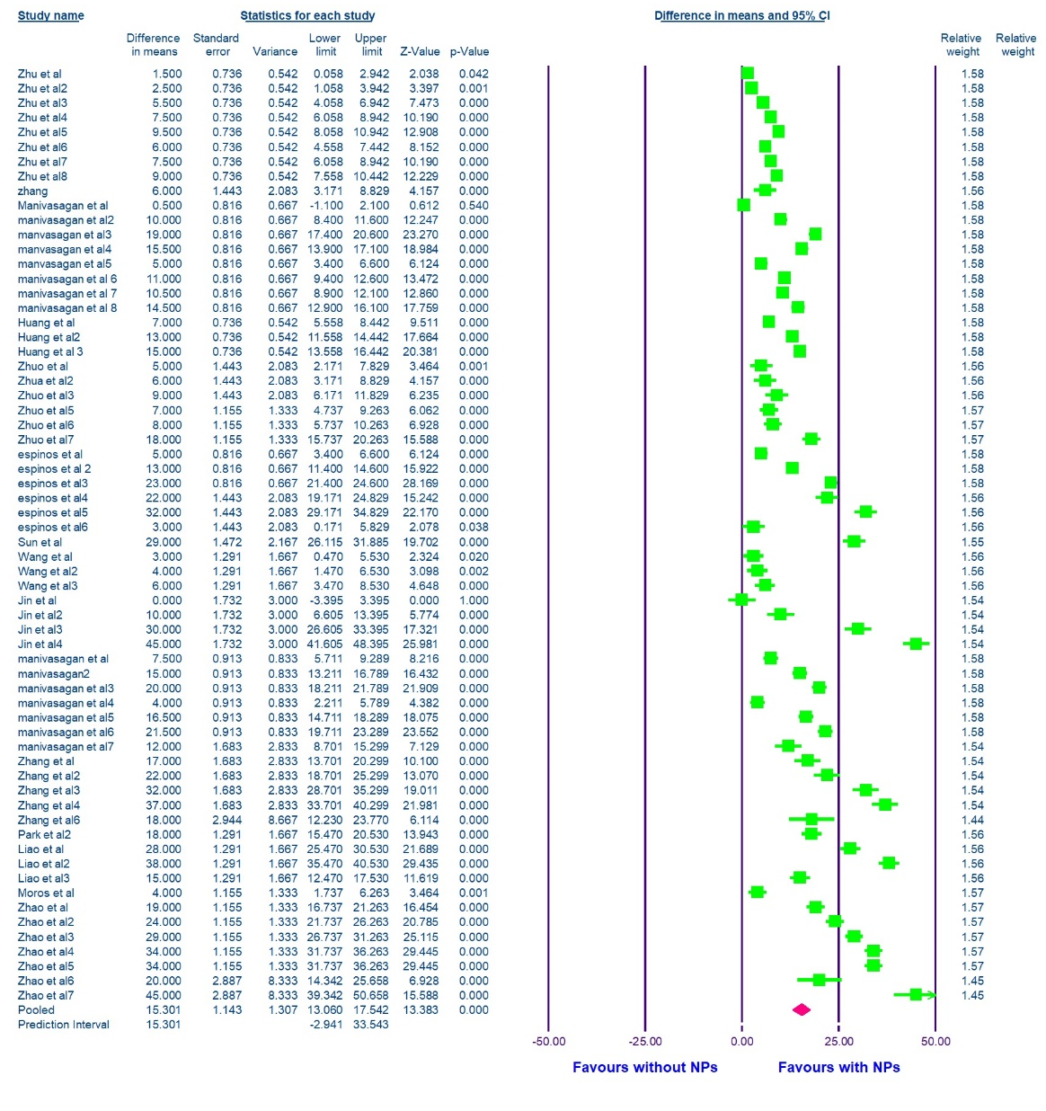
Fig. S1. Forest plot of pooled temperature elevation across 64 in vitro studies. Gold nanoparticles with laser irradiation produced a significant mean difference of 15.30°C (95% CI: 13.06–17.54°C; p < 0.001) compared to controls, demonstrating clinically meaningful photothermal efficacy.

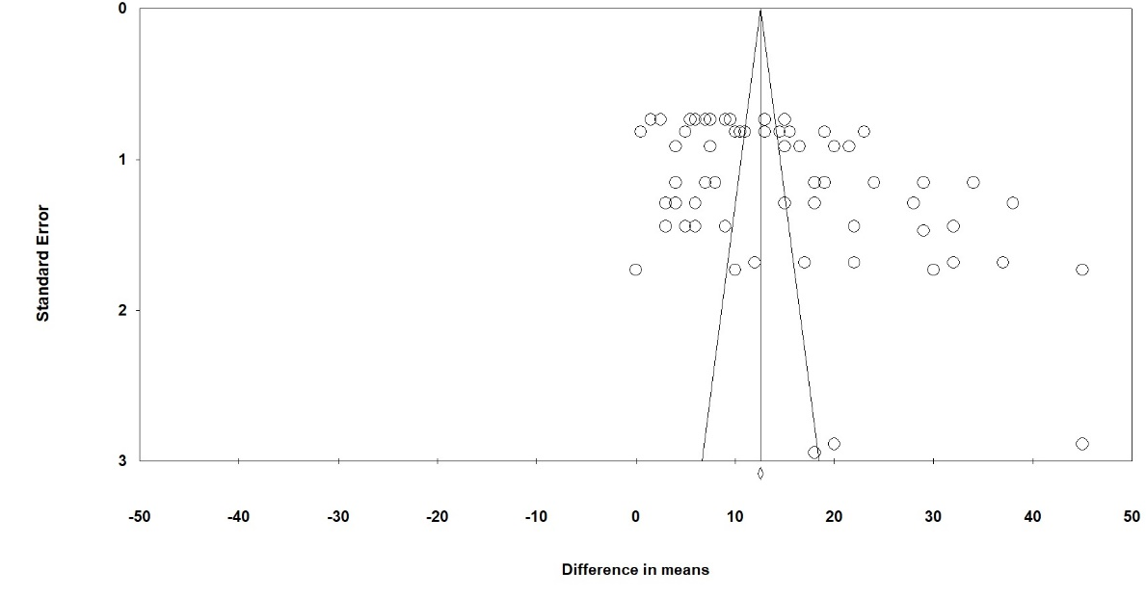
Fig. S2. Funnel plot assessing publication bias in temperature elevation studies. Asymmetrical distribution and significant Egger's test (p = 0.004) indicate selective reporting of larger effect sizes, though the large Fail-Safe N (8,615 studies) confirms the robustness of findings.

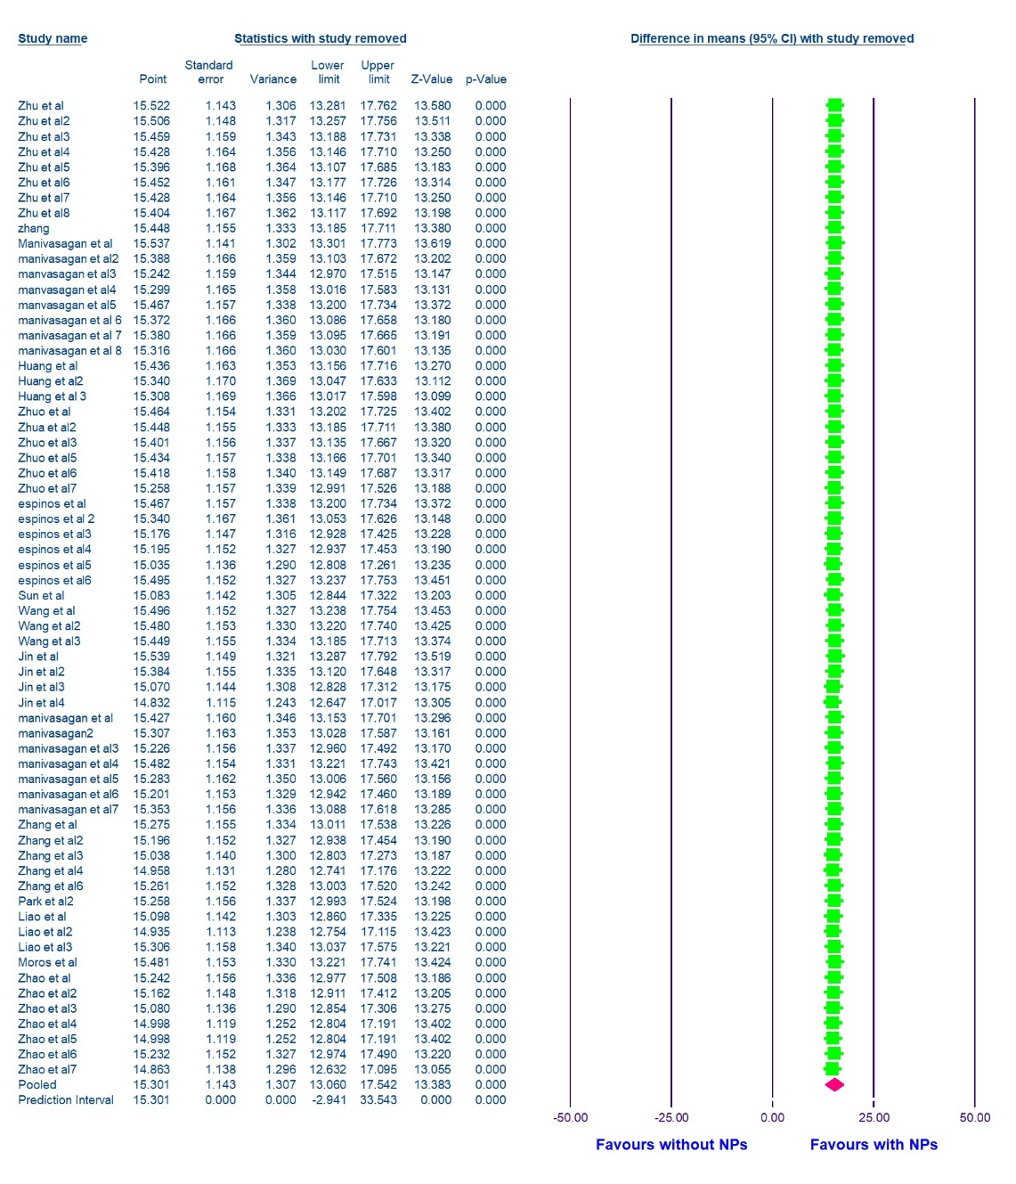
Fig. S3. Sensitivity analysis showing the stability of pooled effect when individual studies are sequentially removed. No single study substantially altered the overall conclusion, confirming the robustness and reproducibility of meta-analytic findings.
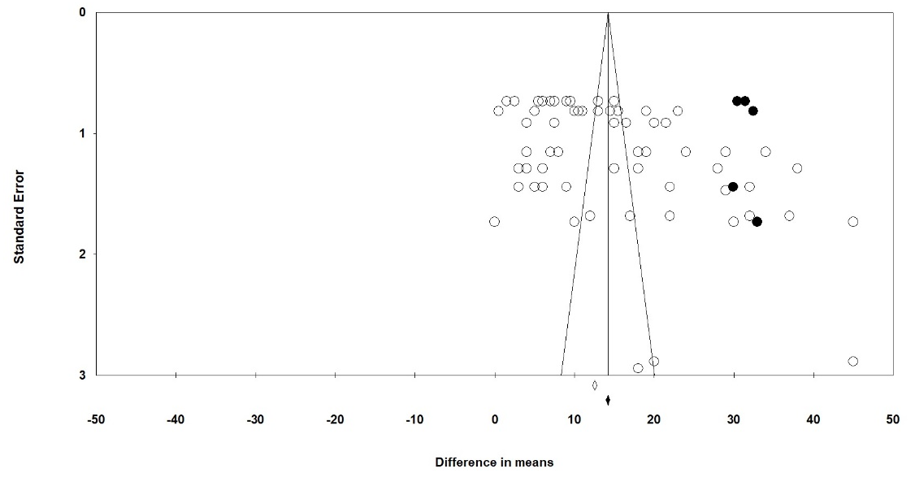
Fig. S4. Trim-and-fill adjusted forest plot demonstrating result stability after accounting for outlier studies. The adjusted pooled mean difference (16.40°C) remained consistent with the original estimate (15.30°C), with minimal change (1.10°C), reinforcing the reliability of the meta-analysis.

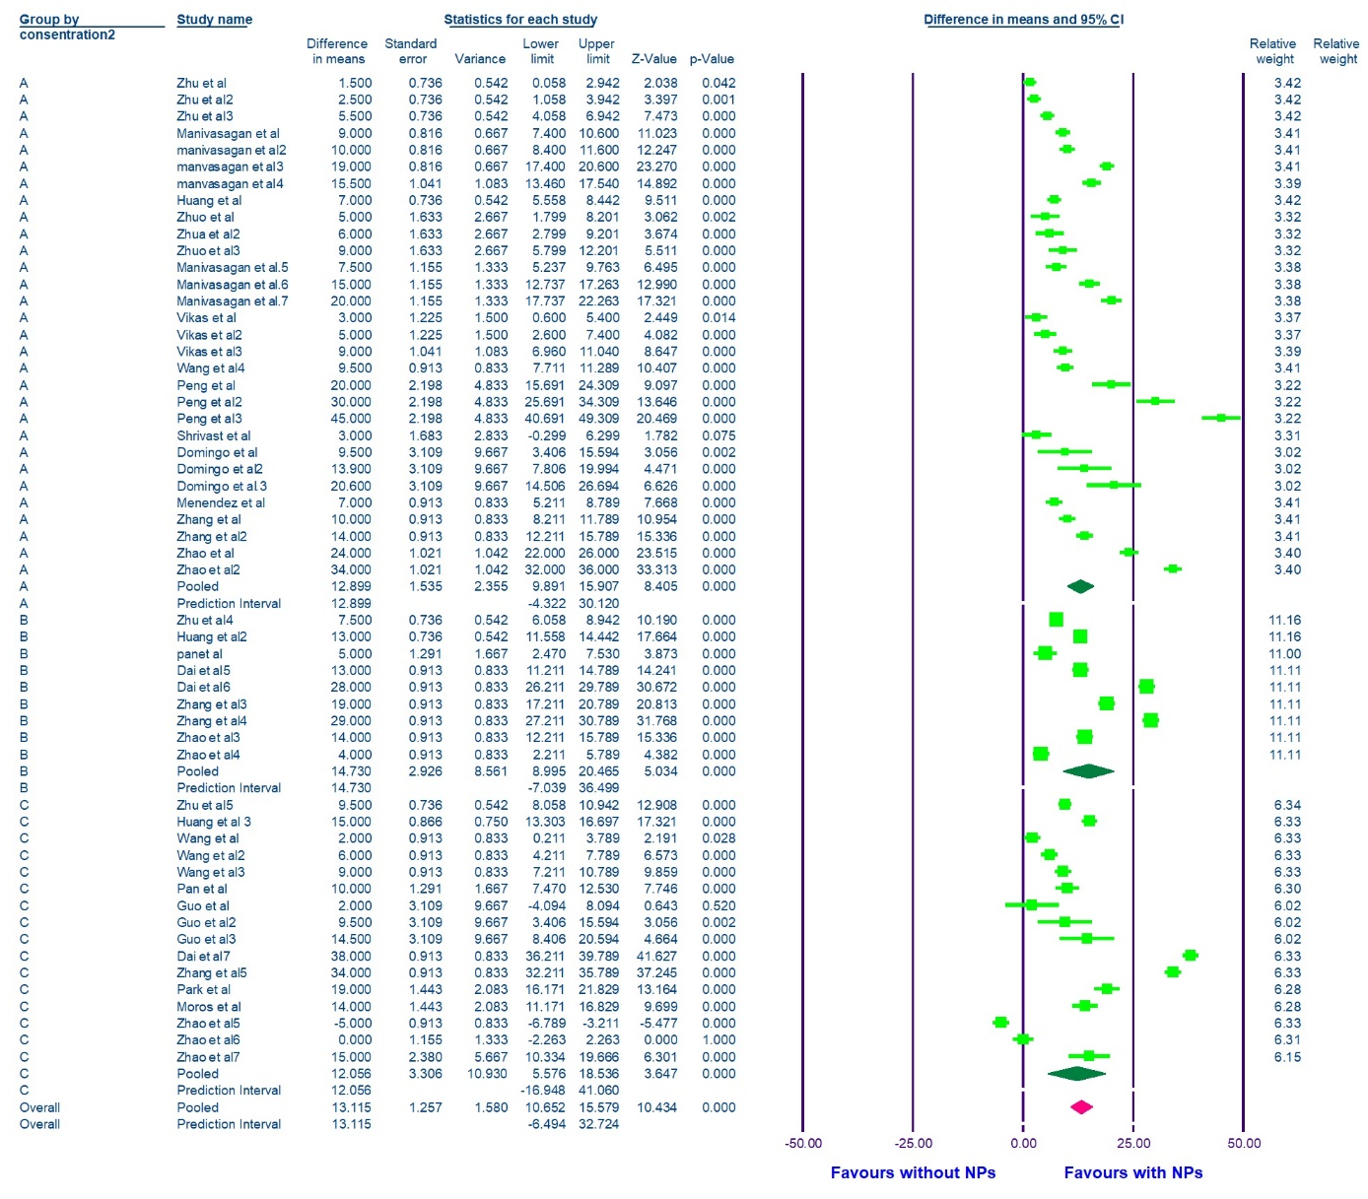
Fig. S5. Subgroup analysis of temperature elevation stratified by gold nanoparticle concentration: Group A (≤50 μg/mL), Group B (50–100 μg/mL), and Group C (>100 μg/mL). Pooled effects were 12.90°C (Group A), 14.73°C (Group B), and 12.06°C (Group C), demonstrating a concentration-dependent response with optimal efficacy in the moderate concentration range.

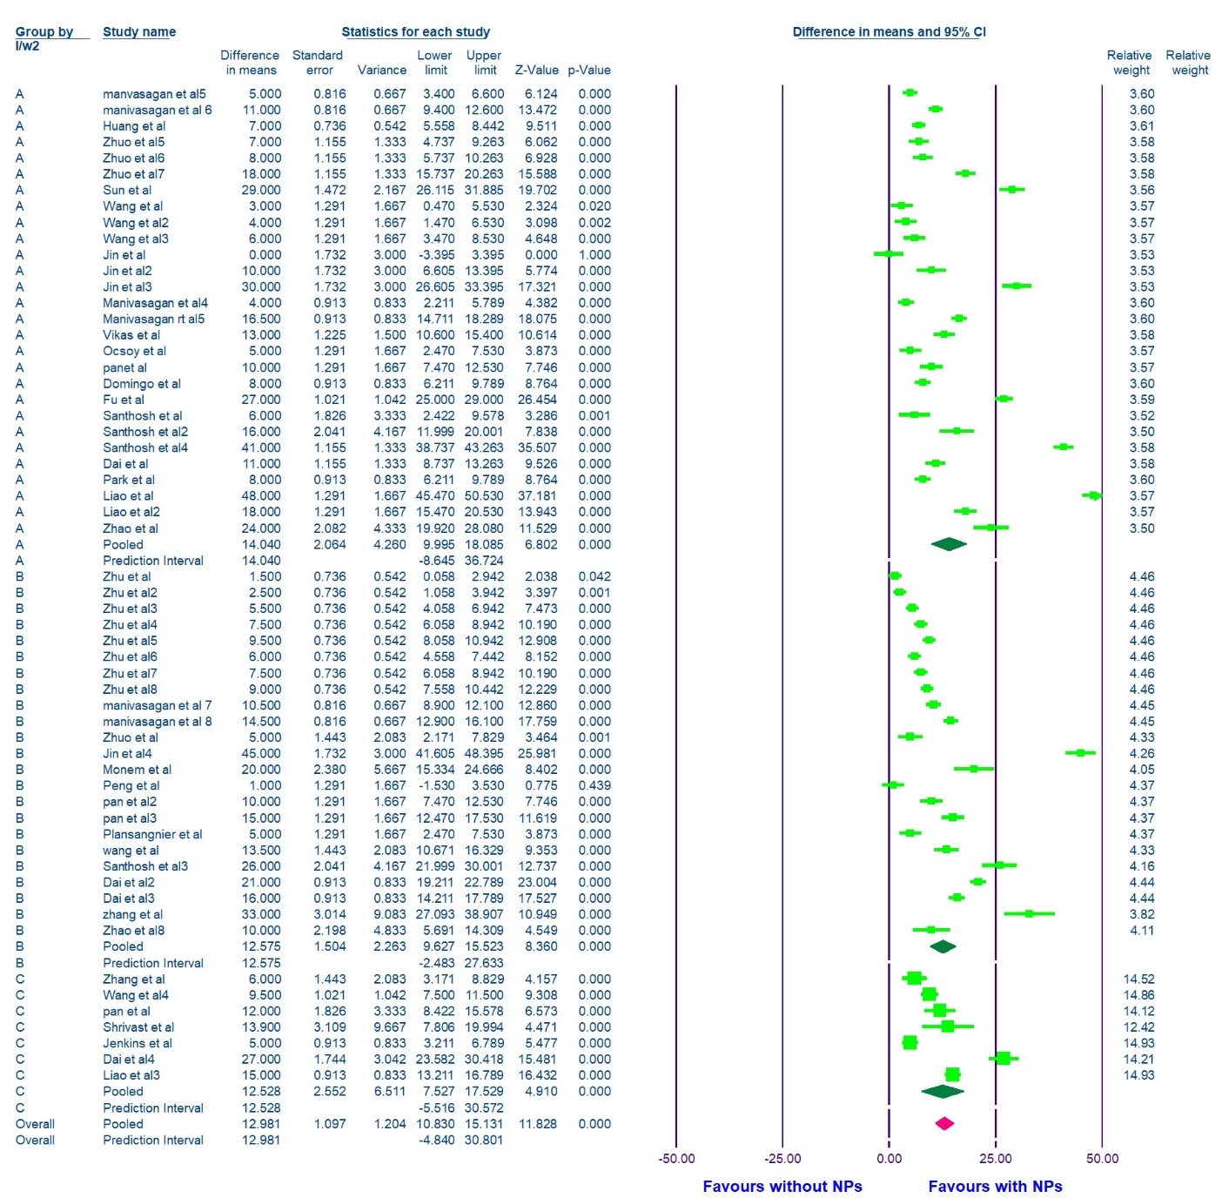
Fig. S6. Subgroup analysis of temperature elevation stratified by laser intensity: Group A (<1 W/cm²), Group B (1–2 W/cm²), and Group C (>2 W/cm²). Pooled effects were 14.04°C (Group A), 12.58°C (Group B), and 12.88°C (Group C), indicating that lower-to-moderate laser intensities produce more consistent thermal responses across cellular studies.

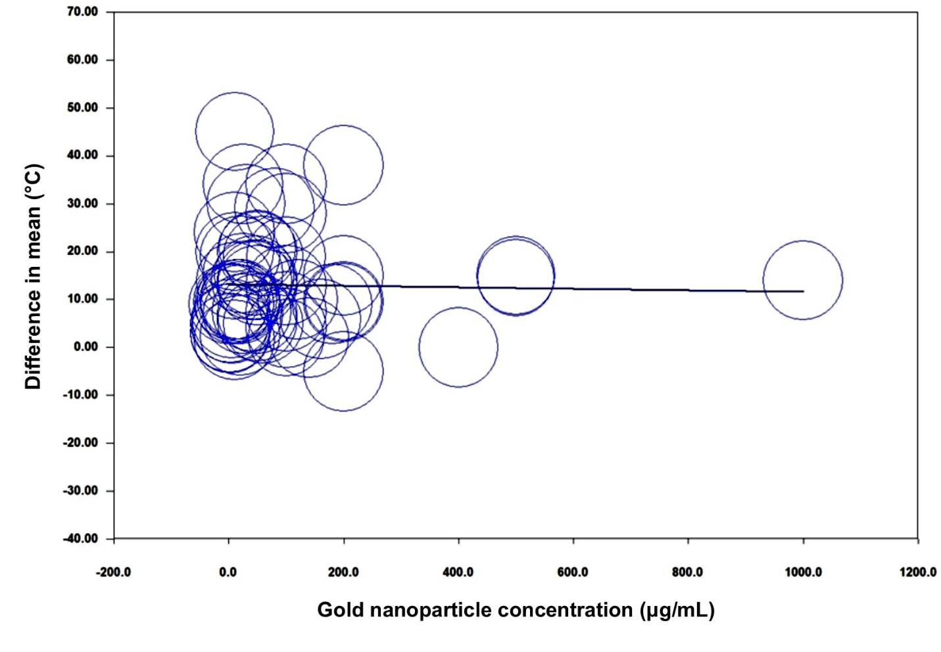
Fig. S7. Meta-regression analysis examining the quantitative relationship between gold nanoparticle concentration (μg/mL) and temperature elevation (°C). The bubble plot, with weighted bubble sizes, does not show a concentration-dependent thermal response and indicates considerable inter-study variability (p = 0.87).

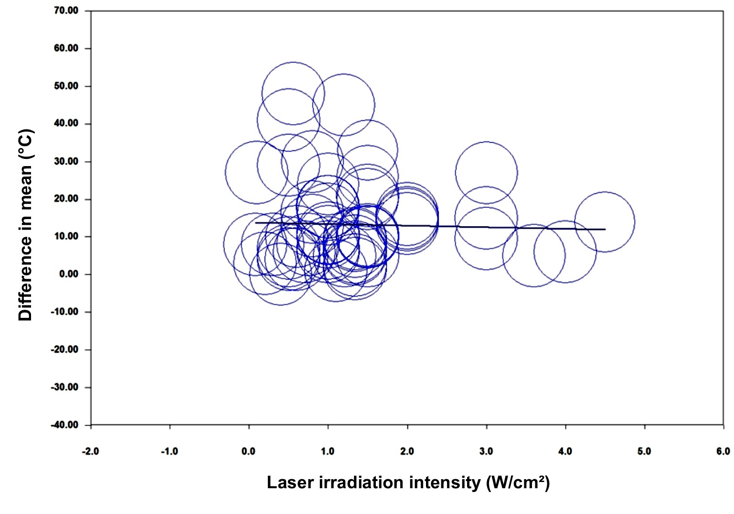
Fig. S8. Meta-regression analysis evaluating the relationship between laser irradiation intensity (I/W, W/cm²) and temperature elevation (°C). The bubble plot with bubble size proportional to study weight demonstrates substantial heterogeneity with no significant linear trend across the intensity range (0–6 W/cm²). The regression line (blue) shows minimal slope, indicating that temperature elevation is relatively independent of laser intensity variations, suggesting that other factors such as nanoparticle concentration and physicochemical properties may be more deterministic of photothermal efficacy.

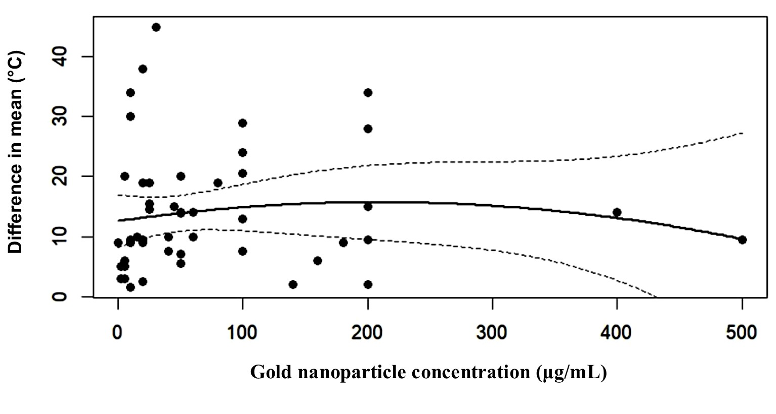
Fig. S9. Quadratic dose-response relationship between gold nanoparticle concentration (μg/mL) and temperature elevation (°C). The fitted curve (solid line) with 95% prediction interval (dashed lines) demonstrates a non-linear relationship with an initial rise in thermal response at low-to-moderate concentrations, reaching a plateau and then declining at higher concentrations (>300 μg/mL). This parabolic pattern suggests optimal therapeutic efficacy within a specific concentration window, with diminished returns or potential toxicity at excessive doses.

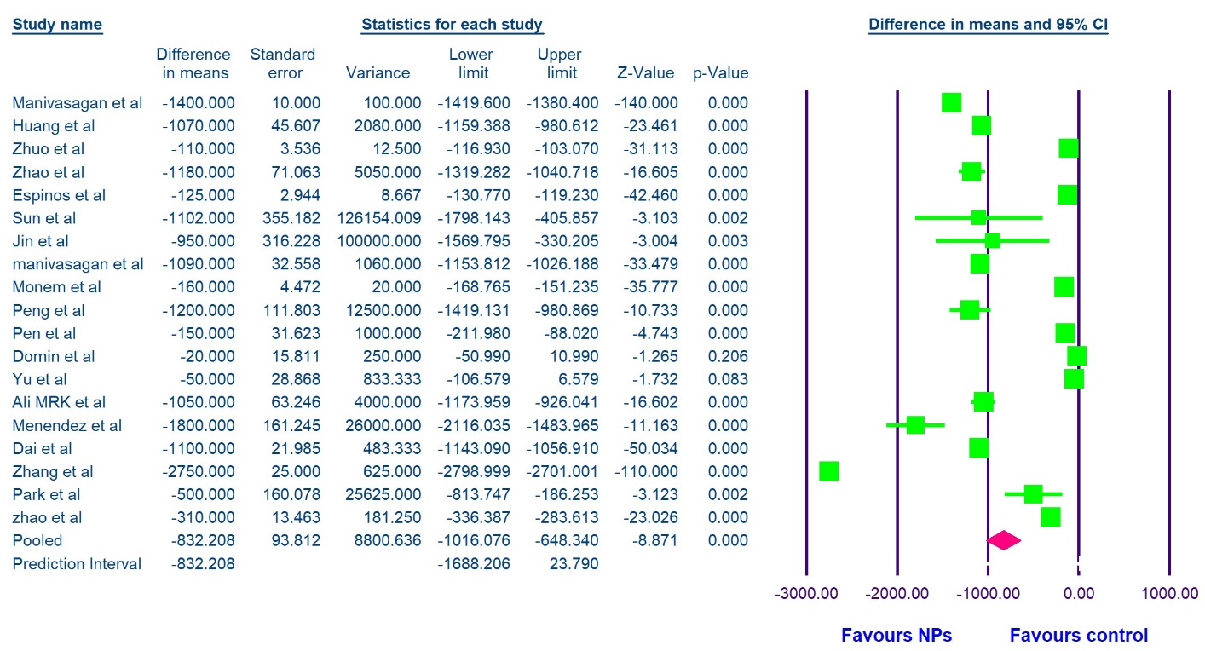
Fig. S10. Forest plot of tumor volume reduction across animal studies. Gold nanoparticles with laser irradiation produced a pooled mean reduction of −832.21 mm³ (95% CI: −1016.08 to −648.34 mm³; p < 0.001), demonstrating significant in-vivo photothermal efficacy.

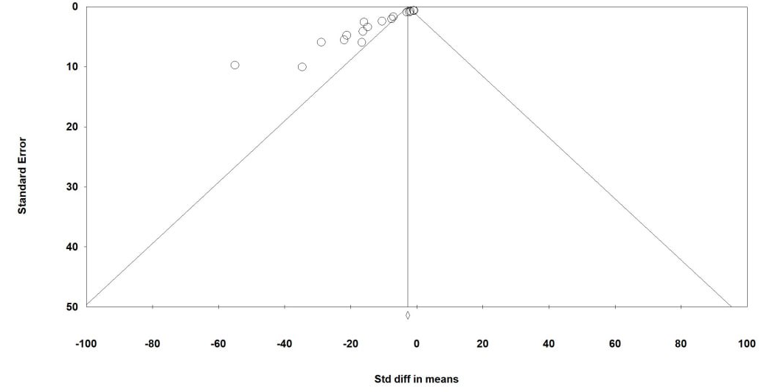
Fig. S11. Funnel plot assessing publication bias in tumor volume reduction across animal studies.

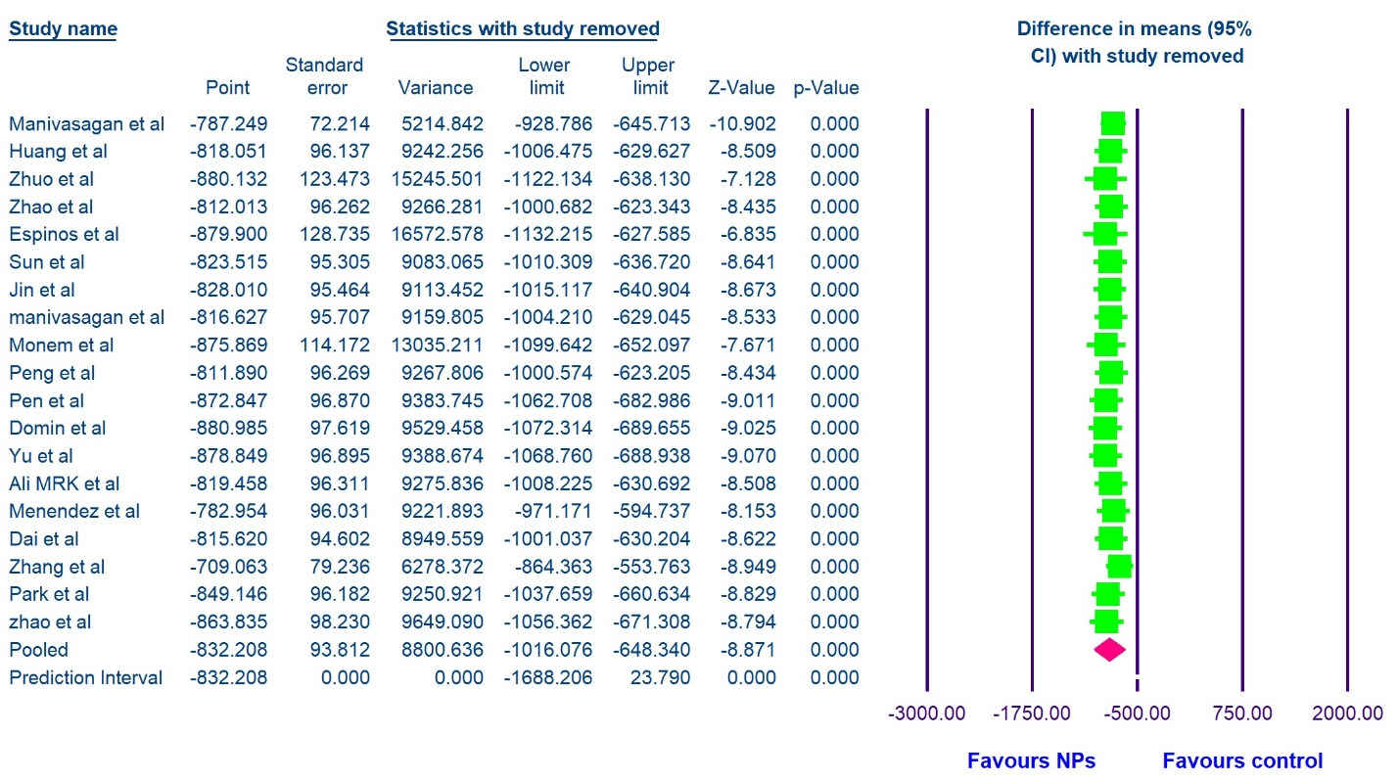
Fig. S12. Sensitivity analysis of pooled tumor volume reduction when individual studies are sequentially removed. All estimates remained statistically significant (p < 0.001) and consistently favored gold nanoparticles, confirming result robustness.

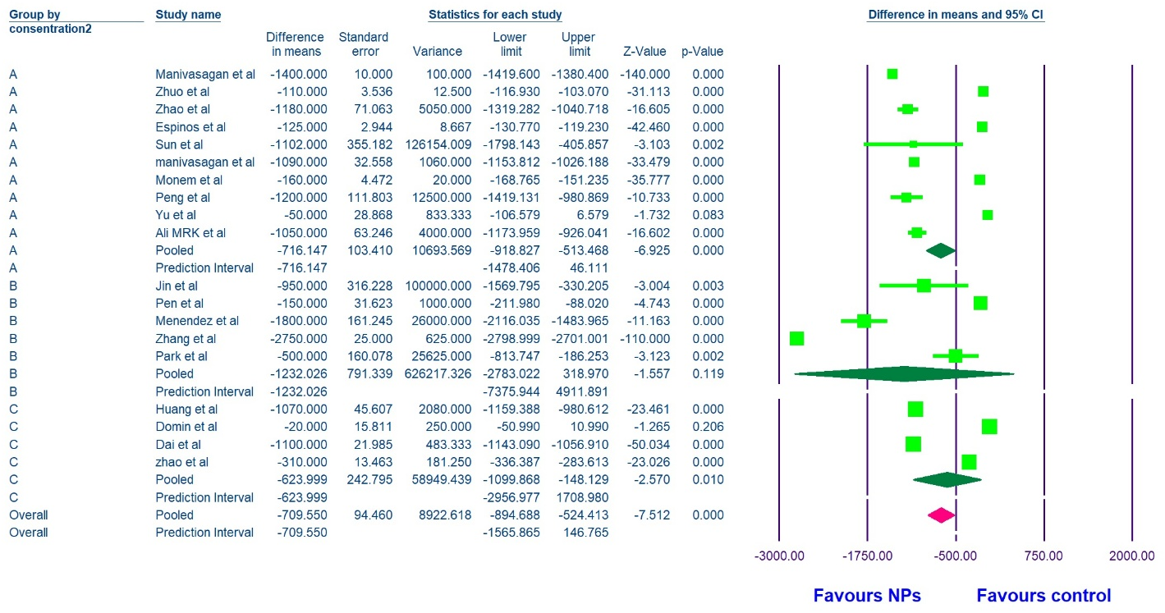
Fig. S13. Subgroup analysis of tumor volume reduction stratified by nanoparticle concentration: Group A (≤50 μg/mL: −716.15 mm³), Group B (50–150 μg/mL: −1232.03 mm³), and Group C (>150 μg/mL: −623.99 mm³). Group B demonstrated the most pronounced tumor reduction, suggesting optimal efficacy at moderate concentrations.

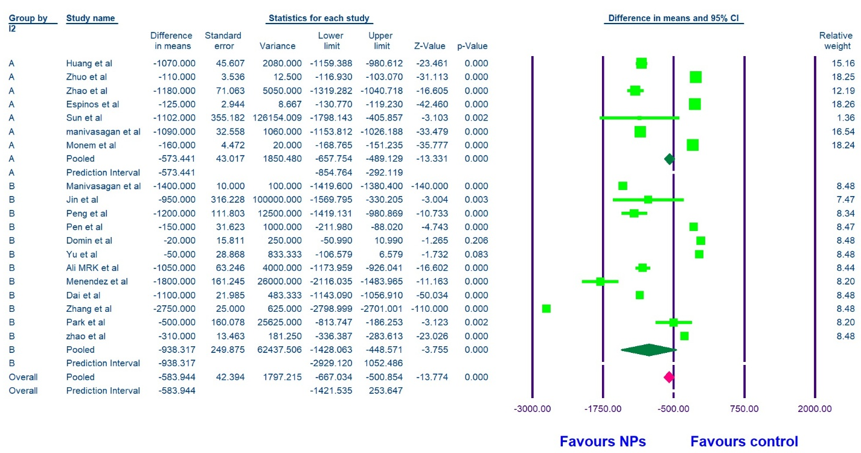
Fig. S14. Subgroup analysis of tumor volume reduction stratified by laser intensity: Group A and Group B. Gold nanoparticles with lower laser intensities (Group A) produced greater tumor reduction (−573.44 mm³) compared to higher intensities (Group B: −938.32 mm³), demonstrating differential efficacy across intensity ranges in animal models.

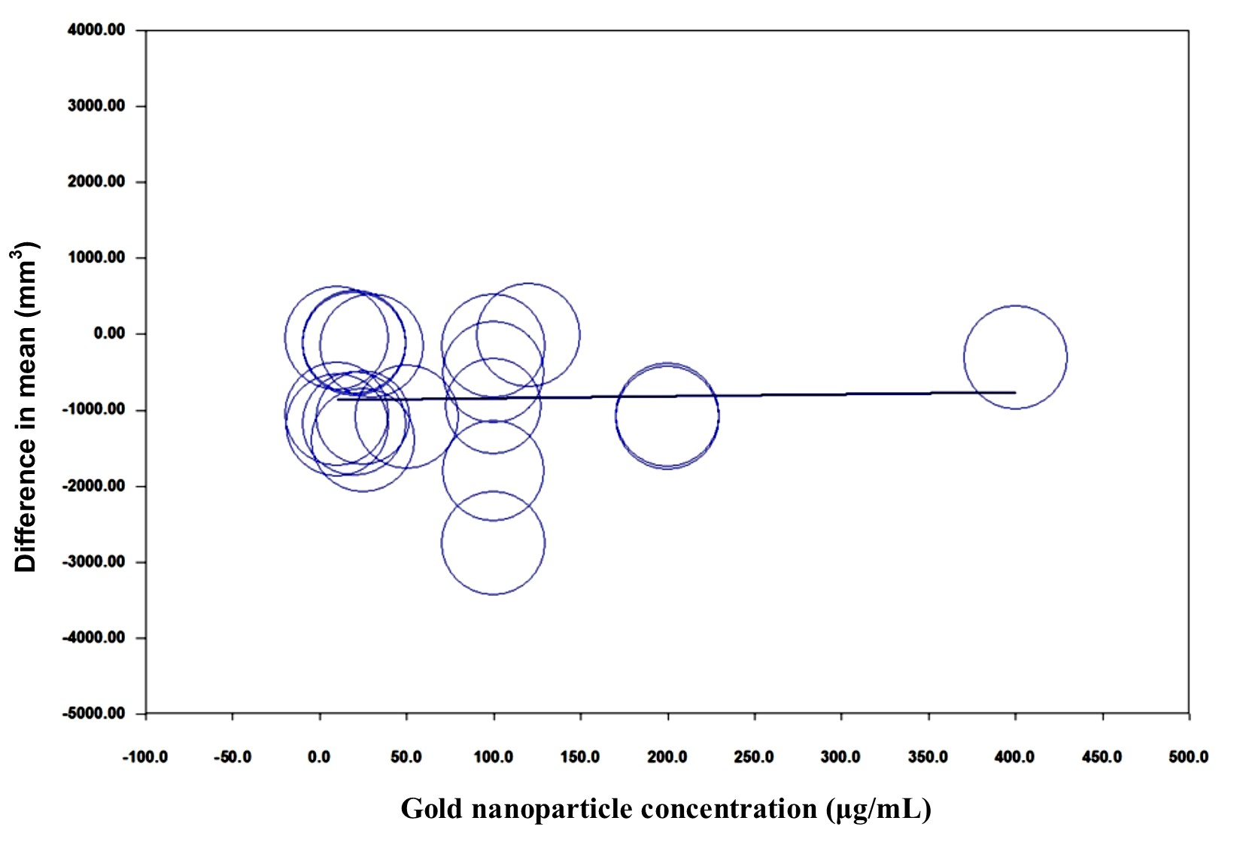
Fig. S15. Meta-regression analysis evaluating the relationship between gold nanoparticle concentration (μg/mL) and in-vivo tumor volume reduction (mm³). The bubble plot demonstrates substantial heterogeneity with no clear linear trend, indicating that tumor volume reduction is influenced by multiple factors beyond concentration alone.

References
1. Zhu, H., et al., Polysarcosine brush stabilized gold nanorods for in vivo near-infrared photothermal tumor therapy. Acta Biomater, 2017. 50: p. 534–545.
2. Hu, Y., et al., AuNRs-PPARγmAb Induce Targeted Adipocyte Apoptosis Through Photothermal Effects for Effective Localized Fat Reduction. Int J Nanomedicine, 2025. 20: p. 9559–9572.
3. Zhang, Z., et al., Biocompatible 5-Aminolevulinic Acid/Au Nanoparticle-Loaded Ethosomal Vesicles for In Vitro Transdermal Synergistic Photodynamic/Photothermal Therapy of Hypertrophic Scars. Nanoscale Res Lett, 2017. 12(1): p. 622.
4. Manivasagan, P., et al., Biocompatible Chitosan Oligosaccharide Modified Gold Nanorods as Highly Effective Photothermal Agents for Ablation of Breast Cancer Cells. Polymers (Basel), 2018. 10(3).
5. Huang, H., et al., Biomimetic gold nano-modulator for deep-tumor NIR-II photothermal immunotherapy via gaseous microenvironment remodeling strategy. J Nanobiotechnology, 2025. 23(1): p. 220.
6. Silva, C.O., et al., Bioproduction of gold nanoparticles for photothermal therapy. Ther Deliv, 2016. 7(5): p. 287–304.
7. Wang, C., et al., Starlike Au nanoparticle unleashing siDDIT3 and photothermal power to combat ferroptosis - driven osteoarthritis. J Nanobiotechnology, 2025. 23(1): p. 487.
8. Zhao, S., et al., BSA-Coated Gold Nanorods for NIR-II Photothermal Therapy. Nanoscale Res Lett, 2021. 16(1): p. 170.
9. Hu, X., et al., Calorimetric lateral flow immunoassay detection platform based on the photothermal effect of gold nanocages with high sensitivity, specificity, and accuracy. Int J Nanomedicine, 2019. 14: p. 7695–7705.
10. Espinosa, A., et al., Cancer Cell Internalization of Gold Nanostars Impacts Their Photothermal Efficiency In Vitro and In Vivo: Toward a Plasmonic Thermal Fingerprint in Tumoral Environment. Adv Healthc Mater, 2016. 5(9): p. 1040–8.
11. Sun, Q., et al., Cancer cell membrane-coated gold nanorods for photothermal therapy and radiotherapy on oral squamous cancer. J Mater Chem B, 2020. 8(32): p. 7253–7263.
12. Wang, P., et al., Evaluating cellular uptake of gold nanoparticles in HL-7702 and HepG2 cells for plasmonic photothermal therapy. Nanomedicine (Lond), 2018. 13(18): p. 2245–2259.
13. Jin, X., et al., Cathepsin B-responsive multifunctional peptide conjugated gold nanorods for mitochondrial targeting and precise photothermal cancer therapy. J Colloid Interface Sci, 2021. 601: p. 714–726.
14. Manivasagan, P., et al., Chitosan/fucoidan multilayer coating of gold nanorods as highly efficient near-infrared photothermal agents for cancer therapy. Carbohydr Polym, 2019. 211: p. 360–369.
15. Zhang, J., et al., Composite scaffolds of gelatin and gold nanoparticles with tunable size and shape for photothermal cancer therapy. J Mater Chem B, 2017. 5(2): p. 245–253.
16. Vikas, R. Kumar, and S. Soni, Concentration-dependent photothermal conversion efficiency of gold nanoparticles under near-infrared laser and broadband irradiation. Beilstein J Nanotechnol, 2023. 14: p. 205–217.
17. Wang, Z., et al., Construction of aptamer functionalized camptothecin incorporated chitosan-palladium/gold nanoparticles delivery improved photothermal activity and anti-lung carcinoma cells. J Mater Sci Mater Med, 2025. 36(1): p. 94.
18. Wang, J., et al., Controllable Synthesis of Gold Nanorod/Conducting Polymer Core/Shell Hybrids Toward in Vitro and in Vivo near-Infrared Photothermal Therapy. ACS Appl Mater Interfaces, 2018. 10(15): p. 12323–12330.
19. Monem, A.S., et al., Cytotoxicity and genotoxicity of gold nanorods assisted photothermal therapy against Ehrlich carcinoma in-vivo. Life Sci, 2020. 257: p. 118108.
20. Peng, J., et al., Delivery of miR-320a-3p by gold nanoparticles combined with photothermal therapy for directly targeting Sp1 in lung cancer. Biomater Sci, 2021. 9(19): p. 6528–6541.
21. Pan, Y., et al., Dendritic Polyglycerol-Conjugated Gold Nanostars for Metabolism Inhibition and Targeted Photothermal Therapy in Breast Cancer Stem Cells. Adv Healthc Mater, 2022. 11(8): p. e2102272.
22. Liu, J., et al., Development of Hollow Gold Nanoparticles for Photothermal Therapy and Their Cytotoxic Effect on a Glioma Cell Line When Combined with Copper Diethyldithiocarbamate. Biol Pharm Bull, 2024. 47(1): p. 272–278.
23. Kim, Y.J., et al., Development of Lactobacillus kimchicus DCY51(T)-mediated gold nanoparticles for delivery of ginsenoside compound K: in vitro photothermal effects and apoptosis detection in cancer cells. Artif Cells Nanomed Biotechnol, 2019. 47(1): p. 30–44.
24. Ocsoy, I., et al., DNA aptamer functionalized gold nanostructures for molecular recognition and photothermal inactivation of methicillin-Resistant Staphylococcus aureus. Colloids Surf B Biointerfaces, 2017. 159: p. 16–22.
25. Kim, D. and H. Kim, Quantitative Analysis of Photothermal Therapy of Tumor Tissue Using Various Gold Nanoparticle Injection Schemes. Pharmaceutics, 2023. 15(3).
26. Pan, S., et al., The Effect of Photothermal Therapy on Osteosarcoma With Polyacrylic Acid-Coated Gold Nanorods. Dose Response, 2018. 16(3): p. 1559325818789841.
27. Domingo-Diez, J., et al., Effect of Photothermal Therapy Using Gold Nanoparticles Conjugated with Hyaluronic Acid in an Intracranial Murine Glioblastoma Model. Int J Nanomedicine, 2025. 20: p. 9327–9346.
28. Amézaga González, M.F., et al., Effect of Physiological Fluid on the Photothermal Properties of Gold Nanostructured. Int J Mol Sci, 2023. 24(9).
29. Kim, D. and H. Kim, Effect of radius-dependent diffusion behavior of various gold nanoparticles on photothermal therapy. Discov Nano, 2024. 19(1): p. 84.
30. Shrivastava, R. and A. Dube, Effect of the polyelectrolyte coating on the photothermal efficiency of gold nanorods and the photothermal induced cancer cell damage. IET Nanobiotechnol, 2017. 11(8): p. 909–916.
31. Bermúdez-Jiménez, C., et al., Effective control of biofilms by photothermal therapy using a gold nanorod hydrogel. J Biomed Mater Res B Appl Biomater, 2020. 108(2): p. 333–342.
32. Domingo-Diez, J., et al., Effectiveness of Gold Nanorods of Different Sizes in Photothermal Therapy to Eliminate Melanoma and Glioblastoma Cells. Int J Mol Sci, 2023. 24(17).
33. Ali, H.R., S.A. Selim, and D. Aili, Effects of macrophage polarization on gold nanoparticle-assisted plasmonic photothermal therapy. RSC Adv, 2021. 11(40): p. 25047–25056.
34. Abdoon, A.S., et al., Efficacy and toxicity of plasmonic photothermal therapy (PPTT) using gold nanorods (GNRs) against mammary tumors in dogs and cats. Nanomedicine, 2016. 12(8): p. 2291–2297.
35. Yu, Y., et al., Efficacy of Temozolomide-Conjugated Gold Nanoparticle Photothermal Therapy of Drug-Resistant Glioblastoma and Its Mechanism Study. Mol Pharm, 2022. 19(4): p. 1219–1229.
36. Ali, M.R., et al., Efficacy, long-term toxicity, and mechanistic studies of gold nanorods photothermal therapy of cancer in xenograft mice. Proc Natl Acad Sci U S A, 2017. 114(15): p. E3110–e3118.
37. Pu, Y., et al., Elucidating the Growth Mechanism of Plasmonic Gold Nanostars with Tunable Optical and Photothermal Properties. Inorg Chem, 2018. 57(14): p. 8599–8607.
38. Plan Sangnier, A., et al., Endosomal Confinement of Gold Nanospheres, Nanorods, and Nanoraspberries Governs Their Photothermal Identity and Is Beneficial for Cancer Cell Therapy. Adv Biosyst, 2020. 4(4): p. e1900284.
39. Mayle, K.M., et al., Engineering A11 Minibody-Conjugated, Polypeptide-Based Gold Nanoshells for Prostate Stem Cell Antigen (PSCA)-Targeted Photothermal Therapy. SLAS Technol, 2017. 22(1): p. 26–35.
40. Jenkins, S.V., et al., Enhanced Photothermal Treatment Efficacy and Normal Tissue Protection via Vascular Targeted Gold Nanocages. Nanotheranostics, 2019. 3(2): p. 145–155.
41. Yang, S., et al., Enzyme-triggered self-assembly of gold nanoparticles for enhanced retention effects and photothermal therapy of prostate cancer. Chem Commun (Camb), 2018. 54(70): p. 9841–9844.
42. Borzenkov, M., et al., Photothermal effect of gold nanostar patterns inkjet-printed on coated paper substrates with different permeability. Beilstein J Nanotechnol, 2016. 7: p. 1480–1485.
43. Wang, X., et al., A Facile Strategy to Prepare Dendrimer-stabilized Gold Nanorods with Sub-10-nm Size for Efficient Photothermal Cancer Therapy. Sci Rep, 2016. 6: p. 22764.
44. Fu, Y., et al., A feasible strategy for self-assembly of gold nanoparticles via dithiol-PEG for photothermal therapy of cancers. RSC Adv, 2018. 8(11): p. 6120–6124.
45. Santhosh, P.B., et al., Femtosecond Laser-Induced Photothermal Effects of Ultrasmall Plasmonic Gold Nanoparticles on the Viability of Human Hepatocellular Carcinoma HepG2 Cells. Cells, 2024. 13(24).
46. Guo, Z., et al., Galvanic replacement reaction for in situ fabrication of litchi-shaped heterogeneous liquid metal-Au nano-composite for radio-photothermal cancer therapy. Bioact Mater, 2021. 6(3): p. 602–612.
47. Menendez, J.B., et al., Glucose-functionalized gold nanoparticles for effective photothermal therapy in lung cancer. Sci Rep, 2025. 15(1): p. 41006.
48. Dai, J., et al., GM-CSF augmented the photothermal immunotherapeutic outcome of self-driving gold nanoparticles against a mouse CT-26 colon tumor model. Biomater Res, 2023. 27(1): p. 105.
49. Zhang, M., et al., Gold Nanocage-Based Photothermal Ablation Facilitates In Situ Vaccination for Melanoma Therapy. ACS Appl Mater Interfaces, 2022. 14(34): p. 38550–38561.
50. Park, S., et al., Gold nanocluster-loaded hybrid albumin nanoparticles with fluorescence-based optical visualization and photothermal conversion for tumor detection/ablation. J Control Release, 2019. 304: p. 7–18.
51. Guerrero-Florez, V., et al., Gold nanoparticle-mediated generation of reactive oxygen species during plasmonic photothermal therapy: a comparative study for different particle sizes, shapes, and surface conjugations. J Mater Chem B, 2020. 8(14): p. 2862–2875.
52. Grosges, T. and D. Barchiesi, Gold Nanoparticles as a Photothermal Agent in Cancer Therapy: The Thermal Ablation Characteristic Length. Molecules, 2018. 23(6).
53. Lorenzana-Vázquez, G., I. Pavel, and E. Meléndez, Gold Nanoparticles Functionalized with 2-Thiouracil for Antiproliferative and Photothermal Therapies in Breast Cancer Cells. Molecules, 2023. 28(11).
54. Wu, Y., et al., Gold Nanorod Photothermal Therapy Alters Cell Junctions and Actin Network in Inhibiting Cancer Cell Collective Migration. ACS Nano, 2018. 12(9): p. 9279–9290.
55. Ali, M.R.K., et al., Gold Nanorod-Assisted Photothermal Therapy Decreases Bleeding during Breast Cancer Surgery in Dogs and Cats. Cancers (Basel), 2019. 11(6).
56. Liao, J., et al., Gold nanorods and nanohydroxyapatite hybrid hydrogel for preventing bone tumor recurrence via postoperative photothermal therapy and bone regeneration promotion. Bioact Mater, 2021. 6(8): p. 2221–2230.
57. Moros, M., et al., Gold Nanorods and Nanoprisms Mediate Different Photothermal Cell Death Mechanisms In Vitro and In Vivo. ACS Appl Mater Interfaces, 2020. 12(12): p. 13718–13730.
58. Zhao, J., et al., Gold nanorods based multicompartment mesoporous silica composites as bioagents for highly efficient photothermal therapy. J Colloid Interface Sci, 2019. 549: p. 9–15.
59. Tang, X., et al., Gold nanorods together with HSP inhibitor-VER-155008 micelles for colon cancer mild-temperature photothermal therapy. Acta Pharm Sin B, 2018. 8(4): p. 587–601.
60. Xing, L., et al., Gold nanospheres enhanced photothermal therapy in a rat model. Lasers Surg Med, 2018.
61. Jafarirad, S., et al., Green and facile synthesis of gold/perlite nanocomposite using Allium Fistulosum L. for photothermal application. Photodiagnosis Photodyn Ther, 2021. 34: p. 102243.
62. Wang, R., et al., Hyaluronic Acid Modified Au@SiO(2)@Au Nanoparticles for Photothermal Therapy of Genitourinary Tumors. Polymers (Basel), 2022. 14(21).
63. Bonamy, C., et al., Impact of Green Gold Nanoparticle Coating on Internalization, Trafficking, and Efficiency for Photothermal Therapy of Skin Cancer. ACS Omega, 2023. 8(4): p. 4092–4105.
64. Yang, H., et al., The impact of size and surface ligand of gold nanorods on liver cancer accumulation and photothermal therapy in the second near-infrared window. J Colloid Interface Sci, 2020. 565: p. 186–196.
65. Knights, O., S. Freear, and J.R. McLaughlan, Improving Plasmonic Photothermal Therapy of Lung Cancer Cells with Anti-EGFR Targeted Gold Nanorods. Nanomaterials (Basel), 2020. 10(7).
66. Li, X., et al., In Vitro and In Vivo Photothermal Cancer Therapeutic Effects of Gold Nanorods Modified with Mushroom β-Glucan. J Agric Food Chem, 2018. 66(16): p. 4091–4098.
67. Yang, T.D., et al., In vivo photothermal treatment by the peritumoral injection of macrophages loaded with gold nanoshells. Biomed Opt Express, 2016. 7(1): p. 185–93.
68. Hu, X., et al., In vivo self-assembly induced retention of gold nanoparticles for enhanced photothermal tumor treatment. J Mater Chem B, 2017. 5(30): p. 5931–5936.
69. Zeng, J., et al., Injectable and Near-Infrared-Responsive Hydrogels Encapsulating Dopamine-Stabilized Gold Nanorods with Long Photothermal Activity Controlled for Tumor Therapy. Biomacromolecules, 2019. 20(9): p. 3375–3384.
70. Espinosa, A., et al., Intracellular Biodegradation of Ag Nanoparticles, Storage in Ferritin, and Protection by a Au Shell for Enhanced Photothermal Therapy. ACS Nano, 2018. 12(7): p. 6523–6535.
71. Ahijado-Guzmán, R., et al., Intracellular pH-Induced Tip-to-Tip Assembly of Gold Nanorods for Enhanced Plasmonic Photothermal Therapy. ACS Omega, 2016. 1(3): p. 388–395.
72. Zhang, D., et al., Intracellularly Generated Immunological Gold Nanoparticles for Combinatorial Photothermal Therapy and Immunotherapy against Tumor. Nano Lett, 2019. 19(9): p. 6635–6646.
73. Wei, Q., et al., Intraoperative Assessment and Photothermal Ablation of the Tumor Margins Using Gold Nanoparticles. Adv Sci (Weinh), 2021. 8(5): p. 2002788.
74. Yuan, G., et al., Intratumoral self-assembly of renal-clearable gold nanoparticles as precise photothermal nanomedicine for liver tumor therapy. Sci Adv, 2025. 11(17): p. eadw7032.
75. Amini, S.M., et al., Investigating the in vitro photothermal effect of green synthesized apigenin-coated gold nanoparticle on colorectal carcinoma. IET Nanobiotechnol, 2021. 15(3): p. 329–337.
76. Cai, R., et al., An iRGD-conjugated photothermal therapy-responsive gold nanoparticle system carrying siCDK7 induces necroptosis and immunotherapeutic responses in lung adenocarcinoma. Bioeng Transl Med, 2023. 8(4): p. e10430.
77. Cai, Y., et al., Laser ablation in liquids for the assembly of Se@Au chain-oligomers with long-term stability for photothermal inhibition of tumor cells. J Colloid Interface Sci, 2020. 566: p. 284–295.
78. Al-Barram, L.F.A., Laser enhancement of cancer cell destruction by photothermal therapy conjugated glutathione (GSH)-coated small-sized gold nanoparticles. Lasers Med Sci, 2021. 36(2): p. 325–337.
79. Wang, Z., et al., Laser-Triggered Small Interfering RNA Releasing Gold Nanoshells against Heat Shock Protein for Sensitized Photothermal Therapy. Adv Sci (Weinh), 2017. 4(2): p. 1600327.
80. Luo, X., et al., Leakage-free polypyrrole-Au nanostructures for combined Raman detection and photothermal cancer therapy. J Mater Chem B, 2017. 5(39): p. 7949–7962.
81. Pan, L.L., et al., Linker-free Gold Nanoparticle Superstructure Coated with Poly(dopamine) by Site-Specific Polymerization for Amplifying Photothermal Cancer Therapy. Chem Asian J, 2020. 15(17): p. 2742–2748.
82. Xia, Y., et al., Liposome-templated gold nanoparticles for precisely temperature-controlled photothermal therapy based on heat shock protein expression. Colloids Surf B Biointerfaces, 2022. 217: p. 112686.
83. Xuan, M., et al., Macrophage Cell Membrane Camouflaged Au Nanoshells for in Vivo Prolonged Circulation Life and Enhanced Cancer Photothermal Therapy. ACS Appl Mater Interfaces, 2016. 8(15): p. 9610–8.
84. Lin, H.C., et al., Mannoside-Modified Branched Gold Nanoparticles for Photothermal Therapy to MDA-MB-231 Cells. Molecules, 2020. 25(8).
85. Wang, C., et al., Mesoporous silica nanoparticles loaded Au nanodots: a self-amplifying immunotherapeutic depot for photothermal immunotherapy. Front Immunol, 2025. 16: p. 1616539.
86. Jung, B.K., et al., Mild Hyperthermia Induced by Gold Nanorod-Mediated Plasmonic Photothermal Therapy Enhances Transduction and Replication of Oncolytic Adenoviral Gene Delivery. ACS Nano, 2016. 10(11): p. 10533–10543.
87. Ye, W., et al., mRNA Guided Intracellular Self-Assembly of DNA-Gold Nanoparticle Conjugates as a Precise Trigger to Up-Regulate Cell Apoptosis and Activate Photothermal Therapy. Bioconjug Chem, 2019. 30(6): p. 1763–1772.
88. Ong, Z.Y., et al., Multibranched Gold Nanoparticles with Intrinsic LAT-1 Targeting Capabilities for Selective Photothermal Therapy of Breast Cancer. ACS Appl Mater Interfaces, 2017. 9(45): p. 39259–39270.
89. Li, N., et al., Multiple gold nanorods@hierarchically porous silica nanospheres for efficient multi-drug delivery and photothermal therapy. J Mater Chem B, 2017. 5(8): p. 1642–1649.
90. López-Méndez, R., et al., Multiscale Thermal Analysis of Gold Nanostars in 3D Tumor Spheroids: Integrating Cellular-Level Photothermal Effects and Nanothermometry via X-Ray Spectroscopy. Adv Healthc Mater, 2025. 14(11): p. e2403799.
91. Park, J.Y., et al., Nanocorona-engineered gold nanostars orchestrate photothermal augmented immunotherapy and durable cancer vaccination. J Nanobiotechnology, 2025. 23(1): p. 697.
92. Singh, N., et al., Nanogold-coated stent facilitated non-invasive photothermal ablation of stent thrombosis and restoration of blood flow. Nanoscale Adv, 2024. 6(5): p. 1497–1506.
93. Xing, L., et al., Nd:YAG laser-induced morphology change and photothermal conversion of gold nanorods with potential application in the treatment of port-wine stain. Lasers Med Sci, 2017. 32(3): p. 629–640.
94. Gournaris, E., et al., Near-Infrared Fluorescent Endoscopic Image-Guided Photothermal Ablation Therapy of Colorectal Cancer Using Dual-Modal Gold Nanorods Targeting Tumor-Infiltrating Innate Immune Cells in a Transgenic TS4 CRE/APC (loxΔ468) Mouse Model. ACS Appl Mater Interfaces, 2019. 11(24): p. 21353–21359.
95. Amarasekara, D.L., et al., Near-Infrared Photothermal Ablation of Biofilms using ProteinFunctionalized Gold Nanospheres with a Tunable Temperature Response. bioRxiv, 2023.
96. Zhang, M., et al., Near-infrared photothermal therapy using EGFR-targeted gold nanoparticles increases autophagic cell death in breast cancer. J Photochem Photobiol B, 2017. 170: p. 58–64.
97. Zhang, M., et al., Near-infrared photothermal therapy using anti-EGFR-gold nanorod conjugates for triple negative breast cancer. Oncotarget, 2017. 8(49): p. 86566–86575.
98. Simón, M., et al., Neoadjuvant Gold Nanoshell-Based Photothermal Therapy Combined with Liposomal Doxorubicin in a Mouse Model of Colorectal Cancer. Int J Nanomedicine, 2023. 18: p. 829–841.
99. Hu, S., et al., NIR Light-Responsive Hollow Porous Gold Nanospheres for Controllable Pressure-Based Sensing and Photothermal Therapy of Cancer Cells. Anal Chem, 2019. 91(24): p. 15418–15424.
100. Singh, S.P., et al., NIR triggered liposome gold nanoparticles entrapping curcumin as in situ adjuvant for photothermal treatment of skin cancer. Int J Biol Macromol, 2018. 110: p. 375–382.
101. Beltran, O., et al., Novel Gold Nanorods@Thiolated Pectin on the Killing of HeLa Cells by Photothermal Ablation. Pharmaceutics, 2023. 15(11).
102. Kim, D. and H. Kim, Numerical Study on Death of Squamous Cell Carcinoma Based on Various Shapes of Gold Nanoparticles Using Photothermal Therapy. Sensors (Basel), 2022. 22(4).
103. Kim, M., et al., Numerical Study on Effective Conditions for the Induction of Apoptotic Temperatures for Various Tumor Aspect Ratios Using a Single Continuous-Wave Laser in Photothermal Therapy Using Gold Nanorods. Cancers (Basel), 2019. 11(6).
104. Hai, Y., et al., Optimization of endothelial growth factor receptor monoclonal antibody-gold nanorods photothermal therapy for laryngeal squamous cell carcinoma. Bioengineered, 2022. 13(2): p. 3262–3274.
105. Fernandes, N., et al., Optimization of the GSH-Mediated Formation of Mesoporous Silica-Coated Gold Nanoclusters for NIR Light-Triggered Photothermal Applications. Nanomaterials (Basel), 2021. 11(8).
106. Wang, X., et al., Photothermal Ablation of Cancer Cells by Albumin-Modified Gold Nanorods and Activation of Dendritic Cells. Materials (Basel), 2018. 12(1).
107. Crawford, B.M., et al., Photothermal ablation of inflammatory breast cancer tumor emboli using plasmonic gold nanostars. Int J Nanomedicine, 2017. 12: p. 6259–6272.
108. Ghaffarlou, M., et al., Photothermal and radiotherapy with alginate-coated gold nanoparticles for breast cancer treatment. Sci Rep, 2024. 14(1): p. 13299.
109. Heidari, M., et al., Photothermal cancer therapy by gold-ferrite nanocomposite and near-infrared laser in animal model. Lasers Med Sci, 2016. 31(2): p. 221–7.
110. Borzenkov, M., et al., Fabrication of Inkjet-Printed Gold Nanostar Patterns with Photothermal Properties on Paper Substrate. ACS Appl Mater Interfaces, 2016. 8(15): p. 9909–16.
111. Mbalaha, Z.S., D.J.S. Birch, and Y. Chen, Photothermal effects of gold nanorods in aqueous solution and gel media: Influence of particle size and excitation wavelength. IET Nanobiotechnol, 2023. 17(2): p. 103–111.
112. Zarska, M., et al., Photothermal induction of pyroptosis in malignant glioma spheroids using (16-mercaptohexadecyl)trimethylammonium bromide-modified cationic gold nanorods. Colloids Surf B Biointerfaces, 2024. 243: p. 114128.
113. Kang, X., et al., Photothermal therapeutic application of gold nanorods-porphyrin-trastuzumab complexes in HER2-positive breast cancer. Sci Rep, 2017. 7: p. 42069.
114. Abo-Elfadl, M.T., et al., Photothermal therapeutic effect of PEGylated gold nano-semicubes in chemically-induced skin cancer in mice. J Photochem Photobiol B, 2016. 164: p. 21–29.
115. Gao, L., et al., Photothermal Therapeutic Gold Nanoparticles Loaded with PD-L1 siRNA Enhanced Killing of NSCLC Cells by Immune Cells. Int J Nanomedicine, 2025. 20: p. 8833–8859.
116. Christie, C., et al., Photothermal Therapy Employing Gold Nanoparticle- Loaded Macrophages as Delivery Vehicles: Comparing the Efficiency of Nanoshells Versus Nanorods. J Environ Pathol Toxicol Oncol, 2017. 36(3): p. 229–235.
117. Wang, S., et al., Photothermal therapy mediated by gold nanocages composed of anti-PDL1 and galunisertib for improved synergistic immunotherapy in colorectal cancer. Acta Biomater, 2021. 134: p. 621–632.
118. Gamal-Eldeen, A.M., et al., Photothermal therapy mediated by gum Arabic-conjugated gold nanoparticles suppresses liver preneoplastic lesions in mice. J Photochem Photobiol B, 2016. 163: p. 47–56.
119. Chen, Z., et al., Photothermal therapy of single cancer cells mediated by naturally created gold nanorod clusters. Opt Express, 2017. 25(13): p. 15093–15107.
120. Shen, W., et al., A Photothermal Therapy Strategy for Monitoring Real-Time Temperature in Kidney Cancers by Injecting Gold Nanorods with Phosphors. J Biomed Nanotechnol, 2021. 17(3): p. 501–508.
121. Neshastehriz, A., et al., Photothermal therapy using folate conjugated gold nanoparticles enhances the effects of 6MV X-ray on mouth epidermal carcinoma cells. J Photochem Photobiol B, 2017. 172: p. 52–60.
122. Suh, D.H., et al., Photothermal therapy using gold nanoparticles for acne in Asian patients: A preliminary study. Dermatol Ther, 2021. 34(3): p. e14918.
123. Nirmal, G.R., et al., Photothermal treatment by PLGA-gold nanorod-isatin nanocomplexes under near-infrared irradiation for alleviating psoriasiform hyperproliferation. J Control Release, 2021. 333: p. 487–499.
124. Mocan, L., et al., Photothermal treatment of liver cancer with albumin-conjugated gold nanoparticles initiates Golgi Apparatus-ER dysfunction and caspase-3 apoptotic pathway activation by selective targeting of Gp60 receptor. Int J Nanomedicine, 2015. 10: p. 5435–45.
125. Mulens-Arias, V., et al., Polyethyleneimine-assisted one-pot synthesis of quasi-fractal plasmonic gold nanocomposites as a photothermal theranostic agent. Nanoscale, 2019. 11(7): p. 3344–3359.
126. Zhu, D., et al., Au-Cu(2-x)Se heterogeneous nanocrystals for efficient photothermal heating for cancer therapy. J Mater Chem B, 2017. 5(25): p. 4934–4942.
127. Liu, X., et al., PolyTLR7/8a-conjugated, antigen-trapping gold nanorods elicit anticancer immunity against abscopal tumors by photothermal therapy-induced in situ vaccination. Biomaterials, 2021. 275: p. 120921.
128. Xu, P., et al., Precise control of apoptosis via gold nanostars for dose dependent photothermal therapy of melanoma. J Mater Chem B, 2019. 7(44): p. 6934–6944.
129. Amarasekara, D.L., et al., Protein-Functionalized Gold Nanospheres with Tunable Photothermal Efficiency for the Near-Infrared Photothermal Ablation of Biofilms. ACS Appl Mater Interfaces, 2024. 16(4): p. 4321–4332.
130. Wang, J., et al., Protein-Induced Gold Nanoparticle Assembly for Improving the Photothermal Effect in Cancer Therapy. ACS Appl Mater Interfaces, 2019. 11(12): p. 11136–11143.
131. Kim, D., J. Paik, and H. Kim, Effect of gold nanoparticles distribution radius on photothermal therapy efficacy. Sci Rep, 2023. 13(1): p. 12135.
132. Lee, C., et al., Rabies Virus-Inspired Silica-Coated Gold Nanorods as a Photothermal Therapeutic Platform for Treating Brain Tumors. Adv Mater, 2017. 29(13).
133. Otari, S.V., et al., Rapid synthesis and decoration of reduced graphene oxide with gold nanoparticles by thermostable peptides for memory device and photothermal applications. Sci Rep, 2017. 7(1): p. 10980.
134. Ferreira-Gonçalves, T., et al., Rational approach to design gold nanoparticles for photothermal therapy: the effect of gold salt on physicochemical, optical and biological properties. Int J Pharm, 2024. 650: p. 123659.
135. Aioub, M. and M.A. El-Sayed, A Real-Time Surface Enhanced Raman Spectroscopy Study of Plasmonic Photothermal Cell Death Using Targeted Gold Nanoparticles. J Am Chem Soc, 2016. 138(4): p. 1258–64.
136. Arami, H., et al., Remotely controlled near-infrared-triggered photothermal treatment of brain tumours in freely behaving mice using gold nanostar﻿s. Nat Nanotechnol, 2022. 17(9): p. 1015–1022.
137. Tang, H., et al., Reprogramming the Tumor Microenvironment through Second-Near-Infrared-Window Photothermal Genome Editing of PD-L1 Mediated by Supramolecular Gold Nanorods for Enhanced Cancer Immunotherapy. Adv Mater, 2021. 33(12): p. e2006003.
138. Pan, Y., et al., Retinoic Acid-Loaded Dendritic Polyglycerol-Conjugated Gold Nanostars for Targeted Photothermal Therapy in Breast Cancer Stem Cells. ACS Nano, 2021. 15(9): p. 15069–15084.
139. Paterson, S., et al., Self-assembly of gold supraparticles with crystallographically aligned and strongly coupled nanoparticle building blocks for SERS and photothermal therapy. Chem Sci, 2016. 7(9): p. 6232–6237.
140. Yin, T., et al., Self-assembly synthesis of vapreotide‑gold hybrid nanoflower for photothermal antitumor activity. Mater Sci Eng C Mater Biol Appl, 2018. 93: p. 716–723.
141. Tao, Y., et al., Target-triggered aggregation of gold nanoparticles for photothermal quantitative detection of adenosine using a thermometer as readout. Anal Chim Acta, 2020. 1110: p. 151–157.
142. Park, J.H., et al., Silica-Capped and Gold-Decorated Silica Nanoparticles for Enhancing Effect of Gold Nanoparticle-Based Photothermal Therapy. Tissue Eng Regen Med, 2022. 19(6): p. 1161–1168.
143. Ali, M.R., et al., Simultaneous Time-Dependent Surface-Enhanced Raman Spectroscopy, Metabolomics, and Proteomics Reveal Cancer Cell Death Mechanisms Associated with Gold Nanorod Photothermal Therapy. J Am Chem Soc, 2016. 138(47): p. 15434–15442.
144. Zhao, M., et al., Single Gold Nanostars Achieve Inherent Cascade Catalytic and Near-Infrared Photothermal Activities for Efficient Tumor Therapy. Bioconjug Chem, 2022. 33(10): p. 1934–1943.
145. Marpu, S.B., et al., Single-Step Photochemical Formation of Near-Infrared-Absorbing Gold Nanomosaic within PNIPAm Microgels: Candidates for Photothermal Drug Delivery. Nanomaterials (Basel), 2020. 10(7).
146. Benjamin, C.E., et al., Site-Selective Nucleation and Size Control of Gold Nanoparticle Photothermal Antennae on the Pore Structures of a Virus. J Am Chem Soc, 2018. 140(49): p. 17226–17233.
147. Saw, W.S., et al., Size-dependent effect of cystine/citric acid-capped confeito-like gold nanoparticles on cellular uptake and photothermal cancer therapy. Colloids Surf B Biointerfaces, 2018. 161: p. 365–374.
148. Depciuch, J., et al., Size-dependent theoretical and experimental photothermal conversion efficiency of spherical gold nanoparticles. Photodiagnosis Photodyn Ther, 2022. 39: p. 102979.
149. Seo, B., et al., Small gold nanorods-loaded hybrid albumin nanoparticles with high photothermal efficacy for tumor ablation. Colloids Surf B Biointerfaces, 2019. 179: p. 340–351.
150. Li, X., et al., Stable and Biocompatible Mushroom β-Glucan Modified Gold Nanorods for Cancer Photothermal Therapy. J Agric Food Chem, 2017. 65(43): p. 9529–9536.
151. Wan, X., et al., A Biomimetic Au-Polyphenol-CuS Photothermal Agent with Acid-Triggered Disassembly for Enhanced Photothermal Conversion. Inorg Chem, 2025. 64(46): p. 22654–22663.
152. Chang, Y.X., et al., Synergistic Reducing Effect for Synthesis of Well-Defined Au Nanooctopods With Ultra-Narrow Plasmon Band Width and High Photothermal Conversion Efficiency. Front Chem, 2018. 6: p. 335.
153. Durán-Meza, A.L., et al., Synthesis and characterization of extremely small gold nanoshells, and comparison of their photothermal conversion capacity with gold nanorods. Nanoscale, 2016. 8(21): p. 11091–8.
154. Oladipo, A., et al., Synthesis of NIR-II Absorbing Gelatin Stabilized Gold Nanorods and Its Photothermal Therapy Application against Fibroblast Histiocytoma Cells. Pharmaceuticals (Basel), 2021. 14(11).
155. Bassi, B., et al., Tailored coating of gold nanostars: rational approach to prototype of theranostic device based on SERS and photothermal effects at ultralow irradiance. Nanotechnology, 2018. 29(23): p. 235301.
156. Tao, Y., et al., Sensitive biosensor for p53 DNA sequence based on the photothermal effect of gold nanoparticles and the signal amplification of locked nucleic acid functionalized DNA walkers using a thermometer as readout. Talanta, 2020. 220: p. 121398.
157. Ali, M.R., et al., Targeting heat shock protein 70 using gold nanorods enhances cancer cell apoptosis in low dose plasmonic photothermal therapy. Biomaterials, 2016. 102: p. 1–8.
158. Mitusova, K.A., et al., Theoretical simulation and experimental design of selenium and gold incorporated polymer-based microcarriers for ROS-mediated combined photothermal therapy. J Colloid Interface Sci, 2023. 643: p. 232–246.
159. Bianchi, L., et al., Characterization of the Laser-induced Thermal Outcome of Gold Nanorods-mediated Photothermal Therapy in Breast Cancer Cells. Annu Int Conf IEEE Eng Med Biol Soc, 2024. 2024: p. 1–4.
160. Feng, Y., et al., Time-staggered delivery of erlotinib and doxorubicin by gold nanocages with two smart polymers for reprogrammable release and synergistic with photothermal therapy. Biomaterials, 2019. 217: p. 119327.
161. Wu, P., et al., Tubelike Gold Sphere-Attapulgite Nanocomposites with a High Photothermal Conversion Ability in the Near-Infrared Region for Enhanced Cancer Photothermal Therapy. ACS Appl Mater Interfaces, 2016. 8(16): p. 10243–52.
162. Chandrasekaran, R., et al., Tumor cell-specific photothermal killing by SELEX-derived DNA aptamer-targeted gold nanorods. Nanoscale, 2016. 8(1): p. 187–96.

