Supplementary Information
PLLA–ZnO nanowire nano-vaccine orchestrates balanced Th1/Th2 immunity and confers prophylactic antitumor protection
Prashant Sharma¹²³*, Bum Chul Park⁴, Jae-Won Lee²³, Young Keun Kim⁴**, Nam-Hyuk Cho²³⁵***

1-Department of Basic Medical Sciences, University of Arizona College of Medicine-Phoenix, BPSP Building, 475 N 5th Street, Phoenix, AZ, 85004, USA.
2-Department of Microbiology and Immunology, Seoul National University College of Medicine, Seoul 03080, Republic of Korea
3-Department of Biomedical Sciences, Seoul National University College of Medicine, Seoul 03080, Republic of Korea
4-Department of Materials Science and Engineering, Korea University, Seoul 02841, Republic of Korea
5-Institute of Endemic Disease, Seoul National University Medical Research Center and Bundang Hospital, Seoul 03080, Republic of Korea

Corresponding Authors: Department of Basic Medical Sciences, University of Arizona College of Medicine-Phoenix, BPSP Building, 475 N 5th Street, Phoenix, AZ, 85004, USA; Department of Materials Science and Engineering, Korea University, Seoul 02841, Republic of Korea; Department of Biomedical Sciences, Seoul National University College of Medicine, Seoul 03080, Republic of Korea
E-mail addresses: psharma1@arizona.edu (PS), ykim97@korea.ac.kr (YKK), chonh@snu.ac.kr (NHC)

Antigen Immobilization and Cellular Uptake Assessment
For fluorescence imaging, we used ZnO-binding peptides (ZBP), labeled at their carboxyl termini with fluorescein isothiocyanate (FITC, Peptron, Korea), and incubated them with PLLA–ZnO nanocomposites for 1 h at 37 °C. ZnO nanowires coated with ZBP–FITC were washed 3 times with PBS, and the composites were imaged and observed using an Olympus FV1000 laser confocal microscope (Olympus, Japan) and analyzed using Fluoview software (Olympus) to confirm surface immobilization. For cellular uptake assessment, DC2.4 dendritic cells were incubated with FITC-labeled ZBP-CEA-coated PLLA (50 μg/mL) or PLLA-ZnO (50 μg/mL) composites for 4 h at 37°C in 5% CO₂. Cells were harvested, washed twice with PBS to remove unbound particles, and analyzed by flow cytometry for FITC fluorescence (ZBPFITC channel) using a flow cytometer (LSR II, BD Biosciences CA, USA). We recorded at least 10,000 events per sample. Data was analyzed using FlowJo software version 8.8.6.

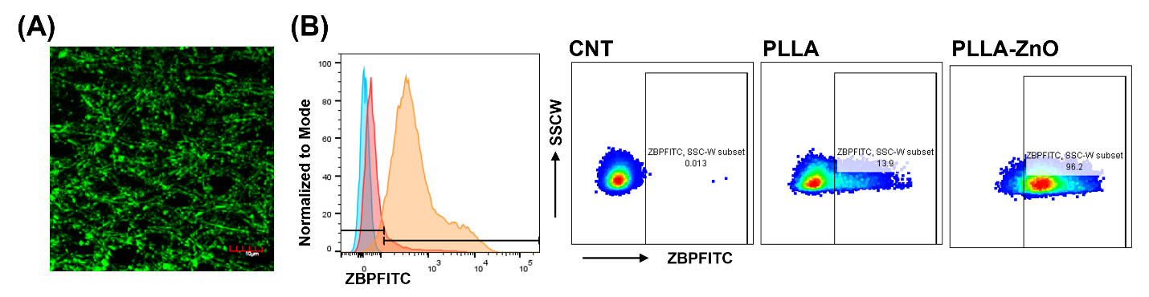
Supplementary Figure 1.
(A) Fluorescence microscopy image of FITC-labeled ZBP–CEA immobilized on PLLA–ZnO composites, confirming antigen attachment along the composite fiber surfaces (scale bar, 10 μm). (B) Flow-cytometric assessment of DC2.4 cell association/uptake of FITC-labeled ZBP–CEA after incubation with antigen-loaded PLLA or PLLA–ZnO composites. Left, histogram overlay; right, representative flow cytometry plots showing the proportion of FITC+ cells. PLLA–ZnO composites were associated with 96.2% FITC+ DC2.4 cells, compared with 13.9% for PLLA composites and 0.013% for unstained control cells, indicating enhanced dendritic-cell association/uptake mediated by the ZnO nanowire platform.

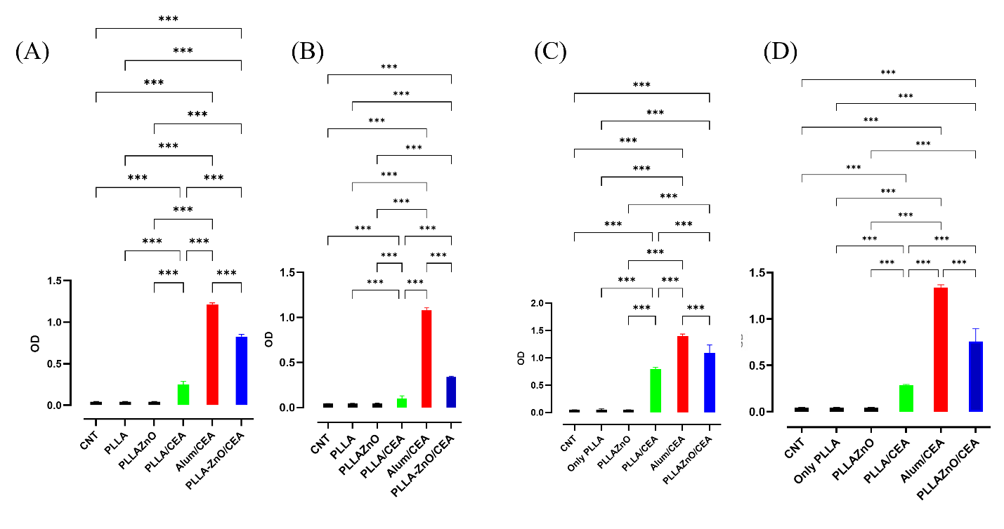
Supplementary Figure 2. IgG1 Antibody Responses Following Vaccination.
CEA-specific IgG1 antibody titters measured at two serum dilutions and time points. C57BL/6 mice (n=5 per group) were vaccinated with PLLA-ZnO/CEA, Alum/CEA, PLLA/CEA, or control formulations on Day 0 (prime) and Day 14 (boost). We performed ELISA on serum samples collected on Day 14 and Day 28 at 1:100 and 1:1000 dilutions. (A-B) Day 14 responses: Alum/CEA induced the highest IgG1 at both dilutions, followed by PLLA-ZnO/CEA and PLLA/CEA. (C-D) Day 28 responses: All vaccine groups showed increased IgG1 after boost. Alum/CEA maintained the highest levels, with PLLA-ZnO/CEA and PLLA/CEA showing proportional increases. Control groups (CNT, PLLA, PLLA-ZnO without antigen) showed minimal IgG1. Data represent mean ± SEM. Statistical analysis: one-way ANOVA with Tukey's post-hoc test; ***p < 0.001, **p < 0.01, p < 0.05, ns = not significant.
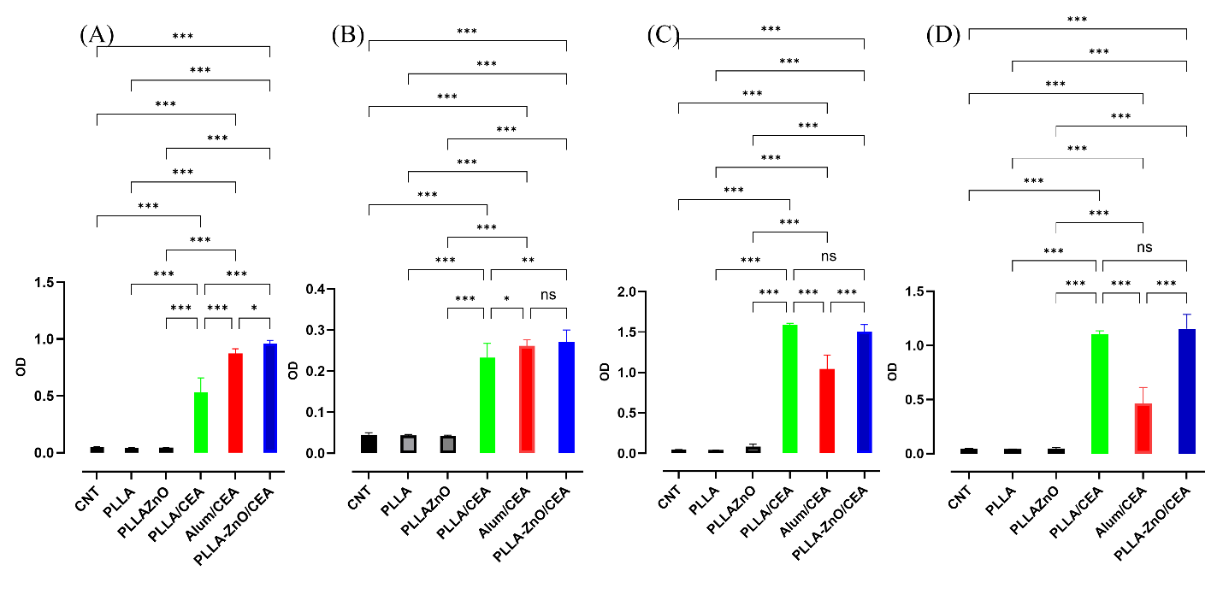 Supplementary Figure 3. IgG2c Antibody Responses Following Vaccination.
CEA-specific IgG2c antibody titters measured at two serum dilutions and time points. Experimental design identical to Figure 2. IgG2c is the Th1-associated isotype in C57BL/6 mice, indicating activation of cellular immunity. (A-B) Day 14 responses: PLLA-ZnO/CEA induced the highest IgG2c at 1:100 dilution, significantly exceeding Alum/CEA and PLLA/CEA. At 1:1000 dilution, PLLA-ZnO/CEA and Alum/CEA showed comparable levels. (C-D) Day 28 responses: PLLA-ZnO/CEA maintained the highest IgG2c at both dilutions, demonstrating sustained Th1 immunity. Alum/CEA showed lower IgG2c expansion consistent with Th2 bias. PLLA/CEA exhibited intermediate responses. Control groups showed minimal IgG2c. Data represent mean ± SEM (n=5 per group). Statistical analysis: one-way ANOVA with Tukey's post hoc test; ***p < 0.001, **p < 0.01, p < 0.05, ns = not significant.

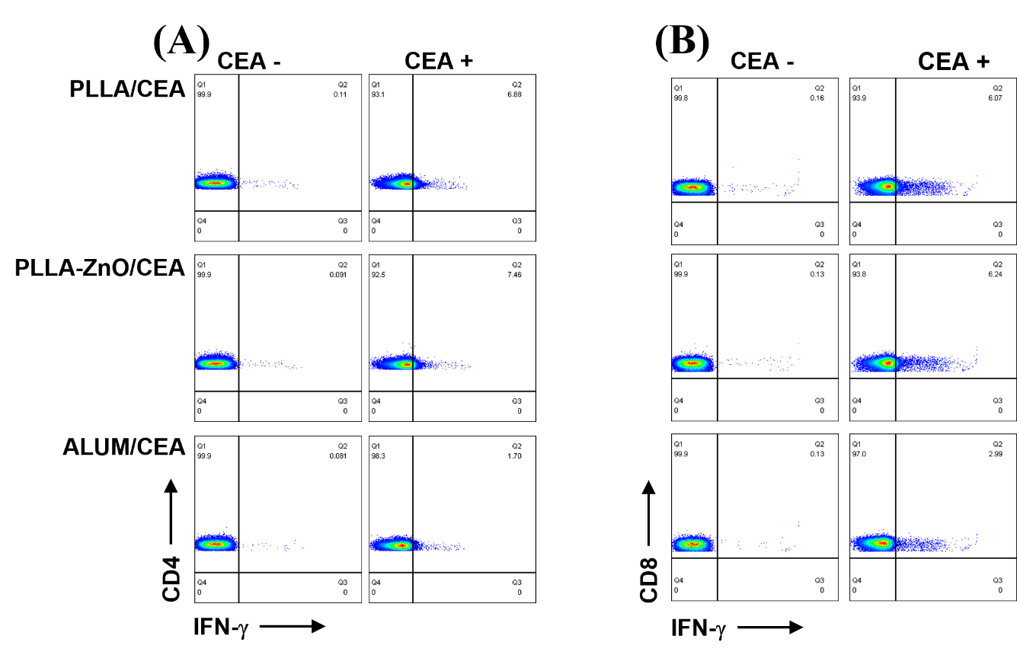Figure 4. Flowcytometry Cellular immune responses following PLLA-ZnO/CEA vaccination. On Day 28, splenocytes were isolated and cultured CD4+ and CD8+ under antigen-positive (CEA⁺) and antigen-negative (CEA⁻) conditions for 16 hours. Cells were analyzed by flow cytometry for (A-B) IFNγ+ CD8+ T cells and IFNγ+ CD4+ T cells.

