Additional file 8
Figure S21 Manhattan plot for fat area at the ischium accounting for live weight using Regional Heritability Mapping
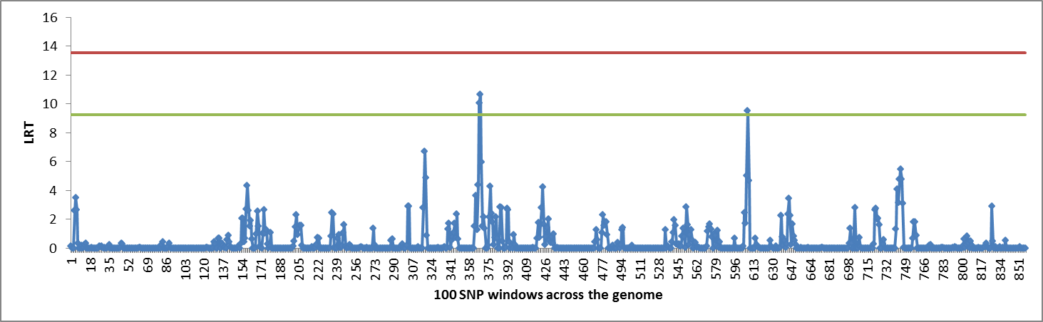

Figure S22 Manhattan plot for fat area at the 8th thoracic vertebra using Regional Heritability Mapping
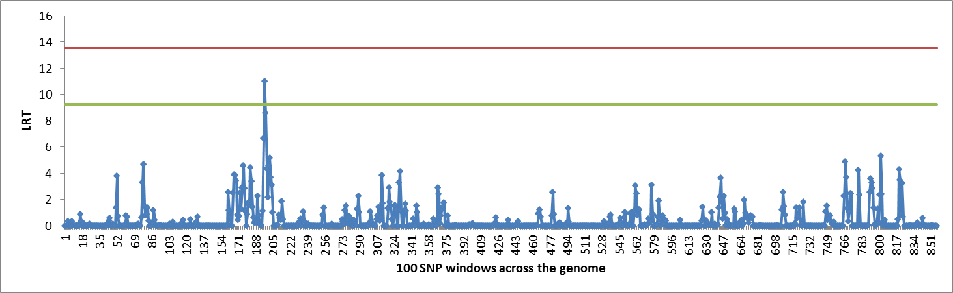

Figure S23 Manhattan plot for fat density at the ischium accounting for live weight using Regional Heritability Mapping
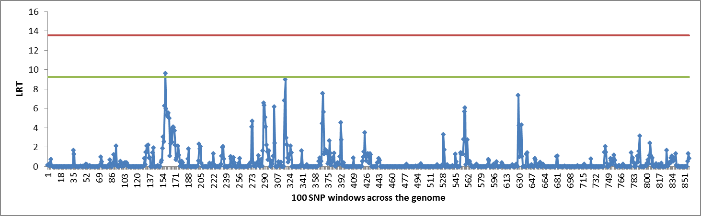

Figure S24 Manhattan plot for muscle weight using Regional Heritability Mapping
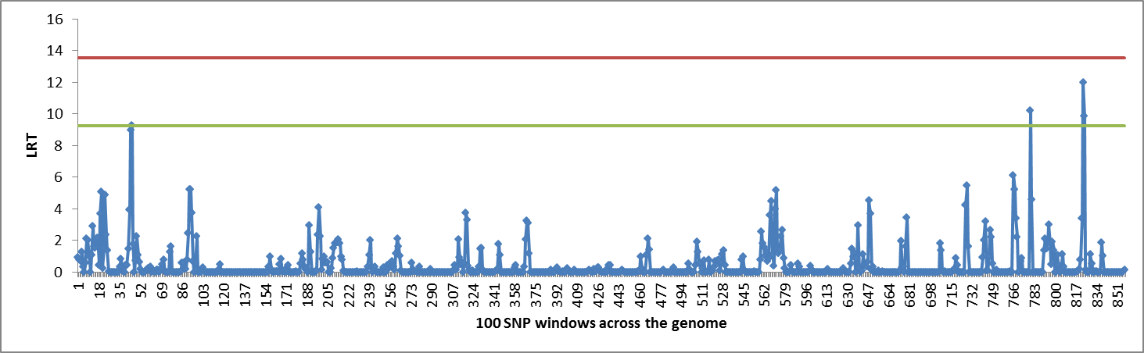

Figure S25 Manhattan plot for muscle area at the ischium using Regional Heritability Mapping
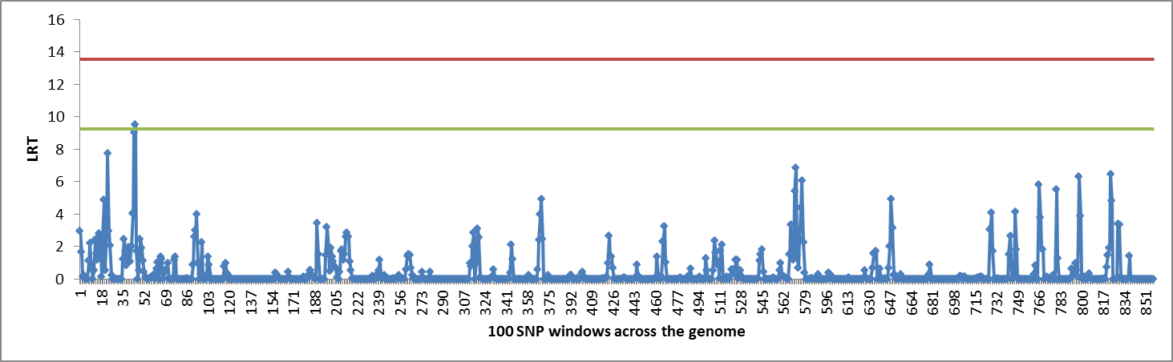

Figure S26 Manhattan plot for muscle area at the 5th lumbar vertebra accounting for live weight using Regional Heritability Mapping
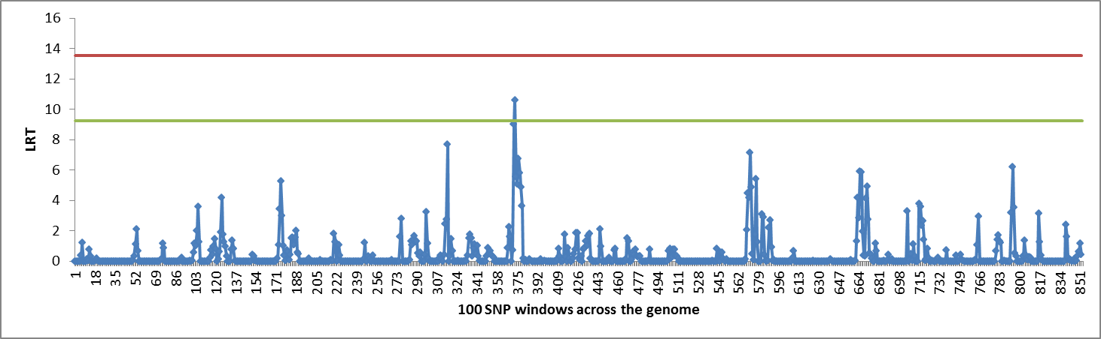

Figure S27 Manhattan plot for muscle area at the 8th thoracic vertebra using Regional Heritability Mapping
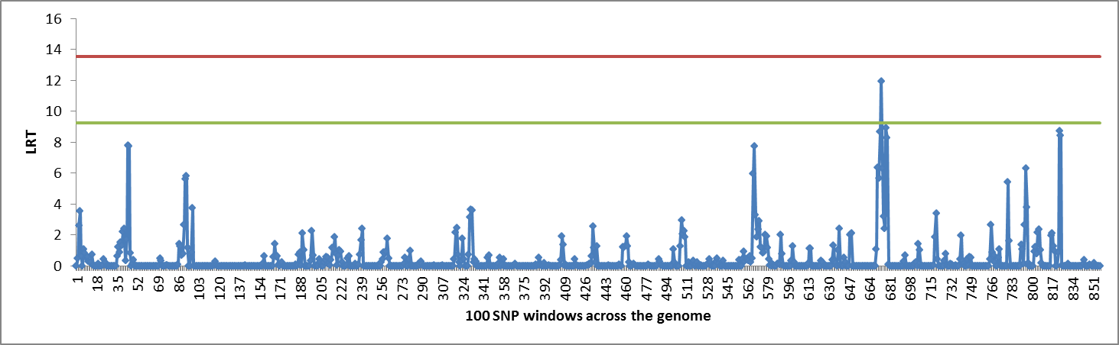

Figure S28 Manhattan plot for muscle area at the 8th thoracic vertebra accounting for live weight using Regional Heritability Mapping
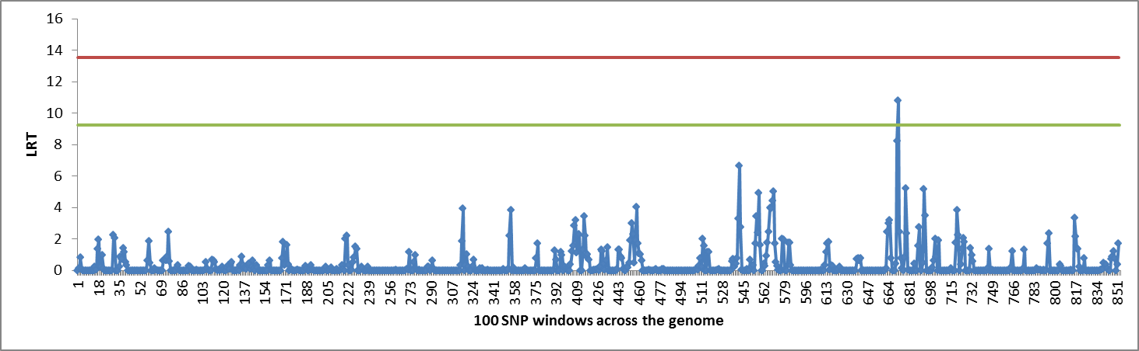

Figure S29 Manhattan plot for muscle density at the ischium using Regional Heritability Mapping
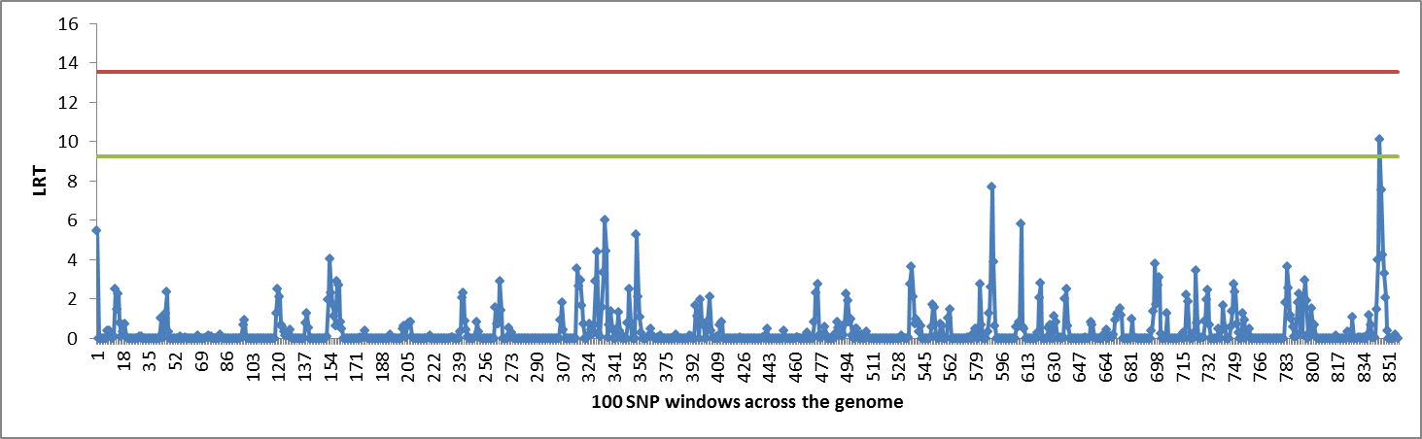

Figure S30 Manhattan plot for muscle density at the ischium accounting for live weight using Regional Heritability Mapping
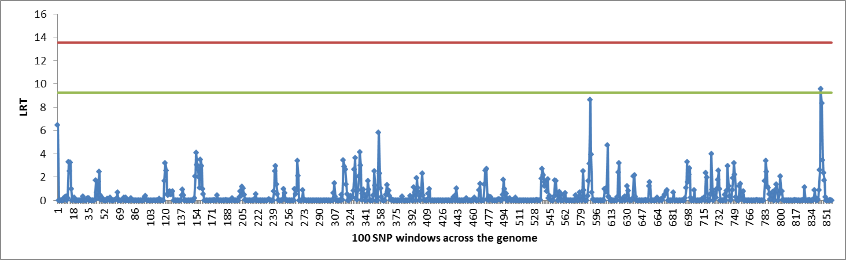

Figure S31 Manhattan plot for muscle density at the 5th lumbar vertebra using Regional Heritability Mapping
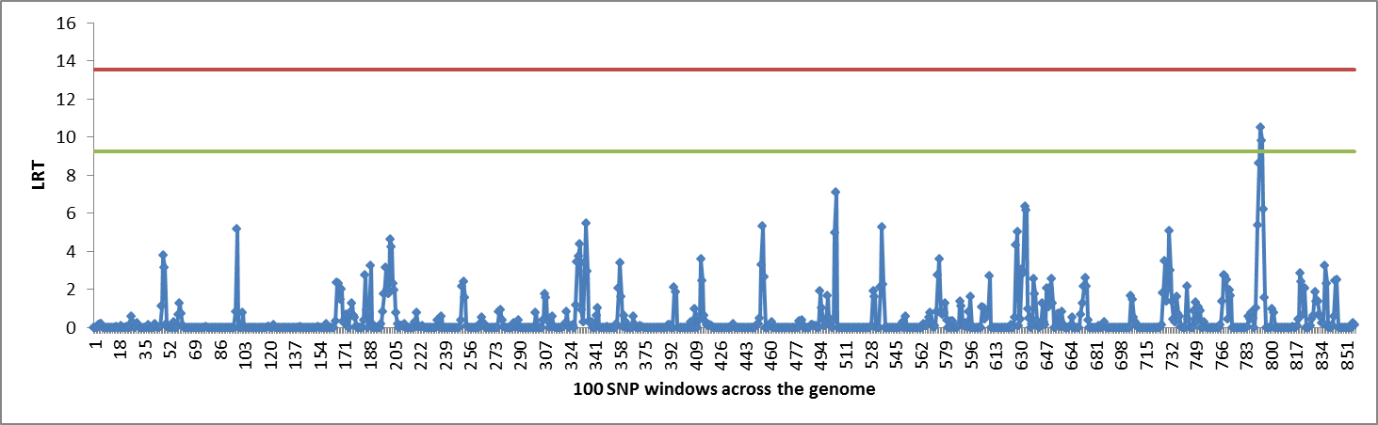

Figure S32 Manhattan plot for muscle density at the 8th thoracic vertebra using Regional Heritability Mapping
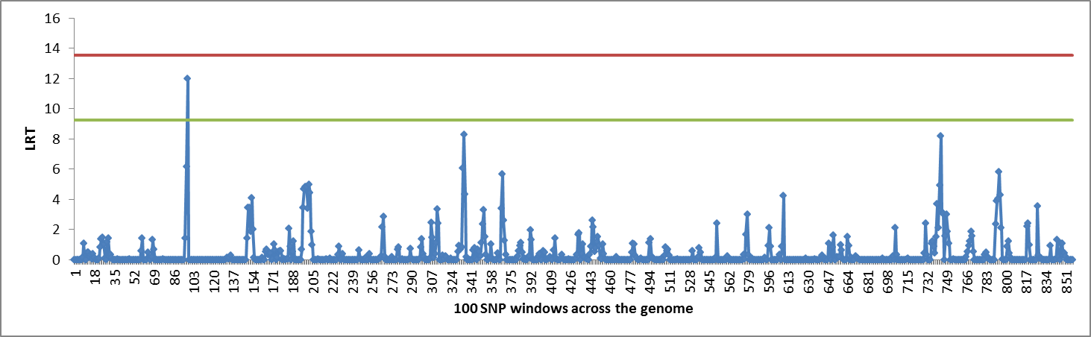

Figure S33 Manhattan plot for bone proportion using Regional Heritability Mapping
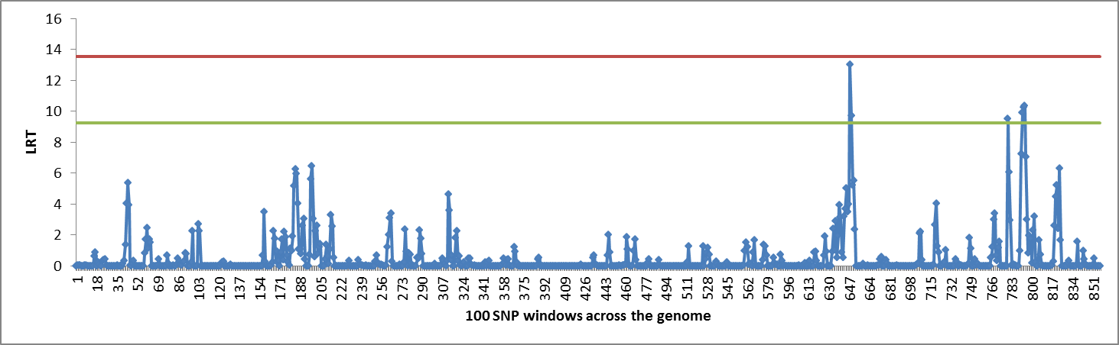

Figure S34 Manhattan plot for total carcass weight using Regional Heritability Mapping
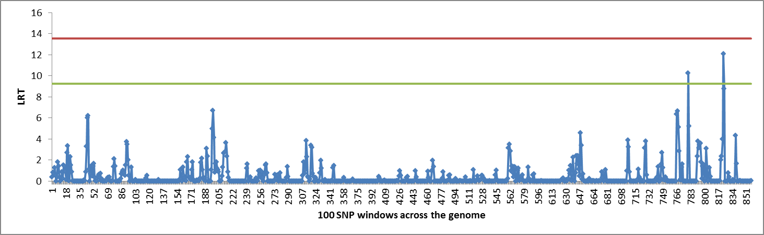

Figure S35 Manhattan plot for muscle to bone ratio using Regional Heritability Mapping

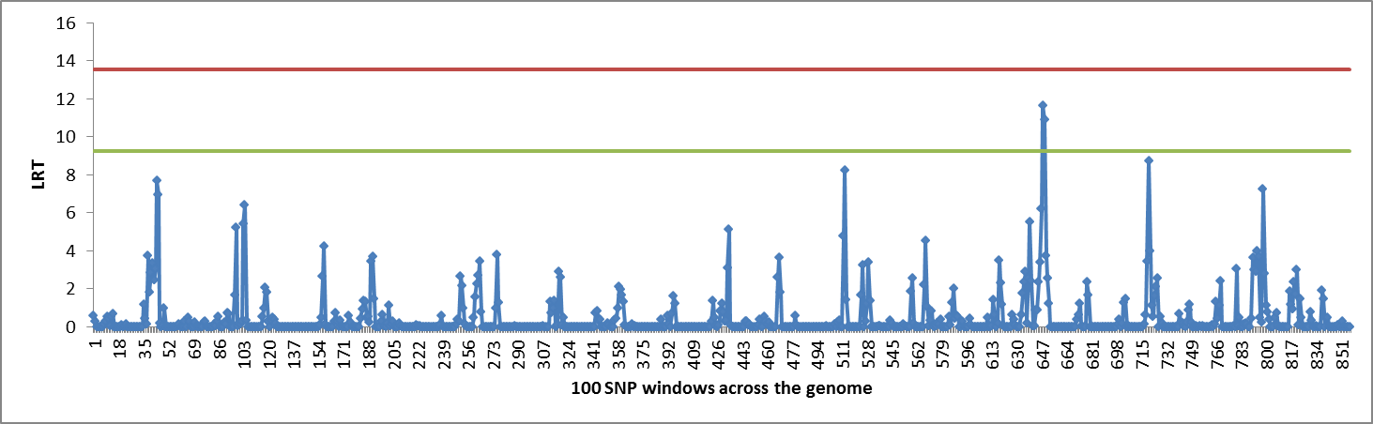

Figure S36 Manhattan plot for live weight using Regional Heritability Mapping
