Additional file 9
Figure S37 Linkage disequilibrium (LD) values (r2 values, expressed as percentage) between SNPs within the interval ranging from SNP s38306 (at 35347156 bp) to SNP OAR6_41768532 (at 37533664 bp) on OAR 6. The colour scheme is as follows: white for r² = 0, shades of grey for 0 < r² < 1 and black for r2 = 1.
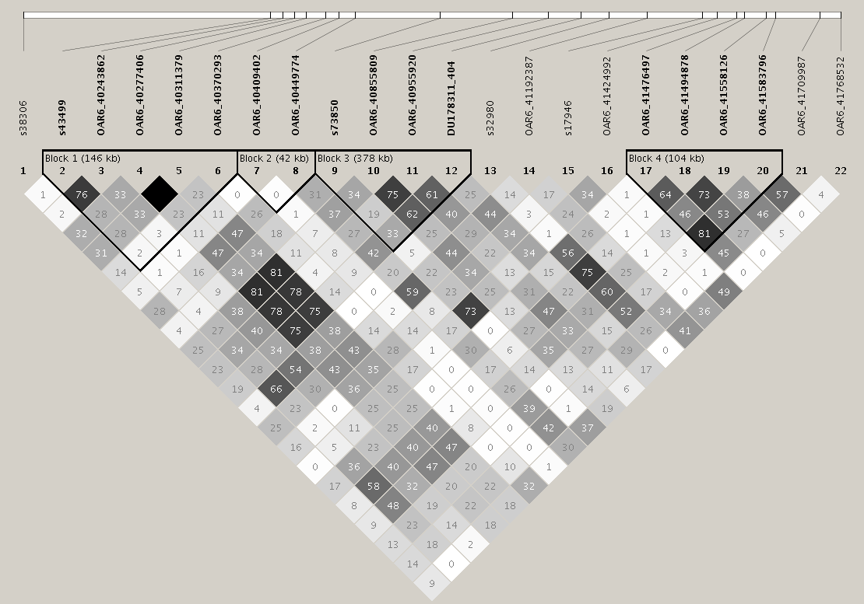

Figure S38 D prime (D') values (D', representing allele frequencies) between SNPs in the interval ranging from SNP s38306 (at 35347156 bp) to SNP OAR6_41768532 (at 37533664 bp) on OAR 6. The standard colour scheme is as follows: white for low D' value (D' < 1) and low LOD value (LOD < 2), blue for high value D' (D' = 1), shades of pink/red for low D' value and low LOD value and bright red for high D' value and high LOD value.
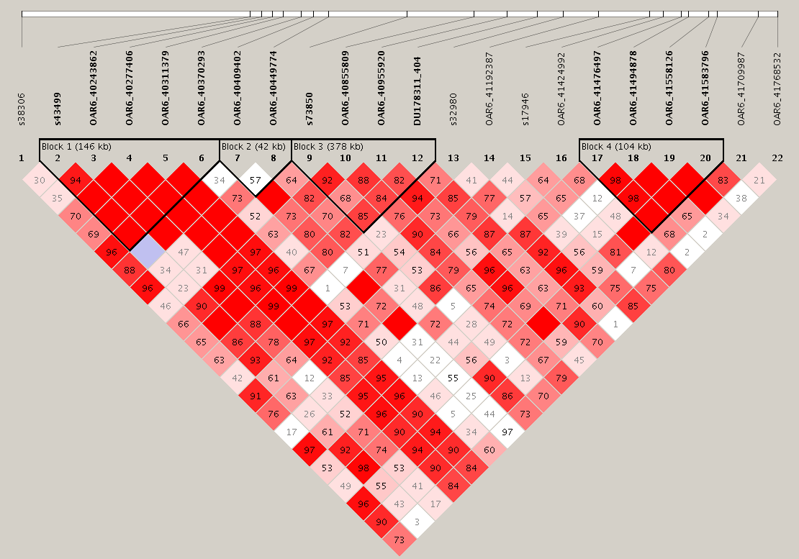

Figure S39 Phased population haplotypes showing each haplotype in a block with the corresponding population frequency and connections from one block to the next one, including in the crossing areas, a value of multiallelic D' shown as a representation of the level of recombination between the two blocks.
