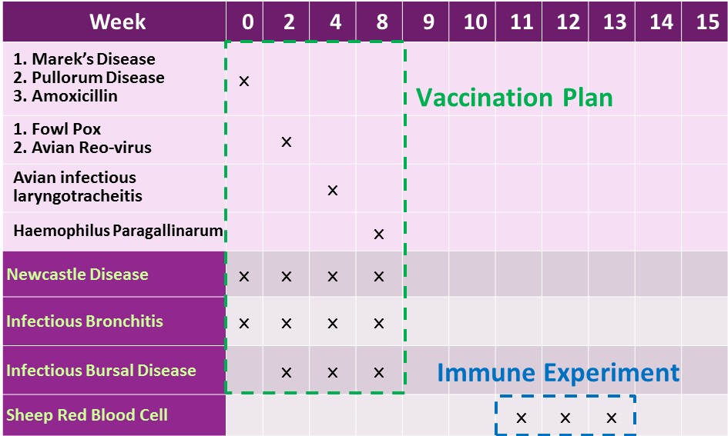
Fig. S3 The calendar of vaccination plan and immune experiment

