Additional file 18 for “High resolution analysis of selection sweeps identified between fine-wool Merino and coarse-wool Churra sheep breeds”
Authors: Beatriz Gutiérrez-Gil, Cristina Esteban-Blanco, Pamela Wiener, Praveen Krishna Chitneedi, Aroa Suarez-Vega, Juan-José Arranz

Figure S5. Graphical representation of the genetic differentiation analysis (a), and the analysis of reduced heterozygosity (b, c) when analyzing the validation dataset “Spanish Merino vs Spanish Churra” considered in the present study.
a) F_{ST} values obtained across the whole genome (averaged in sliding windows of 9 SNPs) when contrasting the 50K-Chip pooled genotypes of the Spanish Merino samples provided by Ciani et al. [34] and a subset of Spanish Churra samples considered in this work. The horizontal line indicates the top 0.5th percent threshold of the F_{ST}-distribution; b) and c) Genome-wide distribution of observed heterozygosity values (averaged over a sliding window of 9 SNPs) for the pooled genotypes of the Spanish Merino (b) and the Spanish Churra (c) samples considered as a validation dataset in the present work. The horizontal lines indicate the bottom 0.5th percent thresholds of the heterozygosity distributions.

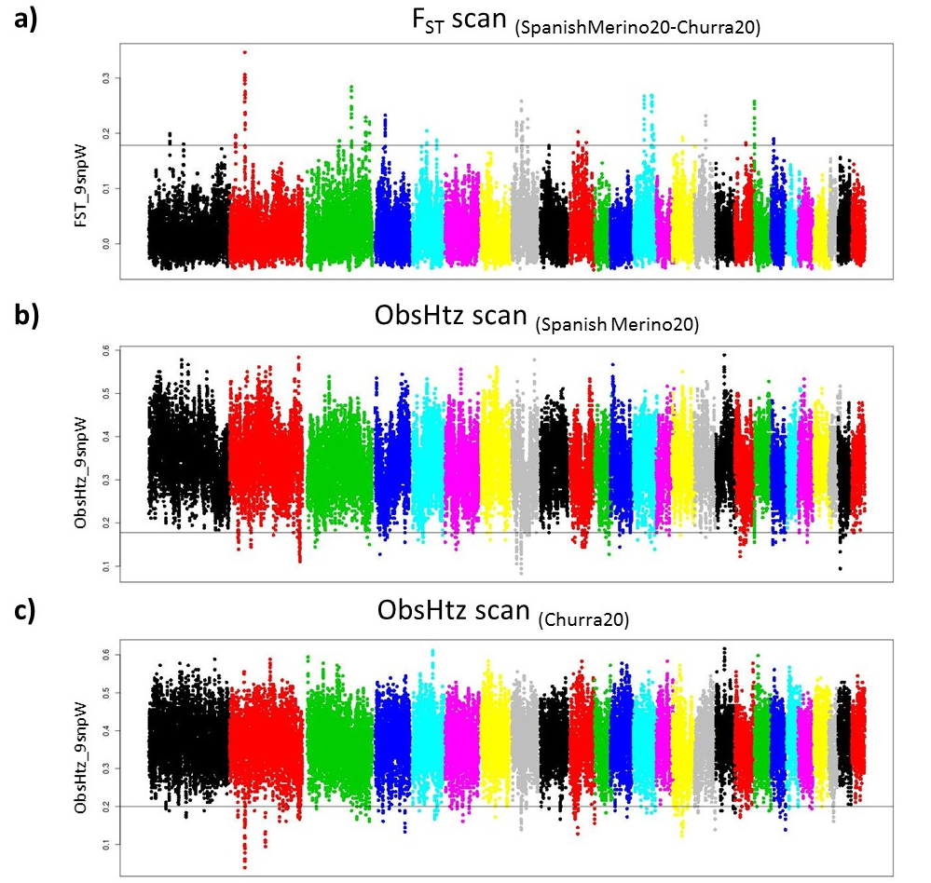

Figure S6. Graphical representation of the selection sweep mapping analyses performed with the two haplotype-based methods used in this work, performed with the hapFLK (a) and the rehh (XP-EHH analysis) (b) software, for the validation dataset considered in the present work (Spanish Merino vs Spanish Churra sheep breeds). Genome-wide distribution of the log (1/P-value) obtained from each analysis are represented in the Y-axis. The horizontal lines represent the significance threshold considered (P < 0.001).

