Additional file 3 for “High resolution analysis of selection sweeps identified between fine-wool Merino and coarse-wool Churra sheep breeds”
Authors: Beatriz Gutiérrez-Gil, Cristina Esteban-Blanco, Pamela Wiener, Praveen Krishna Chitneedi, Aroa Suarez-Vega, Juan-José Arranz

Figure S1. Graphical representation of the Principal Component Analysis (PCA) performed with Eigensoft for the final of 50K-Chip genotypes analysed in this study for a total of 238 fine wool Merino [Australian Industry Merino (n = 88), Australian Merino (n = 50) and Australian Poll Merino (n = 98)] and 278 Spanish Churra individuals.

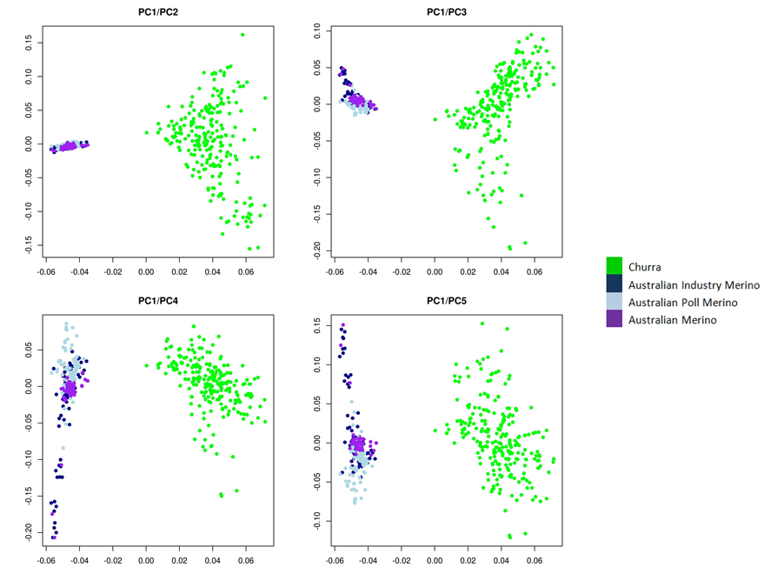

Figure S2. Graphical representation of the results of the cross-validation approach performed with the Admixture software to determine the best K-value.

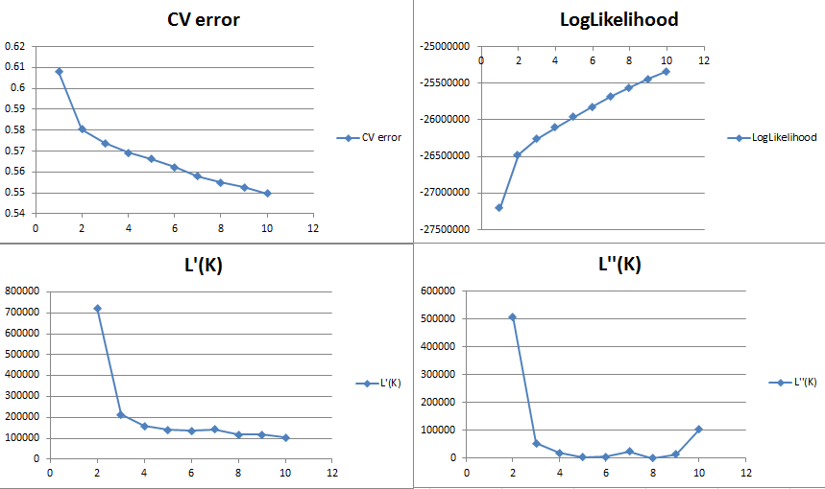
Figure S3. Graphical representation of the proportion of membership of each of the analysed populations for K = 2 as obtained with the Admixture_v1.3 software.
