Additional file 2 – The relationship between expected maximum values for $r_{LD}^{2}$ and $r_{ac}^{2}$
Type of file: docx
Here we use a slightly different notation than in the main text. Consider that $p_{j}$ is the frequency of the minor allele at locus j, $p_{k}$ is the frequency of the minor allele at locus k, minor alleles are coded as 1, and major alleles are coded as 0. Then, considering phased alleles, the variance for e.g. locus j is $p_{j}\left(1-p_{j}\right)$. And the covariance between loci j and k is, considering that e.g. $f\left(11\right)$ is the frequency of haplotype 11 and $a_{. ,j, .}$ is the allele at locus j:
$$cov\left(a_{. ,j, .},a_{. ,k, .}\right)=E\left[\left(a_{. ,j, .}a_{. ,k, .}-E\left[a_{. ,j, .}\right]E\left[a_{. ,k, .}\right]\right)\right]=\left(f\left(0\right)*0^{2}+f\left(01\right)*0*1+f\left(10\right)*1*0+f\left(11\right)*1^{2}-p_{j}p_{k}\right)=\left(f\left(11\right)-p_{j}p_{k}\right)$$
The expected maximum value of $f\left(11\right)$, considering that we process the SNPs such that $p_{j}≤p_{k}$, is obtained when all alleles 1 at locus j are accompanied by an allele 1 at locus k:
$$E_{max}\left(f\left(11\right)\right){=\min\left(p_{j},p_{k}\right)=p_{j}}$$
Thus, the maximum expected value for the covariance is:
$$E_{max}\left(cov\left(a_{. ,j, .},a_{. ,k, .}\right)\right)=max\left(f\left(11\right)-p_{j}p_{k}\right)=\max\left(f\left(11\right)\right)-p_{j}p_{k}=\left(p_{j}-p_{j}p_{k}\right)=p_{j}\left(1-p_{k}\right)$$
Thus, the maximum expected $r_{LD}^{2}$ value is:
$$E_{max}\left(r_{LD}^{2}\right)=\frac{{\left(p_{j}\left(1-p_{k}\right)\right)}^{2}}{p_{j}\left(1-p_{j}\right)p_{k}\left(1-p_{k}\right)}=\frac{p_{j}\left(1-p_{k}\right)}{p_{k}\left(1-p_{j}\right)}$$
A similar reasoning can be used for $r_{ac}^{2}$. In this case, we assume that the loci are in Hardy-Weinberg equilibrium. So, the variance for e.g. locus j is $2p_{j}\left(1-p_{j}\right)$. And the covariance between loci j and k is, noting that e.g. $f_{ac}\left(21\right)$ is the frequency of observing allele count 2 at locus j and allele count 1 at locus k, and considering that $x_{. ,j}$ is the allele count at locus j:
$$cov\left(x_{. ,j},x_{. ,k}\right)=E\left[\left(x_{. ,j}x_{. ,k}-E\left[x_{. ,j}\right]E\left[x_{. ,k}\right]\right)\right]=\left(f_{ac}\left(22\right)*2*2+f_{ac}\left(21\right)*2*1+f_{ac}\left(12\right)*1*2+ f_{ac}\left(11\right)*1*1+f_{ac}\left(10\right)*1*0+f_{ac}\left(01\right)*0*1+f_{ac}\left(00\right)*0*0-2p_{j}2p_{k}\right)=\left(f_{ac}\left(22\right)*4+f_{ac}\left(21\right)*2+f_{ac}\left(12\right)*2+ f_{ac}\left(11\right)*1-2p_{j}2p_{k}\right)$$
To obtain the maximum value of this covariance, the number of appearances of allele counts of 2 at both loci, or equivalently $f_{ac}\left(22\right)$, needs to be maximized. Given that we assume Hardy-Weinberg equilibrium and $p_{j}≤p_{k}$, this means that all allele counts 2 at locus j should be accompanied by an allele count of 2 at locus k. Thereafter, considering the remaining number of allele counts of 2 at locus k, the number of appearances of allele counts 1 at locus j and 2 at locus k, or equivalently $f_{ac}\left(12\right)$, needs to be maximized. Finally, the number of appearances of allele counts of 1 at both loci, or equivalently $f_{ac}\left(11\right)$, needs to be maximized. Expressions for the frequencies of the combinations of allele counts that make a contribution to the maximum possible $cov\left(x_{. ,j},x_{. ,k}\right)$ are obtained as follows:
$$max\left(f_{ac}\left(22\right)\right)=max\left(p_{j}^{2},p_{k}^{2}\right)=p_{j}^{2}$$
Then, $f_{ac}\left(21\right)=0$, and,
$$max\left(f_{ac}\left(12\right)\right)=min\left(f_{ac}\left(1.\right);f_{ac}\left(.2\right)-f_{ac}\left(22\right)\right)=min\left(2p_{j}\left(1-p_{j}\right);p_{k}^{2}-p_{j}^{2}\right)$$
Finally, there will be only allele counts 1 left on locus j if these were not all used to maximize $f_{ac}\left(12\right)$. This is the case when:
$$2p_{j}\left(1-p_{j}\right)>p_{k}^{2}-p_{j}^{2}$$
$$2p_{j}\left(1-p_{j}\right)-p_{k}^{2}+p_{j}^{2}>0$$
$$2p_{j}-p_{j}^{2}-p_{k}^{2}>0$$
Such that:
$$max\left(f_{ac}\left(11\right)\right)=max\left(2p_{j}-p_{j}^{2}-p_{k}^{2};0\right)$$
An overview of these expressions is given in Table S1.
Table S1. Required frequencies for different combinations of allele counts at loci j and k, to maximize $r_{ac}^{2}$between those two loci.
Locus |  | k
 | Allele count | 2 | 1
J | 2 | $$p_{j}^{2}$$ | 0
 | 1 | $$min\left(2p_{j}(1-p_{j});p_{k}^{2}-p_{j}^{2}\right)$$ | $$max\left(2p_{j}-p_{j}^{2}-p_{k}^{2};0\right)$$
Considering these expressions,
$$E_{max}\left(r_{ac}^{2}\right)=\frac{{\left(4p_{j}^{2}+2*min\left(2p_{j}\left(1-p_{j}\right);p_{k}^{2}-p_{j}^{2}\right)+max⁡\left(2p_{j}-p_{j}^{2}-p_{k}^{2};0\right)\right)}^{2}}{2p_{j}\left(1-p_{j}\right){2p}_{k}\left(1-p_{k}\right)}$$
Values of $E_{max}\left(r_{LD}^{2}\right)$ and $E_{max}\left(r_{ac}^{2}\right)$ were numerically compared in Figures S1 and S2 by simply plotting their values against each other, considering that, given the coding of the minor alleles as 1, $p_{j}∈[0,0.5]$, $p_{k}∈[0,0.5]$ and $p_{j}≤p_{k}$. These figures show that for $r_{LD}^{2}≥0.95$, $E_{max}\left(r_{ac}^{2}\right)≈E_{max}\left(r_{LD}^{2}\right)$. Combining the above expressions for $E_{max}\left(r_{LD}^{2}\right)$ and $E_{max}\left(r_{ac}^{2}\right)$, considering that $p_{k}\left(1-p_{j}\right)=\frac{p_{j}\left(1-p_{k}\right)}{E_{max}\left(r_{LD}^{2}\right)}$, we obtain:
$$E_{max}\left(r_{ac}^{2}\right)=\frac{{\left(4p_{j}^{2}+2*min\left(2p_{j}\left(1-p_{j}\right);p_{k}^{2}-p_{j}^{2}\right)+max⁡\left(2p_{j}-p_{j}^{2}-p_{k}^{2};0\right)\right)}^{2}}{\frac{4p_{j}^{2}{\left(1-p_{k}\right)}^{2}}{E_{max}\left(r_{LD}^{2}\right)}}=\frac{{\left(4p_{j}^{2}+2*min\left(2p_{j}\left(1-p_{j}\right);p_{k}^{2}-p_{j}^{2}\right)+max⁡\left(2p_{j}\left(1-p_{j}\right)-p_{k}^{2}+p_{j}^{2};0\right)\right)}^{2}}{4p_{j}^{2}{\left(1-p_{k}\right)}^{2}}E_{max}\left(r_{LD}^{2}\right)$$
Applying this expression (see Figure S3), shows that for $E_{max}\left(r_{LD}^{2}\right)≥0.95$, $E_{max}\left(r_{ac}^{2}\right)$ is at most ~1.0007 times bigger than $E_{max}\left(r_{LD}^{2}\right)$. For $E_{max}\left(r_{LD}^{2}\right)≥0.99$, $E_{max}\left(r_{ac}^{2}\right)$ is at most ~1.00003 times bigger than $E_{max}\left(r_{LD}^{2}\right)$, so in this case, we can assume that $E_{max}\left(r_{ac}^{2}\right)=E_{max}\left(r_{LD}^{2}\right)$.
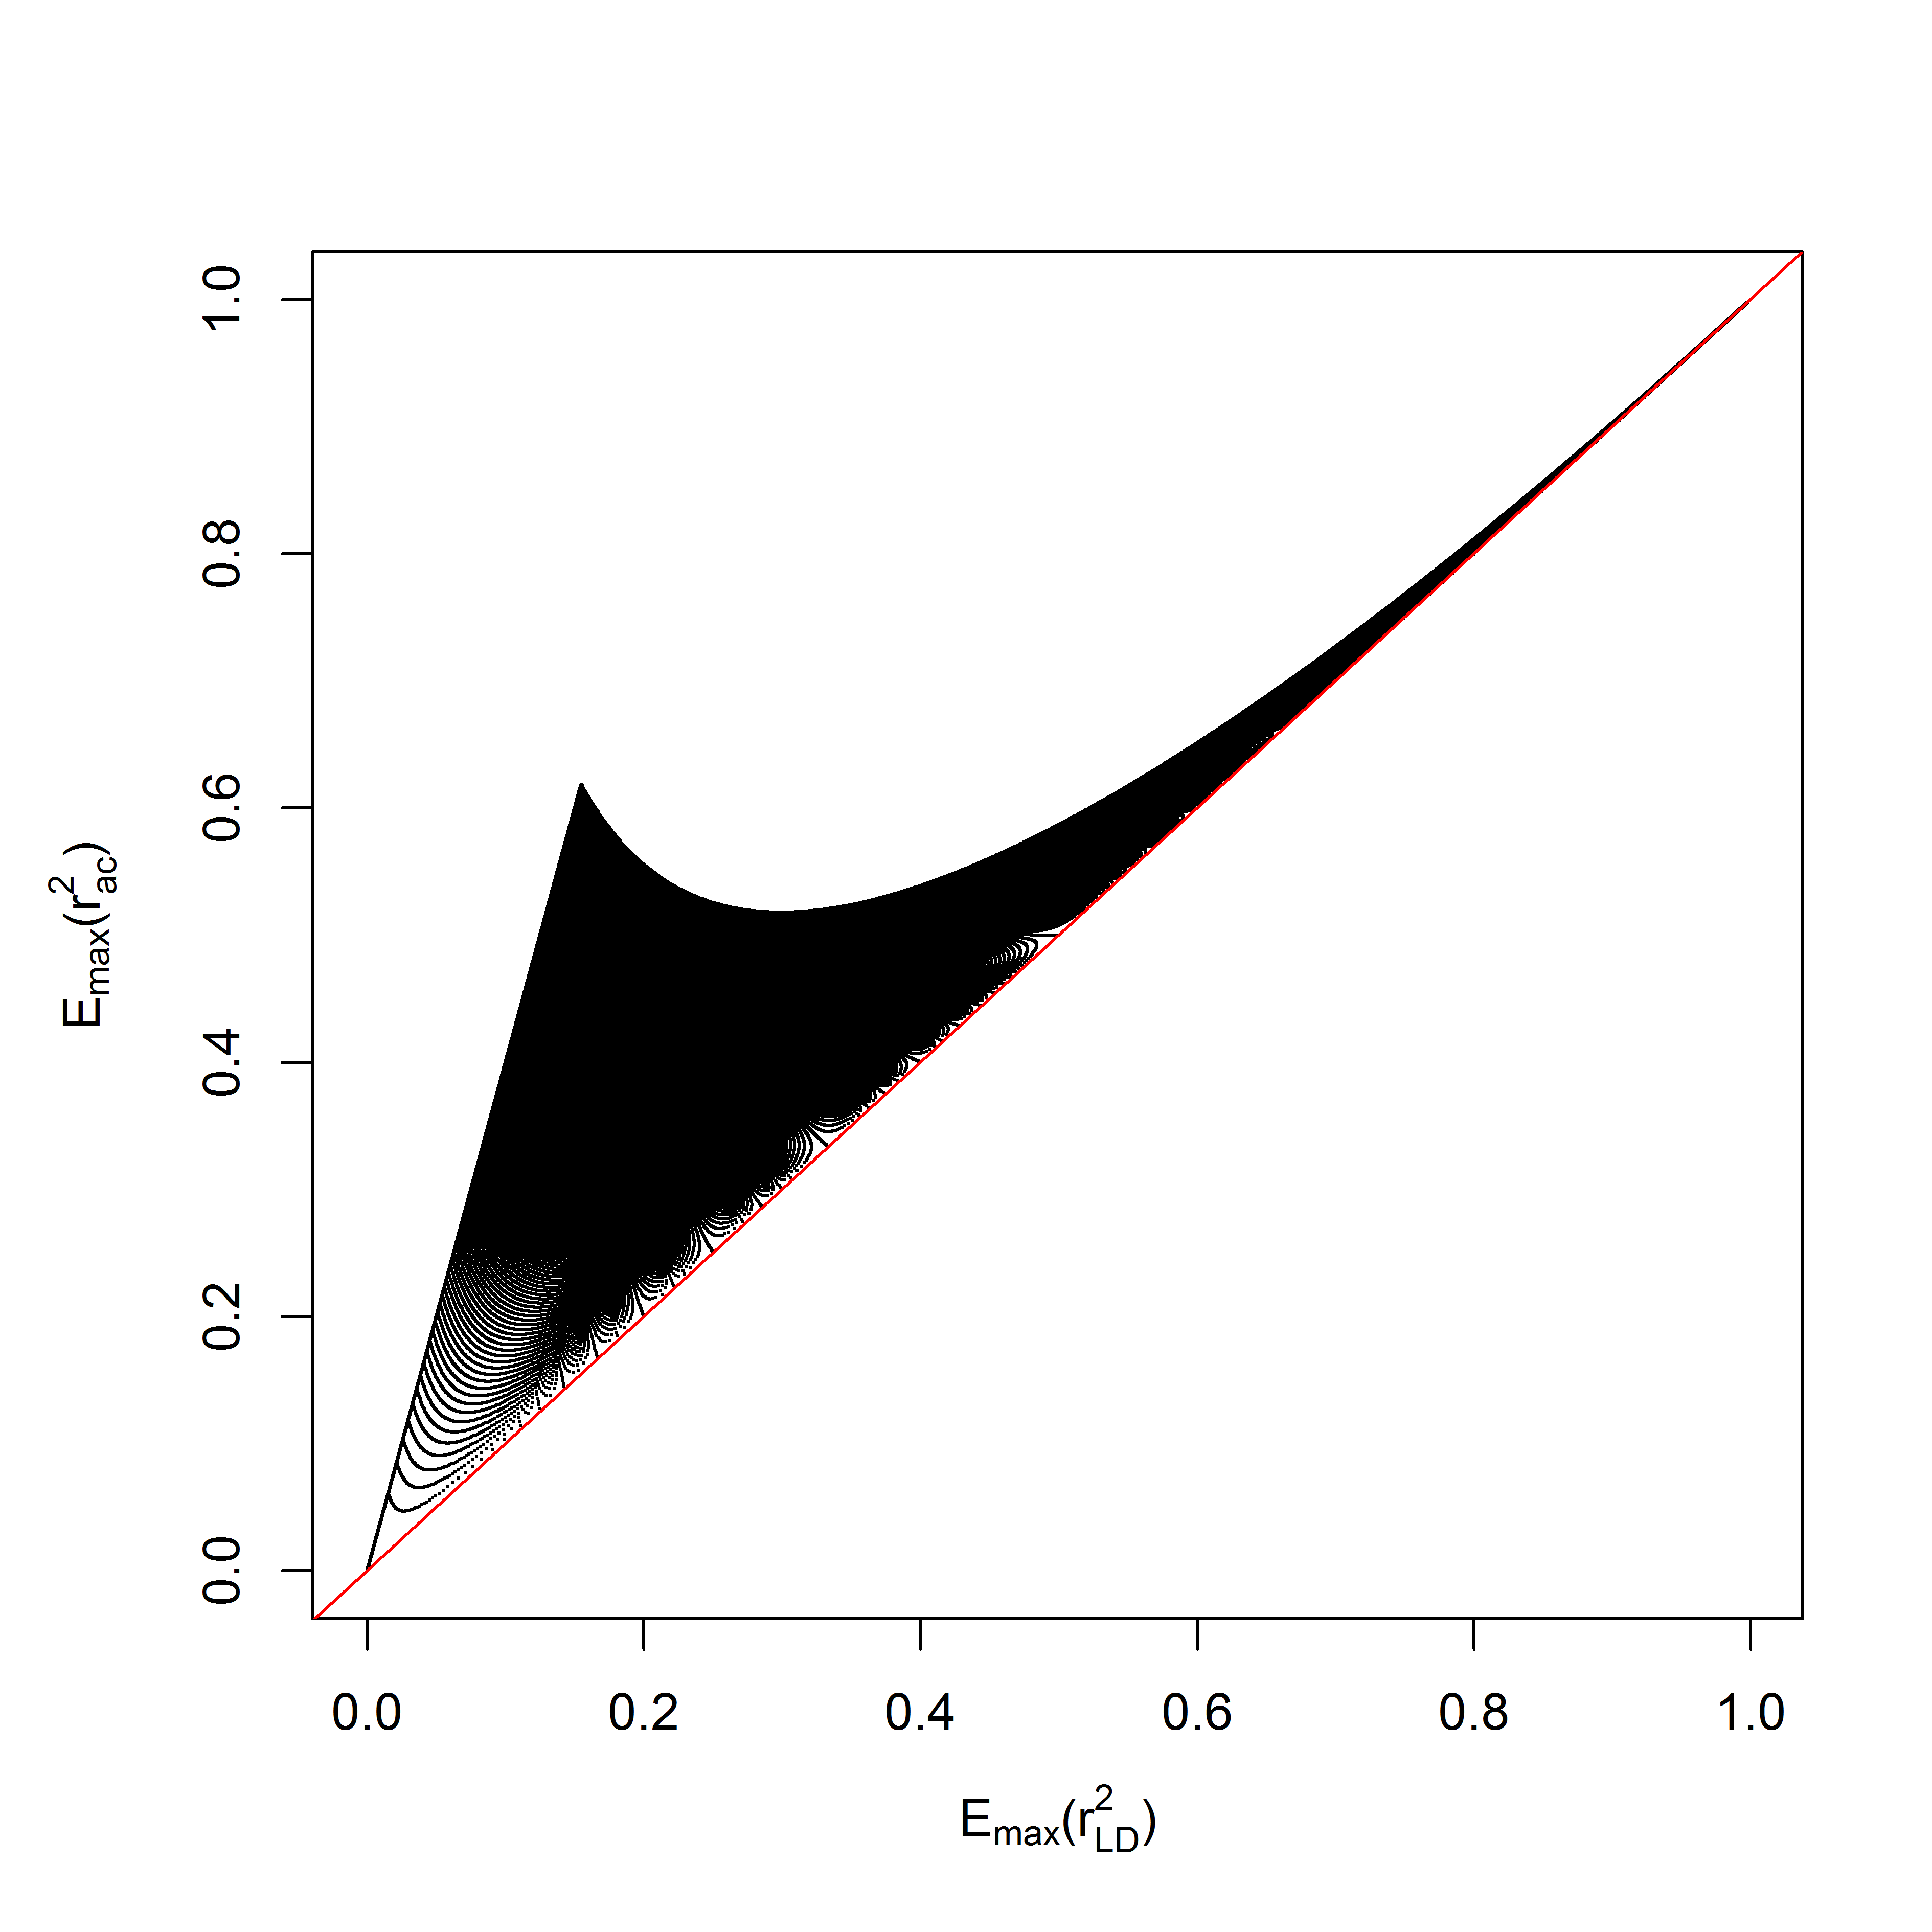
Figure S1 – Comparison of values of $E_{max}\left(r_{LD}^{2}\right)$ and $E_{max}\left(r_{ac}^{2}\right)$ for values of $E_{max}\left(r_{LD}^{2}\right)$ ranging from 0 and 1. Pairs of $r^{2}$ values are indicated by black dots. The red line indicates $r_{ac}^{2}=r_{LD}^{2}$ as a reference.

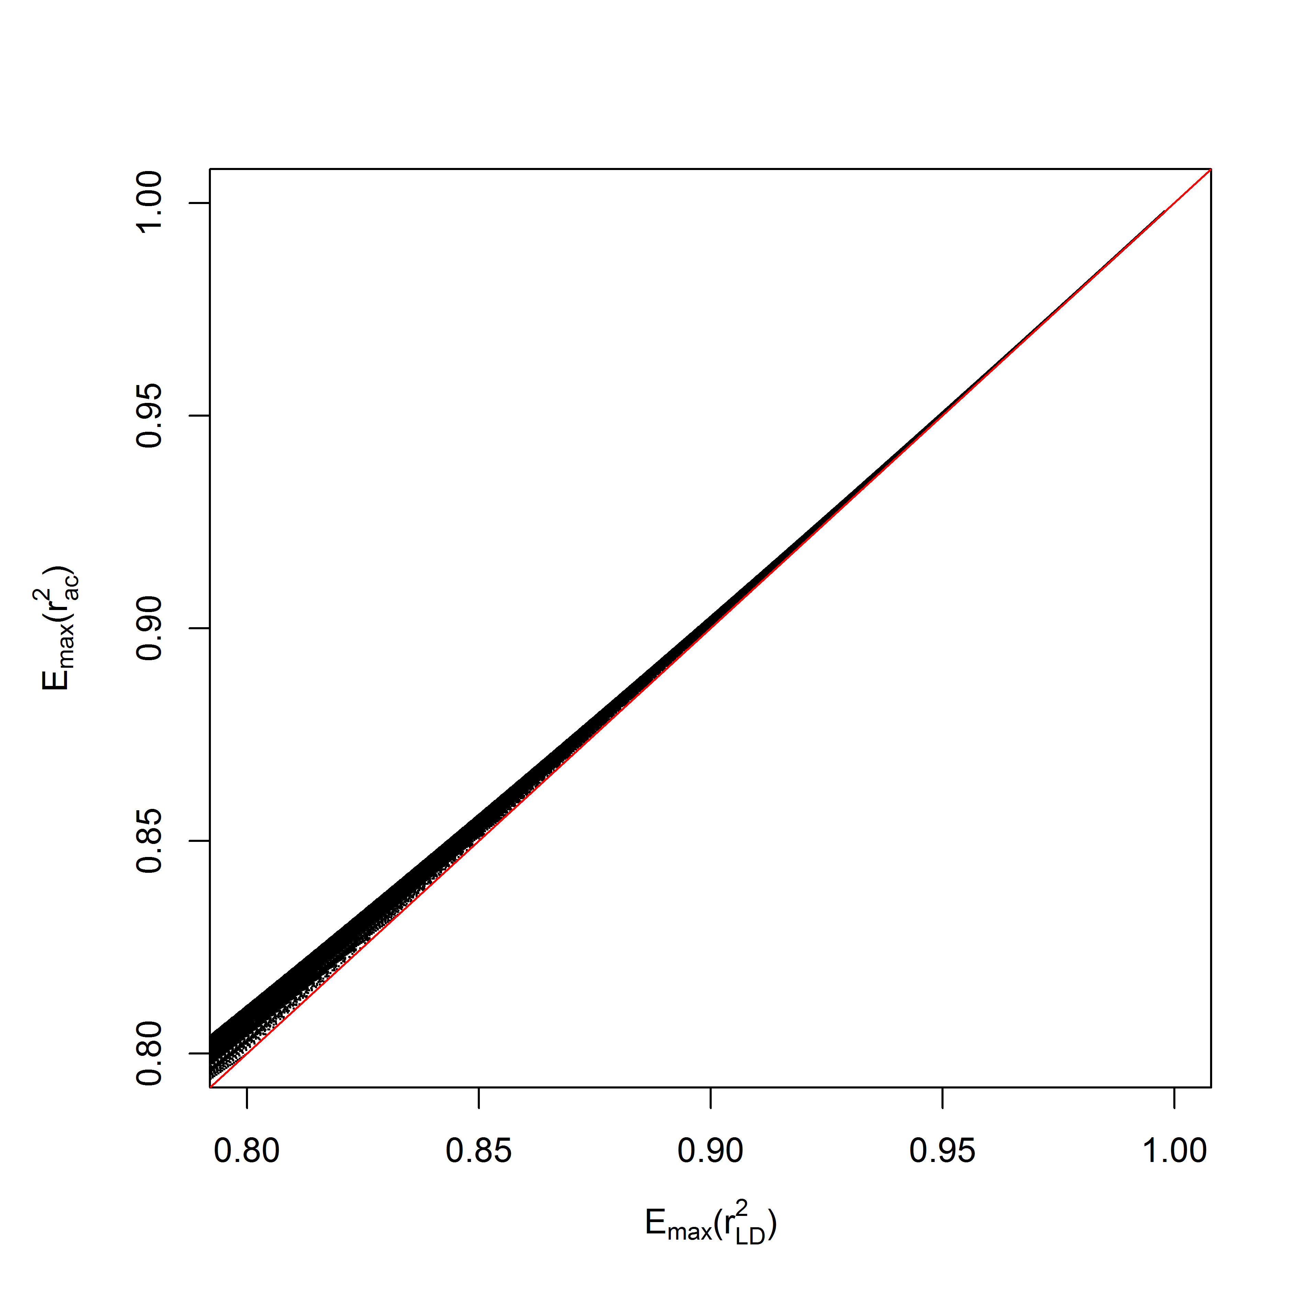
Figure S2 – Comparison of values of $E_{max}\left(r_{LD}^{2}\right)$ and $E_{max}\left(r_{ac}^{2}\right)$ for values of $E_{max}\left(r_{LD}^{2}\right)$ ranging from 0.8 and 1. Pairs of $r^{2}$ values are indicated by black dots. The red line indicates $r_{ac}^{2}=r_{LD}^{2}$ as a reference.

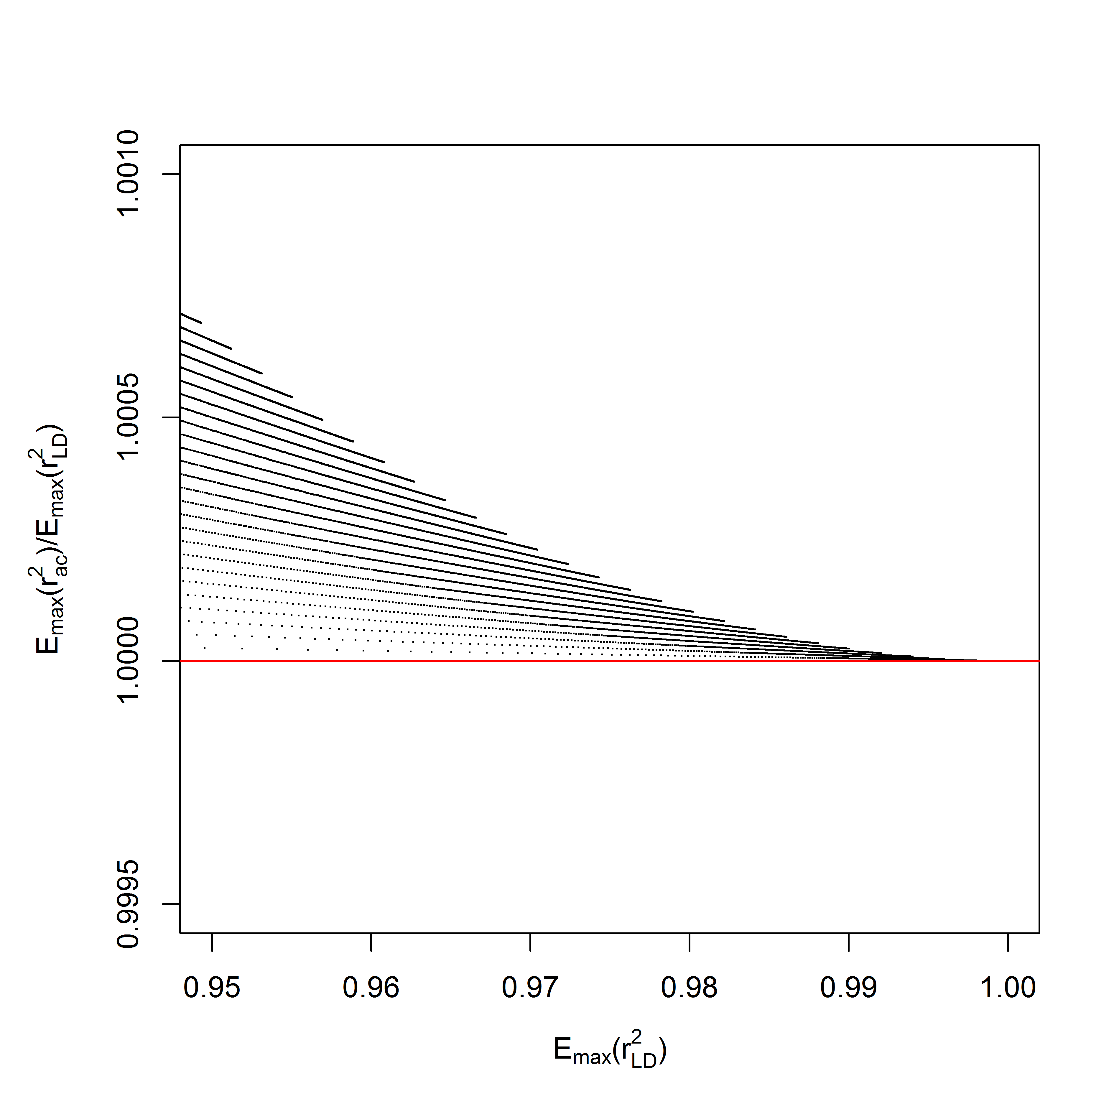
Figure S3 – The ratio $E_{max}\left(r_{LD}^{2}\right)/E_{max}\left(r_{LD}^{2}\right)$ for values of $E_{max}\left(r_{LD}^{2}\right)$ ranging from 0.95 to 1. Pairs of $r^{2}$ values are indicated by black dots. The red line indicates $r_{ac}^{2}=r_{LD}^{2}$ as a reference.

