Additional File S1

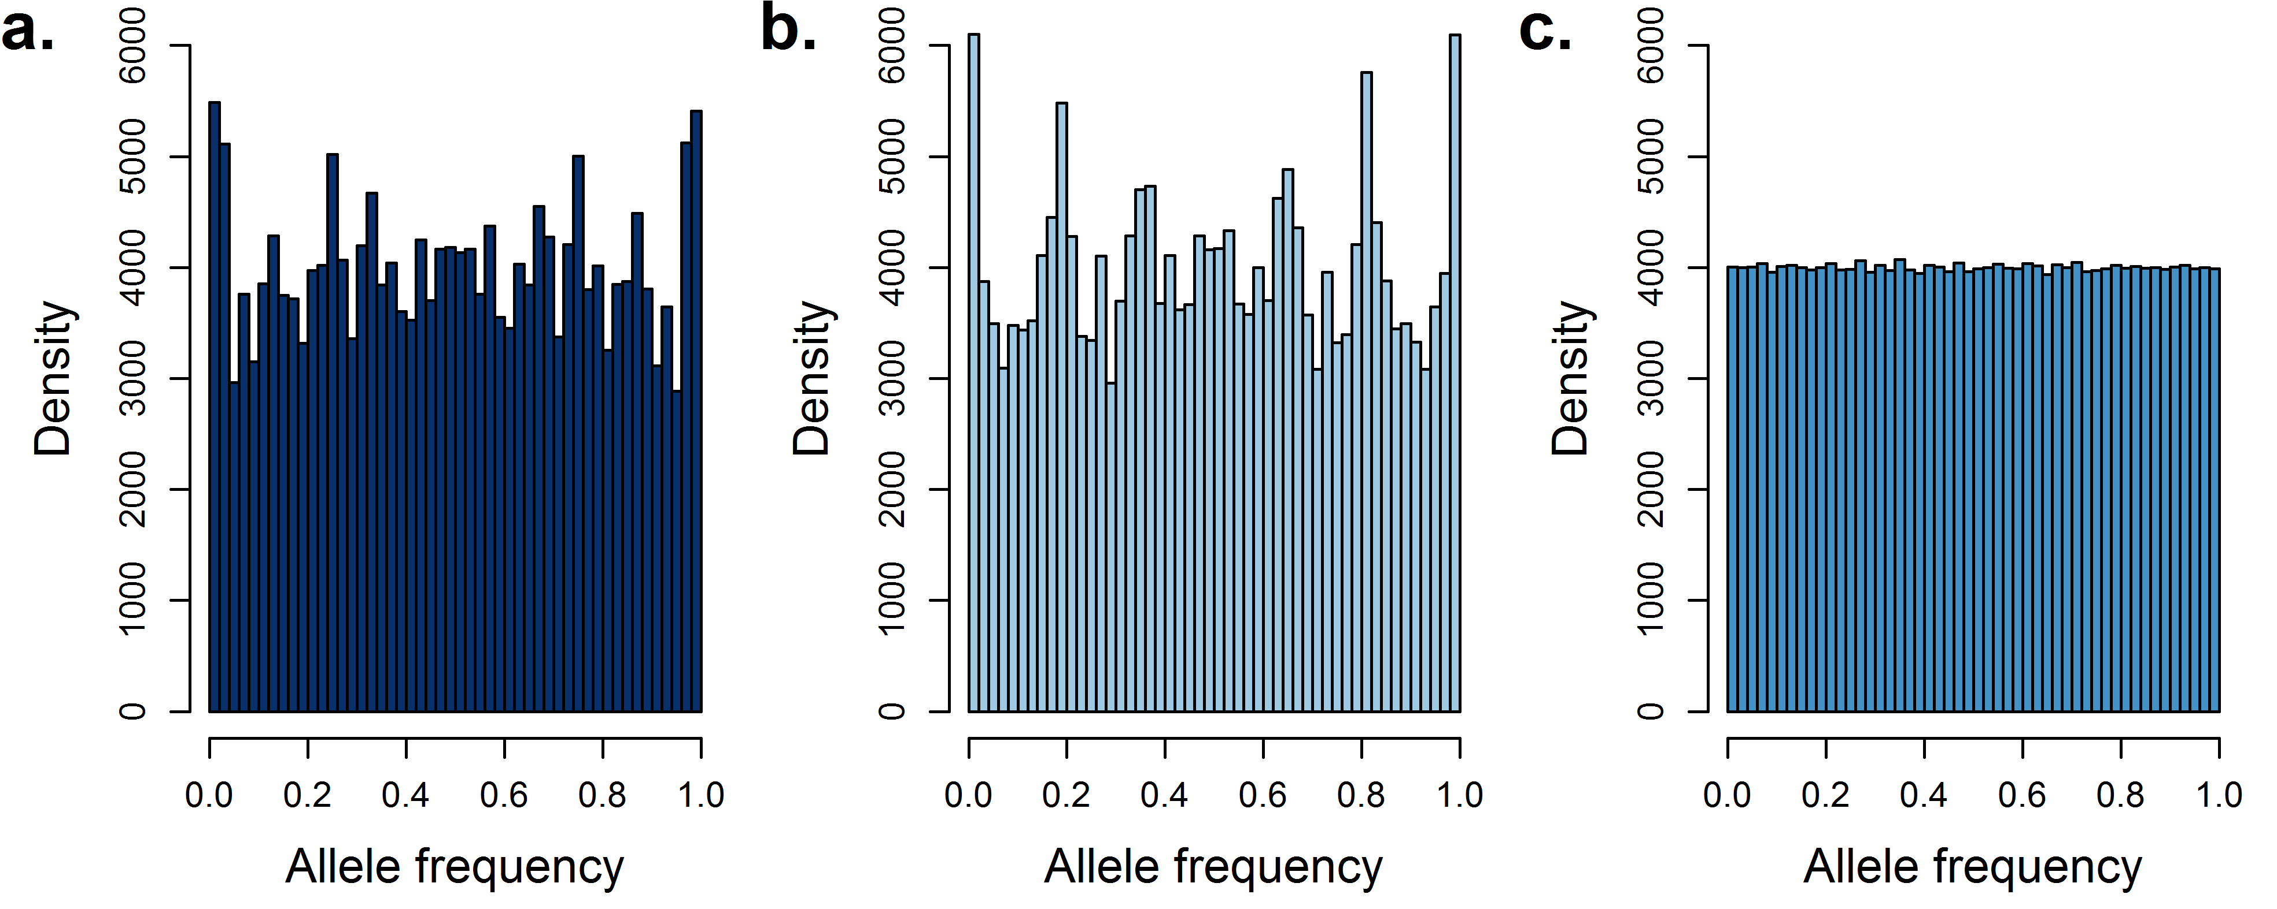
Figure S1.1 - Allele frequency distribution of HDP markers for both populations.
Distribution of allele frequencies of selected markers of the HDP scenario for (a.) population A, (b.) population B, and (c.) the average of both populations for one of the replicates.
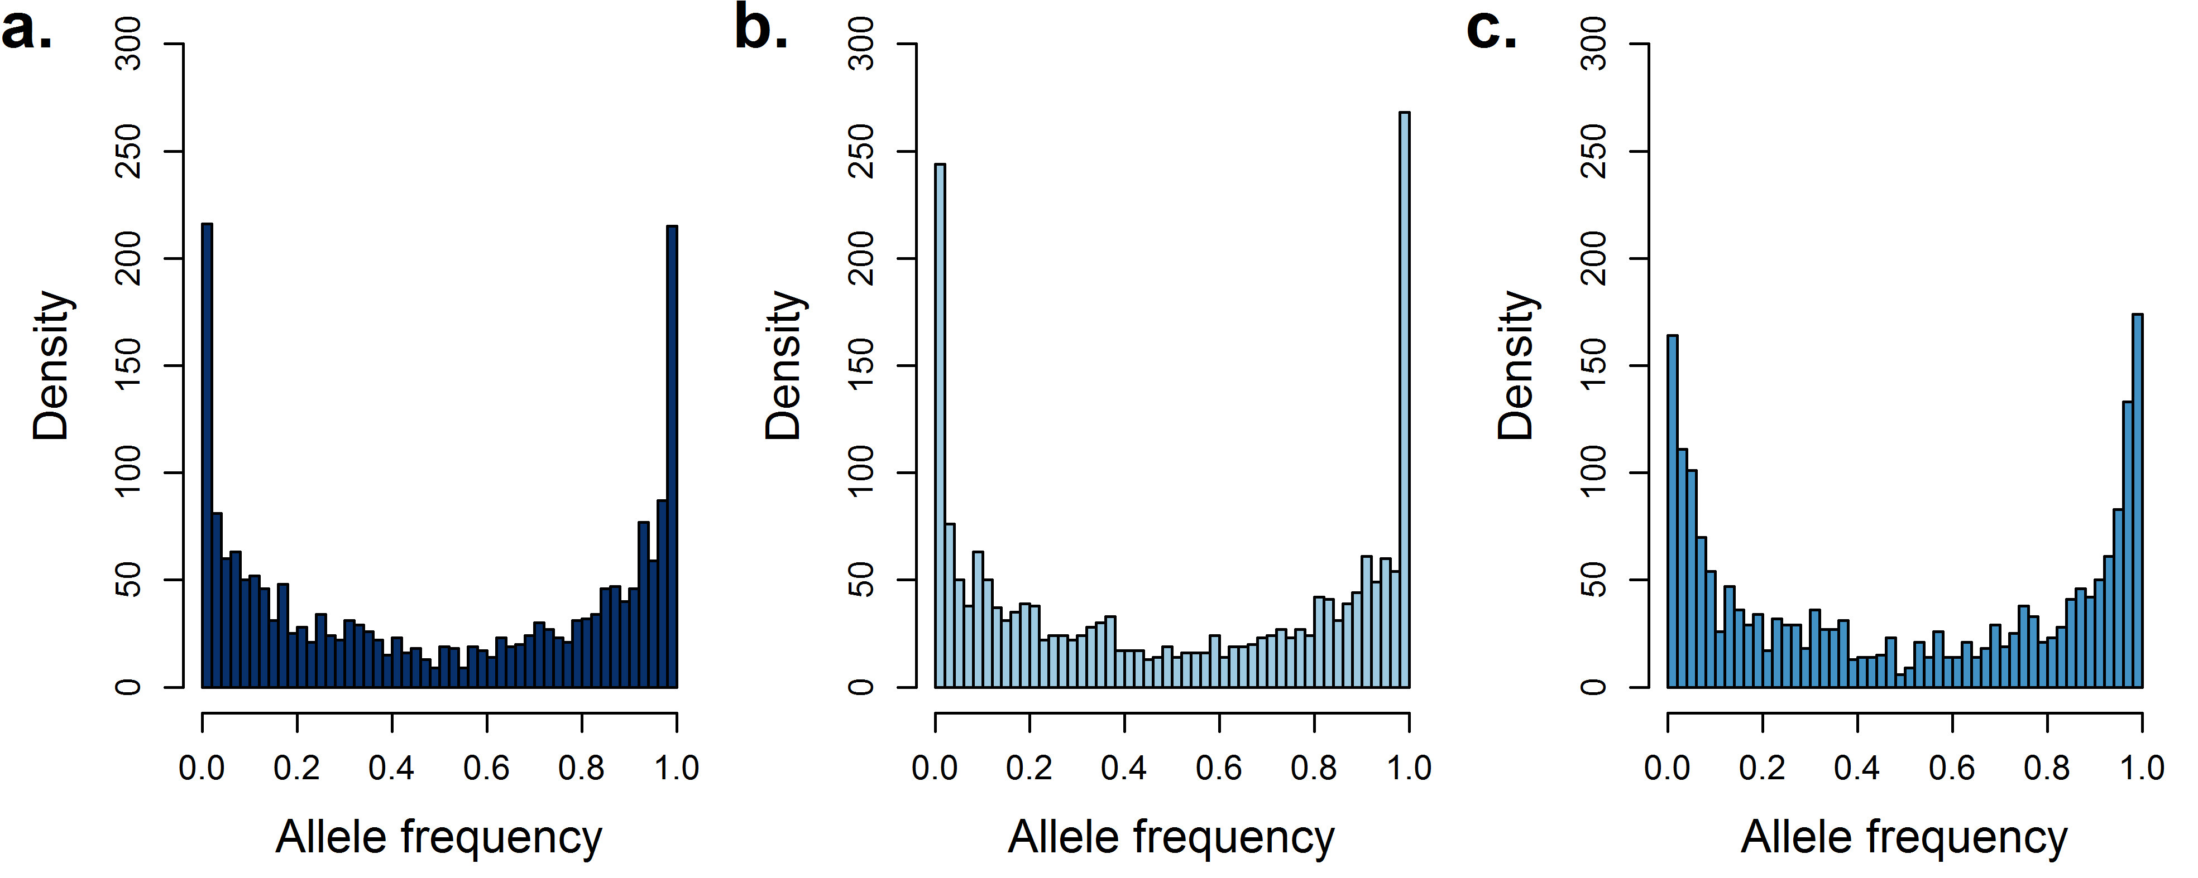
Figure S1.2 - Allele frequency distribution of causal loci for both populations.
Distribution of allele frequencies of selected causal loci for (a.) population A, (b.) population B, and (c.) the average of both populations for one of the replicates.

