Figure S4. Plots of the biological networks most significantly enriched by the most informative genes for RFI classification in liver (A and B) and duodenum tissues (C and D): (A) Carbohydrate Metabolism, Cellular Growth and Proliferation, Organismal Development; (B) Cell Morphology, Cellular Assembly and Organization, Cellular Development; (C) Cell Death and Survival, Connective Tissue Development and Function, Skeletal and Muscular System Development and Function; (D) Cell-To-Cell Signaling and Interaction, Inflammatory Response, Cellular Assembly and Organization. The node color indicates the degree of expression: (red) up-regulated and (green) down-regulated in the Low RFI group relative to the High RFI group. The shape of nodes indicates the functional classes of the gene products.
A
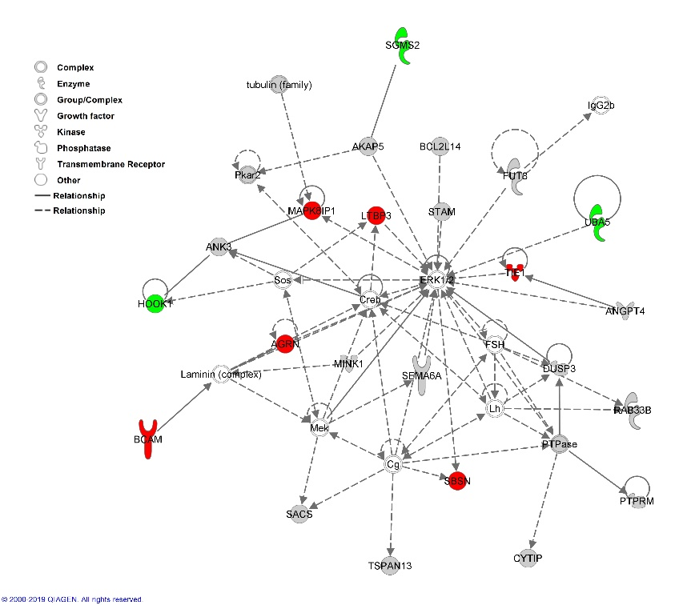
B

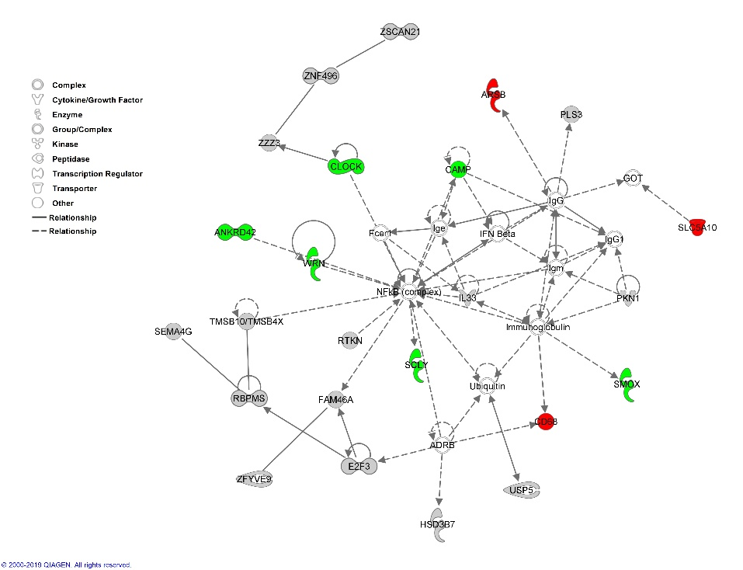

C

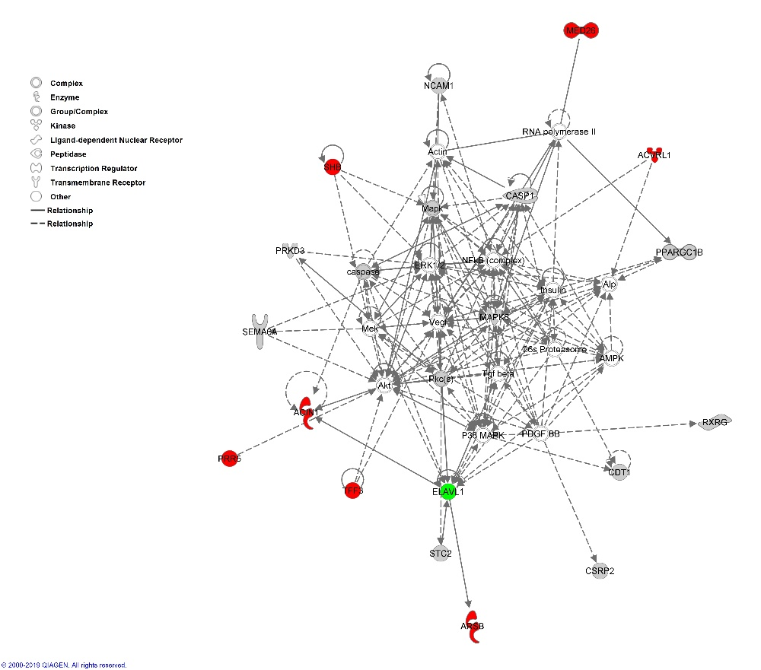

D

