Additional file 2: Figures S1-S3
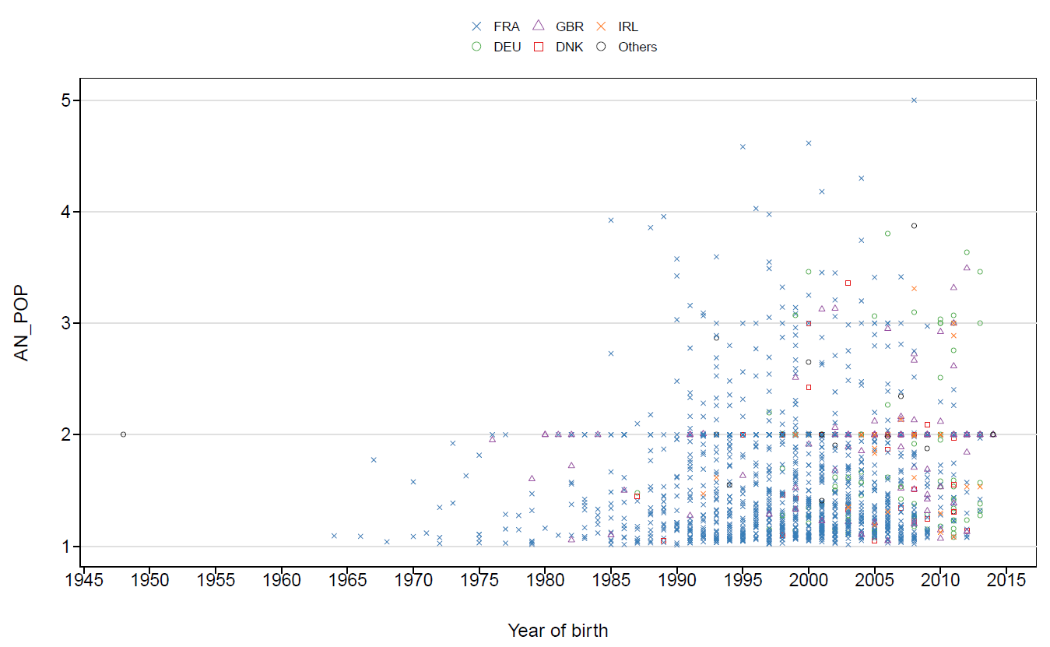
Figure S1. Adjusted Number of Populations (AN_POP) for all common bulls in function of their year of birth and country of first registration. DEU = Germany, DNK = Denmark, FRA = France, GBR = Great Britain, IRL = Ireland.
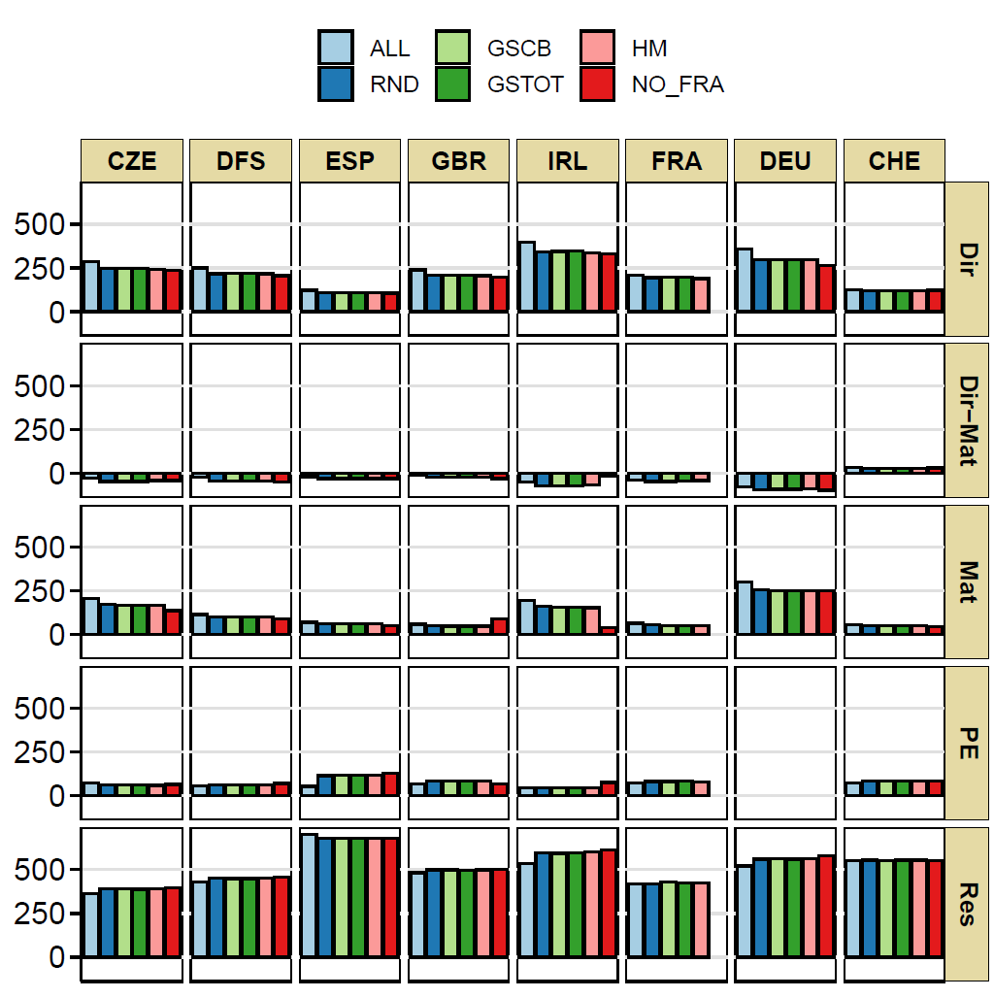
Figure S2. Estimated (co)variance components per population across different scenarios. ALL = all data, RND = herds selected randomly, GSCB = herds selected based on genetic similarity considering common bulls, GSTOT = herds selected based on genetic similarity considering common bulls and common maternal grandsires, HM = herds selected based on harmonic mean of sire’s progeny size, NO_FRA = FRA population not included in the analysis, CZE = Czech Republic, DFS = Denmark, Finland and Sweden, ESP = Spain, GBR = Great Britain, IRL = Ireland, FRA = France, DEU = Germany, CHE = Switzerland, Dir = direct genetic variance, Mat = maternal genetic variance, Dir-Mat = direct-maternal genetic covariance, PE = maternal permanent environmental variance, Res = residual variance.
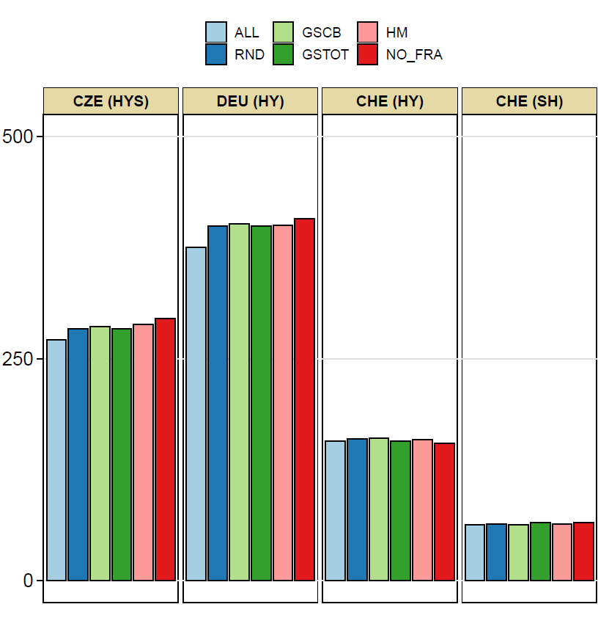
Figure S3. Estimated random contemporary group and sire by herd interaction variances across different scenarios. ALL = all data, RND = herds selected randomly, GSCB = herds selected based on genetic similarity considering common bulls, GSTOT = herds selected based on genetic similarity considering common bulls and common maternal grandsires, HM = herds selected based on harmonic mean of sire’s progeny size, NO_FRA = FRA population not included in the analysis, CHE = Switzerland, CZE = Czech Republic, DEU = Germany, HYS = Herd-Year-Season, HY = Herd-Year, SH = Sire by Herd interaction.

