Additional file 5

Additional Figures S1 – S11
Traits | PNS | PD | DD | TD | HA | MA | TA | COL | MOT | MAS | CON | DEN | Inhibin | SC12 | SC18 | SC24 | PIC3 | DFI3 | HDS3 | PIC4 | DFI4 | HDS4 | LCB | MCB | HCB
PNS |  | -0.696 | -0.161 | -0.734 | -0.534 | -0.468 | -0.066 | 0.272 | 0.546 | 0.465 | 0.068 | 0.292 | -0.068 | 0.085 | 0.224 | 0.131 | 0.055 | -0.211 | 0.061 | 0.185 | -0.325 | 0.220 | 0.250 | -0.251 | -0.175
PD | -0.597 |  | -0.024 | 0.968 | 0.053 | -0.020 | -0.037 | -0.375 | -0.192 | -0.342 | -0.156 | -0.330 | 0.001 | -0.209 | -0.481 | -0.246 | 0.022 | 0.066 | -0.305 | -0.026 | 0.109 | -0.316 | -0.142 | 0.149 | 0.149
DD | -0.153 | 0.003 |  | 0.268 | -0.054 | -0.041 | -0.012 | -0.075 | 0.053 | -0.102 | -0.081 | -0.089 | 0.016 | -0.022 | -0.009 | -0.044 | 0.081 | -0.047 | -0.075 | 0.053 | -0.006 | -0.025 | 0.045 | -0.046 | -0.016
TD | -0.603 | 0.816 | 0.523 |  | 0.036 | -0.030 | -0.035 | -0.343 | -0.179 | -0.381 | -0.174 | -0.411 | 0.005 | -0.222 | -0.509 | -0.272 | 0.035 | 0.072 | -0.291 | -0.017 | 0.115 | -0.301 | -0.108 | 0.115 | 0.127
HA | -0.789 | 0.300 | -0.059 | 0.062 |  | 0.032 | -0.003 | 0.044 | -0.447 | -0.286 | 0.153 | 0.024 | 0.100 | 0.138 | 0.126 | 0.099 | -0.097 | 0.250 | -0.031 | -0.249 | 0.387 | -0.029 | -0.308 | 0.306 | 0.190
MA | -0.533 | 0.143 | -0.024 | 0.148 | -0.019 |  | 0.105 | -0.091 | -0.223 | -0.070 | -0.047 | -0.123 | 0.022 | -0.009 | -0.036 | -0.008 | -0.083 | 0.095 | 0.048 | -0.104 | 0.100 | -0.018 | -0.011 | 0.003 | -0.043
TA | -0.023 | -0.031 | -0.033 | -0.011 | -0.007 | -0.030 |  | -0.221 | 0.012 | 0.005 | -0.001 | -0.152 | 0.007 | -0.033 | 0.105 | 0.023 | 0.000 | -0.016 | 0.011 | 0.001 | -0.014 | 0.015 | 0.005 | -0.010 | -0.011
COL | 0.069 | -0.195 | -0.098 | -0.202 | 0.044 | -0.039 | 0.060 |  | 0.294 | 0.590 | 0.384 | 0.961 | 0.036 | 0.134 | 0.209 | 0.144 | -0.058 | -0.067 | 0.116 | 0.018 | -0.144 | 0.118 | 0.085 | -0.057 | -0.069
MOT | 0.358 | -0.216 | 0.023 | -0.189 | -0.321 | -0.116 | -0.012 | 0.417 |  | 0.738 | 0.016 | 0.306 | -0.001 | 0.059 | 0.124 | 0.130 | 0.261 | -0.300 | -0.149 | 0.351 | -0.367 | -0.137 | 0.240 | -0.237 | -0.103
MAS | 0.305 | -0.231 | -0.026 | -0.174 | -0.371 | 0.026 | 0.069 | 0.629 | 0.690 |  | 0.233 | 0.632 | 0.040 | 0.142 | 0.212 | 0.168 | 0.090 | -0.246 | 0.014 | 0.184 | -0.305 | 0.020 | 0.183 | -0.168 | -0.217
CON | 0.050 | -0.123 | -0.115 | -0.172 | 0.050 | -0.009 | -0.038 | 0.270 | 0.119 | 0.259 |  | 0.424 | 0.102 | 0.184 | 0.201 | 0.172 | -0.018 | -0.040 | 0.048 | 0.017 | -0.069 | 0.045 | -0.032 | 0.055 | 0.000
DEN | 0.065 | -0.134 | -0.148 | -0.194 | 0.036 | -0.040 | 0.006 | 0.894 | 0.435 | 0.663 | 0.333 |  | 0.056 | 0.137 | 0.213 | 0.156 | -0.100 | -0.036 | 0.150 | -0.028 | -0.111 | 0.152 | 0.066 | -0.038 | -0.071
Inhibin | -0.202 | 0.073 | -0.144 | -0.041 | 0.149 | 0.176 | -0.126 | -0.171 | -0.032 | -0.108 | -0.011 | -0.092 |  | 0.228 | 0.231 | 0.276 | 0.014 | 0.043 | -0.048 | -0.005 | 0.053 | -0.046 | -0.031 | 0.041 | 0.026
SC12 | 0.247 | -0.271 | -0.063 | -0.223 | -0.211 | -0.006 | 0.098 | 0.089 | 0.109 | 0.150 | 0.153 | 0.093 | 0.038 |  | 0.891 | 0.663 | -0.062 | 0.004 | -0.035 | 0.003 | 0.026 | -0.022 | -0.042 | 0.046 | -0.051
SC18 | 0.178 | -0.292 | -0.061 | -0.242 | -0.103 | 0.004 | 0.095 | 0.160 | 0.117 | 0.164 | 0.133 | 0.151 | 0.113 | 0.885 |  | 0.846 | -0.095 | 0.003 | -0.016 | -0.017 | 0.041 | -0.010 | -0.084 | 0.092 | -0.008
SC24 | 0.125 | -0.164 | -0.022 | -0.147 | -0.083 | 0.004 | 0.034 | 0.132 | 0.079 | 0.122 | 0.090 | 0.095 | 0.119 | 0.794 | 0.915 |  | 0.033 | -0.038 | -0.021 | -0.092 | -0.015 | -0.018 | -0.099 | 0.116 | 0.008
PIC3 | 0.266 | -0.122 | -0.059 | -0.143 | -0.252 | -0.050 | 0.066 | 0.054 | 0.174 | 0.166 | 0.054 | 0.019 | -0.026 | -0.068 | -0.053 | -0.048 |  | -0.657 | -0.880 | 0.896 | -0.435 | -0.868 | 0.193 | -0.153 | -0.141
DFI3 | -0.324 | 0.198 | 0.096 | 0.221 | 0.294 | 0.031 | 0.075 | -0.110 | -0.206 | -0.191 | -0.212 | -0.089 | 0.051 | -0.113 | -0.052 | 0.089 | -0.828 |  | 0.306 | -0.711 | 0.818 | 0.273 | -0.311 | 0.302 | 0.301
HDS3 | -0.069 | -0.028 | -0.012 | -0.018 | 0.082 | 0.048 | -0.061 | 0.038 | -0.120 | -0.059 | 0.159 | 0.073 | -0.016 | 0.129 | 0.190 | 0.128 | -0.746 | 0.123 |  | -0.726 | 0.048 | 0.998 | -0.054 | 0.008 | -0.009
PIC4 | 0.284 | -0.155 | -0.066 | -0.161 | -0.272 | -0.024 | 0.054 | 0.099 | 0.180 | 0.208 | 0.103 | 0.077 | -0.072 | 0.086 | 0.028 | 0.012 | 0.676 | -0.784 | -0.393 |  | -0.718 | -0.715 | 0.308 | -0.271 | -0.210
DFI4 | -0.272 | 0.177 | 0.078 | 0.180 | 0.255 | 0.006 | -0.035 | -0.122 | -0.230 | -0.201 | -0.171 | -0.111 | 0.083 | -0.141 | -0.086 | -0.045 | -0.548 | 0.713 | 0.046 | -0.937 |  | 0.029 | -0.395 | 0.389 | 0.317
HDS4 | -0.072 | -0.026 | -0.015 | -0.017 | 0.086 | 0.050 | -0.061 | 0.038 | -0.123 | -0.062 | 0.159 | 0.073 | -0.015 | 0.129 | 0.180 | 0.119 | -0.740 | 0.119 | 0.999 | -0.385 | 0.036 |  | -0.046 | -0.002 | -0.027
LCB | 0.298 | -0.167 | -0.054 | -0.149 | 0.051 | -0.060 | 0.067 | 0.094 | 0.171 | 0.225 | 0.183 | 0.080 | -0.059 | 0.031 | 0.035 | 0.052 | 0.419 | -0.493 | -0.204 | 0.483 | -0.507 | -0.202 |  | -0.981 | -0.746
MCB | -0.290 | 0.168 | 0.054 | 0.150 | 0.253 | 0.061 | -0.067 | -0.094 | -0.291 | -0.222 | -0.182 | -0.081 | 0.062 | 0.005 | -0.034 | -0.049 | -0.455 | 0.412 | 0.203 | -0.536 | 0.404 | 0.201 | -0.999 |  | 0.785
HCB | -0.242 | 0.096 | 0.034 | -0.019 | 0.256 | -0.030 | -0.007 | -0.088 | -0.273 | -0.242 | -0.226 | -0.099 | 0.026 | -0.069 | -0.051 | -0.032 | -0.420 | 0.426 | 0.145 | -0.469 | 0.387 | 0.149 | -0.813 | 0.752
Fig S1. Genetic correlations for 25 bull-fertility phenotypes in Brahman (above diagonal) and Tropical Composites (below diagonal). Negative genetic correlations are presented in red, while positive ones are presented in blue. Darker shades of red or blue correspond to more extreme correlations (closer to 1 or –1), while pastel shades correspond to lower genetic correlations. The numerical values represented herein are the underpining values for Fig 1 in the main text. Abbreviations are described in the main text (see Table 1).
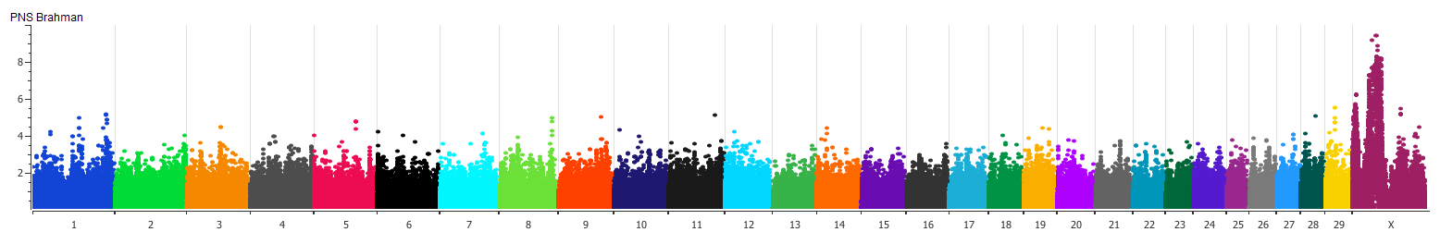
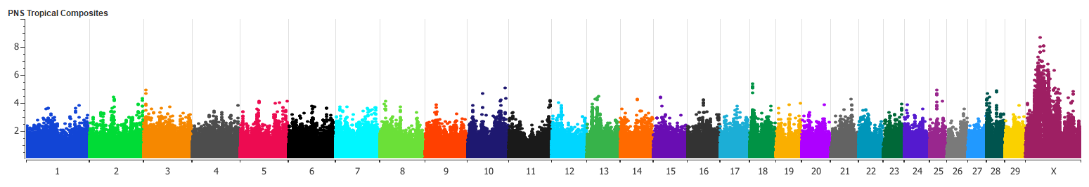
Fig S2. Manhattan plot for the analyses in each of the two breeds: SNP associations for the percentage of normal sperm (PNS). Despite breed differences, it is possible to observe that SNP in the X chromosome seem important for PNS in both breeds.
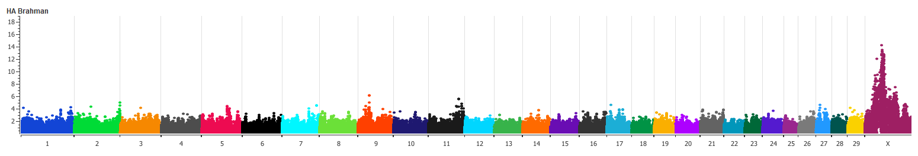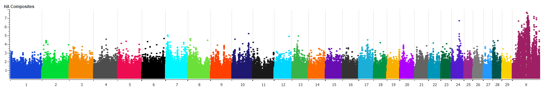
Fig S3. Manhattan plot for the analyses in each of the two breeds: SNP associations for the percentage of sperm with head abnormalities (HA). The QTL for HA was defined because of the highly significant SNP associations in that breed. Still, this QTL might be relevant to Tropical Composites as well, since SNP associations can be seen in that breed too.

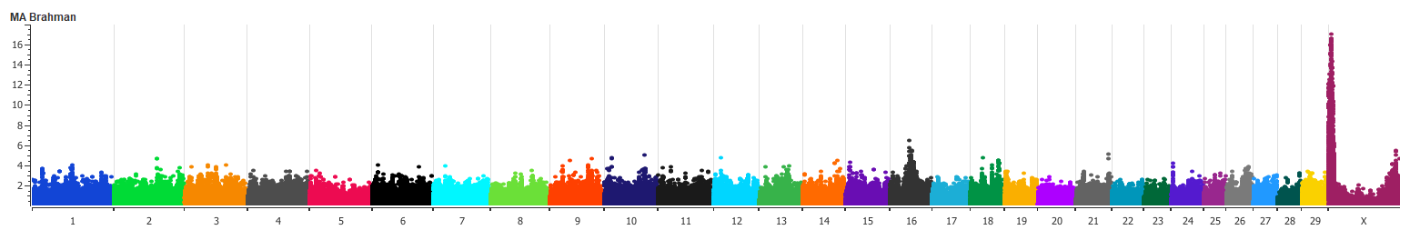
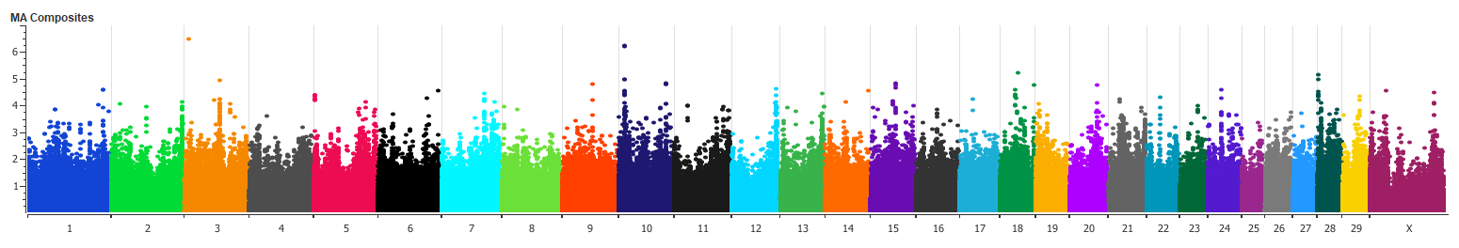
Fig S4. Manhattan plot for the analyses in each of the two breeds: SNP associations for the percentage of sperm with mid-piece abnormalities (MA). Note that the association peak in chrosome X occurred only in Brahman, with not even suggestive associations for the Tropical Composite GWAS. These results were also shown in the main text, as an example of breed specific QTL.
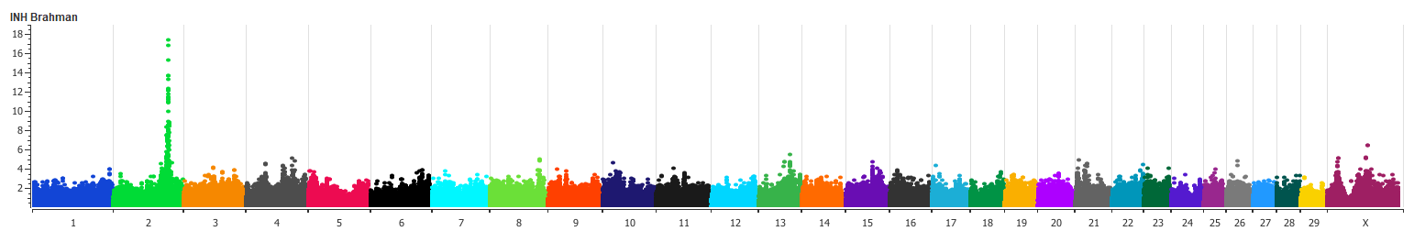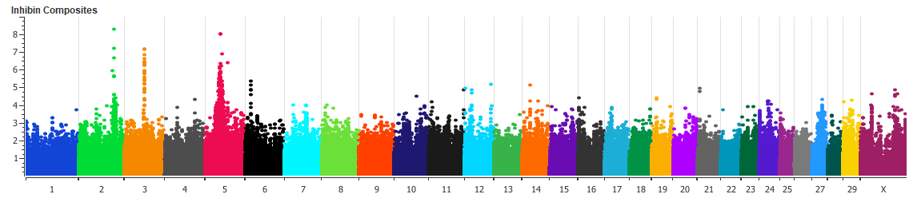
Fig S5. Manhattan plot for the analyses in each of the two breeds: SNP associations for Inhibin hormone levels (INH). Note that the SNP associations in chromosome 2 appear in both breeds, while associations in chromosome 3 and 5 only occurred in Tropical Composites.
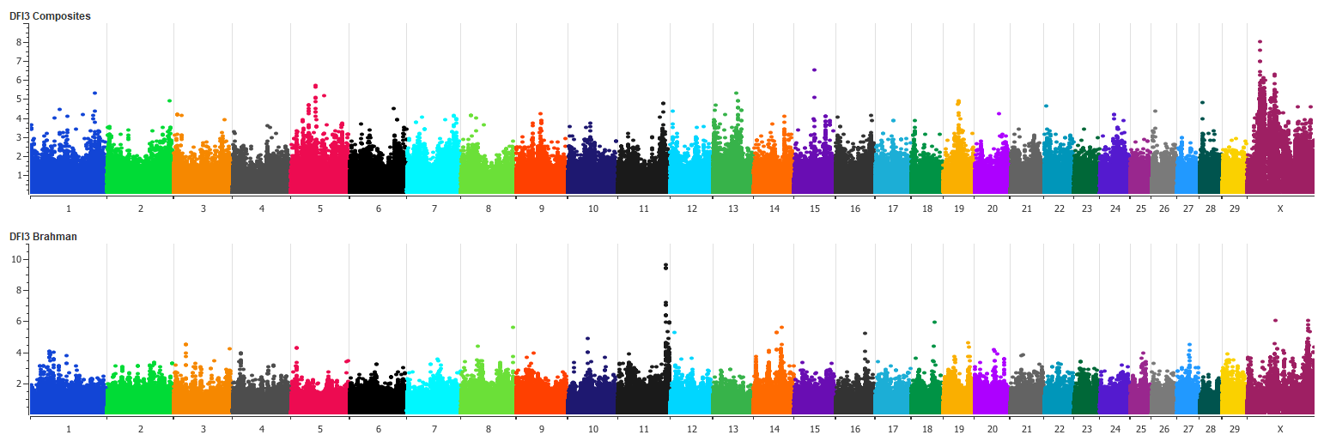
Fig S6. Manhattan plot for the analyses in each of the two breeds: SNP associations for the DNA fragmentation index (DFI3). Note that the association peak in chromosome 11 is only present in the Brahman analyses.
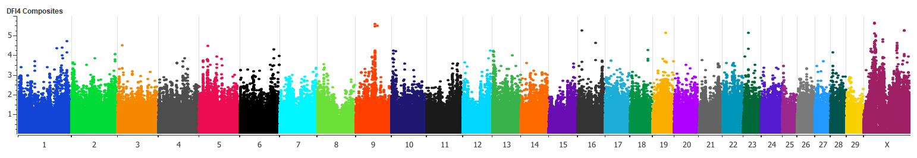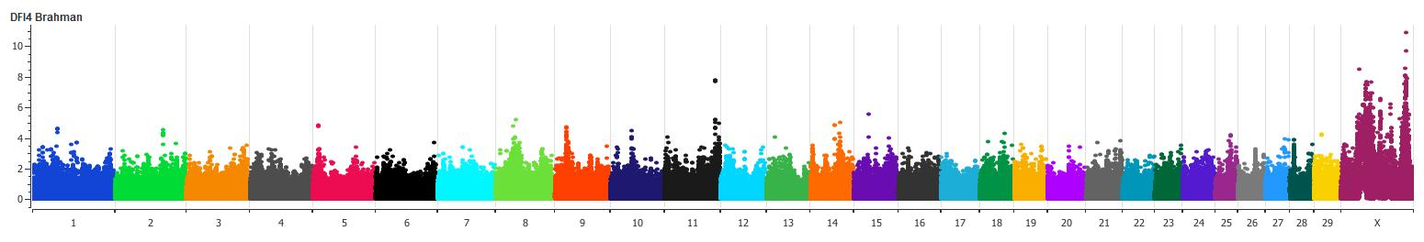
Fig S7. Manhattan plot for the analyses in each of the two breeds: SNP associations for the DNA fragmentation index measured with an alternative cytometry method (DFI4, see methods for phenotype details).
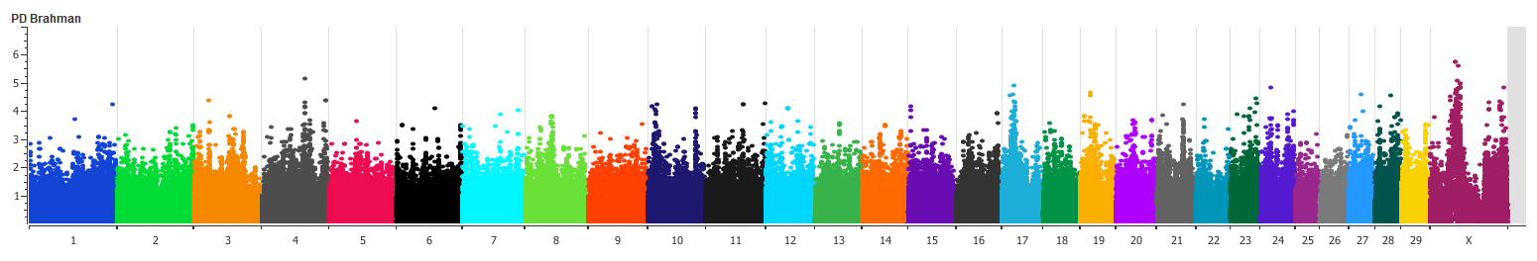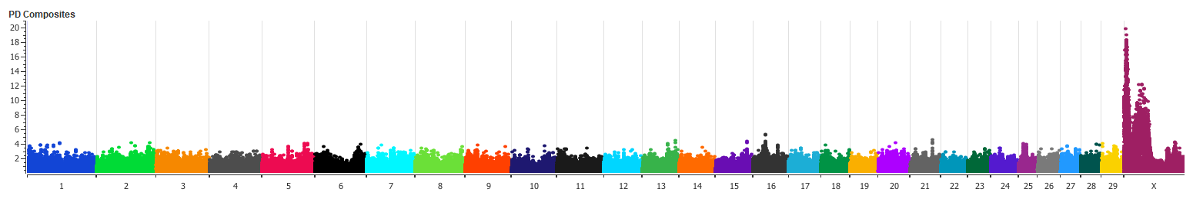
Fig S8. Manhattan plot for the analyses in each of the two breeds: SNP associations for the percentage of sperm with proximal droplets (PD). Note that the significant associations accumulate in the X chromsome and that there is evidence for more than one PD QTL in Tropical Composites. These PD associations seems to be breed specific, althought they overlap with the MA and the HA QTLs proposed from the Brahman results (Fig S3 and S4).
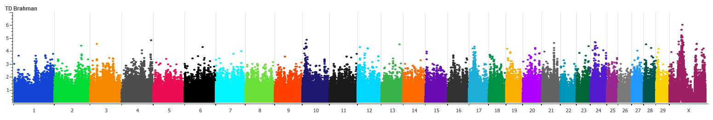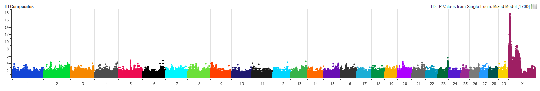
Fig S9. Manhattan plot for the analyses in each of the two breeds: SNP associations for the percentage of sperm with total droplets (TD). The total droplets SNP associations seem specific to Tropical Composites.

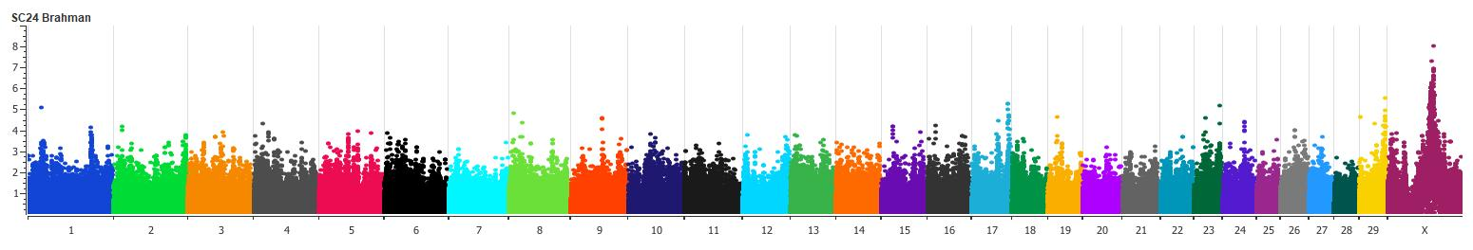
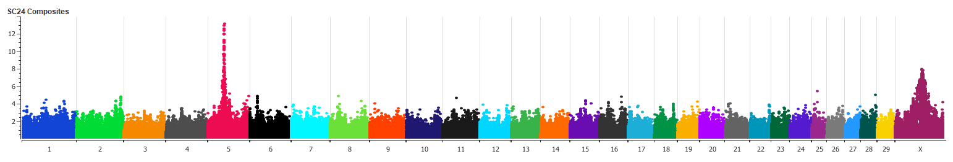
Fig S10. Manhattan plot for the analyses in each of the two breeds: SNP associations for scrotal circunference measured at approx 24 months of age (SC24). The significant associations observed in chromsome 5 led to proposing a QTL that is specific to Tropical Composites. SNP associations observed in both breeds suggest that the X chromosome could be important for scrotal circunference too.
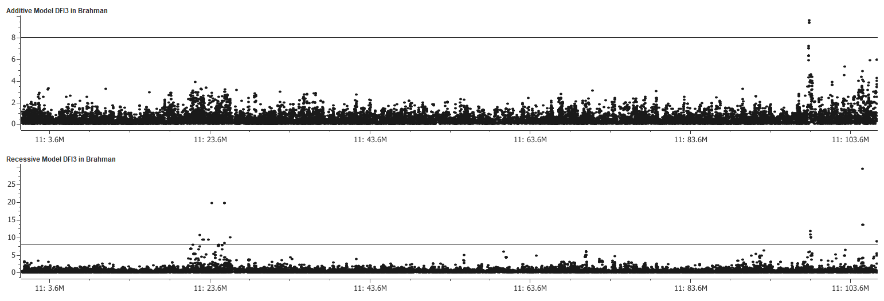
Fig S11. Manhattan plot for the additive (top) model and the recessive (bottom) model: SNP associations in chromsome 11 for DNA fragmentation index (DFI3) in Brahman.

