Additional file 3
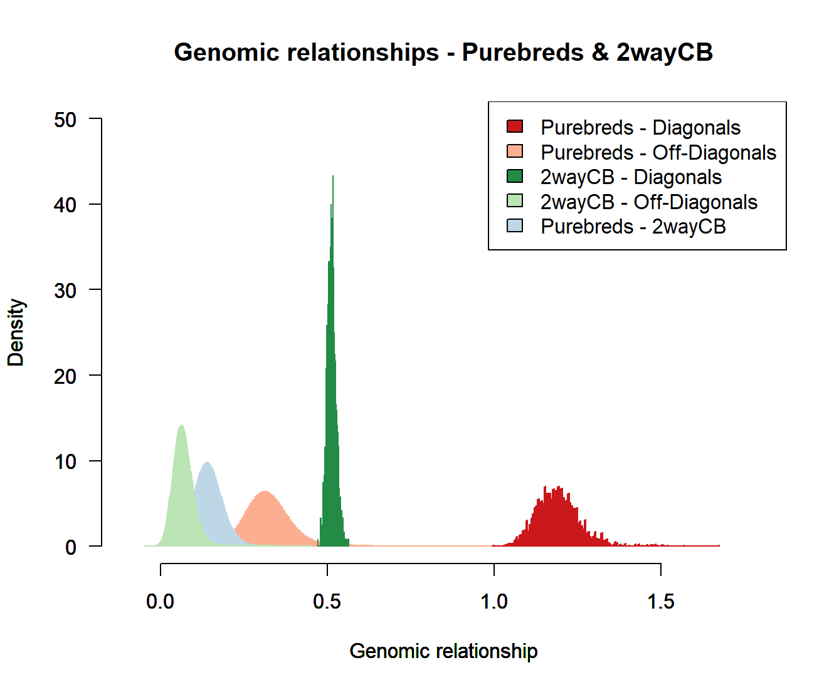
Figure S3.1 – Histogram of relationship in partial relationship matrix with two-way crossbreds.

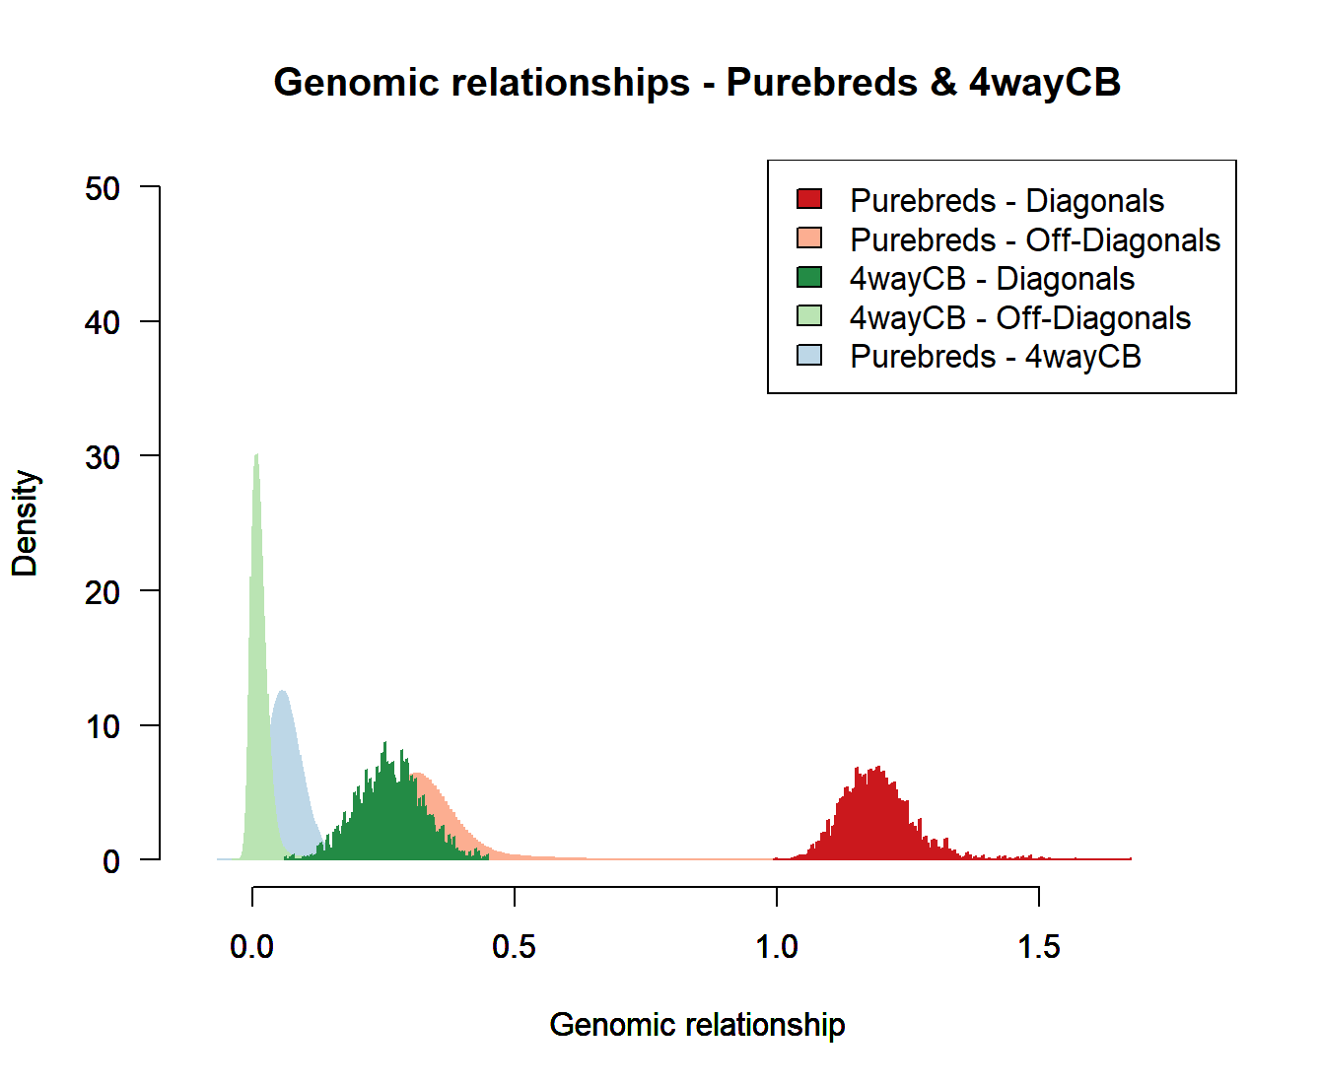
Figure S3.2 – Histogram of relationship in partial relationship matrix with four-way crossbreds.

