Fig. S1:

RFI divergence between female and male R+ and R- chickens over 40 generations
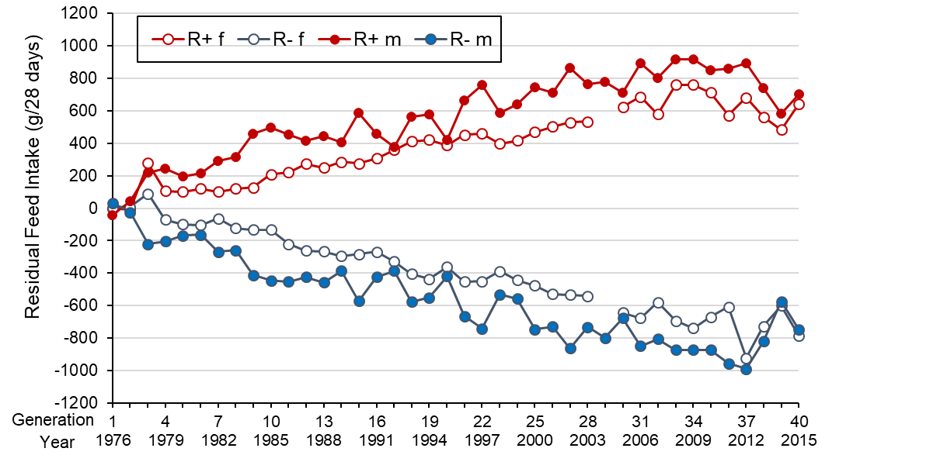
The R+ line is represented in red and the R- line in blue. Each dot is the value of residual feed intake (RFI) estimated for males and females at each generation of selection. R+ f = females from the R+ line; R- f = females from the R- line; R+ m = males from the R+ line; R- m = males from the R- line

