A comprehensive genome-wide scan detects genomic regions related to local adaptation and climate resilience in Mediterranean domestic sheep
Valentina Tsartsianidou^{1*}, Enrique Sánchez-Molano², Vanessa Varvara Kapsona³, Zoitsa Basdagianni⁴, Dimitrios Chatziplis⁵, Georgios Arsenos⁶, Alexandros Triantafyllidis¹ & Georgios Banos^{3,6}
¹ Department of Genetics, Development & Molecular Biology, School of Biology, Aristotle University of Thessaloniki, 54124 Thessaloniki, Greece
² Division of Genetics and Genomics, The Roslin Institute and Royal (Dick) School of Veterinary Studies, University of Edinburgh, Easter Bush, Midlothian EH25 9RG, UK
³ Department of Animal and Veterinary Sciences, Scotland’s Rural College, Roslin Institute Building, Easter Bush, Midlothian EH25 9RG, UK
⁴ Department of Animal Production, School of Agriculture, Aristotle University of Thessaloniki, 54124 Thessaloniki, Greece
⁵ Laboratory of Agrobiotechnology and Inspection of Agricultural Products, Department of Agriculture, International Hellenic University, Alexander Campus, 57400 Sindos, Greece
⁶ Laboratory of Animal Husbandry, School of Veterinary Medicine, Aristotle University of Thessaloniki, 54124 Thessaloniki, Greece

Corresponding author: Valentina Tsartsianidou. ¹ Department of Genetics, Development & Molecular Biology, School of Biology, Aristotle University of Thessaloniki, 54124 Thessaloniki, Greece. Phone: +306951626615. Email: tsarvale@bio.auth.gr
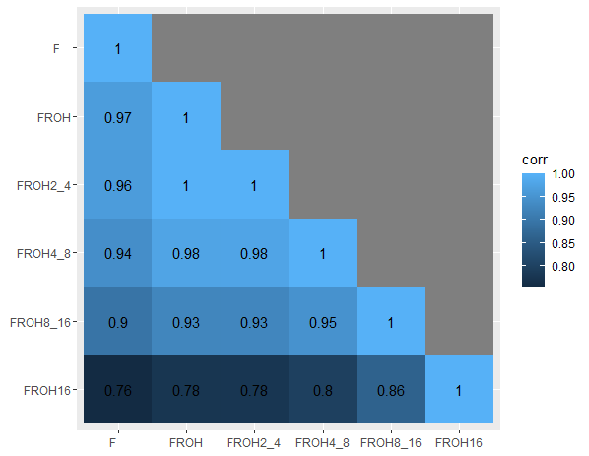
Additional File 1: Figure S1: Correlation heatmap between different measures of inbreeding coefficient.

The respective coefficients are the SNP-based genomic inbreeding (F), the whole-genome ROH-based inbreeding (F_{ROH}), and the F_{ROH} by the respective size classes (ROH segment length) 2–4 Mb (FROH2_4), 4–8 Mb (FROH4_8), 8–16 Mb (FROH8_16), >16 Mb (FROH16).

