A comprehensive genome-wide scan detects genomic regions related to local adaptation and climate resilience in Mediterranean domestic sheep
Valentina Tsartsianidou^{1*}, Enrique Sánchez-Molano², Vanessa Varvara Kapsona³, Zoitsa Basdagianni⁴, Dimitrios Chatziplis⁵, Georgios Arsenos⁶, Alexandros Triantafyllidis¹ & Georgios Banos^{3,6}
¹ Department of Genetics, Development & Molecular Biology, School of Biology, Aristotle University of Thessaloniki, 54124 Thessaloniki, Greece
² Division of Genetics and Genomics, The Roslin Institute and Royal (Dick) School of Veterinary Studies, University of Edinburgh, Easter Bush, Midlothian EH25 9RG, UK
³ Department of Animal and Veterinary Sciences, Scotland’s Rural College, Roslin Institute Building, Easter Bush, Midlothian EH25 9RG, UK
⁴ Department of Animal Production, School of Agriculture, Aristotle University of Thessaloniki, 54124 Thessaloniki, Greece
⁵ Laboratory of Agrobiotechnology and Inspection of Agricultural Products, Department of Agriculture, International Hellenic University, Alexander Campus, 57400 Sindos, Greece
⁶ Laboratory of Animal Husbandry, School of Veterinary Medicine, Aristotle University of Thessaloniki, 54124 Thessaloniki, Greece

Corresponding author: Valentina Tsartsianidou. ¹ Department of Genetics, Development & Molecular Biology, School of Biology, Aristotle University of Thessaloniki, 54124 Thessaloniki, Greece. Phone: +306951626615. Email: tsarvale@bio.auth.gr
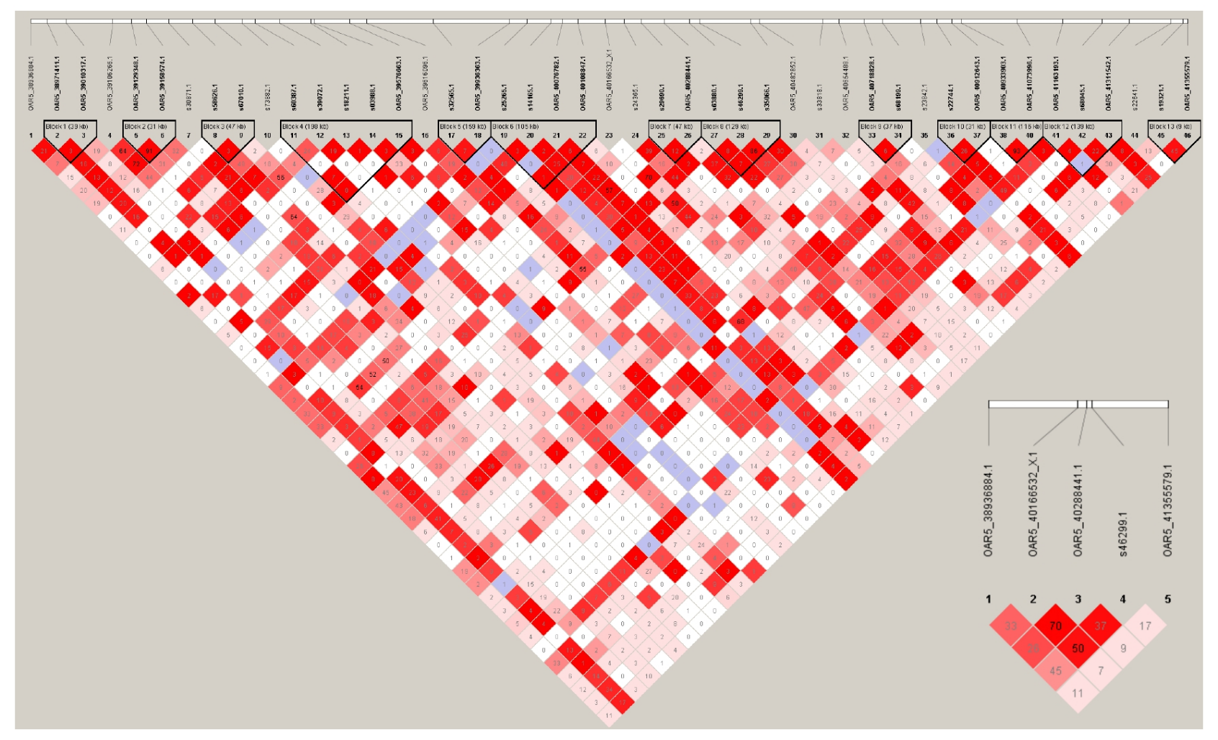
Additional File 6: Figure S4: Linkage disequilibrium (r2) heatmap of chromosome 5 region associated with Chios sheep resilience to hot weather conditions.
This region is extending between the furthest SNP markers above the genome-wide and suggestive significance thresholds spanning a region of 2.41 Mb for animal resilience to temperature change in hot weather. The pairwise LD between these two SNP markers is illustrated at the bottom right part.

