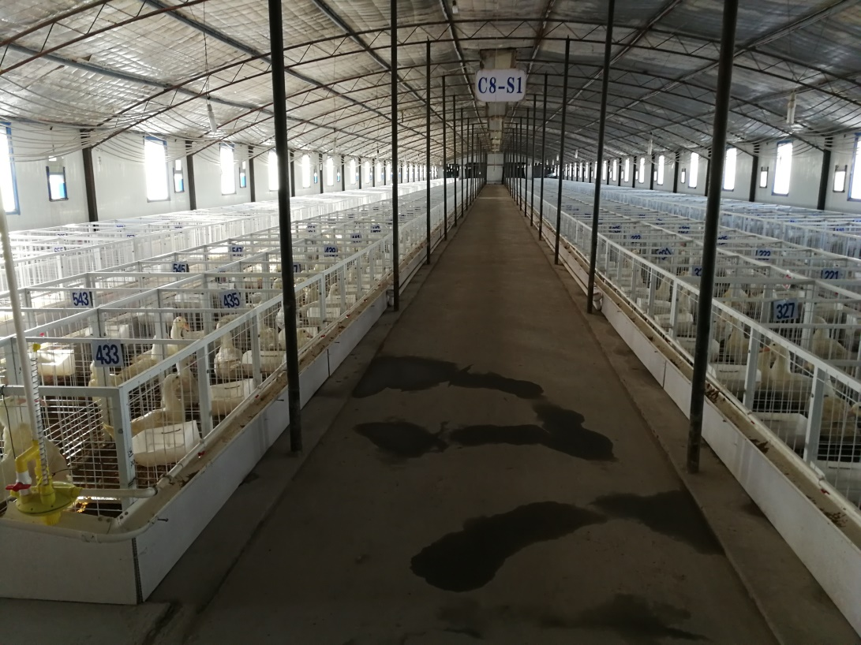
Fig.S1 The individual cage used for duck. The area of cage is set up with 1m by 1m.

