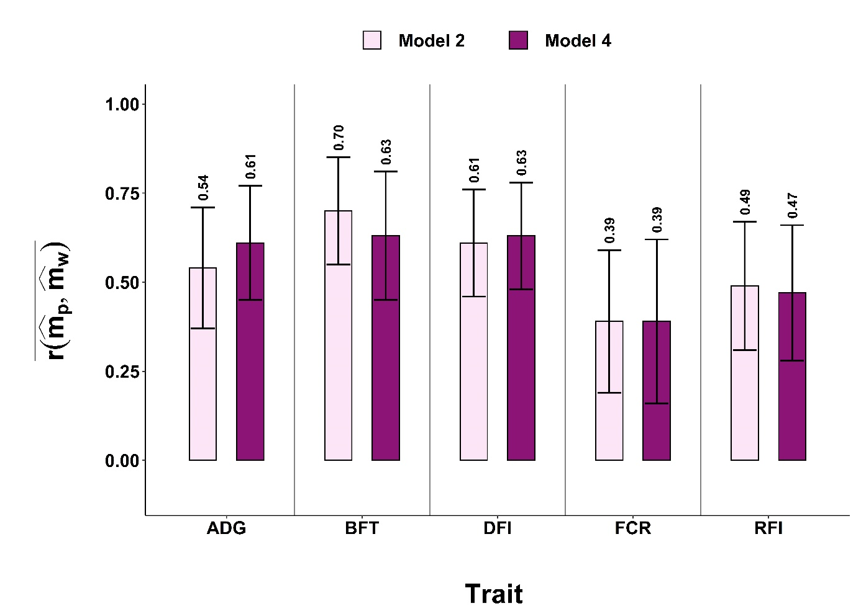
Figure S1. Average correlations between ${\hat{m}}_{p}$ ($\hat{m}$ using a partial dataset) and ${\hat{m}}_{w}$ ($\hat{m}$ using the whole dataset) for the CG design, and their SD as error bars
ADG average daily gain, BFT backfat thickness, DFI daily feed intake, FCR feed conversion ratio, RFI residual feed intake, EMV estimated microbiota values

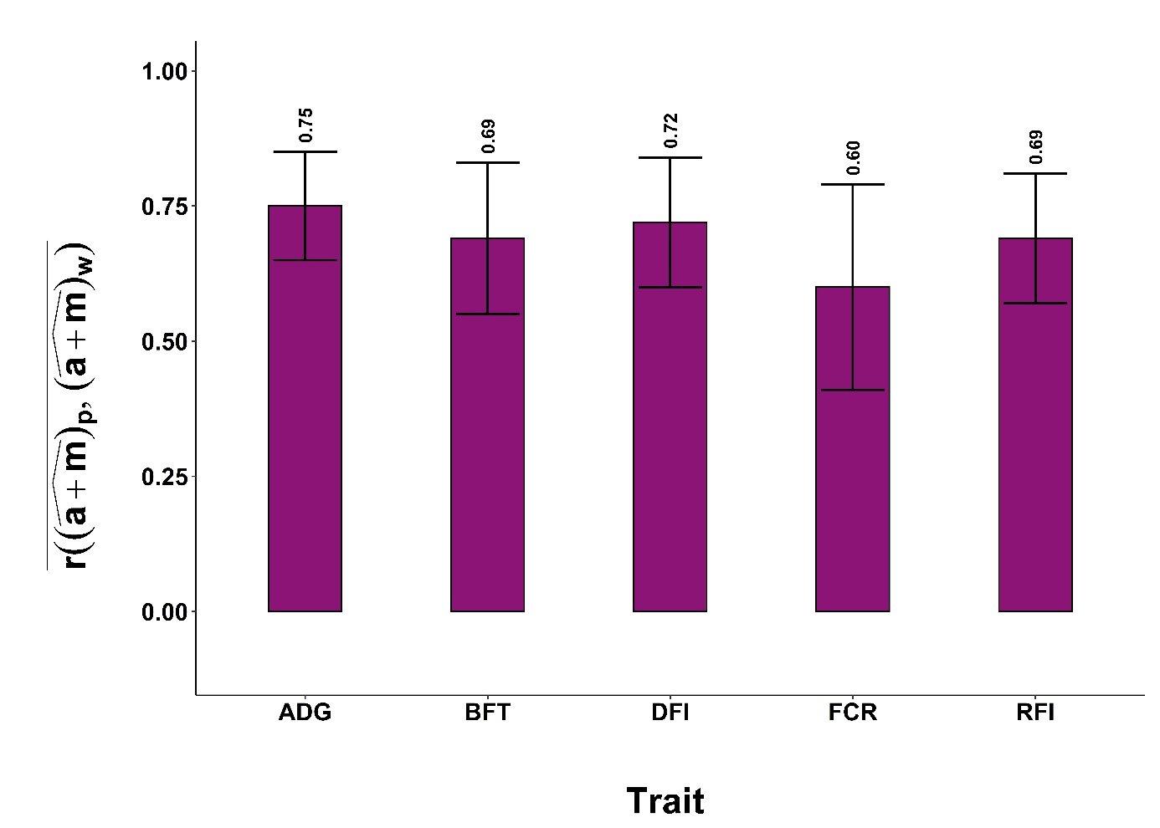
Figure S2. Average correlations between ${(\hat{a+m})}_{p}$ and ${(\hat{a+m})}_{w}$ for CG designs, and their SD as error bars
ADG average daily gain, BFT backfat thickness, DFI daily feed intake, FCR feed conversion ratio, RFI residual feed intake

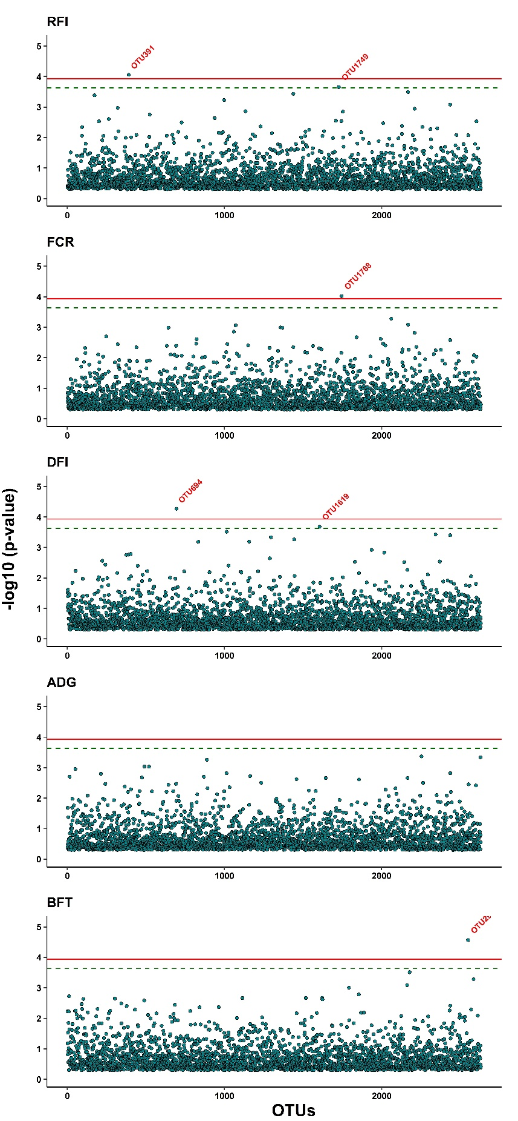
Figure S3. Results of microbiome wide association analyses using back solving of BLUP solutions between operational taxonomic units and residual feed intake (RFI), feed conversion ratio (FCR), daily feed intake (DFI), average daily gain (ADG) and back fat thickness (BFT). In the plots, the solid and dashed lines represent significance and suggestive significance at 5% and 10% family-wise type I error rates, respectively.

