Additional file 3
Figure S1 Plot of pedigree-based (x-axis) and genomic-based (y-axis) relationships between genotyped animals. The red dots indicate the relationships of the 41 genotypes removed due to pedigree incompatibilities.

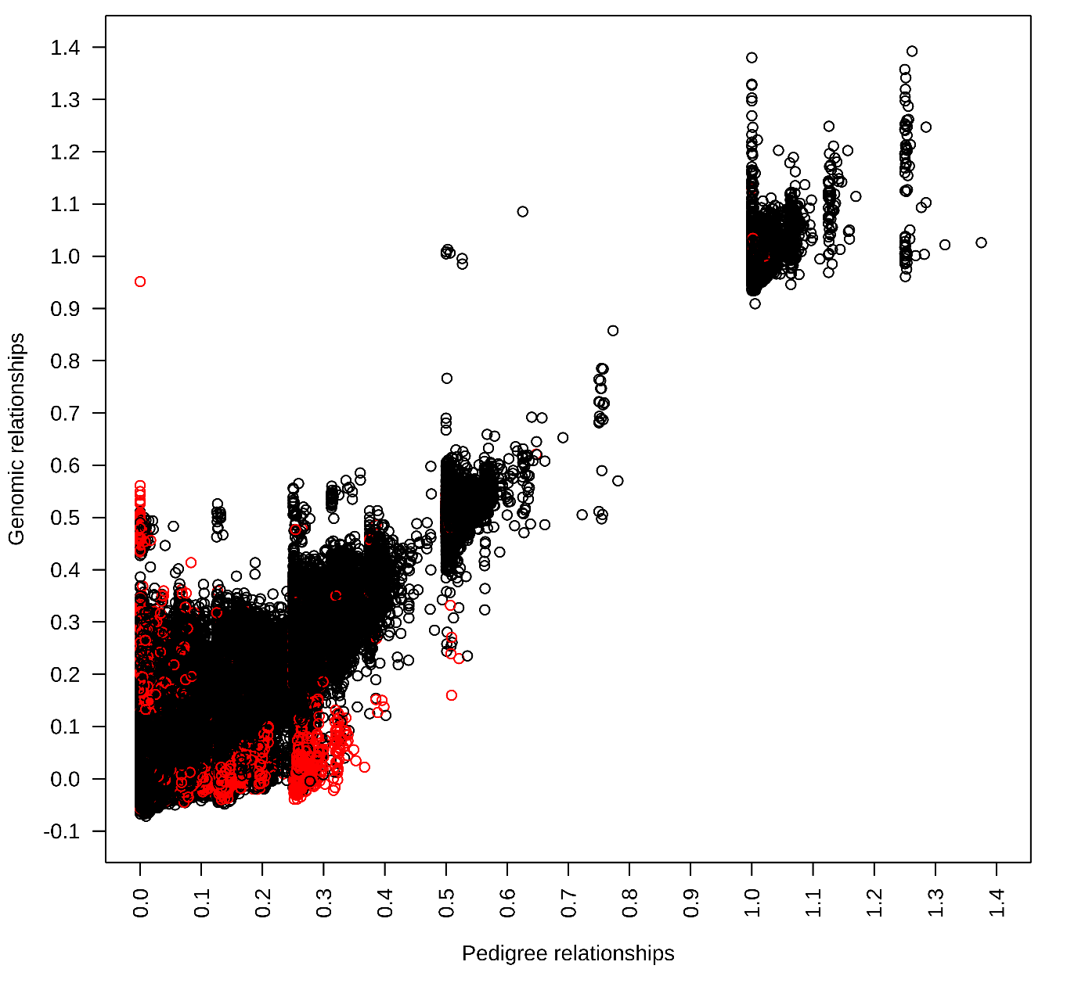

Figure S2 Differences in genetic trends ª between ssSNPBLUP_{INT} and PBLUP_{INT} per country ^{b} for sires with at least 10 recorded offspring in the country (only birth years with at least 5 sires are included).
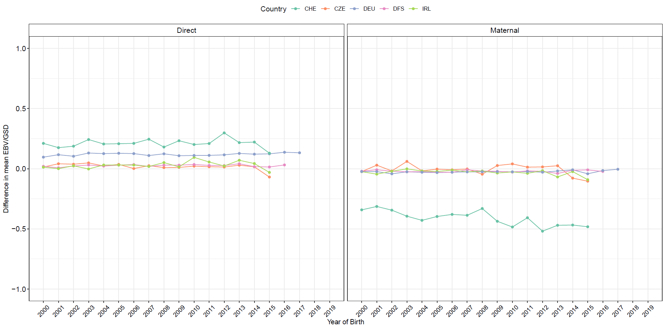
ª Differences between the mean EBV in ssSNPBLUP_{INT} and the mean EBV in PBLUP_{INT} for the period 2000-2019 in each country expressed in genetic standard deviations (GSD).
^{b} CZE = Czech Republic, DFS = Denmark, Finland and Sweden, IRL = Ireland, DEU = Germany, CHE = Switzerland.

