Figure S1 Distribution of the minor allele frequencies of the Illumina array-specific SNPs in Scenario 1 and the Affymetrix array-specific SNPs in Scenario 2.
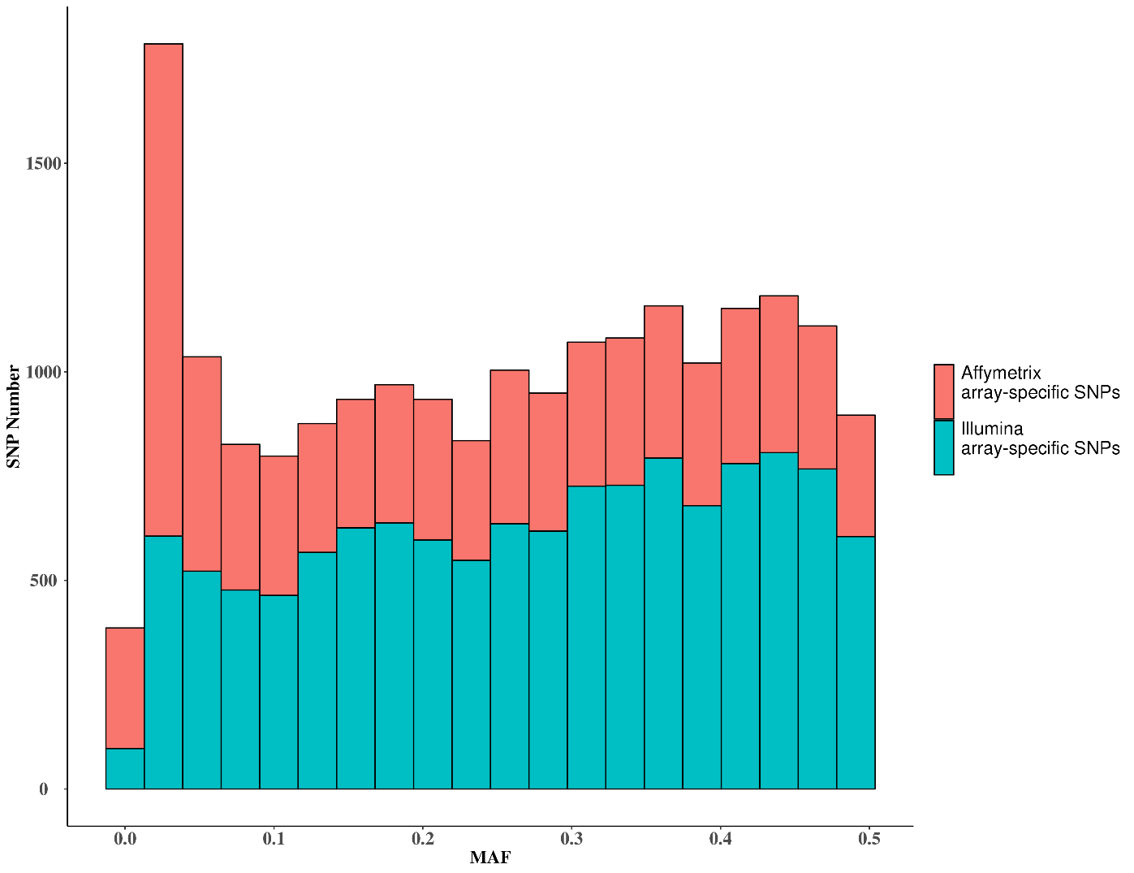

Figure S2 Effect of allele frequency on ${2p_{j}q_{j}\left(q_{j}-p_{j}\right)}^{2}$.
