Fig. S1. Venn diagram illustrating the number of the variants called by BaseVar, GATK and Bcftools

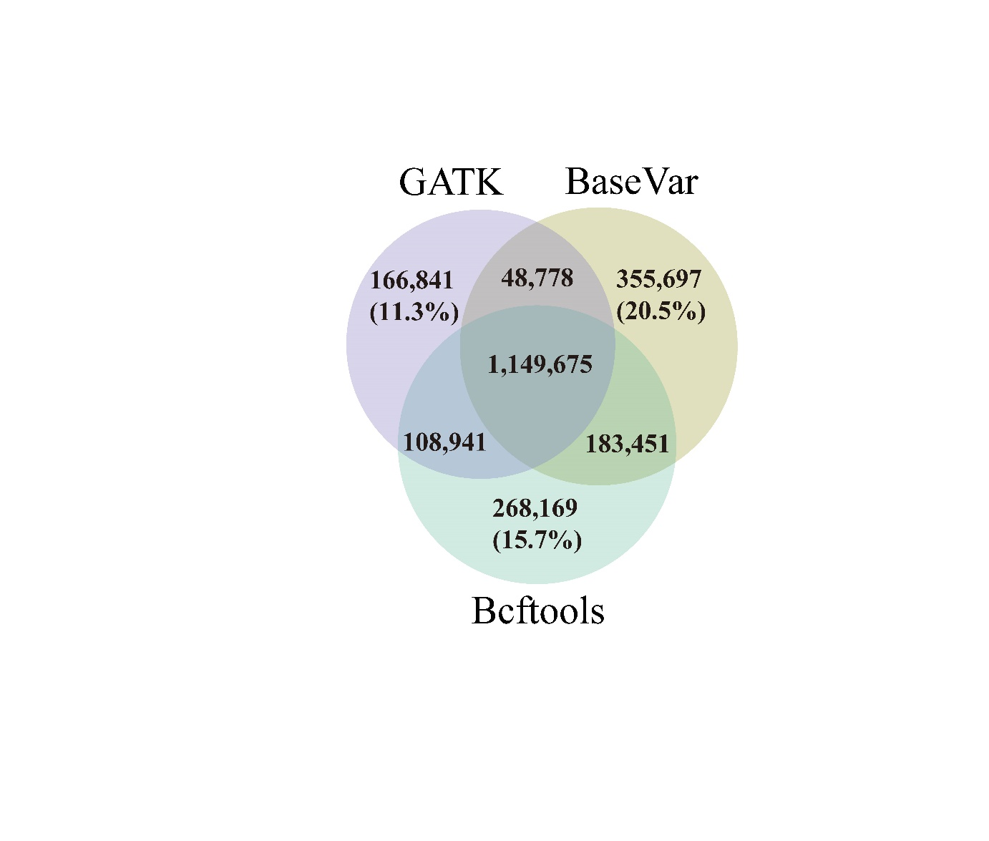

Fig. S2. CLR and Pi analyses in the Angora rabbit population

Fig. S3. Q-Q plots for the Angora rabbits (A: Body weight, B: DFW, C: CVDFW, D: LCW, E: LFW, F: RCW)
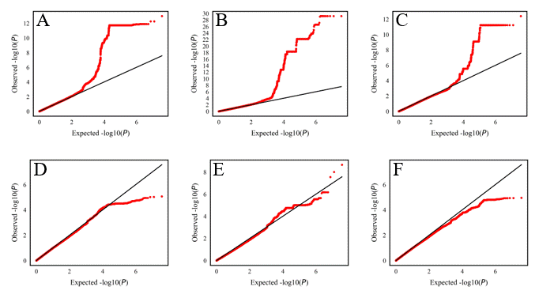

Fig. S4. Manhattan plots for the Angora rabbits (A: Body weight, B: DFW, C: CVDFW, D: LCW, E: LFW, F: RCW)
