Additional File 3: Figure S3. Manhattan plot for AGE, BF and TTN in the discovery population, samples excluding the discovery population (the training and validation population) and all 3549 samples.
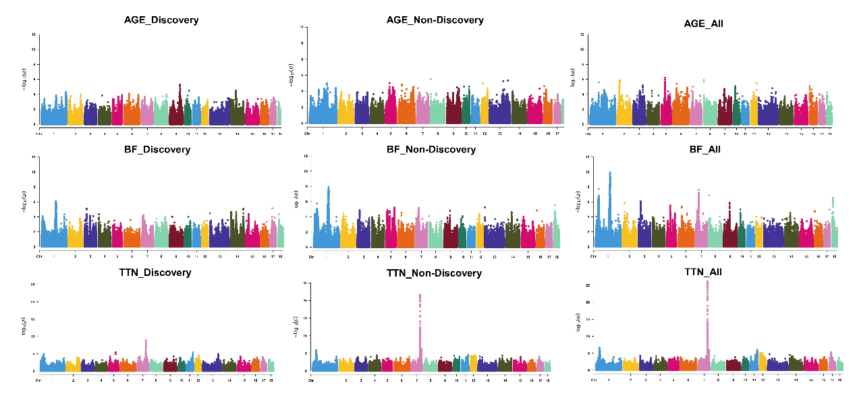
AGE, age to 100 kg live weight; BF, back fat thickness; TTN, total teat number.

