Additional file 2 Figure S1

Genetic and phenotypic correlations between the same egg quality trait at different ages are shown in Figure S1.

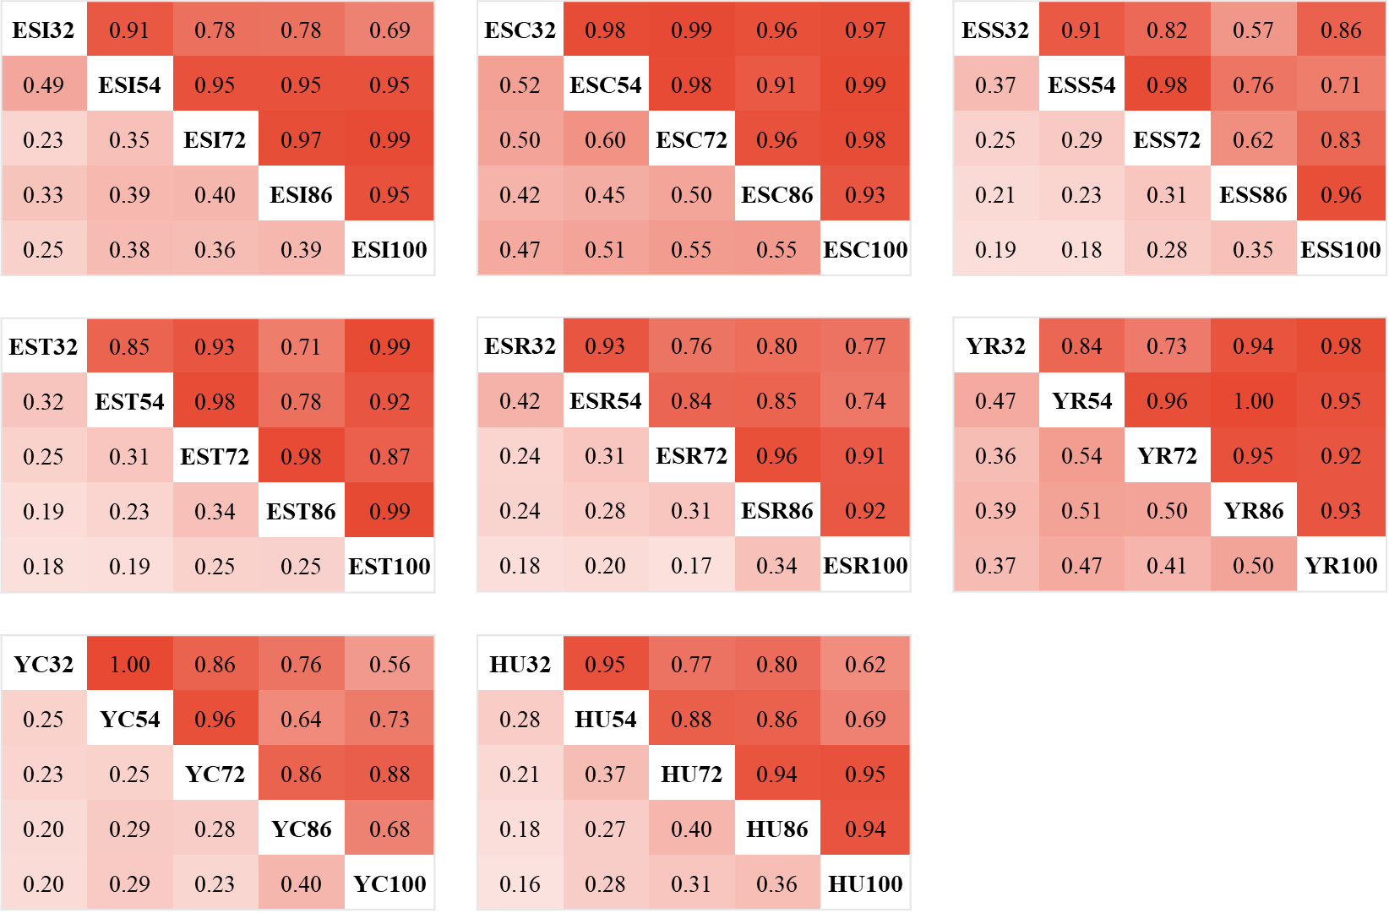

Figure S1. Genetic and phenotypic correlations between the same egg quality trait at different ages.
ESIX: egg shape index at X weeks of age, ESCX: eggshell colour at X weeks of age, ESSX: eggshell strength at X weeks of age, ESTX: eggshell thickness at X weeks of age, ESRX: eggshell ratio at X weeks of age, YRX; yolk ratio at X weeks of age, YCX: yolk colour at X weeks of age, HUX: Haugh unit at X weeks of age.
The upper triangle are genetic correlations and lower triangle are phenotypic correlations.

