Additional file 5 Figure S2
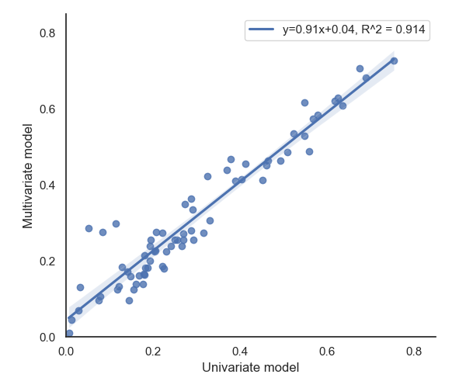
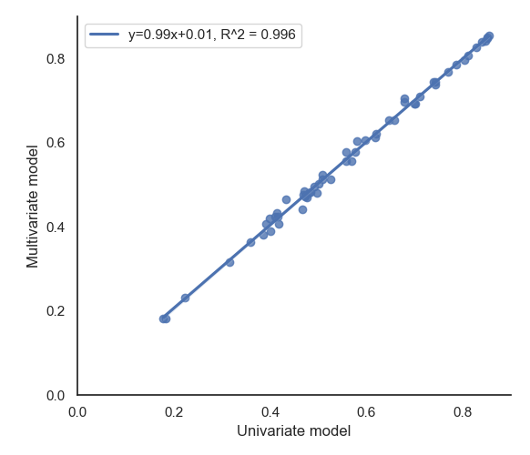
The relationship for heritabilities and repeatabilities between the univariate and the multivariate models are shown in Figure S2. The relationship was estimated with the Spearman correlation coefficient using “ggpubr” R-package (https://www.r-project.org/). Across all detected traits, the squared correlation coefficient for heritabilities is 0.914, and the squared correlation coefficient for repeatabilities is 0.996.
a
b
Figure S2. Spearman correlation coefficient between the univariate and the multivariate model for heritabilities (a) and repeatabilities (b).

