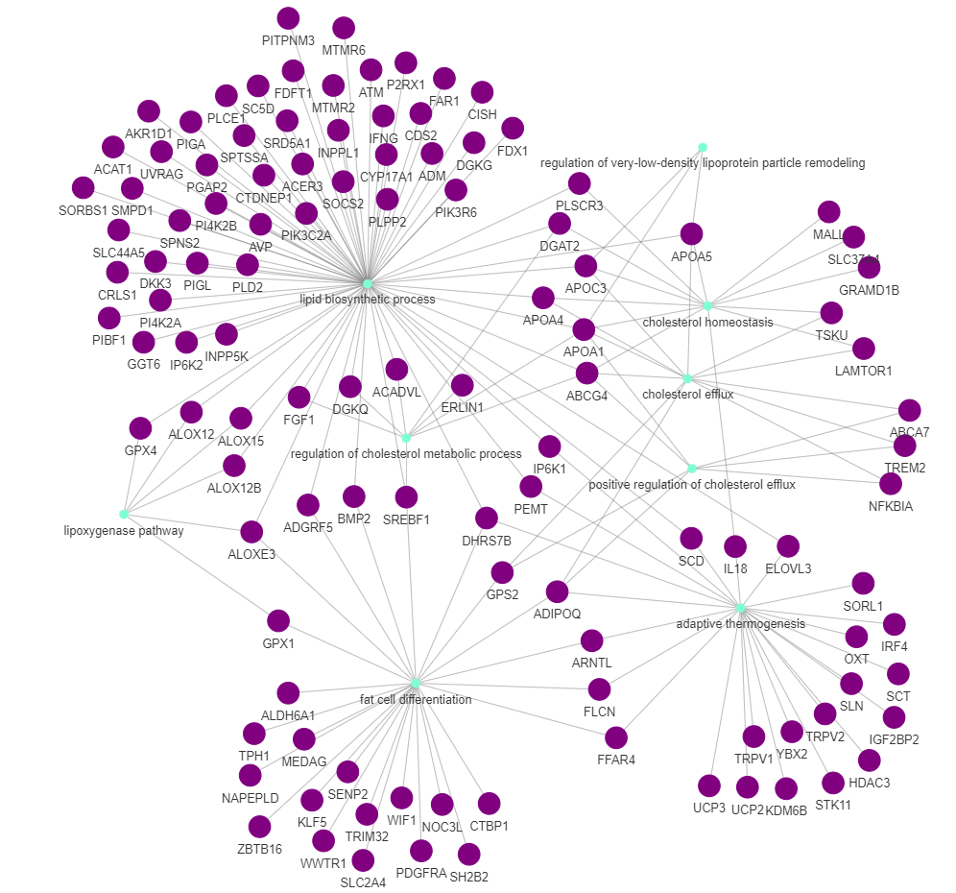
Figure S3: Network composed by genes (in purple) and enriched Gene Ontology terms (in green) associated with lipid metabolism identified for the list of genes harboring exclusively confirmed selective sweeps composed by more than 60% of adaptation studies.

