Additional file 4: Correlation allele frequency change and GWAS results for loci with MAF > 0.1

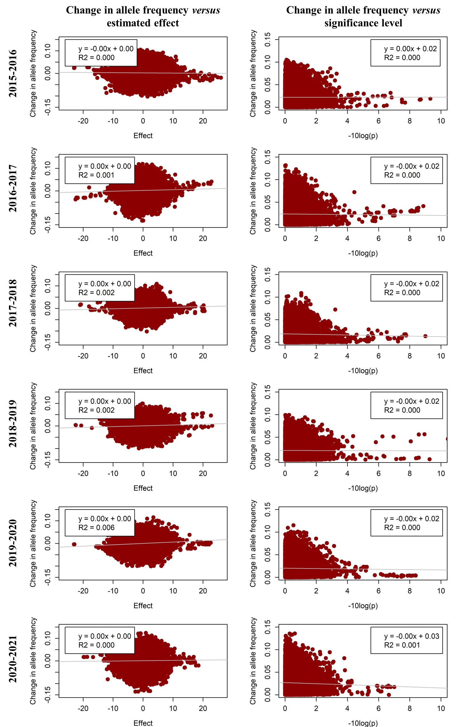
Figure S4.1 Change in allele frequency versus estimated effect and significance level for daily gain in each year in line A using only loci with a MAF above 0.1. Estimated effects are from a GWAS per year, and the change in allele frequency is the change towards the next year, with the absolute value of allele frequency change for the significance level.
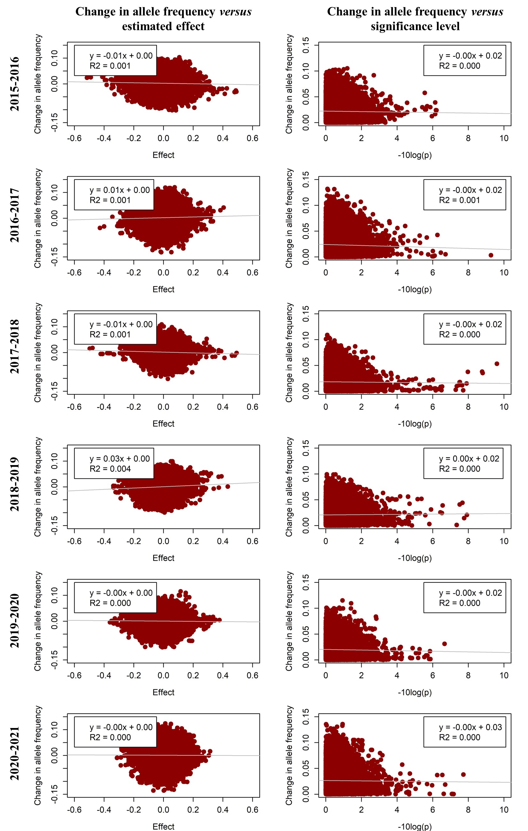
Figure S4.2 Change in allele frequency versus estimated effect and significance level for fat depth in each year in line A using only loci with a MAF above 0.1. Estimated effects are from a GWAS per year, and the change in allele frequency is the change towards the next year, with the absolute value of allele frequency change for the significance level.
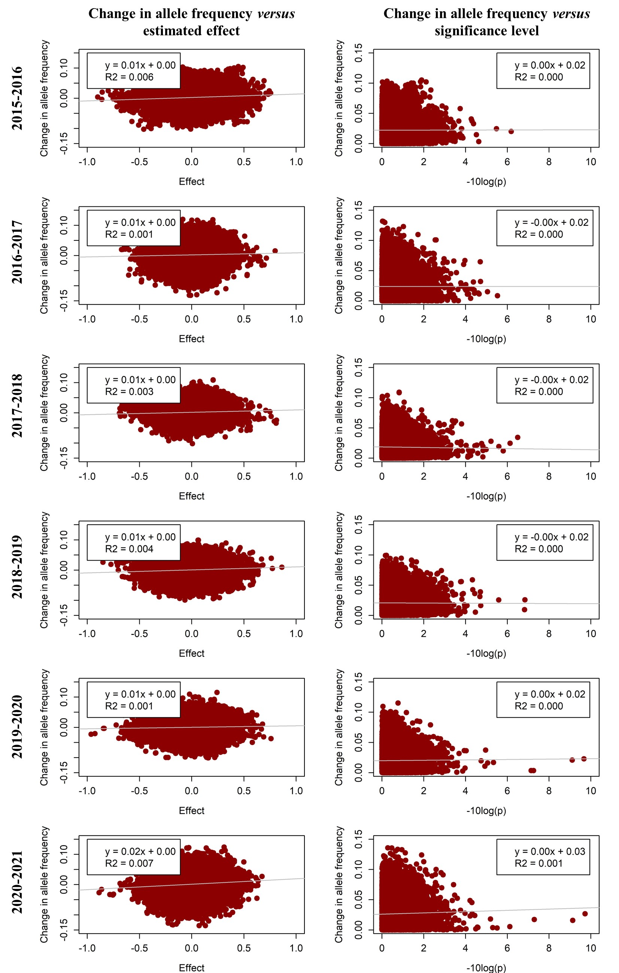
Figure S4.3 Change in allele frequency versus estimated effect and significance level for muscle depth in each year in line A using only loci with a MAF above 0.1. Estimated effects are from a GWAS per year, and the change in allele frequency is the change towards the next year, with the absolute value of allele frequency change for the significance level.
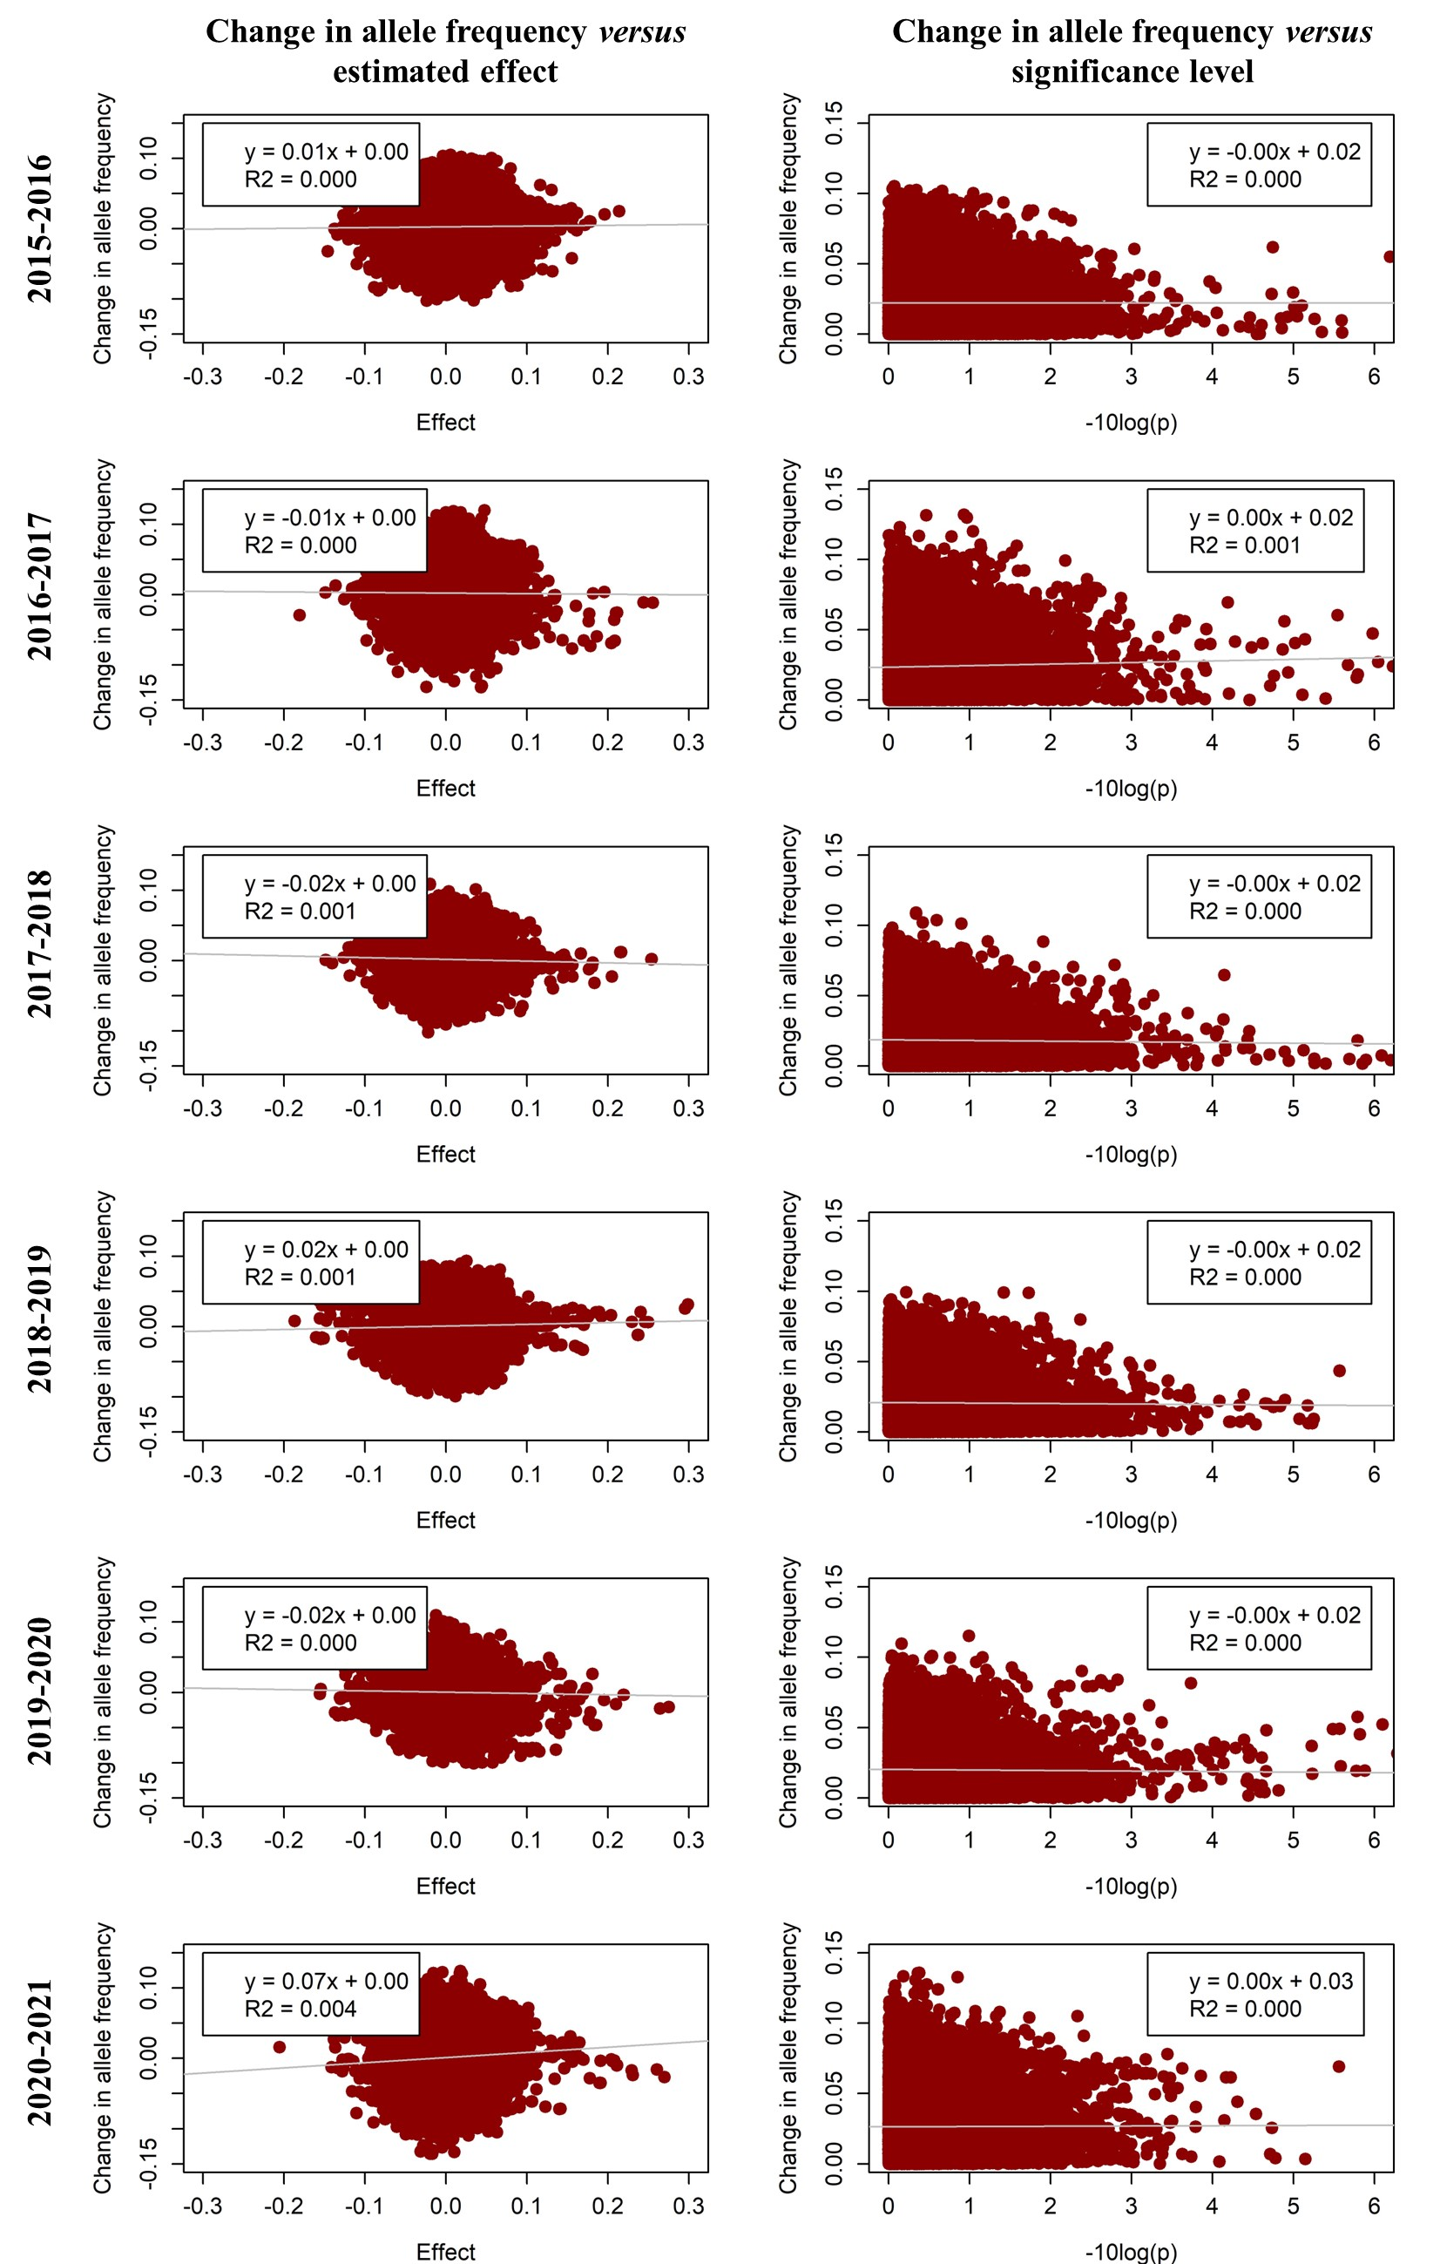
Figure S4.4 Change in allele frequency versus estimated effect and significance level for number of teats in each year in line A using only loci with a MAF above 0.1. Estimated effects are from a GWAS per year, and the change in allele frequency is the change towards the next year, with the absolute value of allele frequency change for the significance level.
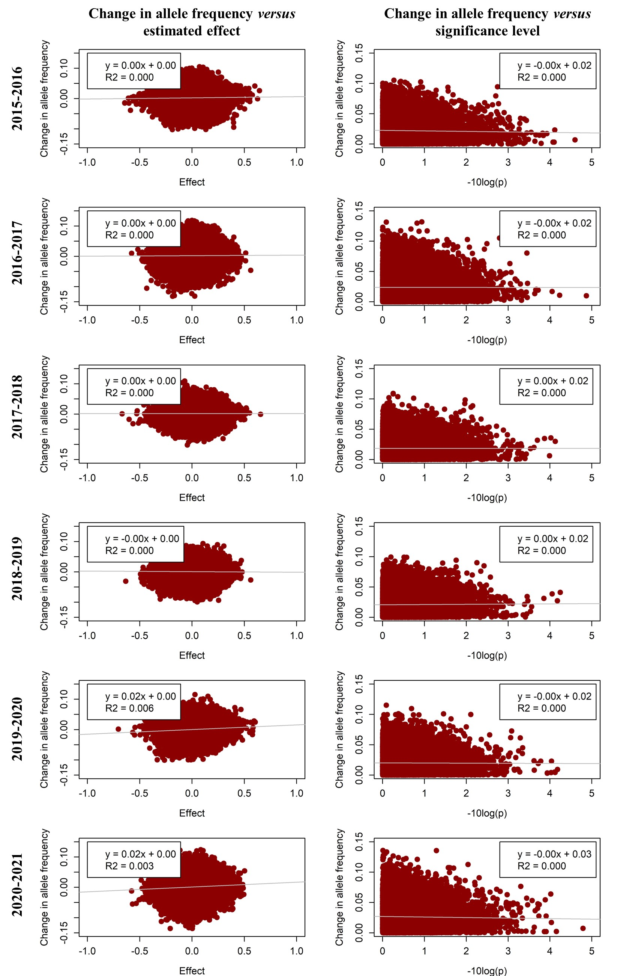
Figure S4.5 Change in allele frequency versus estimated effect and significance level for total number born first parity in each year in line A using only loci with a MAF above 0.1. Estimated effects are from a GWAS per year, and the change in allele frequency is the change towards the next year, with the absolute value of allele frequency change for the significance level.
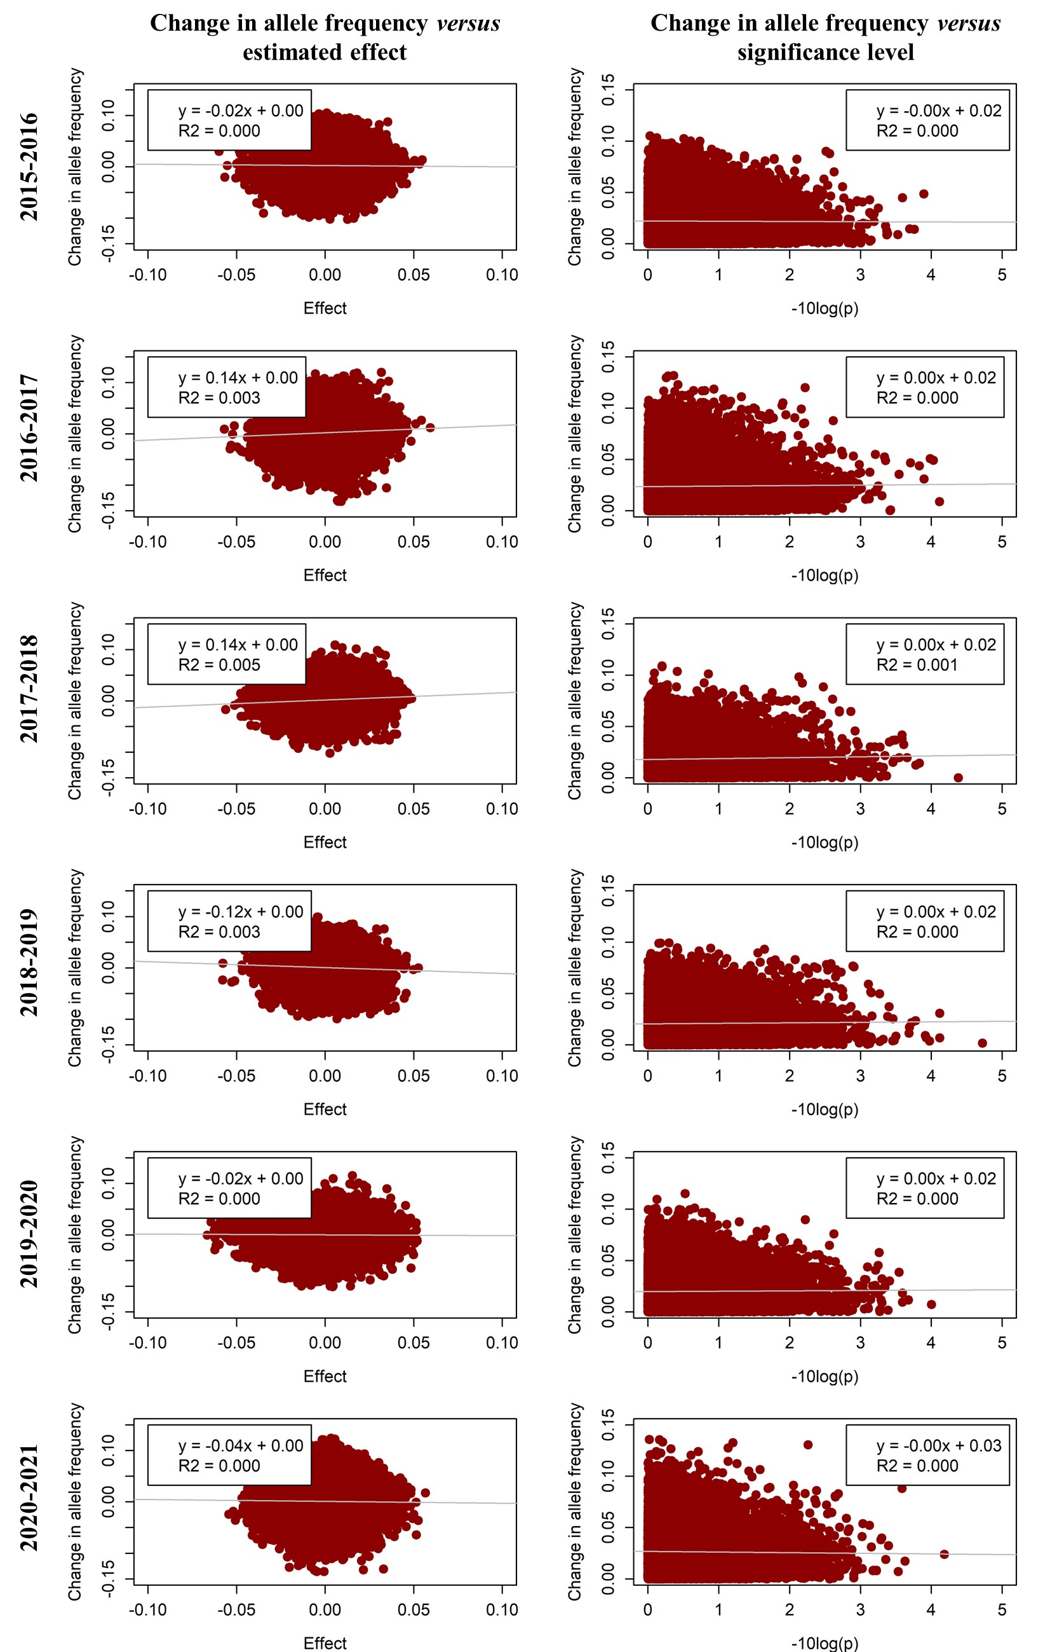
Figure S4.6 Change in allele frequency versus estimated effect and significance level for average birth weight first litter in each year in line A using only loci with a MAF above 0.1. Estimated effects are from a GWAS per year, and the change in allele frequency is the change towards the next year, with the absolute value of allele frequency change for the significance level.
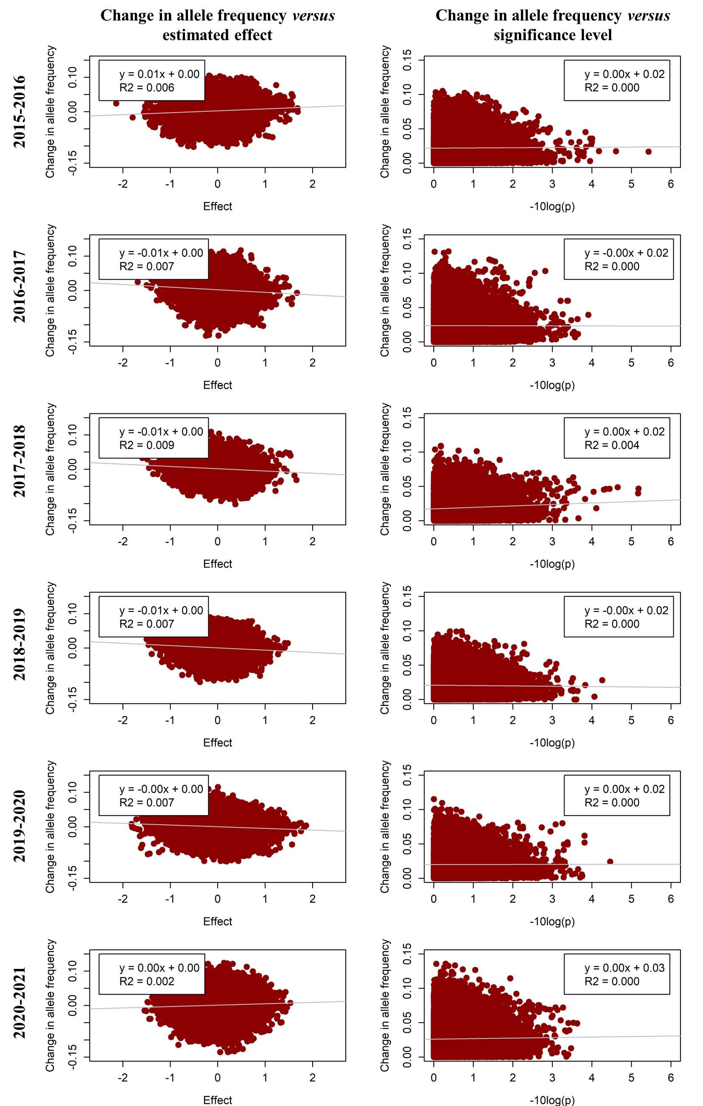
Figure S4.7 Change in allele frequency versus estimated effect and significance level for CV of birth weight first litter in each year in line A using only loci with a MAF above 0.1. Estimated effects are from a GWAS per year, and the change in allele frequency is the change towards the next year, with the absolute value of allele frequency change for the significance level.
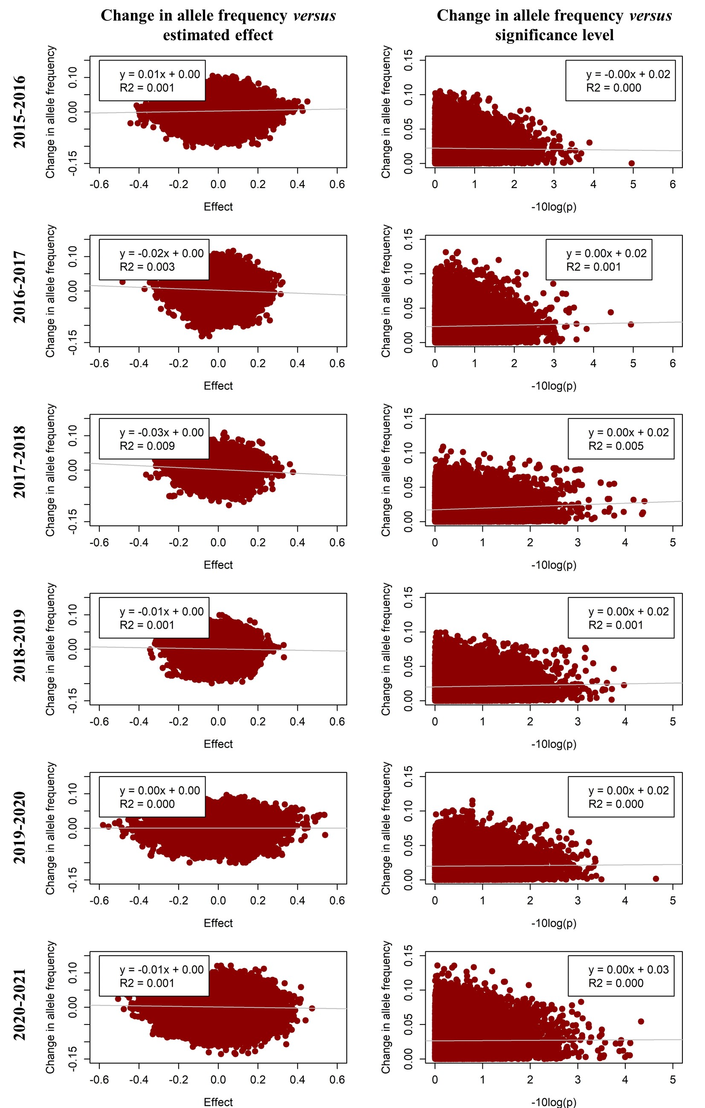
Figure S4.8 Change in allele frequency versus estimated effect and significance level for number of small piglets in each year in line A using only loci with a MAF above 0.1. Estimated effects are from a GWAS per year, and the change in allele frequency is the change towards the next year, with the absolute value of allele frequency change for the significance level.
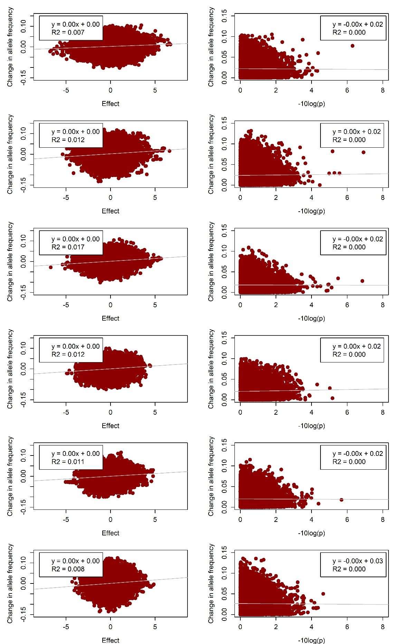
Figure S4.9 Change in allele frequency versus estimated effect and significance level for the index in each year in line A using only loci with a MAF above 0.1. Estimated effects are from a GWAS per year, and the change in allele frequency is the change towards the next year, with the absolute value of allele frequency change for the significance level.
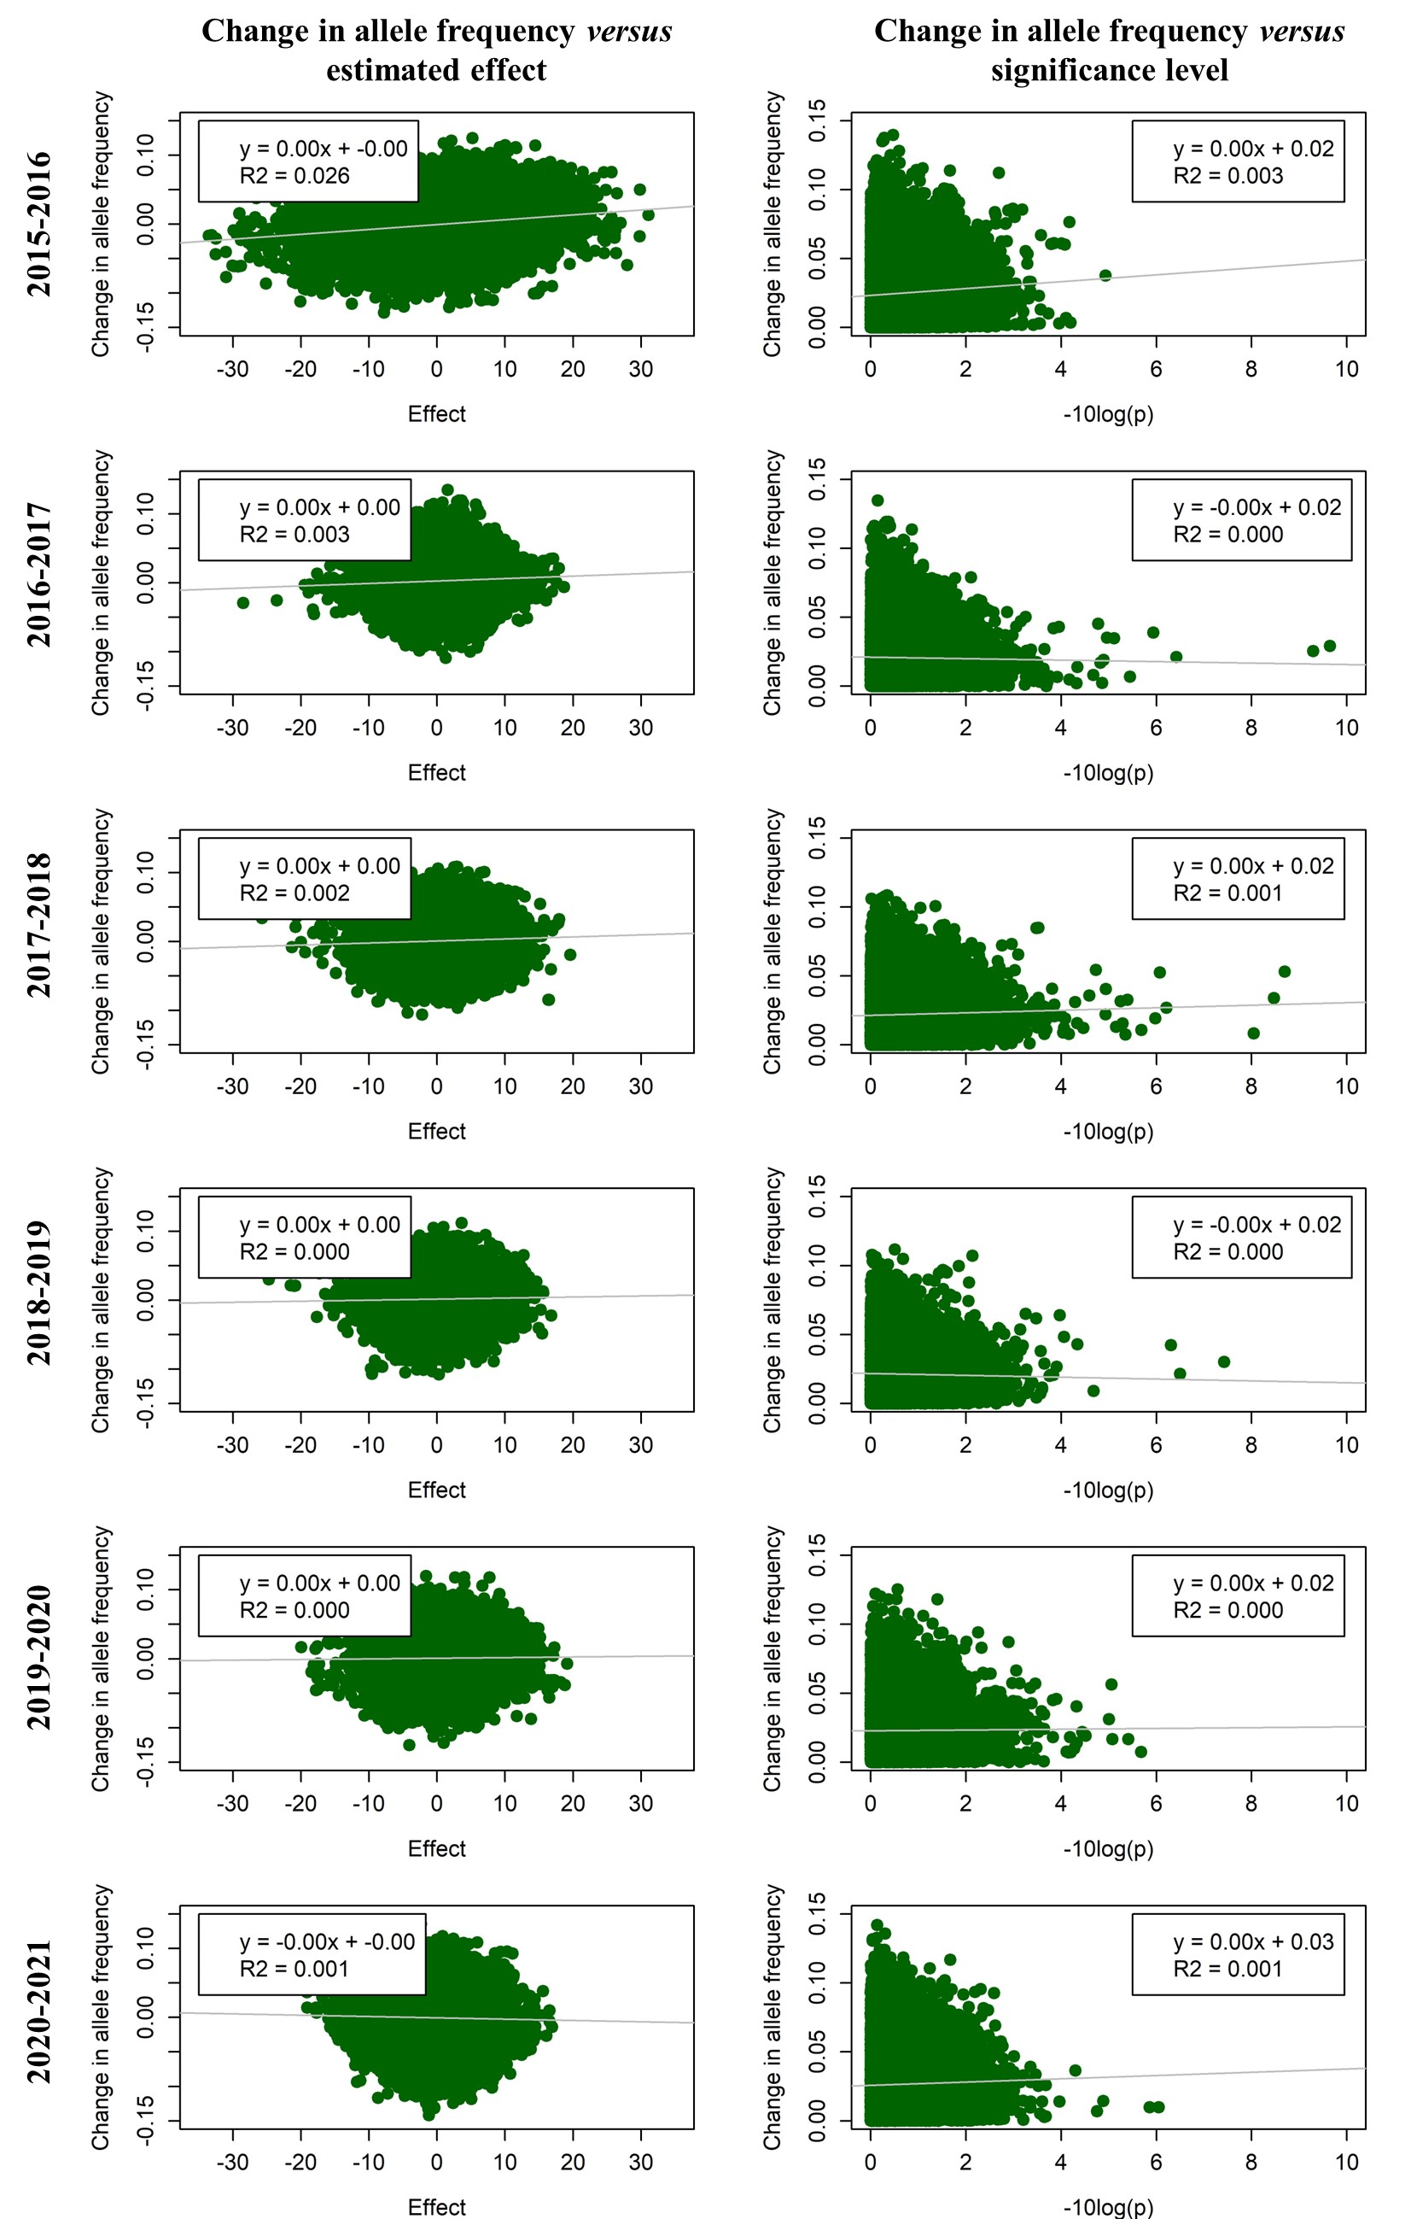
Figure S4.10 Change in allele frequency versus estimated effect and significance level for daily gain in each year in line B using only loci with a MAF above 0.1. Estimated effects are from a GWAS per year, and the change in allele frequency is the change towards the next year, with the absolute value of allele frequency change for the significance level.

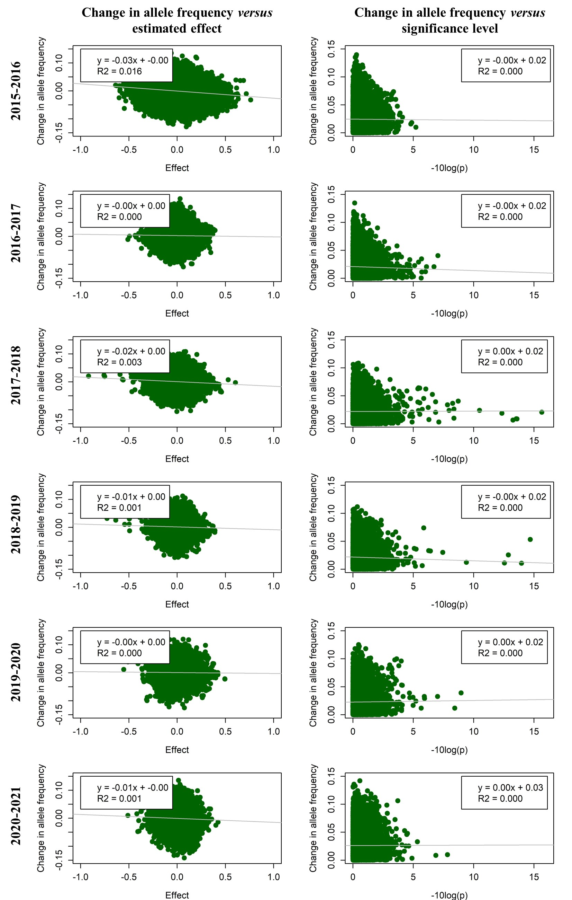
Figure S4.11 Change in allele frequency versus estimated effect and significance level for fat depth in each year in line B using only loci with a MAF above 0.1. Estimated effects are from a GWAS per year, and the change in allele frequency is the change towards the next year, with the absolute value of allele frequency change for the significance level.
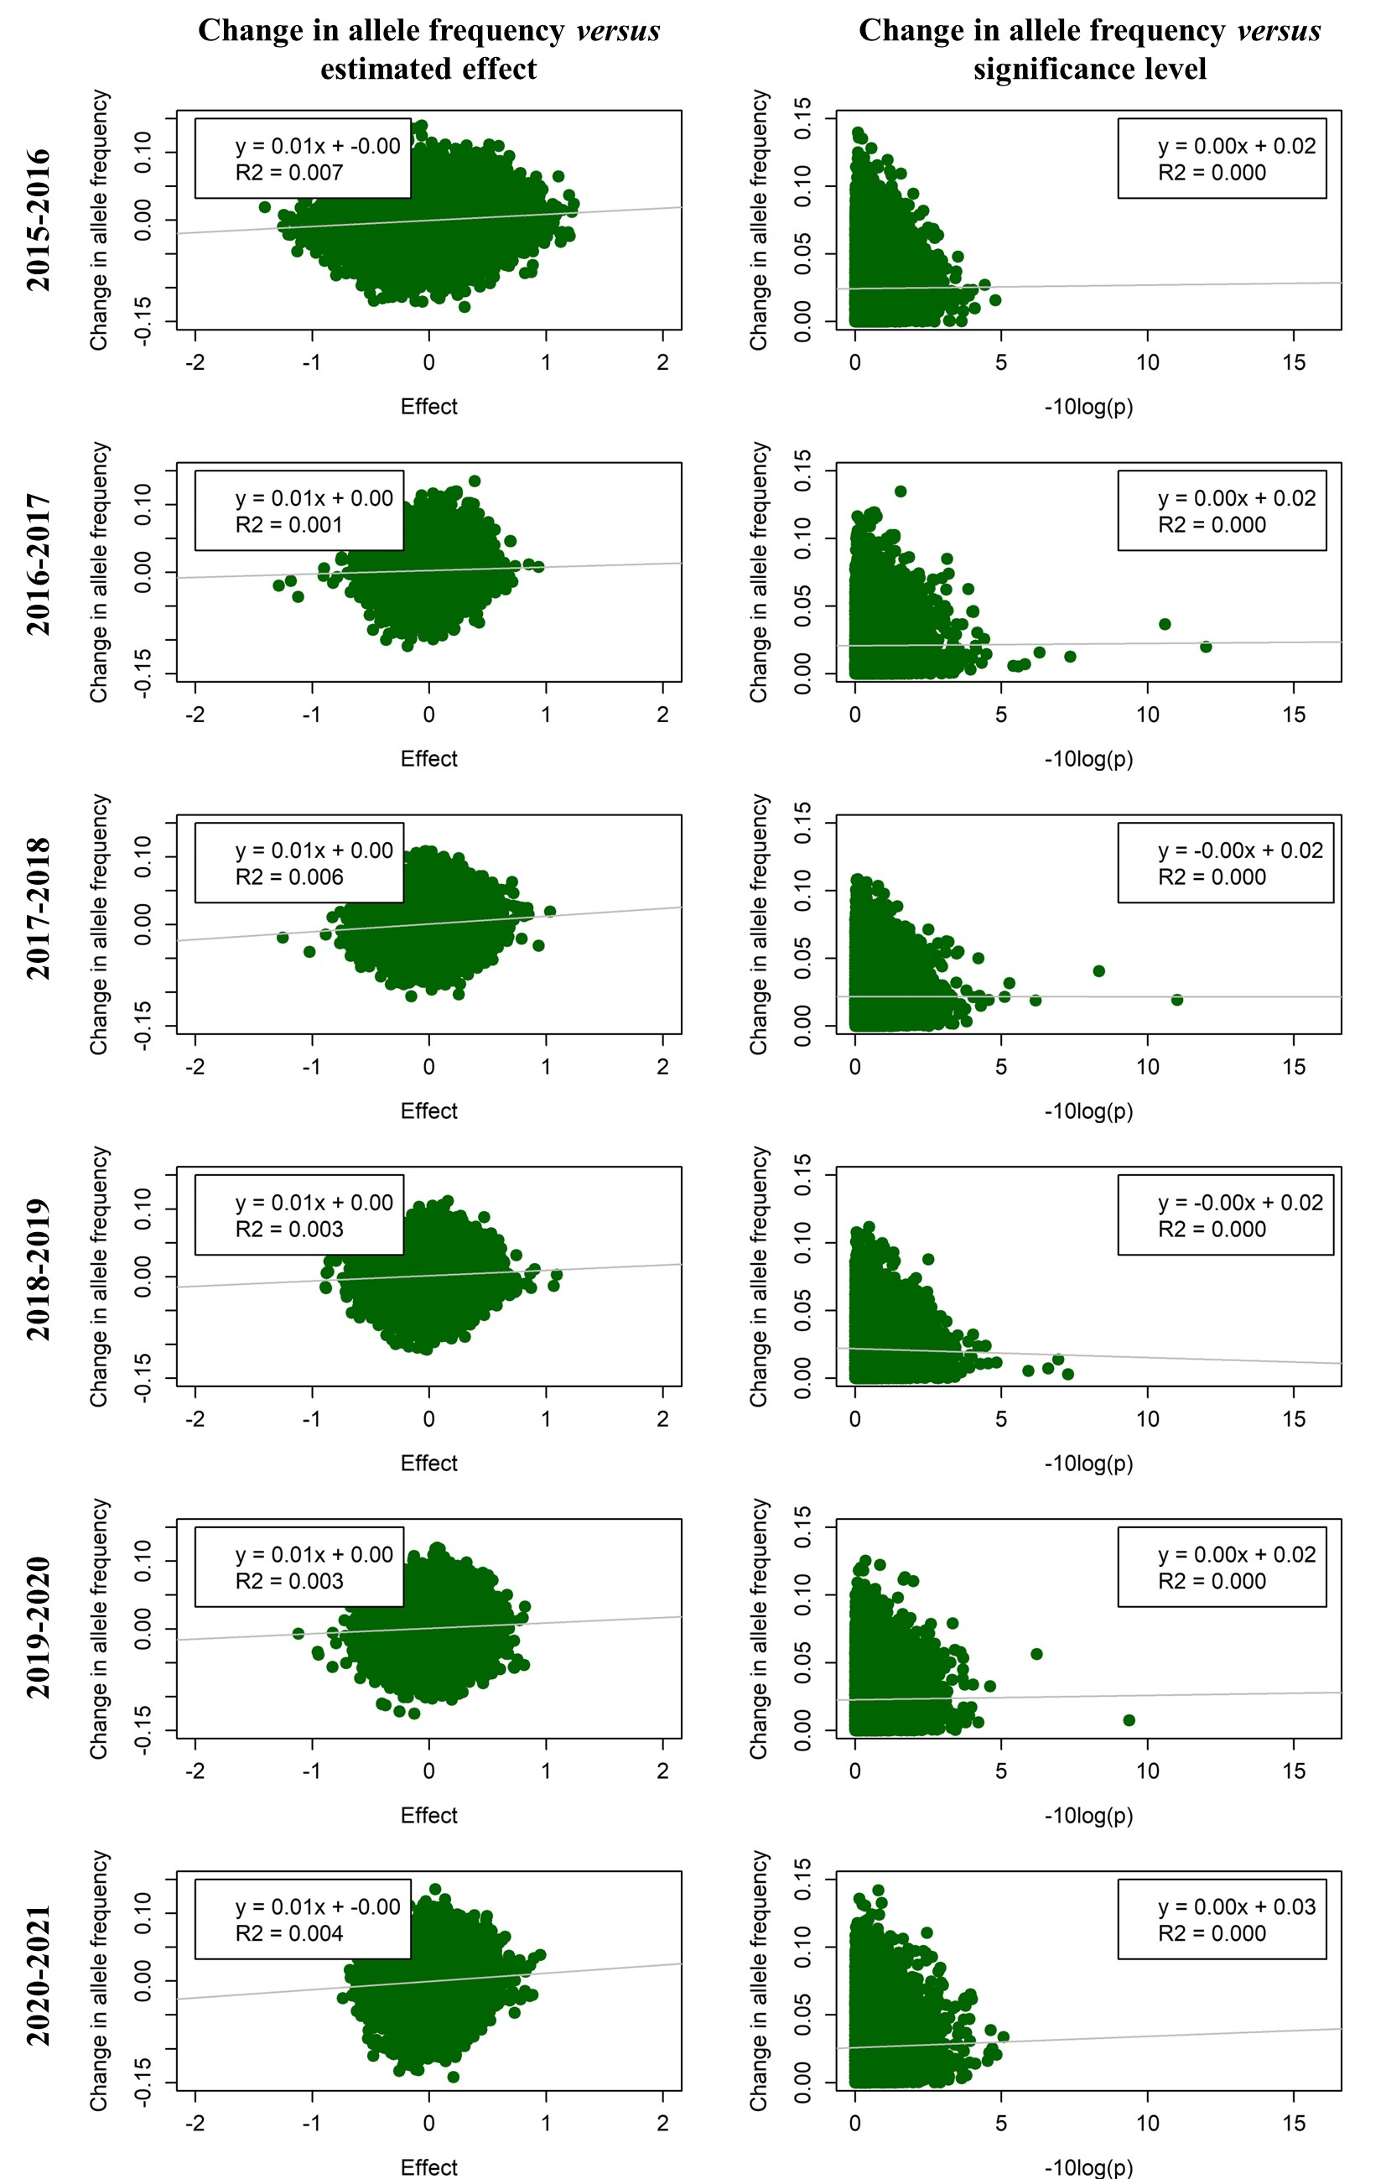
Figure S4.12 Change in allele frequency versus estimated effect and significance level for muscle depth in each year in line B using only loci with a MAF above 0.1. Estimated effects are from a GWAS per year, and the change in allele frequency is the change towards the next year, with the absolute value of allele frequency change for the significance level.
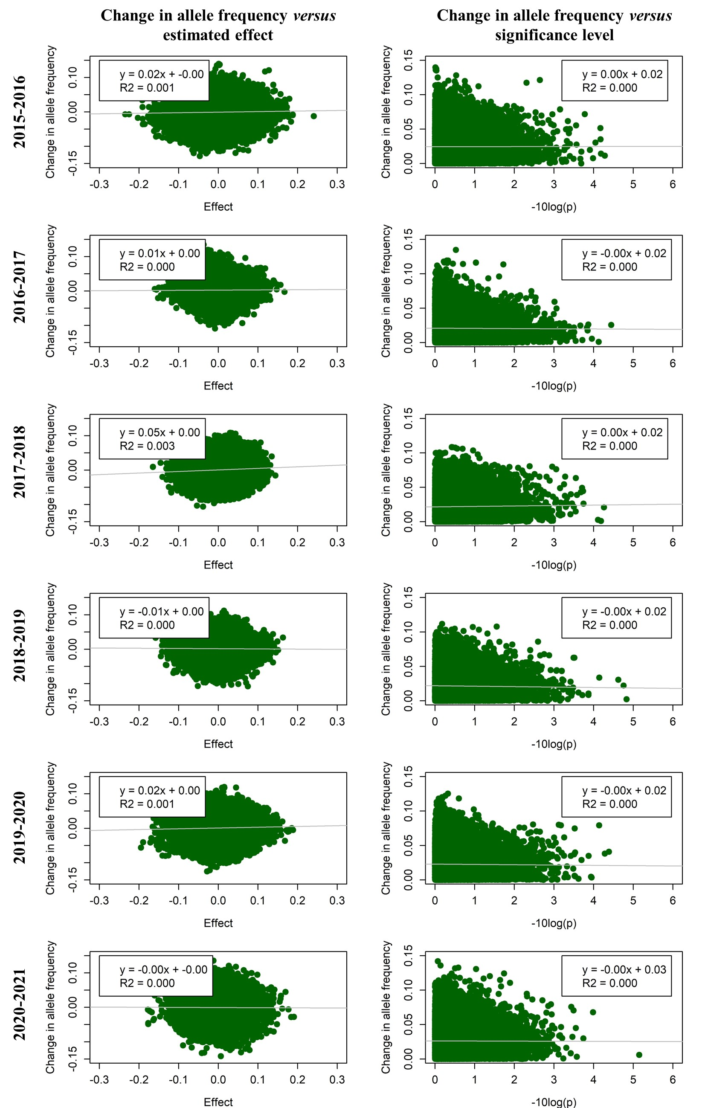
Figure S4.13 Change in allele frequency versus estimated effect and significance level for number of teats in each year in line B using only loci with a MAF above 0.1. Estimated effects are from a GWAS per year, and the change in allele frequency is the change towards the next year, with the absolute value of allele frequency change for the significance level.
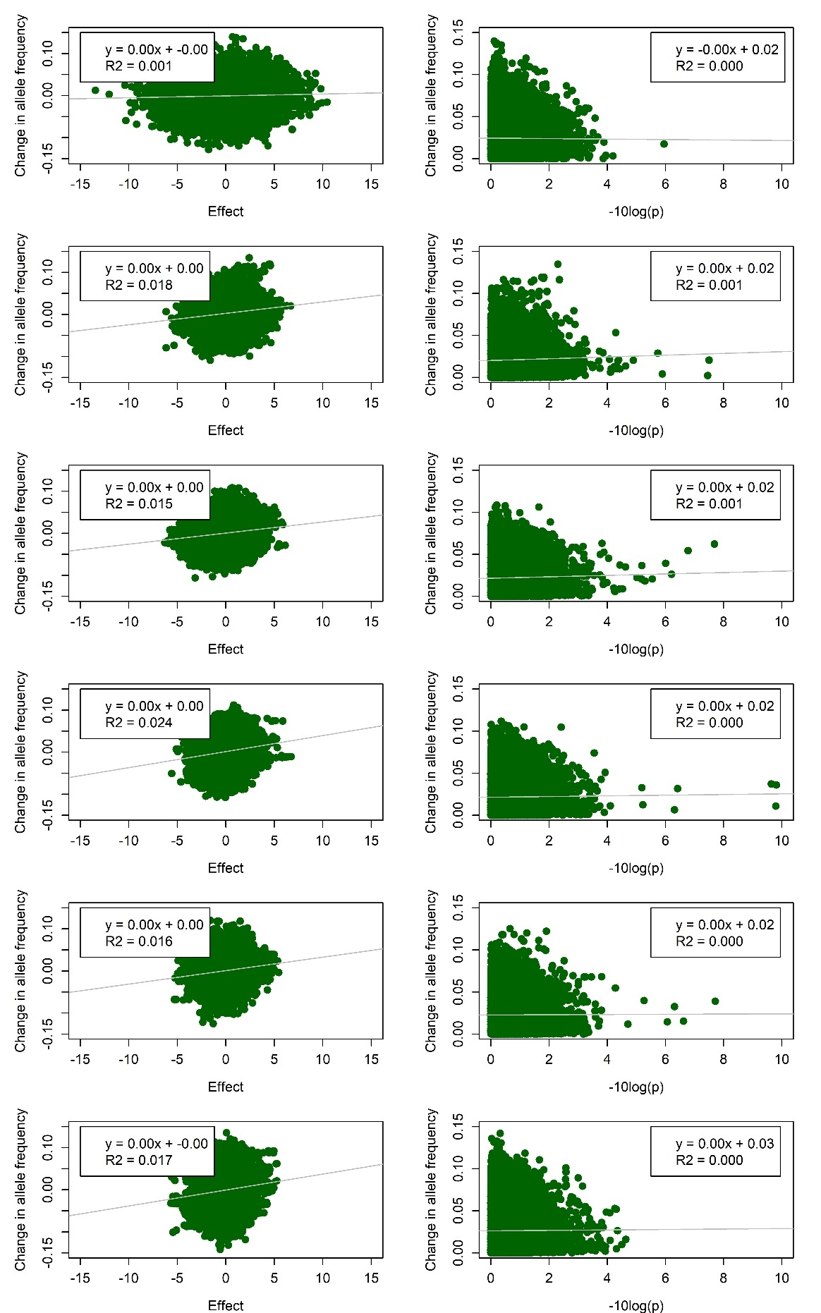
Figure S4.14 Change in allele frequency versus estimated effect and significance level for the index in each year in line B using only loci with a MAF above 0.1. Estimated effects are from a GWAS per year, and the change in allele frequency is the change towards the next year, with the absolute value of allele frequency change for the significance level.

