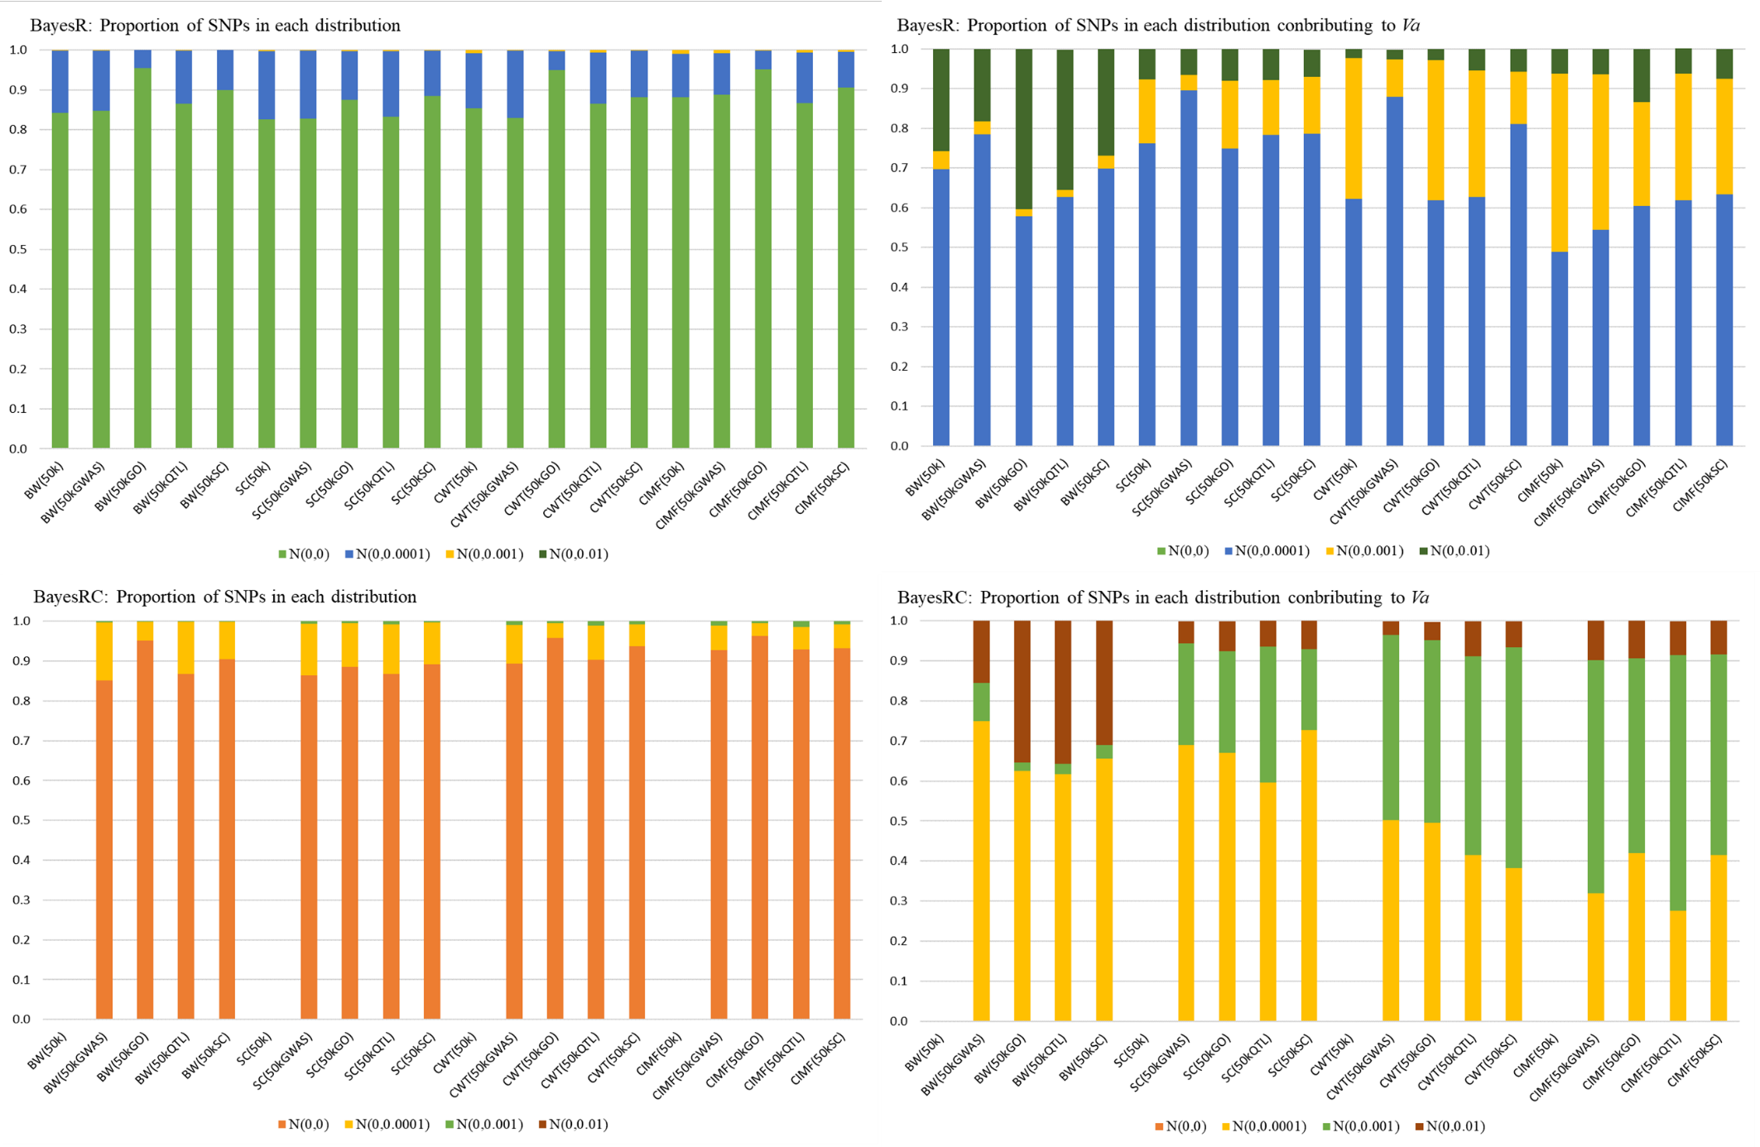
Additional file 2 Figure S1 Proportion of SNPs and SNP effects (V_{a}) in each mixture component from the Bayesian models

